Module A – Lesson 8 Study Notes:
Introduction
Which gemstone is the most significant historically and economically?
- Diamond

Most everyone knows about diamonds, their value and historical importance, and appreciates their physical properties. Even with a general understanding of diamond, there continues to be wonder, mystery, and desire associated with these precious stones.

Explain the origins of the word diamond.
- The word diamond originates from the Greek word adamao meaning “I tame” or “I subdue”
- Adamao is a root word for the word adamantine. Adamao is used to describe great hardness. Diamonds are the pinnacle of hardness
- Adamantine describes lustre, like that of a diamond

Where were diamonds first mined?
- India

In Sanskrit, diamond was endowed with the name vajra, and the earliest record of this word dates to the 4th century BC. In ancient India, diamonds of euhedral shape (e.g., octahedrons) were the most valued. But the fire (its dispersion of light) and brilliance of diamonds was also recognized as a valuable feature.

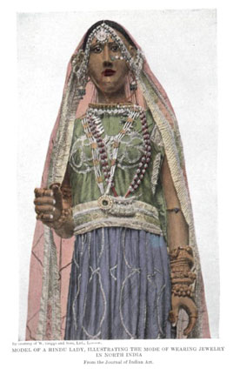
Model of a Hindu lady, illustrating the mode of wearing jewellery in North India. This figure appeared in Kunz, G.F. (1915) The Magic of Jewels and Charms, with permission from the Journal of Indian Art.

What is so significant about 1st century BC?
- Use of the word adamao began in the Mediterranean
- Carvings of hard gemstones ruby and sapphire began to appear
- Diamond carving tools were noted in Chinese literature

One of the most reliable historical pieces of evidence of diamond's value during Roman times comes from the discovery of a rough diamond set in gold within the tomb of a wealthy young woman.

How far can the European history of diamonds as gemstones be traced back to?
- As far as 13th century BC
- In this period, diamonds adorned jewelry as symbols of power
- Diamonds also began to be faceted in Antwerp and Venice

What is so significant about the 17th century?
- Non-royalty upper upper class individuals started to adorn their own jewelry with diamonds
- Prior to the 17th century, the right to adorn diamonds onto jewelry was reserved for royalty

Of course, these people were hardly peasants but rather wealthy upper-upper class, also interested in diamonds for the show of power.

A shift in jewellery design also occurred during this time period where diamonds (and other gemstones) became the centers of attention instead of the piece of art that they were hosted within. It is during this paradigm shift in jewellery where diamond cutting became more important and the existing rose and table cuts were replaced with the newly developed old cut.

Name and describe the successor to the old cut.
- The brilliant cut
- Designed to enhance the beauty of a stone and maximise the stone’s fire and brilliance at the expense of total weight of the stone
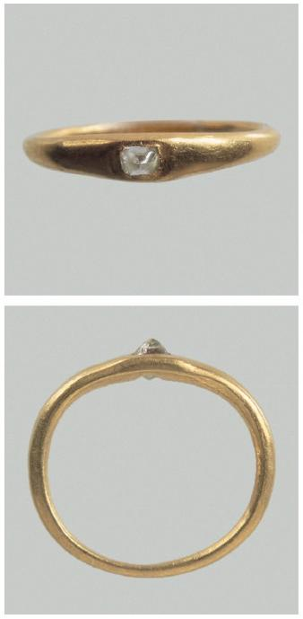

The Vallerano Diamond, found during excavations of a ~150 AD tomb in Vallerano, Italy. This figure appeared in Bedini et al., 2012 (optional reading)

Historically, diamonds were extremely rare and sourced from only a few scattered alluvial (i.e., within river gravels) localities.

Where were these localities first discovered?
- Golconda Region of India and subsequently in Brazil by the 18th century

It has been supposed that a maximum 50,000 carats could have been produced annually from India before the 18th century and that the alluvial sources from Brazil did not produce large amounts.

What event led diamonds into becoming more common in the hands of the upper-class?
- The discovery of kimberlite in Kimberly, South Africa 1867
- Eventually, more and more diamondferous kimberlite was discovered and mined allowing upper-class men to obtain diamonds

Originally, the discoveries in South Africa were made by individuals and mineral claims were hotly fought over. The establishment of the De Beers Consolidated Mines Ltd. in 1888 changed all these, and eventually the face of diamond mining in South Africa.

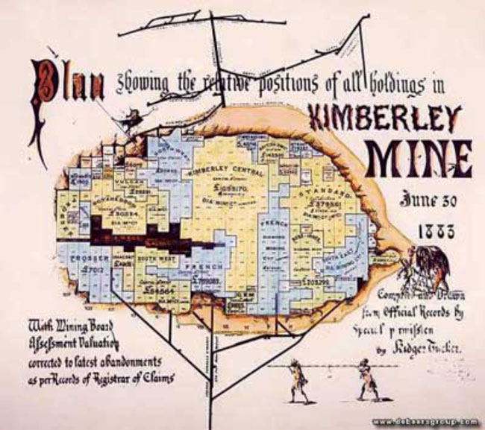
A map showing the positions of the various holdings at Kimberley Mine in 1883. Figure courtesy of the De Beers Group.

Shortly after the turn of the 20th century, the diamond industry consisted primarily of the De Beers group who were mining the large majority of diamonds from South Africa and also marketing them to the consumer. Having a single organization controlling the majority of diamond production and sales has had a profound impact on the development and evolution of the global diamond industry. From the outset, the diamond mining operations at Kimberley alone were producing on the order of 250,000 carats yearly. By the early 1900's that number had increased to almost 3 million carats annually (compare this to the total production from Brazil at 50,000 carats over several years!). The subsequent rise of competing diamond producers (Soviet Union in the 1950's, Australia in the 1980's and Canada in the 1990's) and the drive by consumers to ensure conflict-free diamonds has significantly changed the way diamonds are mined, polished, and sold.
Today, the global diamond industry has a handful of major corporate players, which means that De Beers' production contribution is now down to about 60% of the global total. A number of government and non-government organizations now regulate the movement of diamonds, a highly valued commodity with significant liquidity, and are working to ensure the civil rights of miners.
What role does Kimberly Process play in the diamond industry?
- Monitors the import and export activity of diamond producing countries.
- Keeps tabs on legitimately mined and processed diamonds

What is the percent of the global diamond trade comes from conflict zones?
- Estimated to be less than 1%

This is about 1 million carats of the 170 million carats of rough diamond produced annually across the globe. Applying a value of ~$100 USD / carat, we're looking at about $100 million not traded through the Kimberley Process. For perspective, South Africa now produces almost 15 million carats annually, about 8% of the global production.

Due to the significance of diamonds in history, economics, and social issues, there is a great deal of high quality information regarding diamonds available online. It is provided primarily through governments, museums, educational institutions, and corporate websites. (Note: be wary of inaccurate information from small businesses or uncertified personal home pages!) The resources available have been created for a variety of reasons, but primarily have the goal to educate the general public and consumers of the world about general properties and the history of diamonds. In response to the movie "Blood Diamond", the negative profile of conflict stones has risen dramatically along which have been a multitude of websites that document the breadth of the diamond industry from mine to market.

