LECTURE 5: WHAT IS AN ECOSYSTEM?

ECOSYSTEM
- First proposed by Tansley in 1935
- Modified over time as we learned more about interactions between plants, between animals, and between plants and animals
- Whittaker (1975): “an ecosystem is a functioning system that includes an assemblage of interacting organisms (plants, animals, and saprobes) and their environment, which acts on them and on which they act”

SYSTEMS THEORY
- Boundary
  - Space
  - Time?
- Open system vs. closed system
- Ecosystems are open systems, but where are the boundaries?

TROPHIC LEVELS
- Levels 1: Plants and algae make their own food and are called primary producers
- Level 2: Herbivores eat plants and are called primary consumers
- Level 3: Carnivores which eat herbivores are called secondary consumers
- Level 4: Carnivores which eat other carnivores are called tertiary consumers
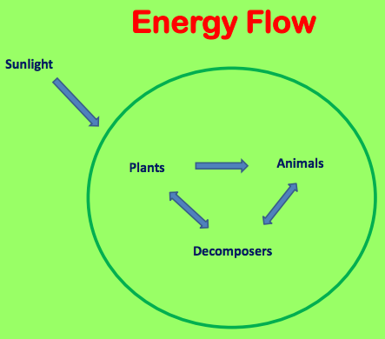
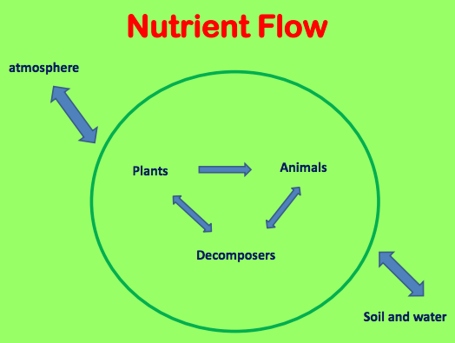

ECOSYSTEMS ARE DYNAMIC
- Structure is always changing
- Autogenic change – without outside influence
- Allogenic change – outside agent

HOLLING:

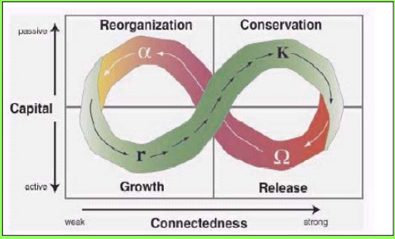

COMPLEX ADAPTIVE SYSTEMS
- Dynamic network of interactive systems – mycorrhizal connections
- Energy flow
- Nutrient flow

NOT A “SUPER-ORGANISM”
- No natural selection at community level
  - Need competition
  - Individual level
- Plants rarely exhibit mutualism
  - No food web between plants
  - Plant-animal interactions can exhibit mutualism
- Redundancy

ECOSYSTEM MANAGEMENT
- Maintaining a healthy system
- The heart of sustainability

