ECON 2117 : Introduction to Development Economics

Introduction – September 8th 4
Introducing Economic Development – September 13th & September 15th 4
What is economic development? 4
Strata of living 6
What constitutes well-being? 6
Amartya Sen’s Capabilities Approach 7
Comparative Economic Development – September 20th & 22nd 8
Indicators of Development 8
Gross National Income (GNI 8
Power Purchasing Parity 9
Health and Education 9
The New Human Development Index 9
Dimension Indexes 9
$Dimension index = Country's value - minimum valueMaximum value - minimum value$ 9
Overall Index 10
Key Commonalities of Developing Countries 10
Diversity within Commonality 11
Convergence 12
Convergence 12
Divergence 12
World-as-one convergence 12
Economic Growth – September 27th & 29th 13
Production Possibilities Frontier 13
Classic Theories 16
The Neocolonial Dependence Model 18
The Harrod-Domar Growth Model 20
Y = F (K;L) = min (AK; BL) 21
The Solow Model 22
Contemporary Models – October 4th and 6th 22
Coordination Failures and Complementarities 22
Coordination Failure 22
Complementarities 25
Diagram of Multiple Equilibria 27
The Big Push Model 28
The O-Ring Model 28
Poverty, Inequality and Development – October 18th & 20th 29
Measuring Inequality 29
Kuznets ratio 29
Lorenz Curves 29
Gini Coefficients 31
Measuring Absolute Poverty 32
Income Poverty 32
Kuznets’ Inverted-U Hypothesis 34
Growth and Poverty 35
Policy Options 35
Population Growth – November 1st & 3rd 36
The Demographic Transition 36
The demographic transition illustrated 36
The Malthusian Population Trap 37
Microeconomic Theory of Fertility 43
Policy Approaches 48
Guest Speaker Nov 22nd, Marie Christelle Mabeau 48
Urbanization – November 8th & 10th 49
Urbanization 50
The Todaro Model 50
The Harris-Todaro Model 51
Extensions of the model 58
Policy Implications 58
Human Capital – November 17th 58
Investment in Education and Health 58
The Child Labour Model 59
The Environment and Development – Nov 22nd & Nov 24th 61
Environmental Kuznets Curve 61
Market Failure 62
Public Goods and Bads 62
Protection of forests as a public good (or Deforestation as a public bad) – Model 63
International Trade & Development = Nov 30th & Dec 1st 65
Primary Products and Export Dependence 65
Export Dependence 65
Export Earnings Instability 66
Traditional Theory of International Trade 66
Factor Endowment Theory 66
Critique of the Traditional Theory 68
Import Substitution and the Theory of Protection 69
Import Substitution 69
Foreign Aid and Conflict 71
Foreign Aid 71
Conflict & Development 72
The Production Possibilities Model and Conflict 73
The Fungibility of Foreign Aid 74
Bonus: Guest Speaker #2 76
Philip Fry 76

Introduction – September 8th
Assessments
Weekly Assignment – 1-3 questions
Midterms 1-2 – MCQ and Short Answer
Midterm 1 – October 13th
Practice Assignment Chapter One – September 24th
Real Assignment Chapter Two – October 1st

Introducing Economic Development – September 13th & September 15th

What is economic development?
Life expectancy and income per capita are two dimensions (indicators of development)
In development economics, we are concerned by several different indicators
Education
Health
Income
Poverty/Inequality
Security/Stability
Trade
Resources
Development economics is the study of how economies are transformed from stagnation to growth and from low-income to high-income status and overcome problems of extreme poverty.
As opposed to economics (a study of the allocation of scarce resources), a subset of political economics – draws from other disciplines – influence of power on the allocation of resources. Incorporates elements of other subfields – labour, behavioral, environmental economics. Economic, social, and political mechanisms to improve the quality of life.
Development is the process of improving the quality of all human lives and capabilities by raising people’s levels of living, self-esteem, and freedom.
Requires massive transformations of institutions and structure.
Transformations could mean good or bad change
Uses economic models, empirical evidence.
Institutions are formal rules, informal norms, shared understandings and “ways of doing things” that shape and constrain interactions. Abstract definition. “Rules of the game”. – United Nations – World Bank – Legal Systems – Capitalism – Mass Media – Government
A social system is the organizational and institutional structure of a society (values, attitudes, power structures), how various actors relate together
Institutions are subsystems or a type of social system
Need to be mindful of the choices of outcomes and focus of developmental policy. Interdependent relationship with economic actors, development policies need to be mindful of how these values influence us.
Economic growth is considered a good outcome, can be considered controversial as a good outcome.
In traditional economics, we focus on increases in income per capita thinking that this benefits all in a society that lead to economic growth.
The reduction or elimination of poverty, inequality is considered a good outcome, generally uncontroversial.
Development looks at improving the conditions of everyone by multiple indicators.
Strata of living *see Box 1.2 of Textbook (p.6)*
Touches on material living conditions only.
Lowest stratum – extreme income poverty or multiple deprivations from services like health or education
Subsistence societies, children especially vulnerable, theoretically access to primary school but difficulties accessing education, challenges accessing clean water, rural
More than 1 billion people live with acute deprivations (according to the UN)
Second-lowest stratum – relatively poor, likely expected to suffer deprivations
About 3 billion people
Informal employment, poor housing conditions, access to water may need to be treated, basic cooking, rural
Second-highest stratum – relative middle-class
Insecure employment, more likely urbanized, may be able to complete secondary schooling, indoor plumbing, present in situations of extreme inequality, food insecurity
Highest stratum – relatively rich
Secure housing with amenities (AC, running water, internet access), secure employment, possible completion of post-secondary schooling, enough clothing, consumption goods, formal and informal protection against falling into a lower stratum

What constitutes well-being?
More than having access to goods and services
More than income and wealth
Consider the use of material goods for people
Understanding the difference between the empirical data and the advantages they bring to people
There are differences in what we can do with our money

Amartya Sen’s Capabilities Approach
What matters for well-being goes beyond the availability and characteristics of commodities to consider their use.
There is a difference between measured income and the advantages of that income.
Income won’t be advantageous without available resources
Money isn’t enough to make one well
Commodities (ex: schools) are not ends, the ultimate outcome should be for people to be able to access the benefits from the commodity (ex: education)
Functionings
What a person can do or does with the commodities they possess.
A functioning is a valued being or doing
Ex: being healthy, being well-nourished
A functioning is different from having goods
A functioning is different from having utility (happiness)
The idea of functionings isn’t subjective, they are an absolute value, doesn’t depend on if people want the valued being or doing
Capabilities
Capabilities are freedoms that people have, given their personal characteristics and control over their commodities
Happiness
Can be valued
Figure 1.1 Income and Happiness: Comparing Countries
Life satisfaction versus income per capita
Related, income only increases life satisfaction to a certain point
Marginal utility of additional income decreases
Factors: services available to the population, security, geography, (in)equality

Comparative Economic Development – September 20th & 22nd
Quantitative comparison methods
We are comparing countries here

Indicators of Development
Traditionally, we only associate development with economic growth
It still is engrained in the common psyche
Particularly income
Gross National Income (GNI)
Levels of income per capita
We’re going to prefer GNI versus GDP, because we’re only looking at the benefits of production in the country itself. GNI reflects what citizens can do with income they receive, whereas that is not true of value added in goods and services produced in a country.
Tend to breakdown countries by their income level.
World Bank:
“Low income” “Low-middle” “Upper-middle” “High income”
Everyone but the high income is considered developing
High income starts at ~12,500$ income per capita
Sometimes even high-income countries will still be looking for development for some or parts of their population in cases of extreme national inequality
One-dimensional index
May not give a full picture because of differences in the cost of living
Power Purchasing Parity (adjusting for cost of living)
Using exchange rates doesn’t give the full picture (are imperfect)
PPP-method used to compare the living standards

Health and Education
What do we choose as measures of health or education?
How do we capture the quality of the education?
Measures of schooling: secondary school completion or enrolment
What kind of measures of health are important? How do we gather the data?
Undernourishment, Under 5 mortality rate, life expectancy at birth

The New Human Development Index
UN Development Program created it.
Brings together multiple dimensions to give one number.
This number will be a statistic for human development
Ranks countries between 0 (low human development) – 1 (high human development)
Dimension Indexes (health, education, income)
Income: real per capita GNI (PPP-adjusted) —> ln GNI
Education: arithmetic mean of avg years of schooling (adults) and the expected years of education (children)
Health: Life expectancy at birth

$$Dimension index = \frac{Country's value - minimum value}{Maximum value - minimum value }$$
Example: How well is Canada doing for health?
Life expectancy in Canada is 82 years at birth
Minimum life expectancy for the world is 20 years
Maximum life expectancy is 85 for the world
$Health (Canada) = \frac{82-20}{85-20}=\frac{62}{65}= 0.95$

Overall Index
$HDI = H^{1/3} E^{1/3}I^{1/3}$
The various dimensions are not interchangeable, a boost in one cannot placate the other, it’s a geometric equation —> imperfect substitutability
Other indexes ca be used:
Index adjusted for inequality, gender inequality, multi-dimensional poverty index

Key Commonalities of Developing Countries
Low levels of living and productivity
Low levels of human capital
Human capital : productive investments in people, such as skills, values, and health resulting from expenditures on education, on-the-job training programs, and medical care
Lack of education, health, etc.
High levels of income inequality and absolute poverty
Absolute poverty: the situation of being unable or only barely able to meet the subsistence essentials of food, clothing, shelter, and basic health care.
High rates of population growth
Social fractionalization
Significant ethnic, linguistic, and other social divisions within a country.
Large rural population with rapid rural-urban migration
Low levels of industrialization
Adverse geography
Storms, diseases, climate change
Underdeveloped financial systems and markets
Imperfect markets: markets in which assumptions of perfect competition are violated by the existence of a small number of buyers and sellers, barriers to entry and incomplete information
Lingering colonial impact and external dependence

Diversity within Commonality
Even between developing or developed countries there are discrepancies
Between low income, low middle income or high middle income countries there are large discrepancies in under-5 mortality rates
Similarly the same thing in teacher to pupil ratios
Productivity (output per worker)
Varies substantially between developing countries
Could be because in very low-income countries there is little income for investment which keeps productivity low
Average levels of nutrition, health and education
Inequality and extreme poverty
Population growth rates
Social divisions (fractionalization)
Ethnic or religious causes
Agriculture and industry
Industrialisation export-focused on manufactured goods considered a goal
Primary products versus manufactured goods
Geography
Endowments of natural resources: a nation’s supply of usable factors of production, including mineral deposits, raw materials, and labour.
Effect on development, could present an advantage or a curse
Imperfect markets
Colonial impacts
International relations
Less weight in negotiations
Bias of banking institutions

Convergence

Convergence
Shrinking of income gaps, the tendency of per capita income (or output to grow faster in lower-income countries than in higher-income countries so that lower-income countries are “catching up” over time. When countries are hypothesised to converge not in all cases but other things being equal (particularly savings rates, labour force growth, and production technologies), then the term conditional convergence is used.
Faster economic growth in lower income countries
More recently, some convergence
Reasons to expect:
Technology transfer
Lower income countries quickly adopting advanced technologies -> higher productivity
Factor accumulation
Diminishing marginal return

Divergence
Widening of income gaps, a tendency for per capita income (or output) to grow faster in higher-income countries than in lower-income countries so that the income gap widens across countries over time
Faster economic growth in higher income countries
In the long-term, widening gap

World-as-one convergence
At the individual level versus country level
Studies suggest divergence in this case
Absolute convergence
Large gaps for a long time even if there is convergence
Even when the average income of a developing country is becoming a larger fraction of developed country average incomes, the absolute differences in incomes can continue to widen for some time before they finally begin to shrink

Economic Growth – September 27th & 29th

Production Possibilities Frontier
This model does not dictate economic growth, a tool used in theories
Components of economic growth
- Capital accumulation
Increasing a country’s stock of real capital (net investment in fixed assets). To increase the production of capital goods necessitates a reduction in the production of consumer goods.
Increases in the stock of capital
Buildings, technology, etc. but also social infrastructure
Adding new resources
Updating the quality of the existing capital
V. Trade-off: current consumption vs future consumption (investment)
- Growth in population
Because it leads to a growth in the labour force
Important that the economy can productively employ a growing labour force
- Technological progress
The most important
New and improved ways of doing things
Types of technological progress:
Neutral technological progress
More output with same input
Labour-saving technological progress
Ex: tractors
More output with same/less labour
Issue of quantity
Labour-augmenting technological progress
Ex: Brightspace
Augment the quality of the labour
Issue of quality
Capital-saving technological progress
Ex: Adding a night shift
Same capital, more output
Issue of quantity
Capital-augmenting technological progress
Ex: New materials for uses
Involves improving the quality of existing capital
Issue of quality
Shows the max attainable output combinations of two commodities that can be produced
A curve on a graph indicating alternative combinations of two commodities or categories of commodities (ex: agricultural and manufactured goods) that can be produced when all the available factors of production are efficiently employed. Given available resources and technology, the curve sets the boundary between the attainable and the unobtainable.
When all the available factors of production are fully and efficiently employed
Given available physical and human resources and technology
Production Possibilities Curve
Ex: radios and rice

Everything on the curve is efficient
Everything within the curve is attainable, but not efficient
Everything outside of the curve is unattainable
An improvement in technology can lead to a shift outward
If there is a parallel shift: balanced increase that equally affects rice and radio

If there is an unparalleled shift: favors one product over the other (but both are increased)

If the curve pivots: if the technology favors the production of one but not the other

There is no information on the externalities (environmental, cultural, etc. that come from this new technology).

At point A: there are idle resources, resources that could be used but aren’t (underutilized resources)
Growth without more inputs or improved technology

Neither A or A’ are efficient

Classic Theories
Linear Stages of Growth Theories
1950s-1960s: end of WW2, Marshall Plan
Development = rapid aggregate economic growth
Development as sequential stages of economic growth
“Take-off” stage into self-sustaining growth
Walt Whitman Rostow
Stages-of-growth model of development
A theory of economic development, associated with the American economic historian W.W. Rostow, according to which a country passes through sequential stages in achieving development.
Structural Change Models
1960s-1970s
Used modern economic theory + econometrics
Focus on transformation (internal) domestic economy
Agricultural to industrialized manufacturing and service economy
Generate rapid, sustained economic growth
The hypothesis that underdevelopment is due to underutilisation of resources arising from structural or institutional factors that have their origins in both domestic and international dualism. Development therefore requires more than just accelerated capital formation.
The Lewis Model
Assumes two sectors: rural subsistence agricultural sector (assumes there is a surplus of labour in this sector) & the modern urban industrial sector
When urban wages are higher than the rural wage, employment in the urban sector is going to increase as they hire the surplus labour from the rural sector this is going to continue until the marginal product of labour is = to the wage in the urban sector
Assumptions of this model:
- Assumes that the profits of the industry are going to be reinvested to increase the capital stock which increases the demand for labour until there is no longer a surplus of labour in the rural sector
This process leads to the transformation of the economy, so that the economy transforms from a traditional rural agricultural focus to an urban industrial economy
However, there multiple assumptions that are viewed as problematic:
- That profits are re-invested
- No consideration of capital flight
- Does not consider labour-saving capital investment that won’t increase the demand for labour (anti-developmental economic growth)
- Assumes full employment in the industrial sector, unemployment is an issue in developed countries as well
Limited in its real-world applications
International-Dependence Revolution
1970s+ new interest
Radical, political
Institutional, political, and economic rigidities
Dependence and dominance relationships between developing and developed countries
Focus on poverty, employment, opportunities, inequality in growth
Three schools of thought: neocolonial dependence, false-paradigm model, dualistic development thesis

The Neocolonial Dependence Model
An international capitalist system of inequality (between rich and poor countries) & small groups of elites within developing countries (serving/dominated by the international capitalist system and rewarded/dependent on the system)
A model whose main proposition is that underdevelopment in developing countries because of the continuing exploitative economic, political and cultural policies of former colonial rulers toward less-developed countries.
The center: developed countries
The periphery: developing countries
Elites:
  - A small privileged ruling class in developing country
  - High incomes, social status, political power
    - Ex: landlords, military rulers, salaried public officials
  - Benefit from the international system of inequality
  - Serve and are rewarded by the international special interest groups
    - Ex: multinational corporations, World Bank, IMF
  - Discourage reform efforts and perpetuate underdevelopment
- Underdevelopment is due to highly unequal international capitalist system of rich-poor country relationships
  - Underdevelopment is externally induced
- The international system of inequality
  - Unequal power relationships between “center” and “periphery”
  - Dominant countries exploit dependent countries
- Developed world nations + domestic elites
  - Directly and indirectly control dependent developing nations’ economies
Neoclassical Free-Market Counterrevolution
1980s-1990s
The 1980s resurgence of neoclassical free-market orientation toward development problems and policies, counter to the interventionist dependence revolution of the 1970s.
Underdevelopment caused by poor resource allocation
Incorrect pricing policies
State intervention
Economic efficiency and economic growth
Eliminate government regulations and price distortions (factor, product and financial markets)
Privatize state-owned enterprises
Promote free trade and export expansion
Promote foreign investment from developed nations
Free market analysis
Markets alone are efficient
Competition is effective
Technology is freely available and nearly costless
Information is freely available and nearly costless
Government intervention is distortionary
Free markets: the system whereby prices of commodities or services freely rise or fall when the buyer’s demand for them rises or falls or the seller’s supply of them decreases or increases.
Public Choice Theory
Politicians, bureaucrats, citizens, and states are purely self-interested and use power and authority to selfish ends
The theory that self-interest guides all individual behaviour and that governments are inefficient and corrupt because people use government to pursue their own agendas.
Market-friendly Approach
Recognizes market imperfections and the role of government intervention

The Harrod-Domar Growth Model
Investment leads to economic growth
A functional economic relationship in which the growth rate of GDP depends directly on the national net savings rate and inversely on the national capital-output ratio
Y = output (GDP), K = capital stock, L = labour stock, A = fixed technological coefficient
B = fixed technological coefficient, c = capital-output ratio, s = saving ratio
Important assumption to the model: No substitutability in the factors of production – one factor is limiting and one factor is in surplus
Aggregate production function with fixed technological coefficients

Y = F (K;L) = min (AK; BL)
AK – capital, BL – labour
Important assumption: capital is the limiting factor, labour is abundant – AK < BL
Y = AK
1/B (AK) – labour hired
Net saving: S = sY
Savings expressed as a proportion of disposable income over some period of time
Net investment: I = ΔK (change in capital stock)
The capital-output ratio: ΔK/ΔY = c (units of capital needed for unit of output)
A ratio that shows the units of capital required to produce a unit of output over a given period of time.
Savings equal investment: S = I
Growth rate of GDP: ΔY/Y = s/c
To grow: save and invest a certain proportion of GDP
Insufficient savings slower growth
Additional output from additional capital: 1/c = A, if A grows than that means a more efficient use of capital, can also lead to economic growth
Two other important components of economic growth: labour (is not considered in this model) and technological progress
This model is useful in an economy where labour is abundant
Ex: s = 8%, c =4
$∆y/y = S/c = 8\%/4 = 2\%$
S increases to 20%
$∆y/y = s/c = 20\%/4 =5\%$
If the country wants to grow by 5% but the savings rate is only 8%, we say there are insufficient savings is a “savings gap” - foreign aid or private investment
Improved efficiency faster growth
A lower c leads to higher growth
Ex: s = 8%, c = 4, 8/4 = 2%
S = 8%, c=2, 8/2 = 4%
Better efficiency leads to faster growth
Model assumes that new capital can be effectively turned into greater output. Which isn’t always the case in developing countries

The Solow Model
Assumes:
- Diminishing returns to labour and capital
- Constant returns to both jointly
Production function: Y = K^x (AL)^1-x
A grows exogenously
Model implies conditional convergence in incomes per capita given that all else is equal

Contemporary Models – October 4th and 6th

Coordination Failures and Complementarities

Coordination Failure
- Coordination failures occur when agents’ inability to coordinate their actions leads to an outcome that makes all agents worse off
  - This can occur when actions are complementary
  - Actions taken by one agent reinforces incentives for others to take similar actions
- when the agents cannot coordinate for a good outcome
- leaves the agents in an undesirable equilibrium where everyone is worse off
Prisoner’s Dilemma
Unitary actors: P1 & P2
Choice: Cooperate or Defect simultaneously
If both cooperate, they both get a pay off (R1, R2)

 | Cooperate (P2) | Defect (P2)
Cooperate (P1) | R, R | S, T
Defect (P1) | T, S | P, P

T > R > P > S
What is the solution to this game?
T = 2, R = 1, P = O, S = -1
 | C2 | D2
C1 | 1,1 | -1, 2
D1 | 2, -1 | 0,0
  - If player 2 cooperates, player 1 defects
  - If player 2 defects, player 1 defects
- Nash equilibrium: where p1 &p2 defect (best option)
  - Unique
  - Pair of best responses
  - There was a better outcome, but they can’t achieve it because both have better incentives to defect individually
Stag Hunt
P1 & P2
Hunt the stag or the hare
 | P2
P1 |  | Stag | Hare
P1 | Stag | a,a | c,b
P1 | Hare | b,c | d,d
- A > B>D>C
A = 1, B = 0, D = 0, C = -2
 | P2
P1 |  | Stag | Hare
P1 | Stag | 1,1 | -2, 0
P1 | Hare | 0, -2 | 0,0
Solution
Nash Equilibrium
If player 2 hunts a stag, hunter 1 hunts a stag
If player 2 hunts a hare, hunter 1 hunts a hare
If player 1 hunts a stag, hunter 2 hunts a stag
If player 1 hunts a hare, hunter 2 hunts a hare
2-Nash Equilibrium
Stag-stag or hare-hare
Two solutions, one better than another
Hare-hare is the safest
Stag-stag leaves everyone better off
If the players hunt a hare, there is a coordination failure
Situation in which the agents are unable to coordinate on a better outcome
Where to meet?
If everyone in class wants to meet in Ottawa (no COVID)
But there is no wifi, cell data, no means of comms
Where to meet? Solution: This classroom
When to meet? Solution: Class time
Solution: This classroom at class time – focal point
Focal point: an outcome that’s natural/obvious (natural default)
Could solve a coordination problem
Another game

Goal: to choose the same square
Multiple equilibria
If each card has it’s own value – the nash equilibrium would be the highest payment
Third party intervention
Something to help P1 &P2 communicate
Coordination problems can leave an economy stuck at a bad equilibrium
With low average income, low growth, or extreme poverty
With a region stuck in subsistence agriculture, where farmers have little incentive to specialize
With individual firms underinvesting in a new technology that benefits other firms, or unwilling to invest first
There can be an important role for government policy interventions
To push towards a self-sustaining, better equilibriumm
Complementarities:
an action by one agent that encourages another actor to act
Ex: Firms & Workers
Firms: hiring workers, workers need specific skills
Workers: acquiring skills?
Firm’s choices: enter market or not enter
Workers’ choices: acquire skills or not
 | Worker
Firm |  | Skills | No Skills
Firm | Enter market | Good for firms & workers | Be bad for the firm
Firm | Not enter | Bad for workers | Default/Status quo
We could consider that workers acquiring skills is complementary to firms entering the market

Don’t wanna be the first one to get skills – might be useless
But if incentive for one worker to get skills, then everyone get skills
Many newer theories of development emphasize complementarities
Several things must work well enough and at the same time, to get sustainable development under way.
When complementarities are present, one firm’s action increases the incentives for other agents to take similar actions.
We will look at two models: Big Push model and O-ring model
Under some circumstances, this can lead to multiple equilibria

Diagram of Multiple Equilibria
*See notebook*
Rank the equilibria:
Suppose D3 is “better” than D1
Pareto Superior
In this case, D1 is a coordination failure
To achieve better equilibrium, we need to invest more
The privately rational choice is to not increase it
Problems of Multiple Equilibria
Inefficient Advantages of Incumbency
Increasing returns in the modern sector can lead to a bad equilibrium
A large incumbent modern firm may have advantage over a new (smaller) firm employing a new and better technology
Behavior and Norms
High corruption or low equilibria
The importance of good institutions
Cooperative norms encourage cooperation
Linkages
One way to solve coordination problems is to focus policy on encouraging industries with key linkages (ex: paper and notebook: paper to notebook (forward linkage), notebook from paper (backward linkage)
When certain industries are developed first, their interconnections or linkages with other industries will facilitate or induce development of new industries
Inequality, Multiple Equilibria, and Growth
High income and low income equilibria, related to access to credit
Poverty trap related to lack of access to schooling across generations due to a lack of access to credit

The Big Push Model
Coordination failure associated with initializing industrialization
Starting form a subsistence economy, no workers have money to buy goods from the first industrialized firm
As each industrialized firm opens, workers spend their money on goods
The profitability of one industrialized firm depends on whether other firms industrialize
The first industrialized firm trains workers, other firms can attract these trained workers with a higher wage
Anticipating this, the first firm doesn’t pay for training and industrialization doesn’t happen
There is a positive externality of industrialization by an individual firm on other firms’ profitabilities (pecuniary externalities)
This can lead to multiple equilibria
In some cases, a big push may be needed to get a sufficient number of sectors to industrialize, in order to generate enough income (though higher industrial sector wages and industrial sector profits) to get industrialization underway
A big push as a concerted economy-wide and probably public-policy led effort to get development under way

The O-Ring Model
A model with strong complementarities among inputs in production
*See notebook*
A firm with high-productivity workers can afford to hire more high-productivity workers, because the value of the firm’s output is higher
As a result, high productivity workers work with other high productivity workers, and low productivity workers with low productivity workers
So, some firms and workers or even an entire economy can fall into a trap of low productivity, while others enjoy high productivity

Poverty, Inequality and Development – October 18th & 20th

Measuring Inequality
Personal or size distributions
Total incomes received by individuals or households
Source, location, and occupational source of income is ignored
Total population is divided into groups/sizes

Kuznets ratio
A measure of the degree of inequality between high- and low-income groups in a country
Ratio of income received by the top 20% and bottom 40% of the population
The higher the ratio the higher the inequality
Example: Table 5.1 in Textbook
Quintiles – 20%
Deciles – 10%
In the example, if the richest 20% have 51$ out of 100 and the poorest 40% have 14$ out of 100
Kuznets ratio = 51/14 = 3.64

Lorenz Curves
Can be used to demonstrate inequality in other measures as well
Horizontal axis: income recipients in cumulative percentages
Vertical axis: share of total income received
Ex: poorest 20% hold 10% of income, poorest 80% holds 50% of income

Perfect equality

The further from the diagonal, the greater the degree of inequality

The Lorenz curve will always be below the line of perfect equality
Lorenz Criterion
When one curve lies above the other curve, the former is more equal than the latter

If one curve crosses the other curve, we need more information or assumptions to tell which one is more equal (curve for country C is blue and curve for country D is red)

Gini Coefficients
The area between the diagonal and the Lorenz curve (with the black lines) divided by the total area of triangle in which the curve lies (the blue part)

An aggregate measure of inequality between 0 (perfect equality) and 1 (perfect inequality)
Can be the same for two Lorenz curves that cross
Gini Coefficient Properties
Anonymity Principle: the measure does not depend on who has the higher income
How we feel about the individuals has no impact
If we wish to see the distribution compared between groups (ex: are the richest doctors or entrepreneurs?) we need to use another measure
Scale independence principle: the measure is not based on the size of the economy or currency used
Population independence principle: the measure is not based on the number of income recipients
Transfer principle: if some income is transferred from a rich person to a poor person (not so much that they are now richer than the rich person), the new income distribution is more equal.

Measuring Absolute Poverty

Income Poverty
The number of people who are unable to command sufficient resources to satisfy basic needs.
The total number “headcount”, H, whose incomes are below the absolute poverty line, Yp. N is the total population.
$Headcount index = \frac{H}{N}$
The higher the index, the higher the number of people living under the poverty line is increased
Total poverty gap (TPG) measures the total income necessary to raise those below the poverty line, up to the poverty line.

$TPG = \sum_{i = 1}^{H}{(Y_{p}-Y_{i})}$
(Yp – Yi) gives the distance from the poverty line
Average poverty gap (APG) : how much income per capita is needed to bring everyone above the poverty line
$APG =\frac{TPG}{N}$
Normalized poverty gap (NPG) : without specific units of measurement
$NPG = \frac{APG}{Yp}$
Number between 0 (no poverty) and 1 (most severe poverty)

Kuznets’ Inverted-U Hypothesis
In the early stages of economic growth, the distribution of income worsens and then improves at later stages.
The Kuznets curve reflects the relationship between a country’s income per capita and its inequality of income.

Income per capita
Explained by structural changes: as the modern sector continues to develop, the wages increase in both the rural and urban sectors (due to the absence of labour surpluses)
Generally disproven by current data
Inequality depends on who is driving the economic growth and the major variable is the introduction of targeted policies.

Growth and Poverty
Reducing poverty need not lead to slower growth
- Widespread poverty creates conditions in which the poor have no access to credit, so reducing poverty could lead to more investment
- The rich in many poor countries do not save and invest substantial proportions of their incomes, so there is no justification for extreme inequality
- Low incomes and low levels of living can lower productivity, leading to slower growth, increasing living standards could mean better productivity and stimulate growth
- Raising incomes of the poor will increase demand for locally produced necessities, would also increase the demand for employment and lead to growth
- A reduction of mass poverty acts as a powerful incentive to participate in the development process

Policy Options
- Progressive taxation
Richer you are, the more you pay
Helps to fund government investments in human capital and infrastructure that can reduce poverty
However, challenges with implementation
Richest can afford ways to evade taxation increasing the burden on lower- and middle-income people who don’t, hence maintain inequality (or making it worse)
- Transfer payments and public provisions
Includes provisions of necessities and public health projects
However, some challenges with implementation
What to fund, who to fund, where to fund for the best use

Population Growth – November 1st & 3rd

The Demographic Transition
The transition from low to high to low population growth
Stage 1: subsistence economy - high birth rates and death rates
There could be many children born, but very poor health outcomes
Slow population growth
Stage 2: modernization – decline in death rates without decline in fertility, high population growth rates
Decline in death rates due to improved access to technology/resources
Stage 3: modernization and development, decline in fertility, low or no population growth
Still low death rates, improved healthcare, decline in fertility
Low death rates + low birth rates slow population growth

The demographic transition illustrated

This doesn’t apply to all countries, not empirically supported
Some of the things that effect population growth:
- Culture
- Gender
- Opportunity costs

The Malthusian Population Trap
Thomas Malthus proposed a relationship between population growth and economic development
How a society can be trapped with a stable population with low quality of life.
Land is fixed
As the population grows, each member of the population has less land to work
Each member’s marginal contribution to food production declines
Per capital food production declines (in an agrarian society the equivalent of the income per capita)
As the population grows, land is used more heavily, per capita food production decreases keeping population growth low, but also keeping everyone at a lower quality of life.
Growth in food supply falls behind population growth
The result is a stable population living at or slightly above the subsistence level (“the Malthusian population trap”)
To avoid this, birth rates must be restrained.

The basic Malthusian population trap model
Population growth rates and aggregate income growth rates compared against per capital income levels

If income grows faster than the population (like in Zone 1 &3), income per capita is increasing
If the population grows faster than income (like in Zone 2), income per capita is decreasing. In other words, if we land in Zone 1 or 3, income per capita will grow and we will move along the curves. If we land with Zone 2, then income per capita will decrease and we will move backwards along the curve (indicated by the arrows on the graph.
That is why S is the stable equilibrium (if we start below it (Zone 1) or above it (Zone 2) there is a tendency to end up there). S is the Malthusian trap, people at S are stuck at or just above subsistence levels.
At S, Malthusian Checks happen, things like starvation, disease (due to poverty) keeps population low
We want to land at T, but that can only be established if we land precisely there by chance.
Or we can escape the Malthusian trap in other ways as outlined below :
Possible solutions to escape the Malthusian Population Trap:
Social progress: manages to substantially lower fertility rates (ex: reproductive rights, more women in the workplace, etc.), reduces population growth rates below income growth rates

Technological progress: augments the quality of the land or the productivity of workers, increases income growth rates so they exceed population growth

These are possible solutions for escaping the poverty trap as income exceeds the population growth at all points thus avoiding any unfavourable equilibriums.

Criticisms:
- Technological progress is ignored
  - Land is fixed and decreasing returns to scale
  - Technological progress can augment the quality of land (productivity increases)
- Population increases with per capita income
  - No clear correlation between population growth and income per capita levels
  - Household income levels, not per capita income levels, matters for fertility rates
- Limited applicability to contemporary nations

Microeconomic Theory of Fertility
Microeconomic principles and optimization to explain family size decision-making
Fertility as a rational choice
A household chooses how many children to “consume” as part of their utility maximization problem
Children are a special kind of “good”
A household has a given set of preferences for children and other goods
Maximizes utility derived from consuming these goods subject to a budget constraint
Important terms:
$C_{d}$: the demand for surviving children
Y: level of household income
$P_{c}$: the “net” price of children (anticipated cost + opportunity cost of having children – benefits of having children (ex: old age security))
$P_{x}$: the price of all other goods
$t_{x}$: the tastes for all other goods relative to children
$G_{p}$: the total quantity of other goods consumed by the parents
Indifference curves

The budget constraint
$Y = P_{x}G_{p} + P_{c}C_{d}$

The household’s problem
The household wants to maximize the indifference curve given the budget constraint

If the household income increases, the amount of goods that can be consumed (Gp and Cd) also increases, the budget constraint shifts to the right and a higher indifference curve can be attained

If Pc (net price of children) increases, the number of children that can be “consumed” decreases, the budget constraint pivots to become more vertical

If Px (price of other goods) increases, the amount of goods other than children that can be consumed decreases, the effect on Cd is ambiguous (we need more assumptions), but the budget constraint pivots to become more horizontal

If the preferences for having children over consuming goods is not a given

The demand for children in developing countries
Choice of first two or three children not very responsive to relative price changes
The theory applies to additional (marginal) children
There may also be preferences according to gender which can change the Pc interpreted by the household, the Pc of a child can be different if it’s a girl versus a boy due to cultural roles (ex: a society where boys are expected to take care of their parents or will bring in more income, boys may have a lower “cost” than girls).
Implications (to reduce family size):
Increase education (role, status) of women
Increase women’s non-agricultural wage employment opportunities
Increase family income levels (employment and/or redistribution of income
Reduce infant mortality rates
Develop outside-of-the-family old age security systems for parents
Expand schooling opportunities

Policy Approaches
Developing Countries
Encourage small families
Family planning programs
Economic incentives
Direct regulation
Enhance the status of women
Developed countries:
Reduce inequalities in the use of resources
Reduce the waste of resources
Encourage immigration

Guest Speaker Nov 22nd, Marie Christelle Mabeau
Research on: Institutional (colonial) determinants of fertility in Africa
Why this topic?
Sub-saharan Africa still has the highest fertility rate in the world
There are important variations between countries
High fertility is costly
- Poses health risks
- Detracts from human capital
- Slows economic growth
- Exacerbates environmental threats
Two motivating questions:
Why does high fertility persist?
What are the policies to be implemented?
Observed
Franco countries generally have higher fertility rates as of 1970
The gap between anglo and franco fertility continues to grow
What is the effect of the colonial legacy?
- Colonial population policies
  - French policies restricted access to family planning that continue to be implemented
- Economic institutions (property rights)
  - English policies more conductive to growth
- Education policies
  - French policies less extensive and more stringent
However,
Britain and France colonized different groups of countries
Differences in indigenous culture and geography could be behind different fertility rates
To identify the relationship between colonial legacy and fertility:
Identification Strategy: Regression Discontinuity Design
Sampled from countries with same ethnic group in order to eliminate difference in cultures as possible sources of different fertility rates
Policy Options outlined:
Increase the opportunity cost of having a child
Landlocked countries are more so affected by colonial discrepancies
Countries with sea access don’t show the same distinction – shows that it is able to reverse the effects of the colonial legacy

Urbanization – November 8th & 10th

Urbanization
The more developed, the more urbanized
Some argue, developing countries are excessively urbanized or urbanizing too rapidly
Rapid urbanization has seen growth of massive urban slums and shantytowns
Accelerated migration of rural migrants to urban areas
Growth in the informal urban sector
Development policies must focus on the character of urban growth
Observed in both developed and developing nations
Why do people migrate to urban sectors (even if job prospects aren’t better)?

The Todaro Model
Migration is an economic phenomenon
Migration is a rational individual decision despite urban employment
Migration depends on expected, rather than actual differences in urban and rural incomes
Migrants consider the labour market opportunities available (rural, urban) and choose the option that maximizes expected gains
A potential migrant migrates if the expected income in the urban sector (for a given time horizon) exceeds the rural income.
The individual compares:
Expected net (because the probability of finding a job) urban income over a period (aka the average income in the urban sector)
VS
Rural income over the same period (average income in the rural sector)
The individual decides to migrate if the expected net income from the urban sector exceeds the rural income
Example 1.1:
Period: 1 year
Probability of finding an urban job: 25%
Average annual income in the urban sector (Yu) = 100$
Average annual income in the rural sector (Yr) = 50$
We assume that if they are unemployed in the urban sector they receive 0$
Expected net urban income: (0.25)(100) = 25$
In this case, it is not rational to migrate
Example 1.2:
Same info as above except:
Probability of finding an urban job: 75%
Expected net urban income: (0.75) (100) = 75$
In this case, it is rational to migrate
Migration can continue even when unemployment is high
Longer period under consideration
The individual would migrate if the present-value of expected net urban average income for 20 years is greater than the average rural income for 20 years

The Harris-Todaro Model
An equilibrium version of the Todaro model
The model assumes 2 sectors: agriculture (rural) and manufacturing (urban)
A worker can only work in one sector at a time
Workers in the agricultural sector earn agriculture (rural) wages (Wa)
Workers in the manufacturing sector earn manufacturing (urban wages) (Wm)
The model is represented diagrammatically in figure 7.9 of the textbook

Situation 1.1: Perfectly flexible wages and no unemployment

Why is that the equilibrium?
    - Suppose that…

If Wm is set artificially high, the wage leads to lower demand for labour in the manufacturing sector
More people are employed in agriculture at a lower wage
Workers will leave the rural sector to go to the urban one to get higher wages until the wages equalize at the equilibrium point
Section 2.1: Fixed manufacturing wage (aka minimum wage) & no unemployment

Section 3.1: Fixed manufacturing wage & allow for unemployment

If we allow for unemployment, agricultural workers can attempt to get an urban job.
What are their chances?
Depends on the amount of migration
Lus total urban labour pool
Suppose there are 50 jobs in the urban sector & 100 people looking for an urban job
Probability of securing an urban job:
$\frac{L_{m}}{L_{US}}= \frac{50}{100} = 50\%$
As migration increases Lus increases, so the probability of finding a job decreases
When does migration stop? When it’s no longer rational to migrate
Point at which the individual is indifferent to migrating:
$W_{a}=\frac{L_{M}}{L_{US}}W_{M}$
If Wa > Lm/Lus x Wm then no migration takes place
If Lm/Lus x Wm > Wa then migration makes sense
Represented graphically:

3.1.1 Fixed urban wage and unemployment + indifference curve

3.1.2 Fixed urban wage and unemployment, equilibrium

Conclusion: the decision to migrate is dependent on expected earnings in the urban sector
Numerical example 3.1: fixed wage and unemployment
Wa = Lm/Lus x Wm_
Suppose:
Wm_ = 3$
Wa = 1.50$
Probability of getting an urban job: 2/3
The individual compares 1.50$ to 2/3 x 3
1.50$ versus 2$
The rational decision is to migrate
Suppose:
Wm_ = 3$
Wa = 1.50$
Probability of getting an urban job: ½
The individual compares 1.50$ to ½ x 3
1.50$ versus 1.50$
Indifferent about migrating

Extensions of the model
- Informal work: a migrant may find informal urban work (Wm- or Winformal)
- Human capital: potential migrants may have different levels of education, may increase the likelihood of finding a job
- Positive externalities: migrates from one region could benefit future migrants from the same region, easier time finding a job
- Fixed manufacturing wage: high urban sector wages can be a result of imperfect information, efficiency wages, etc.

Policy Implications
- Minimize rural-urban economic opportunity imbalances
- Urban job creation can lead to higher levels of unemployment due to migration
- Indiscriminate education expansion can lead to increased migration and unemployment
- Wage subsidies can lead to more unemployment due to induced migration
- Integrated policies (urban AND rural development) are needed

Human Capital – November 17th

Investment in Education and Health
- Human capital refers to human capacities that can raise productivity
- This includes health and education
  - Health and education are considered valued outcomes of development
  - Highly unequal access to both
- Health and education are complementary
  - If you boost one, the other receives a boost too
  - If people are healthier, they learn better
  - If people are more educated, they understand health programs better
- Increased incomes afford improved health and education
  - STILL, increases in income DO NOT automatically lead to improved health and education
- Human capital investment can lead to higher future incomes
- Positive externalities of human capital can lead to market failure in the health and education investment

The Child Labour Model
Child labour is a widespread problem:
Poor health of child workers
Work instead of attending school
Includes hazardous work
Child labour model assumptions:
- Household with high enough incomes will not send their child to work
- Child and adult labour are substitutes
  - Adults can do any job children do and will be more productive at it
- All unskilled adults work regardless of the wage
Labour Supply in the Model

Labour Demand in the Model

The Model

2 possible stable equilibria: bad (child labour), good (no child labour)
All families are better off when all refuse to send children to work, but there is a coordination problem
Good equilibrium in which no children work may be achievable through effective ban on all child labour
Good equilibrium is self-enforcing: wages are high enough such that no child works

The Environment and Development – Nov 22nd & Nov 24th
Environmental degradation can lead to the misuse of resources which impacts well-being
Environmental degradation imposes costs on society:
- Costs in health
- Costs in productivity
- Mitigation costs

Environmental Kuznets Curve
Pollution and other forms of environmental degradation increase and then decrease as per capita income increases
Inverted-U pattern: environmental protection is desired and affordable when incomes are high

Evidence for environmental problems
Holds for some pollutants: sulfur dioxide, nitrogen oxides
DOES NOT HOLD: unsafe water: sanitation increases with income at low income levels
DOES NOT HOLD: some forms of environmental damage increases at high income levels
DOES NOT HOLD: loss of biodiversity, may be irreversible and NOT reverse

Market Failure
A market failure occurs when the market does not allocate scarce resources to generate the greatest social welfare.
There are many market failures related to the environment.
For example: loss of biodiversity and pollution
Biodiversity can be considered a public good
Public Good
Non rival: someone benefitting from it does not take away the opportunity for someone else to benefit from it
Non excludable: it is not just those who contribute to it that reap benefits from it
Example: Lighthouse
In the case of biodiversity, the market failure is due to the price not reflecting the true cost (the cost of biodiversity loss)

Public Goods and Bads
Public Good:
Provides benefits to all (non-excludable)
Enjoyment (or use) by one individual does not diminish enjoyment (or use) by others (non-rival)
Public Bad:
Decreases well-being of others
Non-excludable and non-rival
Example : pollution
Pollution causes harm even to those who don’t contribute to it
Example: deforestation
Example: climate change

Protection of forests as a public good (or Deforestation as a public bad) – Model
Suppose individual A is the only person in the world
A’s Marginal Benefit from each protected tree:

The marginal cost (MC) to protect the trees is composed of:
- The cost of forest maintenance
- The opportunity cost (what we could’ve used the wood for) à
According to the Market outcome, (given by the intersection of the A curve and the MC curve)
A will pay Pm for each tree saved Qa, the total cost to A would be Pm x Qa
Now, suppose there are now two individuals, A & B
A & B’s marginal benefit for each tree protected

According to the market outcome, B contributes Pm x Qb to protect Qb amount of trees.
A gets to free-ride on B’s contribution since A’s demand is satisfied by B’s contribution so A does not contribute
So what would be the socially optimal number of trees protected for A & B
The aggregate demand curve for A & B

Market outcome < socially optimal outcome

Solution: government intervention to correct the market failure

International Trade & Development = Nov 30th & Dec 1st

Primary Products and Export Dependence

Export Dependence
A country’s reliance on exports to finance development
Dependence on
Primary products exports
Ex: coffee, cotton, palm oil
Must import manufactured goods

Export Earnings Instability
Low income elasticity of demand for primary products
The relative price of primary products tend to fall as incomes rise
Volatile commodity prices
Export earnings volatility as a result

Traditional Theory of International Trade

Factor Endowment Theory
    - Same technologies for production
    - Different factor endowments; land, labour, capital
    - Relative factor prices differ relative to the factor endowments
      - Ex: labour is cheaper where larger endowment of labour
    - Different proportions of factors lead to different products being produced.
For a country abundant in labour, the advantage lies in the production of labour-intensive goods which leads to a focus (specialization) and the export of the labour-intensive goods
For a country abundant in capital, the advantage lies in the production of capital-intensive goods, focus (specialization) on and the export of the capital-intensive goods.
Example:
There are two different countries
One belonging to the less-developed world (LDW)
Labour-abundant
One belonging to the rest of the world (RoW)
Capital abundant
There are two commodities
Agricultural goods (labour-intensive)
Manufactured goods (capital-intensive)
Situation 1: No Trade
If we assume there is no trade both groups will be producing on their PPF curve
(Pa/Pm) is the relative price of the goods
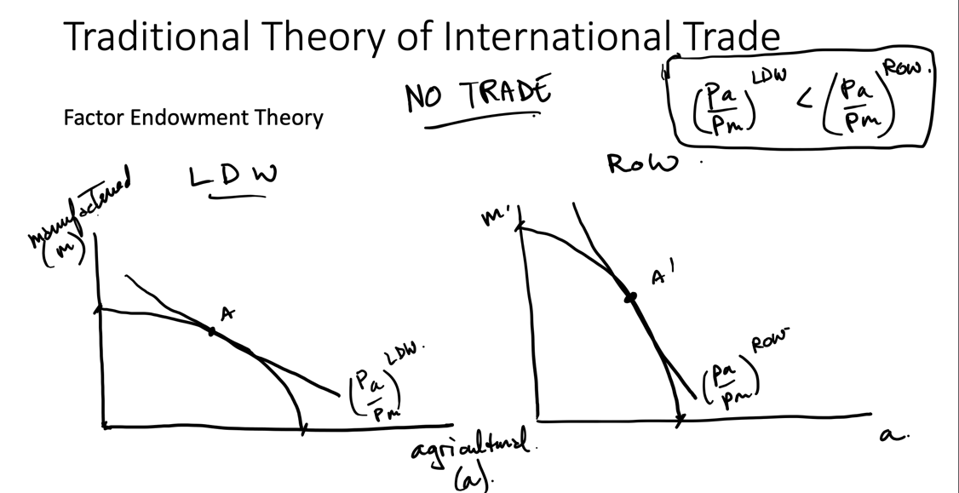
Situation 2: With Trade
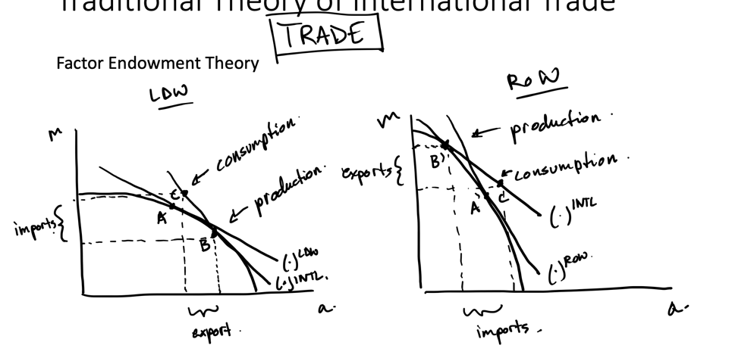
Numerical Example 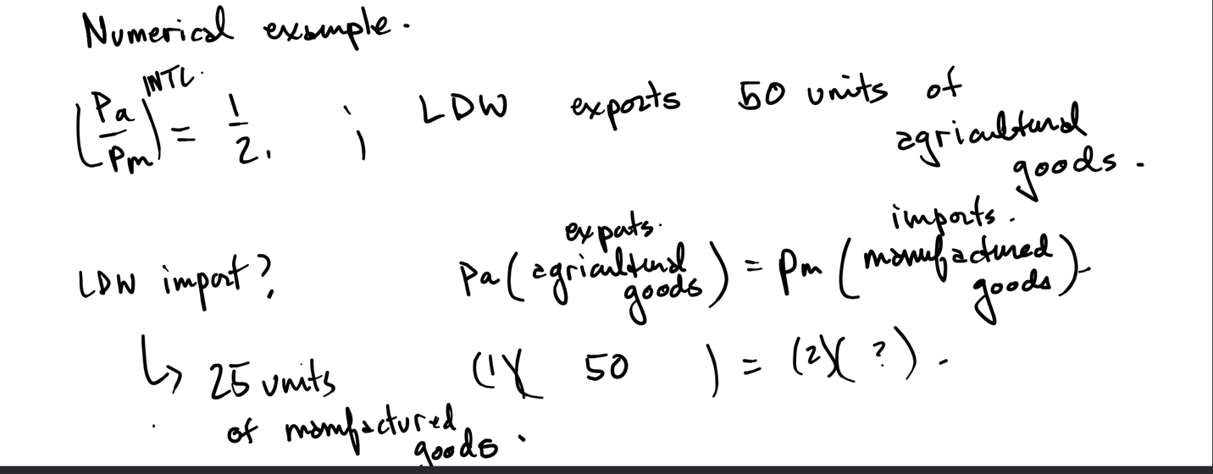
General Outcomes Expected from the Factor Endowment Theory
Consumption increases with trade
Partial specialization in goods that use the abundant factor intensively
Export goods that use the abundant factor intensively
Import goods that use the scarce factor intensively
Factor prices equalize across trading countries
Owners of abundant factor gain relative to owners of scarce factors
Trade promotes more equal income distribution within a country
Trade stimulates economic growth
As a result,
Developing Countries are encouraged to focus on the production of labour and land intensive primary products for export
Import manufactured goods (capital intensive production) from developed countries

Critique of the Traditional Theory
Critique of assumptions of the traditional neoclassical model of trade
- Fully utilized resources
  - There is often unemployment, or underutilized resources (human resources)
  - Vent for surplus
    - Basically where a country can produce more goods than they consume and sell it to get rid of the surplus (See below)

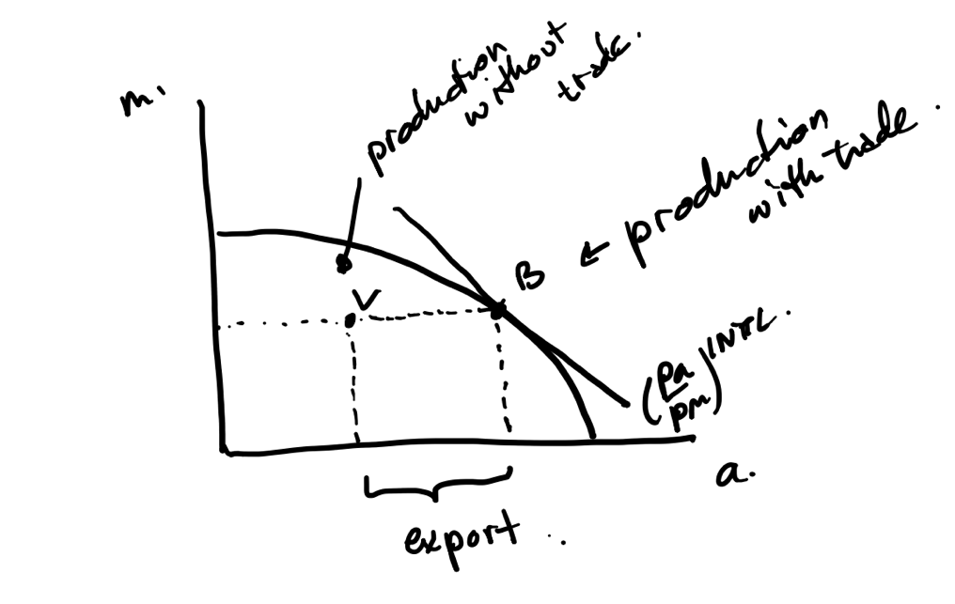
- Fixed technology
  - There may be synthetic substitutes
  - Other things to reduce the need for natural commodities
- No role of national governments
  - Tariffs, quotas, subsidies
- Trade gains accrue to nationals
  - Enclave economies
    - Foreign owned operations
    - Few linkages to the wider economy
    - GDP > GNI
    - Gains from trade accrue largely to nonnationals

Import Substitution and the Theory of Protection

Import Substitution
An attempt to replace importation of commodities with domestic production (usually manufactured consumer goods)
Strategy:
- Tariff or quota on imported good
- Set up industry to produce good (infant industry)
Goal:
- Eventually, infant industry “grows up”, is competitive on the world market
- Protection no longer needed
Example
No trade
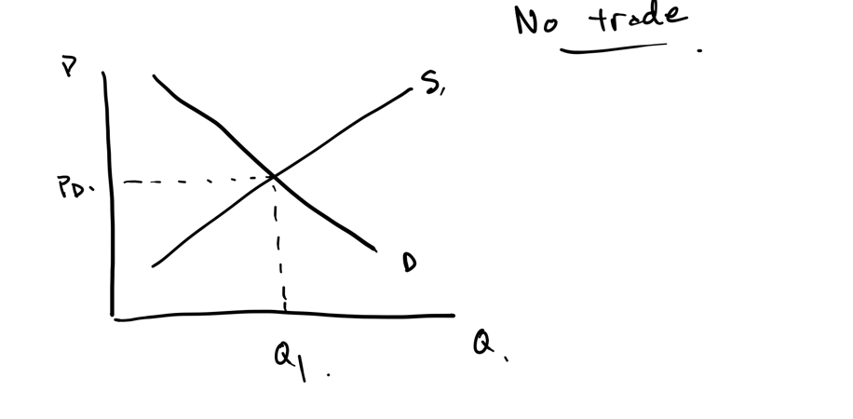
Now take a small open economy where there is world price lower than that of the domestic price

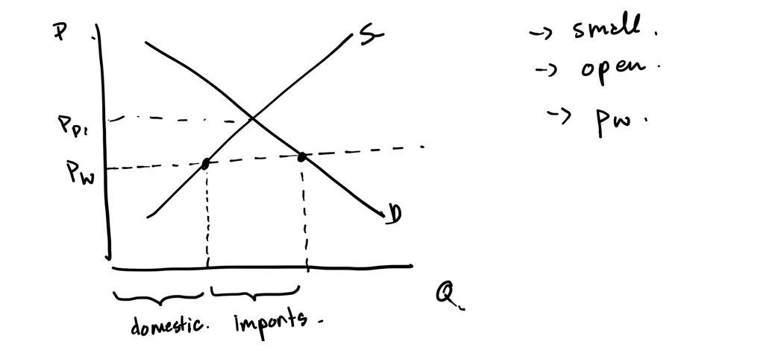
With a tariff (To)

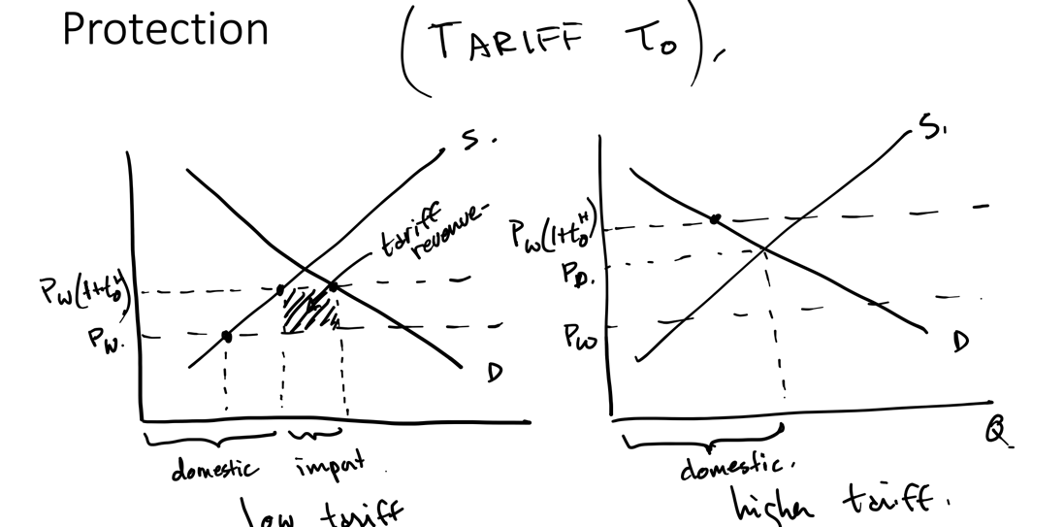
The results of Import substitution
Largely unsuccessful
Inefficient and costly
Benefits foreign firms and wealthy nationals
Government subsidized inputs from foreign firms
Overvalued exchange rate hurts primary product exports
Forward and backward linkages inhibited

Foreign Aid and Conflict

Foreign Aid
What is foreign aid?
Foreign aid is the (direct or indirect) international transfer of public funds from one government to another
Which transfers should be included or not?
Implicit capital transfers
  - Preferential tariffs are often not considered to be foreign aid
Not commercial flows of private capital
- Things like portfolio investments and foreign direct investment ARE considered aid when they shouldn’t be
Foreign aid as generally defined in economics has two main characteristics
Non-commercial objective (& non-military)
Concessional terms
Favorable interest rates or repayment
Official (government) and unofficial (NGOs) aid
- Official will be like bilateral assistance, or public aid
  - Loans or grants from one country to another
- Unofficial aid will be private assistance from NGOs
Donor motivations for aid
Moral and humanitarian
Political; strategic, security
- Might try and give to geographically strategic countries, or might try and reduce the reasons for migration from a country
- They could also try and improve stability in a country
Economic:
Savings gap: insufficient public savings
Exchange gap: more money spent on import than money earned from export
- Imports could be boosted through foreign aid if there is an exchange gap
Fiscal gap (third gap): not enough investment (mostly public)
- Public investment and infrastructure is insufficient to compliment private investment, this would cause the fiscal gap
Considerations:
Skills gap: certain projects need specific skills, training of locals
Absorptive capacity: ability of foreign aid to be productively used in the economy
Recipient motivations for aid
Moral and humanitarian
Political; strengthening political power and legitimacy
Economic; stimulate economic growth
Nongovernmental Organizations
Non-profit organizations involved in financial and technical assistance to developing countries
Less politically constrained
Work with local organizations
Sometimes may be perceived better by the community
The economic effects of aid
Controversial, subject to criticism
Possibility of the misuse of funds
Evaluation of development assistance

Conflict & Development
Consequences of violent conflict:
  - Death
  - Sexual violence
  - Reduced health
  - Wealth destruction
  - Food insecurity
  - Lost schooling
  - Displacement
Causes of conflict
  - Horizontal inequalities
    - Inequalities between groups in the society
    - Empirical evidence
  - Resource scarcity
    - Fighting for resources
    - Empirical evidence
  - High value exportable resources
    - Uneven distribution of benefits
    - Empirical evidence
  - Commitment problems
    - Some resources are indivisible
  - Coordination problems
    - In a multi-equilibria situation, conflict is a bad outcome in the presence of a better one (peace))

The Production Possibilities Model and Conflict
Economic costs and consequences of conflict
- Diversion of resources to the military 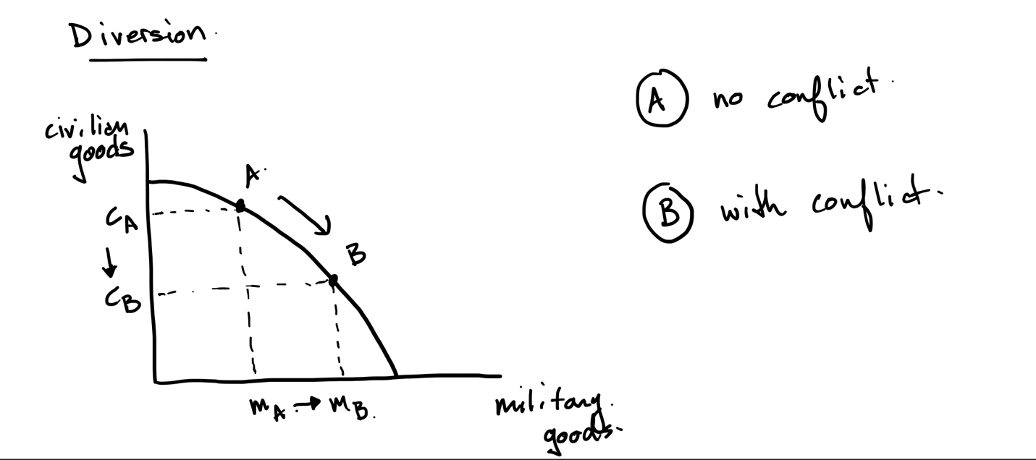
- Destruction of people and property 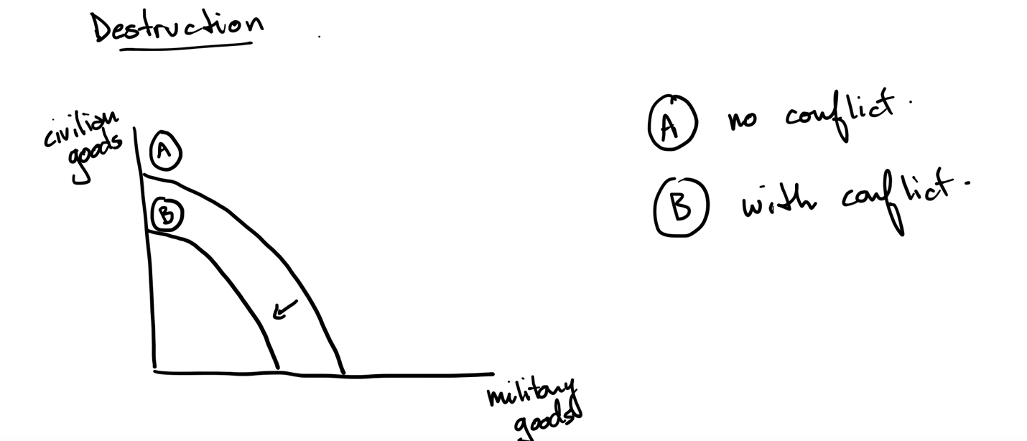

The Fungibility of Foreign Aid
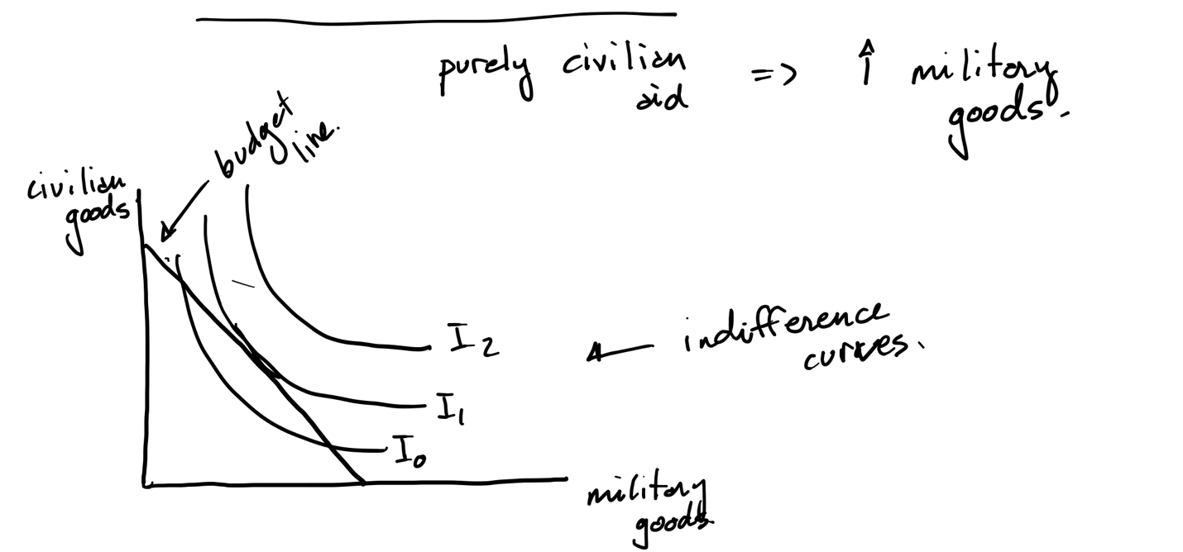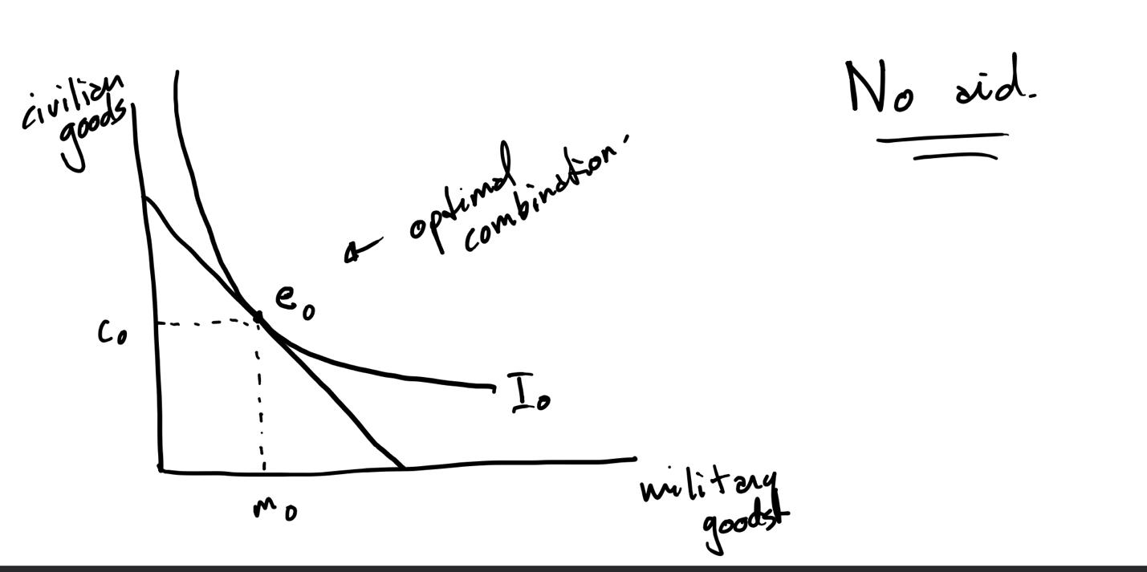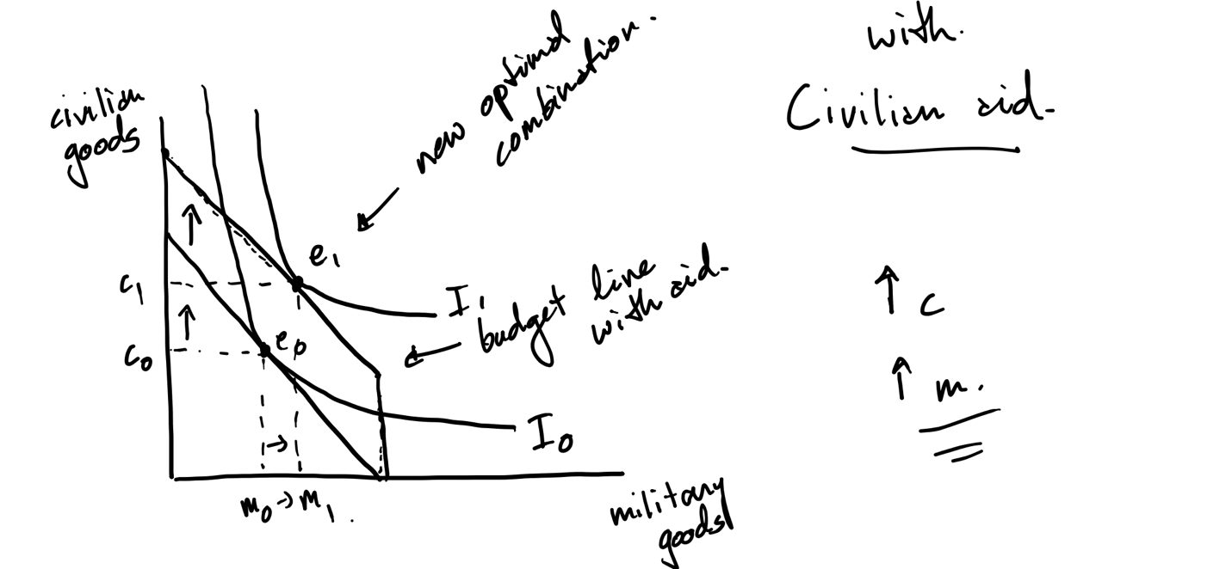

Bonus: Guest Speaker #2

Philip Fry
What is happening to people who used to herd cattle in Rwanda who are moving into the dairy industry?
Started with the discovery of a cattle pot specific to a certain region
Consequences of modernisation on these cattle herders:
Patching of grass due to the transition from open grazing to allotted plots of land
The introduction of money (commodification of cattle)
Distances relationship between cattle and people
Smaller herds than before
Mixed herds (imported and longhorn crossbred)
Longhorn: adapted but produce less milk
Imported cattle: no adaptation, produce less milk

