- Neurons: nerve cells specialized for communications
  - Dendrites: part of the neuron that receive the signals
    - Picks up impulse.

  - The Cell Body (Soma): central region of the neuron, responsible for the maintenance of cell.
    - Materials needed by the neurons are made here

  - Axon: long extensions specialized for sending messages
    - Carries nerve impulses

  - Synapses: space between two connecting neurons through which messages are transmitted.
    - Synaptic Cleft: space between two connecting neurons where neurotransmitters are released.

  - Axon Terminal: knoblike structure at the end of the axon
    - Synaptic Vesicles: spherical sacs containing neurotransmitters.

- Excitatory: transmitter substance excites post-synaptic neuron (More likely to fire)
- Inhibitory: transmitter substances inhibits post-synaptic neuron (Less likely to fire)

- Glial Cells: support cells in the nervous system that play roles in the formation of myelin and blood-brain barrier, respond to injury and remove debris.
  - Blood-brain barrier: glial cells forming a fatty coating that prevents certain substances from entering the brain.

- Electrical Responses of Neurons:
  - Ion: positively or negatively charged particles produced when substances are dissolved in water.

  - Resting Potentials: electrical charge difference (-70 millivolts) across the neuronal membrane, when neuron is not being stimulated.

  - Action Potentials: an electrical impulse that travels down the axon and allows neurons to communicate.
    - Synaptic Knobs: balloon-like structures at the end of the branches of an axon containing neurotransmitter
    - Neurotransmitter: chemical messengers specialized for communication and released at the synapse.

    - Absolute refractory period: time during which another action potential is impossible; limits maximal firing rate.
      - Myelin sheath: glial cell-wrappers around axons that act as insulators of the neuron’s signal.

  - Graded Potentials: postsynaptic potentials that can be excitatory or inhibitory depending on whether positively or negatively charged particles flow across the neuronal membrane and in which direction they flow.
    - Threshold: membrane potential necessary to trigger action potential

- Chemical Neurotransmission:
  - Receptor Sites: locations that uniquely recognize a neurotransmitter
  - Reuptake: means of recycling neurotransmitters

Neurotransmitter | Selected Roles | Drugs that Interacts with it
Glutamate | Main excitatory neurotransmitter in the nervous system; participates in relay of sensory information and learning | Alcohol and memory enhancers interact with NMDA receptors, a specific type of glutamate receptor.
GABA | Main inhibitory neurotransmitter in the nervous system | Alcohol and antianxiety drugs increase GABA activity.
Acetylcholine (Ach) | Muscle contraction (PNS)  Cortical Arousal (CNS) | Nicotine stimulates Ach receptors.  Memory Enhancers increase Ach.  Insecticides block the breakdown of Ach.  Botox cause paralysis by blocking Ach.
Norepinephrine(NE) | Cortical Arousal (CNS) | Amphetamine and methamphetamine increase NE.
Dopamine | Motor Function and Reward | L-Dopa, increases dopamine is used to treat Parkinson’s.  Antipsychotic drugs, which block dopamine action, are used to treat schizophrenia.
Serotonin | Mood regulation, aggression, temperature regulation, and sleep/wake cycles | Serotonin-selective reuptake inhibitor (SRRI) are used to treat depression
Endorphins | Pain Reduction | Narcotic Drugs – codeine, morphine, and heroin – reduce pain and produce euphoria
Anandamide | Pain Reduction, increase in appetite | Tetrahydrocannabinol – found in marijuana – produces euphora

  - Acetylcholine: neurotransmitter used to control activity, including movement, memory, attention, and dreaming.
  - Dopamine: neurotransmitter that plays a key role in movement and reward.
  - Endorphins: chemicals in the brain that play a specialized role in pain reduction.

- Nervous System

- Central Nervous System (CNS): Brain and Spinal Cord
- Peripheral Nervous System (PNS): All the other nerves
- 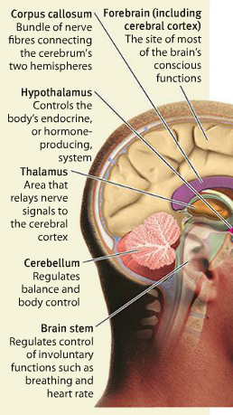
- The Forebrain (Cerebrum): forward part of the brain that allows advance intellectual abilities.
  - Cerebral Cortex: outermost part of forebrain, responsible for analyzing sensory processing, programming motor movements, and higher brain functions.

- 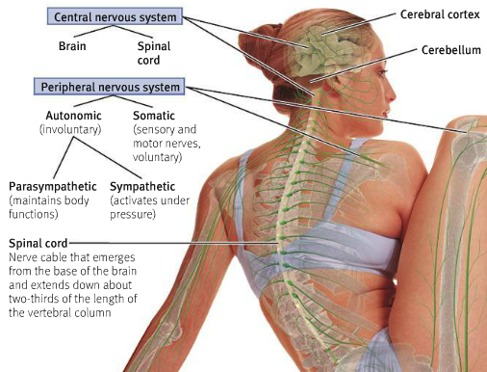

- The cerebral cortex is divided into two cerebral hemispheres, connected by the corpus callosum.

- Behold the FPOT.
- 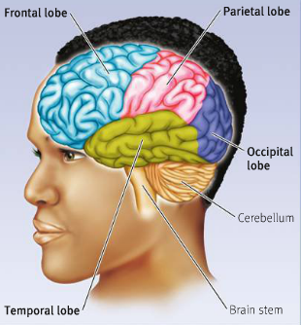

Functional Regions in the Cerebral Cortex
    - Primary motor cortex: responsible for body movement
      - Prefrontal cortex:
        - Broca’s Area: region that plays a key role in language production
    - Primary sensory cortex
      - Primary somatosensory cortex
      - Primary visual cortex
      - Primary auditory cortex
    - Association cortex

Temporal Lobe: hearing, understanding language, and storing somatic memories.
    - Wernicke’s Area: language area responsible for understanding speech.
- 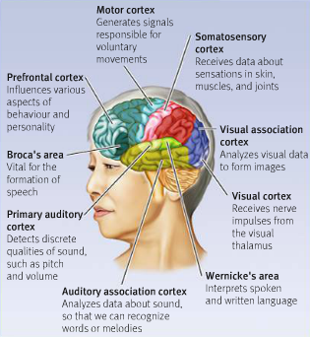

Basal Ganglia: Two sets of structures that help control movement.

- Emotion and The brain

- Limbic System: emotional center of the brain that also plays a role in smell, motivation, and memory
  - Hippocampus: responsible for spatial memory
  - Amygdala: plays a key role in fear, excitement, and arousal.
    - Active in risky decisions.
  - Hypothalamus: part of the brain responsible for maintaining a constant internal state.
    - Directs maintenance activities

- The Autonomic Nervous System: peripheral nervous system controlling the involuntary actions of our internal organs and glands, which participates in emotion.
  - Symphatetic Division: active during emotional arousal, especially during a crisis.
  - Parasymphatetic Division: part of the autonomic nervous system that controls rest and digestion.

- The Endocrine System: system of glands and hormones that controls the secretion of blood-borne chemical messengers
  - Hormones: blood-borne chemicals that influence target tissues and glands.

  - Pituitary Glands: master gland that, under the control of the hypothalamus, directs the other glands of the body
  - Adrenal Gland: tissue located on top of the kidneys that releases adrenaline and cortisol during state of emotional arousal.

- Mapping The Mind to Understand Actions:

- Lesions: area of damage due to surgery, injury or desease.

- Brain Damage:

- Nature vs Nurture:

  - Chromosomes: slender threads inside a cell’s nucleus that carry genes
  - Genes: genetic materials composed of DNA

  - Genotype: our genetic makeup
  - Phenotype: our observable traits
  - Dominant genes: genes that masks other gene’s effects
  - Recessive: genes that are expressed only in the absence of a dominant gene
  - Fitness: organism’s capability to pass on their genes.

- Heredity:
  - All of traits, tendencies you inherited from your biological ancestors
- Heritability:
  - How much of the diversity in a trait in a given population is due to genetics.

  - Studying Heritability Through
    - Twin Studies
      - Monozygotic Twins
      - Dizygotic Twins
      - Same gene same environment

    - Family Studies
    - Adoption Studies
      - Same gene, different environment

- Sensation: sensory receptors and nervous system. Detecting properties of stimuli
  - Sensory adaptation: diminished sensitivity when constant stimulation
  - Transduction: transforming sensory input into neural impulses our brain can interpret.

  - Threshold
    - Absolute Threshold: lowest level of stimulus needed for the nervous system to detect a change 50% of the time
    - Just Noticable Difference: size of a difference in a stimulus needed to notice that a change has occurred.
    - Signal Detection Theory:
      - Discriminating Signal from Noise in which it’s embedded.

- Perception: organizing and interpreting sensory input. Enables recognition of meaningful objects and evens.

- The Visual System:

  - Brightness: the intensity of the reflected light that reaches our eyes.
  - Hue: color of light.

Functions of the Eye Parts:
- 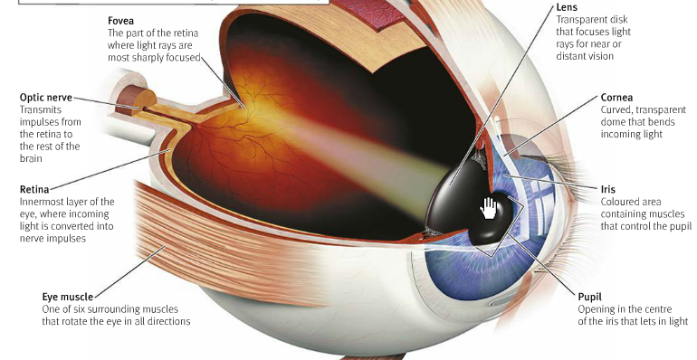

Steps of Vision:
    - Light Enters Pupil
    - Lens accommodates for distance, focuses and reflects the image to back of eye (Retina)
      - Upside down and reversed
    - Light particle passes through transparent ganglion cells & bipolar cells
    - When light hits molecules of photopigments in rod or cone, molecules split apart and bleach.
    - Signal passed from photoreceptor to bipolar cell, to ganglion cell
    - Axon of ganglion cell heads to optic nerve, on to visual cortex

Fovea is responsible for Acuity (Sharpness of Vision)

  - Rods: receptor cells in the retina allowing us to see in low levels of light
  - Cones: receptor cells in the retina allowing us to see in colour.

Blind Spot: part of the visual field we can’t see because of an absence of rods and cones.

Trichromatic Theory: HERMAN VON HELMHOLTZ!
  - Retina should contain 3 receptors sensitive to Red, Blue and Green

- BLINDNESS.

- Gestalt Psychology: The whole is more than the sum of its parts.
  - Types of Processing:
    - Bottom Up:
      - Start with info from senses, works up to integration
        - Building schema
        - Differences in sensations can lead to differences in perception

    - Top Down:
      - Guided by knowledge, expectations, or beliefs
      - Fitting incoming info to existing schema
      - Differences in knowledge can lead to differences in perception

- Gestalt Laws of Grouping
  - Proximity
  - Similarity
  - Symmetry
  - Closure
  - Good Continuation
  - Figure-ground

- Perception of depth: ability to see objects in 3D even though images from the retina are in 2D. From distance.
  - Binocular
    - Retina Disparity: a slightly different image is projected onto the retina of each eye
    - Convergence: muscular cue. Eyes turn inward, muscle tension signals brain to interpret angle of eyes
  - Monocular
    - Relative Size
    - Interposition or Overlap
    - Elevation
    - Texture Gradient
    - Linear Perspective
    - Light and Shadow

- From the optic nerve to the brain

- Dorsal Stream: Where?
  - Perception of Location and Movement
- Ventral Stream: What?
  - Three dimensional form perception

- The Auditory System:
  - Audition: our sense of hearing

- Detecting Sounds:
  - Pitch: frequency of the waves
    - Place Theory (High Pitch): vibrate parts of basilar membrane near oval window
    - Volley Theory (Medium Pitch): fire in the middle of basilar membrane, but out of sync
    - Frequency Theory (Low Pitch): fire neurons in tip of basilar membrane

  - Loudness: height of sound waves measured in decibels.
  - Timbre: the quality or complexity of the sound.

- 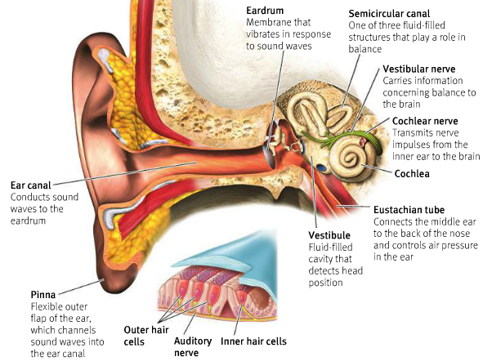

Steps to Hearing:
    - Pinna funnels wave into ear canal, causing eardrum to vibrate.
    - Ossicles vibrate in turn (MIS), stapes presses on membrane behind oval window, moving gel inside cochlea.
    - Gel inside cochlea vibrates basilar membrane
    - Auditory hair cells on basilar membrane vibrate, which pulls at cilia
    - Pulling at cilia changes electrical charge across membrane, transducing mechanical energy into auditory neural activity.

- Olfaction and Gustation System
  - Olfaction: sense of smell
  - Gustation: sense of taste

19
- explain the role of biology in the discipline of psychology.
- describe how biological psychology helps us understand phenomena like love.
- identify the parts of a neuron.
- describe the process of neuronal communication.
- compare and contrast “graded potentials” versus “all or none responses.”

20
- List and describe key points about major neurotransmitters
  - GABA
  - ACH
  - Glutamate

- List and describe the key functions of the major brain parts, including what would happen if they were damaged
- Describe the effects of severing the corpus callosum

21
- List and describe the key functions of the major brain parts
- Describe the effects of severing the corpus callosum
- Summarize current research-based thinking on hemispheric lateralization
- Discuss how brain damage can teach us about brain function.
- Differentiate Broca’s aphasia and Wernike’s aphasia in terms of brain regions involved and key symptoms.

22
- Discuss how brain damage can teach us about brain function.
- Differentiate Broca’s aphasia and Wernike’s aphasia in terms of brain regions involved and key symptoms.
- Predict the effects of lesions to various parts of the brain, including structures in the limbic system.
- Describe the key points of the process of natural selection
- Distinguish heritability from heredity
- Describe how heritability is assessed
- Compare and contrast sensation and perception.

23
- List the 5 main steps involved in the sense of audition
- Explain why alcohol causes the spins
- Explain how different sounds are transduced and perceived from sound waves

- 24
  - Describe the major structures of the eye, and explain how they guide the incoming ray of light toward the eye’s receptor cells.
  - Describe how the cells of the retina transduce photons of light into neural energy.
  - Distinguish trichromatic from opponent process theories of colour vision.
  - Describe the two pathways through the brain involved in the conscious experience of visual perception, including
- 25
  - Describe the two pathways through the brain involved in the conscious experience of visual perception, including what information is processed in each stream.
  - Describe how blindsight is possible in the brain.
  - Describe the key message of Gestalt psychology.
  - Differentiate top-down from bottom-up processing.
  - Provide examples of Gestalt principles that help us understand the process of visual perception.
  - List and describe examples of binocular and monocular distance cues.

