Psychosocial Development in Late Adulthood Part 1: Thursday September 16th 2020

When is the dividing line between ‘middle age’ and ‘old age’?
- ‘a moving target’ in today’s world; obsolete definitions
- What is the underlying purpose?
  - E.g. seniors’ discounts by drugstores; memberships in clubs
  - Many people who are above 65 don’t want to be called seniors
  - Different age for discounts at many different stores
- Formerly: 65 years= senior citizen in Canada
  - was age of retirement; age to receive government assistance programs
  - No longer have a required age of retirement
  - Previous gov considered upping the age to start the old age pensions to 67 but many Canadians objected it so it did not happen

Age definitions
Old:
- almost always seen as negative
- often associated with being useless, fragile, or obsolete
- why are women usually always old hags in fairy tales?

Ageism:
- “systematic stereotyping of and discrimination against people because they are old, just as racism and sexism accomplish this with skin color and gender

Geriatric:
- A branch of medicine focusing on the care of older people and the unique problems associated with aging
- Age not precisely defined (60 yrs.)
- Describing someone as geriatric: can imply the senior is worn out or senile
- People living much longer: USA Social Security began in 1935 when average life expectancy in the US was 61 years. Now, it is closer to 79 years
  - You can see there that there might be some discussion of upping the age of which people start to get benefits from the government
- There’s a difference between geriatrics and gerontology

Aging:
- The lifelong process of growing older; not just a later life experience

Old Old:
- Late adulthood
- Older adult
  - Much more acceptable term than senior citizens
- “young old”
  - People 55 to 70
- Old Old
  - Over 70/75
- People don’t like being called; elderly, geriatric, or old
- People living longer so need new language and terms

Successful Aging:
- We tend to associate natural physical aging with disease (unnatural)
- We speak of ideal “successful aging” (which is really how NOT to age)
  - Botox/plastic surgery
- “successful aging” is really anti-aging
- This view makes normal physical decline seem as “undesirable and preventable”
- This view promotes “eternal youth” scenario
  - This is not going to happen, everyone is going to age

Intergenerational Equality (new form of ageism):
- Paint seniors as dependent, unproductive, costly
- Suggest too much $$ being spent on the elderly

When does a person become old?
- Survey found that Americans aged 18 to 29 believed that a person becomes old when they turn 60, whereas those over 65 said a person doesn’t get old until his or her 74th birthday (the same survey found that only 35% of people over age 75 said they felt old)
- A British survey of adults over 40 found that most of them believed old age began at 80 yrs.

Cultural Views on Aging
- Aboriginal populations: wisdom, respect
- Japan: jaal piety- honouring one’s ancestors
- Tarahumara (Mexico): gain strength as you age;
  - Living in the state of Chihuahua in Mexico
  - “the running people”

Aging as a Social Construction
- Social construction: the meaning that society places on a concept (what most of society agrees is the meaning)
OR
- “the socially created characteristics of human life based on the idea that people actively construct reality” (it is neither natural or inevitable)
- Stereotypes of aging
- Aging, aged: fluid concepts
- “70 yrs. is the new 55”

The Social Clock******* need to know
- The social clock: age graded expectations for life events
  - In Canada there is a societal consensus around the expectations around what happens at a certain age
  - E.g. getting married, birth of a first child, buying a home, retiring
  - Can lead to stereotypes of aging because what happens I you don’t meet those social clock expectations?
  - Culturally specific
  - More variable. Less prescriptive nowadays

What is Old?
- “everybody wants to live long, but nobody wants to be ‘Old’. ‘Old’ is not a positive word. That’s why I came upon the word ZOOMER. You take the word ‘Boomer’ in wide usage, add the concept of ‘Zip!’ and you ger ‘Zoomer’.” -Moses Znaimer

Aging is a Vicious Cycle
- We don’t always have a very positive outlook of aging in our society
- We expect seniors to maintain a youthful vision of beauty
  - Don’t allow people to age naturally
  - Different for women and men

Brigitte Bardot
- Has not had any cosmetic work done
- What could be more beautiful than a dear old lady growing wise with age? Every age can be enchanting, provided you live within it” (aged 85 yrs.)

Sophia Loren
- Has had procedures to maintain youthful beauty
- People are more comfortable with Loren and her surgically maintained because she is seen to not have “let herself go” (85 yrs. old)

Old Age… ‘God’s waiting room’?
- Just waiting to get to heaven or the next world depending on your beliefs
- Part of the reason that we don’t understand seniors or the ageism thrown at our seniors in today’s society is due to a lack of intergenerational awareness

Myths and Realities
- Ageism: prejudice vs older people
- Why do people know so little about old age?
  - Lack of intergenerational awareness and time spent with elderly
- Old age perceived as weakness, sickness, dying
- Research shows that Canadian seniors express high life satisfaction; seniors GIVE to their children more than they take (until age 70)

Aging Suit: Video
- Josh (tried the suit) couldn’t wait to get out of it
- Said the restrictions of the suit completely change how he felt and how confident he would be going outside
- Takes a whole new set of coping strategies

Positive Aging for women
- Burden heavier for women
- Ideal older woman has to be healthy, slim, discreetly sexy and independent
- Men allowed to be old
- This view says aging is avoidable and if you’re older and not healthy, it’s your own fault
- Women wear clothes to try and cover up signs of aging (loose skin and wrinkles)

Dove’s Pro-Age campaign
- New line of products that do not try to hide aging
- Embrace aging: talk about ‘the mature consumer’
  - Rather than using more ‘offensive’ term such as old
- Uses ‘fuller figured’ real women not models
- BUT it’s still all about the beauty business; Unilevel makes many products that deny aging

Ageism in the Workplace
- View older workers as slow, can’t keep up, don’t contribute to the team, more expensive
- Older workers also show more loyalty, less absenteeism
- Sexism: want younger, more attractive workers

Impact on our Social Structures
- Family: more 3 & 4 generation families
- Economy: grandparents still working
- Education System: more older students in schools, universities
- Health care system: currently treats acute (short term) illness but seniors need chronic care (long term care)

Stereotypes *********need to know
- New ageism: the belief that older people need special treatment due to poor health, poverty, lack of social support
  - Tend to lump all old people together in one
  - Talking baby talk to old people
  - Yelling at a senior assuming they are hard of hearing
- Compassionate stereotype: a stereotype that attempts to create sympathy for the elderly but doesn’t give a true picture of old age
  - Road signs of old people crossing the road; can be offensive because not all elderly people take a long time to cross/have a cane

Intergenerational Equality (new form of ageism):
- Paint seniors as dependent, unproductive, costly
- Suggest too much $$ being spent on the elderly and not enough on the younger people

Seniors Care
By the year 2020, it is expected that 75% of nursing medical time will be spent with older adults

“Healthy Aging”
- Women feeling like they have to fight the signs of aging
  - Dye hair
- Beauty work; the work you have to do to hide aging
- Agelessness is unrealistic
- Youthful in spirit; mind-body split
  - Young mind in an old body
  - False cheerfulness
  - Denying the old age

‘Like being on a cruise ship’
- American Senior Living House
- Suggests that old age is like hopping on a cruise ship
  - Many low-income seniors cannot afford moving into retirement homes

Education as an antidote to ageism *** need to know
- Reading programs; students going to read to elderly
  - Young people felt very comfortable reading to the senior
- We need to acknowledge that on many cultural group’s families live in multigenerational households
- Youth who have positive interactions with seniors report more positive views of them
  - This needs to happen more so that views on both elderly and young improve
- Most seniors are happy, little/no mortgage, kids grown, better educated, more income today; not old, crotchety folks!
  - Young crotchety people exist too!!

Business has taken note; welcoming seniors in many different ways
- Lounges in shopping malls, fireplaces in McDonalds
  - A place where seniors can come and meet/socialize
- Viagra and ‘the little pink pill’
- Senior travel
  - Specifically veered toward seniors
    - Accessibility

A Society for All Ages
- Government created National Seniors Council in 2007 as a voice of seniors to government
  - “a society for all ages” approach

- Seniors advocates want minister to be more than a token
  - New minister for seniors appt. July 2018
  - 1st time MP Filomena Tassi (age 56 yrs)
  - The minister will need to have access to funding from infrastructure, health and other portfolios to improve the lives of seniors
    - Having an MP is not enough
- Bev Schulte, Minister for Seniors
  - Appointed Nov 2019
  - Environmental activist, mechanical aerospace engineering degree from Princeton

What to do in terms of AGEISM?
- Avoid social policy based on the ‘time bomb’ or fear
  - Everyone is going to be a senior eventually; don’t fear it, be active and healthy in your young life so that you can be more somewhat and active in old age
- Create more balanced views of later life
  - It is very possible to continue doing lots in senior years
- Avoid stereotypes
- There is no one way to grow old
  - We need to allow for more ways to grow old
  - Too much societal pressure, judgement and stereotypes

The Big 5 Personality Traits
- Openness: inventive/curious vs. consistent/cautious
- Conscientiousness: efficient/organized vs. easy-going/careless
- Extraversion: outgoing/energetic vs. solitary/reserved
- Agreeableness: friendly/compassionate vs. cold/unkind
- Neuroticism: sensitive/nervous vs. secure/confident

Chapter 1: Aging and Society

Psycho-social Aspects of Aging: Monday Sept 21st/

Aging: Introduction

Dimensions of Aging
People Age
- Physiologically: what happens to your body
- Psychologically; dealing with the mind; especially as a function of awareness, feeling or motivation
- Socially: cultural age expectations of how people should act, behave as they age
Chief Justice of Canada’s Supreme Court: Beverly McLaughlin
- First woman to hold this position
- Worked right up until the mandatory retirement age

Gerontology
- Definition:
  - The scientific study of aging and its consequences
- Aging is a multidisciplinary field
- The study of social, cultural, psychological, cognitive, and biological aspects
- Gerontology includes:
  - The study of physical, mental, and social changes in older people as they age
  - The investigation of the changes in society resulting from our aging population
  - The application of this knowledge to policies and programs

Aging: A Global Phenomenon
- Population aging worldwide at an unprecedented rate
- 1950-2000: people 60 years + tripled
- Family, education, work, business, government are all affected

Early 1900s- Canada
- Leading cause of death: infectious diseases
  - E.g. tuberculosis, pneumonia, influenza
- Average life expectancy around 60 yrs
- Later we got vaccines; antibiotics saved lives
- Penicillin discovered 1928
- People living longer
- Better nutrition, improved sanitation, smaller families

Life Expectancy at birth: Canada

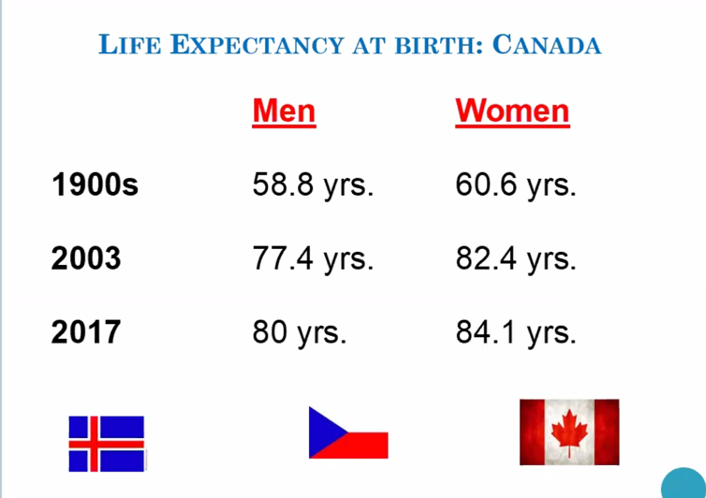

Canada ranks 16th in terms of life expectancy among 191 countries (Hong Kong was at top)

Aging: The Demographics
- Centenarians in Canada increased to 4,635 in 2006, up more than 22% from 2001
- Centenarians in 2001; 5,825
- Increased by 41%, to reach 8,230 people in 2016, making it the fastest growing age group between 2011+2016
- Today: 10,795 (80% are women)
- 5 female for cent Arians for ever 1 male over 100

Population Aging
- 3 conditions that affect population size and structure
  - Immigration
    - We need immigrants to keep our population numbers increasing
  - Death rates
  - Birth rates
- Nearly one in six Canadians (16.1%): a record 5.8 million Canadians- was at least 65 years old
- Canadians 65 years+: in 2011 13.7% of population, 2016 16.1% of population

Young and Old in Canada
- People aged 65 years and older outnumber children 0 to 14 years
- 2015: for the first time, there were more people aged 65 years and older in Canada than children aged 0 to 14

- 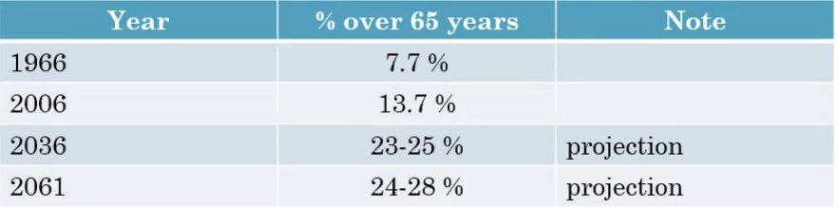

Canada: an “old” country
- Median age also used to measure aging population (middle)
- Median age:
  - The world: 29.6
  - Canada: 42
  - Uganda: 15.8
  - Japan: 47

Canada: median age
Total: 42.2
Male: 41
Female: 40

Mortality and Morbidity
- Mortality: death rate
- Morbidity: the illness
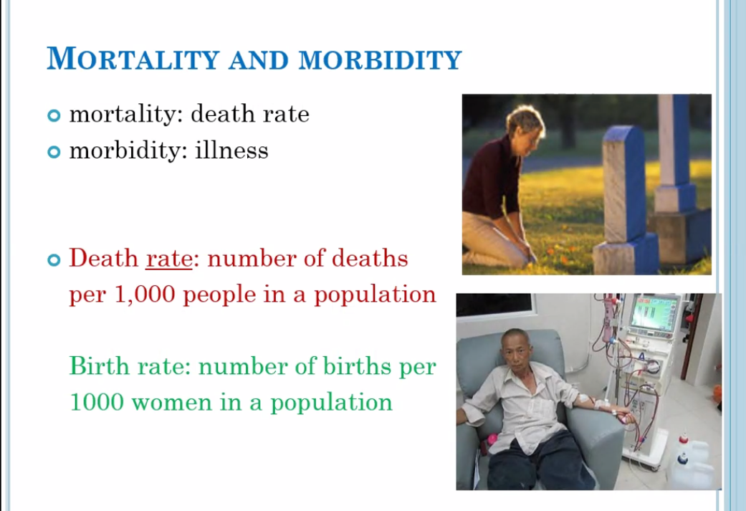

The Boomers
Cohort b. between 1946-1965
- 1 in 3 Canadians today is a boomer
- First boomers turned 65 in 2011
- 10 million boomers will move into their seniors’ years in the next 20 years
- 1,200 boomers turn 65 a day

- Boomers are the largest demographic ever in history
  - “the Pig in the Python”
  - Canada is said to have had the ‘loudest’ baby boom

Impact on Society and Economy
- By 2031, the “full boomer” generation will be over the age 65, and the front cohort will have turned 85

“Baby Bust”
- 1965 onwards
- Use of birth control pill and woman in the workforce
- Fertility rate:
  - 1961: 3.84 children per woman
  - 1966: 2.81
  - 2000: 1.49
  - 2015: 1.60
  - 2019: 1.52
- The decrease in the birth rate sped the rate of population aging in Canada

Imminent Crisis?
- Economy, pension system, health and welfare systems, long term care (LTC)
- ‘demographic time bob’, ‘age quake’, silver tsunami’
- As big a threat at climate change’
- Elderly portrayed as a societal burden
- ‘apocalyptic demography’: the belief system that asserts the population aging with its ‘hordes’ of older people will bankrupt society and exact an unfair toll on younger generations

Health Care Challenges?
- “four in every five Canadians believe that the demands placed on the health system by aging Baby Boomers will result in reduced access and lower quality care, a poll commissioned by the Canadian Medical Association reveals”

Health Care Workforce
- ¼ Canadian health professionals are baby boomers themselves; people who will be soon retiring
- Impact on the workforce and mentorship
- “… if the health needs of Canadians continue to change according to past trends, and if no policy interventions are implemented, Canada will be short almost 60,000 full-time equivalent RNs by 2022

Aging in Place
- “the total number of long-term care beds in Canada is forecasted to grow from approximately 280,000 beds in 2008 to 690,000 in 2038. This leaves a projected shortfall of more than 157,000 beds in 2038”
- On August 31, 2010, the Ontario Ministry of Health and Long-Term Care announced the Aging at Home Strategy… providing support to seniors to continue living independently in their homes

High Users: 60 yrs. plus
- Research conducted by CHSPR “why do some people use so much healthcare?’ showed that almost half of high users were aged 60 or over… and over 80% of high users had at least six different types of illness and almost one third actually had ten or more illnesses with chronic physical and mental health conditions being the most common
- However, other critics say the drivers of cost are actually;
  - Technology
  - Labour
  - Increased service utilization across all ages

Reflection
- Canada’s population includes a growing proportion of older persons as a result of declining fertility rates and increasing life expectancies
- Overestimated assumptions about the negative or catastrophic and inevitable implications of population aging for public services tend to serve particular political and economic goals
- Meanings of old age are shaped by more than individual beliefs: they have origins in wider social and cultural forces

Difference in Aging Population//Gender, Covid, LTC: September 28th /October 30th 2020

Canada Baby Boom ****need to know******
- Those born in 1946-1965
- 1st boomers retired in 2011
- 1000 Canadians a day turn 65 now
- By 2031, all boomers will have reached 65 and proportion of seniors could reach 23%
- About 1 in 4 Canadians will be a senior baby boomer

Happy Feet
- Social construction of gender
  - We are led to believe all females birth the young and should take care of them
  - Fathers: warriors; provide the food (bring home the bacon)
  - Emperor penguins: mothers leave to hunt for food and father stays home and stays with the kids

- Seahorses
  - Female seahorses provide eggs to male
  - Male fertilizes them in his pouch
- We need to resist the stereotype of women doing most of the work with children

Gender
- Perth Ontario has the highest share of women in Canada where there are only 80 men per 100 women
- Differential in longevity between men and women in Canada
  - Women live longer
- Across Canada, among those aged 85-99 there are just 54 men for every 100 women

Ramifications for Women (Canada)
- Women are more likely to be widows
- More likely to live alone
- More likely to face a chronic disease or have a disability
- More likely to be poor in their senior years
  - Higher poverty among senior women than senior men

Alzheimer’s and Dementia
- Women are statistically more likely than men to develop Alzheimer’s disease ** NEED TO KNOW***
- While 16% of women over 71 years old develop the degenerative brain disorder, while only 11% of men of the same age are afflicted with it

Intersectionality
- Intersectional theory: asserts that people are often disadvantages by multiple sources of oppression; their race, class, gender identity, sexual orientation, religion, and other identity markers

“Ethno-cultural” Seniors
- Multiple jeopardy theory:
  - Old age can add to the disadvantages of ethnicity, class and gender (the iron triangle)
    - E.g. poor aboriginal women

Buffering theory: *******need to know for test****
- A culture that values seniors and provides meaningful roles for them tends to protect them to a degree from losses and social devaluation in later life

New Canadians
- In 2010, immigrant women and girls were more likely than their Canadian-born counterparts to be living in a low-income household
- Prevalence of low-income was greatest amongst recent immigrant women at 28.3% compared to 17.5% in the total female immigrant population and 14.6% in the Canadian-born female population
- Senior immigrant women ages 65 and over had the lowest low-income rate (14.4%)
- The longer time a new immigrant spends living in Canada, we see a decline in their low-income status except senior women aged 65 and over

Growing Population
- Since 2006, the aboriginal pop had grown by 42.5%

3 aboriginal groups in Canada: Inuit, First Nations and metis

How do we define Poverty?
- No official measure of poverty in Canada
- Most use stats Canada low income cut offs of LICO
  - Measure below which people said to live in straightened circumstances

Low Income Cut off

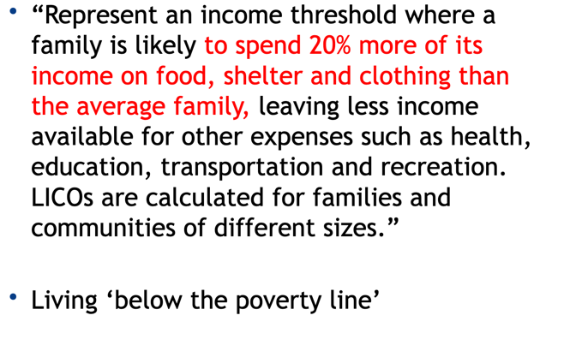

Covid and Gender
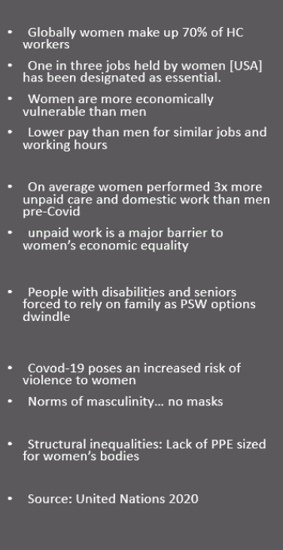
Sandwich generation: mostly women some men, have child responsibilities but also have responsibilities of caring for an elder *****need to know*****

‘Global condom shortage looms as coronavirus shuts down production’ (headline)
- Sexual and reproductive health care not classified as “essential” services in most countries during Covid

Maternal and child health
- “… modelling showed that covid-19 would lead to additional deaths in women. In Nigeria for example; antenatal visits were down by 50% and delivers with a skilled birth attendant were down by 40% since the country’s lockdown
- One in 10 children in Nigeria does not reach their 5th birthday

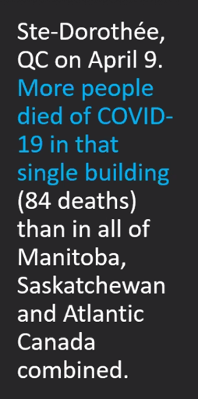

Covid 19 crisis in nursing homes in a gender crisis
- in nursing homes, women represent more than two thirds of residents
- more than 90% of paid staff in LTC homes are women
- More than 80% of unpaid family caregivers are women” ***need to know***
- Way more women dying in homes???

Colonialism: Why decline in Aboriginal Languages
- In many cases, children were barred from speaking their mother tongue at school (Residential school)
- Among Indigenous people, 1 in 3 elders and 1 in 10 children speaks an Indigenous language as their mother tongue
- Mother tongue definition: Canada; the first language that you learn when you are a baby
- There are now twice as many Indigenous children as elders who can speak an Indigenous language ** need to know for test**

- Buffy Sainte-Marie
  - According to the 2011 National Household Survey, 17% of the population who had an aboriginal identity, responses that they were able to conduct a conversation in an Aboriginal language

Only 2% of Iqaluit are seniors
Average age in Iqaluit is 23
Ottawa is home to more Inuit than the rest of the north

Aging of Ethnic Populations
- Different societies respond to aging in different ways
- Filial piety; sense of respect and responsibility of senior population
- 1981-2001: decline in traditional European immigrants to Canada from 45.5% to 24.6%
- Increase in Asian immigrants 13.9% to 36.5%
- Visible minorities 65 years plus: 39% Chinese, 21% South Asian, 13% black
- 1 in 5 people in Canada are not white

Immigrants
- Among all seniors in the Canadian population, 30% foreign-born
- Greek, Chinese, Italian families immigrating to candida tended to have large families, live in cities and live with their children
- India, china, Philippines- 3 top countries today
- Institutional completeness; amount of community support different cultures offers their older members ** NEED TO KNOW **
- Planners need to take ethnicity into account when planning programs

Where do senior people of colour live?
- Older POC live in cities of the POC population:
  - Toronto: 43% live in Toronto
  - Vancouver: 18%
  - Montreal: 12%
- Tend to have difficulty speaking one of the official languages
- Tend to initially have limited resources

Family Reunification
- The majority of senior immigrants were sponsored as family-class immigrants by their relatives
  - Under the riles, the family member must support and house the older adult for up to 10 years
  - Good: family support
  - Negative: isolation and dependency

Yee Hong Toronto
- Officially opened in 1994 the Yee Hong Centre now operates 4 LTC centres in Scarborough, Markham and Mississauga
- Serve the South Asian, Filipino and Japanese communities
- Operate a total of 805 LTC beds and serve over 15,000 individuals from different ethnic communities on a daily basis in the GTA

Macro Theories: Thursday October 1st 2020
**READINGS AND SLIDES WE GET TO TODAY ARE ON TEST

Theoretical Perspectives
- A theory provides a perspective
- Ways of looking at the world
- Theory: a set of interrelated propositions or principles designed to explain an observable phenomenon

Theory is:
- Set of interrelated concepts, definitions and propositions
- A group of related concepts that propose actions that guide practice
- A theorist’s thoughtful examination of a phenomenon

Why Study Theory?
- Helps us integrate knowledge
- Are explanations of phenomenon
- Help predict what will happen in the future
  - Who will go into a nursing home or not?
    - Widow
- Offer ways of solving problems
  - Best way for adults to cope with depression

Theories and research
- 4 ways theory is valuable to researches
  - Integration of new knowledge with info already known
  - Provides framework for explanation of findings
  - Predicts outcomes in future research\provides practical info for the development of social programs and intervention

Theory of Chronic Sorrow
- Looked at parents who had lost a child or have a child battling cancer
- Its ok and it’s a phenomenon that people that lost a child will have reoccurring chronic sorrow for a very long time
- Grief should not be looked on as something we need to fix but instead something that is completely normal (having sadness around the loss of a child)
- Now applying this theory to spouses of people with Alzheimer’s disease

Theoretical perspectives of aging
Overview
- 2 levels of theory:
  - Micro or individual level
    - Individuals and their interactions
  - Macro or societal level
- 2 theoretical perspectives we will look at briefly:
  - Functionalist perspective
    - Social order is based on consensus, cooperation and shared norms and values
    - All parts of society serve a role or function to keep society in a state of balance or equilibrium
  - Conflict perspective

Functionalist Perspective
- Macro level perspective
- Social order is based on consensus, cooperation and shared norms and values
- All parts of society serve a role or function to keep society in a state of balance or equilibrium
- Society is
  - A cooperative exercise with parts that work together
  - A whole society or macro view

Structural Functionalism Theories
- Macro level theories
- Society is a system of interconnected parts that work together in harmony for the whole
- Social institutions serve important functions for society
  - They adjust one another as the system responds to internal and external pressures
- Stresses interconnectedness
  - The interconnectedness of society; interdependence
- The natural state of society is one of balance
- Structural functionalist approach; we are all connected

Critiques of Functionalist Theories
- The view here is that society always attempts to create an orderly transition to a new, stable state
- Structural functionalism assumes shared norms and values shape individua; behaviour
- It also assumes society changes or evolves in a positive direction
- Social problems are therefore seen as “dysfunctions”
- The main aging theories from the 1960s e.g. disengagement theory and activity theory all rely on structural functionalism

Conflict Theories
- Society consists of conflicts between dominant and subordinate social groups
- Few gerontologists used this in the past
- Social determinants of health, life course approach; inequalities early in life can lead to disadvantages later in life

Feminist Theory
- “feminist theory is a body of writing that attempts to describe, explain, and analyze the conditions of women’s lives”
  - E.g. vest made to fit male police officers
- Many different kinds of feminist theory
- Liberal feminism, Marxist, socialist, radical, identity, post-modern, ‘third wave’
- Feminism is not a unified concept
  - Can be problematic because it means different things to different people
- All agree on two things”
  - Female and male experiences not the same
  - Male perspectives are currently and historically dominant and female perspectives are often marginalized, muted or simply unrecognized
- For example,
  - History is presented to us as the accomplishments of great men
  - Women’s contribution and participation are seldom highlighted
  - Paid childcare during the war but stopped after the war
  - ‘girls can’t do math’

Feminism
- “feminism is a theoretical project whose purposes are to understand the power structures, social practices, and institutions that disadvantage and marginalize women, and to devise innovative strategies of social transformation that will promote women’s emancipation.”

Gender and Aging
- Why are elderly women more likely to be poor? Live alone? Die in institution?
- Why does our society expect senior women to be still sexy when this is not expected of senior men?

The Life I Had ** NEED TO KNOW***
- Patriarchy: a system of power through which males dominate; society’s domination by patriarchal power structures
- Sexual division of labour: the nature of work performed as a result of gender
  - E.g. man is the breadwinner, women are homemakers
- Emotional labour: often unrecognized use of feelings as part of paid work usually by women; ‘just what women do’
  - Ignores caregiver burnout ect.

FIRST TEST CONTENT ENDS HERE*********************************************************

Interlocking Systems of Oppression
- Race, class and gender oppressions are linked
- Intersectionality
- Why are older women poor? Aboriginal women even poorer still?
- Need for a feminist analysis

Intersectionality
- Coined by American critical legal race scholar Kimberlé Williams Crenshaw (1989)
- “inequalities are never the result of single, distinct factors. Rather they are the outcome of intersections of different social locations, power relations and experiences.”
- How is a single 90-year-old woman’s life probably different if she is?
  - Aboriginal, minority, immigrant, in a wheel chair, lesbian… etc.

Ignoring Gender and Aging??
- much of the first 3 waves of the women’s movement did not focus on women and aging
- are seniors’ activist groups; e.g. raging grannies
- covid does not discriminate by gender but it is not gender neutral

CH 1 Summary
1.The growth of the older population in Canada has made aging a major social issue—one that will affect us all.
2. Gerontology has two goals: first, to increase our knowledge about old age and, second, to improve the quality of later life. In Canada today, these goals take the form of scholarly research and the practical application of research findings.
3. Canadians have both positive and negative images of aging and older people. Many of these stereotypes have little basis in fact. Negative attitudes can lead to prejudice and discrimination against older people.
4. New images of aging have begun to emerge. These include the image of the ever-youthful person; the active, engaged senior; and the older person who accepts aging and the physical changes it brings.
5. A growing population of healthy and active older people will lead Canadians to rethink their views of aging. Gerontology tries to replace stereotypes with facts, information, and a clearer understanding of later life.
6. Population aging has led to a new form of ageism. Some writers scapegoat the older population and blame older people for rising pension and health-care costs. Gerontologists refute these claims and present a more balanced view of Canadian society in the future.
7. Education can play an important role in combating ageism. Experiential learning and service learning gives you

CH 2
- Social gerontology: includes psychosocial, socio-economic-environmental, and practice related research
  - Looks at aging from the points of view of both the individual and the social system

Social Theories in the Field of Aging (Individual Theories): Thursday October 15th 2020

Social Gerontology
- Gerontology field looks at 3 areas:
  - Biomedical
  - Psycho-social
  - Socio-economic-environmental
- Social gerontology looks at last 2
- Social gerontology: a subfield within gerontology focusing on the social side of aging (not the physical or biological)
  - This field is interested in the social and the societal

Alzheimer’s
- So, the social gerontologist may look at biological area like Alzheimer’s but not the biomedical, rather issues like caregiver stress, or how society needs to respond to Alzheimer’s in an aging population

Theories of Individual Aging
- Activity theory
- Disengagement theory
- Social exchange theory
- Continuity theory
- Age stratification theory
- Life course perspective

Activity Theory (1953)
- 1st theory of aging (Havighurst and Albrecht)
- Life satisfaction decreases with age but can be remedied by engagement in activities
- Theory says that people age successfully when they stay active and maintain their social interactions
- Older adults must resist the shrinking of their social world
- Activity and life satisfaction are linked

4 concepts
- Activity
- Equilibrium
- Adaptation to role loss
  - E.g. If you retire and lose your job, you would get a new one
- Life satisfaction

Positives and Negatives
- Positives
  - Sits well with people because it reflects the North American view that being active and busy make you happy, useful
  - Has a positive outlook on aging
  - Sees old age as a continuum of the middle years
- Negatives
  - Research on this theory is mixed (if doing activities will make you happy or not
  - Just because you join a club it doesn’t mean you will be happy
  - Idea that replacing a new activity for an old activity and thinking it will be the same isn’t always true
  - Social and psychological needs of seniors can change overtime
  - Can be dependent on socio-economic status**
  - Disability can get in the way of being active

Disengagement Theory (1961) Dickson and Henry
- Society and seniors have mutual withdraw from each other
  - Said that that’s just the way it is and people are fine with it
- Seniors wish to be less involved (underlying assumption)
- Said disengagement is almost inevitable with age
- -ve view of aging

Positives and Negatives
- Positives
  - Acknowledges the role of society toward seniors (not just at the individual level)
  - Helps people to see aging as a gentle process
- Negative
  - There was no evidence for this theory
  - Stereotypes old age as a time of weakness
  - Seniors reengage with society (even if they disengage first)
  - Many seniors were voluntary alone

Social Exchange Theory (1961)
- Interaction between individuals
- Older people have little to exchange
- Withdraw from relationships
- Older have fewer resources?
- Conflicted support

Critique
- Positive
  - Looks at interactions between seniors and others/ how seniors deal with other people
- Negative
  - Assumes older people have fewer resources (which is just simply not true)

Continuity Theory (1989) Robert C. Atchley
- People most satisfied when they continue their middle years activities and roles
- Therefore, old age is a continuation (similar to activity theory)
- People can best adjust to aging by maintaining a continuity with their past
- As long as rate of change is in accordance with their own choice and societal norms

- Positives and Negatives
  - Positive
    - Looks at aging as a process
    - Says that the rate of change has to be in accordance with the senior’s own choices and societal norms
  - Negative
    - If your middle years were dysfunctional you probably would not want to carry that on
    - Assumes everyone was happy with their middle years
    - Why is it that middle age is the standard for old age?

Age Stratification Theory
- also called “aging and society paradigm”
- the movement of age cohorts over the lifespan
  - e.g. the Silent Generation; The Boomers; the Millennials; Gen X; Gen Y
- lifespan development can be understood by the understanding of this process of “the standardization life course”
  - e.g. ’child of the Depression’

Social Generation
- a generation is a term of the years (roughly 30) accepted as the average period between the birth of parents and the birth of their offspring
- having similar ideas, problems, attitudes, ect. lived through the same specific events (eco crisis, war, political changes ect.) These events may influence their views of the world
- Corresponding years:
  - G.I Generation (the greatest generation) 1901-1924
  - Silent Generation (the lucky few) 1925-1942
  - Baby Boomers 1943-1960
  - Generation X (baby busters) 1961/64- 1978/82
  - Generation Y (millennials) 1982-1996/2004
  - Generation Z (digital natives) 1995/2005- present

The Memory Project
- Mendel Thrasher
- POW in WW2
- German Luger
- Relocation of Japanese-Canadians to internment camps in the interior of British Columbia

Age Stratification Theory; Critique
- Positive
  - Separates age changes over the life course (aging) from age differences between cohorts
    - Highlights historical and social change and its impact
  - Shows relationship between aging and social structures
- Negative
  - Not everyone experiences the world the same
  - Individual action not recognized
  - Were tensions between social groups during eras
  - Issues of power amongst group (race, class, gender)
Life Course Perspective
- Bridges micro and macro levels
- Explains continuity and change of a person over time
- Recognizes life’s transitions
- Sees interaction of social life, history, culture, biography
  - E.g. early life experiences affect you later in life

Individual and Social Forces in Aging
- Past experiences matter; cumulative effect
- This perspective recognized variety in life course, variety amongst cohorts but also change across the life span
- Aging is a “lifelong, dynamic, interactive, multidirectional process”
- Aging involves both continuity and change

A Life Course Perspective Critique
- Positive
  - Bridges micro and macro
  - Recognition of diversity within and between cohorts as well as the individuals experience
  - Combines soc, psych, historical, anthro
  - Highlights interdependence of people’s lives
  - Recognized aging as dynamic process throughout life
- Negative
  - Not one single theory
  - Life course research remains at individual level

