Antibiotic resistance: Can we ever win?
Modified from a Case Study created by Maureen Leonard, Biology Department Mount Mary College, Milwaukee, WI. The case study was modified with the help of Laura Philips, graduate student at the University of Carleton (Summer 2021).

Assignment Instructions
This is a home assignment. Home assignments replace face to face classes.

If you need help for your home assignment, please ask your friends or myself, I am always there for my students. You can take an online appointment to see me by clicking the following link: https://calendly.com/elaine-beaulieu/15min

 | Estimated time: 1:30h

- You may work in teams, if you do, identify your partners below.
- You must answer all questions, or your assignment will not be graded.
- The completed assignment must be submitted in a pdf format.
- You must hand in your written assignment by downloading the completed assignment on Brightspace.
- Your home assignment is worth 30 points of your homework mark.
- You will need to watch the following video and answer the following questions pertaining to the videos to complete the assignment.
- All questions must be answered for the assignment to be marked.
- Only a few questions will be marked, you don’t know which one. The answers to all questions will be given to you after everyone has submitted their assignment, so you can compare your answers to that expected by the professor.

The following team members collaborated on this assignment. Although we have worked together, each member has written their answers in their own words.

Team member name | Student ID

Introduction

Watch the following video (it’s awesome!) by Ed Yong, a wonderful science communicator, who wrote the best-selling book “I contain Multitude”, highly recommended.

Superbugs that resist antibiotics can evolve in 11 days | I contain multitudes, 8:50min.



Quick fire revision round (to get you in the mood):

Circle or highlight the correct answer.

- What is a superbug?
- A bacterium resistant to all antibiotics
- A bacterium resistant to first-line antibiotics
- A bacterium completely resistant to one specific antibiotic
- None of the above

Answer: A

- How do resistant microbes emerge?
- Antibiotics induce resistance mutations
- Antibiotics select out non-resistant mutants
- Presence of drug in a bacterium turns on innate resistance mechanisms
- None of the above

Answer : D

- Who is the largest consumer of antibiotics?
- The medical industry
- The scientific research industry
- The agriculture/meat industry
- None of the above

Answer: C

Part 1 – Measuring resistance
﻿Katelyn was excited to start her summer job in her microbiology professor’s research laboratory. She had enjoyed Dr. Johnson’s class, and when she saw the flyer recruiting undergraduate lab assistants for the summer, she had jumped at the opportunity. She was looking forward to making new discoveries in the lab. On her first day, she was supposed to meet with Dr. Johnson to talk about what she would be doing. She knew the lab focused on antibiotic resistance in Staphylococcus aureus, especially MRSA (methicillin-resistant S. aureus).

She still remembered the scare her family had last year when her little brother, Jimmy, got so sick. He’d been playing in the neighborhood playground and cut his lip when he fell off the jungle gym. Of course, he always had cuts and scrapes—he was a five-year-old boy! This time though his lip swelled up and he developed a fever. When her mother took him to the doctor, the pediatrician said the cut was infected and had prescribed cephalothin, an antibiotic related to penicillin, and recommended flushing the cut regularly to help clear up the infection.

Two days later, Jimmy was in the hospital with a fever of 103°F, coughing up blood and having trouble breathing. The emergency room doctors told the family that Jimmy had developed pneumonia. They started him on IV antibiotics, including ceftriaxone and nafcillin, both also relatives of penicillin.

It was lucky for Jimmy that one of the doctors decided to check for MRSA, because that’s what it was! MRSA is resistant to most of the penicillin derivatives. Most cases of MRSA are hospital-acquired from patients who are already susceptible to infection, but the ER doctor explained that community-acquired MRSA was becoming more common. The doctor then switched the treatment to vancomycin, a completely different kind of antibiotic, and Jimmy got better quickly after that.

Katelyn had dropped Jimmy off at swimming lessons just before coming to work at the lab. As she waited in the hallway for Dr. Johnson, she hoped that she would be at least a small part of helping other people like Jimmy deal with these scary resistant microbes. She was surprised when the professor burst out of the lab, almost running into her.

“Hi Katelyn, I’m really sorry but I have to run to a meeting right now—they sprung it on me last minute. There are a bunch of plates in the incubator right now that need their zones of inhibition measured. I’ll be back in a few hours,” Dr. Johnson said as he rushed down the hallway with a stack of folders.

Katelyn dug out her old lab notebook to look up what she was supposed to do. She found the lab where she and her fellow students had examined the antimicrobial properties of antibiotics using the Kirby-Bauer disk diffusion technique. Looking at the plates Dr. Johnson had told her about, she saw they had all been “lawned,” or completely coated with microbes to make a thick hazy layer over the agar surface. She could also see paper disks with letters on them, and some of the disks had clear zones around them where the microbe had been inhibited (Fig. 1). Her notebook explained how to measure the zone of inhibition around the disks (Fig. 2).
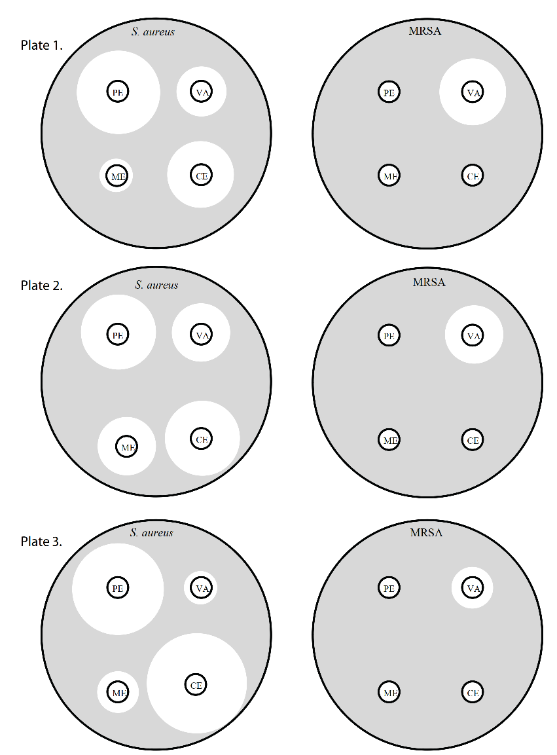
Figure 1. Agar plates of S. aureus or MRSA lawns with antibiotics disks placed on them.


Figure 2. Katelyn’s diagram of how to measure a zone of inhibition from her microbiology lab notebook.
﻿After measuring the zones of inhibition for each antibiotic on the plates shown in Figure 1, Katelyn analyzed her data by calculating the average and standard error for each variable and created the following graph.
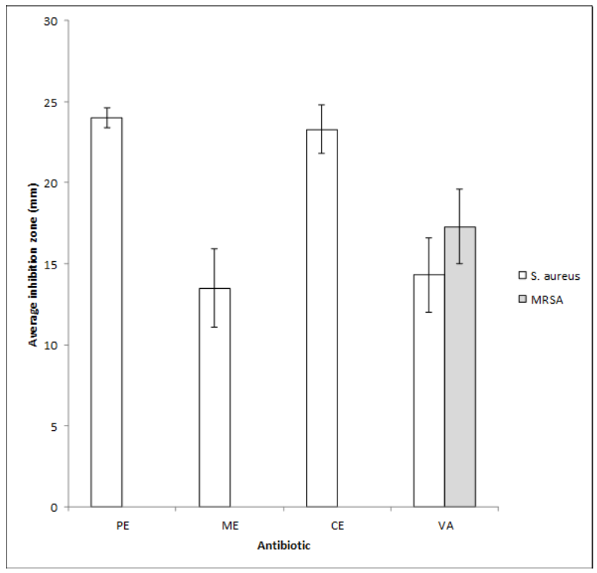
Key:
PE = penicillin,
ME = methicillin,
CE = cephalothin,
VA = vancomycin

Measurements in mm.

Questions:

- ﻿Which antibiotics where most effective against S. aureus? Against MRSA? 1 point

The antibiotics most effective against S. aureus were penicillin (PE) and cephalothin (CE). The antibiotic most effective against MRSA was vancomycin (VA).

- ﻿When comparing the antibiotics effective against both organisms, were there differences in effectiveness? 1 point

There was a difference in effectiveness in reference to the resistance ability of MRSA. The only antibiotic effective against MRSA was VA while all antibiotics (PE, ME, CE, VA) had a degree of effective against S. aureus. MRSA was resistant against all antibiotics except for VA.

- Why wouldn't Jimmy’s doctors have given him vancomycin when he first arrived at the hospital with an infection? 1 point

The doctors thought that Jimmy originally had S. aureus and VA is not the most effective antibiotic against this strain.

Part 2 – Resistance
﻿Among the first antibiotics used on a large scale was penicillin, which was discovered in 1929 by Alexander Fleming. It was finally isolated and synthesized in large quantities in 1943. Penicillin works by interfering with the bacterial cell wall synthesis. Without a cell wall, the bacterial cells cannot maintain their shape in changing osmotic conditions. This puts significant selective pressure on the microbes to evolve, as they cannot survive the osmotic stress. Any microbe that can resist these drugs will have a survival advantage and reproduce more, making the population of microbes antibiotic resistant.

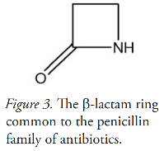
The specific mechanism of penicillin is the prevention of cell wall synthesis by the ß-lactam ring of the antibiotic (Fig. 3), which binds and inhibits an enzyme required by the bacterium in this process.

The enzyme is called penicillin-binding protein (PBP), even though it is an enzyme involved in cell wall synthesis. Normally enzymes have names that indicate what they do and end in the suffix -ase, like lactase, the enzyme that breaks down lactose. Figure 4 is a representation of PBP and its active site.

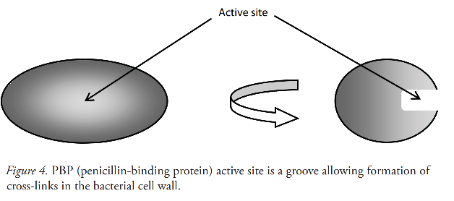

﻿Bacterial cell walls are layered structures, where each layer is made of peptidoglycan, a sugar and protein polymer. Each layer is cross-linked to the next, strengthening the wall and allowing the cell to resist osmotic pressure. The way the enzyme PBP works is to form those cross-bridges by joining strings of amino acids together in the active site, which is a groove in the protein (Fig. 5).
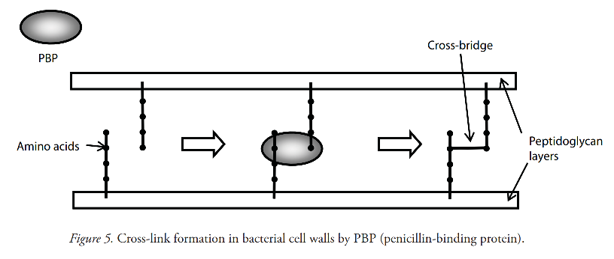

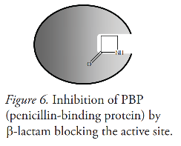
﻿The PBP takes amino acid residues attached to peptidoglycan layers and forms bridges between them within the active site groove. This cross-linking, or cross-bridging, stabilizes and strengthens the cell wall. ß-lactam antibiotics interfere with the PBP enzyme by binding to the active site, blocking the site from the amino acids (Fig. 6).

There are over 80 natural and semi-synthetic forms of ß-lactam antibiotics, including cephalothin and methicillin. Vancomycin also interferes with cell wall synthesis, but its mechanism of action is to bind directly to the cell wall components (Figs. 7 and 8).
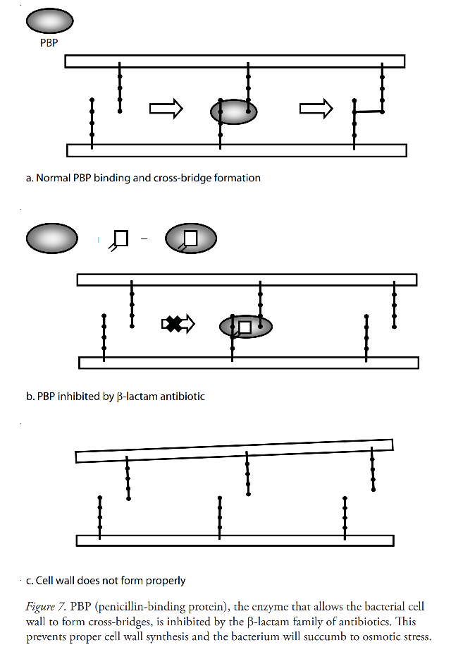
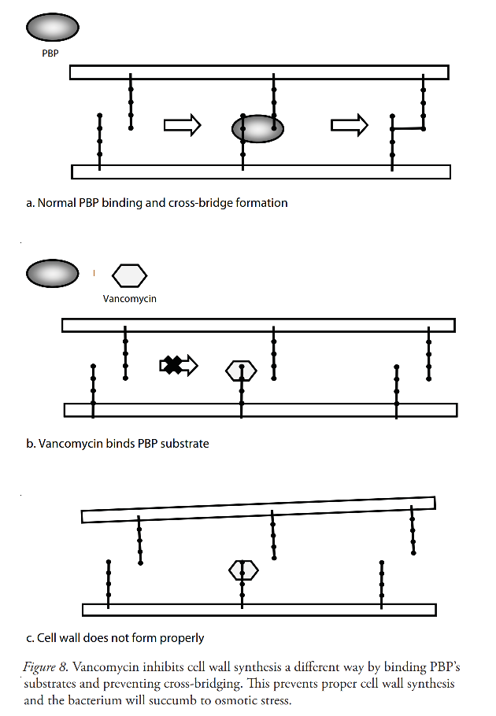
﻿The first MRSA case was discovered in 1961 in a British hospital and was the result of a mutation in the enzyme normally inhibited by the ß-lactam ring of methicillin. The site where the antibiotic would bind no longer allowed access to the ring, so the enzyme continued to function normally. The microbe acquired a new gene that, when made into protein, was a different version of PBP, one that couldn’t be inhibited by penicillin.

You can watch this video to help you understand how ß-lactams interfere with cell wall synthesis. You only need to watch the first half of the video (0 to 3:40min)

B-Lactams: Mechanisms of Action and Resistance by Mechanisms in Medicine



Questions

- ﻿Describe what is happening in Figures 7 and 8 in a complete sentence of your own words. 1 point

Figure 7 is showing how b-lactam antibiotics bind to the Penicillin-Binding Protein (PBP) inhibiting its ability to form cross-bridges between the amino acids of peptidoglycan layers. Figure 8 is showing how Vancomycin binds to the amino acids themselves (PBP substrate) preventing the PBP from being able to form cross-link between one amino acid to another on opposite peptidoglycan layers.

- What are the differences in how β-lactam antibiotics and vancomycin work? 1 point

B-lactam antibiotics bind to the enzyme, PBP, while Vancomycin binds to the substrate, amino acid chains.

- What other mechanisms could arise in bacteria, to allow resistance to the β-lactam antibiotics? 1 point

The amino acid chain that the PBP binds to could mutate making PBP unable to bind to it.

- Could resistance arise to vancomycin? Why or why not? 1 point

Yes, because the amino acid chain that vancomycin binds to on the peptidoglycan layer could mutate and produce a different version of a chain that it can’t bind to.

Part 3 – Restoring susceptibility
﻿Katelyn had been working for Dr. Johnson for a month, and while she had become quite good at measuring inhibition zones, she didn’t know why she was doing all this work. She had gotten very curious after she began doing all the measurements on a new set of antibiotics. This experiment involved infecting mice with MRSA and tracking how the MRSA grew over time.

Data were collected by counting the cells of MRSA taken from fluid samples from the mice. The cells were measured by taking one gram of the fluid and spreading it over plates, but now Katelyn counted the colonies that grew on the plate after 24 hours. Because there were so many, she measured the colonies as “log CFU/g.” A CFU is a colony forming unit, or essentially a cell that will divide into a colony that can be seen. Because there can be so many, Katelyn measured them on a logarithmic (log) scale. The raw data in her lab notebook looked like the following:

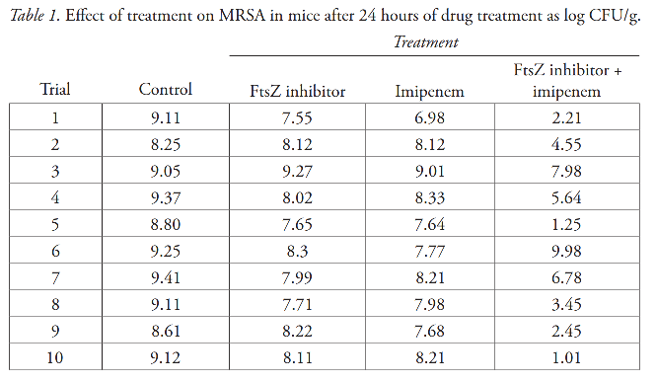

Questions:

- ﻿What do you think the experimental question is? 1 point

How effective is drug treatment on MRSA in mice after 24 hours?

- Looking at the data in Table 1, what do these numbers mean? (Keep in mind a log value means each integer increase is a ten-fold increase in the number of cells.) 1 point

FtsZ and imipenem together is more effective in controlling bacterial spread.

- What do you think FtsZ inhibitor and imipenem are? 1 point

Imipenem is an antibiotic and the FtsZ inhibitor inhibits the formation of FtsZ which aids in the spread of MRSA.

Next, Katelyn further analyzed the data she collected by calculating the average and standard error.

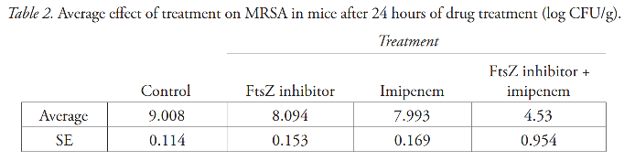

Question:

- ﻿ Does Table 2 change your interpretation of the experimental data from question 4? Why or why not? 1 point

No, it reaffirms my previous answer: FtsZ inhibitor and imipenem work better together to control MRSA spread in mice.

Katelyn then made the following graph (Fig. 9):
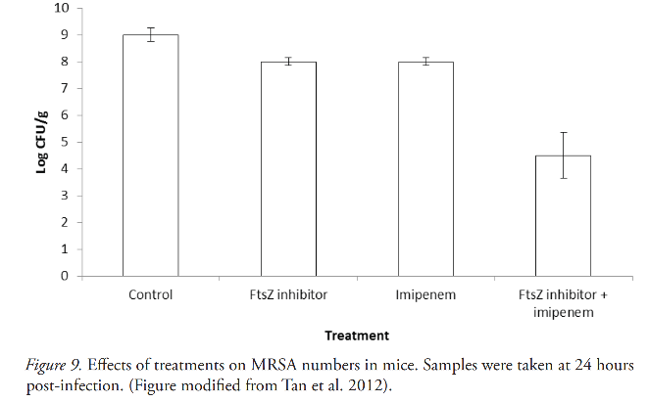

﻿

Katelyn was very excited by the results, but she didn’t know what an FtsZ inhibitor was, or what imipenem was. She decided to ask Dr. Johnson what his research was all about. “Dr. Johnson, look at these results I got from the last round of plates,” Katelyn said as she handed him a copy of the results above. “What exactly are we testing here?”

Dr. Johnson looked at the results and smiled. “These are great! This could really change the way we deal with antibiotic resistance.”

“To answer your question, ß-lactam antibiotics are still the most heavily used antibiotics, though resistance is a big problem. Most treatments have changed to using multidrug regimens in the hopes of allowing the antibiotic to still function while at least slowing down the resistance mechanism.”

“Another approach involves looking for other proteins that could be inhibited and looking for existing inhibitors to make into drugs. Instead of looking just for new antibiotics, we’re looking for new targets.”

Dr. Johnson handed Katelyn a few papers to read. In them she learned that the protein FtsZ helps “pinch off” the new cells at the end of cell division. This involves interacting with the cell wall as it is synthesized, and if FtsZ is interfered with, cell wall synthesis stops too. This prevents cell division, and the microbe can no longer reproduce. Dr. Johnson tested the new target idea by using a recently discovered inhibitor of FtsZ to see what effects that had on a MRSA infection. As part of the study, the inhibitor was tested by itself and in combination with imipenem, a ß-lactam antibiotic, resulting in the data above.

Questions:

- How effective was the FtsZ inhibitor alone? Imipenem alone? 1 point

FtsZ inhibitor and imipenem alone were only nominally effective in controlling MRSA spread.

- How effective was the combination of the inhibitor and the β-lactam antibiotic? 1 point

Together they were much more effective.

- How would you explain these results? 1 point

The FtsZ inhibitor prevents FtsZ protein from being formed which aids in the formation of MRSA. Imipenem inhibits MRSA.

