- Nature of adolescence
  - Genetic, biological, environmental & social factors influence adolescent development
  - Hall’s (1904) “storm & stress” view: conflict with parents, mood disruptions, and risky behavior
  - Offer et al.’s (1988): storm and stress are normal, universal and inevitable.
  - Challenges for adolescents

- Physical changes during puberty
  - Puberty: period of rapid physical maturation involving hormonal & body changes that occur primarily during adolescence
  - Male pubertal characteristics
  - Female pubertal characteristics & menarche
    - First period sooner and sooner across generations – century to century
      - More fat in food and less exercise
  - Weight & height gains
  - Growth spurts: 9 for girls, 11 for boys

- Hormones: powerful chemical secreted by endocrine glands & carried via bloodstream
  - Hypothalamus, pituitary gland, & gonads
  - Hormones:
    - Testosterone
    - Estradiol
  - Complexity of hormone-behaviour link
  - Timing & variations in puberty

- Gender differences in body image
  - Appearance
  - Physical & mental health problems
    - Decrease body satisfaction – poorer overall health
  - Best & worst aspects of being a boy or a girl
    - Sports – boys best
    - Fashion – girls best
    - Breast cancer, periods, PMS, childbirth – girls worst
    - Discipline – girls worst
  - Girls tend to have more negative body images than boys, but there is considerable variability

- Maturity
  - How teens define maturity & who they like to spend time with:
    - Adultoids/pseudo-matures: 25%
      - Feel older, live for the moment, behavioral problem
    - Immatures: 30%
      - No psychological maturity
      - Feel younger
    - Matures: 44%
      - Feel slightly older, self-reliant and responsible
  - Body art
    - Tattoos 60% - grades As and Bs – individuality and self-expression
    - Body piercings=risky behaviour

- Brain
  - Fmri studies reveal significant structural changes
  - Changes in limbic system
    - Change in amygdala and hippocampus
  - Risk taking
    - Frontal lobe – last to develop, executive brain branch
  - Nature vs nurture question

- Adolescent sexuality:
  - Cultural/geographic differences in sexual exploration
  - Television viewing and sexual behaviour
    - Television increases likelihood of sexual intercourse
  - Canadian Youth, Sexual Health, & HIV/AIDS Study findings
    - Positive: little use of illicit substances
    - Negative: Peer pressure, alcohol, decrease sex knowledge, risky behaviour
      - Girls with low self-esteem
      - No school involvement
      - Multiple sexual partners
      - Pregnancy

- Developing sexual identity:
  - Physical, social, & cultural factors
  - Master emerging sexual feelings form a sexual identity
  - Same & other-sex sexual attraction is on a continuum
    - Ex. some homosexuals have a level of other/heterosexual attraction
  - Self-devaluation by lesbian, gay, bisexual, & transsexual youth
  - “passing” & “coming out”

- Timing of adolescent sexual behaviours:
  - Varies by age, gender, and proclivity toward sexual activity
  - 43% of 15-19 year olds reported sexual intercourse (2003-2005)
  - Reasons for abstaining from sexual activity
    - Not ready
    - Self-esteem
    - Religion
  - Reasons for engaging in sexual activity
    - Serious relationship
    - Peer pressure
    - Alcohol
    - Drugs
  - Early sexual activity linked with other risky behaviours, school problems, STIs, pregnancy

- Risk factors and sexual poblems:
  - Dating violence: highest in high school
  - Contraceptive use: many don’t use contraception or use it inconsistently
  - Sexually transmitted infections
    - Chlamydia
    - Gonorrhea (50%)
    - Genital herpes (30%)
    - HIV (1%)
  - HPV: vaccine protects against some types

- Adolescent sexuality:
  - Risks for mother & infant
  - Rates of adolescent pregnancy in Canada:
    - Declining everywhere except Nunavut, Saskatchewan, & Manitoba
    - Abortions decreasing
    - Many pregnancies among 18-19 year olds are planned
      - Immigrants
      - Insecurity
    - Consequences of teenage pregnancy
  - Adolescent pregnancy: Global comparisons
    - Canadian teen pregnancy rate lower than US & UK but higher than France, Sweden, Japan, & other industrialized nations
  - Consequences of adolescent pregnancy
    - Economic
    - Educational
  - Reducing adolescent pregnancy
    - Sex education & family planning
    - Access to contraception
    - Life options approach
    - Abstinence, especially for young adolescents
    - Broad community involvement & support

- Nutrition, Exercise and Sleep
  - Nutrition & exercise
    - Exercise linked with positive cognitive & social outcomes
    - Good nutrition particularly important during adolescence
  - Sleep patterns & circadian rhythms
    - Sleep deficits
    - Circadian rhythm: behavioural, physical, & mental changes that occur over approximately 24 hrs.
    - Shift in biological clock
- Eating Disorders
  - Fast food & sedentary lifestyle contribute to obesity, hypertension & diabetes
  - Eating disorders increasingly common; 27% of 12-18 year olds have disordered eating behaviours
  - Factors related to adolescent eating disorders
  - Body image
    - Parenting
    - Sexual activity
    - Role models
    - Screen time
  - Anorexia nervosa: life threatening eating disorder that involves relentless pursuit of thinness via starvation
    - 1.5% of Canadian teens have had it
    - 10% die within 10 years of diagnosis
    - Characteristics of those suffering from anorexia nervosa
      - Weight < 85%
      - Distorted body image
      - Fear of gaining weight
    - Media influences
  - Bulimia nervosa: binge & purge
    - 90% are women
    - 70% eventually recover
  - Obesity: too much fatty tissue, measured by BMI

- Risk and vulnerability:
  - Risk taking
  - Suicide
  - Self-injury
  - Health-compromising behaviours
  - Drugs
  - Link with criminal activity
- Substance use and abuse:
  - Cigarette smoking
    - Declines in tobacco use
    - Health consequences of smoking
  - Prescription & non-prescription drugs
  - Dopamine & the brain
    - Pleasure-reward circuit
    - Incentive value
    - Thrill-seeking, novelty & pleasure-seeking trigger dopamine
  - Gambling
  - Combatting substance abuse

- Teen depression:
  - Depression: experiencing over a prolonged period of time a range of symptoms, including fatigue, irritability, inability to make decisions, sleeping problems, lack of interest in daily activities, suicidal thoughts
  - Galambos et al. longitudinal study found:
    - depression is more common in girls
    - Links between smoking, social relationships & body image with depression
  - Link between depression & suicide
  - Socio-cultural worlds of development: Suicide

- Adolescent Cognition:
  - Piaget’s theory
    - Formal Operations Stage
      - More abstract thinking, hypothetical possibilities, logical reasoning
      - Hypothetical-deductive reasoning: create hypothesis, deduce implications, test implications
      - Assimilation & accommodation
    - Evaluating Piaget’s theory
      - Individual differences
      - Role of culture & education greater than Piaget proposed
      - Challenges to stage-like framework
      - Some abilities emerge earlier than Piaget posited
      - Valuable concepts

  - Adolescent egocentrism: heightened self-awareness & self-consciousness
  - Imaginary audience: others are interested in them as they themselves are
  - Personal fable: uniqueness & invincibility

- Information processing:
  - Executive functioning
  - Decision making: role of personality traits & social context
  - Critical thinking
    - Increased speed, automaticity & capacity of information processing
    - Broader content knowledge
    - Increased ability to construct new combinations of knowledge
    - Greater range of strategies
  - The Brain
    - Frontal lobe & pruning
    - Use it or lose it principle

- Education:
  - Service learning: social responsibility & community service
    - Student improvement
    - Katimavik
  - Effective schools
    - Accountable & responsive
    - Effective leadership, clear academic goals, safe climate, expectation of mastery, etc.
    - Hidden curriculum
  - Dropping out of high school

Self-esteem:
  - Links between adolescent self-esteem & outcomes in adulthood
  - Self-esteem in girls often declines during adolescence (11-15 yo to 26 yo)
    - Negative body image
      - Decrease mental and physical health
    - Social relationships

- Identity:
  - Self-portraits that develop over our lifetime
    - Pieces include: vocational/career, political, religious, relationship, achievement/intellectual, sexual, cultural/ethnic, personality, physical, interest identities.
    - Process is gradual and can occur time & time again
  - Erik Erikson’s psychosocial moratorium/delay
    - Gap between childhood security and adult autonomy
  - Identity development: lengthy, complex, & life-long
  - James Marcia’s identity statuses & development
    - Crisis: exploration of alternatives
    - Commitment: personal investment in identity
    - Four statuses of identity

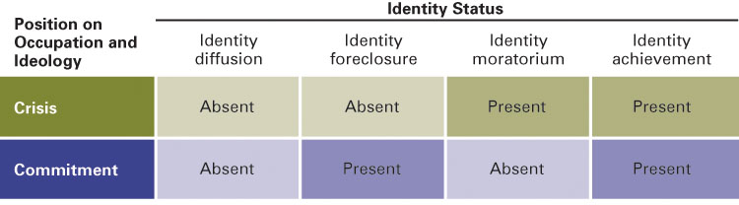
  - Emerging adulthood & beyond
    - Key changes in identity take place in early adulthood
    - MAMA cycles
  - Bingham & Stryker’s reworking of Erikson
    - Gender differences in identity formation
    - Socialization issues
      - Emotional & financial autonomy are contemporary predicaments
      - Acquiescent and dependent girls – crisis: autonomy (emotional and financial)
      - Achieving and independent boys – crisis: establishing intimacy
    - Socio-emotional development rooted in control, commitment & challenge
    - Hardy personality
      - Anxiety – Recognize, tolerate, act
      - Tackling reality vs. fantasy
      - Goals and priorities
      - Life project
      - Consistent choices with goals
      - Setting boundaries
      - Wants, desires and asking assertively
      - Trusting self and own perceptions
  - Elkind’s Age Dynamisms
    - Distance between teenage and childish self
    - Continuity (Piaget’s stages and cultural background)

- Jessica Yee is an aboriginal keeping cultural values.

- Families:
  - Family influences
    - Individuality: self-assertion & separateness
    - Connectedness: mutuality & permeability
  - Autonomy & attachment
    - Gender difference
  - Balancing freedom & control: locus of control
    - External locus of control (Japan)
    - Internal locus of control (USA)
  - Parent-adolescent conflict (Autonomy vs attachment)
  - Peers

- Religion:
  - Religious & spiritual development
  - Religion & identity development
    - Pre-spiritual and post-religious
  - Positive role of religion in adolescents’ lives
    - Social competence
    - +’ve peer relationships
    - Academic achievement
    - Emotional regulation
    - Prosocial behaviour
    - Self-esteem
  - Downward trend in Christian adolescents
  - Upward trend in atheism, Islam, Buddhism and Hinduism
  - Cultural differences

  - Race, visible minority, ethnicity, culture
  - Bicultural identity
  - Value conflicts, assimilation & multiculturalism
    - Assimilation
    - Multiculturalism=interculturalism
    - Positive ethnic identity = positive outcome
  - Ethnicity, race, & socio-economic status
  - Rites of passage to adulthood
  - Traditions & changes in adolescence around the world
    - Canadians marry late, Russians early
    - Street Kenyan adolescents struggle to survive in stressful situations.
  - Health – Less disease, ++ drug
  - Gender – Education, sexual expression
  - Family – Extended/Nuclear, Authoritarian/Authoritative
  - Education – increasing (not everywhere), women test better
  - Work – Industrialized countries
  - Peers – Important in Western culture, women in Arabic countries vs. Canada

  - Sexual identity: inner conviction about maleness or femaleness
  - Sexual orientation: behaviour
  - Gender: imposed social & psychological conditions
    - Physical & psychological conditions/development
      - Piaget’s schemata
    - Cultural context
      - Homophobia

- Adolescent groups:
  - Harry Stack Sullivan (1953): the role of friends in shaping development
  - Characteristics of adolescent friendships:
    - Friend’s grade point averages
      - Academic behaviour
      - +’ve behaviour
    - Same age friends vs. diff age friends

- Peer groups:
  - Positive & negative pressure
  - Peer pressure (grade 8 and 9)
  - Cliques
    - Tension between belonging & independence
    - Identity vs. self-esteem

- Dating
  - Developmental changes in dating
    - Added importance
    - Hanging out, heterosexual groups
  - Cyberdating
    - Popular in middle school
    - Can be dangerous
  - Socio-cultural contexts & dating
    - Values and religious beliefs
    - Identity with religion – possible cultural conflict
  - Dating violence
    - Physical, sexual, verbal or psychological
    - ‘Sexting’
    - 14 yo male = highest assault rate, girls < 16 yo = highest abused rate
  - Dating & adjustment
    - Dating adolescents are more accepted by peers and more attractive
    - Early age dating = depressive symptoms
      - Emotionally unavailable parents
      - Externalized problems of delinquency, drugs, etc.

- Brain
  - Exuberance & risk-taking behaviour
  - Dopamine decreases over time (& w stress)
  - Addictive drugs jump start dopamine and prolong stay

- Young offenders (12-18)
  - Youth Criminal Justice Act (2003)
  - Youth violence (17-18 yo)
    - Gang identity – violent/criminal activity
    - Early onset (< 11) more –‘ve development outcomes
  - Street youth
    - Safer place than home
    - Physical/sexual abuse
    - Addiction and sex trade
- 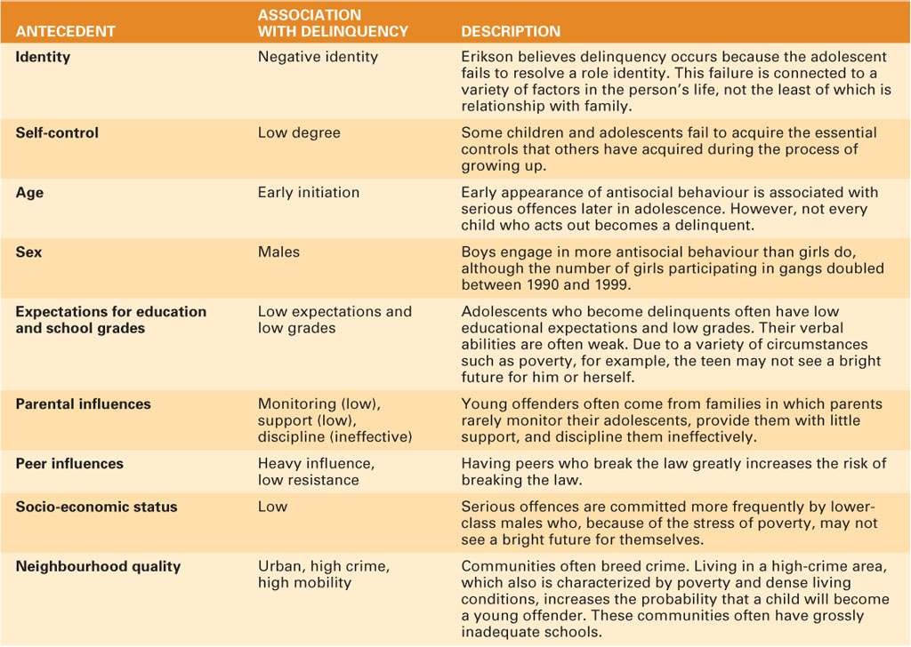

- Successful Prevention & Intervention Programs
  - At-risk adolescents tend to have multiple problems
  - Effective interventions
    - Broad-based partnerships
    - Specific program focus/training/educational curricular resources
  - Parenting strategies
    - One-word signals
    - Reflective questioning
    - Careful choice of arguments
    - Listening
    - Praise when earned

- Statistics Canada (2009) markers of the transition to adulthood
  - Left school
  - Left parental home
  - Has full-time full-year work
  - Is in a conjugal union
  - Has children who live with them

- Arnett’s notion of emerging adulthood: left dependency of childhood but have not assumed full responsibilities of adulthood
  - Identity exploration
  - Instability
  - Self-focused
  - Feeling in-between
  - Age of possibilities
- Assets that an individual’s well-being in the transition to adulthood: intellectual, psychological, social

- Stress
  - Sources of stress
    - Feeling overwhelmed
    - College females twice as likely to be stressed
  - Coping with stress
    - Keep thing s in perspective
    - Talk to someone
    - Identify what helps you relax & do it
    - Take a break & try relaxation, yoga, etc.
    - Get enough sleep
    - Exercise regularly and make time for fun
    - Watch diet

- Health
  - Twice the mortality rate of adolescents
  - Young males 2X mortality rate – ethnic and cultural diff
  - Bad habits during adolescence persist during adulthood
  - Reduce incidence of health-impairing lifestyles
  - Peak physical performance 19-26 yo – decline at 30

- Obesity:
  - Heredity
  - Leptin
  - Set point
  - Environmental factors
    - ½ Canadians overweight – 15% obese (BMI>30)
    - Poverty
- A word about dietary fats
  - 1/3 Canadian’s budget spent in restaurants
- Dieting
  - 1 – 2/3 regain weight
  - yo-yo dieting = gall bladder damage
- Restrained eating: skip breakfast, only this
- Unrestrained eating: planned, no skipping meals
- Unit bias: Huge containers are main cause of overeating

- Aerobic exercise
  - Sustained simulation of heart & lungs
  - Links with physical health – decrease heart disease
  - Links with mental health – decrease depression

- Substance abuse:
  - Alcohol
    - Binge drinking – 1/3 undergrads
      - Males and kids away from home
      - Female rate – increase 125%
      - Affect academic performance & memory
      - 1/3 rule for binge drinking:
        - 1/3 die, 1/3 overcome, 1/3 relapse
    - Gambling? 92% relapse
    - Alcoholism
      - Genetic and environmental
        - 1/9 who drink become addicted
      - Nalotrexone & behaviour intervention
      - Male, sex, neglecting risk
  - Cigarette smoking
    - 30% cancer, 21% heart disease, 82% pulmonary disease
    - 9000 people die/year of second hand smoke
    - heavy smokers = middle age
    - Addiction
    - Colds, infection, alcohol, cough, headaches
    - Quit? Antidepressants, cold turkey, lighter smokes, control social drinking, substitute nicotine
  - Disease model of addiction - nature
    - Inherited or early life
    - Gene link not proved
  - Life-process model of addiction - nurture
    - Habitual response, gratification & security
    - Understood only in social and experience context

- Sexual Orientation
  - Di(tri)chromatome continuum
- 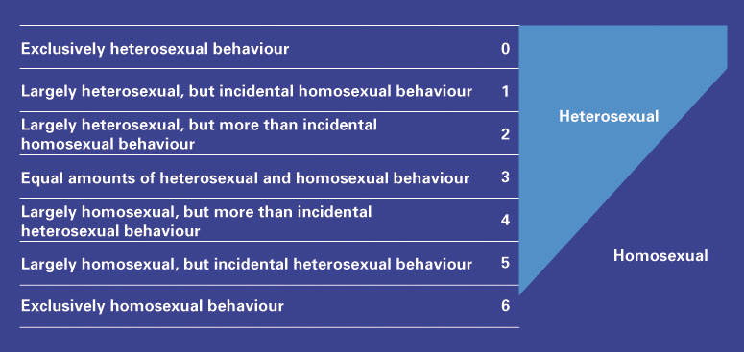
  - Attitudes and Behaviour of Lesbians and Gay Males
    - Similar psychological response
    - Suicide particularly in gay adolescents
    - Stigma, prejudice & discrimination
    - Same gender differences
    - Lesbians better at working together
    - Men > women with permissive sex
  - Factors
    - Genetic, hormonal, cognitive, environment
    - 2-5 months after conception
      - female hormone = attracted to males
  - Bicultural identity
    - Social adaption: beyond sex polarities
    - Balance between 2 cultures
  - 20% crime on person or property
  - 50% verbal discrimination
  - 10% employment/housing

- STIs
  - HPV
    - Warts/cancer
    - 75% of Canadians
    - 70% of Cervical Cancer
  - Gonorrhea - #2
  - Syphilis
    - ++ males
  - Chlamydia
    - 20% women, 50% men
    - Asymptomatic
    - Ectopic preg and infertility
  - Genital herpes
    - Virus
    - 1/5
    - No cure
    - 1/3 newborns die, ¼ brain damage
  - HIV & AIDS
  - Protecting against STIs
    - Know your and your partner’s risk status
    - Obtain medical examination
    - Have protected sex
    - Do not have sex with multiple partners

- Rape
  - Date/acquaintance rape
  - Contributing factors of dating violence
    - Patriarchal society
    - Peer pressure
    - Intergenerational violence
    - Social learning theory
- Sexual harassment

- Piaget:
  - Realistic & pragmatic thinking
    - Decline of idealism
    - Applying acquired knowledge
  - Reflective & relativistic thinking
    - Overcoming right/wrong thought and absolute
    - multiculturism
  - Is there a fifth, postformal thought?
    - Postformal thought: understanding that the correct answer requires reflective thinking & can vary from one situation to another; the search for truth is never-ending.
    - Not final
    - Change always
    - – Missing evidence

- Creativity:
  - Peaks in adulthood (in 40s) & tends to decline
  - Qualifiers regarding age & creative accomplishments
  - Domains
  - Variability

- Development:
  - Practical considerations in careers & education
  - Choosing a major in university
  - Establishing a career in a particular field
  - Knowing what is most important helps refine career choices
  - Examples:
    - Working with people they like
    - Working in a prestigious career
    - Earning high salary
    - Not having to work long hours
    - Mentally stimulating work
    - Geographical considerations

- Occupational outlook:
  - Keeping up with occupational outlook
    - People identify with work
  - What employers are looking for
  - Academic, personal management, & teamwork skills
- Work:
  - Effects of work on variety of dimensions
    - New life structure and rhythm
  - Worker demands for flexibility often not matched at work
  - Work during school
  - Unemployment = stress
  - Dual-career couples
    - more money and more challenges

- Temperament:
  - Stability of temperament
  - Correlation between temperament & adult adjustment
    - Active 4 year-old = outgoing 23 yo
  - Inhibition
    - Less assertive
    - Less likely to seek social support
    - More stable
  - Ability to control emotions and resilience
  - Intervening contexts
    - Helping children be accepted, allowing child to retreat, let them contribute, be calm and acceptiong

- Attachment shapes development throughout adulthood
  - Do attachment style with parents repeat with romantic partners?
  - Hazan & Shaver’s attachment styles
    - Secure – 60-80%
      - Trust and commit
    - Avoidant
    - Anxious
  - Links between attachment styles & psychological outcomes
    - Insecurely attached
      - increase depression, unwanted sex
      - decrease orgasm
  - Emotionally Focused Therapy (EFT) for couples
    - Bowlby
    - Healing old attachment injuries
    - 70-75%

- Familiarity
  - Closer relationship
- Similarity
  - Attitudes and lifestyles
- Consensual validation: our own attitudes and behaviour are supported by others.
  - Tend to shy away from unknown
  - usually same-same, occasionally opposites attract
- Physical attraction
  - Mostly important in early relationship
  - Vary across culture and time
  - Marlene and David Roche – she’s pretty, he is not

- Intimacy
  - Erikson’s stage: intimacy vs. isolation
    - Finding oneself yet losing oneself in another person
    - Relationships formed on equality
  - Intimacy & independence
  - Women are conditioned to think of men’s happiness, not their own
- Sternberg’s triangular theory of love
  - Romantic love
    - Infatuation - Passionate (eros)
    - Intimacy
  - Companionate love
    - Intimacy, commitment
  - Fatuous
    - Passion, commitment
- Consummate love
  - Sternberg’s triangular theory of love

- Women – close friends, talk/listen, sympathetic
- Men – in/out-door activities, less likely to talk about weaknesses

- Chronic loneliness & consequences
  - Caused by social isolation
    - Impaired physical/mental health; early death
    - Unsatisfied with friends
  - Emotional loneliness
    - Unsatisfying romantic/emotional relationships
  - Lack of secure relationships – adjustment problems & punishing behaviour
  - Transition to university & loneliness

- Marital trends in Canada
  - Delay in marriage (late 20s) and childbearing (30s/earky 40s)
  - Increase in cohabitation, decrease in traditional families, increase divorce

- Social Contexts
  - Desired traits for marriage partner
    - Chastidy
      - ++ importance: India, Iran, Taiwan, Japan, Ireland
      - -- : Sweden, Finland, Norway, Germany
    - Domesticity/House-keeping
      - ++: Zulu, Columbia, Etonia
      - --: USA, Cnaada, West Europe
    - Religion
      - ++: Islam, Hindu
    - Timing
      - Eastern Europe<N. America<Scandinavia & Japan

- Making marriage work:
  - Gottman’s 7 principles
    - Establish love maps
    - Nurturing fondness and admiration
    - Turning toward each other rather than away
    - Letting your partner influence you
    - Solving solvable conflicts
    - Overcoming gridlock
    - Creating shared meaning
  - Forgiveness & commitment

- Good marriage:
  - Physical and mental health outcomes of good marriages
  - Reasons for the correlation

- Family life cycle:
- Leaving home and becoming a single adult: launching
- Joining of families through marriage: the new couple
- Becoming parents & a family with children
- The family with adolescents – increase in flexibility of family boundaries
- The family at mid-life – accepting exits and entries into family system
- The family in later life – accepting generation role shift

- Parenting myths:
  - Birth of a child will NOT save a failing marriage
  - Child will NOT behave like parents did in childhood
  - Child DOES NOT give parents a second chance for achievement
  - Parenting is NOT instinct
    - Interpersonal skills and emotional demand
    - Formal education or from parents
    - Adapt to child developmental changes

- Single adults:
  - Stereotypes of single adults
    - Swinging vs desperately lonely and suicidal
    - 58% - extreme stress of being single
  - Challenge of forming intimate relationships, loneliness, and finding a niche
  - Advantages
  - Pressures for singles over 30

- Divorce:
  - Measurement challenges
  - 1 in 4 marriages end before 30th anniversary
  - ½ in Quebec
  - Divorce tends to occur before 10th anniversary
  - Youthful, low education, low income, no religion, divorced parents, baby before marriage
  - Dealing with divorce
    - Custody issues most challenging
    - Common pathways for exiting divorce
      - Enhancers – opportunity
      - Good-enoughs
      - Seekers – relationship jumping
      - Libertines – sex, sex, sex
      - Competent loners - +’ve attitude, would consider new relationship
      - Defeated - depressed
    - Recommendations for divorced adults
      - Focus on future
      - Decide carefully
      - Use strengths to cope
      - Possibility
  - Many divorced adults remarry within 4 years of divorce
  - Remarried adults with families find it difficult to stay married
    - Usually not for love
    - Finance, children, loneliness, take –‘ve relationship patterns into new relationship

- Women giving birth for first time 21 years increasing to 25
  - Less physical energy, more medical problems
  - More educated
  - Higher income
- Better fathers

Parental care + institutional care
  - Collective-orientated: based on duty/obligation to country, family, etc.
  - Objective: Universal principles

- Lone parent adults:
  - Most headed by women; economic consequences
  - Most under 45 years old
  - Some single women choosing to have children

- Gay and Lesbian Adults:
  - Preference for long-term committed relationships
  - Children in gay & lesbian families have comparable psychological outcomes as those with heterosexual parents.
  - Most children in gay or lesbian family have heterosexual orientation

Moral development:
  - Bronfenbrenner’s 5 moral orientations based on context
    - Self-oriented morality
    - Authority-oriented morality
    - Peer-oriented morality
    - Collective-oriented morality
    - Objectively-oriented morality
  - Adverse events may cause upward movement to self-oriented morality
- Women:
  - Jean Baker Miller: women tend to interact with others in ways that promote the other person’s development
    - Self motivation, self determination = greater power
  - Lerner’s notion of “I-ness” and its importance in relationships
    - Separated while emotionally connected
    - Strong, assertive, independent and authentic self
  - Women are more relationship-oriented than men
- Men:
  - Pleck’s role-strain view: male roles are contradictory and inconsistent
  - Areas in which men’s roles can cause strain:
  - Health
    - - life span, + suicide, + car accidents, + homicide
    - Male-female relationships: sexual abuse
    - Male-male relationships: competitive rather than collaborative
  - Socialized to internalize “unmanly” feelings
  - Levant’s suggestions for reconstructing masculinity:
    - Re-examine beliefs about manhood
    - Separate out valuable aspects of male role
    - Toss destructive aspects of male role

- Baby boomers: born between 1945 – 1960
- Middle adulthood: 40-60 or 65
  - Gains & losses balance each other
  - Influenced by socio-cultural factors
- Defining middle adulthood
  - Late mid life: 55-65
  - Losses may begin to dominate gains

- Mid-life physical changes are gradual
- Visible signs
- Height & weight
  - Height loss – lose bone in vertebrate
  - Weight gain - + mortality and ailments
- Strength, joins, & bones
  - Sarcopenia: age related muscle and strength loss
  - Joints stiff and inefficient
  - Bone density loss
- Vision & hearing
  - - eye accommodation
  - - visual field size; + blind spot
  - - pupil size
  - - 50% hearing at 50+ yo
  - High pitch gone first
- Cardiovascular system
  - Cholesterol increases: LDL – bad cholesterol; aatherosclerosis
    - + bp, obesity, hypertension, insulin resistance, diabetes, CVD
  - Metabolic syndrome
- Sleep
  - Insomnia
    - 40% over 30 yo
    - Women, depressed, obese, drugs, CVD
  - Sleep apnea
    - ¼ mild; 1/15 moderate
- Lungs
  - Proteins decrease elasticity

- Women
- Arthritis
- Hypertension
- Sinus problems

Men
- Hypertension
- Arthritis
- Hearing impairment

CHRONIC

  - Stress & CVD
    - Smoking, overeating, avoid exercise, + bp/hd/death
  - The immune system & stress
  - Stress and the cardiovascular system
    - –‘ve emotional events ~ adrenaline ~ blood clots faster ~ heart attack
  - Poverty & health
    - Altlantic provinces
    - Lone mothers
    - Aboriginal

- Culture and cardiovascular disease
  - Genetic predispositions to disease remain although health practices change
  - Ni-Hon-San Study
    - Japanese
    - Cholesterol, glucose and weight increase as ____ grew and acculturated
    - + stroke rate = alcohol, chain smoking

- Chronic disease is primary cause of death
- Decrease infectious diseases
- Cancer: lung, prostate, & breast (1)
  - 80% over 50
- HD (2)

- Sexuality:
  - Climacteric: mid-life transitions in which fertility declines
  - Menopause: end of menstrual periods
    - Perimenopause: 10 years before menopause
      - Depressed, headaches, moodiness, palpitations
    - Heredity & experiential factors
      - Menopause worse with smoke, alcohol birth control, sugar
    - Side effects
    - Hormone replacement therapies
      - >5 years? Cancer, HD, blood clots, dementia
    - Relaxation and acupuncture
  - Hormonal changes in middle-aged men
    - – testosterone, - sperm count
  - Erectile dysfunction
    - 22% of men
      - smoking, hypertension, cholesterol
  - Sexual attitudes and behaviour
    - Decrease need for intercourse
    - ++ sexual intimacy and concern for partner satisfaction
  - Sexually transmitted infections
    - – safe sex

  - Fluid & crystallized intelligence
    - Fluid: ability to perceive and manipulate info abstractly
    - Crystallized: accumulate info and verbal skills
      - Based on learning experience
    - John Homes: - CI = + FI
  - Seattle longitudinal study on change & stability in intelligence
    - Cognitive functioning in many intellectual skills peaks in middle adulthood
    - Some declines – perceptual speed & numerical ability

- Info processing:
  - Speed of information processing
    - Only perceptual speed and numerical ability decrease
    - After 60 yo, speed declines
  - Memory
    - Verbal peak in 50s (schaie)
    - Decrease info learning
      - Working memory limited
      - Overloaded long term
    - Declines when effective memory strategies aren’t used
  - Expertise
    - Increase extensive highly organized knowledge and domain understanding
  - Practical problem solving
  - Creativity
    - Most creative contributions completed by 50
    - Rollomay “Ultimate betrayal is not to listen to our own original ideas”
    - Csikszentmihalyi’s notion of flow (bing in the groove)
      - Optimal state of intrinsic motivation
      - steps for a more creative life

- Work:
  - Diverse progression of career trajectories
  - Possible experiences with age discrimination
  - Time for reflection of work
  - Peak in position and earnings or multiple financial burdens
  - Problems with technology and pay
  - Planning for retirement
  - Organizational restructuring/resizing, globalization
  - Unemployment
    - Contract jobs and lower wages
  - HRDC barriers:
    - Lower educational levels
    - Outdated skills
    - Lack of job-seeking know-how
    - Negative stereotyping by employers of their abilities

Leisure
  - Activities & interests of their choosing – hobbies, sports, reading, etc.
  - Mid-life changes may produce more time for leisure
  - Psychological preparation for retirement
  - Vacation
    - 21% less likely to die; 32% less likely to die of CVD

Religion:
  - Intelligent Design
  - Statistics Canada’s religiosity index comprised of:
    - Affiliation
    - Attendance
    - Personal practices
    - Importance of religion
  - Canadians: 40% low, 31% moderate, 29% high
  - Atheists & agnostics
  - Frankl’s most distinct human qualities: spirituality, freedom, & responsibility – finiteness of life
  - Baumeister & Vohs (2002) needs for meaning
    - Need for values
    - Need for a sense of efficacy
    - Need for self-worth
  - Generally no correlation between religion & physical health
  - Positive correlation between religious participation & longevity
  - Religion can help with coping

