Hands On Activity #2

Group 3

Samuel Madut - 300070047
Reishika Bhujun - 300035009
Ben Wisniewski - 300082012

ADM 4378 Section A Fall 2021
Business Communication Networks
Professor Raahemi



Date: October 21, 2021

Hands On Activity 1B

- List the PDU at layers 2, 3, and 4 that were used to transmit your HTTP GET packet.
  - Locate your HTTP GET packet in the Packet List and click on it.
  - Look in the Packet Detail window to get the PDU information.
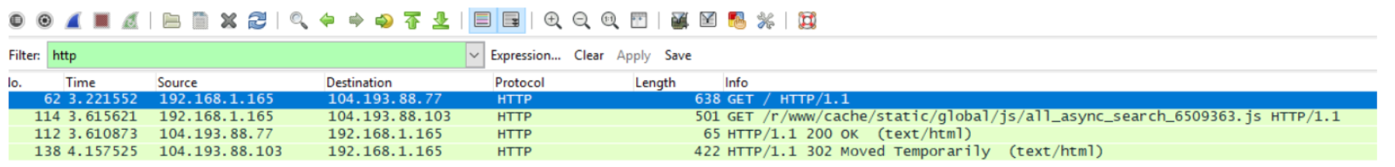
- How many different HTTP GET packets were sent by your browser? Not all the HTTP packets are GET packets, so you’ll have to look through them to answer this question.
From my wireshark session, there were only 2 packets sent. The website used was www.iana.org.

- List at least five other protocols that Wireshark displayed in the Packet List window. You will need to clear the filter by clicking on the “Clear” icon that is on the right of the Filter toolbar.
TCP
TLSv1
DNS
HTTP
SSDP

Hands On Activity 5A
- Use the ipconfig/all command on your computer. What is the IP address, subnet mask, IP address of default gateway, and MAC of your computer?
IP Address: 192.168.1.21
Subnet Mask: 255.255.255.0
IP address of default gateway: 192.168.1.1
MAC: c4:91:0c:b1:39:bd
- Why does every computer on the Internet need to have these four numbers?
You need to have these four numbers to connect to the internet. The IP address, subnet mask, IP address of default gateway, and MAC of your computer are part of the network layer. You cannot find your computer on a network with a MAC address and IP address.
Ping:
- Ping your own default gateway. How many packets were returned? How long did it take for your default gateway to respond?
27 packet returned. 0 packets lost. round-trip min/avg/max/stddev = 3.493/10.061/13.212/3.264 ms

- Ping google.com. How many packets were returned? How long did it take for you default gateway to respond?
6 packets transmitted, 6 packets received, 0.0% packet loss. round-trip min/avg/max/stddev = 14.627/43.209/162.720/53.555 ms
- Ping National Australian University www.anu.edu.au. How many packets were returned? How long did it take for your default gateway to respond?
8 packets transmitted, 0 packets received, 100.0% packet loss. The request timed out.

ARP:

- Type ARP-A at the command prompt. What are the entries in your ARP table?
clearview.home (192.168.1.1) at 0:e:f4:c9:d3:7b on en0 ifscope [ethernet]
rokuultra (192.168.1.2) at 84:ea:ed:16:68:79 on en0 ifscope [ethernet]
madutstv (192.168.1.7) at 78:80:38:a8:82:54 on en0 ifscope [ethernet]
chromecast (192.168.1.9) at 14:c1:4e:16:cb:ea on en0 ifscope [ethernet]
? (192.168.1.12) at c2:4d:b:92:48:72 on en0 ifscope [ethernet]
? (192.168.1.13) at 8e:35:cd:ec:de:f7 on en0 ifscope [ethernet]
iphone (192.168.1.25) at 3e:86:4b:31:38:88 on en0 ifscope [ethernet]
? (192.168.1.255) at ff:ff:ff:ff:ff:ff on en0 ifscope [ethernet]
? (224.0.0.251) at 1:0:5e:0:0:fb on en0 ifscope permanent [ethernet]
? (239.255.255.250) at 1:0:5e:7f:ff:fa on en0 ifscope permanent [ethernet]

- Suppose that there are no entries in your ARP table. Is this a problem? Why or why not?
The ARP table should have entries; it is a problem if there are no entries. “An Address Resolution Protocol (ARP) entry allows an interface to communicate with another interface even if they are not in the same multicast group.” So if there are no entries, you cannot communicate with devices outside the multicast group.
DNS:
- Display your DNS cache using the command ipconfig/displaydns.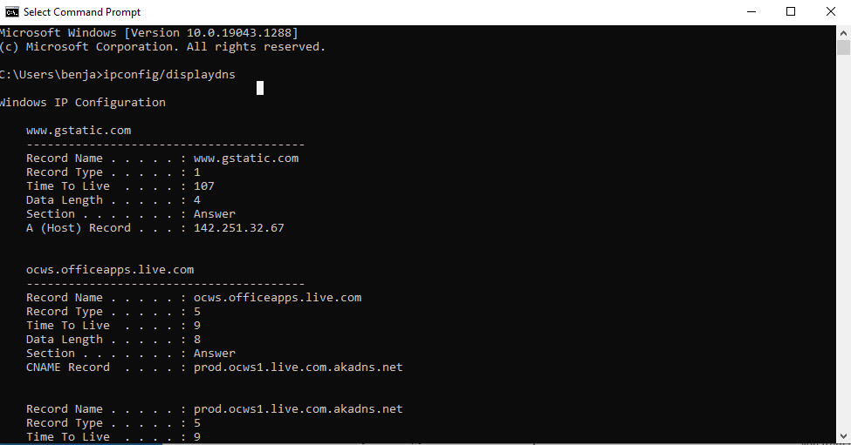

- How many entries are there in your cache?
  - 20
- Open your browser and visit www.ietf.com. Once the page loads, display your DNS cache again. Copy the DNS entry for this website.
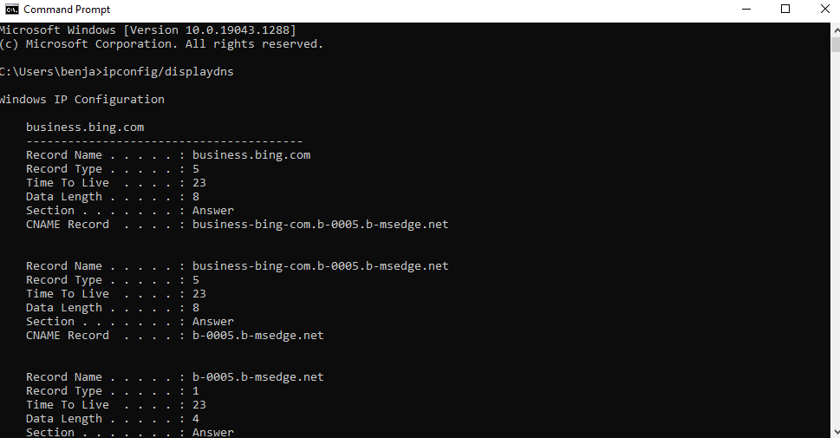
Tracert:
- Type tracert google.com in your command window
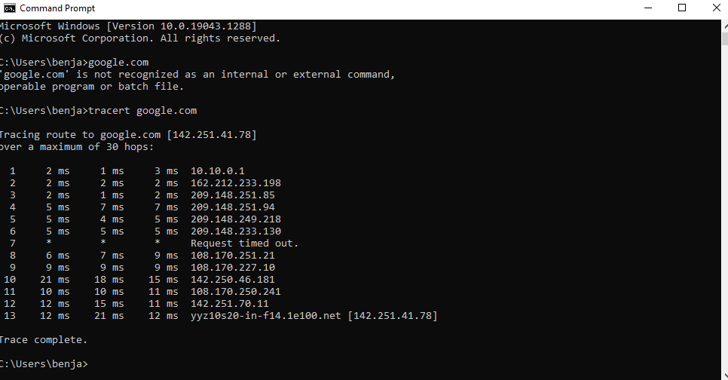
- How many computers/hops did it take the packet to reach Google?
It took 13 hops for the packet to reach google
- What was the shortest hop (in terms of time)? Why do you think this is the shortest hop?
Hop #3 was the shortest, as it had a combined time of 5ms among the time stamps posted.
Group Assignment:

By signing this Statement, I am attesting to the fact that I have reviewed not only my own work, but the work of my colleagues, in its entirety.

I attest to the fact that my own work in this project meets all of the rules of quotation and referencing in use at the Telfer School of Management at the University of Ottawa, as well as adheres to the fraud policies as outlined in the Academic Regulations in the University’s Undergraduate Studies Calendar. Academic Fraud Webpage

To the best of my knowledge, I also believe that each of my group colleagues has also met the rules of quotation and referencing aforementioned in this Statement.

I understand that if my group assignment is submitted without a signed copy of this Personal Ethics Statement from each group member, it will be interpreted by the Telfer School that the missing student(s) signature is confirmation of non-participation of the aforementioned student(s) in the required work.

Signature Date
__Reishika Bhujun________ __October 21, 2021_____________
Last Name (print), First Name (print) Student Number
_RB_______ __300035009__________
Signature Date
____Madut, Samuel______________ _300070047_________________________
Last Name (print), First Name (print) Student Number
_______________________ __October 21, 2021___________________
Signature Date
__Wisniewski, Ben_____ ___300082012____________
Last Name (print), First Name (print) Student Number
____bwisniewski_____ ___October 21, 2021_______________
Signature Date

References

(n.d.). Retrieved from https://www.ibm.com/docs/en/aix/7.1?topic=ipoii-creating-displaying-adding-deleting-arp-entries-modifying-arp-timers

