CRM1301 Final Exam Study Notes/ Quotations

Exam Criteria:
- Takes place December 18th, 2pm-5pm.
- 12p font, numbered pages, double-spaced
- Submit to your TA by email
- Microsoft Word document, submit TWO seperate files in one email
- 750 words max. Including in-text citations, not including works cited
- Cover page (include the question in bold, your name and student id, the department and school, the course code and name, the name of the professor, and the date of submission)
- Due to time constraints, I recommend prepping your exam documents before the time starts, that way you don’t waste time on formatting

Hobbes and Criminology (Oct 21)

Fear of Disorder
- Fear causes crime and solutions
- Criminology focuses on security & problems of order, rather than crime.
- Focus on public disorder
  - Urban decay: The quality of life in the urban is coming undone.
  - Problem 1: white flight (upper-class white families leave which leads to economic decay)
  - Problem 2: racial discrimination
- The decay and the rise of crime within the racial tensions leads to a palpable sense of fear that overcomes the city and its population.
- Tensions between the police and the citizens (especially minority groups) come undone
- George Kelling studied the effective methods for police to reduce crime.
  - Foot patrol does a better job at responding to civilians and reducing crime compared to car patrol.
    - Foot patrol doesn’t reduce crime, but makes citizens feel more secure.
    - Fear of crime happening and fear of being disordered by unpredictable people.
    - A reduction in the rate of crime does not correspond in a reduction in the source of fear. Possibly, addressing the problem of disorder is what reduces people’s fear.
  - Kelling & Jacobs: People aren’t as afraid of crime as they are of disorder (disorderly people).
- The prospect of confrontation with a drunken person can be as fear-inducing to a defenceless person as the prospect of meeting an actual robbery.
- Broken windows theory
  - Built on fear, and relies heavily on it
  - Links fear & crime (go hand in hand)
  - Main argument: fear of being bothered by disorderly people.
  - One (unrepaired) broken window is a sign that no one cares, and that more disorder is to come - one broken window leads to more broken windows.
  - Untended property as well as untended behaviour will lead to a breakdown in the community.
  - If you don’t check the 1st broken window, violent/serious crime is the end result.
    - Many people think that violent crime is rising, so they change their behaviours accordingly. (i.e.: will stay off the street more, but more crime will occur because there is less people)
    - The absence of order will lead to problems and those problems will eventually lead to violent crime.
  - Widens the scope of problematic people and issues.
- Major issue is fear of disorder, not fear of crime.

John Locke, Law, Liberty, Criminology (Nov 2, 4)
Lecture, Nov 2
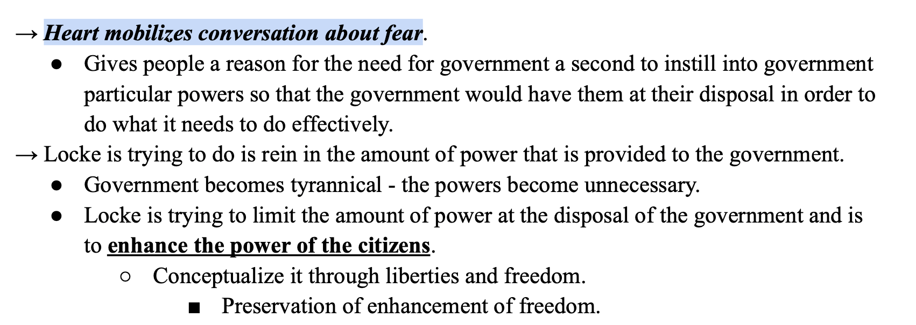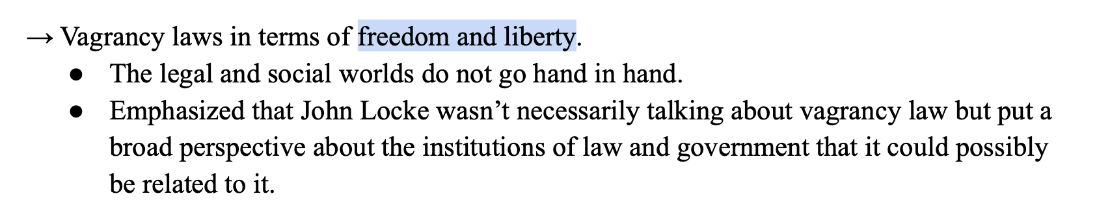
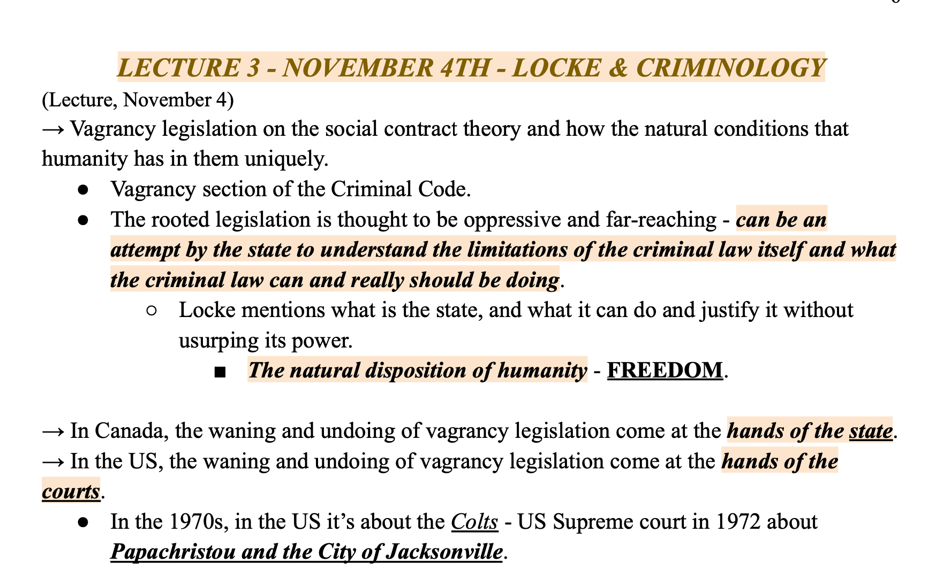
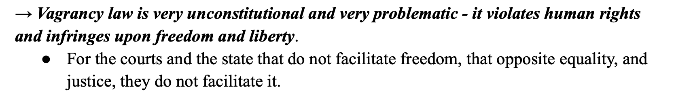

Francis Galton: Heredity and Eugenics (Nov 9, 11)
November 9, Lecture
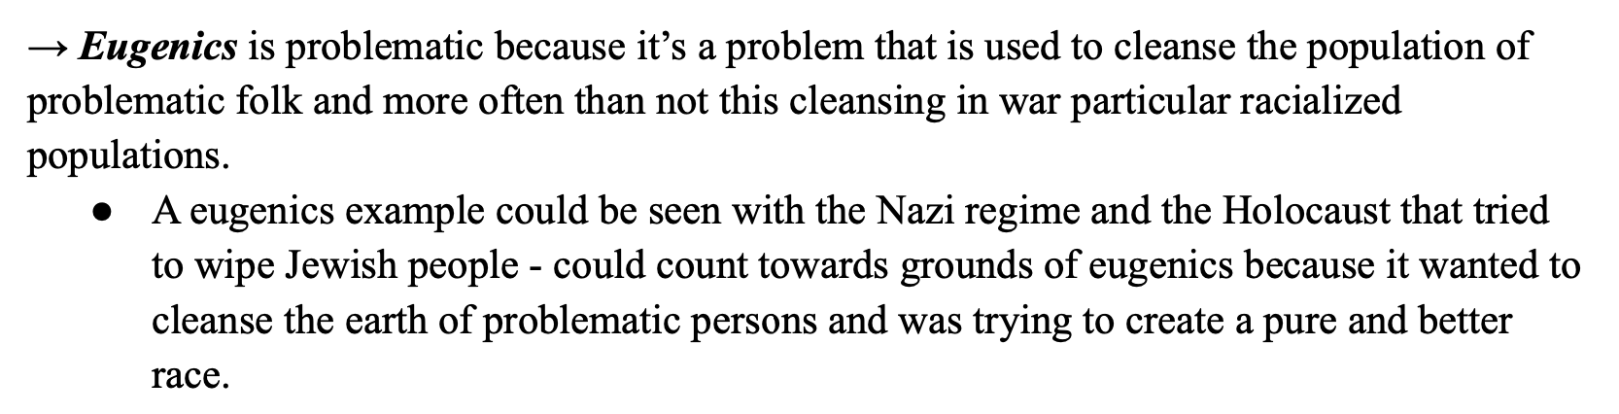
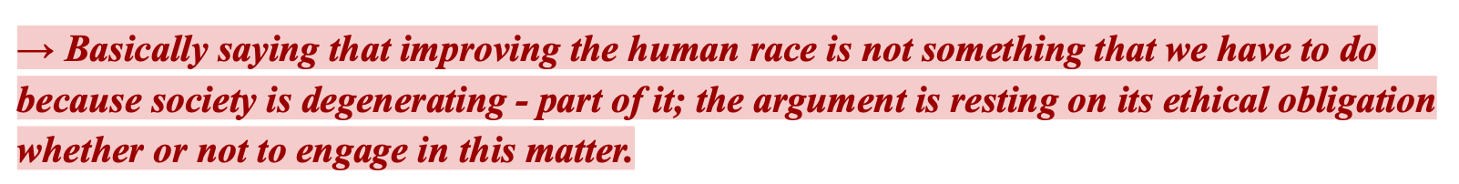

- Eugenics (a term coined by Galton) is designed to cleanse the population of problematic folk/ improve the race as a whole
  - It deals with influences that improve the inborn qualities of the race
  - Taking each class by its best and focusing on the best
  - Immutable charactersitcs- characteristics we cannot change such as sex and race
    - These immutable characteristics were a concern as it was thought that these groups were more prone to crime
  - Will seek quantitative results (through quantitative rigorous research, provide objectives to determine what is plaguing society and provide solutions for society)
- Science (bottom- up) better than philosophy (works at distance)
- Race is degenerating because it is overweighted with burdens without any means to address it
  - Therefore, improvement of human race is not needed
  - There is a social duty to implement eugenics (bc society is degenerating)
  - It is under science that there are significant differences that are ruining society
    - Premise of eugenics that men and women are born different
    - Differences vary in intellectual capacities, energy levels, level of power, disposition (ex: think of dogs and how we have to breed them a certain way to make them different; lap dogs/ herd dogs..)
    - Breeding human race arises controversy- this race will be the ‘saving race for society’
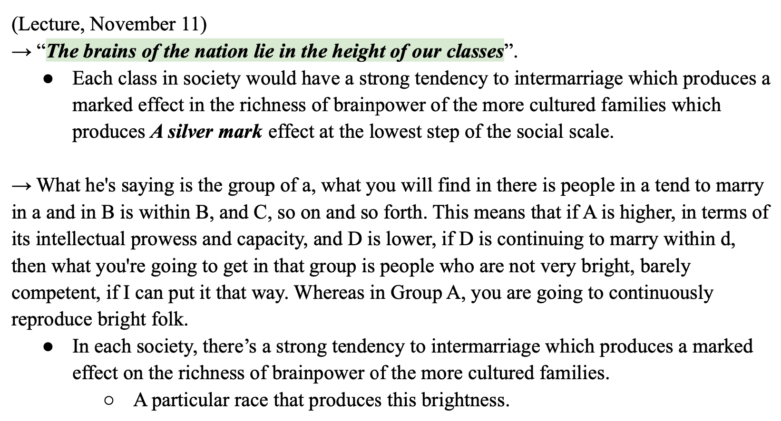
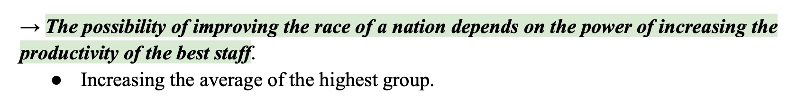

- Need to improve the quality of races
- Cannot improve the faulty groups of society as their traits are inborn
  - Validity of this comes from science- some are gifted by natural birth qualities while others are not
- Proving the notion that geniusness is inherited through eminence, illustriousness, reputation
  - Eminence is met when a person achieves a 1 to 4k ratio position
  - Illustriousness can be revealed by men of particular stock (well educated, important historical men)
    - This is gaged from their reputation
  - Reputation is revealed when it is believed that society owes something to that person
- The intellectualism of our nation lies in the higher classes in our society
  - Intermarriage and the idea that group A should marry in group A and group B should marry in group B…
  - Higher class of society was the main focus to move things up
- Aspects of eugenics
  - 1. Elevating average standard
  - 2. Positive and negative eugenics (galton only speaks of positive)
    - Positive: enhancing top tier of society
    - Negative: restriction of the lower tier population (ex: castration of males) (Galton does not promote negative eugenics)

John Stuart Mill: Speech, Liberty, Harm (Nov 23, 25, 30, Dec 2)
November 23 - reading
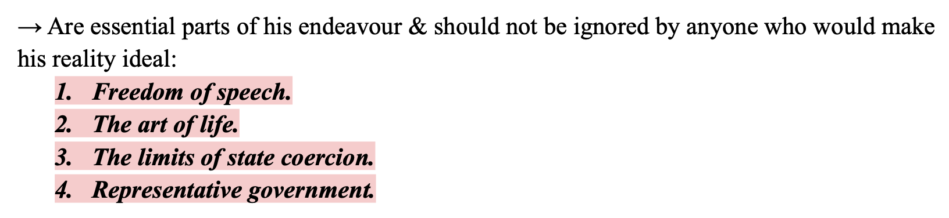

Lecture November 23
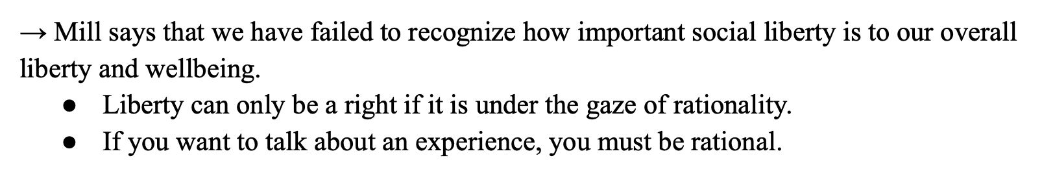

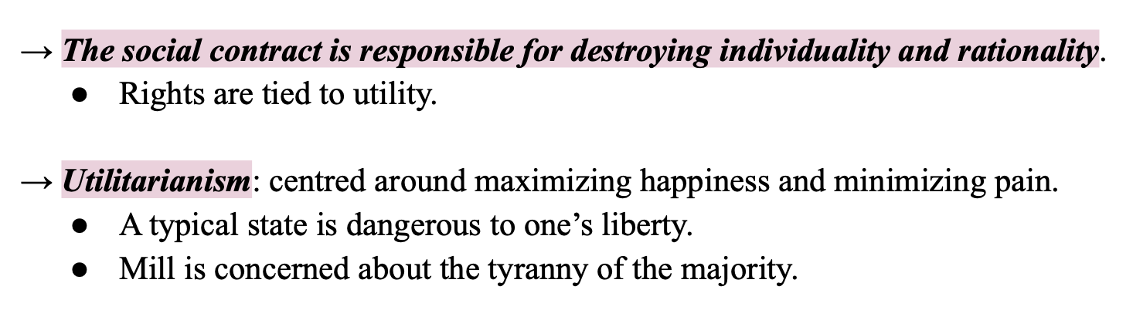
- Mill writes against social contract theory
- Liberty is the state of being free (2 forms)
  - 1. Civil liberty- liberty is a product of the state
  - 2. Social liberty- liberty that exists in society
    - Can be formal and informal
    - Associated with tyranny of the majority
- Mill vs Locke
  - Both are concerned about the nature of liberty of right, limits of the state, and power over people. Also both are concerned about liberty in relation to state
  - Locke says the notion of liberty is tied to rationality and presupposes a rational being in the social contract and liberty
    - Mill says liberty is not a product of natural principle
    - Mill says liberty can only come out of reason
  - Locke uses the notion of perfect freedom drawn from men in their natural condition as the basis to ground liberty in society
    - Mill says natural principles cannot be the basis to ground liberty
  - Locke says society is about coming together and forming a contract
    - Mill says society has nothing to do with social contract
  - Locke- social contract is about giving up executive power of law of nature
    - Hobbes- social contract is about giving up right to all things
    - Mill- social contract kills the rationality and individuality of man
  - Locke is concerned about civil liberty
    - Mill is concerned about social liberty
  - Locke is concerned about tyranny of the minority (us vs. them)
    - Mill is concerned about tyranny of the majority
    - Both can agree that the problem is within, it is us who are destructive to ourselves
- Laws of nature
  - They are eternal, immutable (cannot change), have to be discovered by rational minds
- Liberty comes out of rationality and reason- there is a decline in rational men seen in social contract- Mill wants to rescue rationality
  - Rationality is waning because of social contract
  - Individuality is waning because of social contract
- Individuality
  - One leaves individuality when stepping into society (true self is in state of nature). They are an artificial being
  - Individuality is waning because social contract forces beings to give up themselves
- Utility (utilitarianism)
  - About maximizing happiness and minimizing pain
  - It is the appeal on all ethical questions

November 25, Lecture
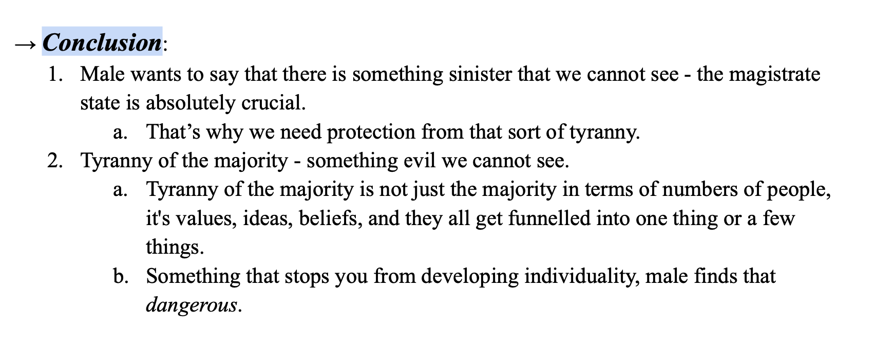
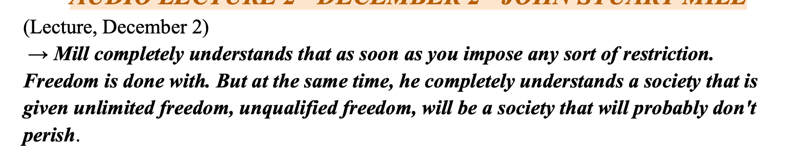
- Tyranny of the majority
  - Speaks to ideas and opinions- can be dangerous
  - Ideas are not being permitted to grow and flourish - affects rationality and individuality- society cannot progress
  - Tendency to of society to impose its own ideals and rules and practices- being prohibited from speaking
  - Ex: 99 people disagree with you, will you speak up?
  - The group stifles those who do not think the same
- Tyranny of the minority
  - Comes from the state
  - Minority is overpowering us
  - Ex: 99 students concerned over the one teacher
- Valid opinions
  - An opinion should not be held to sway other people
    - Even if many agree with an opinion, this does not make it a fact
    - Majority does not equal fact
  - Sufficient reasons provided with opinion becomes a reasoned argument

December 2, Lecture
- Right to voice opinions comes with responsibilities
  - One can say anything they want as long as the statement only affects themselves. When it begins to harm other people, then there is space for potential restrictions
- Harm is the basis upon the balance of freedom and restrictions of freedom
- Fulfillment vs to be full
  - To be full: a particular amount you can fill
  - Fulfillment: to be happy with and about something
    - Tied to happiness, to achieve what one desires
- Mill is interested in promoting happiness
  - Harm is unhappiness- it is anything that stands in the way of happiness
  - Society should intervene in the actions of a particular person when society’s happiness is jeopardized. Otherwise, there is no need to intervene
- Punishment should be for the action, not because the action was disapproved
  - Ex: a drunkard wasting money and is not caring for his children. Punishment is required because they are not fulfilling their duty (taking care of children). Not punishing for their status (that they are a drunkard)
  - Distinction between individual and society/ between status and duty

Reference APA (Not alphabetical!)

Coby, P. (1987). The Law of Nature in Locke’s Second Treatise: Is Locke a Hobbesian? The
Review of Politics, 49(1), 3–28. http://www.jstor.org/stable/1407330

De Ville, J. Deconstructing the Leviathan: Derrida’s The Beast and the Sovereign. Societies
2012, 2, 357-371. https://doi.org/10.3390/soc2040357

Ioannis D Evrigenis (2015). “The State of Nature.” In, The Oxford Handbook of Hobbes. Al P.
Martinich and Kinch Hoekstra (eds.). Oxford: Oxford University Press (electronic publication)

Tuckness, A. (2010). Retribution and Restitution in Locke’s Theory of Punishment. The Journal
of Politics, 72(3), 720–732.

Ranasinghe, P. (2021, October 5). John Locke: Law & Liberty [PowerPoint Slides].

Ranasinghe, P. (2021, September 14). Thomas Hobbes: The State of Nature, the Social Contract and the Basis of Government and Society [PowerPoint Slides].

Tuckness. (2010). Retribution and Restitution in Locke’s Theory of Punishment. The Journal of Politics, 72(3), 720–732. https://doi.org/10.1017/S0022381610000125

Ranasinghe. (2012). Jane Jacobs’ framing of public disorder and its relation to the “broken windows” theory. Theoretical Criminology, 16(1), 63–84. https://doi.org/10.1177/1362480611406947

Ranasinghe. (2010). Reconceptualizing vagrancy and reconstructing the vagrant: a socio-legal analysis of criminal law reform in Canada, 1953-1972. Osgoode Hall Law Journal (1960), 48(1), 55–.

Ranasinghe. (2015). Refashioning vagrancy: a tale of Law’s narrative of its imagination. International Journal of Law in Context, 11(3), 320–340. https://doi.org/10.1017/S1744552315000178

Fancher. (1983). Francis Galton’s African Ethnography and its Role in the Development of his Psychology. The British Journal for the History of Science, 16(1), 67–79. https://doi.org/10.1017/S0007087400019531

ZELINGER. (2019). RACE AND ANIMAL‐BREEDING: A HYBRIDIZED HISTORIOGRAPHY. History and Theory, 58(3), 360–384. https://doi.org/10.1111/hith.12122

Dyzenhaus. (1992). John Stuart Mill and the Harm of Pornography. Ethics, 102(3), 534–551. https://doi.org/10.1086/293423

McGlynn, & Ward, I. (2014). Would John Stuart Mill have Regulated Pornography? Journal of Law and Society, 41(4), 500–522. https://doi.org/10.1111/j.1467-6478.2014.00683.x

Lecture citations

Ranasinghe, P. (2021, October 5). John Locke: Law & Liberty [PowerPoint Slides].

Ranasinghe, P. (2021, September 14). Thomas Hobbes: The State of Nature, the Social Contract and the Basis of Government and Society [PowerPoint Slides].

Citing in-text: (Lecture, October 5) or (Office hours, October 5)

Citing in-text readings:
(Tuckness, 2010, p. #)
(De Ville, 2012, p. #)
(Coby, 1987, p. #)
(Evrigenis, 2016, p. #)
(Ranasinghe, 2021, p. #)
(Ranasinghe, 2010, p #)
(Fanche, 1983, p. #)
(Zelinger, 2019, p. #)
(Dyzenhaus, 1992, p. #)
(McGlynn and Ward, 2014, p#)

TA Emails
Joshua Austin – jaust092@uottawa.ca (for those whose surnames begin with A-K)
Jasmine Kainth – jkain027@uottawa.ca (for those whose surnames begin with L-Z)

Format of title page:

The Question You Are Answering
NAME (STUDENT NUMBER)
Department of Criminology, University of Ottawa
CRM 1301-B: History of Criminological Thought
Professor Ranasinghe
December 18, 2021
Lecture Citations
(September, 14 Lecture) - Hobbes 1(1)1 ………… (Hobbes Lecture 1)
(September, 16 Lecture) - Hobbes 1(1)2 ………… (Hobbes Lecture 2)
(September, 16 Lecture) - Hobbes 1(2)1 ………… (Hobbes Lecture 3)
(September, 21 Lecture) - Hobbes 2(1)1 ………… (Hobbes Lecture 4)
(September, 21 Lecture) - Hobbes 2(1)2 ………… (Hobbes Lecture 5)
(September, 23 Lecture) - Hobbes 2(1)3 ………… (Hobbes Lecture 6)
(September, 23 Lecture) - Hobbes 2(1)3 ………… (Hobbes Lecture 7)

(September, 28 Lecture) - Locke 1(1)1 ………… (Locke Lecture 1)
(September, 28 Lecture) - Locke 1(1)2 ………… (Locke Lecture 2)
(September, 30 Lecture) - Locke 1(2)1 ………… (Locke Lecture 3)
(October, 5 Lecture) - Locke 2(1)1 ………… (Locke Lecture 4)
(October, 7 Lecture) - Locke 2(1)2 ………… (Locke Lecture 5)

(Lecture, October 21) Hobbes & Criminology 1(1) 1 ………… Lecture 1
(Lecture, October 21) Hobbes & Criminology 1(1) 2 ………… Lecture 2

(Lecture, November 2) Locke & Criminology 1(1) 1 ………… Lecture 1
(Lecture, November 2) Locke & Criminology 1(1) 2 ………… Lecture 2
(Lecture, November 4) Locke & Criminology 1(2) 1 ………… Lecture 3
(Lecture, November 4) Locke & Criminology 1(2) 2 ………… Lecture 4

(Lecture, November 9) Galton 1(1) 1 ………… Lecture 1
(Lecture, November 9) Galton 1(1) 2 ………… Lecture 2
(Lecture, November 11) Galton 1(2) 1 ………… Lecture 3
(Lecture, November 11) Galton 1(2) 2 ………… Lecture 4

(Lecture November 23) Mill 1(1) 1 ………… Lecture 1
(Lecture, November 23) Mill 1(1) 2 …………. Lecture 2
(Lecture, November 25) Mill 1(2) 1 ………… Lecture 3
(Lecture, November 25) Mill 1(2) 2 ………… Lecture 4
(Lecture, November 30) Mill 2 (1) 1 ………… Lecture 5
(Lecture, November 30) Mill 2 (2) 1 ………… Lecture 6
(Lecture, December 2) Mill 2 (2) 2 ………… Lecture 7
(Lecture, December 2) Mill 2 (2) 3 ………… Lecture 8

All Lecture Citations: (Lecture, September 14) (Office hour, September 14)
(Lecture, September 16)
(Lecture, September 21) (Office hour, September 21)
(Lecture, September 23)
(Lecture, September 28) (Office hour, September 28)
(Lecture, September 30)
(Lecture, October 5) (Office hour, October 5)
(Lecture, October 7)
1. The “University of Amazingness” recently came into the spotlight. In one of its classes, a professor was called into question because the professor used a word – “abcde” – that is said to be racially toxic to specific groups. The university defended the professor claiming that the professor was seeking to contribute to intellectualism and thus did not sanction the professor. Would John Stuart Mill be in favour of the university’s response in this matter? Discuss
Because hes for freedom of speech as long as it does not harm other ppl

