Week 2
Diversity oppression privilege
Conceptual issues with diversity: diversity: celebratory approach, diff approach, anti oppression approach
Anti oppression and critical social theory. Intersectionality and matrix of oppression. Defining and unpacking privilege
Celebratory:
Serious concerns with this approach as it often fails to address unequal power relations and histories of social exclusion, discrim, privilege and oppression. Risk of trivializing marginalization and oppression
Difference approach: approaches that are rooted in sameness/difference dichotomy reinforce and devalue difference as other. Diversity initiatives that utilize the sameness and difference approach can be problematic when the goal is to help people learn how to appreciate and accept difference as it imlkies a eed to learn how to put up with things that are different from the dominant group
Anti oppression: an anti opp framework built on principles that value social equit social justice and social inclusion. The concepot ogff deivsirty would recognize that people will exp certain advantages and disadv based on the socially oncsutrcted menanings assigned to aspects of ID.
Critical social theory
Conceives human liberation as the highest purpose of intellectual activity. Ben agger argues that cst can be viewed as a theory cluster made up of several theories including critical theory post modernism feminist theory multiculturalism and cultural studies. Most significant aspect of cst that it rejects positivism.
The head circumference of children from high socioeconomic status (SES) homes and whose mothers had earned college degrees were significantly larger than the head circumferences of children from low-SES homes and whose mothers had no degrees
Positivism
Attempts to formulate lawfuil understandings of the social universe following comtes first sketch of sociology as a science. Positive social theory assumes that social laws govern these sorts of relationships between dependent and independent variables-thus more data and rigorous methods would expose these laws.
Dynamics of oppression
Ooppression: intentional and unintentional domination of non dominant groups by a powerful dominant groups that occurs on indiv cultural and structural levels in society
Domination: systematic and continuous exertion of power by dom groups over non dom groups.
Levels of oppression
Personal: usually involves negative stereotypes or prejudice; bullying, harassment, violence etc also covert forms of dom
Cultural: dom groups creatingin and maintaining hierarchical divisions to universalize and impose its own culture as superior.
Structural: ways in which oppression is institutionalized and legitimated in society; laws social practices, int, econ and political systems – how they favour the dom group at the expense of non dom group
Intersectionality
An intersectional paradigm illuminates the ways in which different forms of oppression are all interconnected and therefore cannot be viewed separately form one another.
Matrix of oppression
Developed by patricia hill colliins built on a foundation fo ideological beliefs about dom and how it is socially constructed. No hierarchy along the matrix in terms of one axis being more important
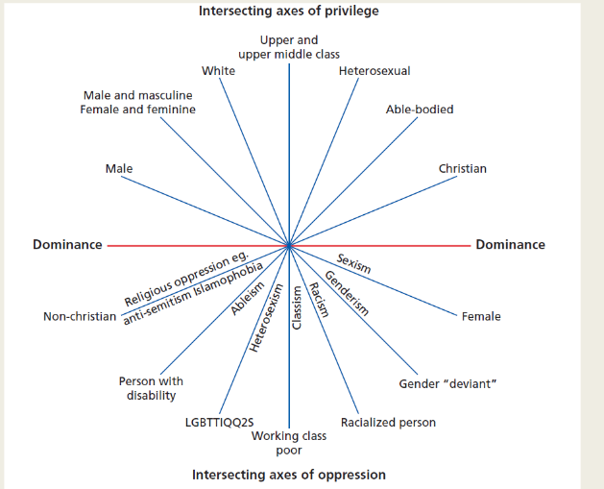

Unpacking our privilege
Priv: being able to decide who gets taken seriously, receives attention, is accountable to whom and for what.
The luxury of obliviousness: term to describe not having to think about privilege. Recognition and acknowledgement of privilege can be the starting point for alarger convo about how we unlearn oppression.
Journey ytoward justice and equity
Social justice: challenges: social structures processes and practices associated with inequalities that lead to oppression
Distributitve and redistributive justice: a social justice model. Concerned with the fair distribution or redistr of material and non material resources between diff groups within a society.
Undeserved: disadvantaged because of structural barriers and disparities
Tokenism: practice of including one or a small number of members of a minority group to create the appearance of representation without giving these members access to power.
Equity equality liberation

Jan 29

Social inequalities as socially structured
Most sociology begins with the assumptions that there is nothing natural or inherently normal about society or its components
Two inequality implications:
Any social construction will reflect, reinforce, and advance interests and realities of those who create, own, and control those convetion
A racialized, gendered, and classed society is inherently unequal
Universality of social inequality
All human societies are informed by the inequalities of exclusion although the expression is relative to time and place
All human groups make distinctions between women and men as well as younger and older; assign a corresponding division of labour based on gender and age; and devalue activities of those on the wrong side of status divide
This devaluation becomes lodged in the founding assumptions and foundational principles of a societys constitutional or moral order
Normalizing inequality
Patterns of inequality are inherent in most if not all human relationships from the interpersonal to intergroup from the institutional to national
Social inequality as problematic
Social inequality is seen as a social problem linked to exclusionary outcomes.
Normative and ethical issues are raised since equality constitutes a core democratic value
Reframing inequality as social exclusion
Income remains one of the better predictors of life satisfaction, social inclusion, and societal cohesion
Social inequality and social exclusion are a mutually reinforcing process
Belonging to a group. How it is given/taken away. Difference shouldn’t dictate belonging
Looking at same space, people see different things, depending on lenses. Through community.

Inequality as interplay of agency, structure, context
Inequality is the interplay of these 3 so that individual responsibility must be situated within a broader context often beyond a persons control
Multiple social locations as intersecting inequalities
Social location – where ppl are socially located in society (standmpoint) with respect to gender race class aboriginality will profoundly influence access to opportunities and outcomes
The interplay of race gender class and abor creates interlocking systems of oppression that amplify the exclusion and exploitation of the historically disadvantaged.
Challenging social inequality: reconstructing the deconstructed
Inequality is defended as beneficial to human progress.
Inequality through neo liberalism is seen as normal necessary and beneficial
According to the sociological lens: there is nothing natural about the structural excluisions that inform social inequality
Social inequality is framed as a social constructed convention created by those in power.

Chapter 3 social inequality
Toronto being called Canadas inequality capital. Tornonto gap between rich and poor growing faser than any other major can cityu
Between 1980 and 2015: income gap among tornot households grew by 31%. More than double the national pace of 14%
In Toronto the opportunity equation no longer accurate. Defined as where success equals hard work plus access to opportunity.

Facts to consider.: about 10th of cans more than 3 mill are living in poversty. Single indivs living on social assistance in Canada receive 600 a month to cover expenses. Students receiving the Ontario student assistance rprogram are allocated roughly 7 50 a day for food. Could you stay within these financial guidelines and still follow nutritional req of Canada food guide?
Social inequality
The unequal distribution of tangible or intangible goods or services to indivudlas or groups in society
Poverty negatively impacts both phys and mental health.
Child poverty rates: Canada ranked 26ht out of 35 ndustrialzied countries. Gap between rich and poor continue to grow.
Richest 20% of the pop received 84% of resources. Remained 80% received 5.5%
social stratification
division of ppl into categories or strata that are rewarded unequally in terms of power property prestige.
Social class: any group of ppl who share same situations in a common social structure
Classism: systemic oppressiomn of subordinate classes by dominant class groups in order to gain advantage and strengthen own position
Measuring inequality
Canada does not have an official definition for poverty. When inequality is measured in Canada 3 diff measures used:
Low income cut off: refer generally to wat ppl call poverty line
Low income measure: measure of poverty that is commonly used for making international comparisons
Market basket measure: based on the cost of a specified basket of goods and services representing a modest, basic standard of living in comparison to standards of community.

Absolute poverty: when indiv lacks even basic resources that are necessary for survival. People who live without food lclothing or roof
Relative poverty: when an indiv or group lacks basic resources for survival when compared with other people in society as a whole. Relative standard of living when measured to others.
In 2009, according to each measure, following numbers living in low income:
Lico- 9.6
Mbm- 10.6%
Lim 13.3%
1 in 10 children live in poverty. Unlikely to have fam fbenefit plans for prescription drugs or vision and dental care
Growing up without basic necessities can: affect mental and pohys health, lead to low birth weight, asthma, type 2 diabetes, malnutrition, learning disabilities,emotional disab, behave probs.
Student poverty: doesn’t receive much attention in media. Often overlooked when discussing poverty reduction strats. Is growing.
Have you had to priorotize housing or food to cover cost of tuition/living expense? Rely on food banks for help
The working poor: precarious employment. Includes part time, temporary, or contract work with uncertain hours, low wages, and limited to no benefits.
Many take 2nd or 3rd job to supplement income. Even those with full time employment, 35h per week at min wage, earn income falling below low income cut off.
Associated with service sector jobs. Precarious employment spreading to areas once deemed stable with benefits and pension opportunities.
More likely to exp discrim in workplace racial discrim most frequent reported. Followed by age and gender.
Higher prevalence of poorer mental health. High levels of anxiety and depression. Low self sesteem. Difficulty sleeping.
Homelessness
Anyone who cant obtain and sustain long term adequate and risk free shelter ofor any reason
Absolute homelessness: indivs who live ieither in emergency shelters or on street
Hidden or concealed homeless: those without a place of their own who live in a car, family, friends, or in long term institution like prison
Relative homeless: those who have housing but who live ni substandard or undersirable shelter/and or who may be at risk of losing homes.
Homessness and mmental health: deinstitutionalization movement started in 1960s. govt removed psychiatric beds from mental health inst and hospitals. Between 1960 and 1976, 27630 beds eliminated. Reduced number of beds available by 57%
Families not prepared to care for loved ones. Social services inadequate. 70% of those with severe mental illness have substance abuse issues.
Commuyity supports fell through. Left a vulnerablke pop to fend for themselves. Estimated 25-50% of homeless have mental illness
At home/chez soi project: after 5 years, in 2014 research indicated that housing first is a model that is highly adaptable, extremely effective, and economically viable. Found dramatic improvements in housing stability and qual of life for participants who were experiencing chronic homelessness and mental illness

Global inequality
Gini index. Most commonly used measure of income inequality; measured from 0 to 1.
0 represents exact equality, every person in a society has same amount of income. 1 reperesents total inequality – one person as all income, rest have nonee.
Income inequality
Between 1989 and 2011 canada gini index moved from a low 0.281 to .317
Compared to peer countries, Canada ranks 12 ou t of 17. Countries with lowest gini index are Denmark (.232) and Sweden (.234). US 0.381
Intersectionality
Gender and social inequality. 2010, 9.3% females in Canada were living on low income. Women exp poverty more than men. 2 main reasons are related to work, paid and unpaid.
race and social ineq
indigenous population in Canada is overrepresented among omeless. Make up less than 4% of Canada total pop but 10% of homeless. History of disenfranchisement, oppression, colonization has led to disparities in health care, income, education among indigen pop. This contributes to increasing number of homeless
age and social ineq
almost one third of Canada omeless are youth aged 16 to 24
public health Canada conducted major longitudinal study 1993-2003 on homeless youth . provided the most comprehendsive pic of that portion of can homeless pop.
Researchh involving 5k homeless youth in seven urban centres found most homeless youth had history of family poverty and unstable housing. 15% came from families that had been homeless at some point.
Close to half had been in foster care: 45%. 50% had lived in group home at some point. Many had experienced violence at home. Street youth exposed to unsafe sexual practice, drug use, poor diet, inadequate shelter, exposure to violence, low levels of soicla support, limited access to med care.

Feb 5 poverty and income
Points to consider:
Minimal changes to income distribution since 1950s
Middle income earners have been impacted significantly – seeing their share move towards the highest quintile – rich getting richer although poor seem to no get poorer
What does income inequality look like? Conditions of poverty: visibility, social norms and stereotypes. Same thing with conditions of wealth
Which measures are most effective in understanding social inequality?
Problematizing social inequality
Sociologigy of social inequality
What5 does sociology bring to table that enhances understanding of social life in general and the inequaliuty of exclusion in particular? Data drive/research based analysis and assessment
Comp[lexity/contextuality of human behavior
Human realities as socially ocnsttructed
Critical orientation/debunking taken for granted ideas and appearances
Searching for root causses of human behavior
Generaliuzation orientation. Understanding the sociological imagination
Discovering the social dimensions of human life
Multiperspectival approach. Examining the trifects of society, social reality, and social behavior framed from a variety of perspectives
Inequality as social stratification
Stratification: the division of society into unequal vertical layers of inequality known a strata
Entails an arrangement by which categories of persons are grouped together into diff statuses according to shared commonalities in occupation, income, wealth, class and race or ethnicity
These categories are hierarchically ranked into layers of unequal worth and arranged in ascending and descending order
Marx: stratification systems embody an economic dimension
Weber: stratification systems reflective of individuals’ market position
Deconstructing social inequality
Whats so social about social inequalioty?
Inequality is defined as social when it is perceived to originate in a society or within a social contrext
Inequality is social defined as an issue or oconcern to society
Inequality is social because its amenable to reform through government action or institituional reform
Inequality is social when it exerts a negative impact on society or inflict harm on segments of society
Inequality analytically interesting:
Social consutrcted, created by human interactivity
Patterned, persistent, pervasive,
Arbitrary or unjustified
Harmful to some demographic in society
Resistant to reform
Material/opbjective. Social variations in power, privilege, resources
Ideological support:
Patterns of inequality are justified and secured by ideas and ideals
Ideology serves three functions to conceal the social constructedness of inequality to rationalize or justify the prevailing patterns of power and privilege to secure the dominant groups sup[remacy over less fortunate, neoliberalism as ideology
Social power: marx: power reflected in class relations
Power flows from ownership of productive property and resources with a corresponding ideology as a form of social control
Inequality as power arose from structural and systemic sources related to exploiutation and class differences between exploiter and exploited

Weber: power is based on interlinkage of class/status/party
Freamed power as ability to command resources and people
Defined power along the lines of social position, goal oritented groups (poli parties) and family bajcground (class)
Michel Foucault: power constitutes a set of capacities, discourses, expert knowledge, or network of relationships that are pervasive and dispersed through society. Power is everywhere yet nowhere as it is diffused, fragmented, discursive, subjective, objective

Feb 12

Gender
Distinguish between bio determination of sex and social construction of gender
Discuss primary agents of gender socialization and how they infl;uence forms of masculinity and femininity
Analyze the forms and causes of gender inequality
Examine how notions of gender identity and gender expression are fluid rather than fixed between male and female or placed along a continuum between these two binaries
Historically, as a society we have had rigid categories to define what it means to be a man or woman. Segmented binary groupings into which males aand females were supposed to fit. People who strayed frm those categories were labelled as deviants and treated as such. Other cultures have different categories. Many indigenous NA subcultures live with two spirited people as third gender

Gender as social construct
Sex: biological components, chromosomal, chemical, anatomical that are associated with male and female.
Gender: a social construct that reefers toa set of social roles, attitudes and behaviors that describe people of one sex or another
Gender identity: the internal perception of an individual gender and how they label themselves
Gender expression: the external display of gender that is generally measured on scale of masculinity and femininity
Sexuality: all ways which indiv exprtess and exp themselves as sexual beings
Two spirited: umbrella term used by indigenous NA ppl to recognize indivs who possess qualities or fulfill roles of both genders
Third gender: 1. A person who does not identify with traditional genders of man or woman but identifies with a third gender. 2. The gender category available in societies that recognize three or more genders
Gender roles: a set of behaviors that are considered acceptable appropriate and desirable for people based on their sex or gender
Gender socialization: process by which males and females are informed about gendered norms and roles in a given society

Agents of gender socialization
As early as 2YO: children are capable of distinguishing btwn boys and girls and learn to evaluate them differently
Toddlers: begin to recognize and adopt gender stereotyped behaviors. Their understanding of gender is flexible. Lacks the permanence associated with rigid classification of male and female, masculine feminine.
Media: tend to reinforce the misoconception that gender is inexplicably tied to sex. Males should be masc. females should be fem
Hegemonic masculinity and emphasized feminity
Hegemonic masc: the version of masculinity that is set apart from all others. Considered dominant or ideal within society. Often associated with toughness, bravado, aggression and violence
Emphasized feminity: acceptance of gender inequality. A need to support interests and desires of men. Often associated with empathy, compassion passivity and focused on beauty and physical appearance
Kilbourne advertising research revealed: mens bodies not as scrutinized and criticized. Objectification of men has increased. Men increasingly presented as bigger stronger and perpetrators of violence. Eroticized violence, featuring women in bondage, battered, or murdered exists
Do images and ads that eroticize violence desensitize ppl to violence in real world? Are people who are exposed to violent images more likely to engage in aggressive behavior?

Gender inequality
Patriarchy: hiustorically any social system that was based on aauthority of the heads of the household which were traditionally male. Recently, the term has come to mean malke domination in general.
Education
Years ago: Canadian women didn’t have same access to education as men. Result: men with higher educational attainment than women. Today: situation different.
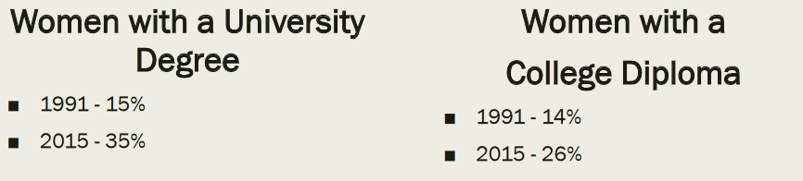
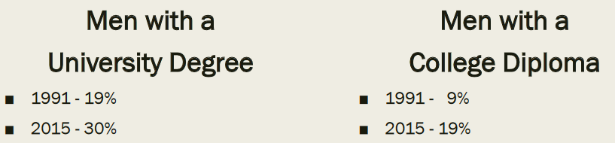

Employment and government
Precarious employment: employment that includes but not limited to part time, temporary, contract work with uncertain hours, low wages, limited to no benefits.
Glass ceiling: an invisible barrier. Prevents women and minorities from advancement in organizations.
Best and worst cities to be a woman in Canada: what are consequences of this disparity? How would you feel knowing that employees working next to you do same job but earn less money based on only being male or female?
Violence against women
Jackson katz: it’s a mens issue. Violence against women is issue for men that requires a paradigm shifting perspective.
Gender based violence: is a serious problem in Canada
Botyh police reported and self reported data indicate that women are more likely than men to exp violence such as intimate partner violence, spousal violence, sexuial violence.
Campaigns challenging violence against women and promoting gender equty. #beenrapedneverreported. Heforshe., walk a mile in her shoes., white ribbon campaign.
The -ness model: deconstructing the binary and continuum
A gender model that differentiates between: gender identity, gender expression, biological sex, sexual attraction, romantic attraction
Presents 2 spectrums for each concept ranging from O, null, nobody on one side to woman-ness/man-ness, femininity/masculinity, femaleness/maleness on the other.
Gender identity:
Cisgender: description of person whose gender id, gender expression, biological sex align
Transgender: blanket term used to describe anyone who does not identify as cisgender
Genderqueer: blanket term used to describe people whose gender falls outside of gender binary. A person who identifies both as man and women. Or as neither man nor woman. Often iused in exchange with transgender
Bigender: person who fluctuates between traditional gender based behaviors and identities. Identifies with both genders or sometimes a third gender
Genderfluid: describes identity that is a fluctuating mix of options available
Genderless: person who doesn’t idenityf with any gender

Gender expression:
Androgyny: a gender expression that has characteristics of both masc and fem
Agender: a person with no or very little connection to traditional systems of gender. Someone who sees themselves as existing without gender. Sometimes called gender neutral or genderless.
Gender nonconforming: refers to gender expression that indicates a non traditional gender presentation
Cross dressing: wearing clothes that conflicts with the traditional gender expression of your sex and gender identity
Drag king person who consciously performs traditional masculinity presenting an exaggerated form of masculine expression, often done by woman
Drag queen person who consciously performs traditional femininity presenting an exaggerate rom of feminine expression often done by man
Metrosexual a man with strong aesthetic sense who spends more time on appearance and grooming than is considered gender normative
Biological sex:
Intersex: a person whose physical anatomy doesn’t fit with traditional definitions of male or female. The number of people whose odies differ from standard def of male or female is approx. 1 in every 100 births.
This challenges the notion that sex is binary and aperson is either exclusively male or female. “nature doesn’t decide where the category of male ends and category of intersex begins or where category of intersex ends and category of females begins. Humans decide”
Transexual: person who psychologically identifies with sex/gender diff from one assigned at birth. Often wish to transform bodies with puberty suppression, hormone therapy, surgery to align their inner sense of sex/gender
Gender confirmation surgery: refer to group of surgical options that alter a persons biological sex. Also referred to as sex alignment surgery or sex reassignment surgery.

Ch5 sexuality
Sexuality: refers to all ways in which indivs exp and express themselves as sexual beings. Sexuality is socially constructed. We learn what is deemed appropriate and inappropriate through our culture and exp.
Sexual scripts: culturally made guidelines that define how one should behave as sexual being.
Cultural script: indicate appropriate sexual roles, norms, and behaviors in a given society. Largely conveyed through massmedia and other social institutions like govt law education family and religion.
Interpersonal scripts: made when indivs use the general guidelines they learned from cultural scripts and adapt them to specific social situations.
Intrapsychic scripts: ability to mentally rehearse outcomes before they occur. Are internal and can include fantasies memories and mental rehearsals of interpersonal scripts
Sexual identities
An all encompassing concept that can include how we view ourselves as sexual beings. Are not restricted to a coice between the two binary oppositions of heterosexual or homosexual. Nor do they have to fall somewhere on a continuum between these two dichotomies.
Sexual expression: ways we engage in sexual behaviors.
Sexual orientation: romantic emotional sexual attractions we exp.
Gay: someone who is emotionally and physically attracted to same sex
Lesbian: woman sexually attracted to woman
Term homosexual been placed on list of offensive terms. News agencies encouraged to restrict use of word altogether.
Heterosexuality: or straight. Being sexually attracted to opposite sex.
Heteronormativity: concept for compulsoryu heterosexuality.
Heterosexxism belief in natural superiority of heterosexuality as way of life. Its logical right to social dominance.
Homophobia.: irrational fear dislike hatred intolerance and ignorance toward and the marginalization of non heterosexuals. Reinforces belief in natural superiority of heterosexuality as way of life.
Bisexuality: person who is romantically and or sexually attracted to people of own and other gender
Asexuality: people who do not experience sexuial attraction to any group of people

Power of language
Language important aspect of culture. Words saturated with meaning and can hjold power over people
LGBTQQIP2SAA
Lesbian, gay, bisexual, transgender, questioning, queer, intersex, pansexual, twospirited, androgynous, and asexual. Sometimes a third A to represent allies
Intersectionality
Gender and sexuality: thesexual double standard: the belief that there are different rules and standards of sexual behavior for women and men.

Feb 26
Historically the concept of race was used to biologically categorize people based on physical characteristics including skin color.
Today: genetic science tells us this bio concept of race is a myth
Race: concept no longer recognized as valid. Previously referred to bio divisions between human beings based primarily on colo.
Racialized persons or communities: iundivs or groups of persons. Other than indig people. Subjected to differential and or unequal treatment based on their designation as a member of a particular race.
People of colour. Outdated term originally intended to be more poisiutive and inclusive of people than the terms nonwhite or visible minorities. Used to refer to those who experienced racism.
Visible minorities outdated term primarily used in Canada by statistics Canada. Referred to a category of persons who are non Caucasian in race or non white in colour and do not report being indigenous
Racism displayed as offensive jokes, emails hate crimes. Deeply rooted in prejudicial attitudes values and racialized stereotypes. Becomes embedded in systems and institutions over time.
Reverse discrimination: against whites. Ion the form of affirmative action, employment equity and diversity policies. The concept of reveerse discrimination is considered by many to be impossible because of existing power structures in society.
Concept of race as biological myth
Historically the concept of race meant
A biological division of humans. Based on physical attributes like skin color and other phys traits. These differences drew a colour line that has categorized people into four or five groups we all races.
Samuel Morton
American physician and scientist. During 1820s and 1830s. conducted a systematic analysis of hundreds of human skulls from all over the world. Intended to confirm his hypothesis that there were differences among races not only in terms of their origin. But also in terms of brain size.
Created hierarchy among different racial groups of their brain capacity based on skull measurements. Assigned the largest brain capacity to English Europeans. Assigned smallest brain capacity to africans Australian aborigines. Modern neuroscience refutes mortons findings.
Other race scientists
Josiah nott, George gladdon, louis Agassiz (mid to late 19th cent). Attempted to prove that blacks and whites not from same species.
Peter Sandiford attempted to prove that racial and ethnic diff in iq scores should be used by Canada as a selection criteria for new immigrants. The intention was to encourage the recruitment of British german and dutch who score well on iq tests and discourage recruitment of poles Italians greeks Asians who didn’t score as well. According to Sandiford Canada needed to protect itself from becoming a dumping ground for misfits and defectives.
Philippe Rushton
Canadian psychologist and prof at uo west Ontario. Suggested his evidence rpvoed whites are more intelligent than blacks. Proposed Asians are the smartest of all.
Racism is an ideology that either directly or indirectly assert that one group is superior to others. Has power to put ideology into practice. Gives advantages privilege and power to certain groups of people. Conversely, can disadvantage/lkimit opportunities of racialized indivs or racialized groups.
Forms of racism
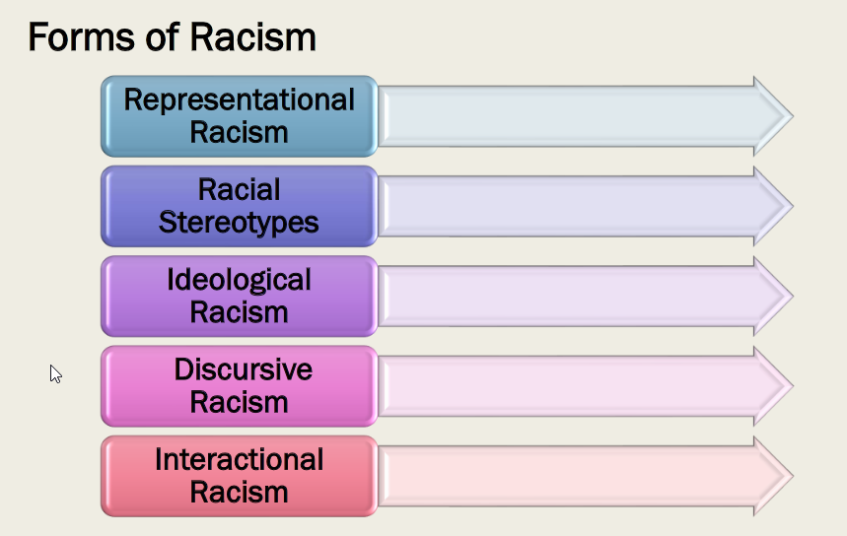

Racial stereotyping: using the concept of race or ethnicity to attach a generalized concept that all members of a group have a particular characteristic or ability
Representational racism: form of racism that uses imagery to depict racial stereotypes often in popular culture and media in a manner that reinforces perceived inferiority of racialized persons or groups
Ideological racism: a form of racism rooted in the ideas beliefs and worldviews that reflect reinforce and advance notions of racial superiority and inferiority
Discursive racism: a form of racism that is expressed through written and spoken communication (discourse) it manifests in racial slurs and hate speech and in words with racial meaning embedded in them.
Interactional racism: a form of racism that is expressed through social interacton with other people, more specifically how those with privilege interact with those oppressed
What is racism
Racism = prejudice + discrimination + power
How can we understand social construction o f race as a method to maintain specific power relations in society?
Which form of racism is most commonly discussed in the public sphere?

How racism operates
Indiv racism: individual discriminatory attitudes or behavior. Motivated by negative evaluation of a person or group of people using a socially constructed concept of race
Overt racism: direct open often public. Like hate crimes/racial slurs.
Everyday racism. Operates at indiv level. Occurs in evderyday social interaction with people, often subtle.
Institutional racism: behavior, policies, practices that disadvantage racialized persons, can be intentional or unintentional
Societal racism: a framework for those concepts, ideas, images, and institutions that we use to interpret and give meaning to racialized thought.
White privilege and forms of its denial
Cultural racism includes both indiv and systemic forms of racism
Employment equity requirement under employment equity actof Canada that eompoyers use proactive employment measures to increase representation of four designated groups: women, people with disabilities, indigenous, and racilized communities in workplace.
Inclusive language a policy or practice that uses language that includes and reflects the diversity of communities in an accurate and respectful way
Racial profiling any action undertaken for reasons of safety security or public protection that relies on stereotypes to treat a person differently. Most relevant inpolicing practices but not limited to context of crim justice.
Racial harassment pattern of behavioral conduct that isolates humiliates or intimidates racialized indivs
Language related discrimination discrim that is based on persons accent or some manner of speech

Explaining the inequality of exclusions: ethnicity versus critical race models fleras 2017

Ethnicity (blame indiv) model: according to the functionalist perspective, a lack of expertise or credentials or adjustments accounts for the failure of migrants and minorities to penetrate the market. Ethnocultural deficits are no less a deterrent to minority success. Becoming modern matters: migants and minorities had to discard their unmodern attachments and assimilate by embracing modernist values.

The critical race (blame the system) model
Race is rigged: racial minorities are at a structural disadvantage. New racialized discourses focus on institutional inclusion, removal of racism and discriminatory barriers at structural levels, and eradication of a normative whiteness that underpins systemic white supremacy.
A blame the system approach to the inequalities of exclusions is consistent with the dynamics of a racialized model.
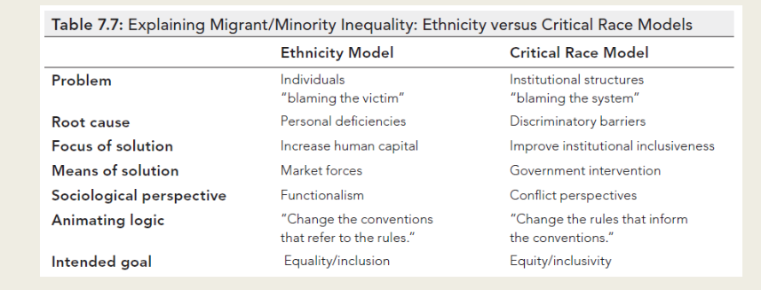

March 5
Indigenous Peoples
Language.
Using right words
Using the right word in right context is important. Terminology may not have been chosen by the groups involved. For example status ad nonstatus Indians are the legally defined terms under the Indian act.
Indian act: assimilatory Canadian federal legislation, passed in 1876 and subsequently amended
Assimilation
A long standing govt policy. Based on premise that indigen peoples would give up their own culture languages and beliefs. Live like British settlers/Canadian citizens
Indian act:
Canadian federal legislation. Passed in 1876 and subsequently amended. Details certain federal govt obbligations. Regulates the management of reserve lands, money, and other resources. It was initiated to compel assimilation in can society
Indigenous
The descendants of groups of people living in the territory at the time when other groups of diff cultures or ethnic origin arrived there
Aboriginal peoples
A legal/administrative category that comprises first nations, inuit, metis. Is often used to describe the indigenous peoples within Canadas boundaries.
first nations
a legal term used to refer to those aboriginal people who are neither inuit nor metis
first nations refers to the ethnicity. Band may be a grouping of indivs within that ethnicity.
Inuit
The aboriginal peoples who live in the far north or artic regions of Canada
Metis
People indigenous to north America whose background is aboriginal and euro ancestry
Role of storytelling in aboriginal communities
Stories filled with spirits animals and seas creatures and deeply based in spirituality
Holistic view of human and natural life emphasized the interconnectedness. Is seen in many elements of indig society
Knowledge system and oral history
Medicine wheel and totem pole, ceremonies and rituals contribute to a rich oral history
This is part of the indigenous peoples shared philosophy and way of understanading how life exists
This knowledge system was legitimized by the supreme court of Canada where oral history was considered legal evidence

Treaties
A formal agreement between two parties that has been negotiated concluded and ratified.
The indig poeoples fiurst contacts with euro were mainly through the participation and partnerships in fisheries and fur trade
First nations treaties are classified into 3 major groups
Preconfederation treaties
Numbered treaties
Land claims
Royal proclamation of 1763 and pre confederation treaties
Peace and friendship treaties
Occurred when French and britihs were vying for control of land in NA
Each country formed an alliance with various first nations
Royal proclomaton: remains in effect today and often referred to as magna carta of Indian rights. Paved way for process that would allow only the crown to purchase aboriginal land
Under these treaties aboriginal people receive: reserves of land, annual or other payments, and hunting and fishing rights
The crown became wealthy from deals.
Numbered treaties
Cede: surrender or forfeit possession of something usually by treaty
Monopoly: situation where someonehas exclusive control over goods or services. Allowos them to set any price
1-11 treaties made between 1871 and 1921
Govt wanted to obtain land and resources to build railroad and make land for settlers. First nations and metis promised reseve lands, hunting and fishing rights, money, annual payments, help with medical care and education. As traditional food supplies became scarce first nations peoples relied on govt food rations
Canada at time of confederations in 1867
By the time nova scotia, new Brunswick, Ontario, quebbec form the dominion of Canada, the robinson treaties, the upper Canada land surrenders, and the peace and friendship treaties already in place.

Issues with numbered treaties
Industrialization of the incoming railway brought immigrants with euro diseases. In addition to language problem,, research shows many promises made were never written into documents. Treaties signed by those who couldn’t read. Many indig nations left out.
Treaty 11: last numbered
Covers most of Mackenzie district. The land in the area deemed unsuitable for agriculture. The federal government was reluctant to conclude treaties. Immediately following discovery of oil at fort norman in 1920, govt moved to begin treaty negotiations.
Land claims
Two types of claims today: comprehensive claims, specific claims,
Since 1974 the fed govt has paid compensation over 2.6b to settle 343 specific claims. Hundreds of other claims still outstanding. Comprehensive claims take avg of 15y to settle.
Case of Dudley George
In 1995 dudley was killed by police in a land claims dispute. During ww2 the govt expropriated land (a burial grond) from stoney point first nation for a military camp
They agreed camp Ipperwash would be returned to the stoney point people but never way. The govt compensated the band for use of land but multiple attempts to return land failed. On sept 4 1995 unarmed stoney point protestors moved into camp Ipperwash. 30 ppl planned peaceful demonstration to occupy land. Ontario premier mike harris insisted they be removed from land. Ontario provincial police opp attempted to forcefully remove protesters by nighttime raid. Unarmed Dudley George shot by opp officer. In 2010 the Ontario govt passed legislation to relinquish control. Actual transfer years away.
Comprehensive claim
Modern day treaties to resolve claims of aboriginal land rightsnot yet delath with by past treaties or through other legal means
Specific claim
Process to deal with past grievances mainly of first natiosn related to unfairly distributed treaty lands or mismanagement of first nations funds by crown
Aboriginal identity
Until about 1850 virtually all dealings between aboriginal and nono abor peoples were connected toland issues. 1950: two acts gazve all responsibility for leasing and collecting rent to the commission of Indian land. It was the first attempt at defining who was Indian and the rights and responsibilities of that status
1869: act developed the first system of aboriginal self govt. elected band councils that remain n effect today. Granted government officials total control over status of Indians. Eg stripped abo women of their legal status if they married non aboriginal men. This formed basis for Indian act 1876
Enfranchisement
Process where an indiv gets the right to vote or become citizen
Indian act 1876
Indian act gave the fed govt responsibility for indig ppls. Lumped all indigen peoples into one group. Disregarded cultural diff between bands. Made them wards of the government effectively forming a parent chilkd relationship.
Status of Indians:
Indian act defined people according to an assigned status.
Status Indians: those indivs who are registered under the Indian act on the Indian register. Entitlted to certain rights and benefits under law.
Non status Indians
Those who consider themselves to be aboriginal or first nations. Were not recogfnized by govt of Canada as Indians under Indian act because they cant prove their status or bc they lost it. Do not share same rights and privileges as status Indians
Treaty Indian
Status Indian who belongs to a first nations that signed a treaty with crown.
Discrim under Indian act
Indian act did not apply to inuit or metis. Other discriminatory inclusions/amendments are until 1960: status Indians not allowed to vote.
1884: prohibited from buying arms or alcohol. 1920: attendance at residential schools for first natons children mandatory. first nations religious ceremonies made illegal. The banning of potlatches and the sundances interfered with aboriginal traditions.
1914-1950: abor ppl were required to get official permission before appearing in public in traditional clothing
1927 band members forbidden from pursuing land claim violations using band funds. Effectively made legal changes to treaty violations impossible.
1930: first nations ppl were banned from pool halls
1951-1985: status was stripped from abor women who married non status men. Non abor women could acquire status by marrying a man who had status.
Residential schools
As part of govt objective to civilize indig ppl govt created resid schools. Removing child from family while untrained would allow them to learn values of new culture.
1883: residential schools built with churches assistance in every province except new brunsiwck, pei, newfoundland
1920: mandatory attendance at resi schools. Children had to attend until 18 but could not attain higher than grade 8 edu
Religious studies took most of morning and chores took most of afternoon. Goal to assimilate intioi mainstream society. Boys taught farm work shoe making or other manual/skilled trades
Girls taught sewing bread baking and hosehold tasks.
Schools managed by churches finanzaced by govt and followed common guidelines.
Guidelines: forbidden to speak native language and punished if caught. Boys girls segregated esp bro/sis. Required to cut their hair eat euro food wear school uniforms. Learned euro sports like soccer/cricket. Forced to celebrate Christian holidays.
Consequences from the residential schools include loss of language and erosion of family values, traditions, and parenting skills.The most negative effects resulted from the physical and sexual abuse. These abuses contributed to the “dysfunction” of Aboriginal families and their communities today
Children grew up w/out proper socialization or parenting skills without belief that they were people of value
Govyt started closing schools in late 1950s. last one closed in 1996. 2008 stephen harper formally apologized to the former students.
60s scoop
Thousands of children scooped form their homes and put up for adoption. Often without consent of their families and bands. Records show that btwn 1960 and 1990, 11132 status Indian children adopted, 70% to non abor fam
the white paper.
In 1969 prime min pierre Trudeau and then minister of inddina affairs jean chretien set about to right wrongs of Indian act. By dismantling it and doing away with notion of status as it pertained to abor ppl.
Provoked wide and organized public outcry from various abor groups and was withdrawn in 1971
Dismantling Indian act would in essence rescind any legal protections helping to define who abor ppl were in law and policy.
Indigenous social movements
Indian act 1876 – present
Several interations through the initial enforcement restricted mobilization organization and travel; and replaced with traditional indigenous governance with Indian act band council
Made traditional everyday activites an act of political protest (such as dancing prayers smoking pipe)
1951: resitrctions onpolitical activity removed
Played significant role in dividing the indig community into status and non status Indians or btwn federally recognized Indians and those indig peoples recognized only as Canadians.
1969 white paper
A federal policy brief proposing the elimination of Indian status and the assimilation of abor pop into dominant can society
The impact of the policy would have far reaching effects among various abor ppl and provided a common collective action frame aligning goals and grievances
The mobilization against white paper was successful and led to a core funding program for abor groups at the federal level and due to the newly available resources there was a shift in focus from local organizing to national level politics. New funding also created new issues as guidelines and restrictions on funding were instituted
Constitution act of 1982
Patriation process created an opportunity for extending and recognizing abor rights and for all groups this would be a significant opportunity. The process raises the bystander publics consciousness of girevances and thus allowed for an extension of aboriginal collective action frames and the opportunity for an alignment of much of the dominant pop with their concerns while some gains were achieved the results were not ideal and led to further divisions among groups and the end of the decade brought cuts to funding and failure to gain more specific recognition of abor in post constitutional conferences.
Dynamics of movement organizations
New focus on interacting with judicial and bureaucratic institutions rather than local comm and the bystander public
Bureaucratisation in a post constitution world
Increased bureau of rights organizations embedded in govt institutions
Assembly of first nations AFN, often entered into relationships and agreements relating to program admin and policy discussions..taxation, membership registries and land management
Native council of Canada NCC, held the responsibility for engaging in consultations that led to the first nations governance act
Strong critiques of both organizations for working so closely with the govt of Canada and ignoring grassroots efforts.
Everyday life as contestation of the colonial condition
Why has the indigenous mvt been so extensive and capable of coming together when necessary?
Kiera ladner argues that the various social actors: “...perceive themselves as being in a constant battle with the government over their rights to live as Indigenous peoples in their homelands; to govern themselves; to exercise those rights and responsibilities accorded to them as nations; and to better their economic, social, and political conditions”
Theoretical framework
Ladner takes on a distinctly anti colonial perspective and utilizes indigenist theory and methodology that use story telling or narration to crete an awareness of the mvt and an understanding of the issues goals aspirations and tensions that define it.
Framing the conflict
“Discontent and episodes of mobilization focused on the primary concerns of each nation, such as territorial intrusions, territory-sharing arrangements, maintaining sacred relationships with a nation’s territory (especially occupied territory), religious and spiritual freedom, sovereignty, self-determination, economic independence, economic assistance (such as farming), health care, treaties, trade networks, and international relations (with both Indigenous and colonial nations)”
The historical context is central to aldners argument around the role of colonialism on the forms and dynamics of the mvt
Understanding the movt
While all facets of the Indigenous movement agree on the goals of good governance, sovereignty, resource/economic rights, social well-being (education, child welfare, and living conditions), and self-determination, their framing of these goals is predicated on and defined by considerations of nationhood and (de)colonization”
“At the end of the day, the dog with the rope around its neck will still want to deal with the issue of the rope, no matter how many cookies it is thrown”
Thus leading us to current mobilizations and struggles for participation
Framing aboriginal inequality: assimilationism, autonomism, accomodationism
Abor ppl constitute what George manuel called fourth world peoples (original inhabitants) who now live as second class citizens, often under third world conditions in what many see as a first class country
Three ideal typical governance models proposed:
Assimilationism: too much autonomy, not enough modernization
Autonomism: too much modernization, not enough autonomy
Accommodationism: too much of both not enough of either
Assimilationist governance model: living together similarly
Assumption that abor ppl must modernize if they hope to achieve equality.
Driving by afunctionalist paradigm. The existing political/economic/social/cultural system is sound and worthwhile. Refusal of abor peoples to join and participate is both counterintuitive and counterproductive.
According to assimilationists, true equality arises from treating everyone the same, regardless of race or ethnicity or aboriginality.

For assimilationists the solution involves their incorporation (absorption) into Canadian society via the following strategies:
1.Eliminate the collectivist mindset and underpins these special provisions and preferential status.
2.Wean Aboriginal peoples away from those “artificially preserved” cultural values and residential patterns that no longer resonate with relevance in a twenty-first-century society.
3.Expose Aboriginal peoples to the discipline of the market.
4.Foster Aboriginal self-sufficiency by incorporating Aboriginal peoples into the economy.

Mar 12
Housing insecurity
Housing and social determinants of health
Rent geared to income: less than 30%
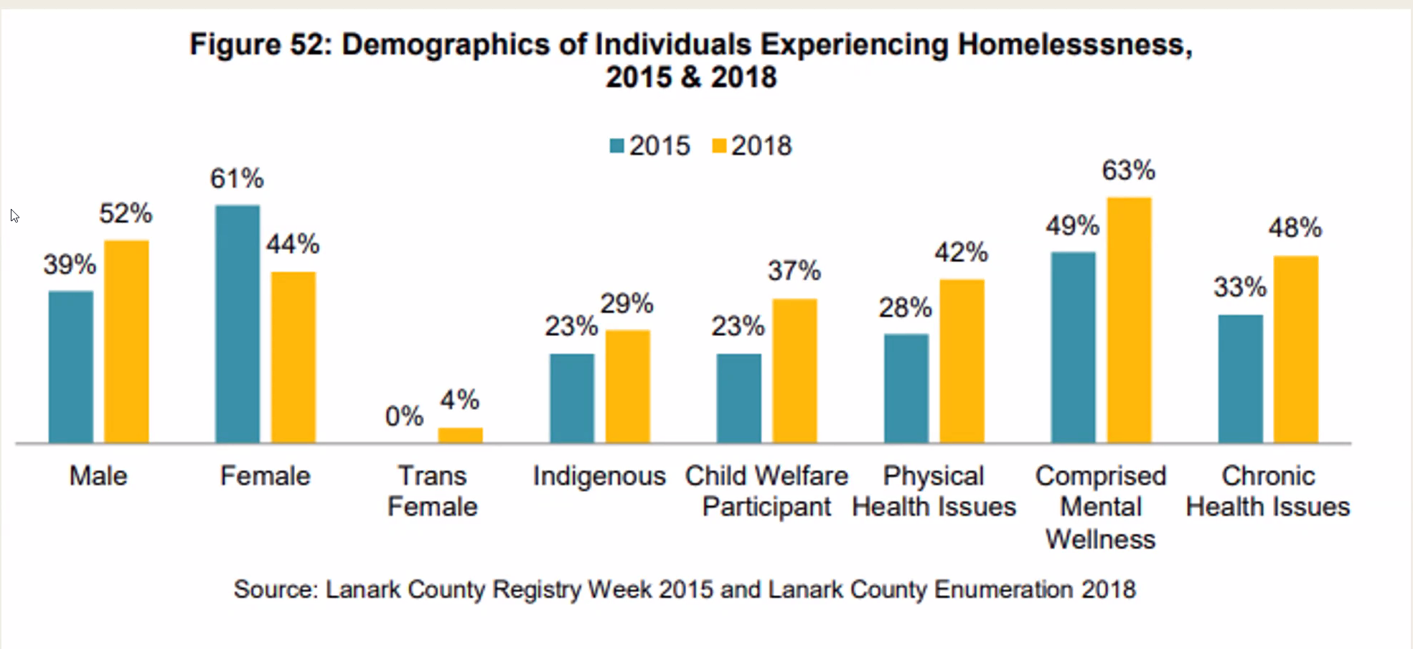
Why are people homeless?
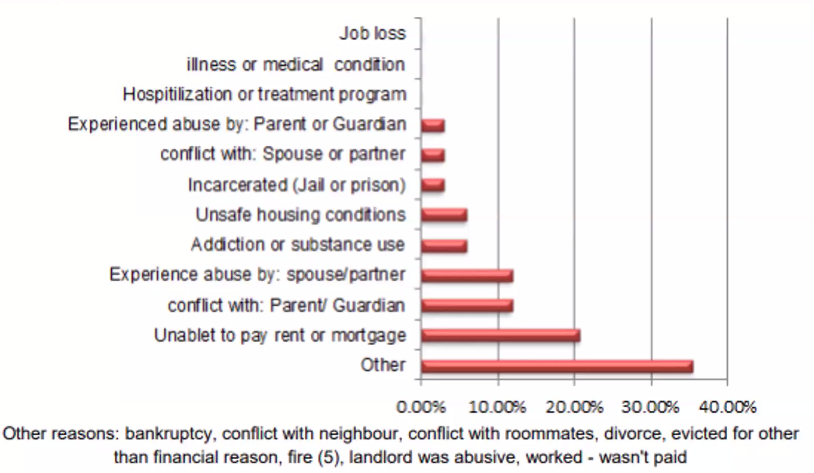

Waiting for affordable housing:
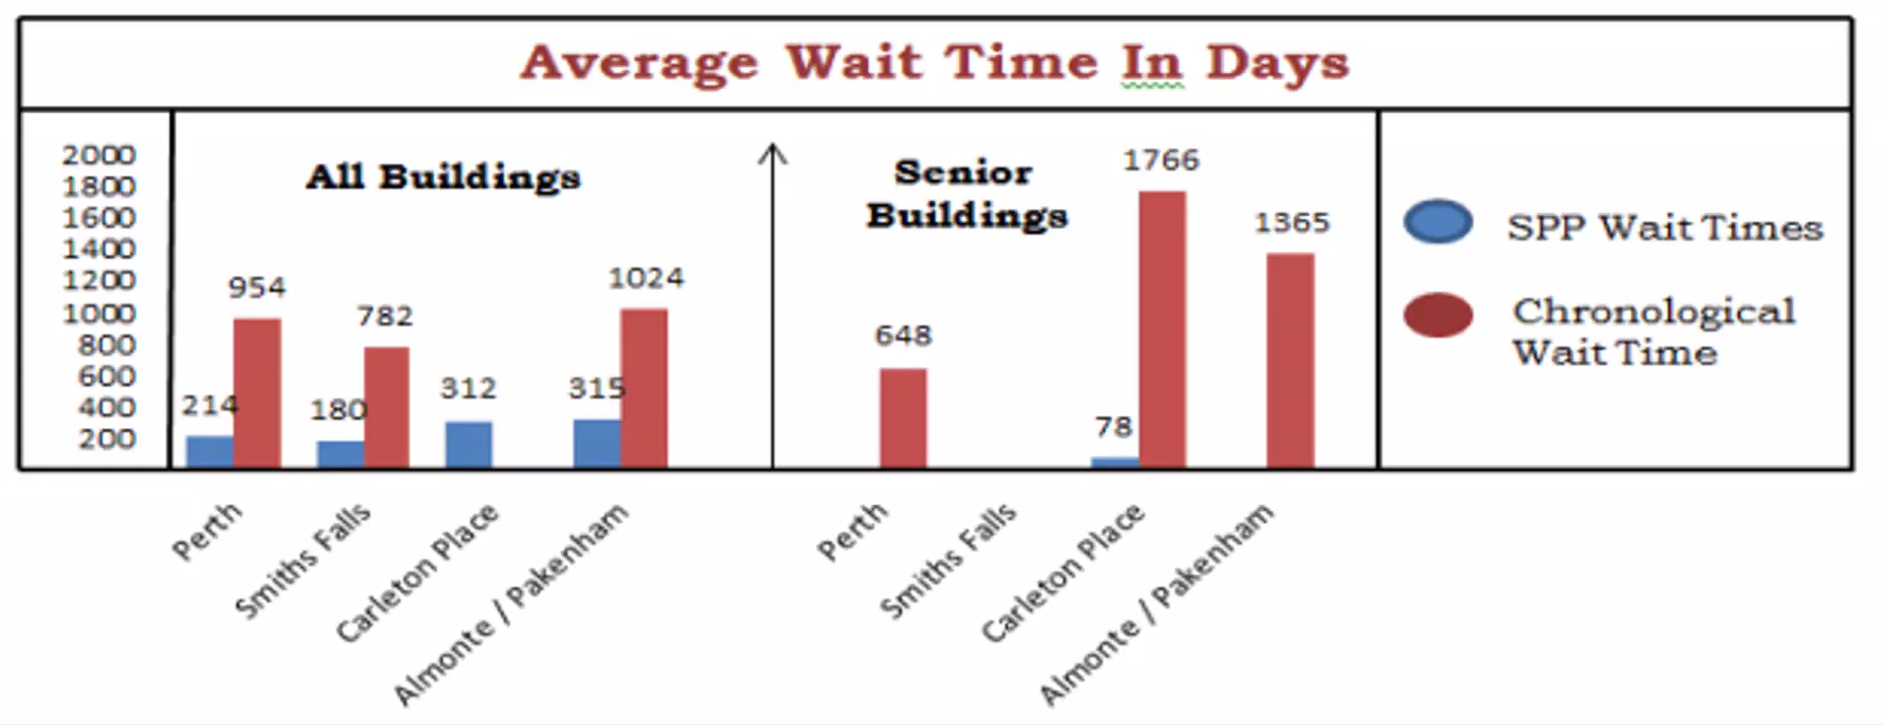

Housing first strategy
First step is to get people into housing
Overall evidence of success when fully implemented – esp when effective supports come in place soon after
Whats missing? Potential of missing core causes of omelessness
Systemic change to end homelessness?
After 2 decades of research, policy and program dev and social responses to the problem of homelessness, we are not much further ahead than we were when homelessness was declared a national disaster in 1998
Beyond stop gap mneasures for resolving homelessness – what does peressinin suggest for solving the housing crisis?

Disability Perspectives
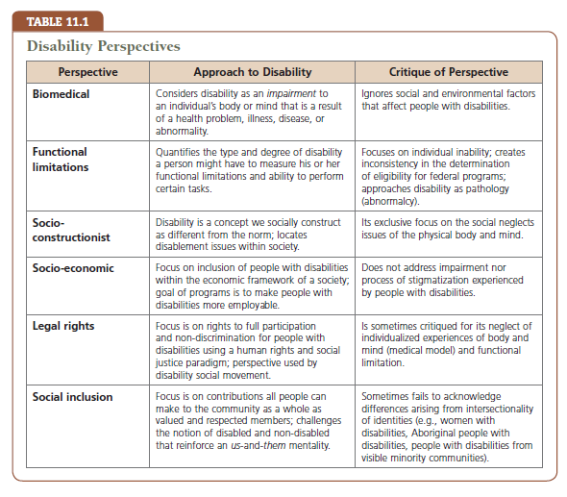
Mar 19
Disability: universal human exp that anyone can exp at any time. Disabilities can limit ability to engage in daily activities, disabilities can be visible or not, temporary, permanent
WHO: united nations authority on health issues
Disability binarism
Mode of thought that classifies people as either able or not
Invisible disability disability that’s not apparent to others
Visible disability: disability that’s apparent by looking at them
People first: inclusive language
Institutionalized: placed in or confined to a residential institution
Compulsory sterilization: govt program forcing or coercing sterilization of persons so they cant have children. Often part of eugenic poprogram to prevent reproduction of members who are deemed undersirable
Deinstitutionalization: social movement that contiunues to reverse the institutionalization of persons with mental illness and intellectual disabilities that began in late 19th and early 19th cent in Canada. Involves process of removing residents from long term institutions to integrated community based settings
Veterans with disabilities
Aftermath of ww1: veterans returned with vision/hearing loss, movility challenges, mental health issues as consequences of war. Change began in social and political context for persons with disabilities
Disability became policy issue in Canada
1918: war amps founded. Canadian national institute for blind incorporated
Aftermath of World War II–Disparities in services and supports between veterans and civilians with disabilities
Began to work as allies to ensure equity for all persons with disabilities–New assistive technologies were developed
The first electric wheelchair to assist war veterans invented by Canadian George Klein
Deinstitutionalization and the Anti-Psychiatry Movement
Anti-Psychiatry –A term coined by David Cooper in 1967–Reflective of a movement that was critical of and opposed to many forms of psychiatric treatment–Concerned about the unequal power relationship between psychiatrist and patient, and the highly subjective process for diagnostic labelling
By the 1960s–The anti-psychiatry movement focused on the use of psychiatry as a means of controlling and pathologizing social deviance
Erving Goffman and Michel Foucault–Critiqued the use of power within psychiatry and its effects on the labelling and stigmatization of persons with mental health issues
Disability Human Rights Paradigm
■1970s –The disability social movement arose as a human rights-based response to discrimination
■The Canadian Human Rights Act (1977)–Guarantees protection from discrimination based on disability
■The Canadian Charter of Rights and Freedoms (1982) –Guarantees a constitutional right to equal treatment and equal protection against discrimination
Entering the 21st Century
■United Nations Convention on the Rights of Persons with Disabilities (CRPD): A human rights instrument adopted by the United Nations in 2006 for the purpose of protecting the human rights and dignity of persons with disabilities; signatories are required to ensure that people with disabilities are equal under the law.
Type of Disability and Poverty Rates
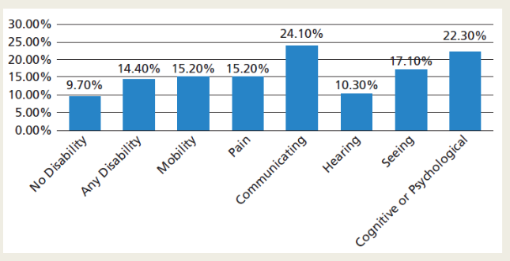
Grounds of Discrimination Complaints Received by Canadian Human Rights Commission 2015
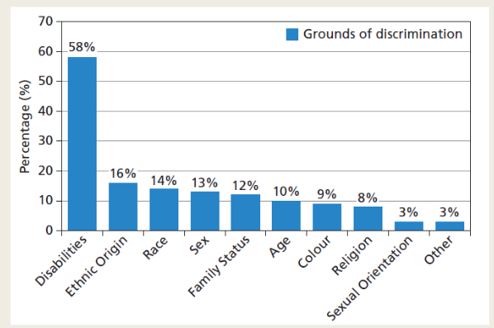
10 Facts and Figures about Having a Disability in Canada
1.One in seven Canadians lives with a disability
2.Half live with severe disabilities
3.Pain most common type of disability in Canadian adults
4.Age matters when it comes to disabilities
5.Family members are primary caregivers for persons with disabilities
6.More help needed with daily living activities
7.Less likely to graduate
8.More people with disabilities are unemployed and underemployed
9.Many companies are not hiring people with disabilities
10.Workers with disabilities meet employer expectations
The Context of Disability within Our Social Environment
■Accessibility–The degree to which a product, device, service, or environment is available to as many people as possible
■Barriers –Policies or practices that prevent full and equal participation in society; barriers can be physical, social, attitudinal, organizational, technological, or informational
At a citizen’s forum, barriers to social inclusion and full participation in civic life were identified:
■Experiences of the body, including fear of ridicule over unpredictable body movements and behaviours, variation in physical strength and energy, and personal care needs.
■Access to physical space, including both the accessibility of the space itself and how people move within that space in terms of the amount of space, placement of items, transportation, and types of devices available for mobility.
■Access to time needed for daily routine, equipment use, and full participation when physical or cognitive issues require this.
■Access to information, such as the technological adaptations people need to listen and communicate.
■Access to social networking opportunities, which include being able to make social connections, having a sense of belonging to the community, feeling valued for one’s contributions, feeling a sense of interdependence and reciprocity with other citizens, and experiencing a people-first approach (Hoyle, 2004)
Universal Design
■Seven basic principles of universal design of physical spaces
■1. Equitable use. The design is useful and marketable to any group of users.
■2. Flexibility in use. The design accommodates a wide range of individual preferences and abilities.
■3. Simple and intuitive use. Use of the design is easy to understand, regardless of the user’s experience, knowledge, language skill, or current concentration levels.
■4. Perceptible information. The design communicates necessary information effectively to the user regardless of ambient conditions or the user’s sensory abilities.
■5. Tolerance of error. The design minimizes hazards and adverse consequences of accidental or unintended actions.
■6. Low physical effort. The design can be used effectively and comfortably and with a minimum of fatigue.
■7. Size and space for approach and use. Appropriate size and space is provided for approach, reach, manipulation, and use, regardless of user’s body size, posture, or mobility. (Connell et al., 1997)
Universal Design and Postsecondary Education
■The focus of accessible education is to create sustainable access based on the following 4 principles–
Dignity for students, by maintaining privacy and not singling them out –
Equitable opportunities and advantages for all students for learning, not just for information
Independence for students, so they can complete learning tasks without specialized help
Integration, so that each student is able to benefit from the same learning experiences
Universal design for learning guidelines (textbook search)

Mental health and stigma
One in five Canadians experiences a mental health problem
■Most Canadians can expect to be affected by mental health issues directly or indirectly
■Yet despite these facts–Stigmatization of and discrimination against persons with mental health issues is widespread
In 2015 –One quarter of all human rights complaints received by the Canadian Human Rights Commission were related to discrimination based on mental health
■“Reducing stigma requires a change in behaviours and attitudes towards acceptance, respect and equitable treatment of people with mental health problems and mental illnesses”

Mar 26
Paulo Freire
Brazilian adult eductor and philosopher
Work draws on marx garmsci and fanon
Developed theories to support literacy efforts in brazil which were ended due to 1964 brazilian coup d’etat resulting in freires imprisonment and exile
Education as an act of depositing
Fundamentally narrative- involves a narrating subject (teacher) and patient, listening objects (students)
Words are emptied of their concreteness and become a hollow, alienated, and alienated verbosity
Narration…turns students into containers, into receptacles to be filled by teacher. More completely she fills receptacles, the better a teacher she is. The more meekly the receptacles permit themselves to be filled the better student they are
Function of banking method
Production of adaptability – the more students work at storing deposits entrusted to them, less they develop the critical consciousness which would result from their intervention in the world as transformers of that world
Subject/object relationship in education and our examination of the world
The educators role is to regulate the way the world neters into the students – and since people receive the world as passive entities, education should make them more passive still, and adapt them to the world – well suited to the purposes of oppressors, whose tranquility rests on how well people fit the world the oppressors have created, and how little they question it
Adapting to oppression?
Education as the exercise of domination stimulates the credulity of students, with the ideological intent (often not perceived by educators) of indoctrinating them to adapt to the world of oppression
How can we pursue authentic liberation if the banking method used in education is our primary method for schooling?
Towards authentic liberation
Authentic liberation- the process of humanization is not tanother deposit to be made in men. Liberation is a praxis: the action and reflection of men and women upon their world in order to transform it. Those truly committed to the cause of liberation can accept neither the mechanistic concept of consciousness as an empty vessel to be filled, nor the use of banking methods of domination (propaganda slogans- deposits) in the name of liberation
Thus Freire argues that dialogue is a key process: dialogue with the people is neither a concession nor a gift, much less a tactic to be used for domination. Dialogue as the encounter among men to name the world, is a fundamental precondition for their true humanization

Problem posing education
Responding to the essence of consciousness-intentionality- rejects communiques and embodies communication
Breaks with the vertical patterns characteristic of banking education through dialogue, the teachers of the studentsand the students of the teacher cease to exist and a new term emerges: teacher student with students-teacher
People develop their power to perceive critically the way they exist in the world with which and in which they find themselves; they come to see the world not as a static reality, but aas a reality in process, in transformation
Process of humanization
Problem posing education affirms men and women as beings in the process of becoming – as unfinished, uncompleted beings in and with a likewise unfinished reality
Whereas the banking method directly or indirectly reinforces mens fatalistic perception of their situation, the problem posing method presents this very situation to them as a problem
The pursuit of full humanity, however, cannot be carried out in isolation or individualism, but only in fellowship and solidarity; therefore it cannot unfold in the antagonistic relations between oppressors and oppressed
Ivan Illich
Deschooling society
Beyond the school ivan Illich argues that the institutionalization of value sleads inevitably to physical pollution, social polarization and psychological impotence: three dimensions in a process of global degradation and modernized misery
Critical of continued funding for schooling as a solution for social inequality- instead proposes emphasis on learning outside of schooling
Learned needs/wants
Paradoxically, then, high aggregate consumption resulting from engineered needs fosters groweing consumer indifference to specific, potentially felt wants. Increasingly, needs are created by the advertising slogan, purchasing made by prescritpiton. Ones action is not the result of personal experience in satisfaction, and the ensuing adaptive consumer substitutes learned for felt needs. As people become experts in the art of learning to need, learning to identify wants from exp becomes a rare competence
Dialectics and praxis
Social movements also produce knowledges through praxis…practices that elucidate the ongoing dialectical relationship between action and reflection, which is an essential dimension of forging a self conscious and effective social movement politics
Within the word we find two dimensions reflection and action in such radical interaction that if one is sacrificed, even in part, the other immediately suffers. There is no true word that is not at the same time a praxis. Thus to speak a true word is to transform the world.

Apr 13
Explanatory frameworks, sociological models

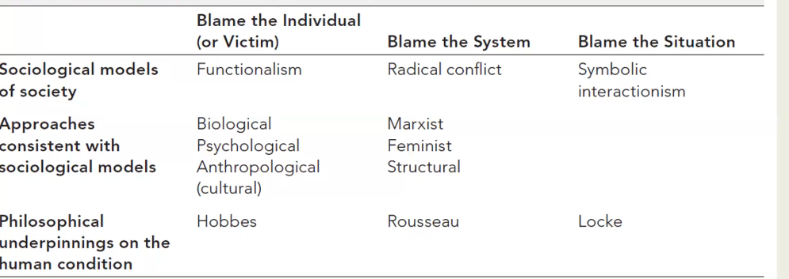
Blame the individual/victim model
Iditenfies individual failure as a prime cause of social inequality
Poor are to blame for poverty: psychological dispositions, cultural deprivation, faulty socialization, moral shortcomings, circumstances of their own making
Functionalism
Inequality is integral to a complex and productive society
All societies must devise a method for motivating their best individuals to occupy the most important and difficult positions
Functionalists interpret inequalities as normal and necessary

Functionalist friendly approaches:
Biology: certain individuals are better adapted for success in the competitive struggle for survival
Psychology: origin of inequality taps into the human psyche. Inequality is an instinctual adaptation to the challenges of survival
Anthropology/culture: cultural lifestyles of the poor at odds with competitive and consumeristic lifestyle. Poverty elicits a cultural response to marginal conditions

Blame the system model:
This mode holds society accountable for social inequality
Problems of social inequality are situated within the institutional structures and ideological arrangements
Institutions criticized for discriminatory barriers and systemic bias
System is slanted in favour of the rich and powerful groups
Three versions of radical conflict: Marxist feminist and structuralist
Radical conflict: Marxism
Inequality is embedded within the capitalist framework of private property
The market economy has contributed to inequality through barriers such as segmented labour, racial divisions, dual labour markets, and systemic structures of discrimination
Feminism
Society is perceived as a patriarchal site of domination
Institutions, agendas and values are designed to reflect reinforce and advance male interests and priorities
Structuralism
Inequities of power wealth and status are anchored in institutional structures of society
Structural inequality is rooted in the very foundations of society

Blame the situation model
Neither the individual nor the system are entirely to blame
Acknowledges interplay of agency with structure, context, power
Grounded in principles of symbolic interactionism
According to symbolic interactionists:
Social reality and intergroup dynamics are central inequalities of exclusion are brought into existence through meaningful interaction and interpretive practices to make sense of the world


