Assignment #1
21F_CST8390_450 - BI AND DATA ANALYTICS

“All material prepared for this assignment was produced by the authors, and material from a third parties, including the Internet has been cited and referenced.”

Table of Contents
Microsoft Excel 3
Screen shot of the first few rows of the table 3
Descriptive Statistics dialogue box 4
Screen shot of the descriptive statistics that Excel generates 5
Weka: Glass Dataset 6
Classify Dataset 6
J48 6
Screen shot of the confusion matrix 7
Naïve Bayes (NB) 8
Preprocess the Dataset 9
Replace missing values 10
Remove duplicates 10
Attribute Filter 11
Classify the Cleansed Dataset 11
J48 11
Naïve Bayes (NB) 12
Observations 13
Wheat Seeds Dataset 15
Screen shot that of text file 15
Preprocess the Dataset 15
Classify the Cleansed Dataset 16
J48 with 10 fold cross-validation 16
Visualize the Dataset 18
Screen shot of the decision tree. 18
Screen shot of the visualize panel 19
Observations 20

Microsoft Excel
Download data and generate descriptive statistics from the page located at https://pbr.com/statistics/bull/.
Screen shot of the first few rows of the table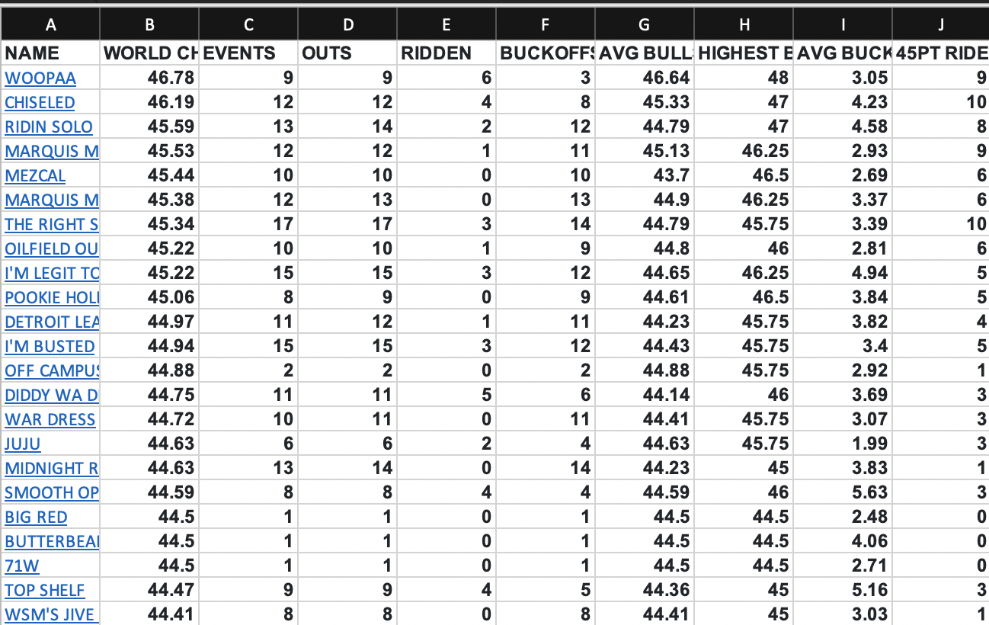

Descriptive Statistics dialogue box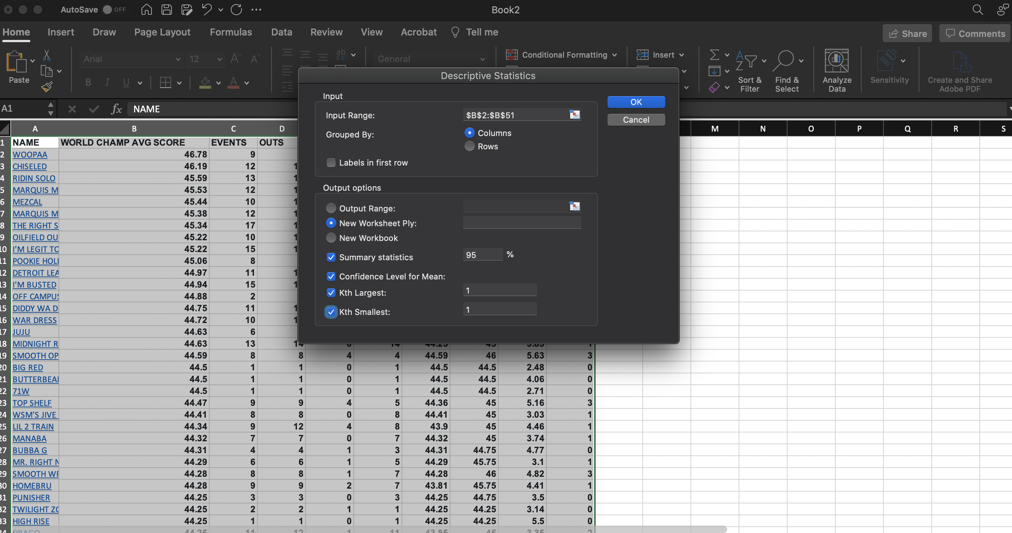
Screen shot of the descriptive statistics that Excel generates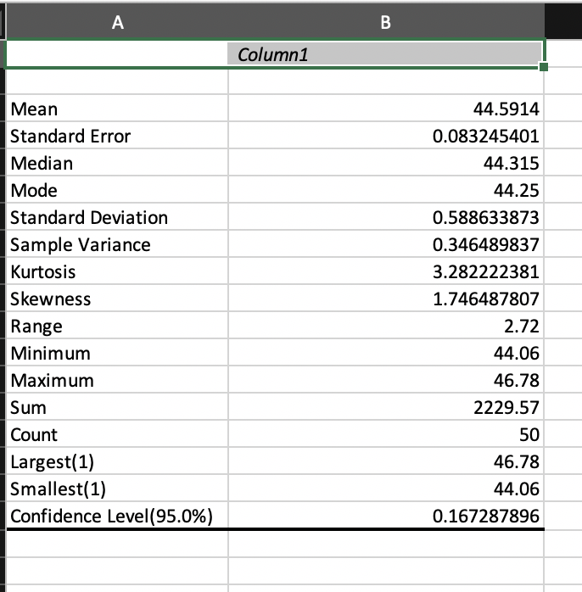

Weka: Glass Dataset

Classify Dataset

J48

Percentage of Correctly Classified Instances
The percentage is 96.2617%

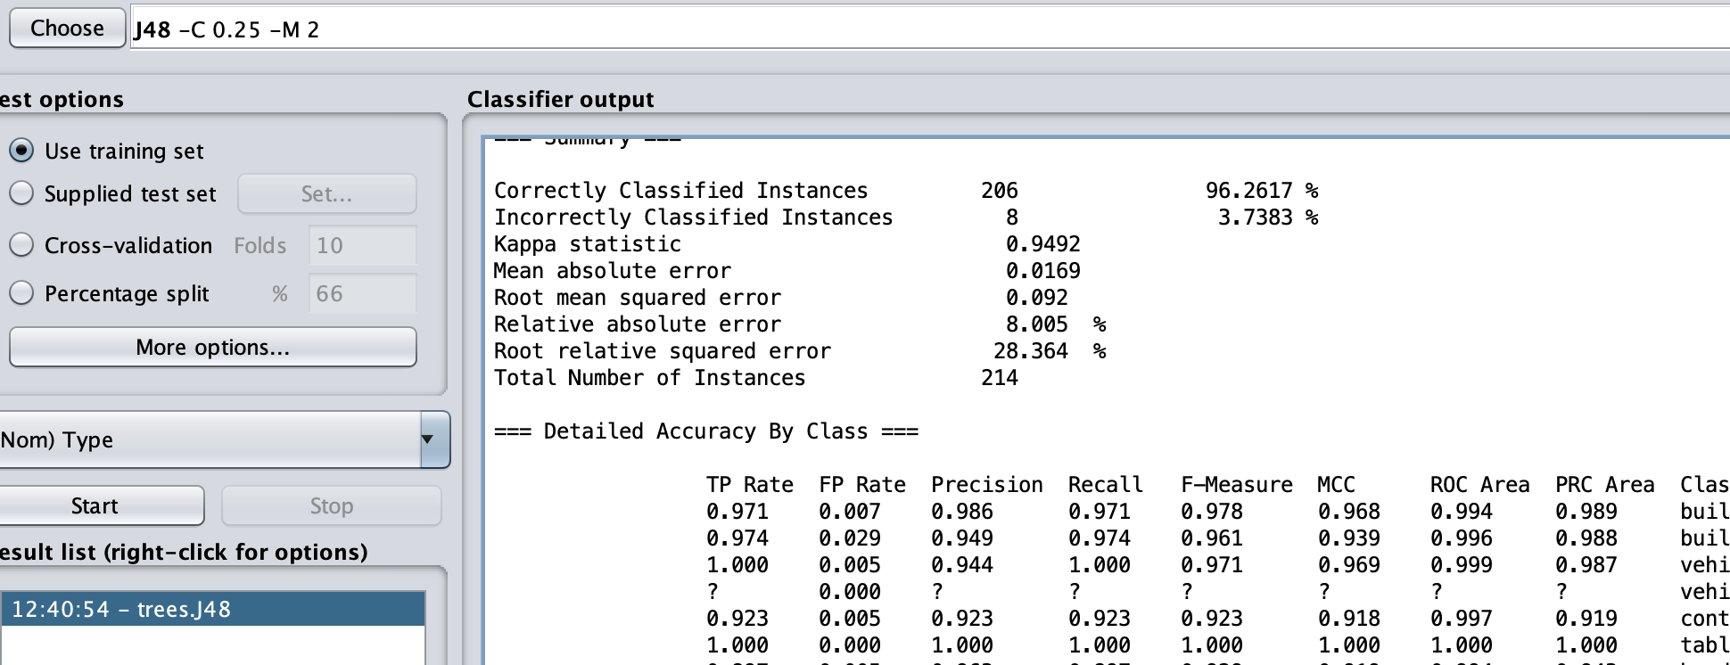

Screen shot of the confusion matrix
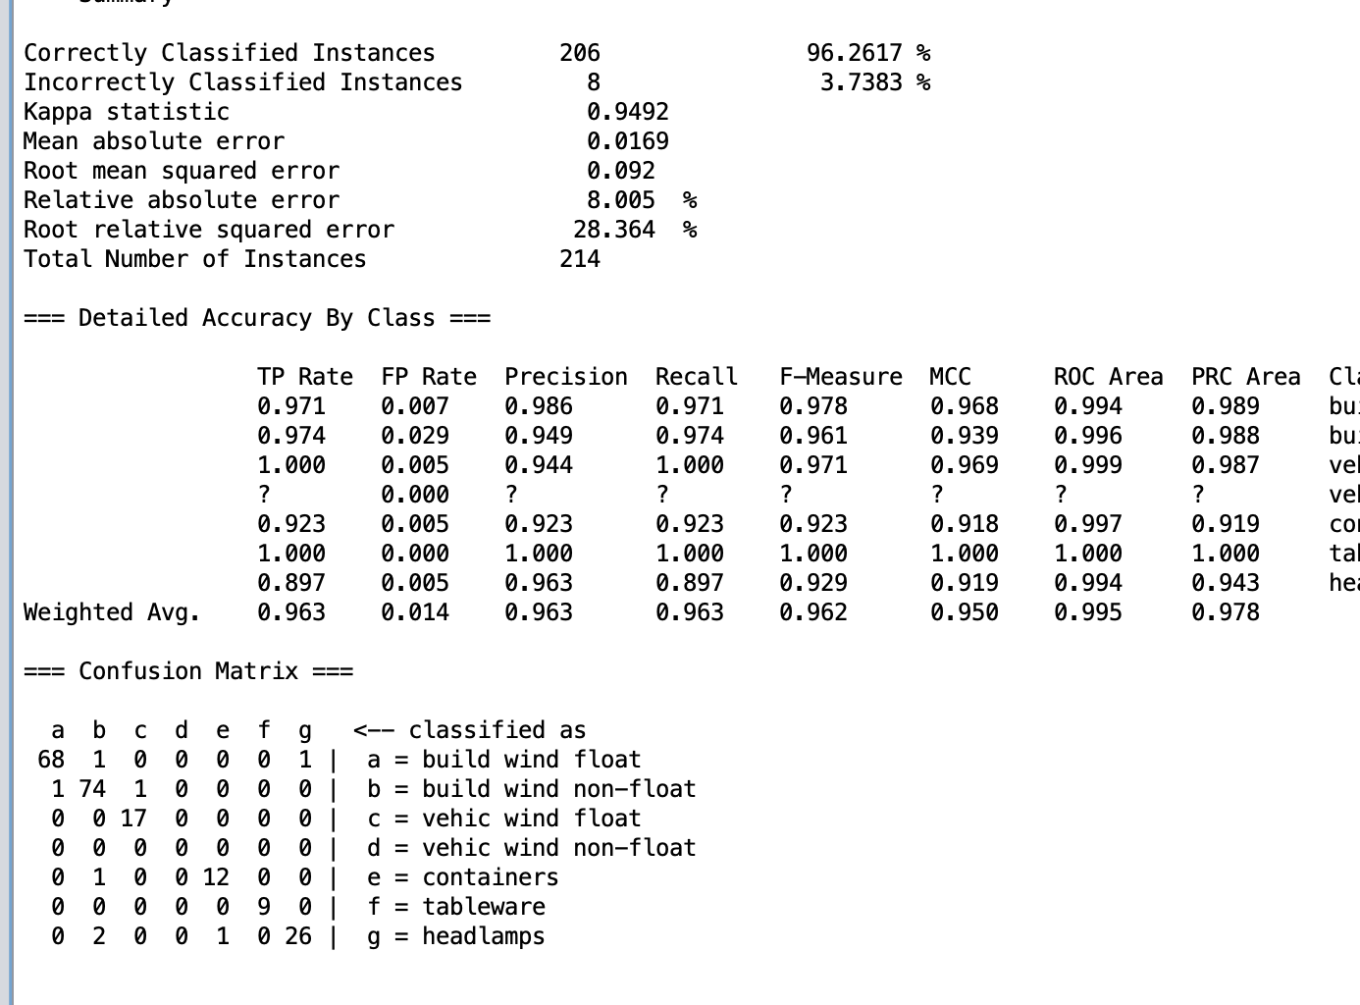

The row “b=build wind non-float” shows the number of windows of type b according to the types classified by the filter.
74 of type b were correctly classified while 1 incorrectly classified as type a and 1 incorrectly classified as type c.

Naïve Bayes (NB)

Percentage of Correctly Classified Instances
The percentage is 55.6075%
Screen shot of the confusion matrix 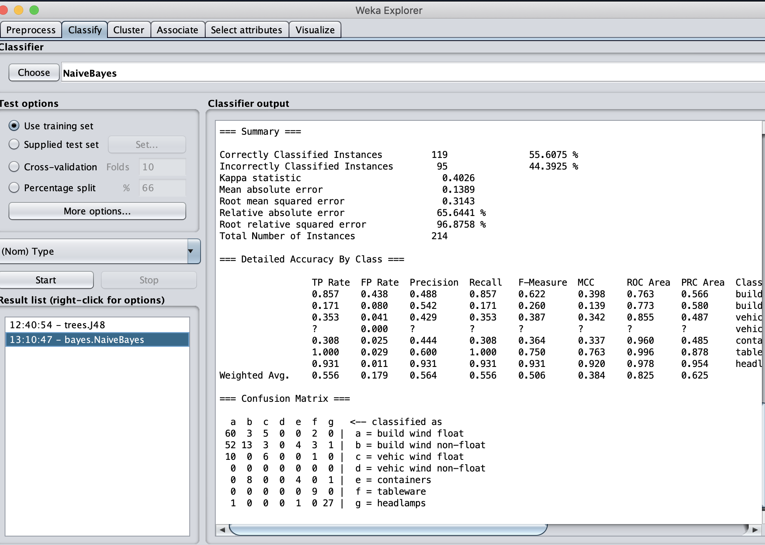
The row “b=build wind non-float” shows the number of windows of type b according to the types classified by the filter.
13 of type b were correctly classified while 52 incorrectly classified as type a, 3 incorrectly classified as type c, 4 incorrectly classified as type e, 3 incorrectly classified as type f, 1 incorrectly classified as type g.

Preprocess the Dataset
    - How many attributes are there in the dataset?
10 attributes
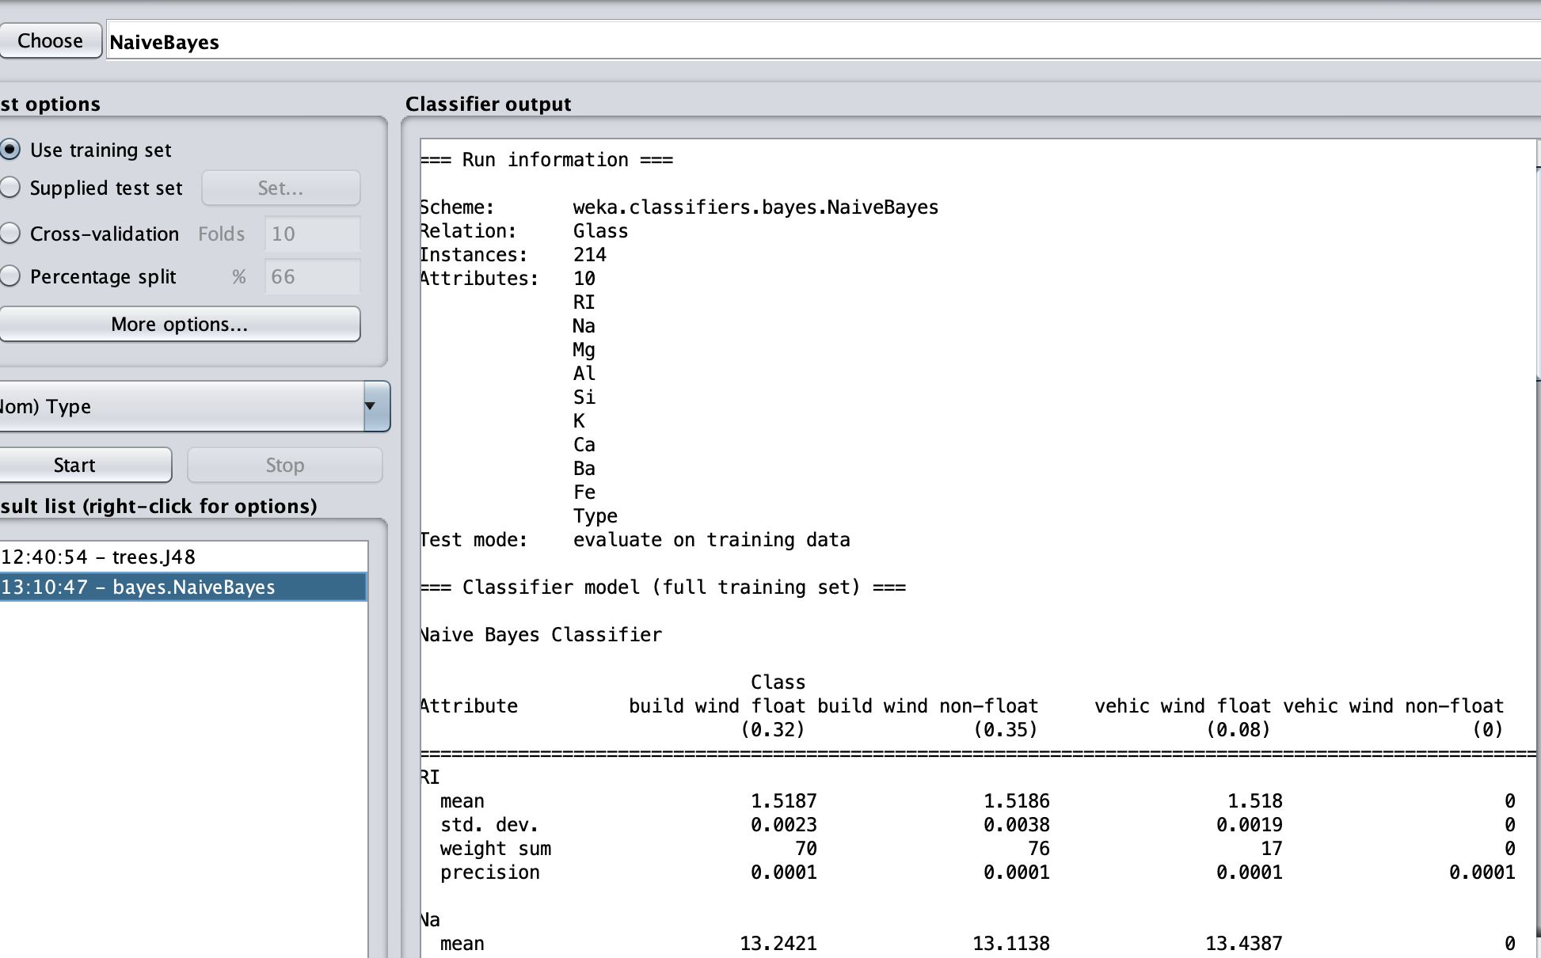
    - How many instances are there in the dataset?
214 instances
    - How many missing values are there in the dataset?
0(0%)

Replace missing values
    - Which filter did you apply and what effect did it have on the dataset?
I used the ‘ReplaceMissingValues‘ filter and it had no effect on the database
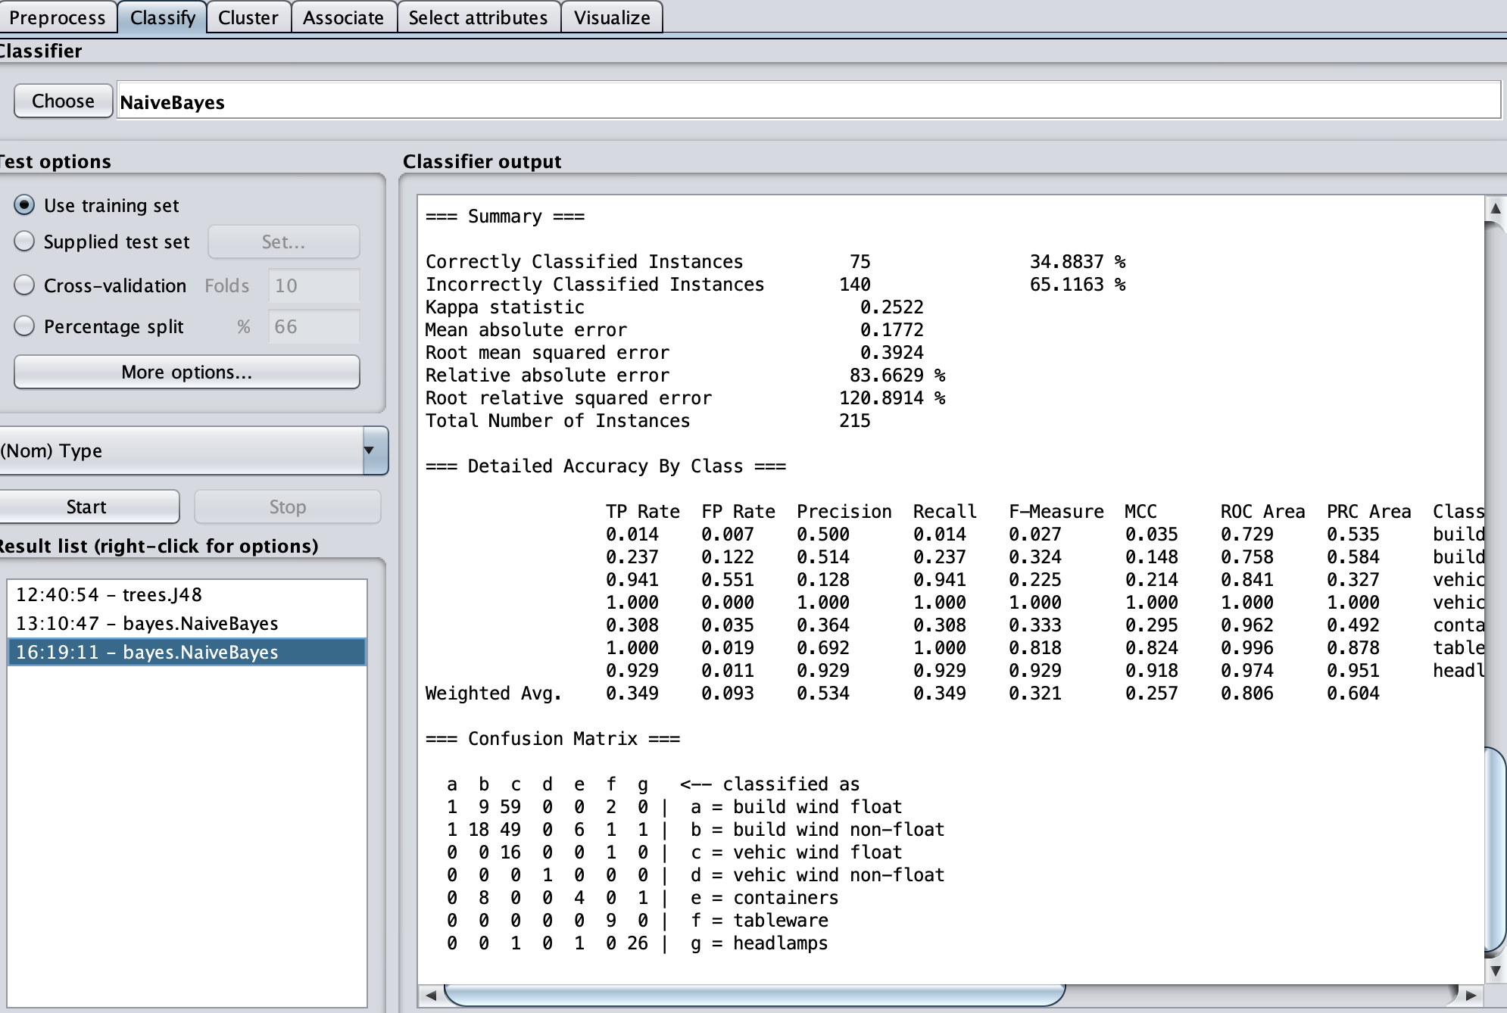
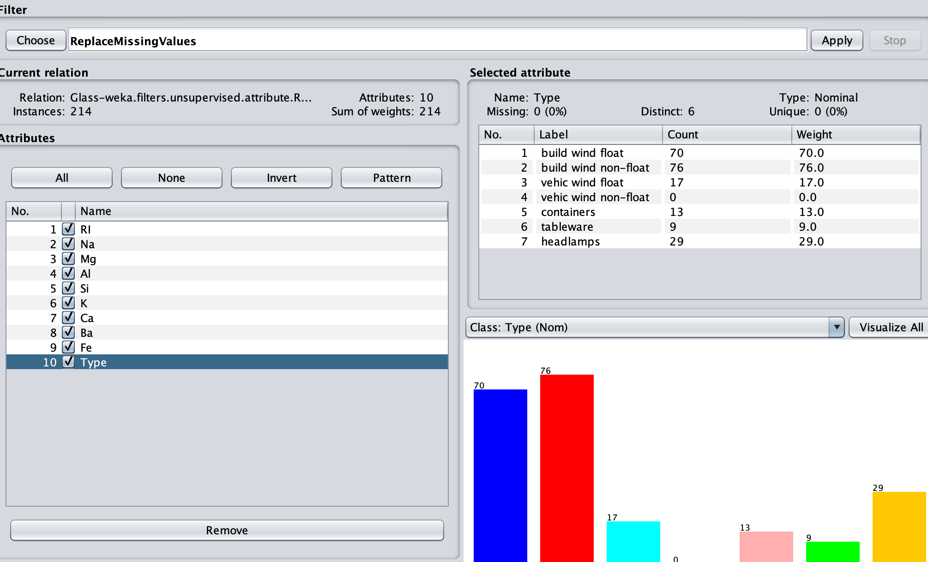

Remove duplicates

I used the ‘RemoveDuplicates’ filter – the value in the Count ‘build wind float’ changed from 70 to 69
Before and after
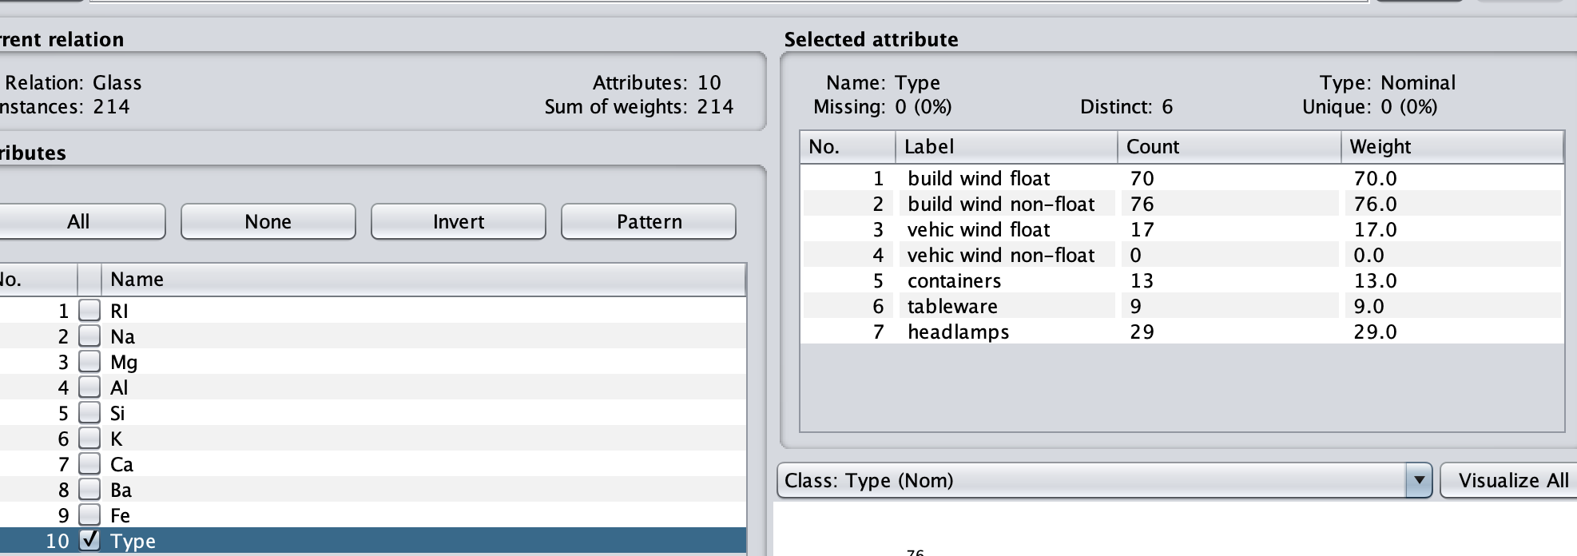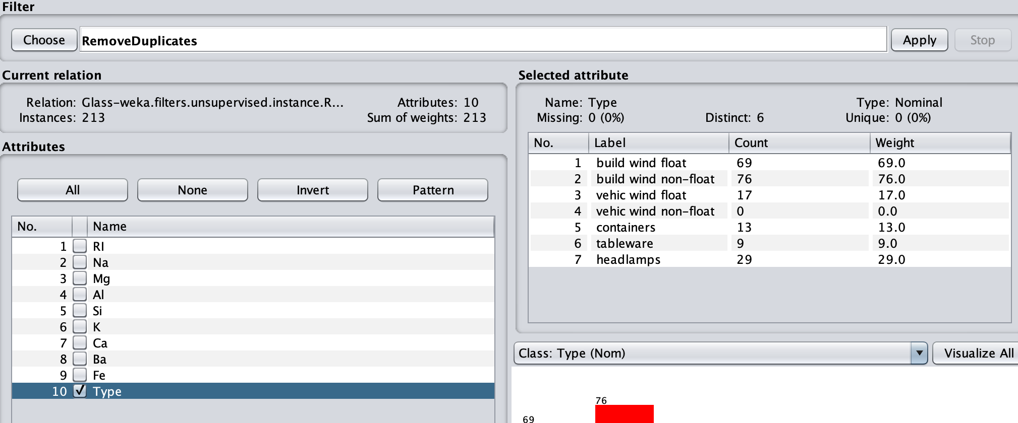

Attribute Filter
I used the ‘SortLabels’ filter which arranged the Labels column in alphabetical order

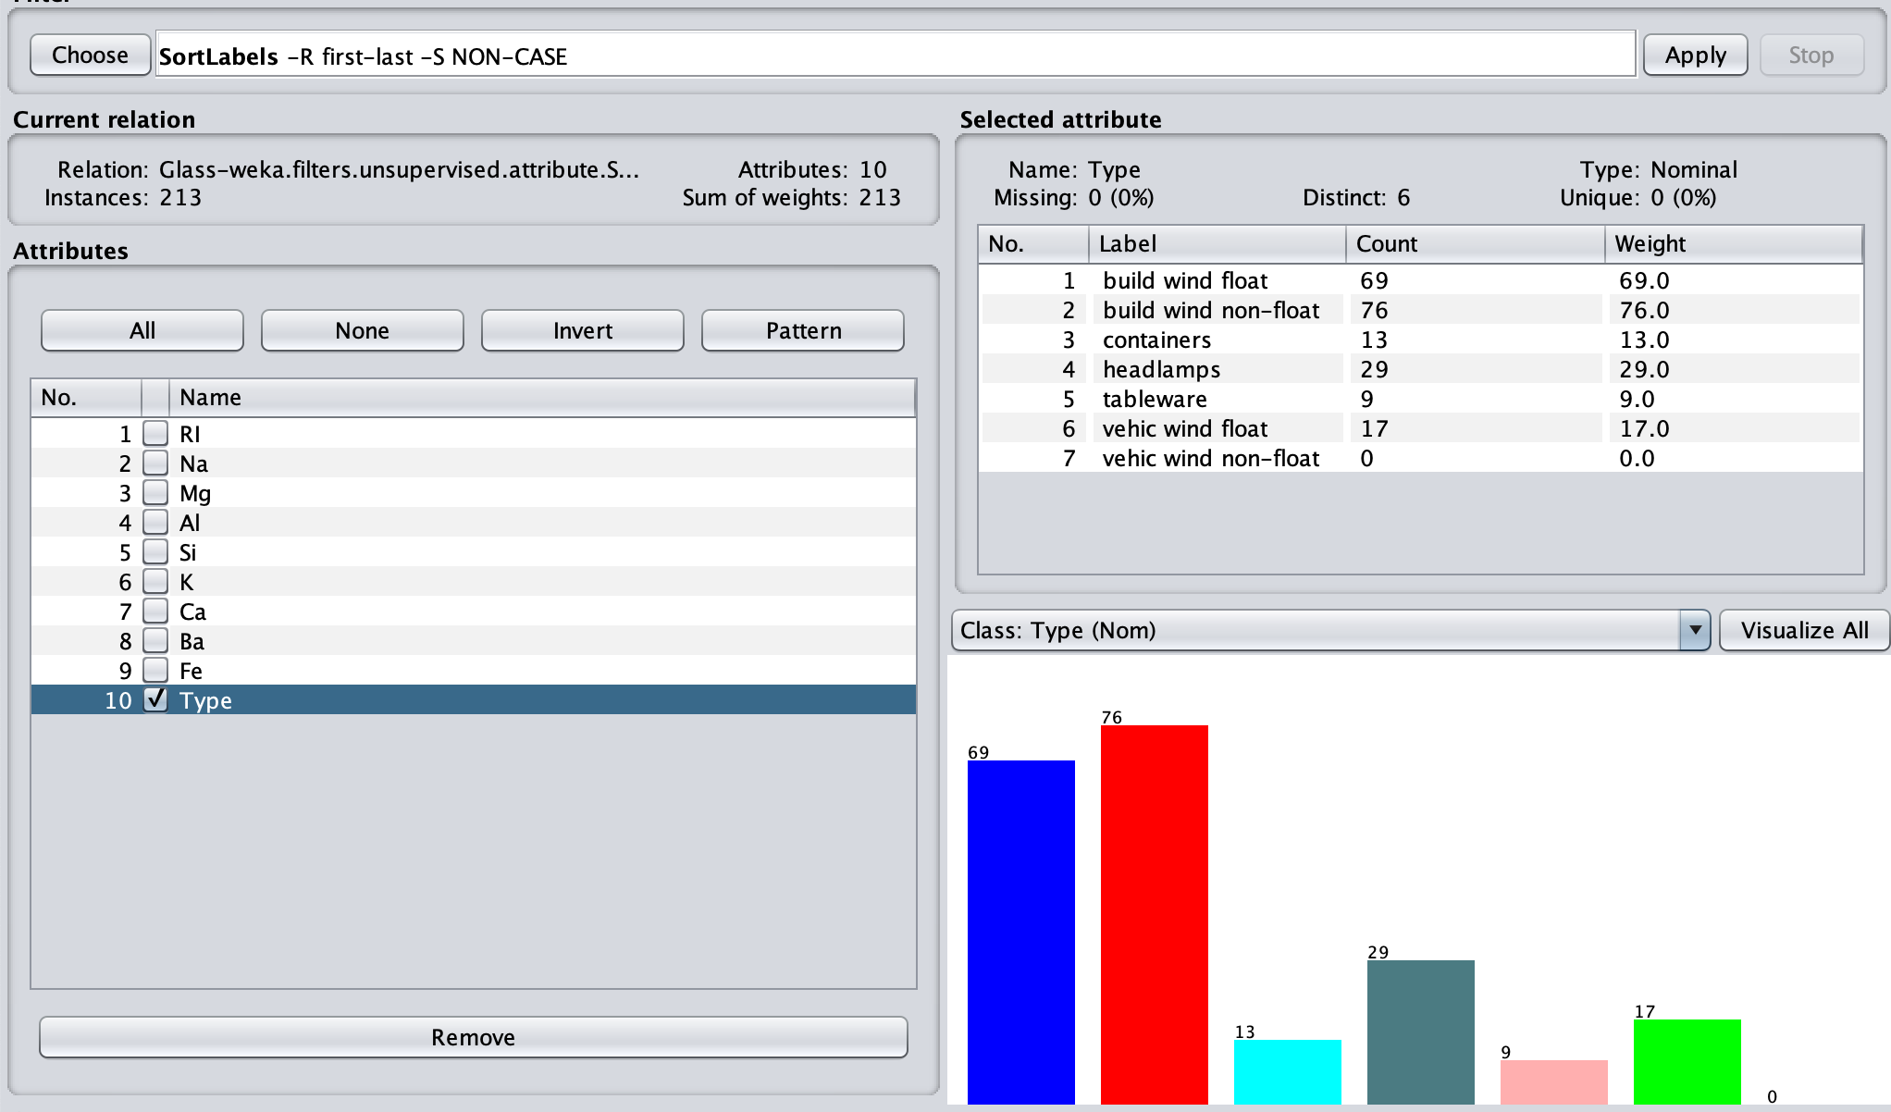

Classify the Cleansed Dataset

J48

Percentage of Correctly Classified Instances
The percentage is 96.2617%

Screen shot of the confusion matrix
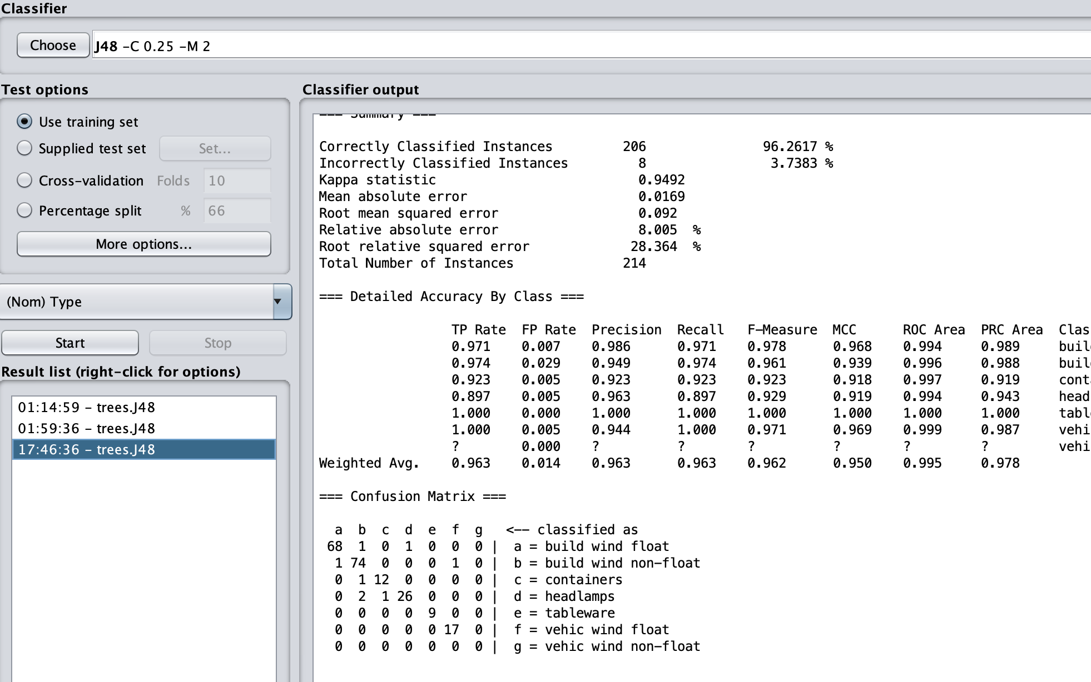
The row “b=build wind non-float” shows the number of windows of type b according to the types classified by the filter.
74 were correctly classified while 1 incorrectly classified as type a and 1 incorrectly classified as type f.

Naïve Bayes (NB)

Percentage of Correctly Classified Instances
55.8685% were correctly classified instances

Screen shot of the confusion matrix
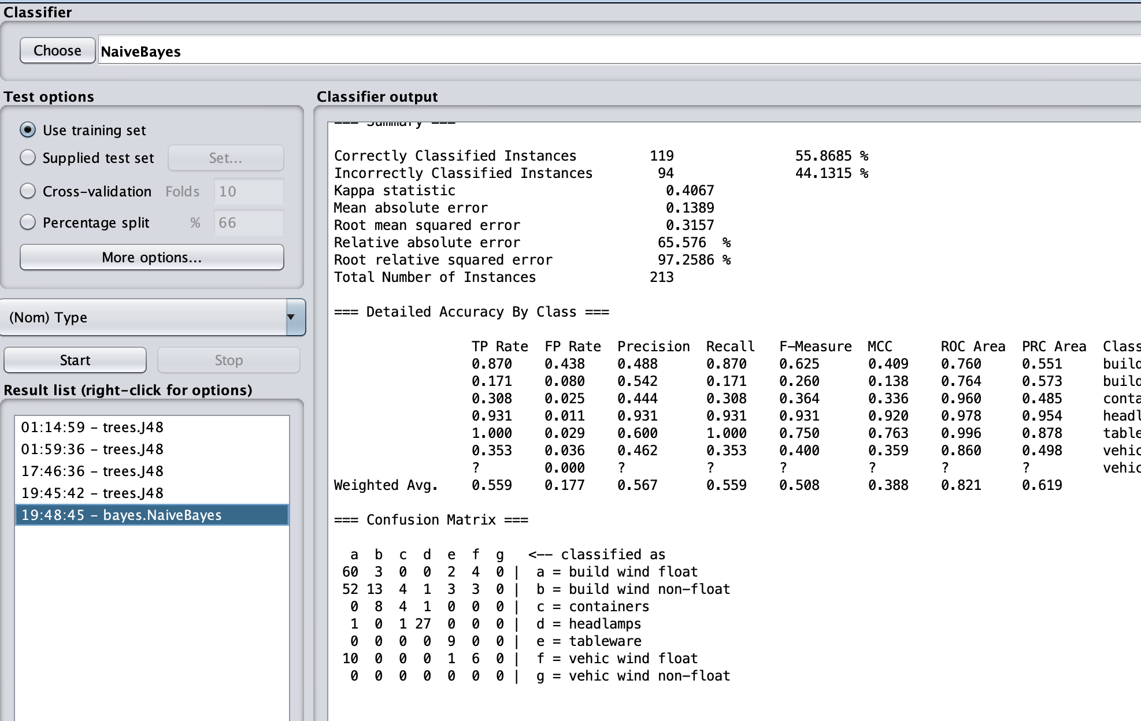
The row “b=build wind non-float” shows the number of windows of type b according to the types classified by the filter.
13 of type b were correctly classified while 52 incorrectly classified as type a, 4 incorrectly classified as type c, 1incorrectly classified as type d, 3 incorrectly classified as type e, 3 incorrectly classified as type f

Observations

  - What effect did cleansing have on classification using J48 and Naïve Bayes?
J48 – cleansing changed the distribution of the incorrect classifications of type b
Type a: 1->1 no change
Type b: 74->74 (correctly classified) no change
Type c: 1->0
Type d: 0->0 no change
Type e: 0->0 no change
Type f: 0->1
Type g: 0->0 no change

Naïve Bayes – cleansing changed the distribution of incorrect classifications of type b
Type a: 52->52 no change
Type b: 13->13 (correctly classified) no change
Type c: 3->4
Type d: 0->1
Type e: 4->3
Type f: 3->3 no change
Type g: 1->0

Wheat Seeds Dataset

Screen shot that of text file
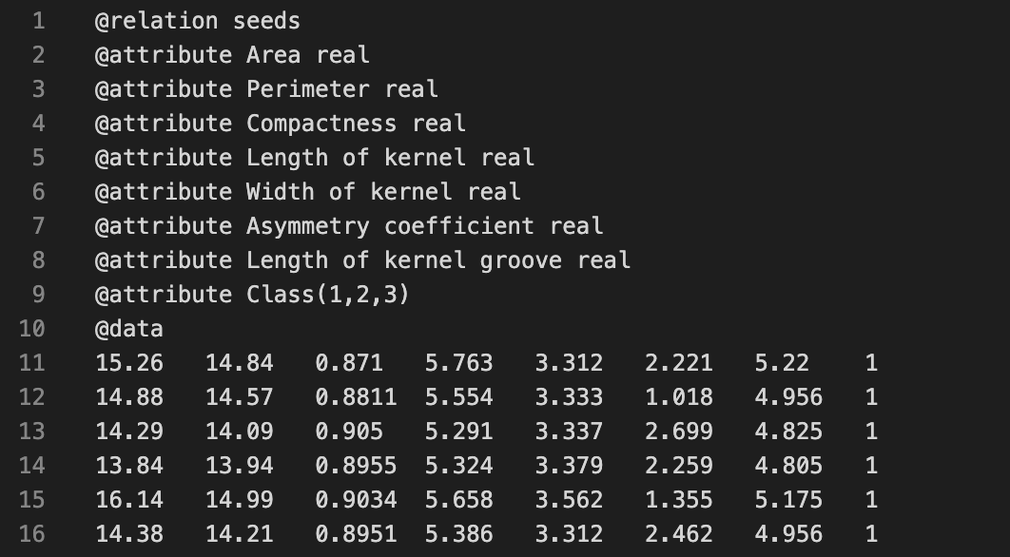

Preprocess the Dataset
- How many attributes are there in the dataset? 8
- How many instances are there in the dataset? 210
- How many missing values are there in the dataset? 0(0%)
- Used the ‘ReplaceMissingValues’ filter followed by the ‘RemoveDuplicates’

Classify the Cleansed Dataset

J48 with 10 fold cross-validation
- What is the percentage of Correctly Classified Instances? 91.9048%
- Submit a screen shot of the confusion matrix and explain the results obtained for “a = 1.”
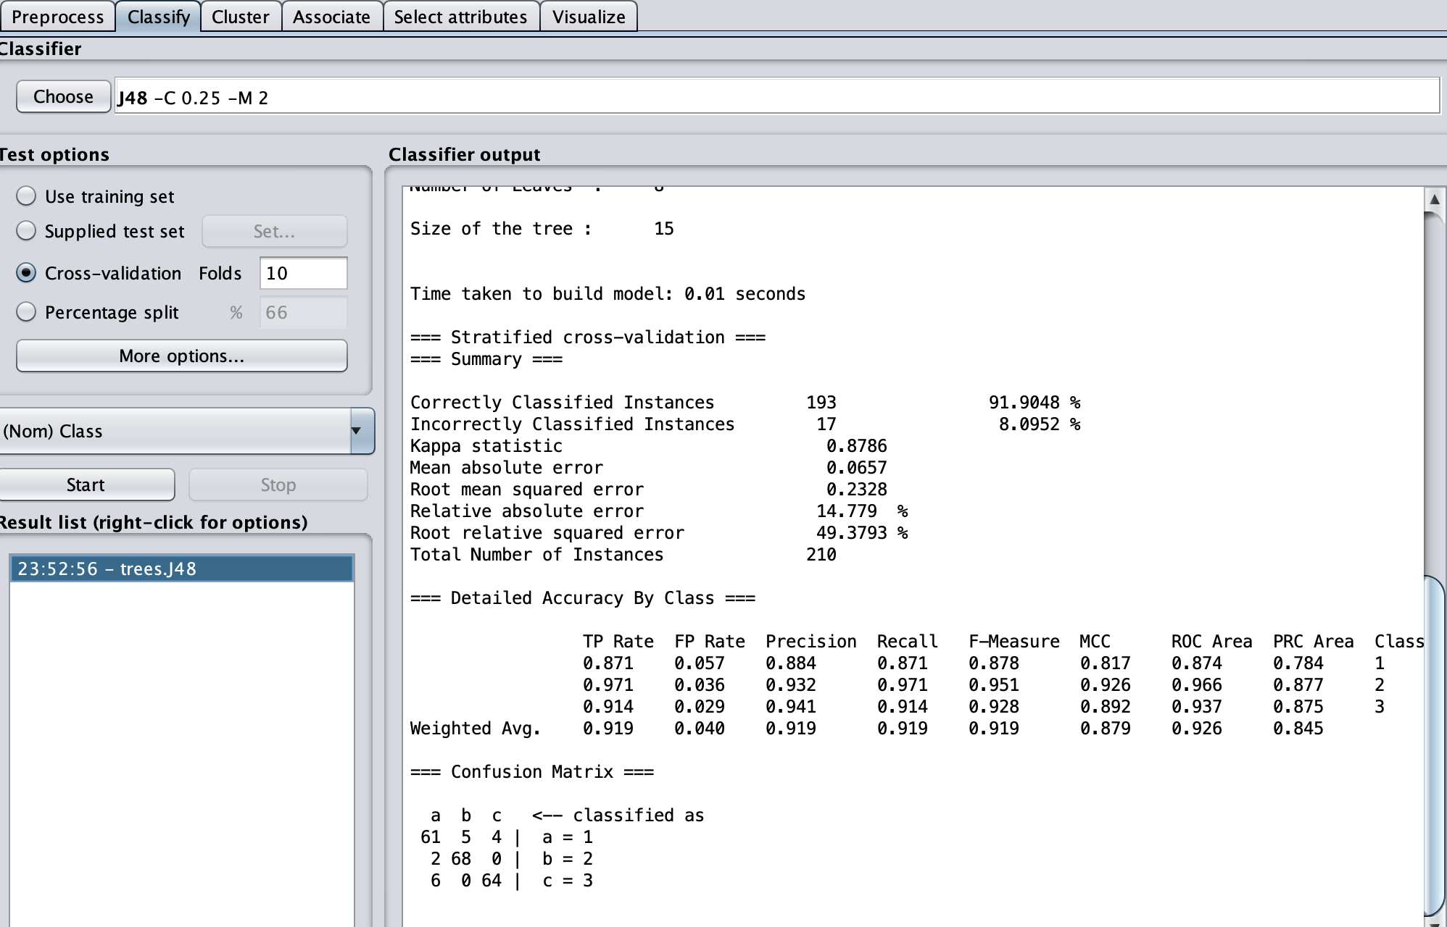

‘a=1’ means that this row in the confusion matrix represents the classification of all instances having attribute ‘Class’ = ‘1’
It shows that 61 instances of Class 1 were correctly classified while 5 instances incorrectly classified as Class 2 and 4 instances incorrectly classified as Class 3

Visualize the Dataset
Screen shot of the decision tree. 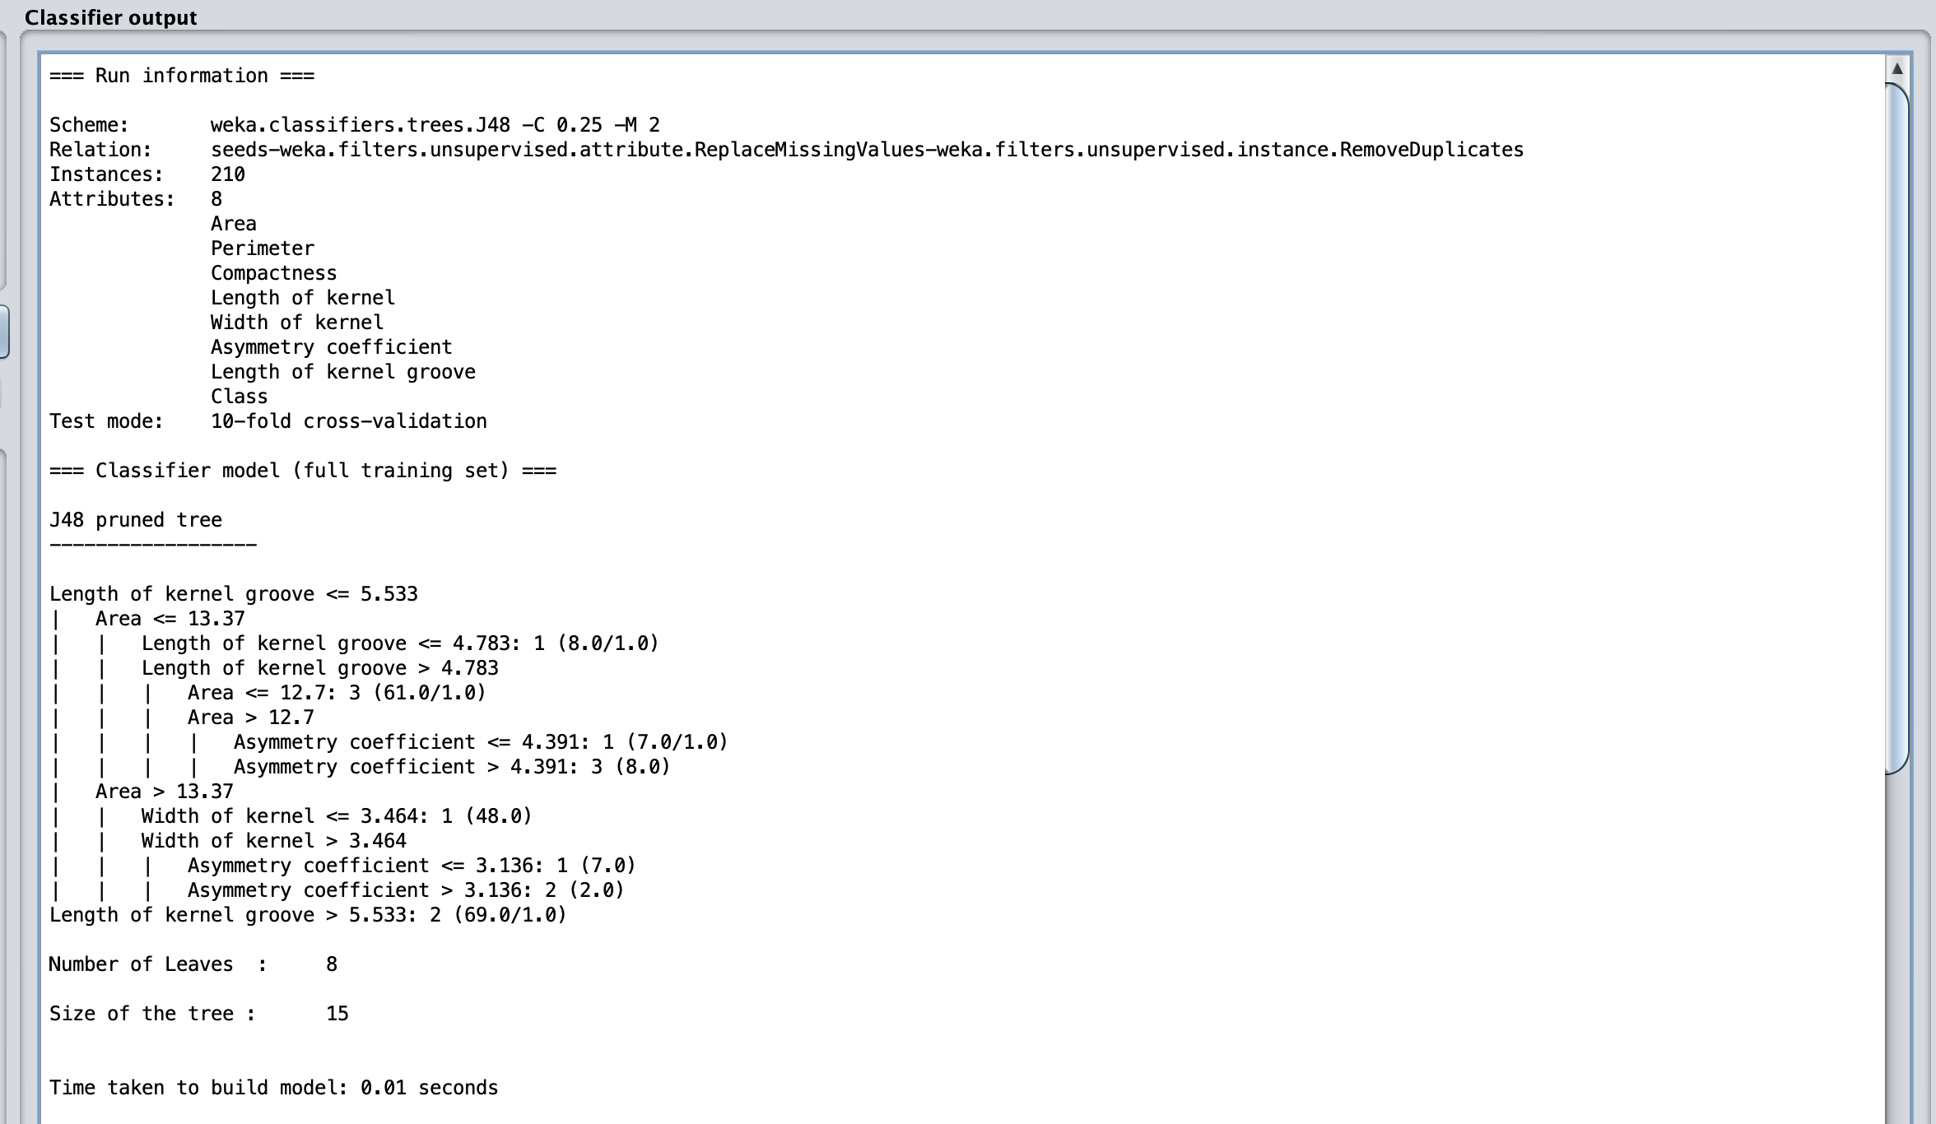

Screen shot of the visualize panel
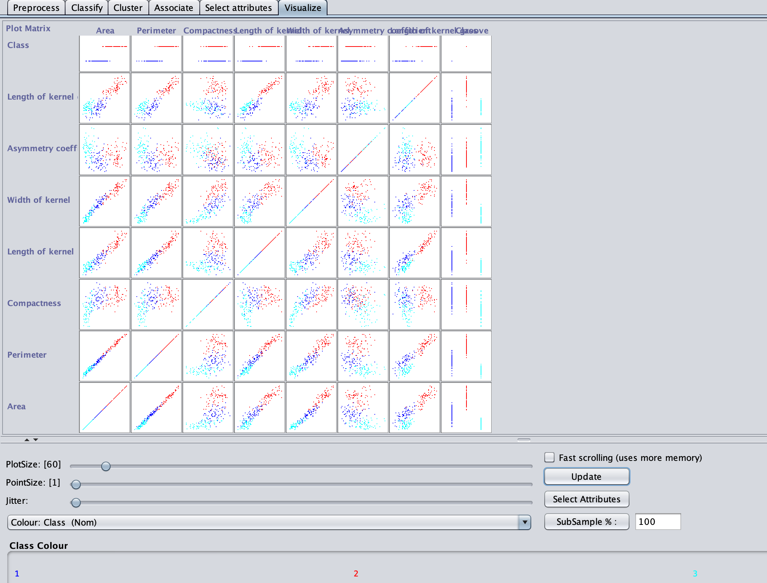

Observations
The grouping of the instances with similar class into clusters tells me that the attributes are clearly directly related to the class type.
Area: Class 2 has the biggest area(15.885>21.18), Class 1 in the median(avg.15.885) and Class 3 the smallest area (10.59>15.885)
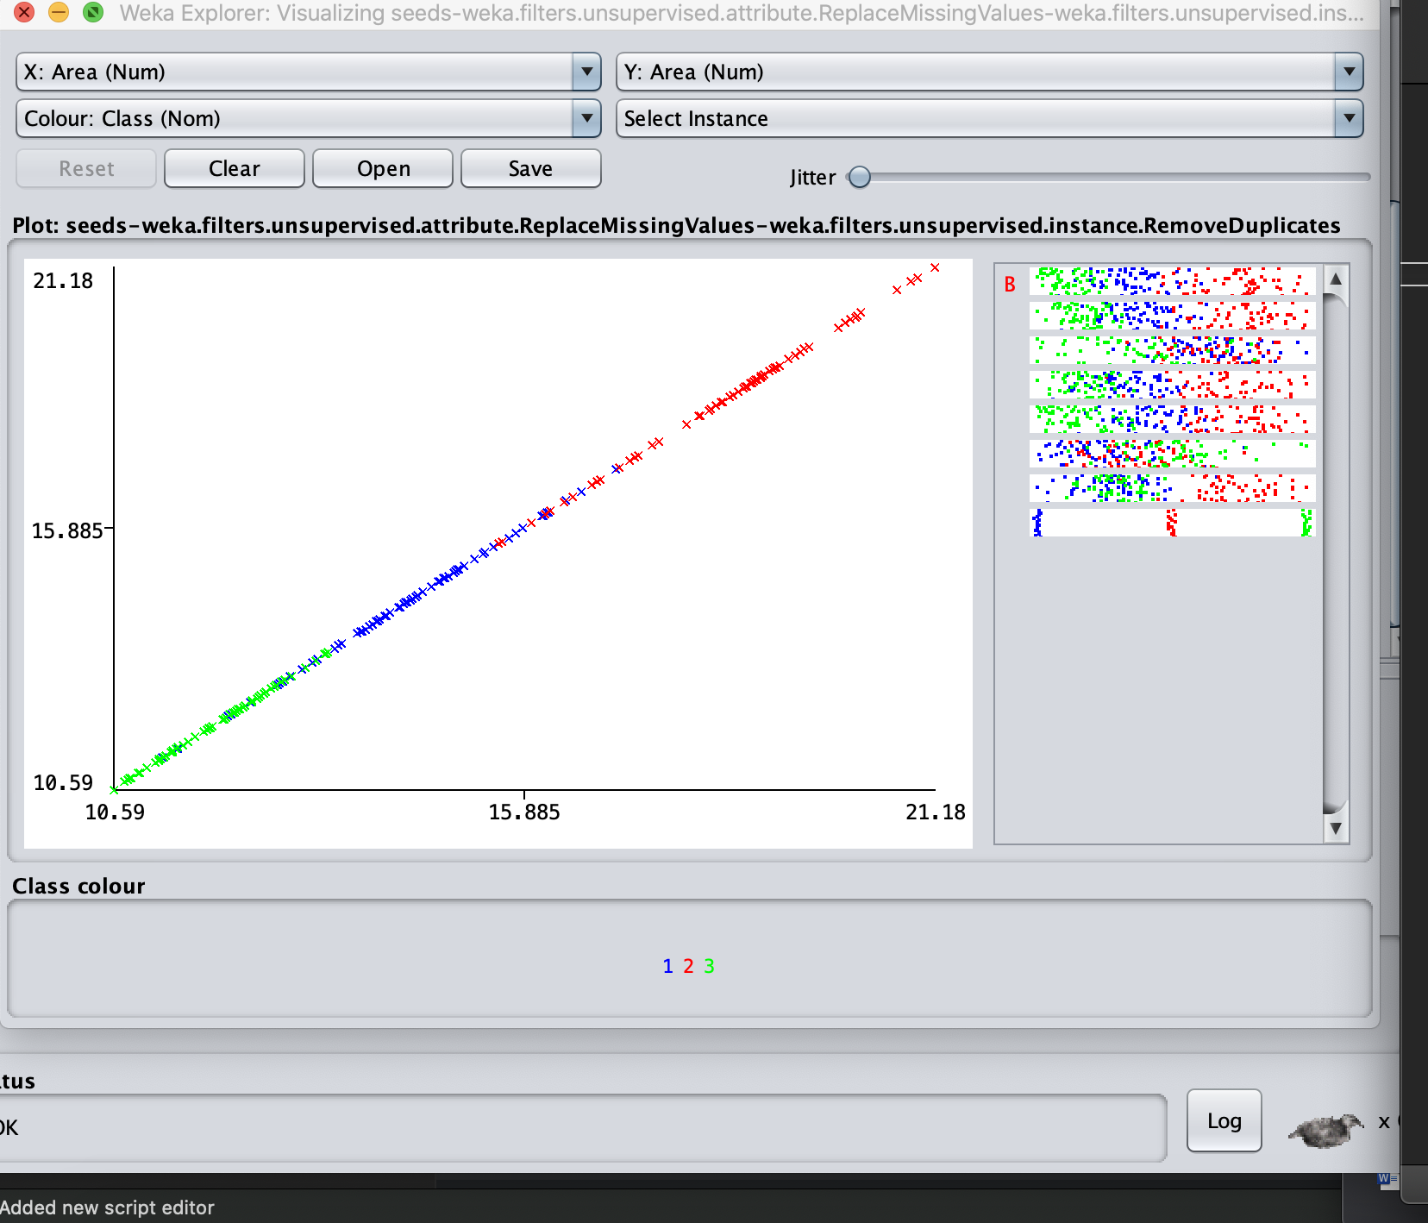
Perimeter: As to be expected, perimeter follows along a similar pattern with the same distribution of classification by dimension with Class 2 the biggest perimeter(14.83>17.25), Class 1 median(14.83), Class 3 smallest (12.41>14.83))
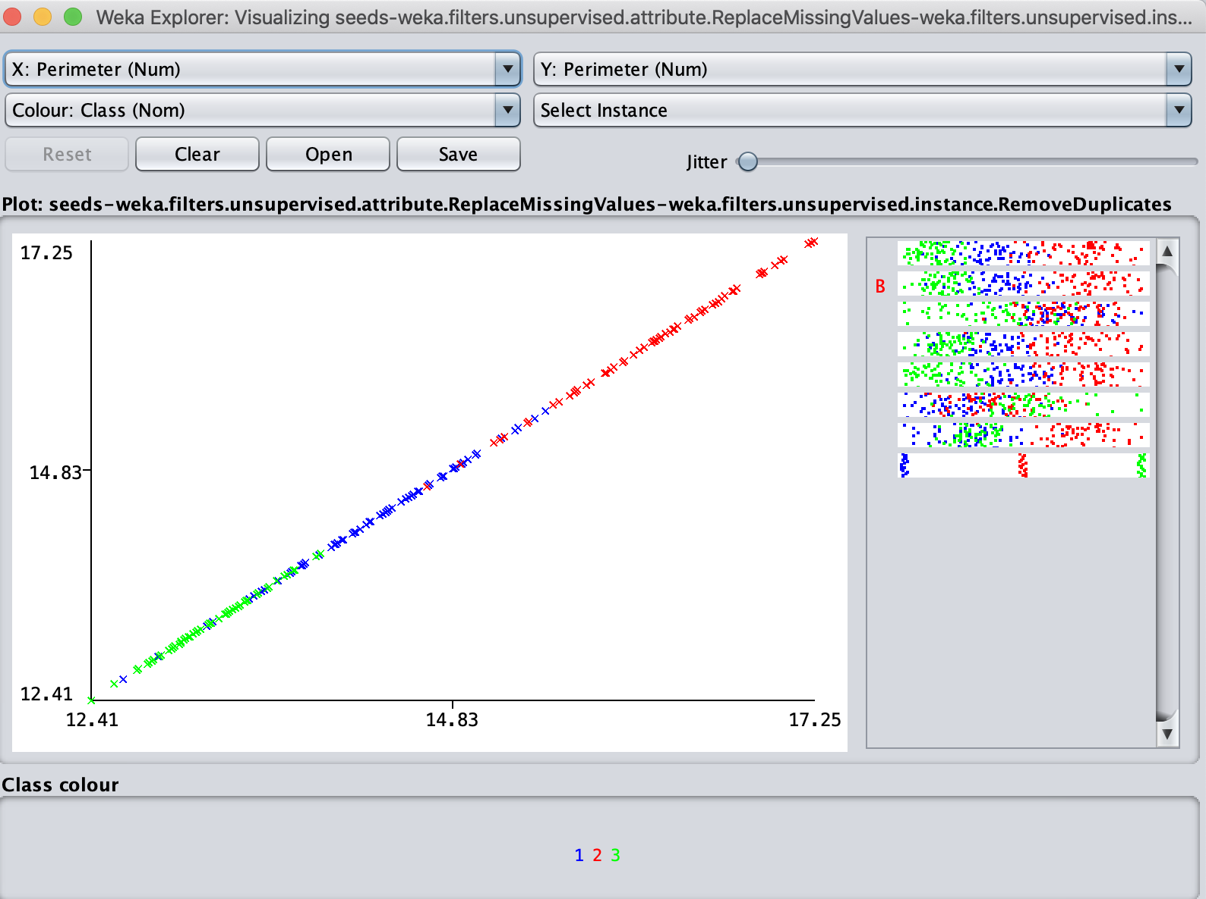
Compactness: Unlike the previous attributes the distribution is not as clear, Class 1 and 2 instances are intermixed suggesting similar compactness ranging from (0.86 > 0.92), while class 3 ranges from 0.81>0.86
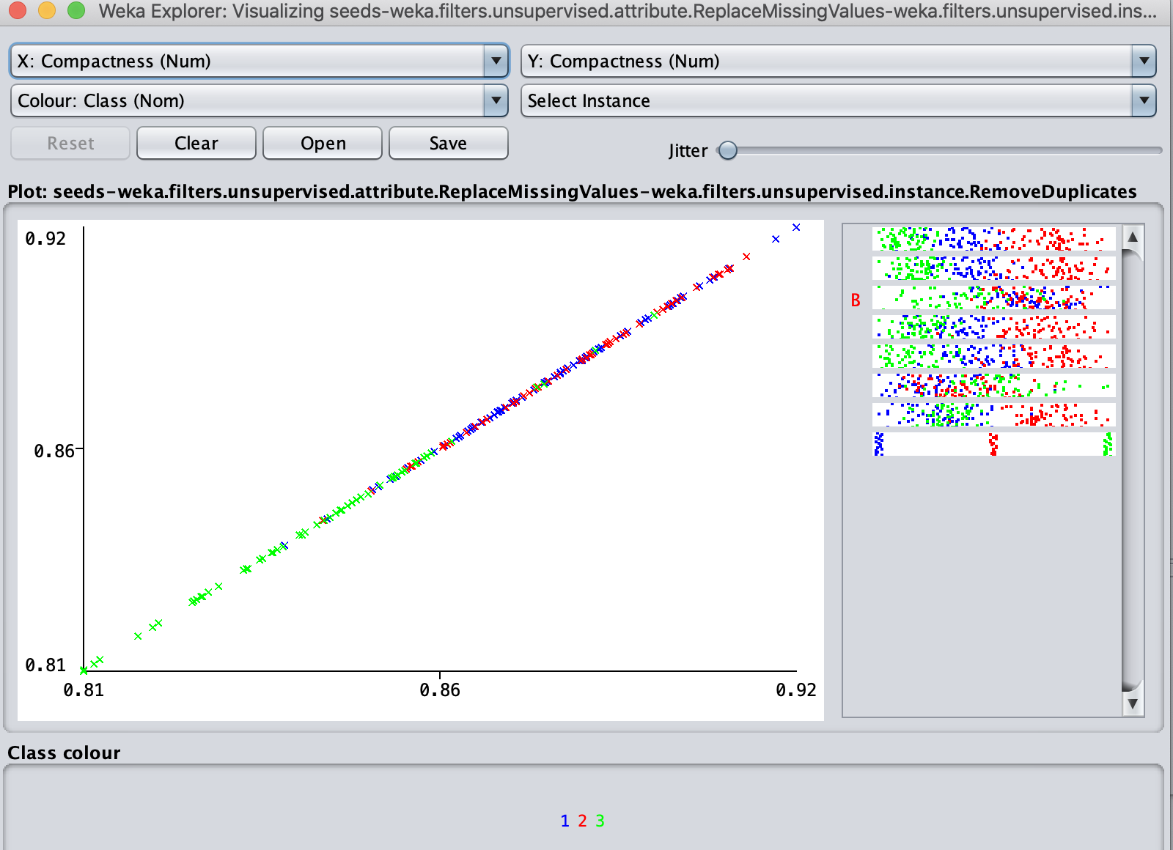
Length of kernel: As to be expected length follows along a similar pattern with distribution of classification by dimension seen in the area and perimeter attributes with Class 2 the longest (5.79 > 6.67), Class 1 median(5.79), Class 3 shortest (4.9>5.79)
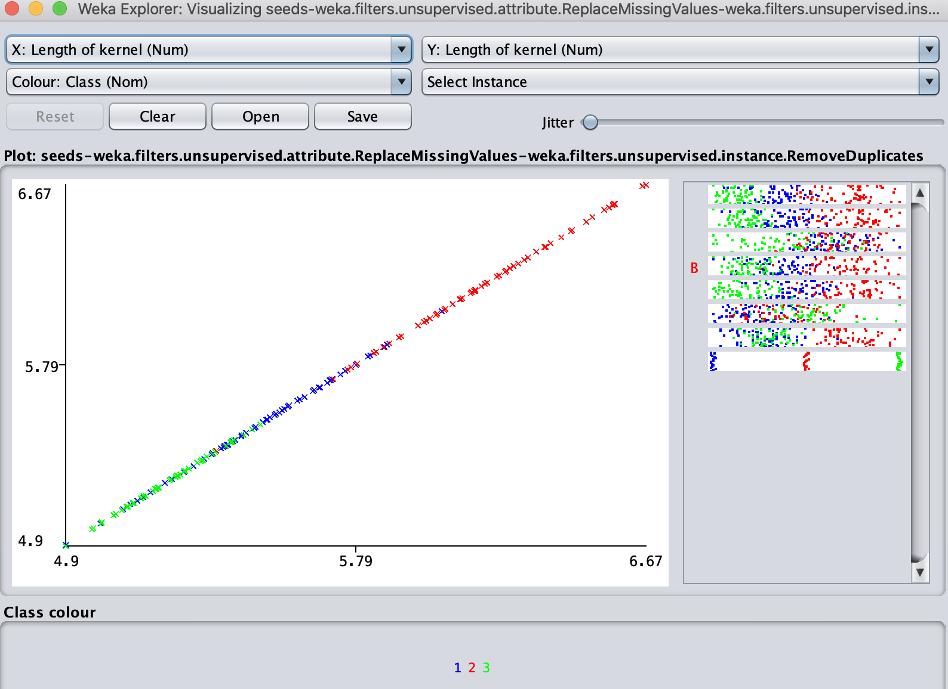
Width of kernel: As to be expected width follows along a similar pattern with distribution of classification by dimension seen in the area, perimeter and length attributes with Class 2 the widest (3.33 > 4.03), Class 1 median(3.33), Class 3 the most narrow(2.63>3.33)
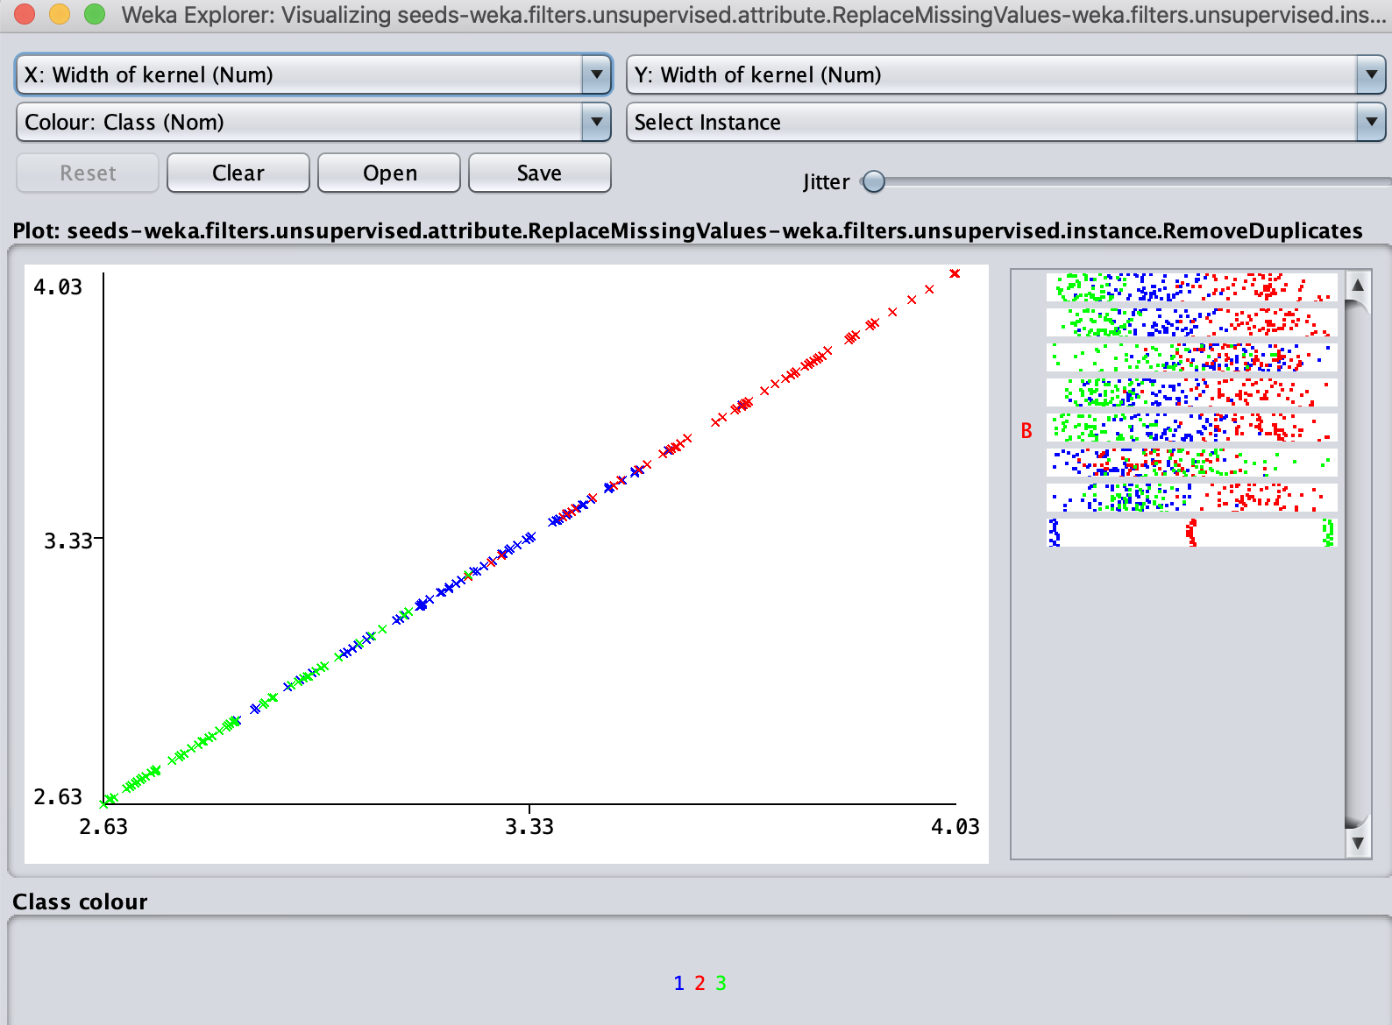
Asymmetry coefficient: Unlike the previous attributes the distribution is not as clear, Class 1 and 2 instances are intermixed suggesting similar asymmetry ranging from (0.77>4.61), while class 3 has a higher coefficient (4.61>8.46)
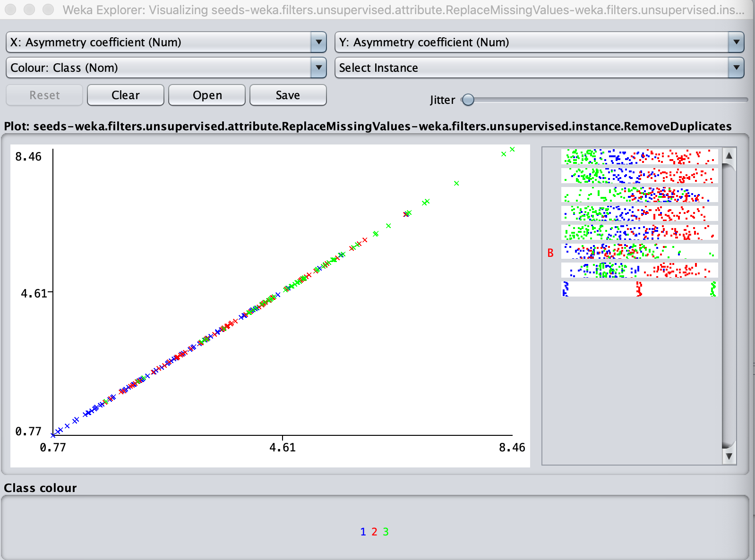

Length of kernel groove: Unlike the previous attributes the distribution is not as clear, Class 1 and 3 instances are intermixed suggesting similar length of the kernel groove ranging from (4.52 > 5.53), while class 2 ranges from (5.53>6.55)


