Final exam notes- MicroEcon

Chapter 3- Characteristics of a competitive market

MARKETS

Market - refers to the buyers and sellers who trade a particular good or service, not to a physical location.

Competitive market is one in which fully informed, price-taking buyers and sellers easily trade standardized goods or services.
- full information about the price and features of the good being bought and sold
- No transaction costs - costs incurred by buyer and seller in agreeing to and executing a sale of goods or services
- a buyer or seller who cannot affect the market price is called a price taker

In the market: Buyers and Sellers
- Buyers(consumers) determine the demand
- Sellers(producers) determine the supply
As a group consumers determine the demand for a product

Demand

Demand - how much of something people are willing and able to buy under certain circumstances

Quantity demanded - amount of a particular good that buyers in a market will purchase at a given price during a specified period

Law of demand - inverse relationship between price and quantity demanded
ceteris paribus - to isolate the effect of a single change in the economy

Demand schedule - the quantities of a particular good or service that consumers are willing to purchase (demand) at various prices

Demand Curve
- demand curve - visually displays the demand schedule
- shows quantities of a particular good or service consumers will demand at various prices
- represents consumers’ willingness to buy and the highest amount they will pay for a given quantity

Determinants of Demand
- non-price determinants of demand can be divided into five major categories:
1. Consumer preferences
2. Prices of related goods
3. Incomes
4. Expectations
5. Number of buyers

Determinants of Demand
Prices of related goods
- two kinds of related goods:
- Substitutes - serve similar purposes; consumers might purchase one in place of the other (opportunity cost of one decreases). If goods are quite similar, we call them close substitutes
- Complements - goods consumed together; buying one makes consumer more likely to purchase the other

Normal goods - increased income causes more demand; decreased income causes less demand

Inferior goods - increased income decreases demand for inferior goods, substituting them with more expensive and appealing goods

Expectations
- consumer expectations about the future (especially prices) also affect demand
- expecting prices to fall may postpone purchasing, causing current demand to decrease

Number of buyers
- curve represents a particular number of buyers; increase in number of buyers will increase demand; decrease in buyers slows demand

SHIFTS IN THE DEMAND CURVE

Determinants of Demand
- shifts in the demand curve are caused by changes in the non-price determinants of demand
- shift is horizontal; non-price determinants affect quantity demand at each price

Determinants of Demand
- decide purchase quantity at new price - follow existing curve from old price to new
- non-price determinants can cause an increase or decrease in demand, shifting the entire curve.
- price change causes an increase in the quantity demanded or decrease in the quantity demanded

SUPPLY

Supply- how much of a good or service is offered for sale under given circumstances

Quantity supplied - amount of good or service offered for sale at a given price during a specified period
- each producer has different price point to decide viability to supply

Law of Supply - quantity supplied increases as price increases and vice versa
- decision to produce a good concerns trade-off of producer benefit from selling and cost to produce it

Shift vs Movement
- Shift: change in non-price determinant, increases/decreases in the quantity demanded
- Movement: change in price, increase or decrease in the quantity demanded.

Supply Curve

- supply can be represented as either a table or a graph
- supply schedule - is a table that shows the quantities of a particular good or service that producers will supply at various prices

Supply curve - graph of the information in the supply schedule
- supply curve shows producers’ willingness to sell (minimum price producers must receive to supply any given quantity)

Determinants of supply
non-price determinants of supply divided into five major categories:
- prices of related goods
- technology
- prices of inputs
- Expectations
- number of sellers

Determinants of supply
- When a non-price determinant of supply changes, the entire supply curve will shift.
- Such shifts reflect a change in the quantity of goods supplied at every price
SUPPLY
- Prices of related goods -affects the opportunity cost of production
- Technology - produce more efficiently, using fewer resources; lowers costs, increasing the quantity producers will supply at each price
- Prices of the inputs - increase production costs; quantity of product producers supply at given price decreases
- Expectations - about future prices affect quantity supplied
- Number of Sellers- product quantities producers will supply at various prices in market
- number of sellers in market is considered fixed on supply curve

MARKET EQUILIBRIUM
- prices/quantities depend on interaction of supply with demand
- market equilibrium - price/quantity lines intersect
- equilibrium price - where lines intersect
- equilibrium quantity - where lines intersect
Reaching equilibrium
Sellers set prices by trial and error or experience.
- incentives naturally drive market toward equilibrium
- surplus - quantity supplied is higher than the demand; excess quantity supplied; incentive to lower price
- shortage or excess quantity demand - demand higher than supplied; incentive is to raise prices
- changes in demand or supply curve, or both, changes market equilibrium
Changes in equilibrium prediction
- when supply/demand move in the same direction, we can predict the direction of the change in quantity but not the direction of the change in price
- when supply/demand move in opposite directions, change in price is predictable, not change in quantity

CHAPTER 4- ELASTICITY

Elasticity - measure of how much consumers and producers will respond to a change in market conditions
- price elasticity of demand
- price elasticity of supply
- cross-price elasticity of demand
- income elasticity of demand

- Price elasticity of demand
- change in the quantity demanded of a good or service when price changes
- price elasticity is the percentage change in the quantity of a good demanded in response to a given percentage
- percentage changes in quantity, rather than absolute changes, eliminates confusion caused by differences in quantity measurement
- price elasticity of demand - always negative; price and quantity demanded move in opposite directions
- midpoint method - measures percentage change relative to point midway between old and new quantities

Determinants
- Consumers are more sensitive to price changes for some goods and services than for others
- availability of substitutes
- relative need vs. cost
- time to adapt to price changes
- scope of the market
Price elasticity of demand
- demand can be perfectly elastic or perfectly inelastic
- perfectly elastic - demand curve is horizontal, (consumers very sensitive to price, demand drops to zero when the price increases even a minuscule amount)
- perfectly inelastic - demand curve is vertical (the quantity
- demanded is the same no matter what the price)
- these two extremes rarely occur in real life

Elasticity is divided into three quantifiable categories:
1. elastic (absolute value of the price elasticity of demand >1)
2. Inelastic
3. Unit-elastic

Total revenue - amount received from sale of goods and services, calculated as the quantity sold multiplied by the price paid for each unit

Price increases affect total revenue in two ways:
- quantity effect - decrease in revenue from selling
fewer units of the good
- price effect - increase in revenue from receiving a
higher price for each unit sold

- quantity effect outweighs the price effect, a price increase will cause a drop in revenue
- price effect outweighs the quantity effect, a price increase will raise total revenue
- elastic - > price causes < total revenue
- inelastic - price % change > causes < % demand
- elasticity of demand is different at different points along a linear demand curve
Price elasticity of supply
- size of the change in quantity supplied when price changes; producers’ responsiveness to price change
- measured as quantity % change divided by price % change
- price elasticity of supply uses same three categories:
- Elastic - value >1
- Inelastic - value <1
- Unit-elastic - value =1
Determinants
- supply is elastic/inelastic depending on supplier’s ability to change quantity produced in response to price changes. Three factors affect this:
- availability of inputs
- flexibility of the production process
- time

Cross-price elasticity of demand
- describes how quantity demanded of one good changes when the price of a different good changes
- if two goods are substitutes, their cross-price elasticity of demand should be positive
- if two goods are complements (consumed together), cross-price elasticity will be negative
Income elasticity of demand
- describes how much quantity demanded changes in response to a change in consumers’ incomes
- income elasticity of demand is negative for inferior goods; quantity demand decreases as incomes rise

Chapter 5- Efficiency

Willingness to pay: ( or reservation price) is an economic term for the maximum price a buyer will pay.
Willingness to sell: is the minimum price a seller is willing to accept in exchange for a good or service.
- buyers want to buy low, sellers want to sell high
- each buyer’s willingness to pay and each seller’s willingness to sell is driven by different factors (trade-offs vs. opportunities)
Measuring surplus
Surplus is the difference between the price at which a buyer or seller is willing to trade and the actual price.
- measures who benefits from transactions and by how much
- economists use “surplus” to describe a fairly simple concept: if you get something for less than you would have been willing to pay, or sell it for more than the minimum you would have accepted
- indifference point - point beyond which buyer will part with money and seller parts with product/service

Consumer surplus - sum of each individual’s consumer surplus to describe the overall benefits that buyers receive in a market
- same term used for individual and collective surplus

Producer surplus - net benefit the producer receives from sale of a good/service, measured by the difference between willingness to sell and the actual price
- term used whether or not the sellers actually produced the good themselves or sell it secondhand

Total surplus: the measure of combined benefits everyone receives from exchange of goods or services
- put the demand and supply curves together and locate the point where they intersect
- zero-sum game - situation in which one gains and another loses an equal amount, such that the net value of a transaction is zero
- voluntary transactions result in both buyer and seller being winners, since they both gain surplus

Using surplus to compare alternatives
In competitive markets, buyers and sellers naturally find the equilibrium price.
- equilibrium: buyers and sellers are perfectly matched
- sellers: point at which total surplus is maximized
- equilibrium maximizes total benefit of all participants

Changing the distribution of total surplus
Imposing artificially high prices on a market hurts consumer surplus, due to fewer transactions and higher prices on remaining transactions.
- producers gain surplus from higher price on transactions that do still take place
- opposite situation occurs when prices are lower than the market equilibrium
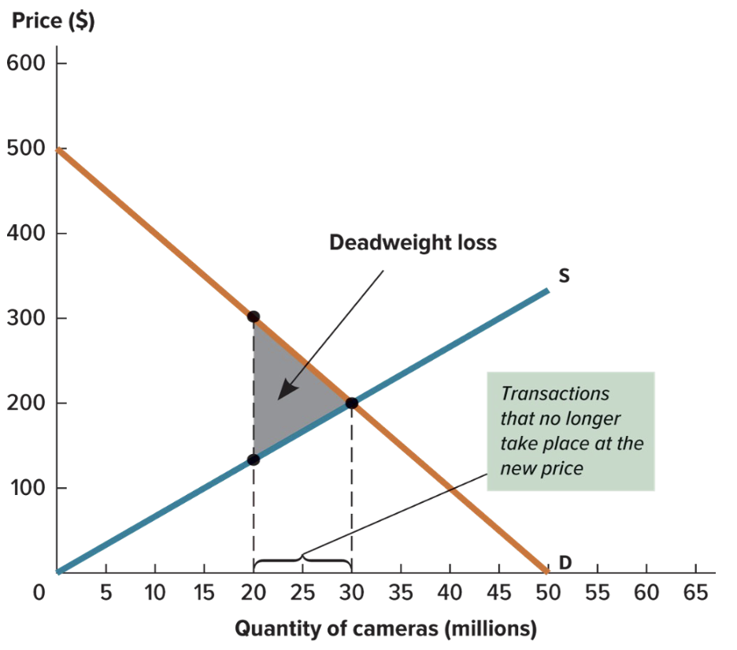
Deadweight loss - loss of total surplus when the quantity of a good is bought and sold is below market equilibrium quantity
Missing markets
- inability to perform market transactions are missing opportunities for mutual benefit
- Missing market - no place for potential buyers and sellers to exchange a particular good or service; quantity is below the equilibrium
- we can increase total surplus by creating new markets and improving existing ones, which has important implications for public policy

Chapter 6- Government Intervention

Every government in the world intervenes in the market, usually for three reasons:
- Correcting Market Failures
- markets do not always operate efficiently
- assumptions of efficient, competitive markets fail causing market failures
- interventions can increase total surplus
- Changing distribution of surplus
- efficient markets maximize total surplus, but outcome may seem unfair
- change the distribution of surplus
- Encouraging or Discouraging Consumption
- people judge certain products as good or bad based on culture, health, religion or other values
- interventions may include bans or taxation

Price controls
- price control: regulation setting maximum or minimum legal price for a particular good
- direct effect of price control is to hold the price of a good up or down when the market shifts, preventing equilibrium
- price ceiling - maximum legal price for a good
- price floor - minimum legal price for a good
Price ceiling
- lower price means fewer producers willing to sell
- causes producer surplus to fall
- total surplus falls as market loses equilibrium
- does not always affect the market outcome
- if ceiling is set above market equilibrium price it is non-binding
Price floor
- way to guarantee minimum income; keeping business alive and ensuring a reliable supply
- price floor can create excess supply quantity equal to difference between quantities supplied and demanded
- can be good for producers but not consumers
- to be fair to all producers, government may decide to buy up all the excess quantity supply so all producers benefit
- we can apply the concept of surplus to formally analyze how this change in total surplus is distributed between consumers and producers.
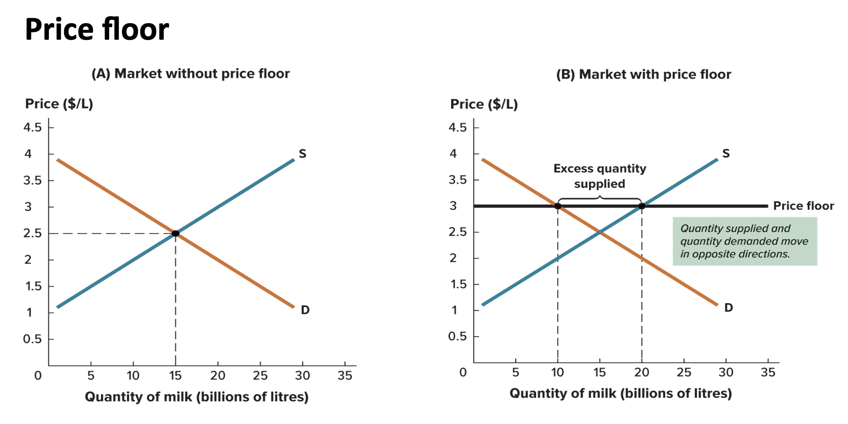
Taxes and Subsidies
- taxes on sellers tend to decrease supply as sales decline
- demand remains the same
- equilibrium price rises while quantity demand falls
- tax wedge - difference between the price paid by buyers and the price received by sellers, which equals the amount of the tax

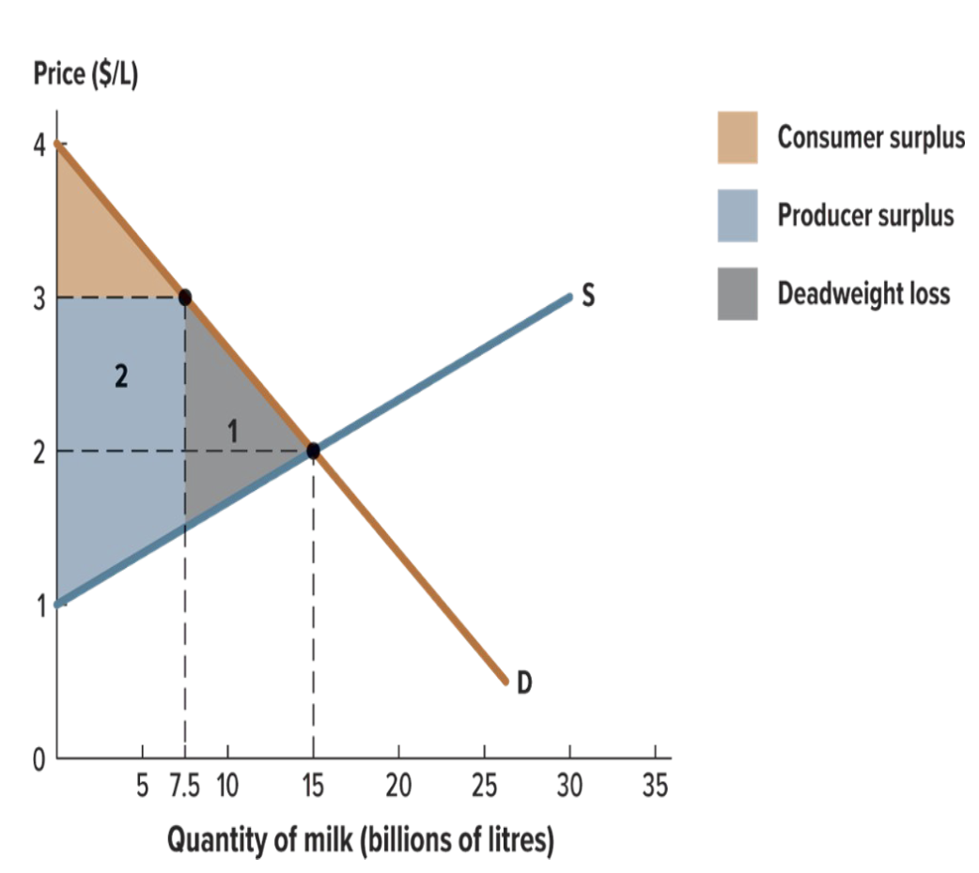
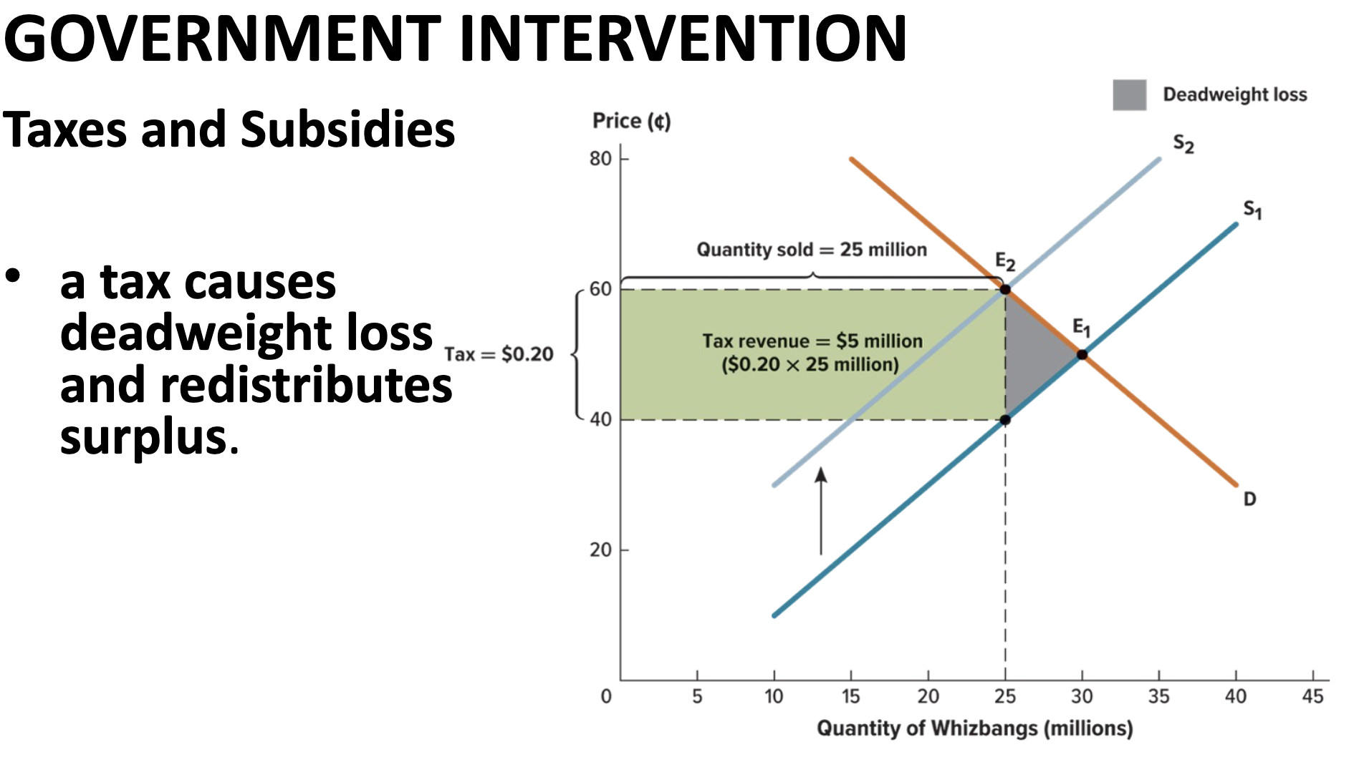
GOVERNMENT INTERVENTION
Taxes and Subsidies
- taxes on buyers have no effect on supply
- demand decreases
- equilibrium price and quantity both fall
- whether tax is levied on buyers or sellers, cost is shared
- tax incidence - relative tax burden borne by buyers and sellers
- statutory incidence - those legally responsible for paying the tax
Subsidies
- subsidy - reverse of a tax; government pays an extra amount to producers or consumers of a good
- subsidies encourage production and consumption of a particular good or service
- alternative to price controls to benefit certain groups without generating a shortage or an excess supplied
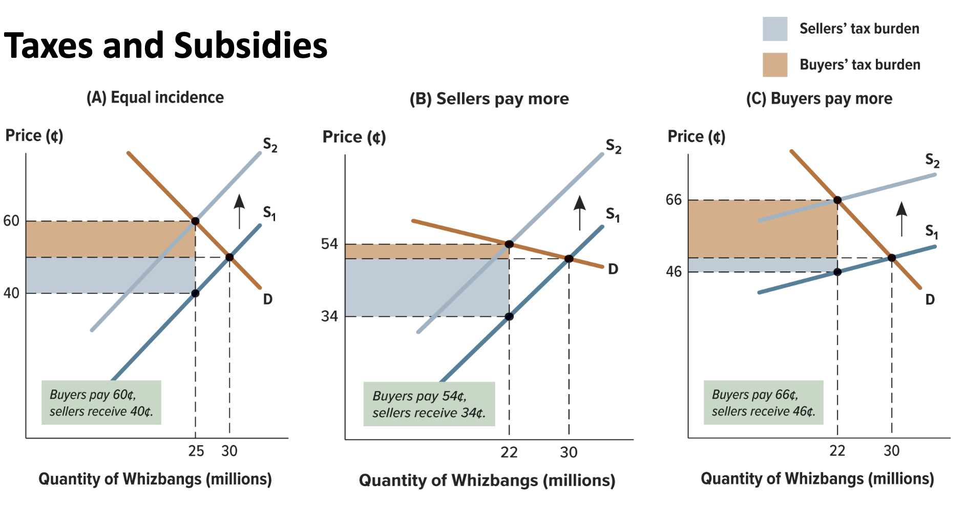

Taxes and Subsidies
Subsidies
- supply increases
- demand remains the same
- equilibrium price decreases and the equilibrium quantity increases
Evaluating intervention
- price controls have opposing impacts on supply and demand
- taxes/subsidies move supplied and demanded quantities in same direction, allow equilibrium
- taxes discourage buying/selling a particular good, raise government revenue, impose costs on buyers and sellers
- subsidies encourage trade of a particular good, cost the government money, benefit buyers and sellers

Long run vs Short run Government Intervention
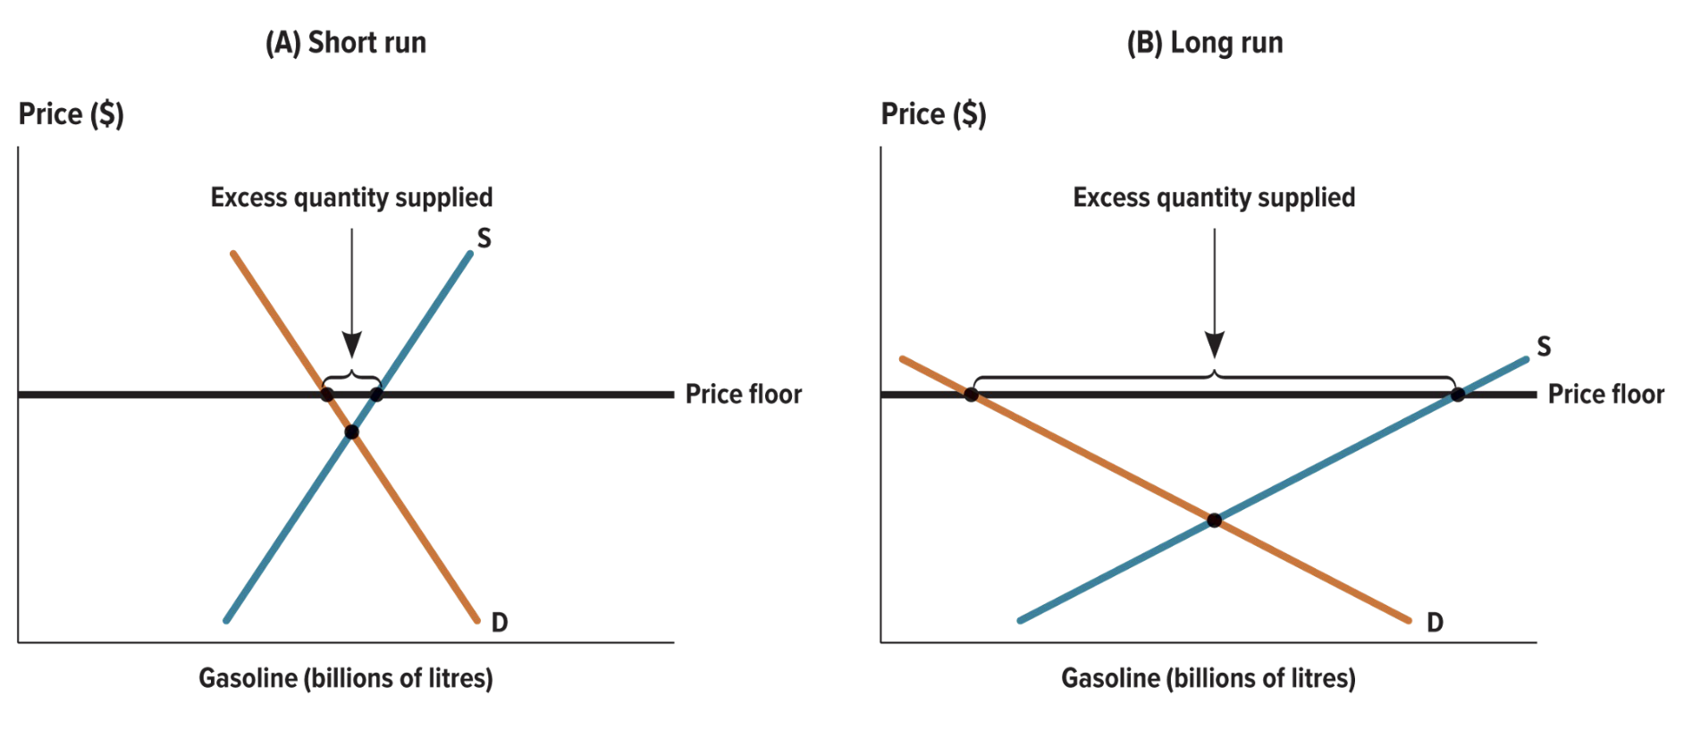

Chapter 7- Consumer Behaviour

the study of how people manage resources
- resource decisions are made by individuals, groups, firms, governments
- resources - tangible and intangible things: cash, land, time, ideas, technology, experience, relationships
Traditionally, economics has been divided into two highly related and interdependent fields:
- microeconomics - study of how individuals/firms manage resources
- macroeconomics - study of the economy on a regional, national, international scale
Utility
The idea of utility is fundamental to economics.
- everyone has different likes/dislikes, situations, incomes, etc. - differences make us appreciate/prioritize different purchases and activities
- utility - measure of the amount of satisfaction a person derives from something
- idea that people are rational utility maximizers is the baseline assumption in economics
- several forms of “utility”

- marginal utility - change in total utility that comes from consuming one additional unit of a good/service
- diminishing marginal utility - utility gained from successive units of a good or service tends to be smaller than the utility gained from the previous unit

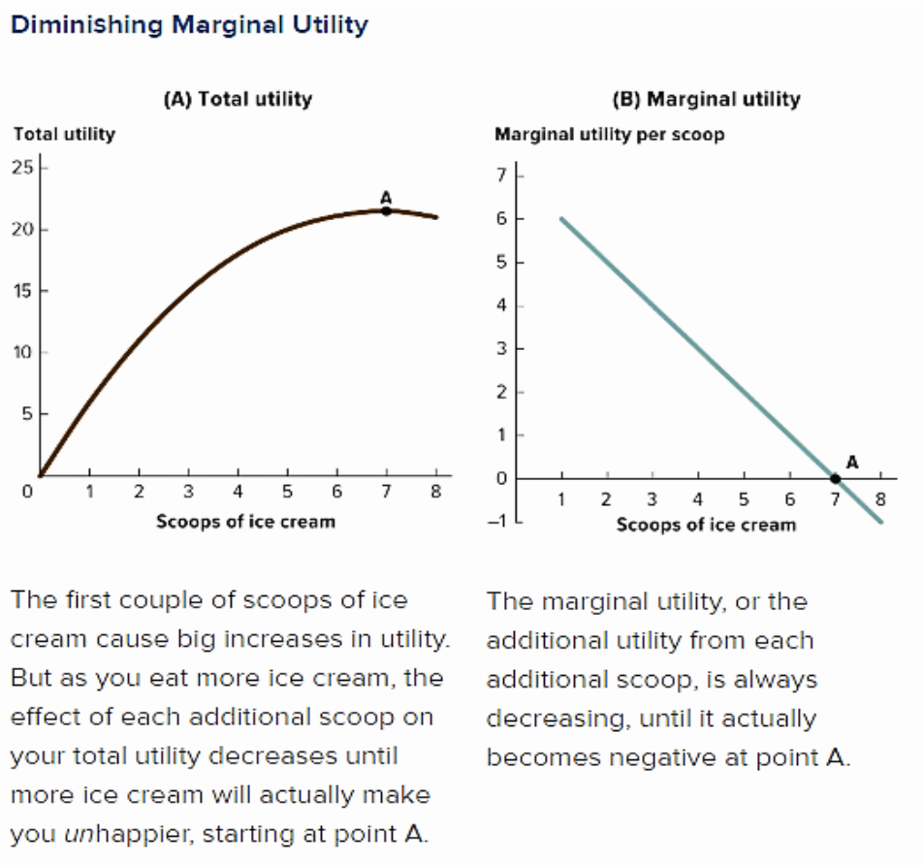
- marginal utility helps make sense of decisions by calling attention to the trade-offs involved
- budget constraint - line composed of all possible combinations of goods/services a consumer can buy with their income
Consumer Behaviour
Responding to Changes in Income and Prices
Income changes:
- >income - more goods and services affordable
- <income - fewer are affordable, reducing consumption
- income effect - change in consumption from increased wealth due to lower prices
Responding to Changes in Income and Prices
Price changes:
- substitution effect - consumption change caused by change in price
- veblen goods - goods people buy because they are flashy and expensive, showing others that they can afford flashy and expensive goods
- A change in the price of one good on the graph rotates the budget curve.
- A change in the price of both goods can lead to a shift in the budget curve as oppose to a rotation
Utility and Society
- common utility maximization misconception is that people are inward-looking consumption machines; utility is subject to envy, status, kindness, emotions
- status utility - comes from two sources:
- direct effect - effect of product on us
- effect other people’s reactions to it have on us
- altruistic utility - motive for action in which utility increases because someone else’s utility increases
- reciprocity utility - responding to another’s action with a similar action (returning a favour)

Chapter 12- Costs of production

- Fixed and Variable Costs
- The first complicating factor in calculating costs is the distinction between fixed and variable costs.
- Fixed costs - don’t depend on the quantity of output produced (machines, buildings, salaried employees)
- Variable costs - depend on the quantity of output produced (raw materials that go into production, many types of labour costs)

Opportunity cost of operations has two components:
- explicit costs - fixed/variable costs (just about all we typically think of as a cost, which require a firm to spend money: rent, labour, materials, machines)
- implicit costs - represent forgone opportunities (opportunities that could have generated revenue if the firm had invested its resources in another way)

Opportunity cost of operations has two components:
- accounting profit - total revenue minus explicit costs (usually seen when a company reports its profits)
- economic profit - total revenue minus all opportunity costs, explicit and implicit
- economic profit = total revenue − explicit costs − implicit costs
- sometimes there is more profit from financial investment than enterprise

Production Function
- inputs - ingredients that go into production process (raw materials, labour, machines, time, ideas)
- outputs - goods and services produced
- production function - relationship between the quantity of inputs and the quantity of outputs
- marginal product - increase in output that can be produced by additional investment
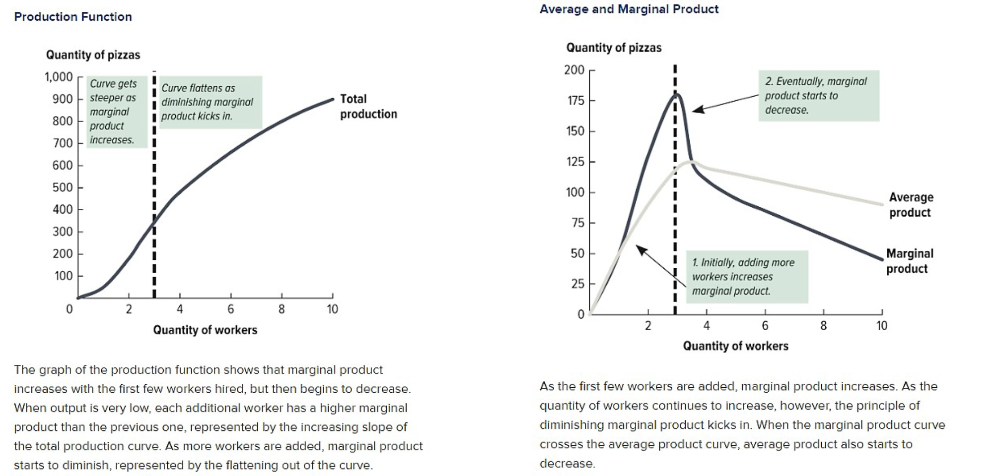
- diminishing marginal product - principle states that the marginal product of an input decreases as the quantity of the input increases

THE COSTS OF PRODUCTION
Cost Curves
- When a firm increases its output by adjusting its use of inputs, it incurs the costs associated with that decision.
- cost of an input won’t decrease simply because you’ve reached point of diminishing marginal product

Total and Average Costs: total costs = fixed costs + variable costs
- average total cost (ATC) = total cost/quantity
- average variable cost (AVC) = variable cost/quantity
- average fixed cost (AFC) = fixed cost/quantity

Total Cost Curve
- total cost curve is the sum of variable and fixed costs
- slope of total cost curve reflects diminishing marginal product
- each additional worker costs the same, but adds fewer additional pizzas
- fixed costs stay the same

Average Cost Curve - average fixed cost decreases as output increases (cost spread over more output)
- average variable cost reflects the marginal product of inputs
- average total cost is the above costs added together

Marginal Cost Curve - inverse of the marginal product curve
- every additional input unit costs the same, regardless of contribution to production
- marginal product initially increases, so marginal cost initially decreases
Marginal and Average Cost Curves- marginal cost of making another pizza is less than average total cost; extra pizza will decrease the average total cost
- marginal cost of making another pizza is more than the average total cost; producing that extra pizza will increase the average total cost
Marginal Cost
Marginal Cost (MC) - marginal cost of production is determined by dividing the change in total cost by the change in the quantity of output
- MC = change (∆) in total cost/change (∆) in quantity
- = ∆ total cost/∆ total quantity
Production
The differences between the costs that firms face in the short run and the long run reflect this need for production adjustment time.
- “fixed” prices vary with time and circumstance
- long run - refers to however long it would take for a firm to vary all of its costs
- planning for the long run considers the scale at which business wants to operate
- returns to scale - describes relationship between the quantity of output and average total cost
- economies of scale - operating on a larger scale may lower average costs
- diseconomies of scale - point at which increasing scale leads to higher average costs
- constant returns to scale - various scales at which a firm can operate without experiencing higher or lower average costs
- when expansion could achieve economies of scale, long-run ATC curve slopes down
- when diseconomies of scale from expansion, the curve slopes up
- long-run ATC curve has flat middle, showing various levels of output for constant returns to scale
- by changing scale, a firm can move along the long-run ATC curve from one short-run ATC curve to
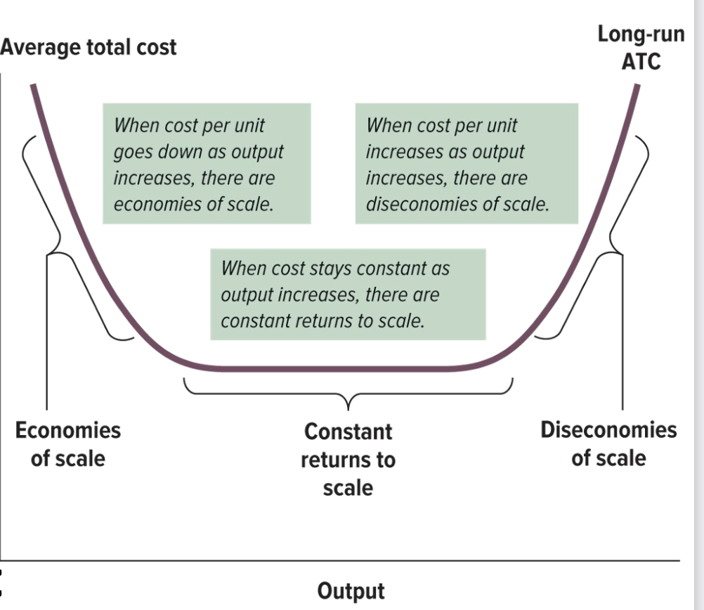
- another
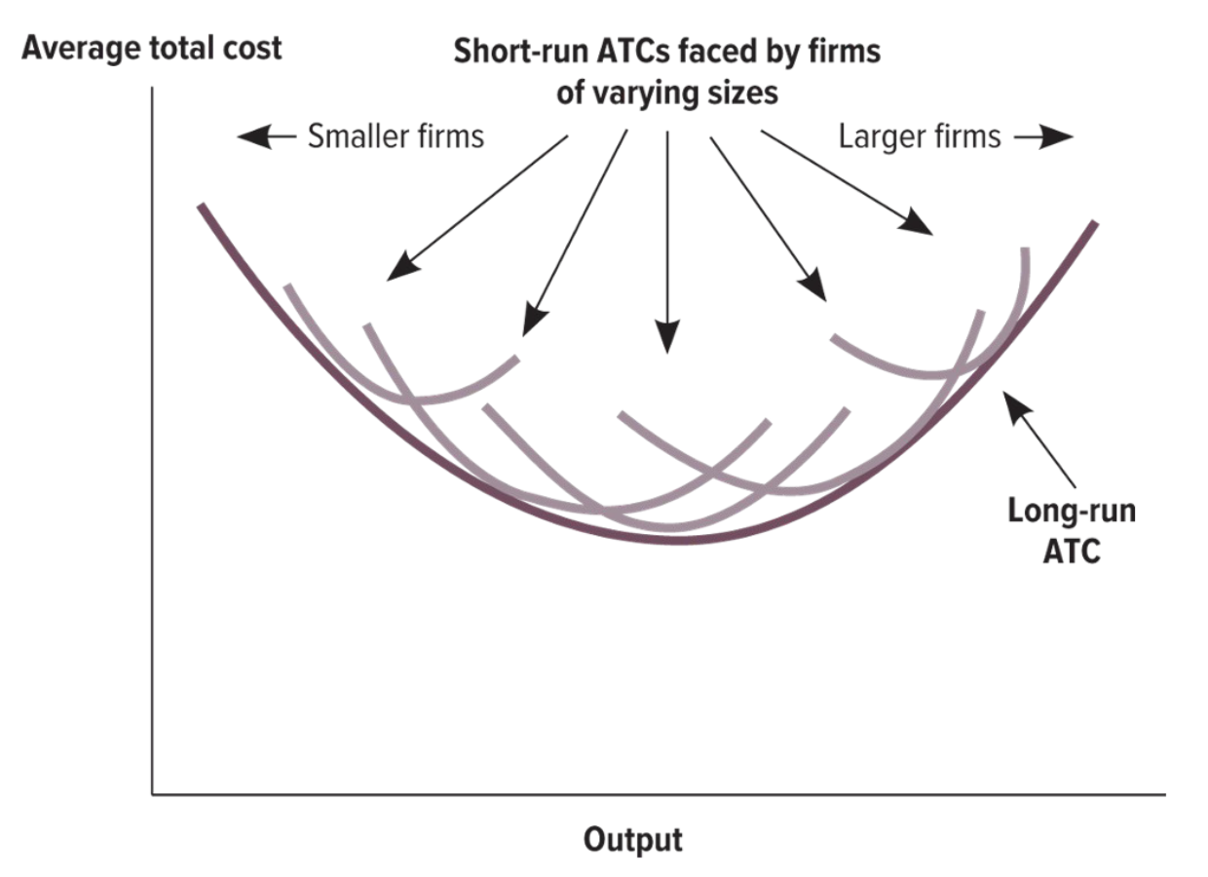
- when a firm moves along the long-run cost curve, it does so by choosing to move to the short-run cost curve associated with a larger/smaller firm
Chapter 13- Perfect competition

The forces of competition help make millions of products and services available and affordable to billions of people
- profits depend not just on revenues, but also on costs
- keep producing as long as marginal cost is less than marginal revenue
- stop producing as soon as the two are equal
- profit-maximizing quantity - quantity at which the marginal revenue of the last unit is exactly equal to the marginal cost
- most extreme choice firm can make about how much to produce is to produce nothing at all

profit-maximizing quantity:
- point where marginal revenue of last unit exactly equals marginal cost
- when marginal revenue > marginal cost, profits increase by making more
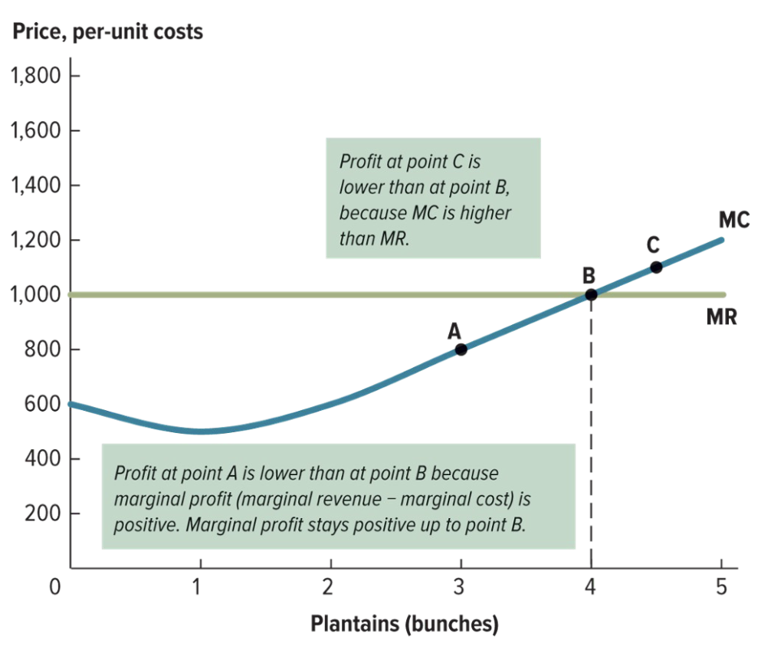
- when marginal cost > marginal revenue, producing another unit is negative
Perfect competition
- section of marginal cost curve above AVC shows firm’s short-run supply curve
- above that point, firm will produce quantity where price intersects the MC curve
- below minimum AVC, firm produces nothing; it would generate a negative profit
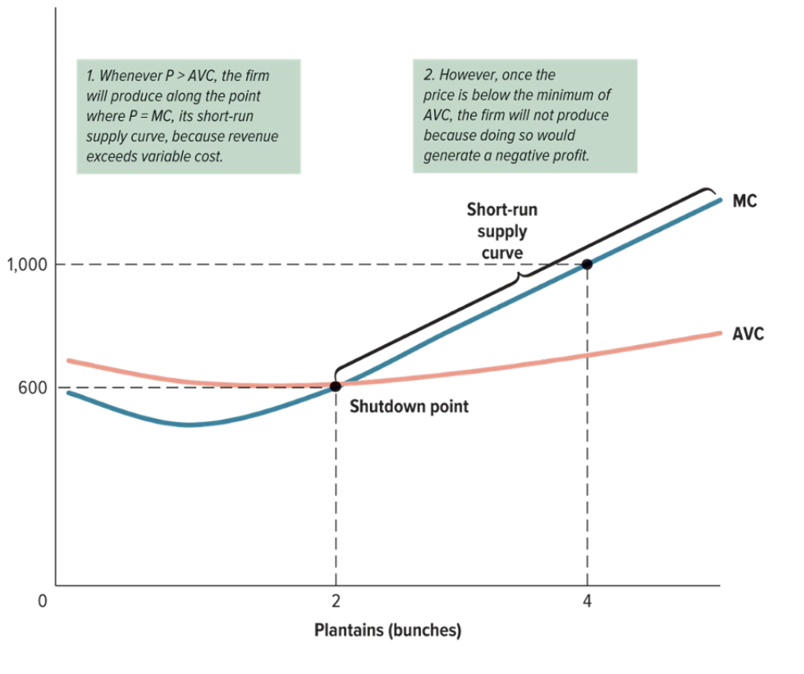
A firm can avoid the variable costs of production and fixed costs by exiting the market
- if price < average total cost, firm should exit the market
- if price > average total cost, firm should enter the market

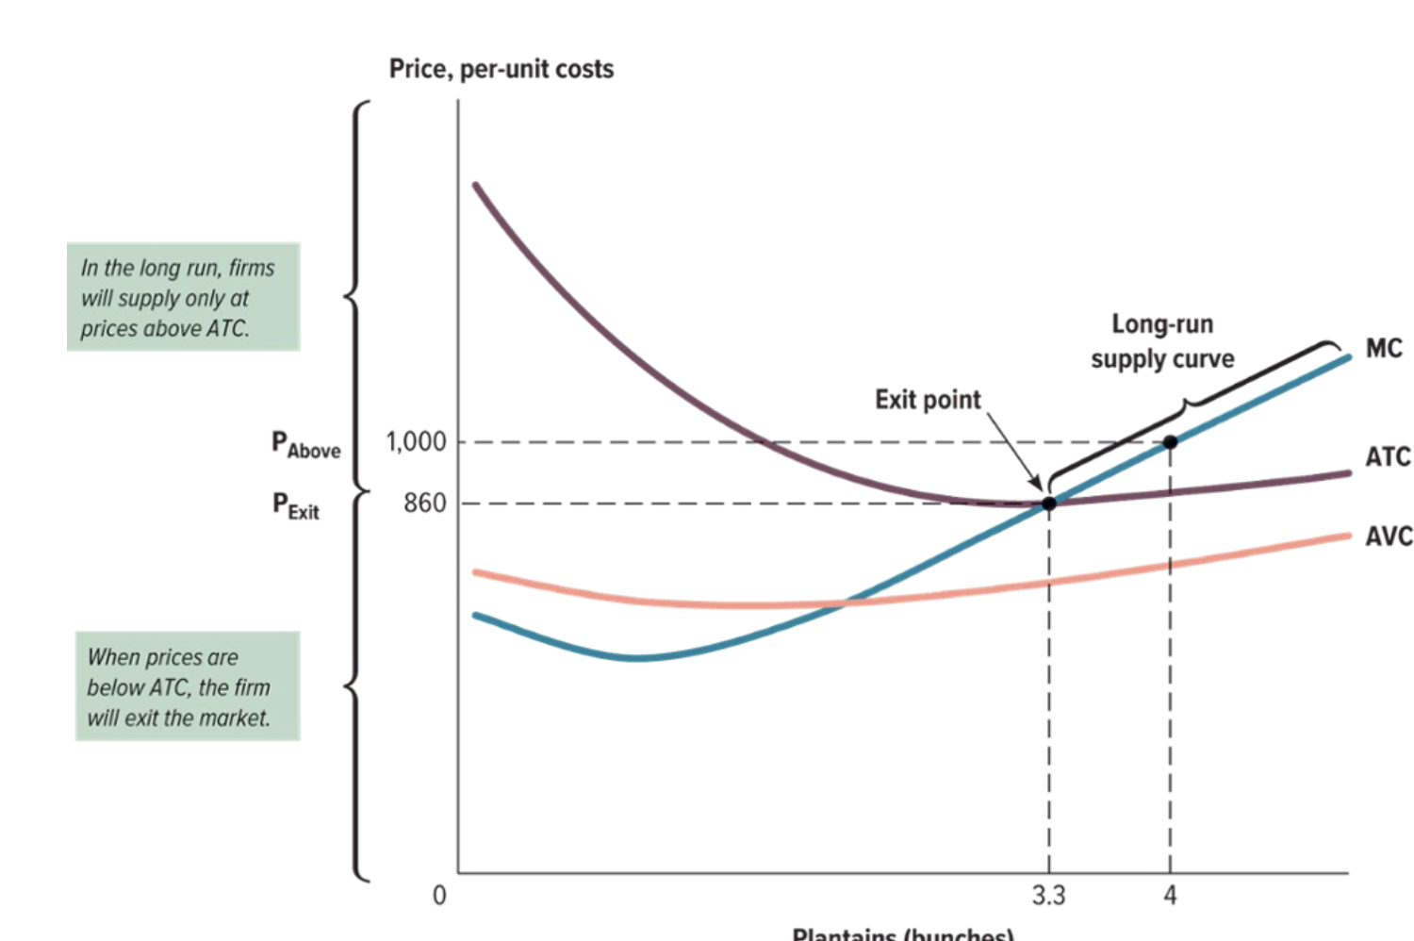
Behind the Supply Curve:
Short-run supply assumes that the number of firms in the market is fixed
- total quantity of a good that is supplied at a given price is sum of quantities each producer supplies
- long-run supply assumes firms are able to enter and exit the market in the long run
- number of firms is not fixed, but changes in response to changing circumstances
Behind the Supply Curve: supply increases increase quantity
- optimal quantity: MR = MC
- each optimal quantity-price pair adds point on curve
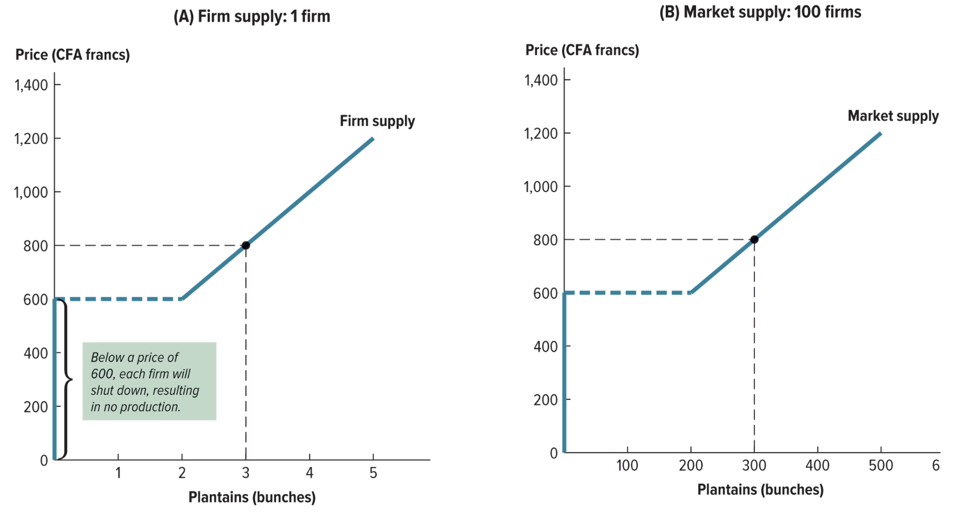
- total quantity supplied = sum of quantity each firm supplies

In the long run, in a perfectly competitive market:
- firms earn zero economic profit
- firms operate at efficient scale
- supply is perfectly elastic
- P = MC = ATC
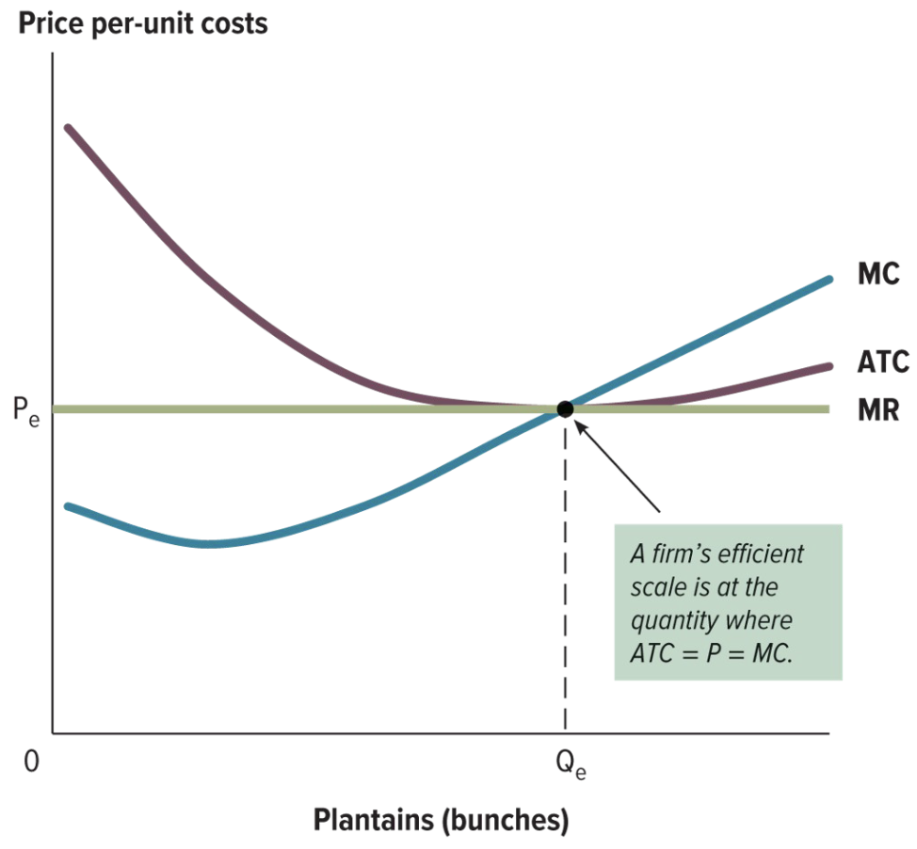
- if market moves away from minimum-of-ATC price, firms will enter or exit the market
- quantity supplied increases/decreases quantity supplied until equilibrium price
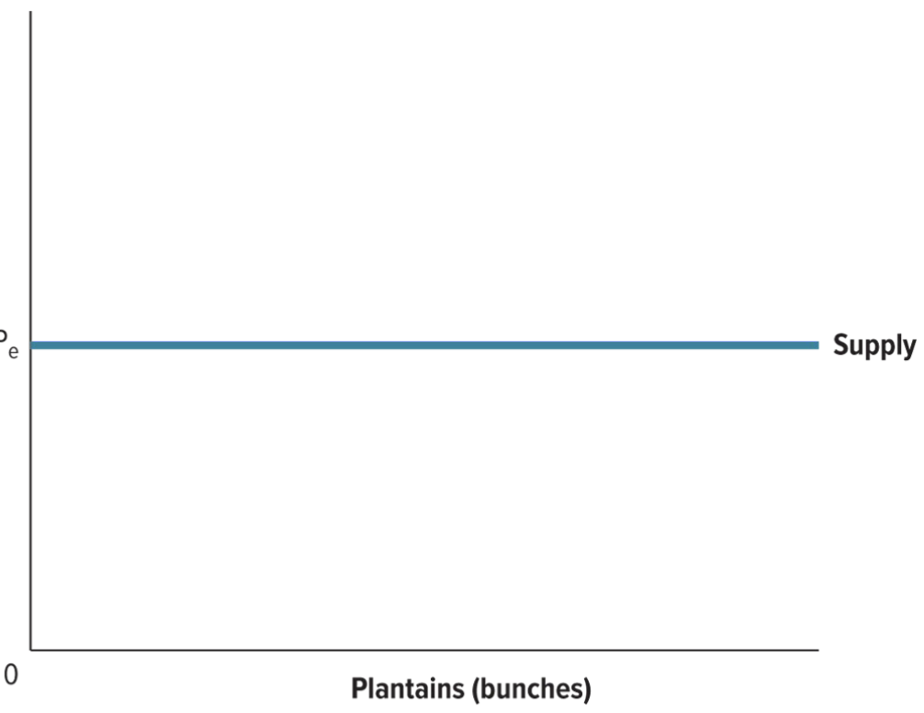
- long-run price is same at any quantity; supply curve is horizontal
- new entrants to an industry are unlikely to achieve the same low costs as firms that have built up expertise over the years
- newer firms with higher costs will enter only markets with higher prices
- long-run supply curve will slope upward, because price has to rise to entice new firms to enter and increase the total quantity supplied
- price = minimum of ATC for the least-efficient firm in the market, not every firm in the market
- last firm to enter the market earns zero economic profit; ATC is equal to price
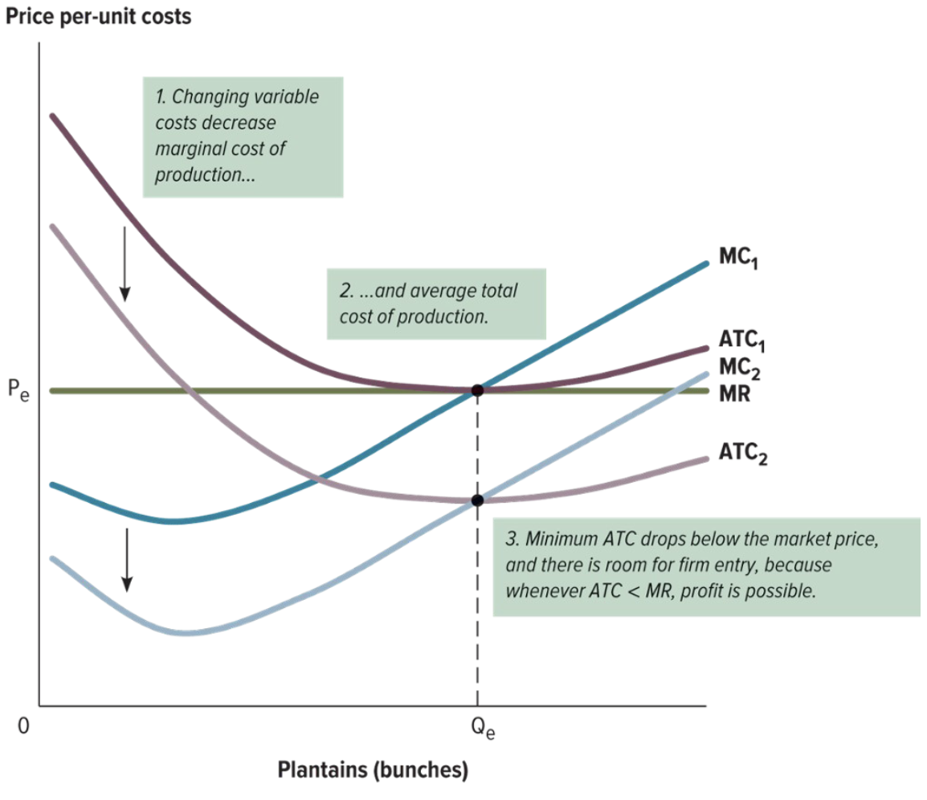
- more efficient firms, with lower ATC, can earn positive economic profit

- improving technology and production processes can decrease ATC
- price must equal minimum ATC in the long run
- prices will fall as production costs

Chapter 14- Monopoly

Properties and behavior of Monopoly economies

Number of firms: one
Differentiated Products: No
Price setter or price taker: Price setter
Price level: Very high
Strategies depend on the rival? : There are no rivals
Entry? : There is no entry
Long-run economic profit: Positive

- A monopoly is the only supplier of a good or service and it has no close substitutes.
- Monopolies are common, and provincial and local governments create them for utility such as water, garbage, electricity and natural gas.
- A monopolist’s output is the market output.
- It’s demand curve is the market demand curve.

What is a Monopoly?
- A firm that is a sole seller of a product, and the product has no close substitutes (similar products).
- Examples of Monopolies are Amazon, Google, Microsoft, Apple and Facebook.

Cause of Monopolies
- A monopoly market has a barrier to entry: an explicit restriction or cost that prevents new firms from entering the market.
- The monopolist is not subject to the restriction and does not bear the cost.
- Other firms cannot enter the market. (barrier to entry)
The two main reasons some markets are monopolies:
- The government creates a monopoly through its practices (e.g. licensing, auctions or in law)
- A firm may have a cost advantage
Causes of Monopolies: Government policies
- Restricting licenses to operate
- Enacting specific legislation to create a monopoly
- A patent: Grants the holder the exclusive right to use or sell an invention for the term of the patent.
Cause of Monopolies: Cost Advantages
- Essential facility: A single firm owns a scare/key resource that a rival needs to survive.
- A single firm has superior technology or organization.
- Natural Monopoly: A single firm can produce the entire market output at a lower price than could several other firms.
Monopoly vs Competition: Demand curves
- In a competitive market, the market demand curve slopes downwards, but a competitive market/firms demand curve is horizontal.
Understanding the Monopolist’s marginal revenue
- Increasing Q has two effects on revenue
- Output Affect: Higher output raises revenue (MR Increases)
- Price effect: Lower price reduces revenue (MR Decreases)

Profit maximization
- Where MR=MC, this is the case for both Monopolies and Competitive markets.
- Where MC and MR intersect, as seen below:

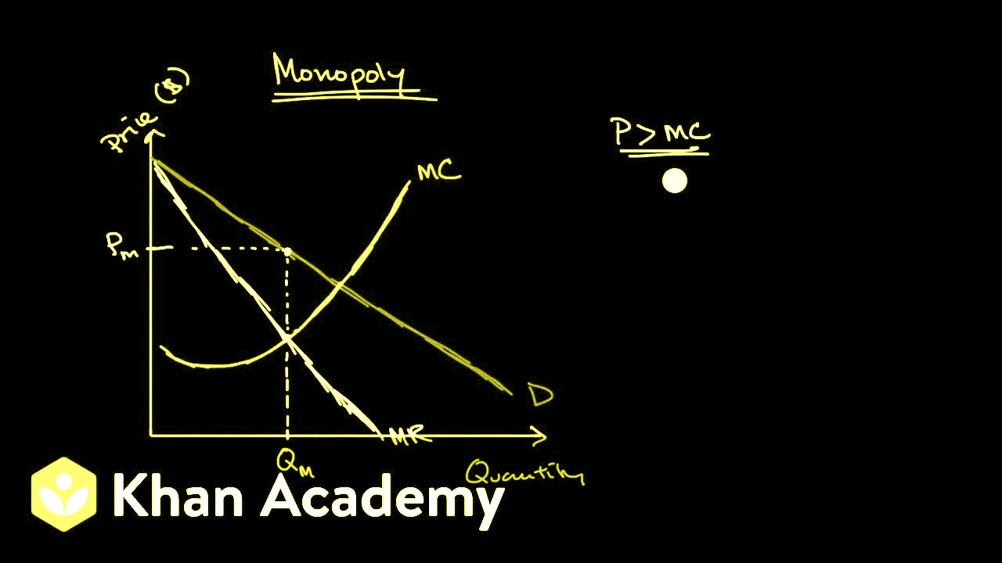
The Monopolist's Profit= TR- TC, same as a competitive firm
= (price)(quantity)- TC
=(price- TC/Q)Q
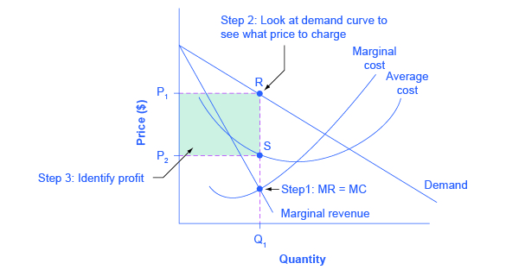
=(price- ATC)Q
A Monopolist does not have a supply curve
- A supply curve provides a unique relationship between price and output
- A competitive firm: Takes price as given, and has a supply curve that shows how its output depends on price
A monopoly is a price maker, not a price taker

In a monopoly equilibrium p>MR=MC

Price Discrimination: Selling a good at different prices to different buyers

Welfare Analysis: Single Price Monopoly
- No discrimiantion: The monopolist charges the same price to all
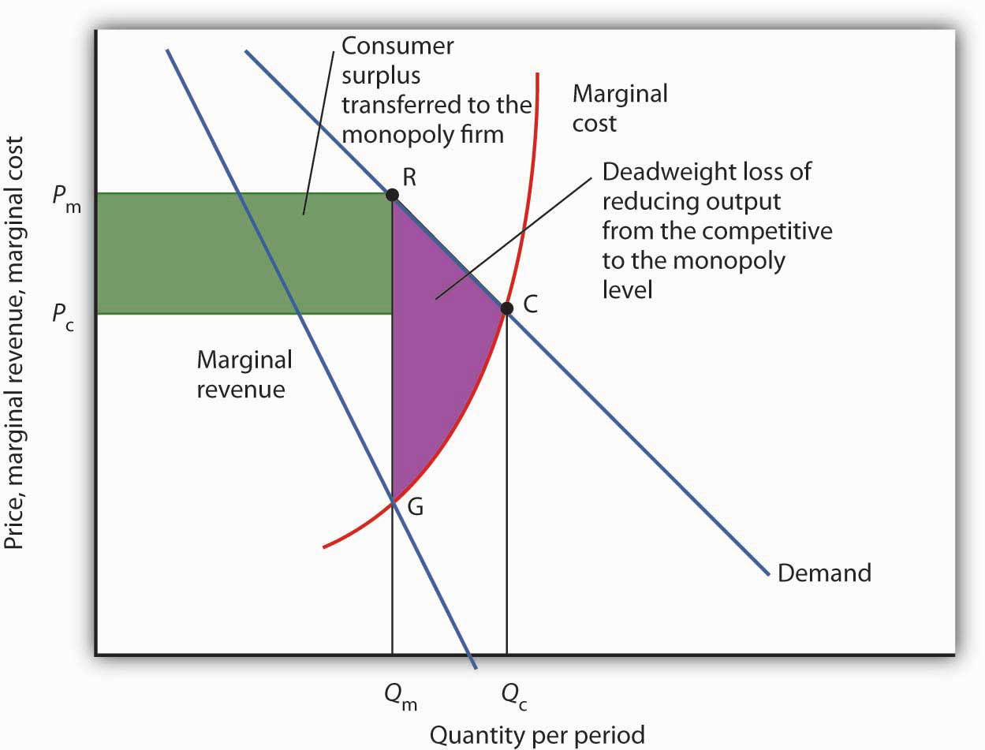
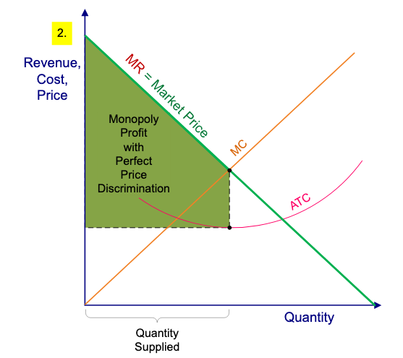
Perfect Price Discrimination:
In the real world perfect price discrimination is not possible:
- No firm knows every buyer’s WTP
- Buyers do not announce their WTP to sellers

Examples of price discrimination
- Airline travel and time of departure: Airlines charge different prices depending on the season and day of the week.
- Age Discounts: A popular way to segment the market is by age category, e.g. students and OAPs often get discounts, such as 10% off.
- Resident parking charges: In some tourist cities, residents get lower prices for public transport and parking.

Public Policy towards Monopolies: Antitrust Laws
- Laws that can ban business practices that are monopolistic or restrain
commerce, and allow the government to break up monopolies.

Public Policy towards Monopolies: Other interventions
- Regulation
- Government agencies set the monopolist’s price at p=MC

When a Monopolist increases(decreases) the amount of output that it produces or sells, its average revenue falls(rises) and it's MR falls(rises)

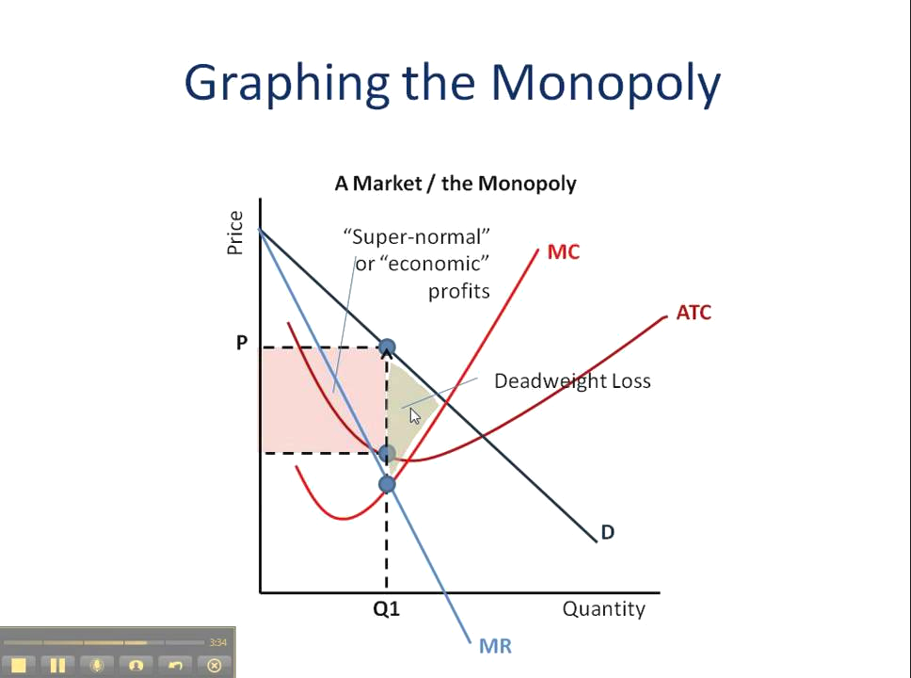

Chapter 18- Externalities

Externalities
- An effect(by-product, spillover) that production or consumption of a good has on the well-being of third parties.
- People who are not directly involved in that market, but are affected by it.

It can be positive or negative

Market failure
- Situations in which total surplus is not maximized at the market equilibrium
- The market outcome is not efficient: the equilibrium quantity is “wrong” and deadweight loss occurs.
Why do externalities arise?
- Because self-interested buyers and sellers in a market neglect the external costs they impose on, or benefits they provide to others when making decisions.
Principle: Governments can sometimes improve market outcomes

Examples of Negative Externalities
- Side effects that adversely affect third parties
- Air pollution from a factory
- The neighbours having sex at 1 am
- Music blasting while you’re sleeping
- Health risks of driving while texting
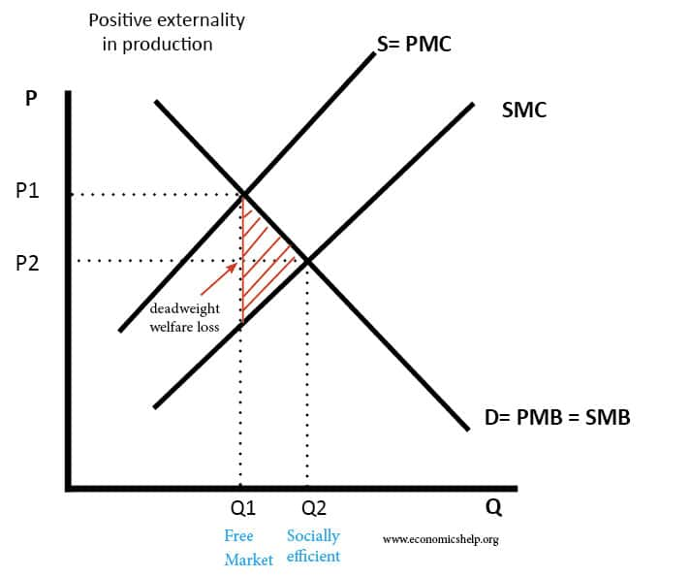
- The height of the demand curve, D, at any Q measures the private value-or the willingness to pay

- Market equilibrium at point (Q2,P2) maximizes consumer and producer surplus

- Adding external benefits/costs to the private costs gives us the social MC/supply curve, S=PMC, which is above the market supply curve by the amount of the external cost for each unit produced.

- The vertical distance between S=PMC and SMC is called the per-unit external cost of whatever that is being sold.

- Social equilibrium is at point (Q1,P1)

- The market equilibrium at (Q2,P2) is not efficient because producers do not bear the cost of pollution they cause for third parties.

- For each unit produced between 0 and Q1, the MB>social MC
- At Q1 the MB=social MC

- For each Q>Q1, social MC>MB
- The optimal level of production is the lower Q1
- Inefficiency (=Q2-Q1) results in the presence of a negative externality.

- The socially efficient price, P1, reflects a higher social cost

