Lab 9: Electromagnetics Part II – Apparent conductivity + Expo Site

Name: Chris Chan ID: 54568993

Overview

In the first part of the lab, we introduce the concept of apparent conductivity for EM measurements and further explore how the apparent conductivity can be computed with the layered structures.

Then in the second portion of the lab, we examine data sets obtained at the old Expo site in the False Creek area of Vancouver. The site has a fairly complex industrial history, and was set to be remediated and turned into a public space. Before any remediation could take place, the site needed to be characterized. You will be examining geophysical data collected over this site. To detect anomalous conductive or resistive targets, we first treat frequency domain EM data collected with the EM-31 instrument. We will interpret the measured EM data sets and characterize the subsurface of the site. To increase reliability we also study gradient magnetics data to obtain information about the magnetic susceptibility subsurface. By integrating these two geophysical data sets we better characterize isolated targets embedded in this region.

Read the background information from the Expo site characterization report (https://gpg.geosci.xyz/content/electromagnetics/electromagnetic_interpretation.html) and use it to answer questions regarding the EM-31 and magnetic gradient surveys.

Notation: In the GPG and in this app we are attempting to keep a consistent notation to help you keep track of the configuration of the source and receiver.

- HCP: Horizontal coplanar system. The associated dipoles are perpendicular to the plane of the loops and are therefore in the vertical direction. The response function associated with this is $ϕ_{V}$.

- VCP: Vertical coplanar system. The associated dipoles are perpendicular to the plane of the loops and are therefore in the horizontal direction. The response function associated with this is $ϕ_{H}$.

Apparent conductivity

Q1. Considering a horizontal coplanar (HCP) configuration of EM system (e.g. EM-31), imaginary part of the measured data, Hs/Hp, can be written as

$$Im\left(\frac{Hs}{Hp}\right)≈\left(\frac{ωμ_{0}σs^{2}}{4}\right)×100 [\%], when δ≫s$$

- $δ$ : skin depth $\left(=500\sqrt{\frac{1}{σf}}\right)$ [m]
- $s$ : source and receiver separation [m]
- $ω=2πf$: angular frequency [rad/s]

a. By using the above equation derive a formula that you can compute apparent conductivity, $σ_{a}$

$$σ_{a}= \frac{4Im\left(\frac{Hs}{Hp}\right)/ 100\%}{ωμ_{0}s^{2}}$$

b. Suppose with the EM-31 you have measured EM data:
- In-phase Hs/Hp: 2.6%
- Quadrature Hs/Hp: 1.15%
Compute the apparent conductivity using the equation that you derived in the above question.
f = 9.8kHz
s = 3.66 m
$μ_{0}$ = 4$π$ x 10⁻⁷
$σ_{a}$ = 0.04438

Q2. For this part of the exercise, use the EM_EM31.ipynb.

The apparent conductivity is equal to the “integral” of the true conductivity and a response function ($ϕ_{V}$ or $ϕ_{H}$; depending upon how the instrument is oriented). Become familiar with this concept by adjusting the parameters $h_{1}, σ_{1}, σ_{2}$ and change the boom configuration and see how this affects the apparent conductivity.

a. Set the parameters to the following: $σ_{1}=0.01, { σ}_{2}=0.01, h_{1}=0.5, h_{boom}=0$. What is the apparent conductivity for each of the configuration (HCP and VCP)? Note description of the horizontal coplanar (HCP) and vertical coplanar (VCP) is shown in GPG.

HCP = 0.010 S/m
VCP = 0.010 S/m
b. Next, set $σ_{1}=0.1$, and keep $σ_{2}=0.01, h_{1}=0.5, h_{boom}=0.$ What is the apparent conductivity for each of the boom configurations (HCP and VCP)?

HCP = 0.036 S/m
VCP = 0.063 S/m

c. Now set $σ_{1}=0.01$, $σ_{2}=0.1, and keep h_{1}=0.5, h_{boom}=0$. What is the apparent conductivity for each of the boom configurations (HCP and VCP)??

HCP = 0.074 S/m
VCP = 0.047 S/m

d. Set $σ_{1}=0.01$, $σ_{2}=0.1$ and increase $h_{1}$ to 1.5. What are the apparent conductivities for each of the boom configurations (HCP and VCP)?

HCP = 0.038 S/m
VCP = 0.025 S/m

e. For the above examples, we observe that the HCP and VCP configurations give different apparent conductivities. How do you explain this?

The different orientation of the dipoles leads to different sensitivities to the inducted field.

f. Using the response function diagrams, and the answers above, which boom configuration has greater depth of penetration? Which is more sensitive to near-surface layers?

The horizontal setup is the best for greater depths of penetration, and the vertical setup is more sensitive to the near surface layers.

Q3. For this part of the exercise, use the EM_EM31.ipynb.

a. Set $σ_{1}=0.1, { σ}_{2}=0.1$, $h_{1}=$0.5. Now raise the boom height, $h_{boom}$. First, look at the HCP configuration. How does the apparent conductivity change?

$$h_{boom}$$ | $$σ_{a}$$
0 | 0.1 S/m
.5 | 0.071 S/m
1.0 | 0.045 S/m
2.0 | 0.024 S/m
3.0

b. Set $σ_{1}=0.01, { σ}_{2}=0.1$, $h_{1}=$0.5. Now raise the boom height, $h_{boom}$. Look at the VCP configuration. How does the apparent conductivity change?

$$h_{boom}$$ | $$σ_{a}$$
0 | 0.1 S/m
.5 | 0.041 S/m
1.0 | 0.024 S/m
2.0 | 0.012 S/m
3.0

Expo Site EM-31 data maps

EM-31 data are measured on a 2m-spacing grid with the boom about 1 m above the surface. At each station, in-phase and quadrature components of Hs/Hp (%) are recorded for EW and NS boom orientations, resulting in four maps as shown below.
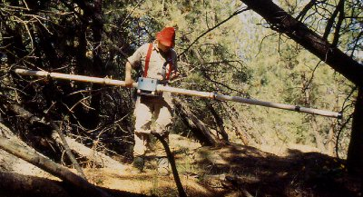

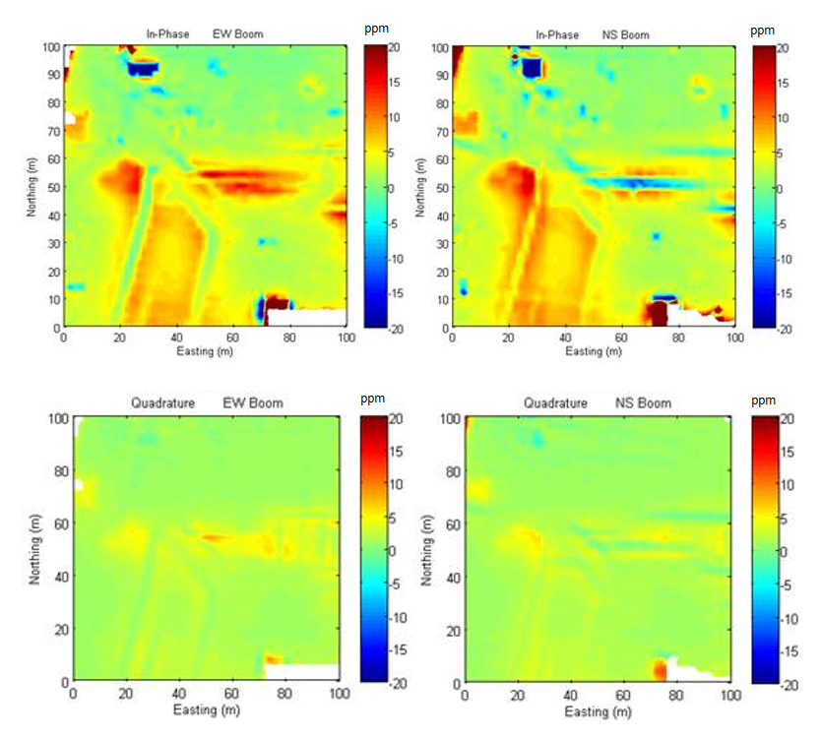

The quadrature data are then converted to apparent conductivity maps. Apparent conductivity can be a good representation of the ground conductivity if the earth is uniform and the Tx-Rx separation is much less than the skin depth (s << $δ$).

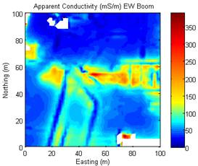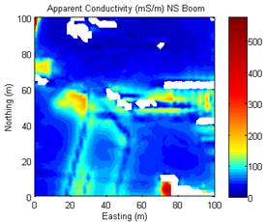
Q4. The EM-31 is often used to measure the Earth's conductivity. Look at the apparent conductivity maps using both EW and NS boom orientations (error readings and negative readings are plotted as white) and answer the following questions.

a. What are the maximum and background conductivities for each map? Calculate the skin depths for the maximum and background conductivities for each map.

Skin depth = $500 \sqrt{\frac{1}{σf}}$ m
EW Boom:

Maximums = 350 mS/m
Background = 25 mS/m

Skin depth max = 8.54m
Skin depth background = 31.94m

NS Boom:

Maximums = 500 mS/m
Background = 50 mS/m

Skin depth max = 7.14m
Skin depth background = 22.59m

b. Based upon this criterion, do you think the inferred ground conductivity at the location with maximum apparent conductivity is reliable? Why or why not?

Based on the large difference of the skin depths in the background and maximum I do not think that the inferred ground conductivity at the apparent maximums is reliable.

c. The apparent conductivity values computed using the EM-31 data are based on the assumption that the earth is a uniform half-space. Based on the apparent conductivity maps, where are the regions that might satisfy this assumption?

The Northeastern portion of both maps seem uniform, and apart from the negative or error reading, the southeastern portions of these maps seem uniform as well.

d. There are some areas with negative apparent conductivities, which are not realistic. Why could this happen? Hint: think about how an apparent conductivity is calculated and the sign convention of EM-31 data; recall the 3-loop model diagram.

With the assumption for EM-31 that the halfspace is uniform, the negative readings are likely due to anomalous objects that not only violate this assumption, but also act as confined conductors, and they are oriented in such a way that the induced field opposes the primary field created by the transmitter.

