OB Notes for Final Exam:

Groups and teamwork:

Groups: A group is two or more people who interact interdependently to achieve a common goal.
Important because:
- Groups influence us: mechanisms by which we acquire beliefs, values, attitudes, behaviors
- They provide a context in which we are able to influence others
- They can be formal or informal.

Types of groups:
Formal groups:
- Established by the organization to help achieve goals
- Most common: managers + subordinates
- Other types: task forces, committees
Informal groups:
- Emerge naturally in response to the common interests of organization members
- Not established by the org., usually not sanctioned by it.
- Can help or hurt the org

Groups Development Stages:

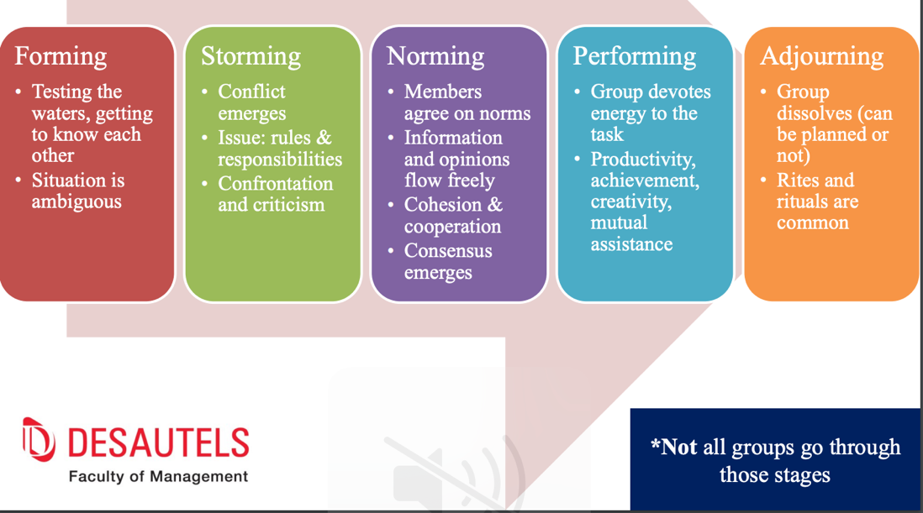

** By selecting people that you have already worked with. The performing stage will arrive faster than if it is a newly formed team.

Group Structure:

- 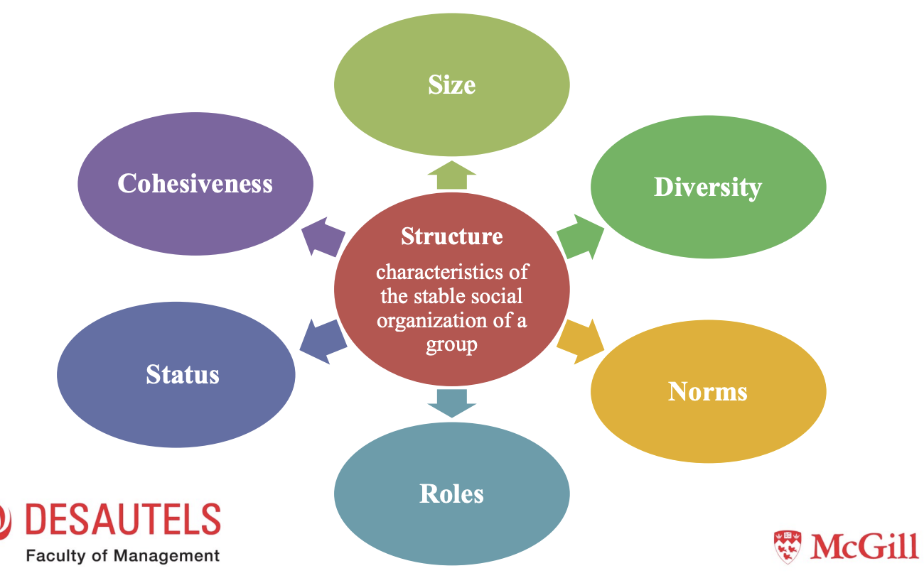

Size: Refers to the number of people in the group.

- Impact on satisfaction: Satisfaction is higher in small groups.
- In large groups: less chances to develop real friendships, more chances of conflict/dissension, people may be inhibited about participating, people identify less easily with successes of the group.
- Impact of the size of the group on performance:
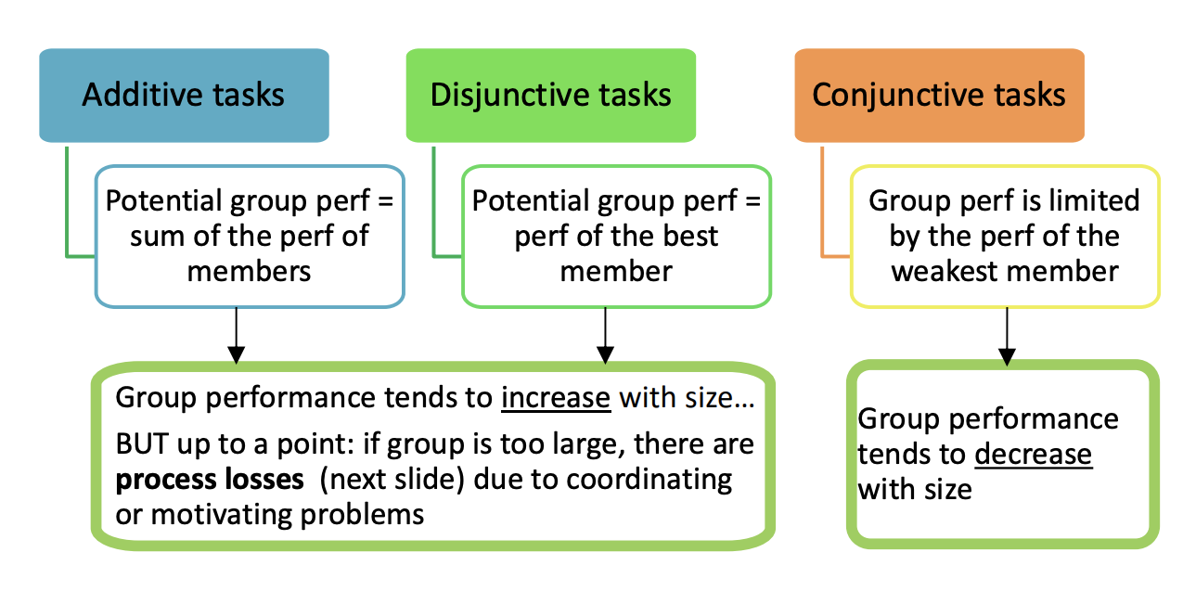

- Additive Tasks Example: adding painter to paint a room increase performance until a certain point (process losses). If you have 400 painter to paint a room nothing will be done.

- Disjunctive Task Example: finding a good idea = only one intelligent person with one good idea. Size of the group does not matter. The probability of finding a good idea is higher as the group size increase.

- Conjunctive Task Exemple: Assembly line?? --> Need smaller group.

Diversity: Diversity refers to differences among groups members, can be on the surface (e.g., gender, ethnicity), or deeper (e.g., values). Affects interaction patterns. May impact performance in different ways.

- Potential Problems:
  - Communication difficulties. Why?
  - Cohesiveness may be difficult to achieve. Why?
  - Take longer to get to performing stage. Why?

- Potential Strenght:
  - Performance tends to be better, especially for cognitive, creativity demanding on tasks and problem solving.

Norms: Norms are collective expectations that members have regarding the behavior of each other. This consistency provides important psychological security and permits us to carry out our daily business with minimal disruption.

- Generally, remain unconscious. Why?
- About Norms development:
  - Why are their norms in groups? : To prvide regularity and predictability tobehaviour
  - How are norms formed? : Based on group members attitude.
  - About what?: Behaviour at least marginally important.
- Much compliance occurs simply because the norm corresponds to privately held attitudes
- Often save time and prevent social confusion – Social codes – Belonging
- Typical norms in groups:
  - Dress norms
  - Reward allocation norms:
    - Equity: reward according to input
    - Equality: same rewards to all
    - Reciprocity: reward people the way they reward you
    - Need/Social responsibility: reward those who need it most
  - Performance norms: appropriate level of performance

Roles: Roles are positions in a group that have a set of expected behaviors attached to them (“packages” of norms that apply to particular members)

- Kinds of roles:
  - Assigned: formally prescribed by the organization: “who does what” and “who can tell others what to do”
  - Emergent: develop naturally to meet socio-emotional needs of group members, or assist in formal job accomplishment: “class clown”

- Potential issues with roles:
  - Role Ambiguity: Refers to unclear expectations, goals, methods, responsibility, etc.
  - Sources:
    - Org. factors: unclear function of role in the organization
    - Role sender: does not have clear ideas regarding the role or does not communicate them clearly
    - Focal person: does not understand clearly
  - Role Conflict: Refers to incompatible role expectations
  - Types:
    - Intrasender: one persons sends incompatible expectations
    - Intersender: different people send incompatible expectations
    - Interrole: different roles of one employee have incompatible expect.
    - Person-role: expectations incompatible with personality, values or skills of employee

Status: Status is the rank, social position, or prestige of group members

- There are formal (clearly visible) and informal status systems (not visible at first sight)
  - Infromal status: Informal status indicates personal capability and social value because it is conferred by colleagues or teammates within an organization based on ability, contribution, and influence. Often associated with performance, but might also include some intangible factors in additional to performance

- Consequences of status differences on communication
  - If they are relatively small, communication moves upwards.
  - If they are large, communication gets stalled. For this reason, it often pays off to reduce status differences

Cohesiveness: Cohesiveness is the degree to which the group is especially attractive to its members.

- Is a relative, rather than absolute property of group (a more or less cohesive than another)

- Contributing factors :
- 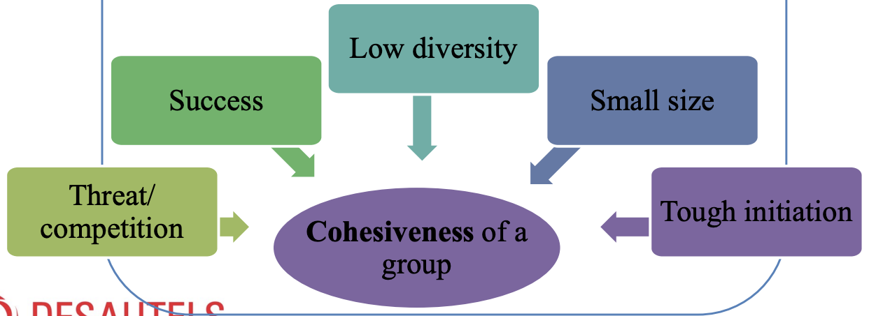

- Consequences:

- 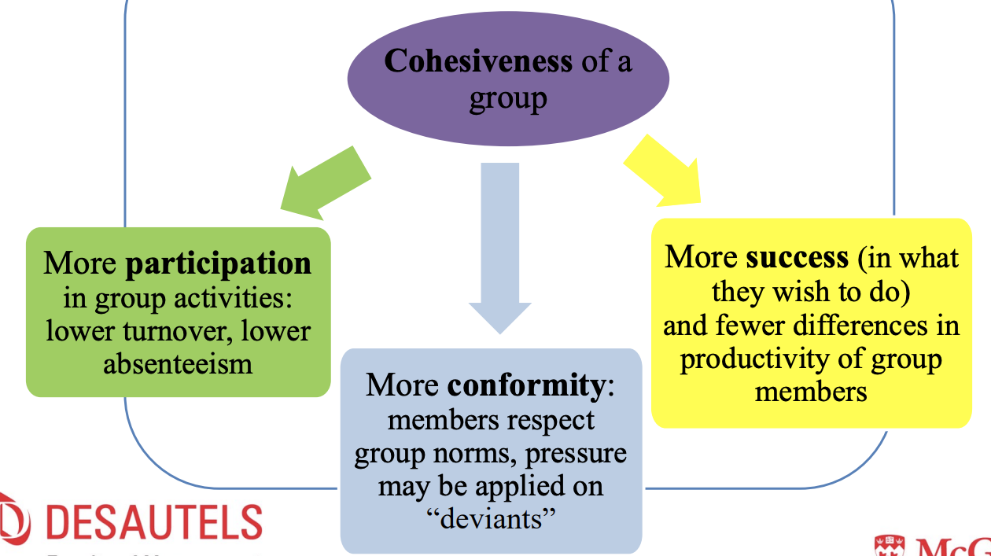

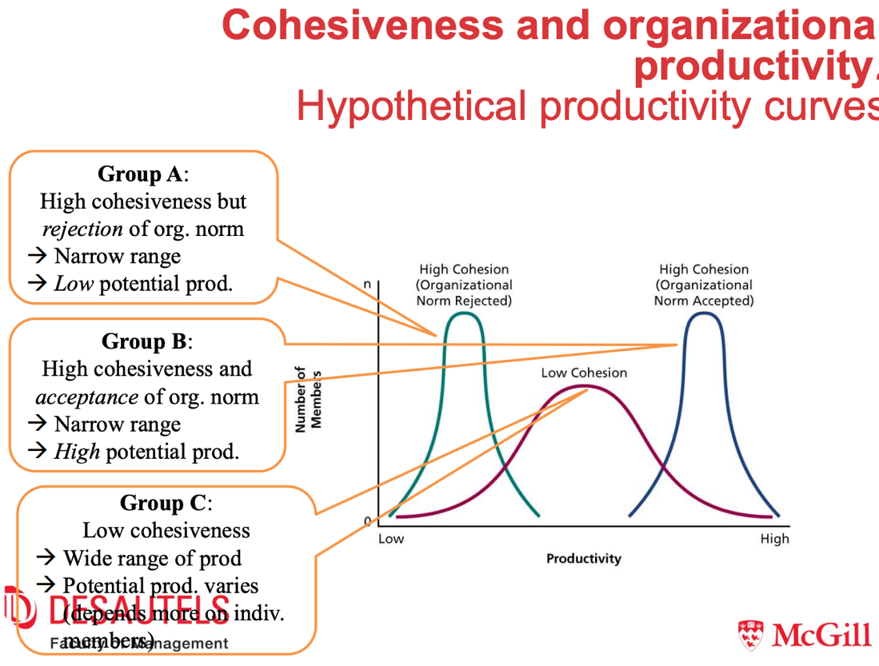

What is a Team?:

- For the sake of this class, it is the same as a group. Anyways, in organizations, groups are often [always] called teams

- To achieve high performance, teams need collective efficacy:
  - shared beliefs that a team can successfully perform a given task
  - self-efficacy does not necessarily translate into collective efficacy

Self-Managed Work Teams: Groups that have the opportunity to do challenging work under reduced supervision.

- The groups regulate much of its own members’ behaviour. Meaning?
- Critical factors of self-managed groups:
  - The nature of the task
  - The composition of the group
  - Various support mechanisme
- Tasks for Self-Managed Groups:
  - Should be complex and challenging
  - They should require high interdependence among team members for their accomplishment
  - The task should have qualities of enriched jobs (i.e tasks significance)
Cross-Functional Teams: Work groups that bring people with different functional specialties together to better invent, design, or deliver a product or service

- Members have to be expert of their own area but able to cooperates with others.
- Cross-functional team are best know for their success in product development.
- Combination of innovation, speed, and quality that come from early coordination among the various specialties
- Cross-functional teams get all of the specialties working together from day one

Principle for effectiveness
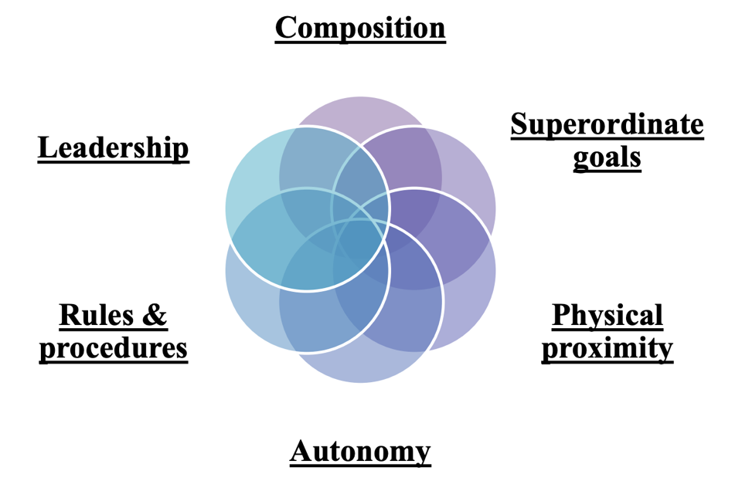

Composition: Relevant specialties are necessary and must be included

Superordinate goals: Attractive outcomes that can only be achieved by collaboration

Physical proximity: Located close to each other to facilitate informal contact.

Autonomy: Autonomy from the larger organization – Functional specialists need authority

Rules & procedures: Basic decision procedures must be laid down to prevent anarchy – nothing petty and unnecessary

Leadership: strong people skills in addition to task expertise – everyone is a specialist

Shared mental models:

- Shared mental models mean that team members share identical information about how they should interact and what their task is.
- They enhance coordination and contribute greatly to effective team performance.
- • They are a particular challenge to instill in cross-functional teams due to the divergent backgrounds of team members.

Social Influence in Organization:

What is a social influence in organization? :

- We often rely on information that others provide. This information dependence gives others opportunity to influence our thoughts, feelings, and actions.
- According to social information processing theory, organizational members use information from others to interpret events and develop expectations about appropriate and acceptable attitudes and behaviours
- Individuals are dependent on the effects of their behaviour as determined by the rewards and punishments provided by others

Social Influence Process and Conformity: One obvious consequence of information and effect dependence is the tendency to conform to social norms
- 3 motives for social conformity:
  - Compliance: prompted by the desire to acquire rewards or avoid punishment
  - Identification: prompted by perceptions that those who promote the norms are attractive or similar to oneself
  - Internalization: prompted by true acceptance of the beliefs, values, and attitudes that underlie the norm

Organizational socialization:

Socialization: the process by which people learn the attitudes, knowledge, and behaviour that are necessary for a person to function in a group or organization.

- The acquisition of information and knowledge is important for newcomers to reduce their level of uncertainty and ambiguity about their new job and organization.

3 Fit That are Important for Sociolization:

- Person job-fit: match between an employee's knowledge, skills, and abilities and the requirements of a job.
- Person-organization fit: match between employee's personal value and the values of an organization
- Person-group fit: match between an employee values and the values of his or her work group.

Org identification: extent to which individuals define themselves in terms of the organization and what it is perceived to represent

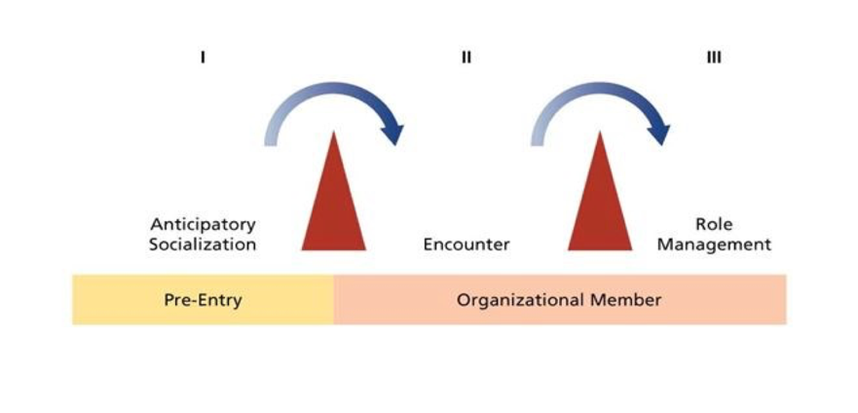

Stages of Organization Socialization:

- Anticipatory socialization: (What is it?)
  - Even before a person becomes a member
  - Skill and attitudes acquisition
- Encounter:
  - New recruit encounter the day-to-day reality
  - Orientation and rotation program
  - Getting to know boss and colleagues
  - Organisation looks for conformity, recruit for need and expectation fulfilment.
- Role management:
  - Fine-tuning and actively managing role
  - Balancing work role with non-work role.

Psychological Contract: Beliefs held by employees regarding the reciprocal obligations and promises between them and their organization. Perception of psychological contract breach occurs when an employee perceives that his or her organization has failed to fulfill one or more of its premises in the psychological contract

Methods of Organizational Socialization:

Realistic job previews: provision of a balanced realistic picture of the positive and negative aspects of a job to applicants.
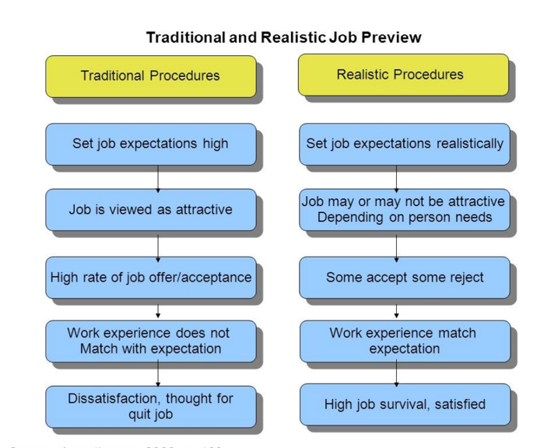

Employee orientation program: designed to introduce new employees to their job, the people they will be working with, and the organization

- Realistic Orientation Program for Entry Stress (ROPES): designed to teach newcomers coping techniques to manage workplace stressors.

Socialization tactics: the manner in which organizations structure the early work experiences of newcomers and individuals who are in transition from one role to another.
- Collective vs Individual Tactics
  - When using the collective tactic, a number of new members are socialized as a group, going through the same experiences and facing the same challenges.
  - The individual tactic consists of socialization experiences that are tailor-made for each new member.
- Formal vs Informal Tactics
  - The formal tactic involves segregating newcomers from regular organizational members and providing them with formal learning experiences.
  - Informal tactics do not distinguish a newcomer from more experienced members and rely more on informal and on-the-job learning.
- Sequential vs Random Tactics
  - With a sequential tactic, there is a fixed sequence of steps or stages leading to the assumption of the role.
  - With the random tactic, there is an ambiguous or changing sequence of events
- Fixed vs Variable Tactics
  - With a fixed tactic, there is a timetable for the newcomers’ assumption of the role.
  - If the tactic is variable, there is no time frame to indicate when the socialization process ends and the newcomer assumes his or her new role.
- Serial vs Disjunctive Tactics
  - The serial tactic refers to a process in which newcomers are socialized by experienced members of the organization.
  - The disjunctive tactic refers to a socialization process where role models and experienced organization members do not groom new members or “show them the ropes.
- Investiture vs Divestiture Tactics
  - The divestiture tactic involves experiences that are designed to humble new hires and strip away some of their initial self-confidence.
  - The investiture tactic affirms the incoming identity and attributes of new hires rather than denying and stripping them away.
Mentoring: an experienced or more senior person in the organization who provides a junior person with guidance and special attention.
- A mentor can provide many careerenhancing benefits to newcomers
  - Sponsorship
  - Exposure & visibility
  - Coaching & feedback
  - Development assignment
- Psychological functions of mentoring:
  - Role modelling
  - Providing acceptance and confirmation
  - Counselling
Newcomer Proactive Socialization Behaviour: Process in which newcomers play an active role in their own socialization
- Feedback Seeking: Requesting information about how one is performing one’s tasks and role.
- Information Seeking: Requesting information about one’s job, role, group, and organization
- General Socializing: Participating in social office events and attending social gathering.
- Relationship Building: Initiate social interaction and building relationship with other in one area or department.
- Positive Framing: Perceiving or framing the new

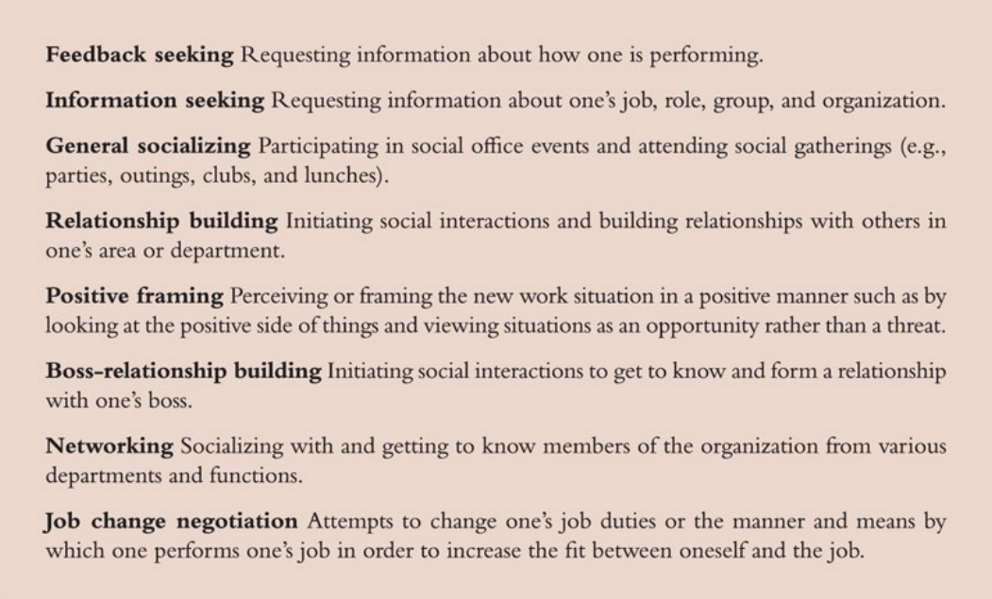

Organizational Culture

What is organizational structure? : The shared beliefs, values, and assumptions that exist in an organization

- CULTURE → NORMS → BEHAVIOUR

- Subcultures: smaller cultures that develop within larger organizational culture and are based on differences in training, occupation, or departmental goal.

- Strong culture: an organizational culture with intense and pervasive beliefs, values and assumptions.

Asset of Strong Culture:
- Organizations with strong cultures have several potential advantages:
  - Coordination
  - Conflict resolution
  - Financial success

Coordination: The overarching values and assumptions of strong cultures can facilitate communication and coordination.
- Different parts of the organization can learn from each other and can coordinate their efforts.

Conflict resolution: Sharing core values is a powerful mechanism that helps to resolve conflicts.
- The core value will often suggest an appropriate dispute resolution mechanism.

Financial Success: Strong cultures contribute to financial success and organizational effectiveness when the culture supports the mission, strategy, and goals of the organization.
- WestJet Airlines: One of the most profitable airlines in North America and consistently ranked as having one of the most admired corporate cultures in Canada.

Liabilities of Strong Culture:
- Strong cultures can be a liability under some circumstances:
  - Resistance to change
  - Culture clash
  - Pathology

Resistance to Change: A strong culture can prove very resistant to change and can damage a firm’s ability to innovate.

Culture Clash: Strong cultures can mix badly when a merger or acquisition pushes two of them together under the same corporate banner.

Pathology: Cultures based on beliefs, values, and assumptions that support infighting, secrecy, and paranoia.
- Some strong cultures can threaten organizational effectiveness simply because the cultures are, in some sense, pathological.

Contributors to Culture:
- Many culture especially strong one reflect the value of an organization’s founder.
- Socialization
  - Step 1: Selecting Employees
  - Step 2: Debasement and Hazing
  - Step 3: Training “in the Trenches”
  - Step 4: Reward and Promotion
  - Step 5: Exposure to Core Culture
  - Step 6: Organizational Folklore • Step 7: Role Models

Diagnosing a Culture:
- The symbol we display
- The ritual we re-enacts
- The stories we tell each other

Communication

Communication: Communication is the process by which information is exchanged between a sender and a receiver.

- You share, or make common, your knowledge and ideas with somebody else
- Communication is the sharing of meaning by sending and receiving symbolic cues
- Effective communication occurs when the right people receive the right information in a timely manner.

Linear Communication Model:
- Sender: the originator of message
- Encoder: The transmitter which converts the message into signals
- Decoder: The reception place of the signal which converts signals into message
- Receiver: The destination of the message from sender
- Noise: Communication disruption during transfer

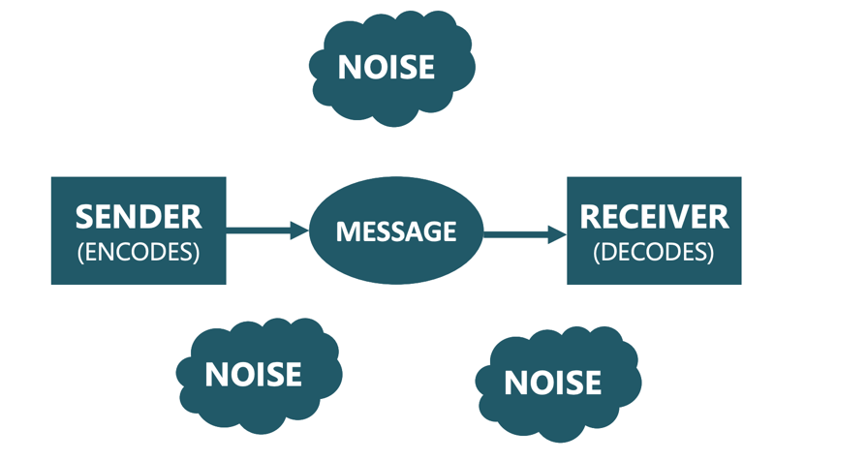

Main Strength of the Model:
- Good description of one-way communication (e.g. Newspapers, Morse, smoke signal

Main Weakness of the Model:
- Depicts communication as a one-way process where speakers only speak and never listen
- Also implies that listeners listen and never speak or send messages

Interactive Communication Model: Schramm’s (1955) interactive model includes feedback from the receiver to the sender.
- Both the speaker and the listener take turns to speak and listen to each other
- Same components as in the Linear Model, with additional elements:
  - Two-way process
  - Feedback (verbal or non-verbal)

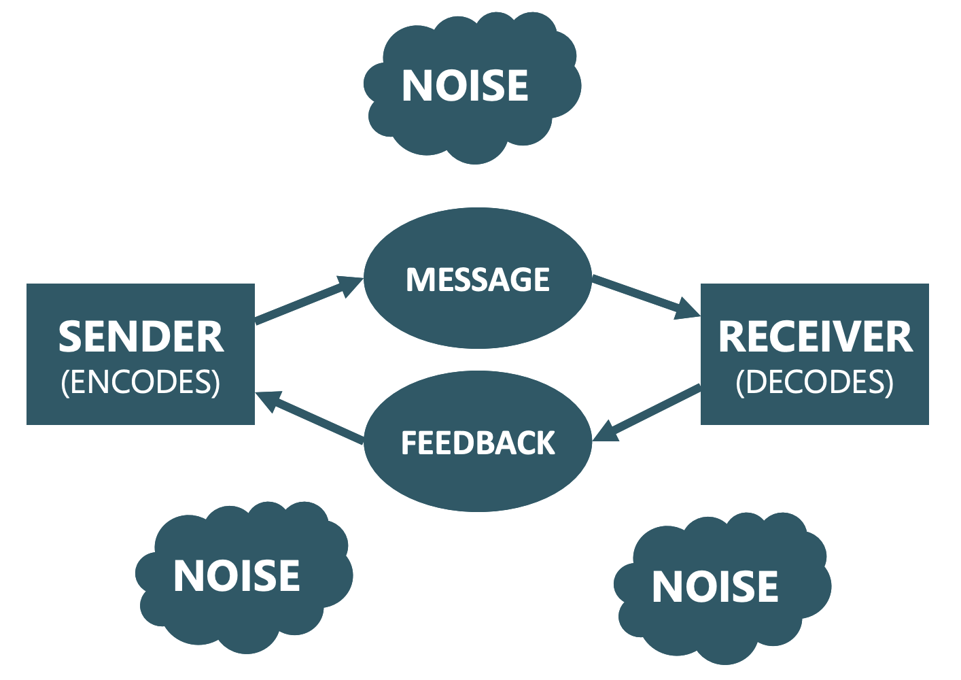

Main Strength of the Model:
- Closer to human communication

Main Weakness of the Model:
- Model does not consider simultaneous communication
- Model fails to show that communication is a dynamic process which changes over time (i.e. common experience)

Transactional Communication Model: Barnlund (1970) model proposes that communicators are simultaneously engaging in the sending and receiving of messages.
- Communication depends on communicators’ fields of experience (e.g. background, knowledge, etc.)
- “Transactional” means that communication is a changing process

Basic or Organizational Communication:
- The lines on an organizational chart represent lines of authority and reporting relationships.
- The chain of command refers to the lines of authority and formal reporting relationships in an organization.
- Under this system, there are three necessary forms of communication:
  - Downward communication
  - Upward communication
  - Horizontal communication

Deficiency in the Chain of Command: The chain of command is often ineffective due to.
- Informal communication: The chain of command does not consider informal communication between members
- Filtering: The tendency for a message to be watered down or stopped during transmission.
- Slowness: The chain of command can be very slow especially for horizontal communication between departments

Voice, Silence, and the Mum Effect

Voice refers to the constructive expression of disagreement or concern about work unit or organizational practices.
- Voice involves “speaking up” and it can be contrasted with silence which means withholding relevant information.
- Voice can be directed horizontally or vertically.
- It can be considered a form of organizational citizenship behaviour.
- More satisfied employees who identify more strongly with their work unit or organization are most likely to speak up as are those who are conscientious and extraverted.
- Direct supervisors and higher-level managers play a critical role in creating a climate in which constructive dissent can emerge.
- A positive climate for voice can contribute to an atmosphere of psychological safety.
- Psychological safety refers to a shared belief that it is safe to take social risks
- Self-censorship will result in a climate of silence
- Another factor that can contribute to silence and works against voice is the mum effect.

The Mum Effect: The mum effect refers to the tendency to avoid communicating unfavourable news to others.
- It is more likely when the sender is responsible for the bad news

Informal Communication and the Grapevine: The chain of command does not consider informal communication between members, however, informal communication help people accomplish their jobs more effectively.

The Grapevine: is an organization’s informal communication network and it helps cut across the formal chain of command.

- Characteristics of the Grapevine:
  - At least 75 percent of the non-controversial organization-related information is correct.
  - Personal information and emotionally charged information are most likely to be distorted.
- Who Participates in the Grapevine and Why?
  - It can be a timely and inexpensive source of information.
  - It can provide an alternative source of power and influence available to all.
  - The exchange of delicate information builds a bond of trust between senders and receivers
  - It provides social and intellectual stimulation.
  - Some gossip can contribute to effective communication.
- Pros of the Grapevine:
  - It can keep employees informed about important organizational matters.
  - It can provide a test of employee reactions to proposed changes without making formal commitments.
- Cons of the Grapevine:
  - The grapevine can become a problem when it becomes a constant pipeline for rumours
  - A rumour is an unverified belief that is in general circulation.
  - Rumours spread fastest and farthest when:
    - The information is especially ambiguous
    - The content of the rumour is important to those involved.
    - The rumour seems credible.
    - The recipient is anxious.

Verbal Communication: Language is a symbolic system used by people to communicate oral or written messages
- Language community: Group of people who share a common language
- Lexicon: Collection of words and expressions
- Phonology: Sounds used to pronounce words
- Jargon: Specialized language used by job holders or members of particular occupations or organizations

- Language Is Ambiguous: Even when using proper grammar, language can fail conveying accurate information.
- “Picasso enjoyed painting his models nude.
- “Visiting relatives can be boring.”
- “I saw the man with binoculars.”

Non-Verbal Communication: Oral and non-oral messages expressed by other than linguistic means
- Sign language and written words are not considered nonverbal communication
- Messages transmitted by vocal means that do not involve language
- Major forms of non-verbal communication include:
  - Body-language
  - Props, artifact, and costumes
Proxemics (Distance): Hall (1963) investigate the relationship between the use of space and interpersonal communication
- He identified four levels of distance:
  - Intimate: 0 to 18 inches
  - Personal: 18 inches to 4 feet
  - Social: 4 to 10 feet
  - Public: 10 feet to infinity

Haptics (Touch): Cultural differences: touching is more prevalent among Italians and Greeks than the French, English and the Dutch (Remland & Jones, 1995)

- Hornick (1992) found that food servers who used touch received larger tips

Chronemics (Times): A study conducted by Burgoon (1989) found that people who arrive 15 minutes late are considered dynamic, but much less competent, composed and sociable than those that arrive on time

- Time can be used as a signal of social or organizational status

Kinesics (Behaviour) : Otherwise referred to as “body language”
- Facial expressions: Smiling increases sociability, likeability, and attraction(LaFrance & Hecht, 1995)
- Eye contact: Successful beggars establish eye contact (Beebe, 1974)
- Physical appearance: 73 defendants who went to trial. Attractive defendants received significantly lighter sentences (Stewart, 1980)

- Body Language: is non-verbal communication that occurs by means of the sender’s bodily motions and facial expressions or the sender’s physical location in relation to the receiver.

  - Two important messages sent via body language:
    - The extent to which the sender likes and is interested in the receiver
    - The sender’s views concerning the relative status of the sender and the receiver.

Vocalics (Paralanguage): Changing meaning through pitch, prosody, intonation, etc.
- Studies have found that people who talk louder, faster, and more fluently are perceived as more persuasive
- Deep voices are often viewed as more credible
- Powerless style of communication (pauses, umhs, uhs, tag questions) lowers perceptions of credibility

Power, Politic, and Ethics

What is Power?

- Power is the capacity to influence others who are in a state of dependence.
- Power can flow in any direction in an organization.
- Power applies to both individuals and groups.

The Bases of Individual Power:

- Legitimate power: Power derived from a person’s position or job in an organization.
- Reward power: Power derived from the ability to provide positive outcomes and prevent negative outcomes. Power that you have because you are able to reward people. (i.e teachers have reward power: they can give point or deduct point because of different reasons.)
- Coercive power: Power derived from the use of punishment and threat.
- Referent power: Power derived from being well liked by others. It stems from identification with the power holder. ( if you like somebody, you tend to do whatever they want)
- Expert power: Power derived from having special information or expertise that is valued by an organization. (Knowing special information that you are good at that nobody else knows.

Employee Responses to Bases of Power:
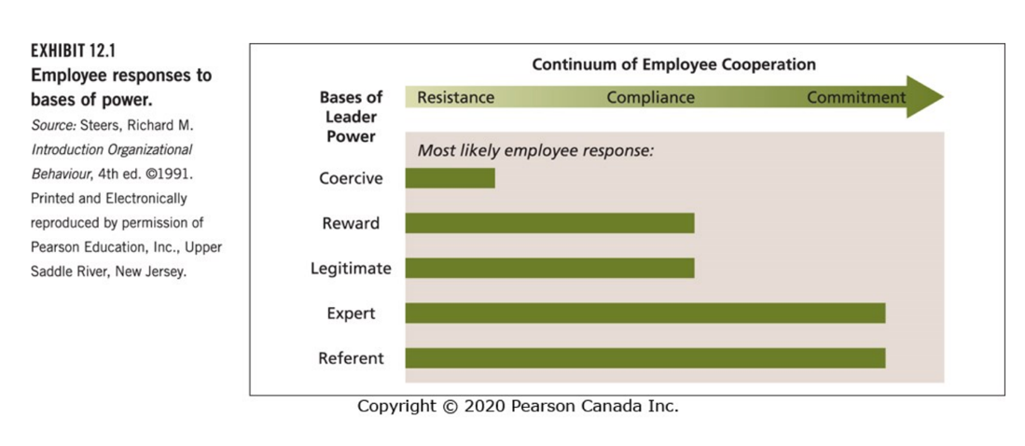
How Do People Obtain Power?:

- Doing certain activities that are:

- Extraordinary: Excellent performance in unusual or non-routine activities.
- Visible: Visible to others and publicized
- Relevant: The activities must be relevant to the solution of important organizational problems.

- Developing informal relationships with the right people that can include:

- Outsiders
- Subordinates
- Peers
- Superiors

Empowerment: Empowerment means giving people the authority, opportunity, and motivation to take initiative and solve organizational problems.

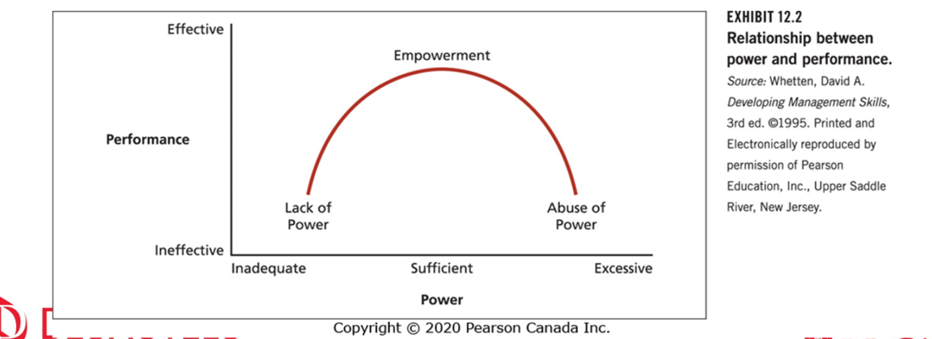

Influence Tactics: They are specific behaviors that people use to affect others and manage others’ impressions of them.

- The use of an influence tactic is determined by one’s base of power and who they are trying to influence.

Putting Power to Work: Assertiveness, Ingratiation, Self-promotion, Rationality, Exchange, Upward appeal, Coalition formation

- Assertiveness: Subordinates are more likely to be the recipients of assertiveness.
- A particularly ineffective influence style is a “shotgun” style that is high on all tactics with particular emphasis on assertiveness and exchange.
- Ingratiation: Using flattery, acting friendly, polite, or humble; opinion conformity.
- Self-Promotion: Touting one's accomplishment, image enhancement, name-dropping.
- Rationality: Using logic reason, planning and compromise. (Mon pere) (i.e. How the vaccine is bad showing graph and research and proof). The use of rationality is viewed positively by other and is frequently used.
- Exchange: You scratch my back and I scratch yours
- Upward Appeal: Making formal or informal appeals to organizational …
- Coalition Information: Seeking united support from other organizational members.

Who Wants Power?:

Need for power (n Pow) is the need to have strong influence over other.

It is a reliable personality

Organizational Politics: Organizational politics refers to the pursuit of self-interest in an organization, whether or not this self-interest corresponds to organizational goals. It is the association between influence means and influence ends that determines whether activities are political and whether these activities benefit the organization.

The Dimension of Organization Politics:
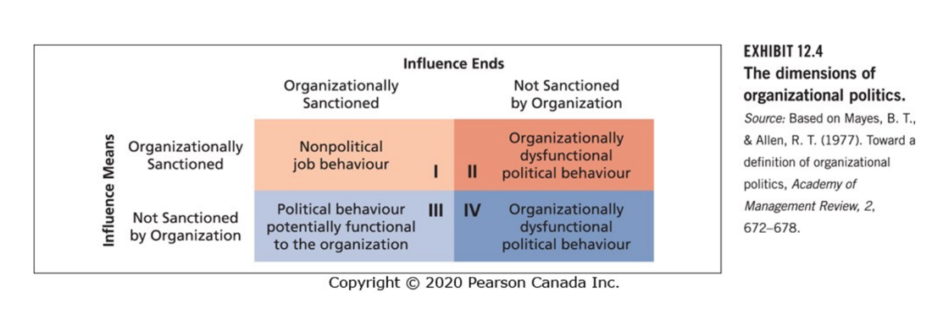

Political Skills: Political skills refers to the ability to understand other at work and to use that knowledge to influence others.

There are four facets to political skill:

- Social astuteness (can “read” people)
- Interpersonal influence (convincing and persuasive )
- Apparent sincerity
- Networking ability

Ethics in Organization: Ethics can be defined as systematic thinking about the moral consequences of decisions.
- Stakeholders are people inside or outside of an organization who have the potential to be affected by organizational decisions. (i.e. Families of the employee are stakeholders, because if you don't treat well your employee it is going to affect their family.)

Common Themes of Ethical Issues Facing Managers:

- Honest communication: You tell the person buying your product that it might be defective (i.e. Johnson & Johnson)
- Fair treatment
- Special consideration
- Fair competition
- Responsibility to organization: Not working to your maximum.
- Corporate social responsibility:
- Respect for law: Some stuff might be ethical but not legal. Amoung the legal thing choose the most ethical behaviour.

Causes of unethical Behavior:
- Gain: people do unethical behavior to gain something.
- Personality
- Extreme performance pressure: if you have financial aid for your study and you have bad grades, you might tend to cheat.
- Role conflict:
- Strong organizational identification: Sometimes you do unethical things because you love your organization.
- Competition
- Organization and industry culture

Whistle-Blowing: Whistle-blowing occurs when organizational members disclose illegitimate practice to some person or organization.

Would you hire a whistle-blower? : No because they lack loyalty even though they are against unethical behavior.

Sexual Harassment: Sexual Harassment is a behavior that derogates, demeans, or humiliates an individual based on that individual's sex.
- It could include touching, sexual force, and sexist jokes, comments, and materials
- The most severe forms sexual harassment are committed by supervisor
- The most frequent perpetrators are coworkers.

Deaf Ear Syndrome: The deaf ear syndrome refers to the inaction or complacency of organizations in the face of charges of sexual harassment.

What can cause this in an organization?....

Effectively Dealing with Allegations of Sexual Harassment:

- Examine the characteristics of deaf ear organizations.
- Foster management support and education. (some people might not realize that some behavior can be seen as sexual harassment by others.)
- Stay vigilant. (i.e. see if people stop going to the kitchen)
- Take immediate action.
- Create a state-of-the-art policy. Making sure that people can report and they can keep their privacy. ( if your superior are the one harassing me, what do you do, since you can’t report to your superior)
- Establish clear reporting procedures

Conflict and Stress

What is a conflict?: A conflict is a process that occurs when one person, group or organization subunit frustrate the goal attainment of other.

- Can be due to:
  - Group identification and intergroup bias
  - Interdependence
  - Differences in power, status, and culture
  - Ambiguity
  - Scarce resources

Types of Conflict:

- Relationship conflict: concerns interpersonal tensions among individuals that have to do with their relationship per se, not the task at hand.

- Task conflict: concerns disagreements about the nature of work to be done.

- Process conflict: involves disagreements about how work should be organized and accomplished.

Modes of Managing Conflict: These approaches to managing conflict are a function of:

- How assertive you are in trying to satisfy your own or your group’s concerns.
- How cooperative you are in trying to satisfy those of the other party or group.

Approaches to Managing Organizational Conflict

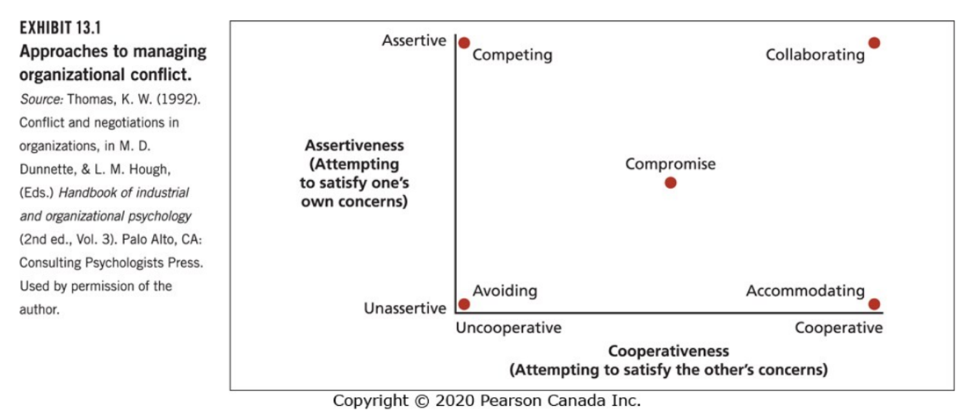

Avoiding: It might be a sensible response when the issue is trivial, information is lacking, people need to cool down, and the opponent is very powerful and hostile.

Accommodating: It can be an effective strategy when you are wrong, the issue is more important to the other party, and you want to build good will.

Competing: It can be effective when you have a lot of power, you are sure of your facts, the situation is truly win-lose, or you will not have to interact with the other party in the future.

Compromise: It is a sensible reaction to conflict stemming from scarce resources and it is a good fallback position if other strategies fail.

Collaborating : It is an attempt to secure an integrative agreement that fully satisfies the interests of both parties (a win-win resolution).

Is All Conflict Bad?:

Constructive conflict: Conflict can be functional when it improves decision and promotes organizational change.

Conflict Stimulation: Conflict stimulation is a strategy of increasing conflict to motivate change.

Model of Stress Period:

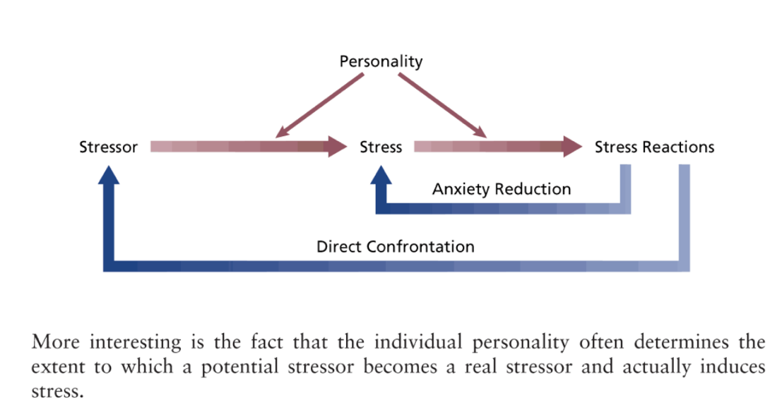

Stressor: are environmental events or condition that have the potential to induce stress.

- Personality often determines the extent to which a potential stressor becomes a real stressor and induces stress.

Stress: Stress is a phycological reaction to the demand inherent in a stressor that has the potential to make a person feel tense or anxious

Stress Reaction: are the behavioral, psychological, and physiological consequences of stress. Some of these reactions are passive responses over which the individual has little direct control (e.g., elevated blood pressure).

Personality Stress: Personality can affect both the extent to which potential stressors are perceived as stressful and the types of stress reactions that occur.

• Three key personality traits:
– Locus of control
– Type A behavior pattern
– Negative affectivity You can be an individual that is high on negative affectivity and high on positive effectivity.

Stressors in Organizational Life:

Executive and Managerial Stressors: Executives and managers make key organizational decisions and direct the work of others.

They experience some special forms of stress:
– Role overload
– Heavy responsibility

Operative-level stressors: Operatives are individuals who occupy nonprofessional and non-managerial positions in organizations.

• Occupants of operative positions are sometimes exposed to a special set of stressors:
– Poor physical working conditions
– Poor job design

Boundary Role Stressors: Boundary roles are positions in which organizational members are required to interact with members of other organizations or with the public.

- High level of emotional labor. Showing emotions that you don’t have.

Burnout: Burnout follows a process that begins with emotional exhaustion (phase 1)that leads to cynicism and depersonalization (phase 2) followed by feelings of low self-efficacy and low personal (phase 3) accomplishment.

Gender and personality are also related to burnout.
– Women are more likely to report emotional exhaustion. -->
– Men are more likely to report depersonalization. --> We socialize men to show less emotions and therefore will show less emotional exhaustion.
– Those with high self-esteem, high conscientiousness, and internal control report less burnout.

Some General Stressor: Some stressors that are experienced equally by occupants of all roles include:

– Interpersonal conflict
– Work-family conflict
– Job insecurity and change
– Role ambiguity
– Sexual harassment

Reactions to Organizational Stress: The reactions that people who experience organizational stress might exhibit can be divided into three categories.
- Behavioural reactions
- Psychological reactions
- Physiological reactions

Behavioural Reactions to Stress: Behavioural reactions to stress are overt activities that the stressed individual uses in an attempt to cope with the stress.
- Behavioural reactions to stress include:
  - Problem solving: Problem solving is directed toward terminating the stressor or reducing its potency.
    - Examples of problem solving include: Delegation, time management, talking it out, asking for help, searching for alternatives.
  - Seeking social support:
  - Performance changes: Stress or stressors frequently cause reduced job performance
    - Some stressors, like role ambiguity and interpersonal conflict, are called hindrance stressors and they damage goal attainment and performance.
    - Some stressors, like a heavy workload and responsibility, are challenging and can damage performance but sometimes stimulate it via added motivation.
  - Withdrawal
  - Use of addictive substances

Psychological reactions: The most common psychological reaction to stress is the use of defence mechanisms.
- Defence mechanisms are psychological attempts to reduce the anxiety associated with stress rather than actually confronting or dealing with the stressor.
  - Rationalization
  - Projection
  - Displacement
  - Reaction formation
  - Compensation

Physiological reactions: Work stress is associated with electrocardiogram irregularities and elevated levels of blood pressure, cholesterol, and pulse.
- Stress has also been associated with the onset of various diseases due to its ill effects on the immune system.

Stress Mindset:
- Positive stress mindset or stress is enhancing mindset
- Negative stress mindset or stress is debilitating mindset

Organizational Strategies for Managing Stress:
- Job redesign
- “Family-friendly” human resource policies
- Stress management programs
- Work-life balance, fitness, and wellness programs

Environment, Strategy, and Structure

The External Environment of Organizations: The external environment refers to events and conditions surrounding an organization that influence its activities.
- The external environment has tremendous influence on organizations.
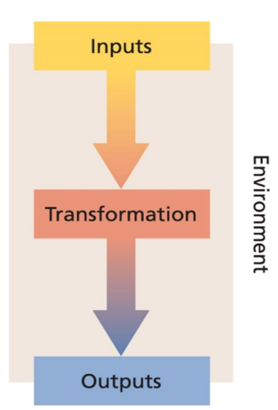

Organizations as Open Systems: Open systems are systems that take inputs from the external environment, transform some of these inputs, and send them back into the external environment as outputs.
- The open system concept sensitizes us to the need for organizations to cope with the demands of the environment on both the input side and the output side.
- Some of this coping involves adaptation to environmental demands and some may be oriented toward changing the environment.

Components of the External Environment: The external environment involves any person, group, event, or condition outside the direct domain of the organization.
- The external environment can be divided into a manageable number of components.
  - The General Economy
  - Customers
  - Suppliers
  - Competitors
  - Social/Political Factors
  - Technology

Interest Groups:
- Interest groups are parties or organizations other than direct competitors that have some vested interest in how an organization is managed.
- They can make competing or conflicting demands on an organization.

Environmental Uncertainty: Environmental uncertainty is a condition that exists when the external environment is vague, difficult to diagnose and unpredictable.

- Uncertainty depends on the environments complexity and its rate of change
  - Simple environment: relative few factors
  - complex environment a large number of dissimilar factors
  - static environment: remain fairly stable over time.
  - dynamic environment: in a constant stage of change which is unpredictable an irregular.

- Incertainty has several effects on organization and their decision makers.
  - Cause and effect relationships: becomes less clear
  - makes priorities harder to agree on and stimulate a fair degree of political jokeying within the organization.
  - more information must be processed by the organization to make adequate decision.
- Organazation act to cope with or reduce uncertainty because uncertainty increases the difficulty of decision-making and thus threatens organizational effectiveness.

Resource dependence: organization are in this state of resource dependence with regard to the environment.
- They are dependent on environmental inputs such as capital raw materials and human resources as well as outputs.
- carefully managing in coping with resource dependence is key to survival and success.

Strategic responses to uncertainty and resource dependence: organazation devote considerable effort to developing and implementing strategies to cope with environmental uncertainty and resources dependence.

- Strategy is the process by which top executive seeks to cope with the constraints and opportunities that an organization’s environment poses.

Strategic Responses to Uncertainty and Resource Dependence: much of the impact that the environment has on organization is indirect rather than direct in the sense that it is the perceived environment that comprises the basis for strategy formulation.

- Strategy formulation involves determining the mission, goals and objective of the organization.

- It must correspond to the constraints and opportunities of the environment.

- Most common strategy response is employed by organisations as a change in organizational structure

What is an organizational structure? Organizational structure is the manner in which an organization divides its labour into specific task and achieves coordination among these tasks

- To achieve its goals an organization has to do two basic things:
  - Divide labour among its members into specific tasks
    - A vertical dimension
    - And horizontal dimension
  - Once labour is divided it must be coordinated to achieve organizational effectiveness.

Vertical Division of Labour: The vertical division of labour is concerned primarily with apportioning authority for planning and decision-making (who gets to tell whom what to do)

- Labour must be divided vertically enough to ensure proper control but not so much as to make vertical communication and coordination impossible

- The proper degree of such division will vary across organization in a cross their functional units

- Key themes that underlie the vertical division of labour:
  - Autonomy and control
  - Communication

Autonomy and Control: The domain of decision-making and authority is reduced to the number of levels and the hierarchy increases.

- Managers have less authority over fewer matters

- a flatter hierarchy pushes authority lower and involves people further down the hierarchy in more decisions

Communication: As labour is progressively divided vertically timely communication and coordination can become harder to achieve
- As the number of level increases filtering is more likely to occur.

Horizontal Division of Labour: Groups the basic tasks that must be performed into jobs and then into departments.

- Required workflow is the main basis of the division.
- Organization differs in the extent of our central division of labour and it suggests some specialization on the part of the workforce.

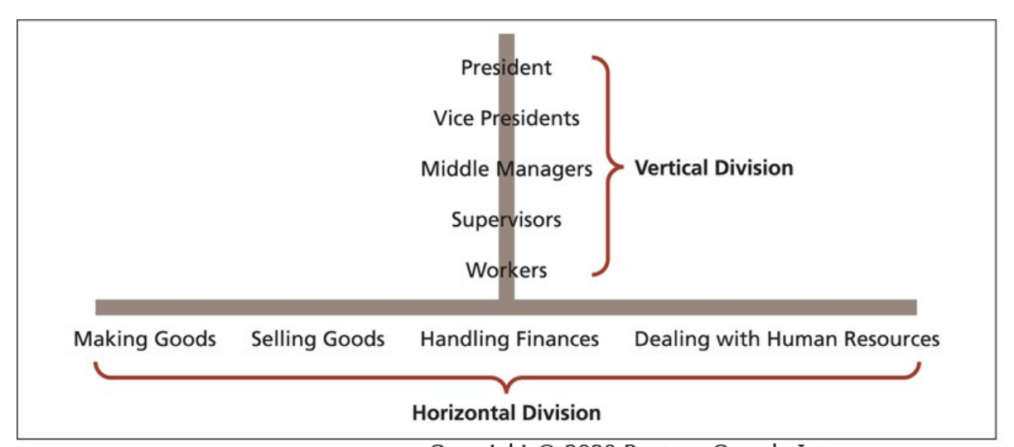

Traditional structural characteristics:
- Span of control
- Flat versus tall
- Formalization
- Centralization
- Complexity
- Size

Span of control: span of control is the number of employees supervised by a manager.

- The larger the span, the less potential there is for coordination by direct supervision.
- as this pen increases the attention that a supervisor can devote to each employee decreases.

Flat vs Tall: Flat organization has relatively few levels in its hierarchy of authority.

- that all organization has relatively many levels in its hierarchy of authority.

Formalization: formalization is the extent to which work roles are highly defined by organization.

- A very formalized organization tolerates little variability in the way members perform their tasks.
- Some formalization stem from the nature of the jobs itself.

Centralization: centralization is the extent to which decision-making power is localized in a particular part of an organization.
- In the most centralized organization, the power for all decisions rests in a single individual such as the president.

Complexity: Complex city is the extent to which an organization divide the labour vertically, horizontally, and geographically.

Example: a fairly simple organization will have few management levels (vertical division) and not many separate job titles (horizontal division).

Size and Structure: Large organization are more complex less centralized taller and more formal than small organization.

- Product departmentation is often preferable to functional department ation has the organization increase in size.

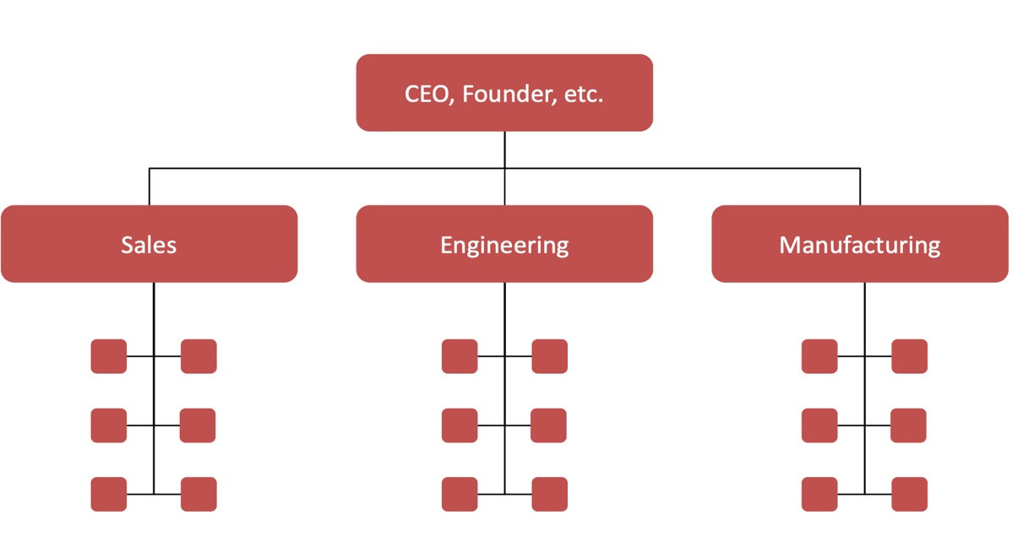

Functional Structure (The Good):

- Clear reporting authority
- Clear promotion lines—clear careers
- Potential to build deep experience
- Often clearly related to one’s training
- Easy to explain

Functional Structure (The Bad):

- Narrow training
- Narrow-mindedness; function at the expense of the organization
- “Silos”: Coordination often happens up at the top, which is slow

Functional Structure (The Limits):

- Weaknesses notwithstanding, functional structures are really efficient when you have one product, serving one market, dealing with one type of customer.
- It’s still better than no structure
- But what happens when you have more than one product, market, or customer?

Divisional Structure: These are the most common types. These correspond to the major dimensions of most firms’ business plans.

- Geographic markets.
- Product or product line
- Costumer, or customer types.

Divisional Structure (The Good):

- Promotes coordination across functions.
- Focuses attention on specific markets, products, or customers.
- Integrates people with different specialities.

Divisional Structure (The Bad):

- Duplication of effort and resources
- Focuses attention on the division rather than the organization
- Silos: coordination within the division means less coordination across the divisions

Structure and Strategy:

- You cannot talk usefully about organizational design without asking what the organization is supposed to do
- All formal structures trade coordination on one dimension with silos on another dimension
- Thus you need to ask: given what we want to do, where is coordination most important?

**See exemples in slides 38 and 39.

Overcoming silos: (Linking)

- This is often where informal structure shows up
- Linking is anything that encourages communication and coordination between groups you’ve created

“Dotted Line Authority”:

- Think of this as a linking mechanism: you’re answerable to more than one boss, but one of them has “right of way
- E.g., you report to a regional director (solid line), but have “dotted-line” reporting to a project-team leader
- What happens when there’s no right of way? Matrix management

Matrix Management:

- most never fully implemented in practice
- Now that we’ve talked about the logic of structure, you can start to see why!
- Rarely is coordination across two dimensions equally important
- Instead, some combination of dotted-line authority and hybrid structure usually makes more sense
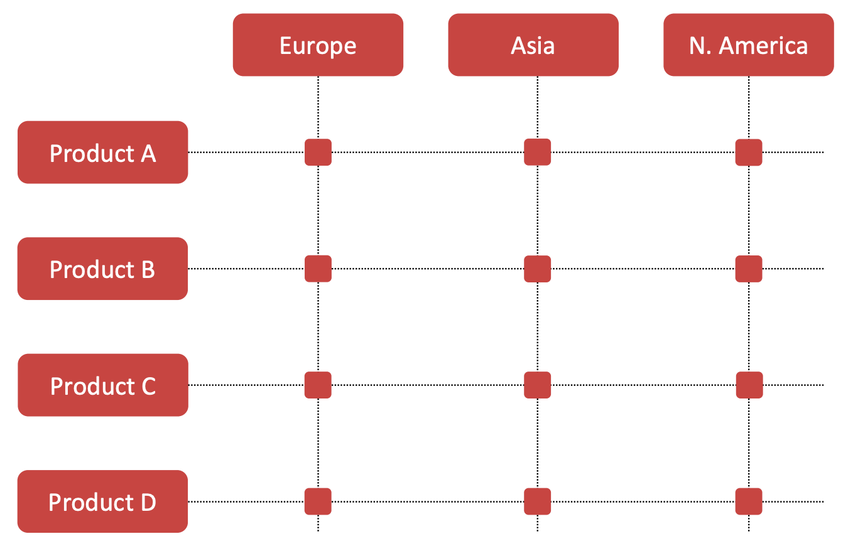

Methods of Coordinating Divided Labor:

- Direct Supervision: Working through the chain of command, designated supervisors or managers coordinate the work of their subordinates.
- Standardization of Work Processes: Some jobs are so routine that the technology itself provides a means of coordination.
  - Little direct supervision is necessary for these jobs to be coordinated.
  - Work processes can also be standardized by rules and regulations
- Standardization of Outputs: Ensuring that the work meets certain physical or economic standards
- Standardization of Skills: Standardized training ensures that workers in particular specialties have certain skills and know what to expect of each other
- Mutual Adjustment: Relies on informal communication to coordinate tasks.
- Liaison roles: A person who is assigned to help achieve coordination between his/her/their department and another department.
- Task forces and teams: Task forces are temporary groups set up to solve coordination problems across several departments, with representative from each department.
- Integrators: Integrators are organizational members who are permanently assigned to facilitate coordination between departments.
  - They are especially useful for dealing with conflict between departments that are:
    - Highly interdependent departments.
    - Have very diverse goals and orientations
    - Operate in a very ambiguous environment.

Organizational Change, Development, and Innovation

Organizational Change: Any substantive modification to some aspect of an organization.

- Strong, well performing organizations have designs whose elements reinforce each other.
- This makes change hard: it’s hard to change one thing without causing problems elsewhere
- Most change efforts fail!

The Concept of Organizational Change:
- The way that changes are implemented and managed is crucial to both customers and organizational members and can have a profound impact on both.
- All organizations face two basic sources of pressure to change:
  - External Sources
  - Internal Sources.
- Environmental changes must be matched by organizational changes if the organization is to remain effective.
- Change can also be provoked by forces in the internal environment of the organization
- Change entails some investment of resources and almost always requires some modification of routines and processes.
- The internal and external environments of various organizations will be more or less dynamic
- As a result, organizations will differ in the amount of change they display.

Why Organization Must Change?:
- Organizations in a dynamic environment must generally show more change to be effective than those operating in a more stable environment.
- Change in and of itself is not a good thing, and organizations can exhibit too much change as well as too little.
- Most CEOs see their organizations as being poor at executing change.

What Organization Can Change?: Most CEOs see their organizations as being poor at executing change.

- Goals and strategies
- Technology
- Job design
- Structure
- Processes
- Culture
- People

- A change in one area very often calls for changes in other areas and will require people changes.
- Failure to recognize this systemic nature of change can lead to severe problems.
- Necessary skills and favourable attitudes should be fostered before these changes are introduced
  - We said it before: communication and involving people is paramount.

The Change Process: Change involves a sequence of events or a psychological process that occurs over time.
- Kurt Lewin suggested that this sequence or process involves three basic stages:

Unfreezing:Unfreezing refers to the recognition that some current state of affairs is unsatisfactory.
- Crises are especially likely to stimulate unfreezing such as a drop in sales, but it can also occur without crisis.
- Top executives can engage in dramatic symbolic acts to underline the need for change. Can you think of some examples?
- Employee attitude surveys, customer surveys, and accounting data are often used to anticipate problems and initiate change before crises are reached.
- People/workgroups vary in their readiness to change and intensity of reaction to change

Diagnosis: Diagnosis isthe systematic collection of information relevant to impending organizational change.
- Initial diagnosis can provide information that contributes to unfreezing by showing that a problem exists.
- Diagnosis can also clarify the problem and suggest what changes should be implemented
- For complex, non-routine problems, change agents are often involved in the diagnosis and change process
- Diagnostic information can be obtained from observations, interviews, questionnaires, and records.
- Attention to the views of customers or clients is critical.
- The intended targets of the change should be involved in the diagnostic process.
- Proper diagnosis clarifies the problem and suggests what should be changed and the appropriate strategy for implementing change without resistance.
- Many firms do not do a careful diagnosis and sometimes confuse symptoms with underlying problems

Change: Change refers to the implementation of a program or plan to move the organization or its members to a more satisfactory state.
- Change efforts can range from minor (e.g., skills training program) to major (e.g., job enrichment, culture change, etc.).
- For change to occur, people must have the capability, the opportunity and the motivation to change.

Resistance: Resistance to change occurs when people either overtly or covertly fail to support the change effort
- People may resist both unfreezing and change.
- Defense mechanisms might be activated during the unfreezing stage
- Even if there is agreement that change is necessary, any specific plan for change might be resisted.
- Change is frequently resisted by those at whom it is targeted.
- What are the causes of resistance? : Some common reasons for resistance include:
  - Politics and self-interest
  - Low individual tolerance for change
  - Lack of trust
  - Different assessments of the situation
  - Strong emotions
  - A resistant organizational culture
  - Strong organizational identification

Reason for Resistance:
- Organizational change is personal!
  - Broken Promises
  - Psychological Contract
- Threat to identity
  - Appreciation, autonomy, status, role
- Uncertain plans
  - Ambiguity
  - Unless there is a compelling case for change
- Cultural differences

Time and Resistance:
- There are considerable differences in how people react to change over time
- Some people are “champions” of change, welcoming it from the beginning and maintaining change-supportive perceptions over time.
- Others are “doubters,” resisting change from the get-go and persisting in their resistance.
- Some employees are “converts” who are resistant at first but come to see the value of change.
- Some are “defectors” who have initial changesupportive perceptions but become resistant over time.
- It is critical to foster positive perceptions for change early and sustain them over time
- Think about your own relationship with change. Do you resist or embrace change?

Change:
- Why change is necessary is rarely obvious to everyone neither is the form it should take (or how)
- Communication and involving people are essentials.
- Linking back to resistance, organizations need change agents and idea champions to make these points

Expectency Theory In Change:
- When members are confident that leaders know what they’re doing
  - See the intrinsic benefits, link to extrinsic rewards…
- When members are confident in their own ability to change
  - Expectations are clear, they have the skills and training, they know how to identify success…
- Members have a positive attitude to the change itself
  - See the intrinsic benefits, link to extrinsic rewards…

Refreezing: Refreezing is the condition that exists when newly developed behaviours, attitudes, or structures become an enduring part of the organization.
- The effectiveness of the change is examined and the desirability of extending the change further can be considered.
- Refreezing simply means that routines and policies are in place to support the change
- Change “need to be reinforced and become institutionalized.”
- Adjustments include
  - Making structural changes
  - Revising job descriptions
  - Aligning performance appraisal and rewards systems with new expectations
  - Adapting recruitment and promotions practices
- Change also needs to be evaluated: is it working? Why or why not? What should we do now?

Learning Organization: Organizational learning refers to the process through which an organization acquires, develops, and transfers knowledge throughout the organization.

- Two primary methods:
  - Knowledge acquisition: acquisition, distribution, and interpretation of knowledge that already exists but which is external to the organization
  - Knowledge development: development of new knowledge that occurs in an organization primarily through dialogue and experience (e.g., interactions, sharing of experiences and knowledge, distribution of new knowledge and information , etc.)
- A learning organization is an organization that has those systems and processes for creating, acquiring, and transferring knowledge to modify and change its behaviour to reflect new knowledge and insights.
- Organizational change is more likely to occur in a learning organization.
- Failure is a more potent determinant of organizational learning than success, because failure stimulates far greater information search and acquisition.
- Taking a less punitive, more supportive stance toward failures might garner great benefits for organizational learning.

Key Dimension of Learning: There are four key dimensions that are critical for a learning organization:
.
- Vision/support: Leaders communicate a clear vision of the organization’s strategy and goals, in which learning is a critical part and key to organizational success
- Culture: culture that supports learning where continuous learning is considered to be a regular part of organizational life and the responsibility of everybody in the organization.
- Learning systems/dynamics: Employees are challenged to think, solve problems, and make decisions and managers must be active in coaching, mentoring, and facilitating learning.
- Knowledge management/infrastructure: Established systems and structures to acquire, code, store, and distribute important information and knowledge, which requires the integration of people, processes, and technology.

Innovation: Innovation is the process of developing and implementing new ideas in an organization
- The essential point is a degree of creativity.
- Innovation is often conceived of as a stage-like process:

Themes Innovation Process:
- Much idea generation is serendipity – The Eureka Moment!
  - But we know from research that you can learn to recreate the conditions conducive to creativity.
- The beginning of innovation can be very haphazard and chaotic.
- The social conditions necessary to generate a new idea, elaborate it, champion it, and implement it are not the same.
- Innovation might be resisted just like any other organizational change.
- Innovation is frequently a highly political process.
- The generation of good ideas is no guarantee that they will be implemented and diffused.

Generating and Implementing Innovative Ideas:

Innovation requires:

- Creative ideas and creative people
- People who will fight for new ideas – Idea Champions
- Good communication.
- The proper application of resources and rewards.

The Knowing Doing Gap:

- The tendency for some organizational cultures to reward short-term talk rather than longer-term action.
- Many organizations foster internal competition that is not conducive to the cooperation between units that many changes require.
- When managers do manage to make changes, these changes sometimes fail because techniques are adopted without understanding their underlying philosophy.

