Frameworks and Models:

PEST
- Demonstrates the (Political, Economic, Social, And Technological) factors that a company has to be aware of.
Porter's 5 Forces
- New entrants
  - Advancement trends of an industry/ new market.
  - How many future competitions will you have?
- Suppliers
  - What suppliers supply who? And are they part of your competition?
  - How many suppliers in this market?
    - Less suppliers means you have less bargaining power, making royalty deals can help you gain exclusivity
- Buyers
  - Who buys your products?
  - Depending on demand your product or service price may increase or decrease.
  - Discretionary purchase (Where people can walk away and not purchase at all based on elasticity of demand.)
- Substitutes
  - Similar products in the same market/industry.
  - More substitutes means you will struggle with marketing a little more as there are more options for the buyer.
  - Creates a price ceiling for your products and in the market.
- Industry Competition
  - Who are you competing with for customers in the same market?
  - Most powerful force that all other forces revolve around
  - Impacts:
    - Price competition
    - Increased costs
    - Lower volume of productions
    - Competition for commodities, materials and products against other similar businesses.

Diamond-E Model
- Allows a business to connect their internal environment to the external environment (Industry, local market, competition)
- How to use this model
  - Analyze the market and see what is working and not working for other businesses
  - Formulate a strategy that is suitable and able to consider contingency plans that will in turn allow the company to succeed with current market trends based on these factors:
    - Management Preferences
      - What do the CEOs want to do with the company? How do they want society to view their company based on this strategy?
    - Organization
      - What is the business good at? Strengths? Weaknesses?
      - How is work divided and how does society view this company?
      - What capabilities does the business have?
      - Are we running the most efficiently and effectively as we could?
    - Resources
      - How many employees do we have to be able to execute this strategy?
      - What are our financial resources looking like? Do we have enough money to perform this plan?
      - Can we alter our product or service based on our current situation to better suit the market?
      - How much debt can the company take on?
NOTE: If any internal area would be altered it would affect every other factor as they are all linked and are dependent on each other. ASK THE QUESTIONS FIRST… Strategy later.

6 Key success factors (KSF) / KPI
- The main goal for these 6 key success factors are to enable the growth of the company over time through holistic thinking (Section off the company into small different components that work together as a system).
- Key performance indicators essentially measure the key success factors for example an indicator of employee performance is efficiency and the turnover applications productivity
- Employees (Turnover applications productivity)
  - Enable the operation of the company
  - Hire, train, motivate to create loyal and productive employees
    - Creates emotional commitment, increases employee productivity
- Customers (Market share, Division of wallet, customer Churn rate)
  - Purchase products and services to provide revenue
  - Customer satisfaction creates loyal advocates for your products
  - Target specific demographics, understand their wants, anticipate their wants for the future, and satisfy them with the product or service

- Products and services (Returns, Defects, warranty claims, waste)
  - The source of revenue
  - The quality of the products and services determine the value
    - Features and qualities
  - Consistent production and delivery of goods and services allows for reliability in the products and services
    - “You get what you pay for”
- Innovation (New products, New approaches, Innovative Ideas)
  - Create a sense of valuable change where new improvements can be found to adapt to changing market conditions
  - Structure must allow new ideas to be explored by experimentation while being creative and respectful to culture.
- Uniqueness (Strong unique reputation, Superior comparative performance)
  - Provides a market advantage; makes the company stand out
  - Valuably and sustainably different from competitors
    - Must be different and unique but not to the point where it is unsustainable
  - Competitor and market insight allow for uniqueness among the organization
- Financial resources (Revenues, Profits, Growth, Return on Investments, Firm Value)
  - How much resources does the company have in total? If that were to be:
    - Financial
    - Employee
    - Technological advancement
    - Inventory of product or services

Case Analysis and Process

What is a good solution?
- Feasible
  - Must be in the companies reach for resources
- Complete
  - It outlines the key activities and actions that must be executed
- Effective
  - The solution is able to achieve the immediate and long-term goals

Steps to creating a good solution:
- Identify the issue and create the big question as to why a solution must be implemented
  - Understand the case by asking questions and see what factors are linked using cause and effect
  - Find the immediate and underlying issues of the case using the issue tree
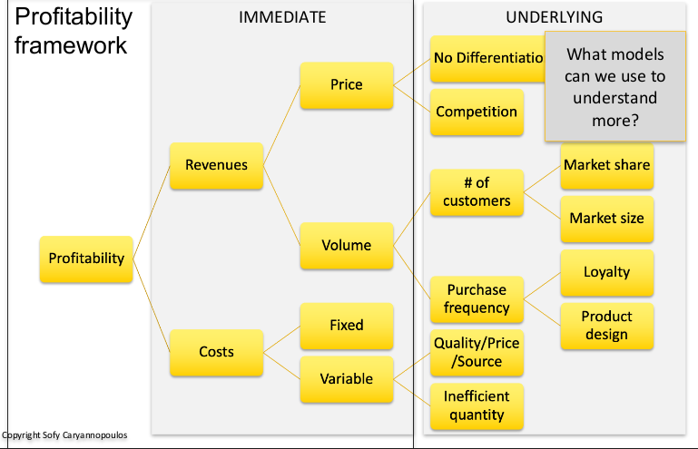

- What objectives, aspirations, criteria that the solution should satisfy for immediate and long term?
  - Objectives: The way you are answering the big question. Influenced by your decision criteria, ways you will answer it.
  - Decision criteria: guides objectives by settings a route (things that should be considered to help reach your goal through your objectives) Kinda like constraints or preferences.
- What are constraints, options and components needed for a complete, feasible, and effective solution?
  - Elements: Complications/Constraints, Strength and opportunities
  - Tools: Models, Frameworks, Issue trees, Diamond-E
- What are the possible options we can use to solve the problem? Which suits our company the best?
  - Strategy
    - What strategy is for answering the big question?
  - Tactical
    - 2-3 main actions needed to make a successful strategy
  - Operational
    - What do we need to make, buy, borrow to implement the tactical recommendations?

