Lab 2: Build and Test a Wired (Ethernet) Network

Things that you will need to know or learn:
- The correct type of cabling to use when connecting network devices
- How to create an Ethernet (wired) network
- Describe the network components (switch, router)
- Use Packet Tracer to set up Ethernet network

What a valid IPv4 address looks like; what a valid subnet mask looks like
- How to determine your IPv4 address and subnet masks using ipconfig
- How to determine your Default Gateway address
- How to verify basic network connectivity using ping
- How to copy text from the command line window
- How to use the windows “Snipping Tool” to screen capture and highlight/annotate
- How to use Wireshark to see actual network traffic

What you need to submit and when:
- Complete the in-lab part of the lab and submit the results on BrightSpace before the due time.
- Complete the “Lab 2 Post-lab” quiz before the due time

Required Equipment/Software:
Network cables from the instructor (Packet Tracer)
This Lab documents downloaded to your laptop

Cable Types
- You will be using 2 types of cables; straight through and crossover in PT.
- A straight through cable is used for connecting different (electrically) types of devices (e.g. PC to switch, router to switch)
- A crossover cable is used for connecting “like” devices (e.g. PC to PC, PC to router, router-to-router and switch to switch)

Task 0: Preparation
Resource files to study before to do this lab
- HowToIP_Win7.pdf
- HowToWireShark.pdf
- Cables.pdf
- ICMP.pdf

Note: Do not start until you have completed ALL steps in this task.

Task 1: Build Network with Packet Tracer
In this task, you will build a network, which consists of two computers and a switch (2960). This is the network topology on which we will build upon in subsequent labs.

Devices needed: Packet Tracer (PT) on your laptop, two PCs, one switch (2960)

Procedure:
1-open the PT software

2- Choose two PC (PC0 and PC1) and one 2960 switch.

3- Connect PC0 to the interface f0/1 and PC1 to the interface f0/2 of the switch (choose the proper cable)

What is the correct cable type to connect the Pcs to the switches’ Ethernet port?

Write it down_ Straight through_____________________ (1 mark)

Note: If you use the right cable, you should see four green dots on the devices

What topology is that? (1 mark)

Write it down_ logical topology_______________

Adding a static IP address to PCs

1-Double click on the PC0 and choose Desktop tab.

2-Click on the IP configuration tab

3-In the IP address box type:
IP 192.168.5.3
Subnet mask 255.255.255.0
Gateway 0.0.0.0
DNS 0.0.0.0
Click on X to save and close the window.

4-Double click on the PC1 and choose Desktop tab

5-Click on the IP configuration tab

In the IP address box type:
IP 192.168.5 2
Subnet mask 255.255.255.0
Gateway 0.0.0.0
DNS 0.0.0.0
Click on X to save and close the window.

How to test PCs connectivity (local network.)

Ping is a command in the TCP/IP protocol to test the connectivity between computers.

1-Double click on the PC0 and choose the command prompt box

2-Type C:\ ping 127.0.0.1 press enter. You should see four TTL reply (Time To Live).
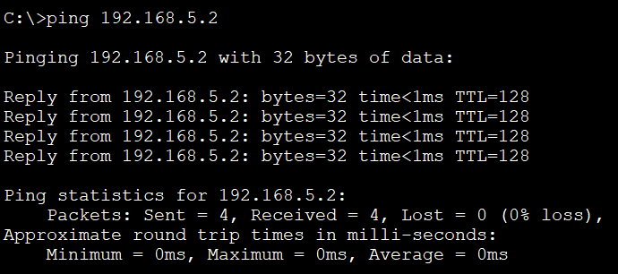

Note: The 127.0.0.1 IP address is called loop back number and it is used to test the TCP/IP within a PC.

Did you get 4 TTL? Yes

Now let us ping another computer on the same network

First, find the IP address for PC0.

1-In the PC0 go to command prompt and type ipconfig and press enter

What is the IP address and subnet mask for PC0? (1 mark)

IP address 192.168.5.3

Subnet mask 255.255.255.0

2-In the PC0 command prompt type C:\ping 192.168.3.9, press enter
Did you get four TTL? Yes or No, why (1 mark)

Explain:__No because IP address is not reachable, not on the network __________________________________________________________

What is the message:
Request timed out.
Request timed out.
Request timed out.
Request timed out.

Ping statistics for 192.168.3.9:
Packets: Sent = 4, Received = 0, Lost = 4 (100 loss)

Now try to find PC1 IP address.

3-What is the IP address of the PC1?

IP address 192.168.5.2

Subnet mask 255.255.255.0

4-From PC0, ping IP address of PC1

Have you been successful ping PC1? (1 mark)

Yes

Save the Packet Tracer activity to a file named: lab2_PT_task1.pkt

Task 02: Setting up a DHCP server

What is a DHCP server? (Google it) (1 mark)

Explain__Automatically assigns IP address_________________________

1-Open a new PT

2-Pickup 6 PCs; pc0, pc1, pc2, pc3, pc4, pc5, one server0, one switch0 (2960)

3-Connect all PCs and server0 to the switch0 with the correct cables.

4-Check the IP addresses of PCs. They should be blank and no IP address
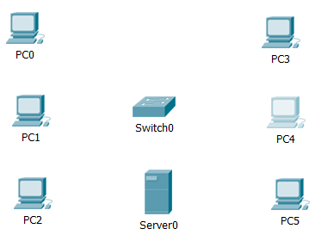

5-Double click on the server0 and choose IP address box
Put a static IP address for the server0

IP address= 192.168.5.10
Subnet mask=255.255.255.0
Default gateway= 192.168.5.1
DNS=1.1.1.1

6-Now click on the service tab and choose DHCP

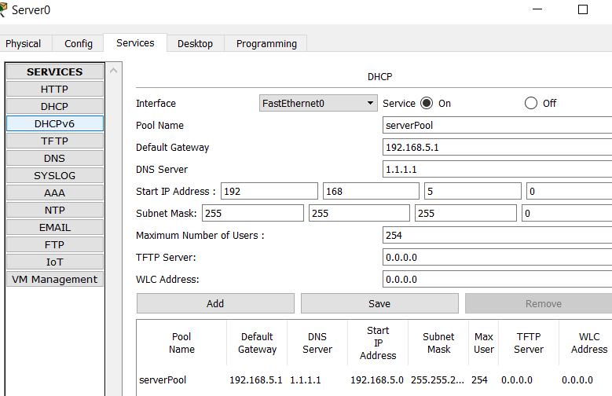
Note: Start IP address and the subnet mask have already filled up and maximum number of users shows 255
Type:
Pool name= severpool (default)
Default Gateway= 192.168.5.1
DNS=1.1.1.1
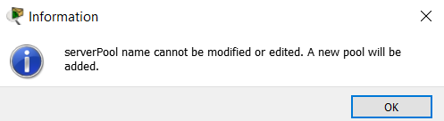

7-Click on Save to save the DHCP pool settings.

Note: you may or may not get this message; click ok

8-Now click on service button, to turn on the service

9-click on X to close the window.

10- Go back to each PC and click on IP box. IP window shows the Static option. Click on DHCP button and wait for a few seconds. All PCs should have a new IP, subnet mask, Default Gateway and DNS address.

Note: to refresh the PCs IP addresses from static to Dynamic just click on the static button and then click on DHCP button again.

What is the DHCP pool name?

Server pool

What is the IP address of PC5 (1 mark)

IP address 192.168.5.7
Subnet mask 255.255.255.0
Default Gateway 192.168.5.1
DNS 1.1.1.1

Why the default Gateway number is the same for all computers? Google it. (1 mark)

Explain all the devices are communicating trough one node on the network

Test the connectivity between PCs (use snipping tools)

From pc0, ping pc5. Take a screen capture, save to a file named: lab2_PT_task2.

Save the Packet Tracer file from this task on your computer, you will need to use it for lab3.

Task 03: How to copy and paste text in the CMD

1-In your laptop go to search and type CMD. The command prompt window will open.

What is the command to find your laptop IP address?

Write it down ipconfig

What is the IP address, subnet mask and default Gateway for your laptop? Copy and paste them here. (2 mark)
IPv4 Address. . . . . . . . . . . : 10.0.0.97
Subnet Mask . . . . . . . . . . . : 255.255.255.0
Default Gateway . . . . . . . . . : fe80::226:86ff:fe99:8b79%15
10.0.0.1

Note: To copy and paste the text in the CMD, just highlight the area that you want to copy and paste it here

Task 04: How to use Wireshark
WS is a sniffing or analyzing tool that helps to capture packets on the network.

Double click on the WS icon in your laptop and let it run. WS begins to capture packets.

Open your browser. In the URL (Universal Resource Locator) type:

http://www.algonquincollege.com and press enter.

Now in the WS, click on the RED button to stop it.
You see hundreds of packets, source and destination address, different protocols. Therefore, you can filter the packets by protocol. Under the RED button, there is a long box, type the following filtering conditions:
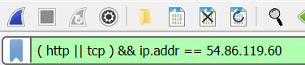

(http || tcp ) && ip.addr == 54.86.119.60

The long box becomes green.
Now you only see the packets between your computer and the college website.
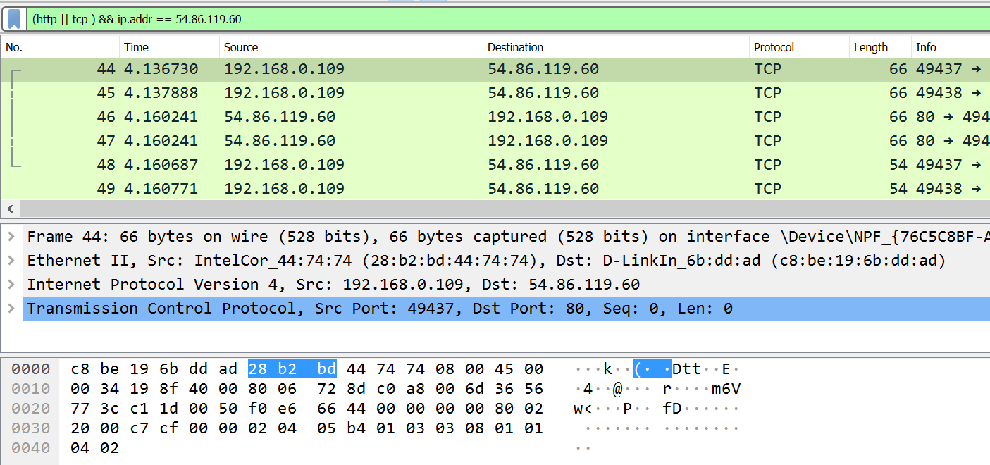

WS has three panes:
Green area shows the NO, Time, Source, Destination, Protocol length, Info
Gray area shows the layer two (data link), frame, Ethernet II for each packet. You can click on each item and read about it more in details.
Black area is the actual data in Hexadecimal number.

Save to a file named: lab2_wireshark_task4.pcapng

Task 05: Submission
Submit the saved files from the previous tasks and this Word file to the drop box inside the folder “lab 02” on BrightSpace.

