Prerequisites
- Boot up your CentOS Linux Box and open Terminal

Deliverables
- A MS-Word file of all screenshots, parts & Qs , to be uploaded in Week10 DropBox
- Demonstration of TASK A to your lab professor
- (Assignment parts total has 7 points, Demonstration of TASK A has 3 points) Total 10 points ( you lose one point for each wrong answer)
- Due date: Two weeks from start of your Week10 Lab’s session
Follow below instructions and create the scripts, make sure it runs properly as instructed.
Reminder: Bash Script Comparison Operators
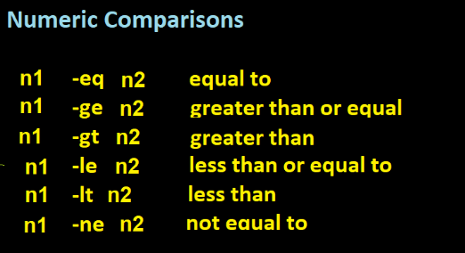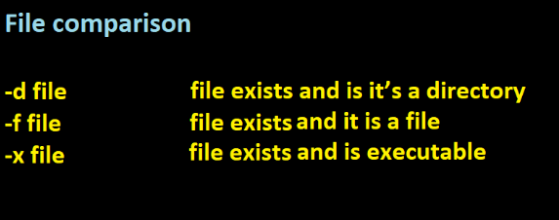
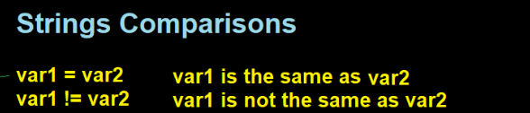

Part 1: File/Directory Operation with bash
Go to Week10 in your home directory, and follow below steps:
In Week10, create a script file called autofile.sh this script should create Dir1 and f1.txt in your current directory automatically. But what if they already exist? We don’t want to overwrite them. So we need to verify if Dir1 or f1.txt is there before creating them. As we need to make decision, so we will use if – then – else block.

For ease of operation, I wrote the sample script for this task below. Enter below script code in the editor. Make sure you give execute permission to script and execute it as below:

$ ./autofile.sh
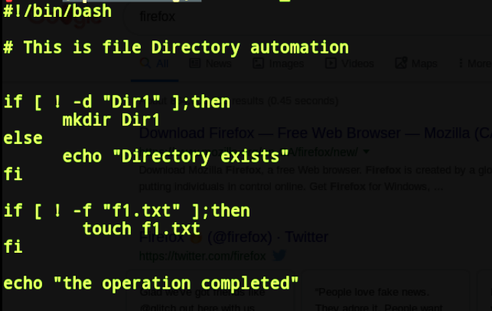

- What is the purpose of –d for in first if block above? [hint: comparison operators]
-d is a operator to test if the given directory exists or not. For instance, I am having a only directory called /home/code/test/. This condition is true only when the directory exists. In our example, the directory exists so this condition is true.
- What is the purpose of –f for in second if block above?
True if FILE exists and is a regular file.
Now complete above script so that it creates below files and directories automatically when you run it.
- Make sure it works as desired and Run ls –l to show all your file are created (Screenshot results + Screen shot script)
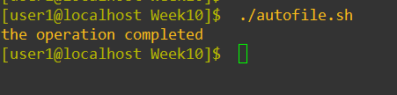
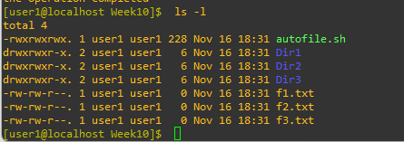
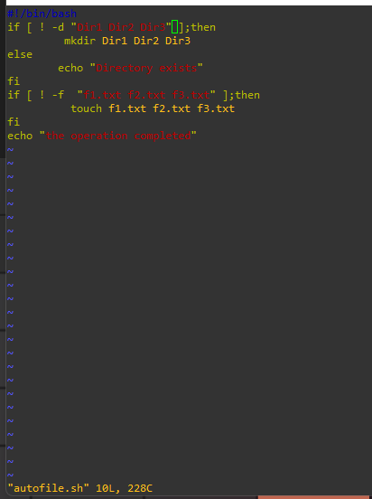

Part 2
Simple Login Script (String comparison)
This script asks for username from input, and verify that it matches with “bob” as username. If username is correct it echoes “Username is OK!” or if not it echoes “Incorrect username”
Enter below script, save as login.sh
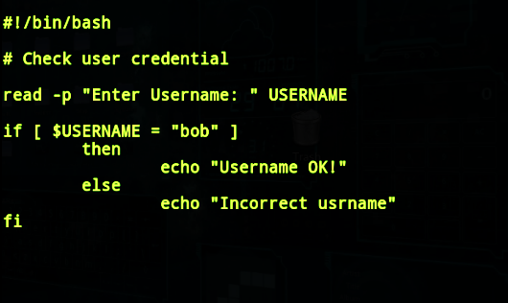

c) Now add another IF-Block to the login.sh in order to ask for user’s password. (Verify if the password is “123” ). Then it echoes “Password OK!” or if it was not the correct password, echos “Incorrect Password!” on the screen.
(Screenshot results + Screen shot script)
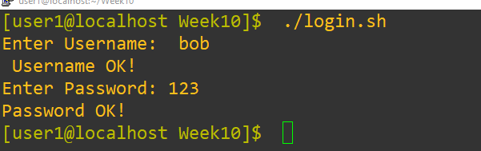

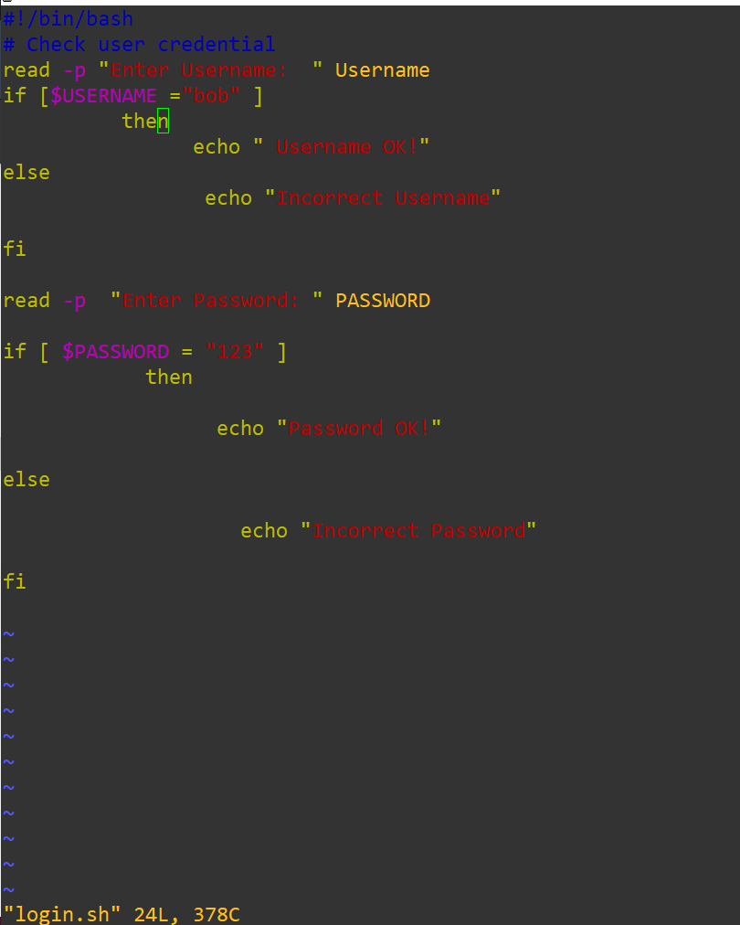

Part 3 – Using While Loop in bash
As discussed before, loops help us to do a task(s) over and over agian
a) Write below script and save it as counter.sh and run it using:
$ ./counter.sh
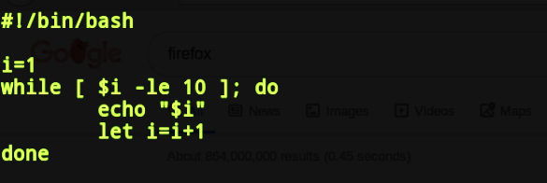
This script uses while loop to count from 1 to 10. Screen shot of output here
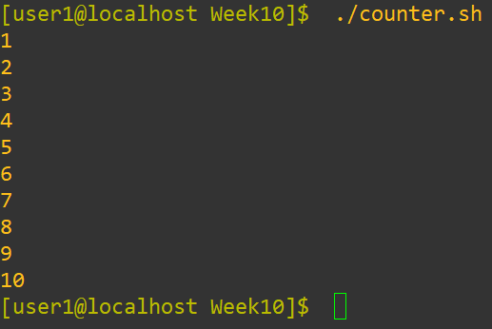

b) Now modify the script so that you can pass the value of counter using positional parameters ($1)
For example:
$ ./counter.sh 20
(It counts up to 20)
Another example:
$ ./counter.sh 35
(It counts up to 35)
Hint: The while condition ( ) this is the part that you need to modify in counter.sh script.
d) Make sure it works properly (screenshot of code + results here)
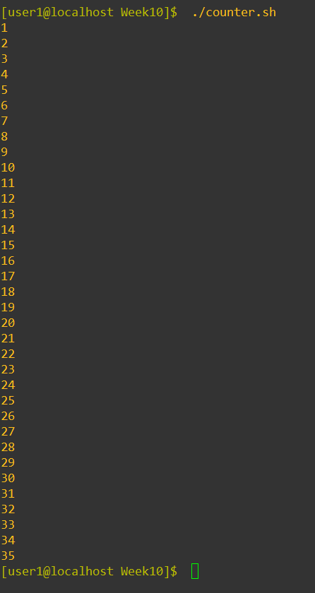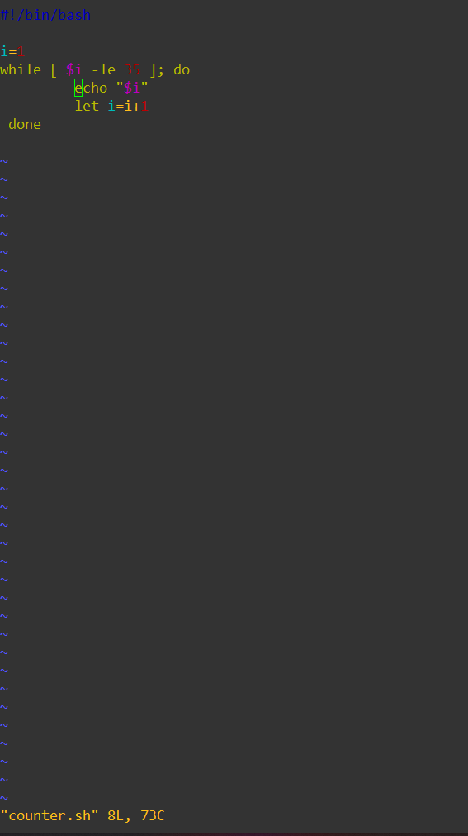

Part 4 - FOR Loop
Modify counter.sh script to use for loop instead of while. To do so you need to change the while loop with a for loop as you see below:
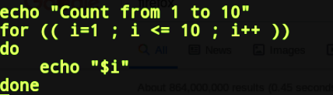
b) It uses for loop to count from 1 to 10. Screen shot of output here10
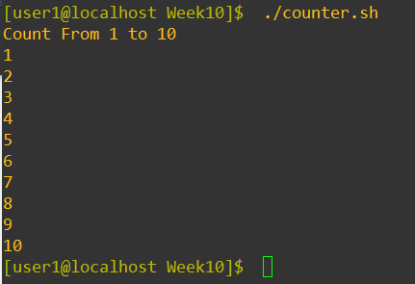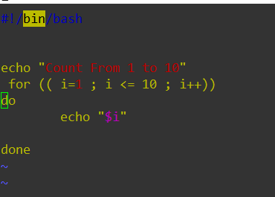

c) Now modify the script so that you can pass the value of counter using positional parameters ($1) e.g.
$ ./counter.sh 20
(It counts up to 20)
$ ./counter.sh 35
(It counts up to 35)
d) Make sure it works, (screenshot of your script + output here)
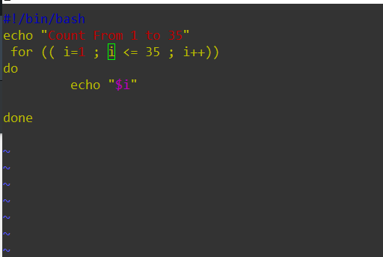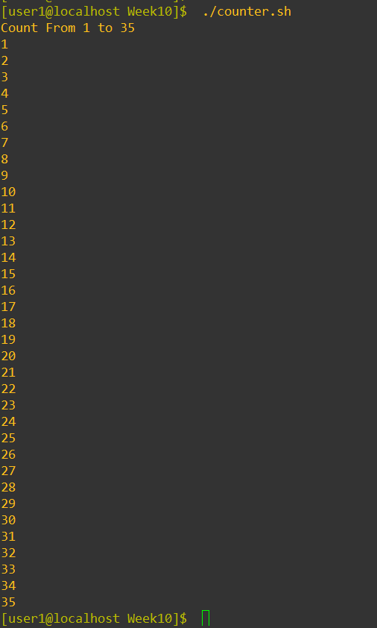

Hint: this is the part you need to modify in counter.sh script.

Q1: What is the benefit of FOR loop compare to WHILE loop?
You will use a FOR loop if you know the amount of time the loop has to run. The benefit over the WHILE loop is that it will not always run in the background slowing down the code.
Q2: What is the benefit of WHILE loop compare to FOR loop?
The benefit of WHILE loop as compared to FOR loop is that it will go (repeat) as often as necessary to accomplish its goal.

Q3: Write down the numerical comparison operators recognized in bash
-eq -ge -gt -le -lt -ne
Q4: How you add comments to your script (e.g: your name, date, usage, copyright info …)
'#' symbol is used to add comment single line in the script

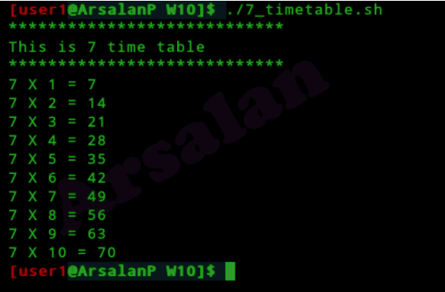
Task-A modify the script in FOR loop so that, it shows 7 time table as shown in the image :
Task-A need to be demonstrated to your Lab professor in person. (3 points)
No written submission’s required for TASK A

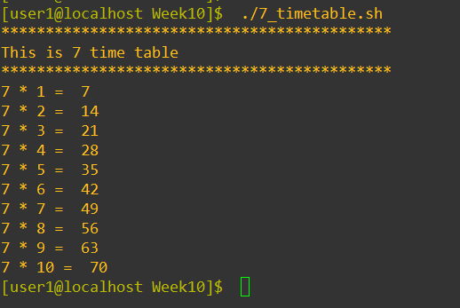
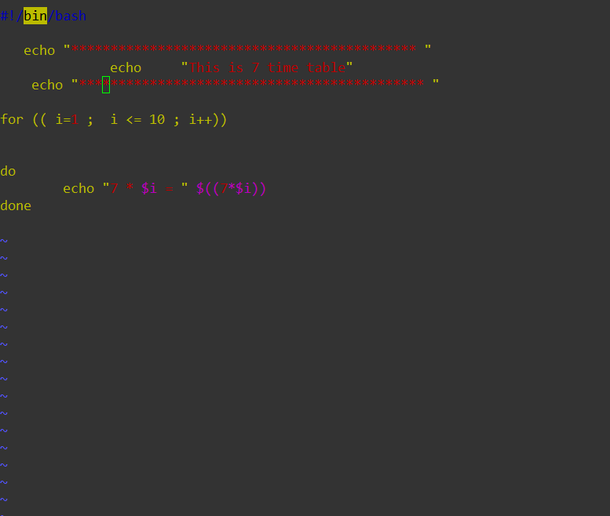

- Shutdown your VM gracefully
- If you had any question ask you Lab Professor

