Why Are Kids/Teens Quitting Sports?

70% of kids stop playing sports by the age of 13!!!

Reasons why kids are quitting
- It’s no longer fun
- They’ve lost ownership of their experience
- Don’t get adequate playing time
- Afraid to make mistakes
- Feeling of disrespect from coaches or parents
- Teams and coaches prioritize winning
- Parents see sports as an investment
- 70% failure rate may make some millions playing baseball but it does not serve the kids in youth sports

Mistakes Parents Make When Child Wants to Quit
- Parents feel they haven’t capitalized on their investment yet
- They try and own the decision more than the child
- See their child as a quitter
- Think they know what the child is going through better than the child itself
- Worry about what other parents think
- Looking too far ahead

How to prevent kids from quitting sports
- Prevent burnout by encouraging them to play other sports
- Stop putting so much pressure on youth athletes
- Remember that it’s still just a game

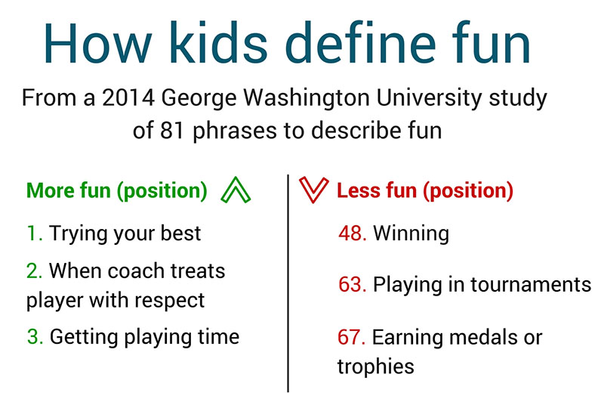

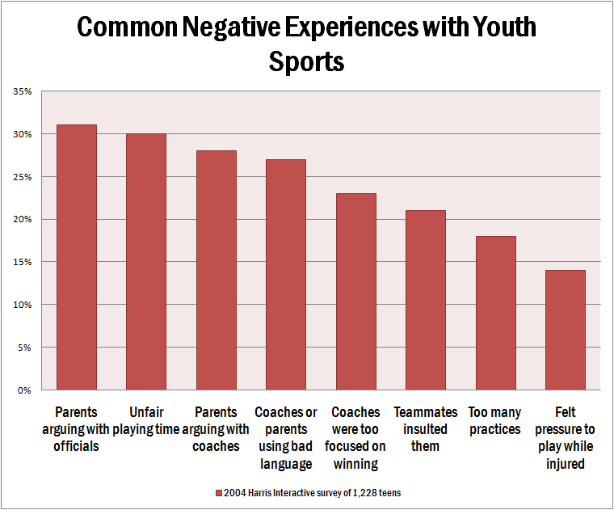
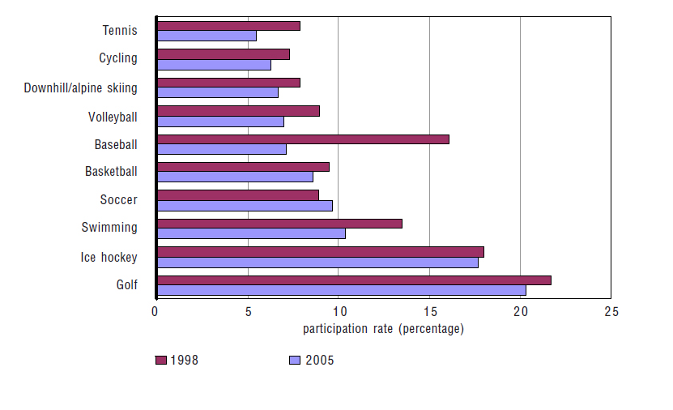

Hazing in Sports

A comprehensive study in 2008 by the National Collaborative for Hazing Research and Prevention shows an increase in hazing activities. This study polled over 11,000 students from across the nation. The top findings show that over half of college athletes are subject to some form of hazing and 47% had already experienced hazing before college. 95% did not report the activity to college officials.
Also reported in this survey is a trend seen across the nation; female athletes are just as prone to hazing rituals as male athletes. Like males, participating in a drinking game was the most frequent hazing activity for females, at 23%. Other dangerous activities reported by female participants included sleep deprivation (10%), drinking alcohol to the point of sickness (9%), and getting a tattoo or piercing (5%).)



