Purpose:
This week’s lab requirement is to install Oracle 12c Release 1 Enterprise Edition dbms on your laptop. If you want you can install Oracle within a VMware virtual machine running Windows 7 Pro or Windows 10 so that you can both isolate CST8276 activities from your other uses, and also can recover your dbms state quickly by reverting to a previous snapshot. However, for this set of Lab sessions this class will install oracle directly on our laptops, it is much faster.
The general process you will follow is (read the rest of the document and carefully follow the step!):
- Connect to Algonquin College's Plato Digital Resource Portal, sign in, download VMware Workstation and MS Windows 7 or 10.
- Install VMware, create a virtual machine, and install Windows as its operating system.
- Connect to Oracle, download Oracle 12 dbms for Windows, unzip the 2 compressed Oracle files into the same folder, run as administrator the Oracle install exec, respond appropriately to the customization prompts including setting the passwords for super user accounts.
Details of the process are provided later in this document.
NOTE: if you want to finish the installation early, download the two zipped files, “File1” and “File2” ahead before the lab. Do Not unzip them.

Deliverable:
To receive 2 marks ensure this lab is completed at end of the lab session. All deliverables are to be submitted via Brightspace in a word file format that contains the answers of the questions provided in section 4 parts: i, j, k, l, m and n.
It is easiest to just submit an updated version of this Word document but containing your answers and screen shots!

Process:
- Download Oracle 12c Enterprise Edition.
  - Please note that the two files are also available in Brightspace through links under the “Oracle files” content area. This is an older version of Oracle that contains almost all of the current features, but will install on a Windows 10 laptop.
- Unzip the 2 Oracle compressed files into a single common folder (the two zipped files should be merged when they are unzipped). Use a folder name that is short and does not contain blanks. (e.g., C:\oracle12cinstall)
- Open a “cmd” window as administrator (i.e., run as administrator). Then, navigate to your installation folder in step 2, and run the following command.
  - On Windows 10: make sure you are running the command as administrator and use the following command line
setup -ignorePrereq -J"-Doracle.install.db.validate.supportedOSCheck=false"
- Respond appropriately to the installation customization queries. The critical steps are highlighted – they are mandatory for this course.
  - Step 1: Configure Security Updates:
    - Email option – leave blank, does not apply
    - Deselect the update notification option. You do NOT want to receive security updates.
    - Press 'Next'
    - Ignore the warning, press 'Yes'.
  - Step 2: Installation Option:
    - Select 'Create and configure a database', then press 'Next'
  - Step 3: System Class:
    - Select 'Desktop Class', then 'Next'
  - Step4: Home User Selection
    - Select 'Use Built-in Windows Account, then press 'Next'
    - Ignore the security warning and proceed.
  - Step 5: Typical Installation Configuration:
    - Accept defaults EXCEPT for the following:
      - Global DB name: change to 'orcl'
      - Make sure to uncheck the ‘create as container database” checkbox
      - Admin (SYS) password: 'yourFirstNamesOracle123' (e.g., dougOracle123)
        - If you receive a warning('INS-30011') that your password strength is poor, ignore it
        - 'Next' / 'Yes' to continue
  - Step 6: Prerequisite Check is performed. This may take some time. Sometimes the installer will pop-up a window underneath a visible window (so that you cannot see the pop-up) so some manual intervention may be required.
  - Step 7: Summary of response is displayed. 'Save Response File' and 'Install'.
  - Step 8: Install Product message is displayed. If you receive a Windows firewall message, allow access for Java
    - Several components are installed
    - In the Password Management screen, change the password for user SYSTEM to : 'yourFirstNamesystem' (e.g., dougsystem). You may unlock and change passwords for some other accounts at the same time (or just leave them defaulted for now. The website https://www.orafaq.com/wiki/List_of_default_database_users
has a list of default Oracle usernames and default passwords.
    - 'OK'
    - Ignore any additional password standards warning message. 'Continue? Yes' / 'OK'
    - Windows 10: If Services for Microsoft Transaction Server cannot start – that is OK. Click Next and Yes when asked are you sure you want to continue.
  - Step 9 Installation was Successful message is displayed. Take your screen shot before closing the window and paste it below (Ctrl-Alt PrtScr to copy the currently selected window) (Ctrl-V to Paste) Then, select 'Close'
    - Paste your screen shot showing successful installation, take a screen shot and save it for your submission
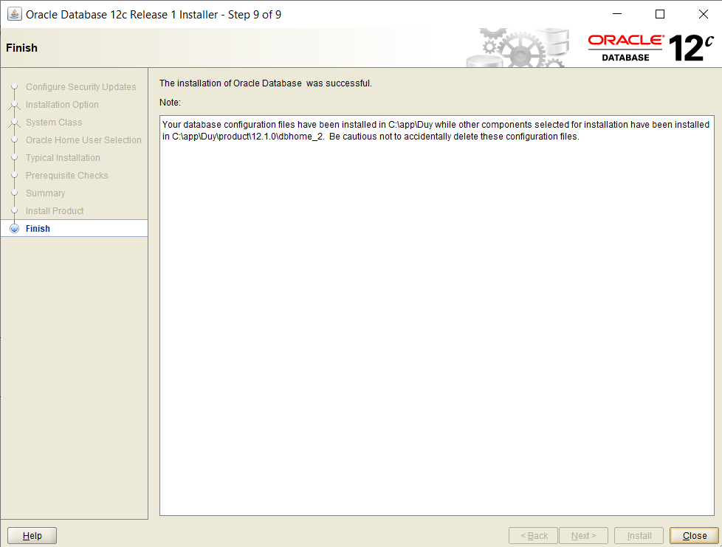

  - Confirm you are able to logon to account SYSTEM. (Open a cmd window and us the sqlplus application.)
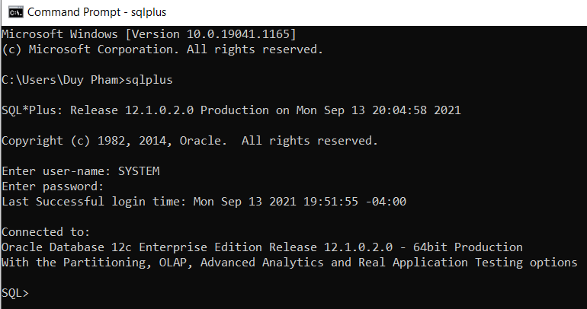

  - Use the SYSTEM account to change the password for SYS (Hint: use “alter user SYS ….”. Set it to “password”

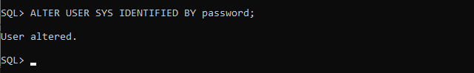

  - Enter: SHOW con_name. The result should be orcl.

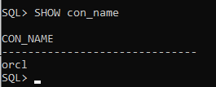

  - Search for the init.ora text file and then copy the location of the init.ora text file to your submission document. This file is located by default here: C:\app\myoracle\admin\orcl\pfile\init.ora where myoracle would be a different value on your system.

C:\app\Duy\admin\orcl\pfile\init.ora.872021232919

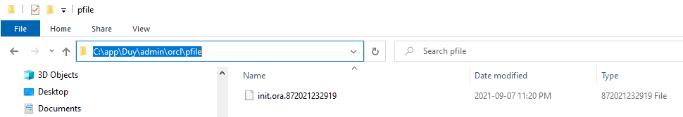

  - Make sure the below script can be executed without errors. Take a screen shot of the output.
CREATE TABLE sales01
(prod_id NUMBER(6)
, time_id DATE
, quantity_sold NUMBER(3)
)
PARTITION BY RANGE (quantity_sold)
( PARTITION sales_p1 VALUES LESS THAN (35)
, PARTITION sales_p2 VALUES LESS THAN (76)
, PARTITION sales_p3 VALUES LESS THAN (MAXVALUE)
);

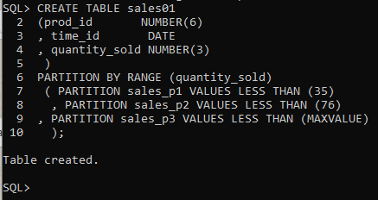

You're done!

