EC 120
Chapter One
Economics : Study of the use of scarce resources to satisfy unlimited human wants Microeconomics: Study causes & consequences of resource allocation (effects of government, price system)

Resources
Capital - Manufactured aids (tools, machinery, buildings)
Entrepreneurship - Provides skills/creativity to produce better resources
Land - Natural Resources (Arable Land, Crude Oil, Minerals.etc)
Labour - Mental + Physical Human Resources
→ Called 'Factors of Production

Opportunity costs: Cost measured in terms of other goods and services that could have been obtained instead; Ratio between [Cost & benefit], each opportunity cost is
an inverse of the other

Given available resources, it's impossible to Produce more of endevaour #1 without taking away from resources allocated to endevaour #2

Production Possibilities boundary/Curve/Frontier
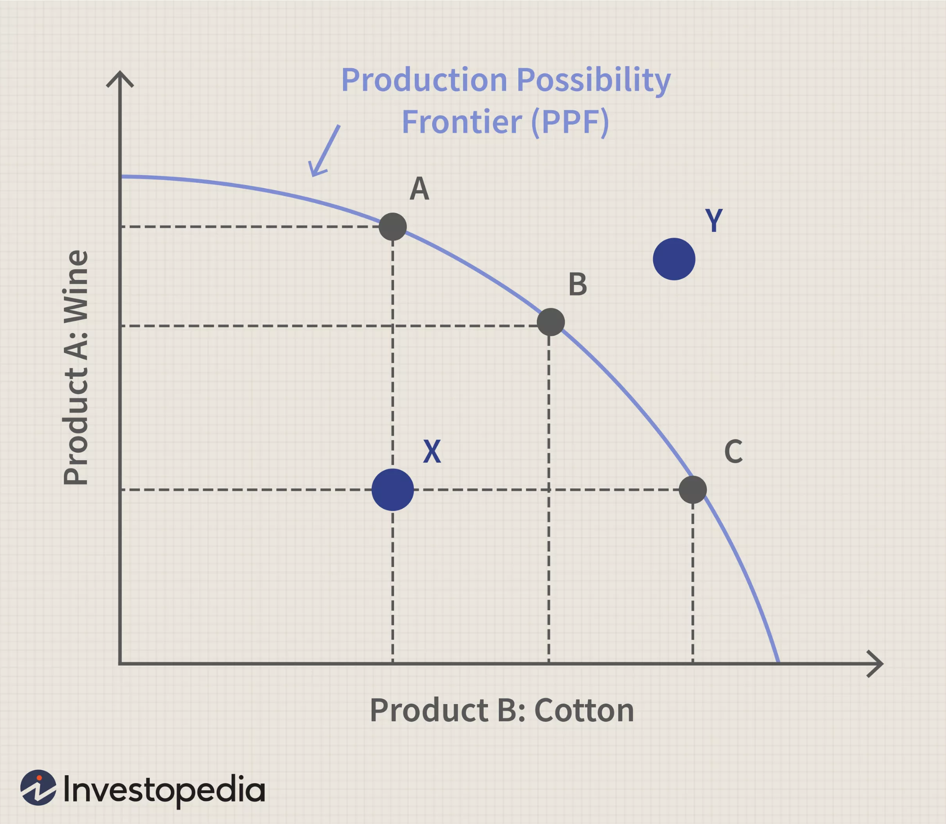

Allocative Efficiency : Particular mix of goods a society produces represents the output that Society most desires
- Application Connection: Consumer-Driven Product Markets

Law of Diminishing Returns: As additional increments of resources are
added to a certain purpose, the marginal benefit from those increments will decline

Comparative Advantage : AKA 'Competitive advantage'; One Party can produce
a good/service at a lower opportunity cost than another party

4 The Economic Problems :
1) What is produced and How?
2) What is consumed and by whom?
3) Why are resources sometimes idle?
4) Is productive capacity growing?

***
Nature of Market Economies
An Economy: A system in which scarce resources are allocated among competing uses

Market Economy Traits : Self-Organizing, Efficiency, Serf - Interest/Incentives

The 3 'Decision Makers' in any economy: Consumers, Producers, Government

Maximizing Decisions : Consumers/Producers make decisions with maximum Self-interest

Marginal Decisions : Marginal cost v.s Marginal Benefit Comparison when making a decision

Circular Flow of Income & Expenditure
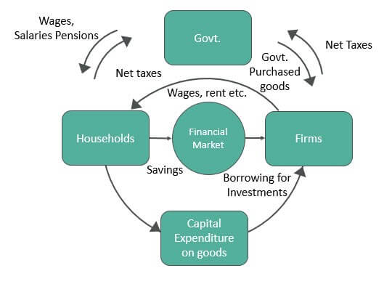
Important to Market Economies : Production and Trade, Specialization, Division of Labour^ , Money & Trade*, Globalization
* Barter =goods for goods trading
^Better fulfills principle of comparative advantage

Types of Economic Systems
Three 'Pure - Type Economies

- Traditional Economies
Based on customs, habit, relatively stagnant economy, works best in a country with an unchanging environment

- Command
Central authority makes economic decisions

- Free -market
Economic decisions are decentralized, coordinated by price systems (market-determined prices), government only handles policies but markets determine all resource allocation & income distribution

- Mixed Economies
"In practice, every economy is a mixed economy”
4 Combinations of significant elements from all 3 systems to determine economic behaviour, increased government intervention to ensure fair competition + economic policy/opportunity for all but markets also maintain some influence

Chapter 2

Positive Statements : Associates a quantity to the judgements of the public
Normative Statements : Structured more like an opinion

EXAMPLE -
P Statement : Raising interest rates encourages people to save
N Statement: People should be encouraged to save } (More Debatable)

Building & Testing economic theories (models)
• Distinguished by variables, Assumptions, Predictions
Endogenous variable: Determined within the theory
Exogenous variable: Influences the endogenous variable, is determined outside the theory
- Ex. weather vs Crop Yield

Assumptions concern motives, directions of causation, & conditions under which the theory is meant to apply
- Ex. Motives: Assumption that consumers want to maximize utility while firms are assumed to try to maximize their profits
- Ex. Direction of Causation : What influences what
- Ex. Conditions : Specifics under which a theory is meant to hold

Predictions Aka Hypotheses

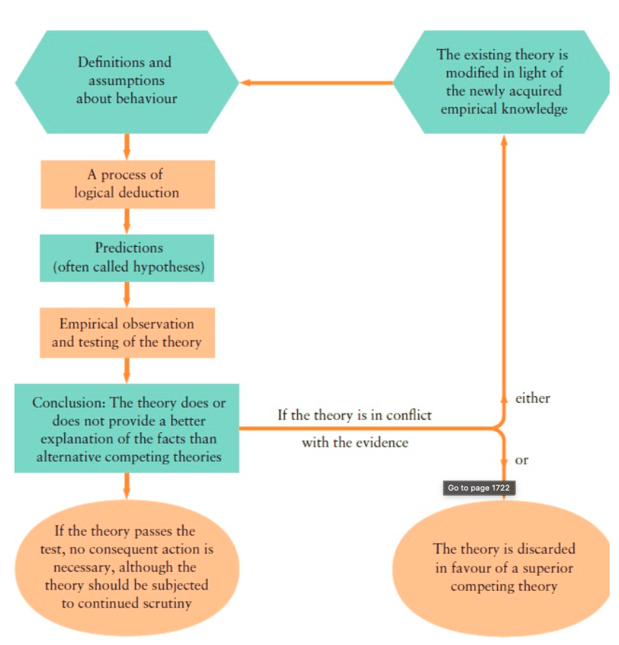

*****
Economic Data
Index Numbers : Economic data figure reflecting a price or quantity compared with a standard/ base value
» Base usually equals 100 & the index number is expressed as 100x the ratio to the base value
- Ex. Base Value = 200 units in 2010
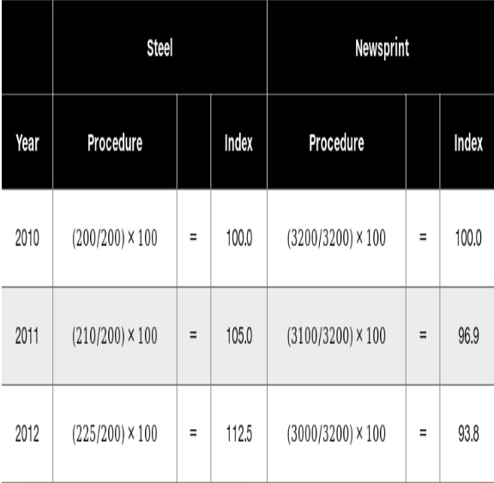

CPI (Consumer Price Index) : Indicator of changes in consumer prices, price of a weighted average market basket of goods & Services purchased by households



