Chapter 11

11.1 The Concept of Budgetary Control and Static Budget Reports

Budgetary control activities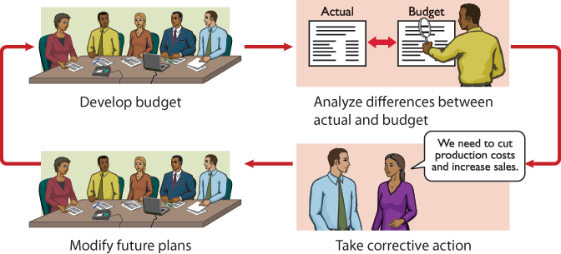

Budgetary control works best when a company has a formalized reporting system. The reporting system does the following:

- 1.Identifies the name of the budget report, such as the sales budget or the manufacturing overhead budget.
- 2.States the frequency of the report, such as weekly or monthly.
- 3.Specifies the purpose of the report.
- 4.Indicates the primary recipient(s) of the report.

Budgetary control reporting system
Name of Report | Frequency | Purpose | Primary Recipient(s)
Sales | Weekly | Determine whether sales goals are being met | Top management and sales manager
Labour | Weekly | Control direct and indirect labour costs | Vice-president of production and production department managers
Scrap | Daily | Determine efficient use of materials | Production manager
Departmental overhead costs | Monthly | Control overhead costs | Department manager
Selling expenses | Monthly | Control selling expenses | Sales manager
Income statement | Monthly and quarterly | Determine whether income objectives are being met | Top management

Static Budget Reports
When it is used in budgetary control, each budget in the master budget is viewed as being static. A static budget is a projection of budget data at one level of activity. These budgets do not consider data for different levels of activity. As a result, companies always compare actual results with budget data at the activity level that was used in developing the master budget.

Budget and actual sales data
Sales | First Quarter | Second Quarter | Total
Budgeted | $180,000 | $210,000 | $390,000
Actual | 179,000 | 199,500 | 378,500
Difference | $ 1,000 | $ 10,500 | $ 11,500
Sales budget report—first quarter
\Hayes Company
Sales Budget Report
Quarter Ended March 31, 2020
Product Line | Budget | Actual | Difference: Favourable (F)/Unfavourable (U)
Rightridea | $180,000 | $179,000 | $1,000 U

A static budget report is, therefore, appropriate for fixed manufacturing costs and for fixed selling and administrative expenses. But, as you will see shortly, static budget reports may not be a proper basis for evaluating a manager's performance in controlling variable costs.

11.2 Flexible Budgets

Visual summary of flexible budgets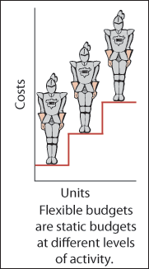

Static overhead budget
Barton Robotic2020
Budgeted production in units | 10,000
Budgeted costs
Indirect materials | $ 250,000
Indirect labour | 260,000
Utilities | 190,000
Depreciation | 280,000
Property taxes | 70,000
Supervision | 50,000
 | $1,100,000

Static overhead budget report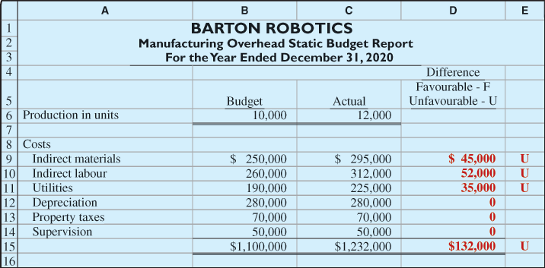

When you calm down and carefully examine the manufacturing overhead budget, you identify the problem: The budget data are not relevant! At the time the budget was developed, the company anticipated that only 10,000 units of robotics controls would be produced. Instead, 12,000 units were actually produced. Comparing actual variable costs incurred at a production level of 12,000 units with budgeted variable costs at an expected production level of 10,000 units is meaningless (see Helpful Hint). As production increases, the budget allowances for variable costs should increase both directly and proportionately. The variable costs in this example are indirect materials, indirect labour, and utilities.

Variable costs per unit
Item | Total Cost | Per Unit
Indirect materials | $250,000 | $25
Indirect labour | 260,000 | 26
Utilities | 190,000 | 19
 | $700,000 | $70
Budgeted variable costs at 12,000 units
Item | Calculation | Total
Indirect materials | $25 × 12,000 | $300,000
Indirect labour | $26 × 12,000 | 312,000
Utilities | $19 × 12,000 | 228,000
 |  | $840,000
Overhead flexible budget report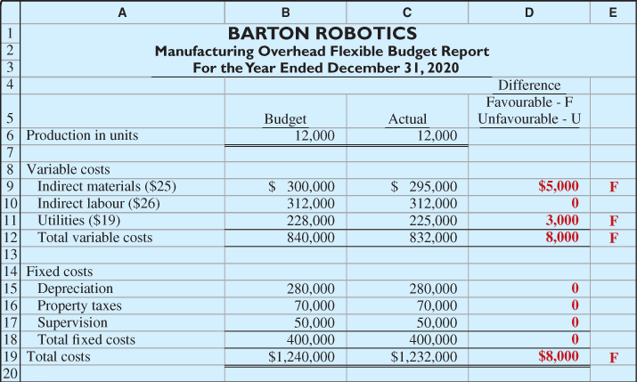

Developing the Flexible Budget
- 1.Identify the activity index and the relevant range of activity.
- 2.Identify the variable costs, and determine the budgeted variable cost per unit of activity for each cost.
- 3.Identify the fixed costs, and determine the budgeted amount for each cost.
- 4.Prepare the budget for selected increments of activity within the relevant range.

The activity index that management chooses should be something that significantly influences the costs that are being budgeted. For manufacturing overhead costs, for example, the activity index is usually the same as the index used in developing the predetermined overhead rate; that is, direct labour hours or machine hours. For selling and administrative expenses, the activity index is usually sales or net sales (see IFRS Notes).

Flexible Budget—A Case Study
Master budget data
Variable Costs |  | Fixed Costs
Indirect materials | $180,000 | Depreciation | $180,000
Indirect labour | 240,000 | Supervision | 120,000
Utilities | 60,000 | Property taxes | 60,000
Total | $480,000 | Total | $360,000
The four steps for developing the flexible budget are applied as follows:
- Step 1: Identify the activity index and the relevant range of activity. The activity index is direct labour hours. Management concludes that the relevant range is 8,000 to 12,000 direct labour hours per month.
- Step 2: Identify the variable costs, and determine the budgeted variable cost per unit of activity for each cost. A cost is variable if total costs vary directly as a result of a change in the activity index, which is the direct labour in this case. In this example, indirect materials, indirect labour, and utilities are variable costs. The variable cost per unit is found by dividing each total budgeted cost by the direct labour hours that are used in preparing the master budget (120,000 hours). For Fox Manufacturing, the calculations are as shown in Illustration 11.14.
- Step 3: Identify the fixed costs, and determine the budgeted amount for each cost. A cost is fixed if the total cost does not vary as a result of changes in the activity index within the relevant range. In this example, depreciation, supervision, and property taxes are fixed costs. Since Fox wants monthly budget data, it finds the budgeted amount by dividing each annual budgeted cost by 12. For Fox, the monthly budgeted fixed costs are depreciation $15,000, supervision $10,000, and property taxes $5,000.
- Step 4: Prepare the budget for selected increments of activity within the relevant range. Management decides to prepare the budget in increments of 1,000 direct labour hours. Illustration 11.15 shows the resulting flexible budget.

Formula for total budgeted costs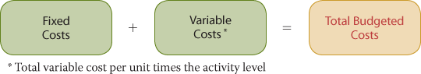

For Fox Manufacturing, fixed costs are $30,000, and the total variable cost per unit is $4. Thus, at 9,000 direct labour hours, the total budgeted costs are $66,000 [$30,000 + ($4 × 9,000)]. Similarly, at 8,622 direct labour hours, the total budgeted costs are $64,488 [$30,000 + ($4 × 8,622)] (see Helpful Hint).

Flexible Budget Reports
Flexible overhead budget report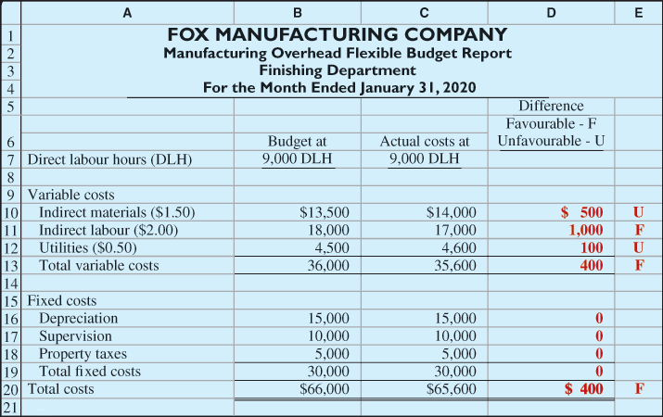

11.3 Responsibility Accounting for Cost and Profit Centres

The Responsibility Accounting Concept
Under responsibility accounting, a manager's performance is evaluated based on matters that are directly under that manager's control. Responsibility accounting can be used at every level of management where the following conditions exist:
- 1.Costs and revenues can be directly associated with the specific level of management responsibility.
- 2.The costs and revenues are controllable at the level of responsibility that they are associated with.
- 3.Budget data can be developed for evaluating the manager's effectiveness in controlling the costs and revenues.

Controllable Versus Noncontrollable Revenues and Costs
- 1.All costs are controllable by top management because of its broad range of authority.
- 2.Fewer costs are controllable as one moves down to each lower level of managerial responsibility because the manager's authority decreases at each level.
In general, costs that a level of responsibility directly incurs can be controlled at that level. In contrast, costs that are incurred indirectly and allocated to a responsibility level are considered to be noncontrollable at that level.

Principles of Performance Evaluation

Materiality
Without quantitative guidelines, management would have to investigate every budget difference no matter how small it was. Materiality is usually expressed as a percentage difference from the budget. For example, management may set the percentage difference at 5% for important items and 10% for other items (see IFRS Notes). The company will investigate all differences that are over or under budget by at least the specified percentage.

Behavioural Principles
The human factor is critical in evaluating performance. Behavioural principles include the following:
- 1.Managers of responsibility centres should be directly involved in setting budget goals for their areas of responsibility. Without such involvement, managers may view the goals as unrealistic or arbitrarily set by top management. Such views can decrease the managers' motivation to meet the targeted objectives.
- 2.The evaluation of performance should be based entirely on matters that can be controlled by the manager being evaluated. Criticism of a manager for matters that he or she cannot control reduces the effectiveness of the evaluation process. It leads to negative reactions by the manager and to doubts about the fairness of the company's evaluation policies.
- 3.Top management should support the evaluation process. As explained earlier, the evaluation process begins at the lowest level of responsibility and extends upward to the highest level of management. Managers quickly lose trust in the process when top management ignores, overrules, or bypasses established procedures for evaluating a manager's performance.
- 4.The evaluation process must allow managers to respond to their evaluations. Evaluation is not a one-way street. Managers should have the opportunity to defend their performance. Evaluation without feedback is impersonal and ineffective.
- 5.The evaluation should identify both good and poor performance. Praise for good performance is a powerful motivating factor for a manager. This is especially true when a manager's compensation includes rewards for meeting budget goals.

Types of Responsibility Centres
Responsibility report for a cost centre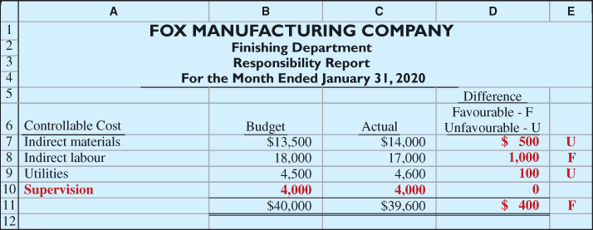
Only controllable costs are included

Or the costs of a company's human resources department may be allocated to profit centres based on the number of employees in each centre. Because these fixed costs apply to more than one centre, they are also called common costs. Most indirect fixed costs cannot be controlled by the profit centre manager.

- 1.Controllable fixed costs are deducted from the contribution margin.
- 2.The amount by which the contribution margin is greater than the controllable fixed costs is identified as the controllable margin.
- 3.Noncontrollable fixed costs are not reported.

Responsibility report for profit centre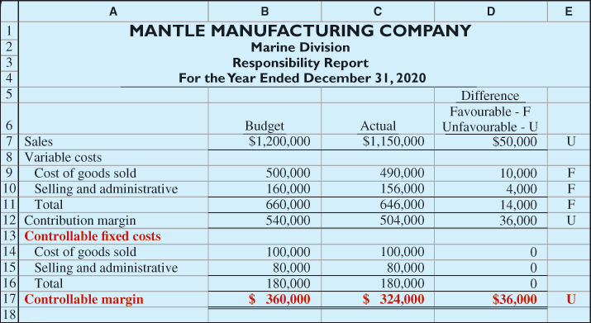
The controllable margin is considered to be the best measure of the manager's performance in controlling revenues and costs. This report shows that the manager's performance was below budgeted expectations by 10% ($36,000 ÷ $360,000). Top management would likely investigate the causes of this unfavourable result. Note that the report does not show the marine division's noncontrollable fixed costs of $60,000. These costs would be included in a report on the profitability of the profit centre.

11.4 Evaluating Performance in Investment Centres

ROI formula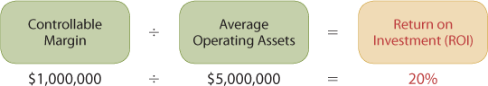
Since an investment centre is an independent entity for operating purposes, all fixed costs are controllable by its manager.

To illustrate this responsibility report, we will now assume that the marine division of Mantle Manufacturing Company is an investment centre. It has budgeted and actual average operating assets of $2 million. We also assume that the manager can control the $60,000 of fixed costs that were not controllable when the division was a profit centre. Illustration 11.26 shows the responsibility report.
Responsibility report for investment centre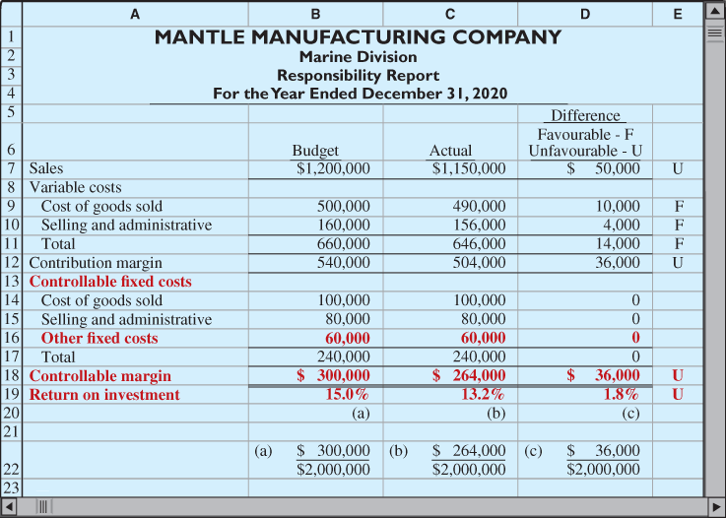

The report shows that the manager's performance based on the ROI was 12% (1.8% ÷ 15%) below budget expectations. Top management would likely want to know the reasons for this unfavourable result.

Judgemental Factors in ROI
The return on investment approach includes two judgemental factors:
- 1.Valuation of operating assets. Operating assets may be valued at their acquisition cost, book value, appraised value, or market value. The first two values are easily found in the accounting records.
- 2.Margin (income) measure. This measure may be the controllable margin, income from operations, or net income.
Each of the alternative values for operating assets can be a reliable basis for evaluating a manager's performance, as long as it is consistently used between reporting periods. However, the use of income measures other than the controllable margin will not result in a valid basis for evaluating the performance of an investment centre manager.¹

Improving ROI
ROI expanded form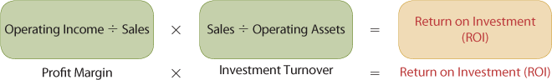

The first term in the expanded formula is profit margin, which focuses on profitability. It shows how the operating margin can be improved by increasing the margin on each dollar of sales. It measures managers' abilities to control the operating expenses that are related to sales during a specific period. The second term of the expanded formula is investment turnover, which focuses on efficiency. It shows how investment turnover can be improved by generating more sales for each dollar invested.

Assumed data for the marine division
Sales | $2,000,000
Variable costs | 1,100,000
Contribution margin (45%) | 900,000
Controllable fixed costs | 300,000
Controllable margin (a) | $ 600,000
Average operating assets (b) | $5,000,000
Return on investment [(a) ÷ (b)] | 12%
Using the expanded form, the current ROI for the marine division of Mantle Manufacturing can be calculated as shown in Illustration 11.29.
ILLUSTRATION 11.29Using the expanded form of the ROI formula to calculate the current ROI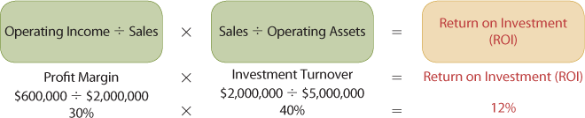

1.Increasing the Controllable Margin. The controllable margin can be increased by increasing sales or by reducing the variable and controllable fixed costs as follows:
- a.Increase sales by 25%.
Sales increase by $500,000 ($2,000,000 × 0.25). Assuming that there is no change in the contribution margin percentage of 45%, the contribution margin will increase by $225,000 ($500,000 × 0.45). The controllable margin will increase by $150,000 if the variable and controllable fixed costs will increase by 25%. Thus, the controllable margin becomes $750,000 ($1,125,000 − $375,000). The new ROI is 15%, as calculated in Illustration 11.30.
ILLUSTRATION 11.30

b.Decrease variable and fixed costs by 10.715%.
Total costs decrease by $150,000² [($1,100,000 + $300,000) × 0.10715]. This reduction will result in a corresponding increase in the controllable margin. Thus, the controllable margin becomes $750,000 ($600,000 + $150,000). The new ROI is 15%, as calculated in Illustratio

2.Reducing the Average Operating Assets. Assume that the average operating assets are reduced by 20% or $1 million ($5,000,000 × 0.20). The average operating assets become $4 million ($5,000,000 − $1,000,000). Since the controllable margin remains unchanged at $600,000, the new ROI is 15%, as calculated in Illustration 11.32.

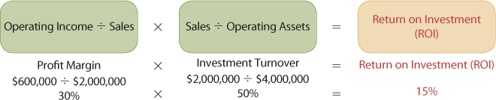

Presented below is information related to the Southern Division of Lumber Ltd.
Contribution margin |  | $1,223,300
Controllable margin |  | $1,018,850
Average operating assets |  | $4,075,400
Minimum rate of return |  | 20 | %

- 

