10.1 Budgeting Basics and the Master Budget

The Benefits of Budgeting
Following are the primary benefits of budgeting:
- 1.It requires all levels of management to plan ahead and to formalize goals on a recurring basis.
- 2.It provides definite objectives for evaluating performance at each level of responsibility.
- 3.It creates an early warning system for potential problems so that management can make changes before things get out of control.
- 4.It makes it easier to coordinate activities within the business. It does this by fitting the goals of each segment with overall company objectives. Thus, production and sales promotion can be integrated with expected sales.
- 5.It results in greater management awareness of the entity's overall operations and the impact on operations of external factors, such as economic trends.
- 6.It motivates personnel throughout the organization to meet planned objectives.

Flow of budget data from lower levels of management to top levels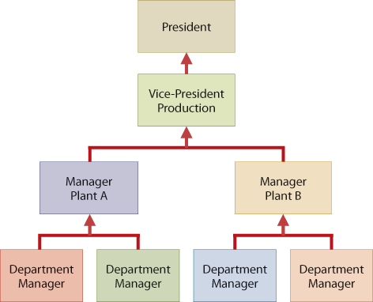

A second disadvantage of participative budgeting is that it can encourage budgetary “gaming” through budgetary slack. Budgetary slack occurs when managers intentionally underestimate budgeted revenues or overestimate budgeted expenses in order to make it easier to achieve budgetary goals for their division.

Budgeting and Long-Range Planning
Budgeting and long-range planning are not the same. One important difference is the time period involved. The maximum length of a budget is usually one year, and budgets are often prepared for shorter periods of time, such as a month or a quarter. In contrast, long-range planning usually covers a period of at least five years (see Helpful Hint).
A second significant difference is in emphasis. Budgeting focuses on achieving specific short-term goals, such as meeting annual profit objectives. Long-range planning, on the other hand, identifies long-term goals, selects strategies to achieve those goals, and develops policies and plans to implement the strategies. In long-range planning, management also considers anticipated trends in the economic and political environment and how the company should react to them.

The Master Budget
The term budget is actually a shorthand term to describe several budget documents. All of these documents are combined into a master budget. The master budget is a set of interrelated budgets that create a plan of action for a specified time period (see Decision Tools). Illustration 10.2 shows the individual budgets included in a master budget.

Components of the master budget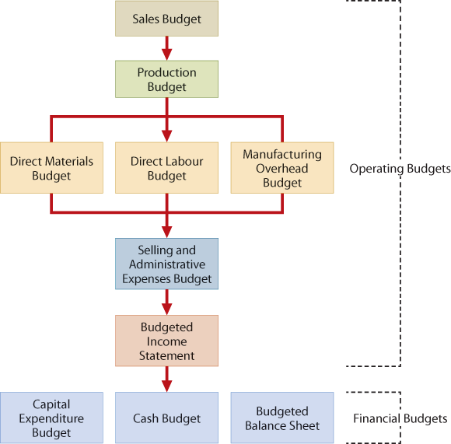

10.2 Preparing the Sales, Production, and Direct Materials Budgets

the sales budget is the first budget that is prepared. Each of the other budgets depends on the sales budget (see Helpful Hint). The sales budget is derived from the sales forecast. It represents management's best estimate of sales revenue for the budget period. An inaccurate sales budget may adversely affect net income.

Sales budget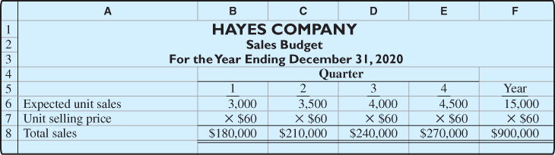

Some companies classify the expected sales revenue as cash or credit sales, and by geographical region, territory, or salesperson.

Production Budget

Production requirements formula

Production budget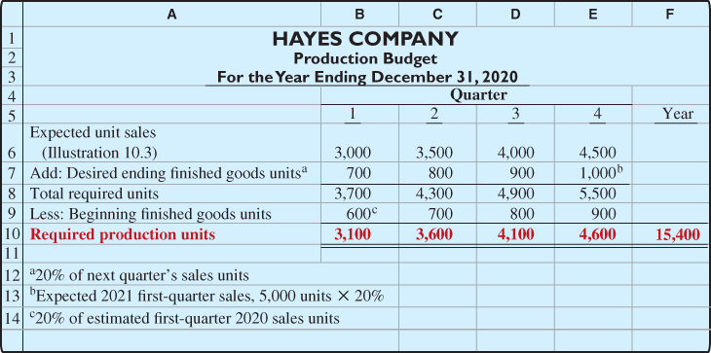

Direct Materials Budget
The direct materials budget shows both the quantity and cost of direct materials that need to be purchased. The first step toward calculating the cost of direct materials purchases is to calculate the direct materials units required for production.

Formula for direct materials units required for production
Units of Direct Materials
(1st quarter)
Beg. Inv. 620
Direct Materials to Purchase 6,300 | Direct Materials Required for Prod. 6,200
End. Inv. 720

Formula for direct materials units required for production

Formula for direct materials units required for production
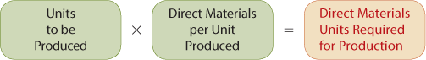

Formula for direct materials units to be purchased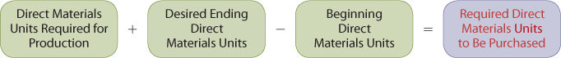

Formula for cost of direct materials purchases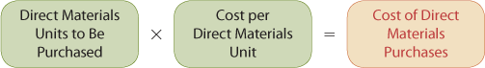

Direct materials budget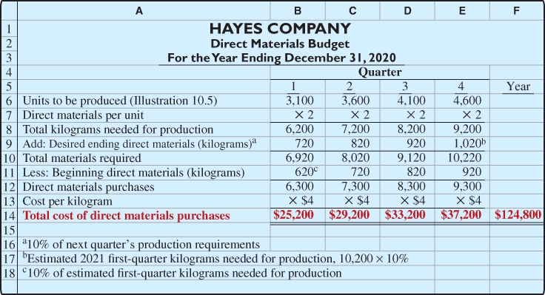

10.3 Preparing the Direct Labour, Manufacturing Overhead, and S&A Expense Budgets

Direct Labour Budget

Formula for direct labour cost

Direct labour budget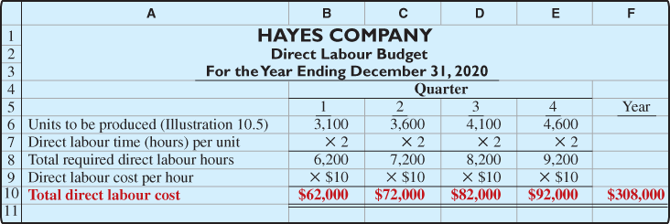

Manufacturing Overhead Budget

Hayes Company expects variable costs to fluctuate with the production volume based on the following rates per direct labour hour: indirect materials $1; indirect labour $1.40; utilities $0.40; and maintenance $0.20. Thus, for the 6,200 direct labour hours required to produce 3,100 units, the budgeted indirect materials cost is $6,200 (6,200 × $1), and the budgeted indirect labour cost is $8,680 (6,200 × $1.40). Hayes also recognizes that some maintenance is fixed. The amounts reported for fixed costs are assumed in our example. The accuracy of budgeted fixed overhead cost estimates can be greatly improved by using activity-based costing.

Manufacturing overhead budget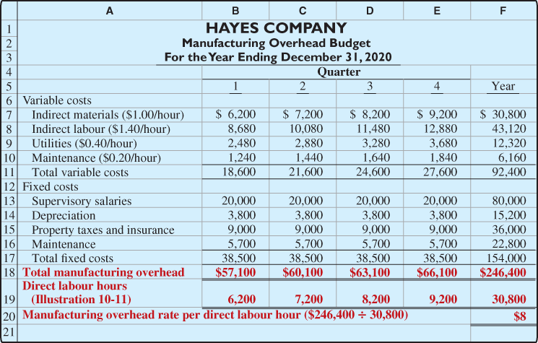

Selling and Administrative Expenses Budget

Selling and administrative expenses budget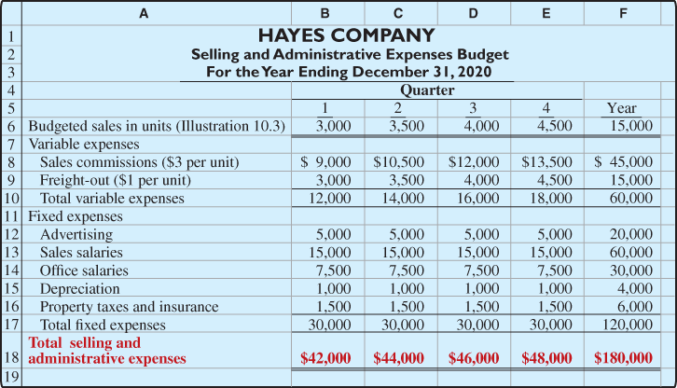

For example, to find the cost of goods sold, it is first necessary to determine the total cost per unit of producing one Rightride bicycle seat.

Calculation of total unit cost
Cost of One Rightride
Cost element | Illustration | Quantity | Unit Cost | Total
Direct materials | 10.9 | 2 kg | $ 4.00 | $ 8.00
Direct labour | 10.11 | 2 hours | 10.00 | 20.00
Manufacturing overhead | 10.12 | 2 hours | 8.00 | 16.00
Total unit cost |  |  |  | $44.00

Budgeted income statement
Hayes Company
Budgeted Income Statement
Year Ending December 31, 2020
Sales (Illustration 10.3) | $900,000
Cost of goods sold (15,000 × $44) | 660,000
Gross profit | 240,000
Selling and administrative expenses (Illustration 10.13) | 180,000
Income from operations | 60,000
Interest expense | 100
Income before income taxes | 59,900
Income tax expense | 12,000
Net income | $ 47,900

10.4 Preparing the Financial Budgets

Cash Budget
The cash budget shows expected cash flows. Because cash is so vital, this budget is often considered to be the most important output in preparing financial budgets

Basic form of a cash budget
Any Company
Cash Budget
Beginning cash balance | $X,XXX
Add: Cash receipts (itemized) | X,XXX
Total available cash | X,XXX
Less: Cash disbursements (itemized) | X,XXX
Excess (deficiency) of available cash over cash disbursements | X,XXX
Financing | X,XXX
Ending cash balance | $X,XXX

The cash receipts section includes expected receipts from the company's main source(s) of revenue. These are usually cash sales and collections from customers on credit sales. This section also shows anticipated receipts of interest and dividends, and proceeds from planned sales of investments, plant assets, and the company's capital stock.

The cash disbursements section shows expected cash payments. These payments include direct materials, direct labour, manufacturing overhead, and selling and administrative expenses. This section also includes projected payments for income taxes, dividends, investments, and plant assets.

The financing section shows expected borrowings and the repayment of the borrowed funds plus interest. This section is needed when there is a cash deficiency or when the cash balance is below management's minimum required balance.

The schedule of cash collections from customers in Illustration 10.17 applies these assumptions. For example, in the first quarter, Hayes collects the $60,000 that was outstanding at the beginning of the quarter, as well as an additional $108,000 (0.60 × $180,000), which is 60% of the first-quarter sales of $180,000. Total receipts in the first quarter are $168,000 ($60,000 + $108,000). In the second quarter, the company collects the remaining 40% of the first-quarter sales of $72,000 (0.40 × $180,000) as well as $126,000 (0.60 × $210,000), which is 60% of the second-quarter sales of $210,000. Second-quarter receipts are $198,000 ($72,000 + $126,000).

Collections from customers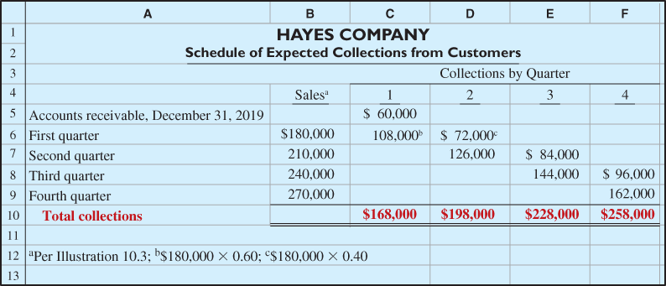

Direct materials (Illustration 10.9): 50% are paid for in the quarter purchased and 50% are paid for in the following quarter. Accounts payable of $10,600 at December 31, 2019, are expected to be paid in full in the first quarter of 2020.
Payments for direct materials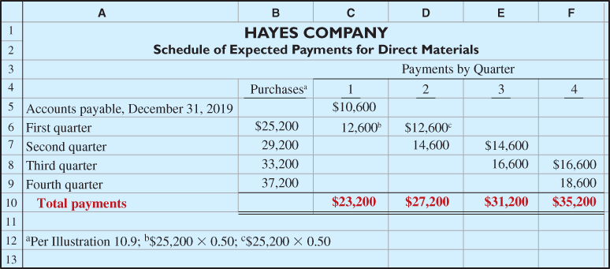

The preparation of Hayes Company's cash budget is based on the following additional assumptions:
- 3.The January 1, 2020, cash balance is expected to be $38,000. Hayes wishes to maintain a balance of at least $15,000.
- 4.Short-term investments are expected to be sold for $2,000 cash in the first quarter.
- 5.Direct labour (Illustration 10.11): 100% is paid in the quarter incurred.
- 6.Manufacturing overhead (Illustration 10.12) and selling and administrative expenses (Illustration 10.13): All items except depreciation are paid in the quarter incurred.
- 7.Management plans to purchase a truck in the second quarter for $10,000 cash.
- 8.Hayes makes equal quarterly payments of its estimated annual income taxes.
- 9.Loans are repaid in the earliest quarter in which there is sufficient cash (that is, when the cash on hand exceeds the $15,000 minimum required balance).

Cash budget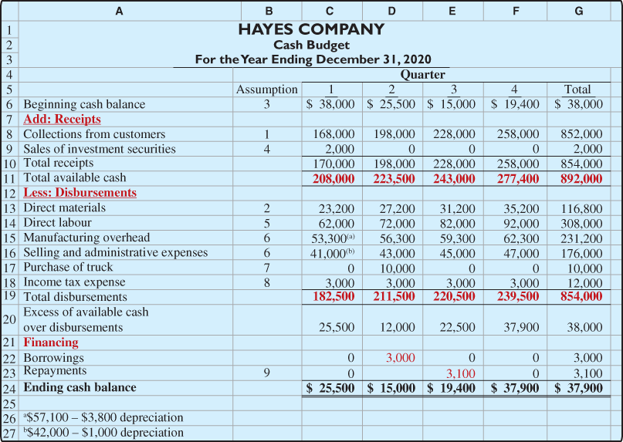

Budgeted Balance Sheet

Buildings and equipment | $182,000 | Common shares | $225,000
Accumulated depreciation | 28,800 | Retained earnings | 46,480
Budgeted balance sheet
Assets
Cash |  | $ 37,900
Accounts receivable |  | 108,000
Finished goods inventory |  | 44,000
Raw materials inventory |  | 4,080
Total current assets |  | 193,980
Buildings and equipment | $192,000
Less: Accumulated depreciation | 48,000 | 144,000
Total assets |  | $337,980
Liabilities and Shareholders' Equity
Accounts payable |  | $ 18,600
Common shares | $225,000
Retained earnings | 94,380
Total shareholders' equity |  | 319,380
Total liabilities and shareholders' equity |  | $337,980

- Cash: Ending cash balance of $37,900, shown in the cash budget (Illustration 10.19).
- Accounts receivable: 40% of fourth-quarter sales of $270,000, shown in the schedule of expected collections from customers (Illustration 10.17).
- Finished goods inventory: Desired ending inventory of 1,000 units, shown in the production budget (Illustration 10.5) times the total cost per unit of $44 (shown in Illustration 10.14).
- Raw materials inventory: Desired ending inventory of 1,020 kg, times the cost per kilogram of $4, shown in the direct materials budget (Illustration 10.9).
- Buildings and equipment: December 31, 2019, balance of $182,000, plus the purchase of a truck for $10,000.
- Accumulated depreciation: December 31, 2019, balance of $28,800, plus $15,200 of depreciation shown in the manufacturing overhead budget (Illustration 10.12) and $4,000 of depreciation shown in the selling and administrative expenses budget (Illustration 10.13).
- Accounts payable: 50% of fourth-quarter purchases of $37,200, shown in the schedule of expected payments for direct materials (Illustration 10.18).
- Common shares: Unchanged from the beginning of the year.
- Retained earnings: December 31, 2019, balance of $46,480, plus net income of $47,900, shown in the budgeted income statement (Illustration 10.15).

10.5 Budgeting in Non-Manufacturing Companies

Merchandisers
As in manufacturing operations, the sales budget for a merchandiser is both the starting point and the key factor in the development of the master budget. There are two major differences between the master budgets of a merchandiser and a manufacturer.
- 1.A merchandiser uses a merchandise purchases budget instead of a production budget.
- 2.A merchandiser does not use the manufacturing budgets (direct materials, direct labour, and manufacturing overhead).
The merchandise purchases budget shows the estimated cost of goods to be purchased to meet expected sales. Illustration 10.22 provides the formula for determining budgeted merchandise purchases.

Merchandise purchases formula

Merchandise purchases budget
Lima Company
Merchandise Purchases Budget
Month Ending July 31, 2020
Budgeted cost of goods sold ($300,000 × 70%) | $210,000
Plus: Desired ending merchandise inventory ($224,000 × 30%) | 67,200
Total | 277,200
Less: Beginning merchandise inventory ($210,000 × 30%) | 63,000
Budgeted merchandise purchases for July | $214,200

Service Enterprises

In a service enterprise, such as a public accounting firm, a law office, or a medical practice, the critical factor in budgeting is coordinating professional staff needs with expected services. I
Direct labour budget for service company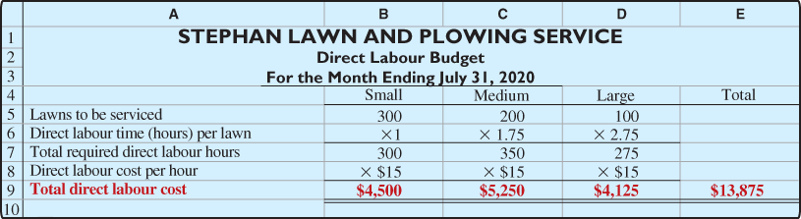

Not-for-Profit Organizations

