Chapter 5

5.1 Traditional Costing Versus Activity-Based Costing

This rate was called the predetermined overhead rate. For job-order costing, we assumed that direct labour cost was the relevant activity base for assigning all overhead costs to jobs. For process costing, we assumed that machine hours were the relevant activity base for assigning all overhead costs to the process or department.

Activity-based costing (ABC) is an approach for allocating overhead costs. Specifically, ABC allocates overhead to multiple activity cost pools, and it then assigns the activity cost pools to products and services by using cost drivers.

• Activity : Any event, action, transaction, or work sequence that incurs costs when producing a product or performing a service.
• Activity cost pool : The overhead cost attributed to a distinct activity (for example, ordering materials or setting up machines).
• Cost driver : Any factor or activity that has a direct cause-effect relationship with the resources consumed.

ILLUSTRATION 5.4The four steps of activity-based costing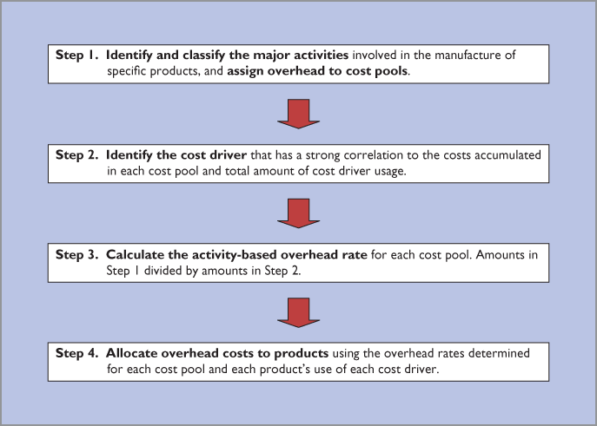

Step 1: Examples of overhead activity cost pools are ordering materials, setting machines, assembling products, and inspecting products.

Cost driver:
Examples are the number of purchase orders, number of set-ups, labour hours, or number of inspections. Illustration 5.5 shows examples of activities, and the possible cost drivers that measure them, for a company that manufactures two types of abdominal exercise equipment: Ab Benches and Ab Coasters.

In the first step, the company allocates its overhead costs to activity cost pools. In this simplified example, it has identified four activity cost pools: purchasing, storing, machining, and supervising. After allocating the costs to the activity cost pools, the company uses cost drivers to measure the costs to be assigned to the individual products based on each product's use of each activity. For example, if Ab Benches require more activity by the purchasing department, as measured by the number of required purchase orders, then the company will assign more of the overhead cost from the purchasing pool to the Ab Benches.

5.2

Step 1:
It requires documenting every activity undertaken to accomplish a task. Atlas Company identified five activity cost pools: manufacturing, setting up machines, purchase ordering, product development, and property and plant.
Activity Cost Pools | Cost Drivers | Estimated Use of Cost Drivers per Activity
Manufacturing | Machine hours | 50,000 machine hours
Set-ups | Number of set-ups | 2,000 set-ups
Purchase ordering | Number of purchase orders | 2,500 purchase orders
Product development | Products developed | 2 products developed
Property and plant | Area (square metres) | 25,000 square metres

dentify Cost Drivers (Step 2)
After costs are allocated to the activity cost pools, the company must identify the cost drivers for each cost pool. The cost driver must accurately measure the actual consumption of the activity by the various products. To achieve accurate costing, a high degree of correlation must exist between the cost driver and the actual consumption of the overhead costs in the cost pool.

Step 3:
ILLUSTRATION 5.8Formula for calculating activity-based overhead rate
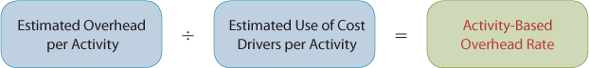

Assign Overhead Costs to Products (Step 4)
In assigning overhead costs, it is necessary to know the estimated use of cost drivers for each product. Because of its low volume and a higher number of components, the Ab Coaster requires more set-ups and purchase orders than the Ab Bench. Illustration 5.10 shows the estimated use of cost drivers per product for each of Atlas's products. Note that of the 2,000 estimated total set-ups, 500 are expected to result from producing the Ab Bench and 1,500 are expected to result from the Ab Coaster.

 |  | Estimated Use of Cost Drivers per Activity
Activity Cost Pools | Cost Drivers | Ab Bench | Ab Coaster
Manufacturing | 50,000 machine hours | 30,000 | 20,000
Set-ups | 2,000 set-ups | 500 | 1,500
Purchase ordering | 2,500 purchase orders | 750 | 1,750
Product development | 2 products developed | 1 | 1
Property and plant | 25,000 square metres | 10,000 | 15,000

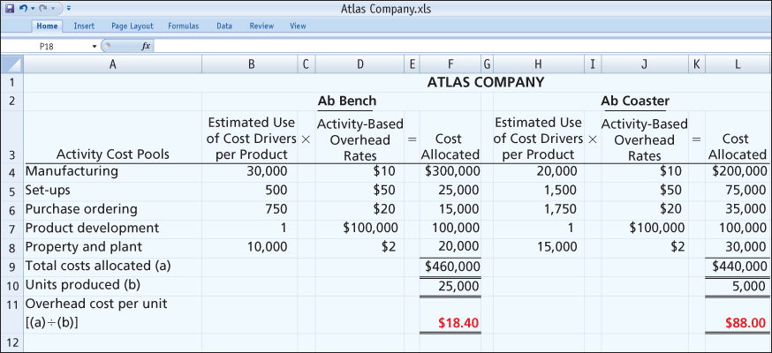

5.3 Benefits and Limitations of Activity-Based Costing

Benefits of ABC
ABC has three primary benefits:
- 1.ABC employs more cost pools and therefore results in more accurate product costing.
- 2.ABC leads to enhanced control over overhead costs.
- 3.ABC supports better management decisions.

Classification of Activity Levels.

To gain the full advantage of having multiple cost pools, the costs within the pool must be correlated with the driver. To achieve this, a company's managers often characterize activities as belonging to one of the following four activity-level groups when designing an ABC system.
- 1.Unit-level activities are performed for each unit of production. For example, the assembly of cell phones is a unit-level activity because the amount of assembly the company performs increases with each additional cell phone assembled.
- 2.Batch-level activities are performed every time a company produces another batch of a product. For example, suppose that to start processing a new batch of ice cream, an ice cream producer needs to set up its machines. The amount of time spent setting up machines increases with the number of batches produced, not with the number of units produced.
- 3.Product-level activities are performed every time a company produces a new type of product. For example, before a pharmaceutical company can produce and sell a new type of medicine, it must undergo very substantial product tests to ensure the product is effective and safe. The amount of time spent on testing activities increases with the number of products the company produces.
- 4.Facility-level activities are required to support or sustain an entire production process. Consider, for example, a hospital. The hospital building must be insured and heated, and the property taxes must be paid, no matter how many patients the hospital treats. These costs do not vary as a function of the number of units, batches, or products.

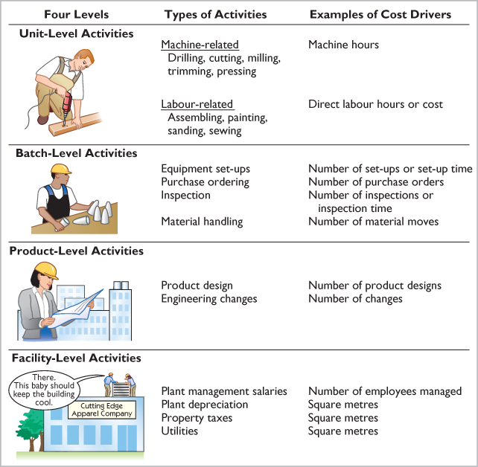

Value-added activities are those activities of a company's operations that increase the perceived value of a product or service to customers. Examples of value-added activities in a manufacturing operation include engineering design, machining, assembly, and painting. Examples of value-added activities in a service company include performing surgery at a hospital, providing legal research at a law firm, or delivering packages by a freight company.
Non-value-added activities are those activities that, if eliminated, would not reduce the perceived value of a company's product or service. These activities simply add cost to, or increase the time spent on, a product or service without increasing its perceived value. One example is inventory storage. If a company eliminated the need to store inventory, it would not reduce the value of its product, but it would decrease its product costs. Other examples include moving materials, work in process, or finished goods from one location to another in the plant during the production process; waiting for manufacturing equipment to become available; inspecting goods; and fixing defective goods under warranty.

