Proposal
Team #5
Hadjer Yahia | Rhita Sbai | Walaa Ghia | Tarek Mehdi | Jessica Meilleur | Gréoire Mismaque

Restaurant X has delicious foods, however, there are flaws in its system that create problems such as: long waiting times, poor employee security, food waste and high costs. Apex Solutions (us) is a team dedicated to solve such problems with simple engineering solutions that include improvements in: layout flow and design, Material flow and handling , and Operations Planning.

• Work place location and design, material flow and handling

Location & Design:

•Facility layout- Layout must be made to minimize total cost

- Construction cost
- Installation cost
- Material handling cost
- Ease of future expansion
- Production cost
- Machine downtime cost
- In-process storage cost
- Safety cost
- Ease of supervision

•Layout Flow: Product and process
-Machinery/equipment arranged for a continuous flow of material in an orderly fashion.
-For a restaurant-> Job-Lot manufacturing (small volume)
-Flow lines vary according to the particular items being produced at a particular time. Machines must be placed close together to minimize handling.

3 types of layout- product, process and fixed position.

Example of restaurant layout + link for more information:
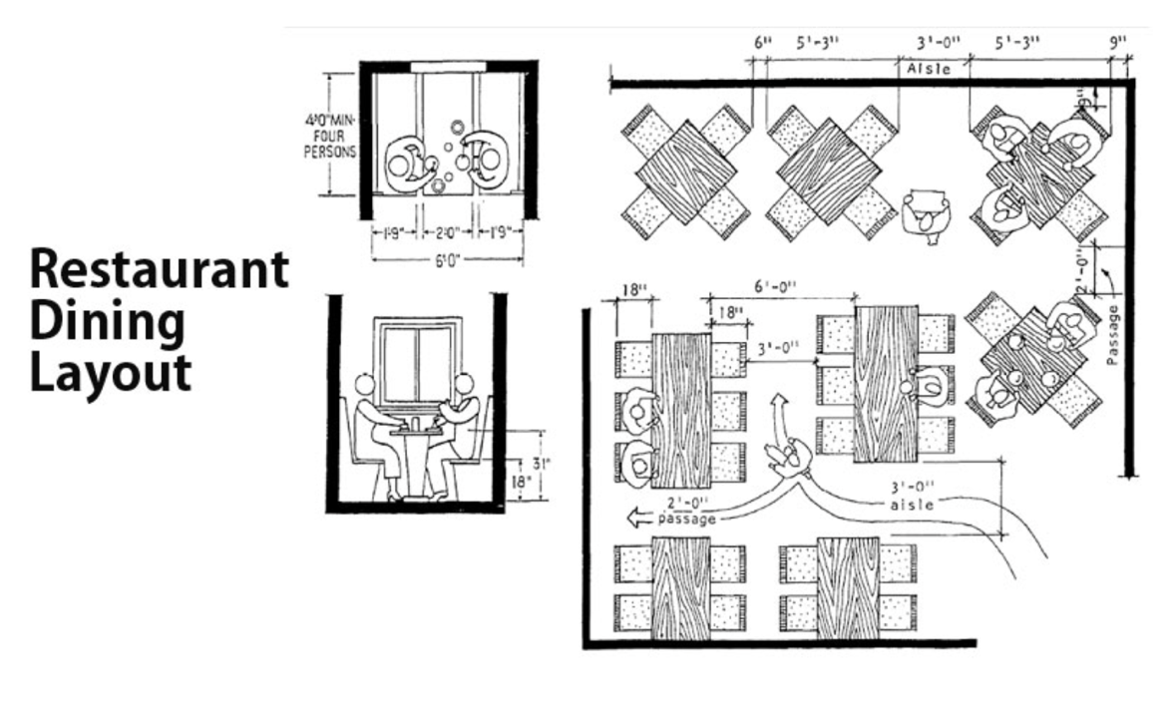
https://www.posist.com/restaurant-times/restro-gyaan/elevate-guest-experience-with-a-stellar-restaurant-layout.html

Material Flow and Handling

•Material handling: Raw->Product->distribution->Discard/recycle

•Cost of handling materials in production operations accounts around 30% + production cost.
- Cost is proportional to distance moved
-Distances- Layout facility
Minimize handling cost- placing interacting departments as close as possible.

Layout + material handling system design but work simultaneously or with a continuous feedback loop- they go hand in hand.

•Product data-

Ex:

Product | Present Quantity | Growth | General
x | Kg/day | Growth rate/year | Description  -where x was packed  -Trucks incoming  -etc

•Material handling systems design

10 principles: https://www.nexonautomation.com/the-ten-principles-of-material-handling/

•Operations Planning

- Demand forecasting
- Operations planning
- Inventory planning and control
- Operations scheduling
- Dispatching and progress control
- Interfaces

•Flow process chart:
Operations
Inspections
Transportation delays
Storage

•Operations Process: Operations and inspection – ex:



