ADM2320 mid – chapters 4,5,6,7

Chapter 4 – Consumer behaviour
- Consumers are the heart of marketing
- Companies with a clear understanding of how and why consumers make their purchasing decisions can better strategize marketing plans
- Consumer behavior is about understanding how consumers buy, use, and think about products, as well as factors that influence their buying decisions
  - Experience: what marketers want to provide consumers
    - By focusing on experience they are going beyond the sale, and want consumers feelings to be positive and create strong brand loyalty
- Marketers must understand the consumer buying process (factors of influence, attitudes and perceptions, likeliness of positive voice reach)

The consumer decision process
- Steps consumers go through before, during, and after making purchases

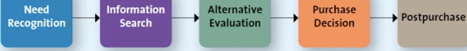
- Applied to any purchase

Step 1 – Need recognition
- When a consumer realizes they have an unsatisfied need for a product
  - Needy state -> desired state (ex. hungry and not hungry)
- Functional needs: pertains to the performance of a product or service (tesla auto pilot)
- Psychological needs: pertains to the personal gratification or pleasure from a product (designer clothes)

- What strategies can marketers use at need recognition stage to target customers?
  - Social media strategies: wish lists, likes, check-ins, bought by, pinned, people search for
  - Post and read online to seek out demand for the need

Step 2 – information search
- Buyers must decide extent of their search
- Internal search: a buyer examines their own memory or knowledge about a product based on past experiences
- External search: buyers seek information outside their personal knowledge base eg. Friends, family, web search, colleagues, etc..

Factors affecting consumers’ search processes
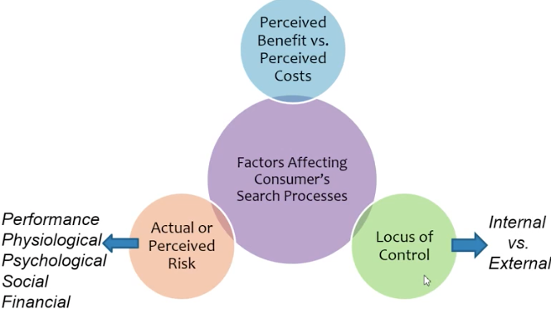
- Perceived benefits vs perceived cost of search is whether the time and effort to search the information about the product is worth it
- Locus of control refers to extent the customer believes they can influence the outcome or decision
- Internal locus is when consumers believe they have some control of the outcome of their actions (so they participate more)
- External locus is when consumers believe that fate or other external factors control the outcomes (less likely to engage)
  - Ex. If cx wants to buy a car, and they believe with research they can get a better deal, they will, though if they don’t, they wont
- Actual or perceived risk is if the 5 risks (performance, financial, social, physiological, and psychological) are greater, the more extensive research one will do
- Performance risk is the perceived danger inherent in a poorly preforming product or service (eg. Tesla’s battery doesn’t last as long as wanted)
- Financial risk is the risk associated with a monetary outlay and includes the initial cost of the purchase, as well as costs of using the item or service
- Social risk is the fears the consumers suffer when they worry that others might not regard their purchases positively
- Physiological risk (safety risk) is the risk associated with the fear of an actual harm should the product not perform properly
- Psychological risk is the way people will feel if the product or service does not convey the right image

Step 3: Alternative evaluation: evaluate criteria and determinant attributes
- Evaluate alternative options in the same market (Tylenol or Advil?)
- Attribute sets:
  - Retrieval sets consist of those brands or stores that can be readily brought forth from memory
  - Evoked sets include only the brands that consumers consider when making a purchase (ideal marketing pinpoint)
- Evaluative criteria: set of salient, or important, attributes about a product, used to compare alternative products ($, size, etc.)
- Determinant attributes: product features that are important to the buyer and on which competing brand are perceived to differ
  - Consumers may use; decision heuristics, compensatory and noncompensatory decision rules
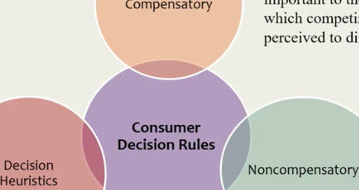

Consumer decision rules: the set of criteria that consumers use consciously or subconsciously to quickly and efficiently select from among several alternatives

Decision heuristics: shortcuts or rule of thumb consumers use to make purchase decisions (quality perceptions, price, brand and product presentation (way product is packaged, presented and displayed – visual appeal)

Compensatory: trading off one characteristic against another, so good characteristics cover for less desirable ones
- Finding the best overall computer, where dell is the best of all factors total

Non-compensatory: when consumers choose a product or service based on a subset of characteristics regardless of their values of its other attributes
- Using price or weight, apple is the best purchase, not considering other factors

Step 4 – Purchases (purchase decisions)
- Key issue: what tactics to encourage purchases? Delivery, multiple purchase options
- Situational factors help facilitate purchases such as having the item in stock, offering many check out options, having many convenient check out lanes, a warranty, or simple return policy
- Retailers use conversion rates to determine purchase intentions into purchases

Purchase decision: customers are ready to buy – decision maybe immediate or later

Step 5 – Postpurchase
- Consumers questions whether they made the right decision (better deal), or are very satisfied and become a loyal customer
- These steps ensure postpurchase satisfaction:
  - Build realistic expectations – not to high or low – and deliver on those expectations
  - Demonstrate correct produce use; improper usage can cause dissatisfaction
  - Stand behind the product or service by providing money back guarantees and warranties

3 postpurchase outcomes: post-purchase dissonance, customer satisfaction, customer loyalty
- Customer satisfaction can be created by marketers by; building realistic expectations (and delivering on them), demonstrating correct product use, providing warranty’s, and encouraging customer feedback
- Postpurchase dissonance is an internal conflict that arises from an inconsistency between two beliefs or between beliefs and behaviour
  - A feeling of guilt or regret
- Customer loyalty develops over time with multiple purchases of a product or brand from the same marketer
- Undesirable consumer behaviour: may occur when we don’t meet a consumers needs
  - Negative worth of mouth

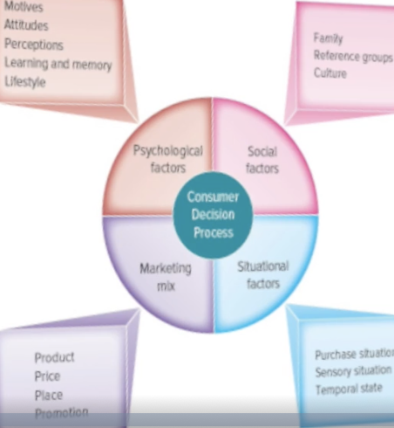- Consumer decision process!

- You go through this 5-step process for all purchases, and marketers can use strategies to ensure you go through these stages, a process called involvement

Involvement and consumer buying decisions

Involvement: time, interest, and effort into a purchase decision

Elaboration likelihood model

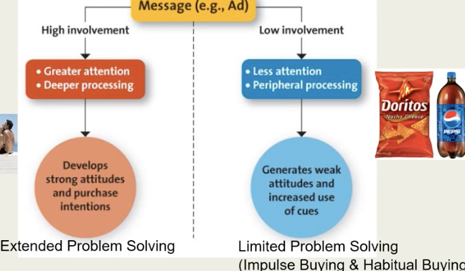

Buying situation strategies (2 for each)
- Strategies marketers can use to help consumers make their decision

Extended problem solving: a purchase decision process during which the consumer devotes considerable time and effort to analyzing alternatives (risk decisions)

Limited problem solving: occurs during a decisions that calls for at most a moderate amount of effort and time
- Includes impulse buying and habitual decision making

Impulse buying: a buying decision made by customers on the spot when they see the merchandise

Habitual decision making: a purchase decision in which consumers engage with little conscious effort (familiarity)

High involvement: car, house, insurance policies
- provide lots of information to the customer about products (educating)
- explain why they are the superior brand as to competition
- cobranding for validation
- understand cxs and tailor a understandable way of sale
- invest in brand development and identification (develop trust and reliability to cx)
- differentiating the brands features
- after-sale communication

Low involvement (impulse purchase): chips at the front of the store
- convenient location (by the check out)
- easily available
- differentiated product from competitors that stays in a cxs mind
- Reminder advertising
- pricing (affordable and competitive)

Factors influencing the consumer buying decisions
- 3 categories: psychological, situational, and social factors

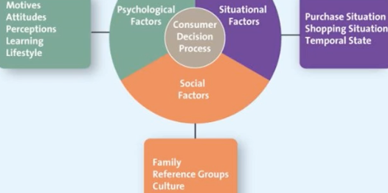

Psychological factors: psychological factors affecting how one sees the marketers msg.

Motives: a need or want that is strong enough to cause the person to seek satisfaction
- Maslow’s hierarchy of needs (consumer needs are achieved from button to top)
  - Theory of human motivation
- Physiological needs basic biology necessities of life (food, drink, rest, shelter, etc.)
- Safety needs safety and security of a person and their belongings (ex. Rogers room monitoring to give cxs comfort of safety in there homes and rooms)
- Love needs friendships, intimacy, family, connection (ex. Tinder, match.com)
- Esteem needs need to gain respect, status and recognition (allows people to satisfy inner desires)
- Self-actualization is when one is completely satisfied with their life and how they live

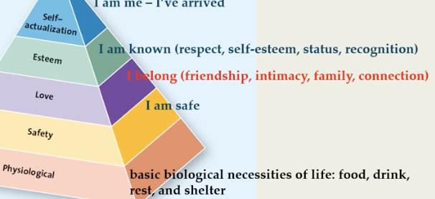

Attitude: a person’s enduring evaluation of his or her feeling towards products, services or ideas
- 3 components: cognitive, affective, behavioural
- Cognitive: How consumers think about products (what they believe to be true)
- Affective: How they feel about products (like or dislike)
- Behavioural: How they act towards products
  - Ex. student believes bulldog skincare is good as its award winning (cognitive), creates confidence as shown in the add for extra work performance (affective) so he goes and buys it from shoppers (behavioural)

Perception: the process by which we select, organize, and interpret information to form a meaningful picture of the world
- 4 aspects:
- selective exposure is when the consumer chooses what they want to expose themselves to (ex. If they don’t like combat sports they will not watch it)
- selective attention consumers only pay attention to specific aspects of what’s aired (ex. While listening to news you only listen to what you find important)
- selective comprehension is when consumers choose to interpret facts or a story through their own understanding and adding their own meaning (a marketer might want an edgy and sexy commercial, though some consumers may find it offensive)
- selective retention when consumers only remember what they want to about a message or advertisement
  - Perception is shaped by many factors: our growing up experiences, cultural upbringing, social class, gender, upbringing, etc..

Learning: a change in thought processes or behaviour due to experiences (experiential learning) or by studying or reading to acquire new knowledge
- Learning affects both attitudes and perceptions
- A person’s perceptions and ability to learn are effected by their social experiences
  - Stimulus generalization and stimulus discrimination show how learning is used in marketing

Stimulus generalization: when consumers associate the learning from one product to the next
- If Tylenol works, you may try other Tylenol products

Stimulus discrimination: differentiate one brand from another to differentiate from competitors and stand out
- Tylenol and advil should be differentiated if there is accurate discrimination
- Marketers want consumers to differentiate their brands from competitors as it helps build loyalty
- If there is no differentiation, they will be seen as substitutes and be used interchangeably thereby reducing loyalty

Lifestyle and Personality: Lifestyle refers to consumers’ interests and the way they spend their time and money, and personality refers to unique psychological characteristics that distinguish a person
- Includes activities (work, shopping sports, hobbies, social events)
- Interests (family, fashion, food, recreation)
- Views (about self, others, social issues, politics, business)
- Personality traits (self-confidence, sociability, dominance, aggressiveness, etc..)
- Self-image (beautiful, smart, proactive, high performer)

Situational factors:
- factors affecting the consumer decision process (factors specific to the shopping situation & temporal state sometimes override or influence psychological & social issues)
- Purchase situation: occasion-based purchase (wedding, baby shower, self)
- shopping situation: situation when in the store actually buying the product
  - Can be affected by: salespeople, store atmosphere, crowding, in-store demo, in-store promos, packaging
- temporal state time of day or season and state of mind when shopping
  - different moods depending on time of day or season
  - all states of mind affect our shopping decisions

Social factors: family, reference groups and culture
- reference groups: one or more person an individual uses as a basis for comparison regarding beliefs, feelings, and behaviours
  - family, friends, coworkers, famous people
  - our purchase decisions are influenced by their words, actions, etc..
    - provide: information, rewards, self-image
- family:
  - marketers need to be aware of the needs of a whole family
- culture
  - shared meanings, beliefs, morals and customs
  - your culture group can be your school, country, religion
  - culture greatly influences consumer behaviour
  - marketers must understand differences among cultures and sub-cultures
    - Subculture: group of people whose beliefs and values differ from the rest of a larger society which they live

What can marketers do at each stage of the consumer decision process?

Need recognition
- Marketers find an opportunity in consumers unmet desires
- “Create a problem” for the consumer
- Share facts and tests of what your product can provide and what they need
- Ask questions to potential buyers

Information search
- Try to understand the sources customers use to search for information and the importance of each source
  - Educate customer of product to build trust and credibility
- Ensure they communicate tactics aimed at reducing risk to customers (guarantees)
- Partnering with google to increase search ranking
- Getting the brand name and discussion of the product online (blogs, media, etc..)

Alternative evaluation
- Provide consumers with competitors information to show what you offer is of better value (regardless of the price)
  - Builds a trusting relationship with the customer

Purchase
- Provide a sense of security
- Keep customer informed
- Test product purchase process (complicated, too many steps, slow?)
- If process is to difficult, changes need to be made
- Send reminder emails for abandon carts or potential purchases

Post purchase
- Identify sources of dissonance
- Offer exchanges or warranties that are straightforward
- Follow-up surveys and emails that thank customers for their purchase

Chapter 5 – Business to Business marketing (B2B)

B2B markets
- The process of buying and selling goods and services, used in the production of further goods and services, among business buyers
  - These good may be raw materials, intermediate goods, or finished products ready for resale to ultimate consumers through wholesalers, retailers, distributors, agents or dealers
    - Ex. Selling jeans for work attire at another corporation is b2b as its not used in an individual household
    - Ex. Apple CarPlay inside of Ferrari, Audi, etc..

- B2b Markets divided into 4 broad categories:
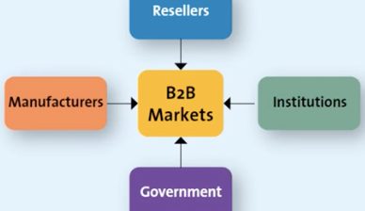

Manufactures: companies that buy raw materials and intermediate products needed for their final products
- Ex. Campbells buys tomatoes and cans for their tomatoe soup
- Contributes 10%+ of GDP
- Employs 1.5M+ people
- Revenues $6B+

Resellers: marketing intermediaries that buy finished products and sell them to ultimate consumers
- Includes; wholesalers, distributors, and retailors
- More than 325,000 firms in Canada, employing about 3M, with $1T in revenue
- Ex. Walmart, best buy, Loblaws

Government: include federal and provincial governments
- One of the largest purchaser of goods and services
- Buys 22B worth of G&S on behalf of federal agencies and departments
- Employs over 20% of Canadian workforce

Institutions: organizations like museums, prisons, religious orgs., hospitals, universities, and other non-profits
- 160,000 non-profits in Canada
- Employs over 2M people
- Revenues over $100B

B2B Electronic Exchanges (electronic trading platforms)
- Used to conduct business transactions
Electronic exchange: trading platform in which order entry and processing, matching of buy and sell order, and price determination are performed by a computer over a network
- System also includes functions for: clearing and settlement procedures, market supervision, and the publication of relevant information

Benefits
1. Expand market research
2. Reduce operational costs
3. result in lower prices for buyers
4. Higher potential profits due to reduced costs
5. Lower inventory requirements
6. Greater transparency
7. More efficient planning because of information sharing
8. reduce bottlenecks

3 Key challenges of reaching B2B clients
- Identify decision makers in the organization who authorize influence purchases
- Understand the buying process of each potential client
  - Can vary depending on org. size, size of purchases, culture of buying org., etc..
- Identify factors that influence the buying process of potential client
  - Salespersons must overcome these 3 challenges to make a sale

Characteristics of B2B markets
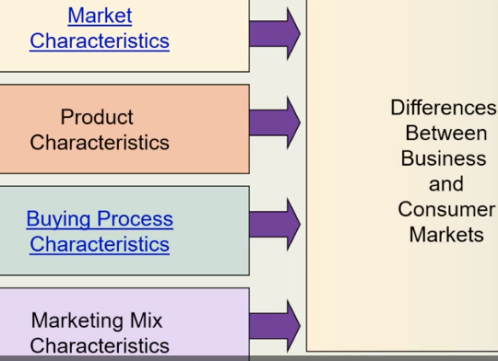

Market characteristics
- Derived demand for business products
  - Ex. Levi jean has demand for fabric, threads, and more inputs based on the final consumer’s wants for jeans (derived demand)
- Fewer customers/buyers (than B2C), geographically concentrated, with larger orders
- Demand is more inelastic
  - Change in price does not affect the quantity demanding (short run)

- Derived demand: the linkage between consumers’ demand for a company’s output and its purchase of necessary inputs to manufacture or assemble that particular output

Product characteristics
- Primarily ordering raw materials and semifinished goods
  - Processed or assembled into finished goods for the ultimate consumer
- Products are tested before shipped
- Each business must meet time frames

Buying process characteristics
- Buying decisions more complex (involves several qualified buyers), structured, formalized, and professional
- Large buying centre involved in decision making
  - Competitive bidding, negotiated pricing, complex financial arrangements, buying criteria, objective
- Qualified, professional buyers – more formalised buying process
- Buying criteria and objective specified
- Multiple participants in purchase decisions
- Close long-term relationships (win-win deals)
- Online buying common
- Reciprocal buying arrangement: two firms agreeing to buy from each other
  - Negatives: excludes other vendors, and limits firms to each others products

Marketing mix characteristics
- Direct selling and physical distribution often essential (salesperson is important)
- Advertising more technical, promotions emphasize personal selling
- Price often negotiated, inelastic, affected by trade/quantity discounts

The B2B Buying Process
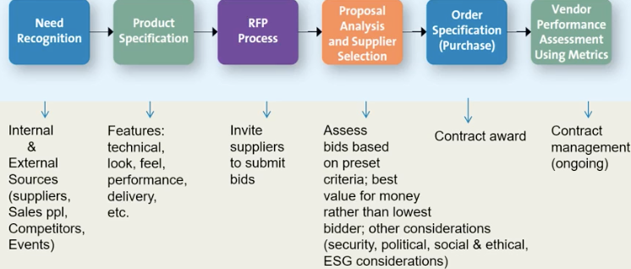

Request for proposals (RFP): a process which buying organizations invite alternative suppliers to bid on supplying their required components

Vendor performance assessment metrics: Importance score (0-1) and vendor performance (1-5)

Factors affecting the B2B buying process (3 key factors)
- The buying centre
- Organizational culture
- Buying situation

The buying centre
- Group of people responsible for the buying decisions in large organization
- Stakeholders who fill different roles in the 2b2 buying process
- Consists of many people each playing 1 or more of 6 roles
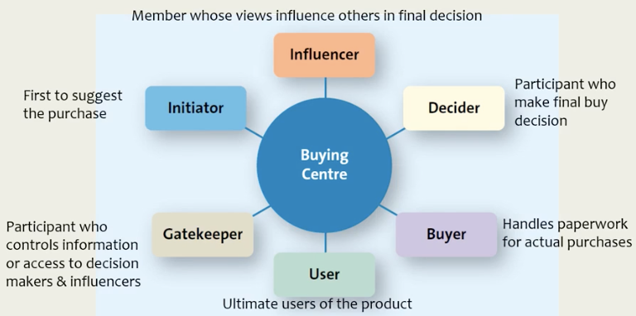
- Ex. Initiator = your doctor, influencer = the pharmacy, decider = the hospital, buyer = hospital’s materials manager, user = patient, gatekeeper = purchasing department

Organizational Culture:
- Reflects a set of values, traditions, and customs that guides a firm’s employees behaviour
  - May be written or unwritten, formal or unformal
- Influences decision process
- 4 types:
  - Autocratic buying centre: centre in which one person makes the decision alone, though there are many participants
  - Democratic buying centre: centre in which the majority rules in making decisions
  - Consultative buying centre: centre in which one person makes the decision, but he or she solicits input from others before doing so
  - Consensus buying centre: centre in which all members of the team must reach a collective agreement through which they can support a particular purchase

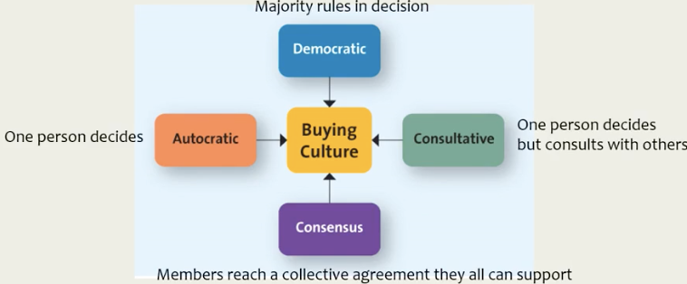

Buying situations
- Buying centre influenced by the buying situation
- New buy is when a product is purchased for the first time
  - Likely to be involved, formal, and complex
  - The buying centre will probably use all 6 steps in the buying process
  - Ex. Fashion show (inspect and order)
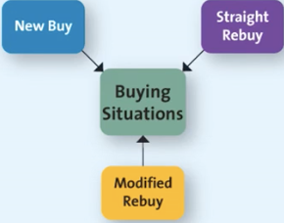
- Straight rebuy is where the company buys additional units of a previously purchased product (most b2b purchases)
- Modified rebuy: purchasing a similar product but changing specifications
  - Current vendors have an advantage
  - Ex. Lower cost hamburger

Building B2B Relationships
- Social media
  - Ex. “game of phones” activity with Fiberlink
- An expert offering advice and knowledge can increase awareness (ex. Blog)
- Linkedn and twitter popular options due to easy communication (hootsuite)
- White papers – provides information about the industry and challenges in an educational context, rather than a promotional sense (no propaganda)
  - Goal: provide valuable information that is easily understood that will help a company address its problems with new solutions

B2B classification system and segmentation
- NAICS code (popular in NA)
  - System developed by Canada, us, and Mexico, to provide comparable statistics about business activities in NA
  - 6-digit system
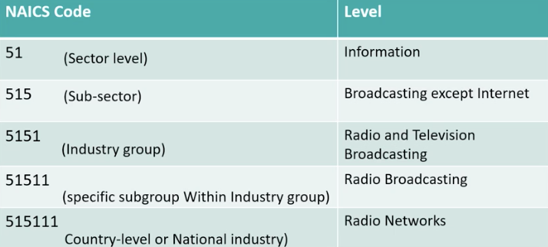
- A 0 indicates as a 6-digit indicates there is no foreign national detail

B2B segmentation bases
1. geographic location (country, region, province)
2. Firm sizes (S,M,L)
3. Account size (S, M, L purchases)
4. Organizational types (governments – federal, provincial municipal), private companies, non-profits
5. Types of products purchased. For example, John Deere, sells agricultural equipment, lawn and garden equipment, contribution equipment, forestry equipment, and engines – each of these are segments on there own

Characteristics of B2B buying compared to b2c buying
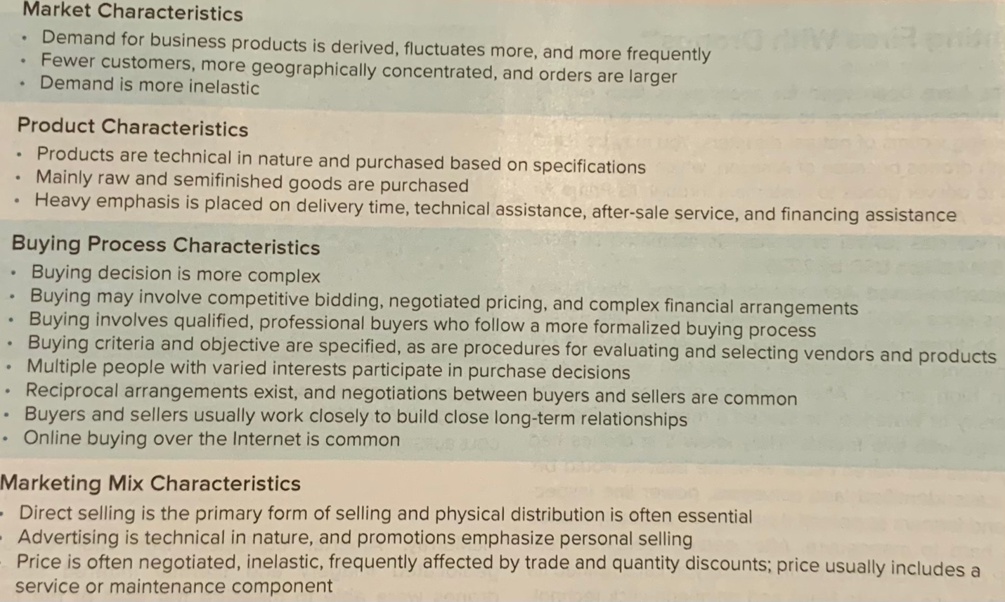

B2B vs B2C market characteristics
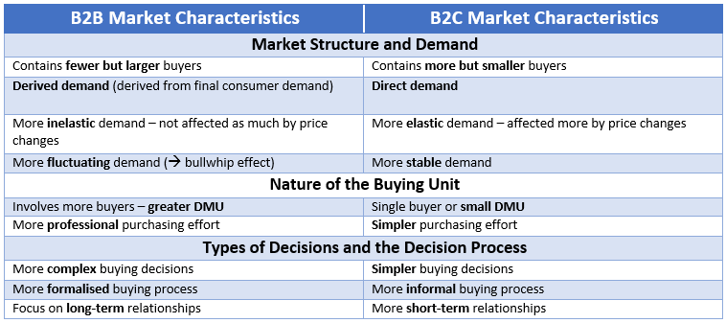

Chapter 6 – Segmentation, targeting, and positioning (STP)

The segmentation-targeting-positioning process
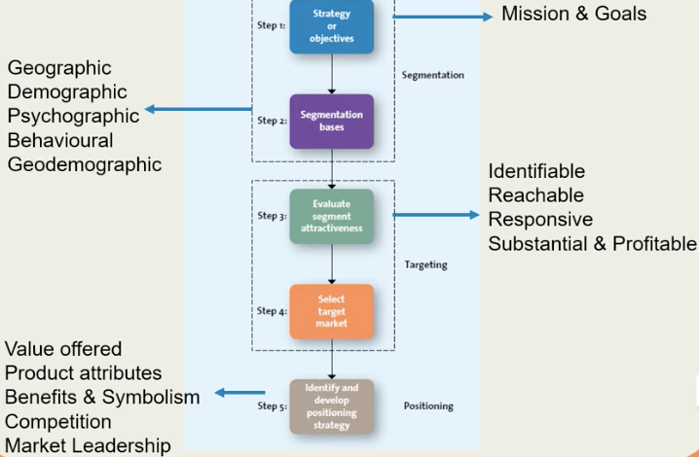

Segmentation
- Taking the overall market for a product, and dividing it into distinct or unique subgroups based on similar, wants, needs and characteristic
  - Each subgroup is called a segment
  - Ex. Bike company may consider everyone who interests one. From here the company can make distinct markets such as kids, adults, seniors, competitive, casual, bike enthusiasts
    - Each group must be clearly distinct for effective segmentation
    - The key to distinct segments is to identify consumers w similar wants, need and characteristics

Step 1: Strategy or objectives
- Articulate mission and objectives of marketing strategy
  - Also alien w/ its strengths, weaknesses, opportunities and threats (SWOT)

Step 2: Segmentation basis (more below)
- Develops descriptions of different target market segments (their wants, needs, and characteristics)
  - Helps firms better understand customer profile

1) Geographic (where they live): group consumers based on geographic location
2) Demographic (who they are): group consumers according to easily measured objective characteristics (age, gender, income, education)
- May not be useful for defining some target segments such as users of activewear
3) Psychographic: How consumers describe themselves (lifestyle, class, personality)
4) Behavioural: benefits consumers derive from products (loyalty, usage, benefits sought)
5) Geodemographic: group of consumers based on geographic, demographic and lifestyle characteristics
- Geographic and demographic bases are widely used because the type of data required is easy to gather
- Psychographic and behavioural bases are more complex but offer deeper insight
  - Ex. 2 20yo uni students may describe themselves completely different
- PSYTE
- Benefit segmentation: segmenting market based on perceived values the consumers believe they will get from the product (ex. the product is cordless and easily portable)

Step 3: Evaluate segment attractive
- Are the segments identifiable, reachable, responsive, and substantial and profitable

Step 4: Select target market (more info below)

Step 5: developing positioning strategy
- Positioning is the mental picture a consumer has about a company and its products and services relative to competitors
  - Can be shaped through its positioning statement (which expresses how a company wants to be perceived by consumers)
- Company’s can use these basis to positioning there products:
  - Value offered
  - Product attributes
  - Benefits and symbolism
  - Competition
  - Market leadership

Psychographic segmentation: How consumers describe themselves
- 3 components of psychographic makeup:
- Self-values: overriding desires that drive how we live our lives e.g, family, community, career, performance-oriented, etc. – this influences the benefits and attributes we seek in products
- Self-concept – image we have of ourselves, eg. Creative, intelligent, funny, disciplined, (un)attractive, etc..
- Lifestyles: how we live our lives to achieve goals eg, workaholic, party animal, fitness junkie, bookworm, social butterfly

- VALS (values and lifestyles survey) Framework (tool for psychographic segmentation)
  - Developed by SBI (strategic business insights)
  - Classifies consumers into 8 segments based on levels of resources and innovation
    - Includes: Innovators, thinkers, achievers, experiences, believers, strivers, makers, survivors
  - Provides in-depth consumer profile and predicts behaviours
  - Often used in conjunction with other segmentation methods as it an expensive process

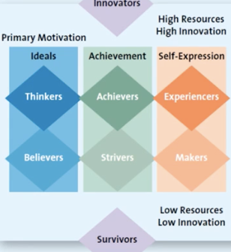

Primary motivation: why consumers buy products
- Ideals (thinkers and believers), achievement (achievers, strivers), self-expression

Achievers
- Goal-oriented lifestyles, respect authority, committed to career and family, active consumers, favour prestige products showing their success
Makers
- Practical people w constructive skills, self-sufficient, traditional views, prefer value over luxury
Survivors
- Believe the world is changing fast, comfortable with familiarity, concerned with safety and security, cautious consumers, love a good deal
Believers
- Conservative, deep-rooted morals, routines, loyal, concrete beliefs (religion, family)
Experiencers
- Variety and excitement, active in sports and socially, enthusiastic, buys fashion and entertainment
Thinkers
- Mature, satisfied, comfortable, responsible, well-educated, practical
Strivers
- Trendy and fun loving, money defines success, favour stylish products, shopping is a social activity and display of status, spend as much as they can
Innovators
- Successful, sophisticated, high self-esteem, change leaders, very active consumers, leaders

Behavioural segmentation
- Groups consumers on bases of benefits they seek from products and services, they’re usage rates, user status, occasion for purchase, and loyalty
- Occasion segmentation: groups consumers based on when they purchase or consume a product or services (ex. Moore’s suits for everyday ware and special occasion)
- Benefit segmentation : groups consumers based on the benefits they derive from products or services
  - Ex. RBC options; youth, nexus, borrowers, wealth accumulators and preservers
- Loyalty segmentation: strategy of investing in retention and loyalty initiatives to retain the firms most profitable customers (PC optimum)
- Usage rates: how often one uses a product or service: occasional, light, med., heavy

Geodemographic segmentation (PSYTE Clusters)
- Grouping of all neighbourhoods in Canada into 60 different lifestyles clusters
- Combines elements of the 3 segmentation bases to group consumers (geographic, demographic, lifestyle)
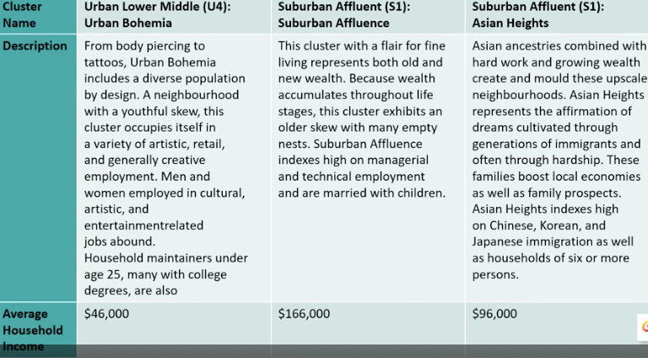

Step 3: Evaluate segment attractiveness
- Is the segment identifiable, reachable, responsive, and profitable?
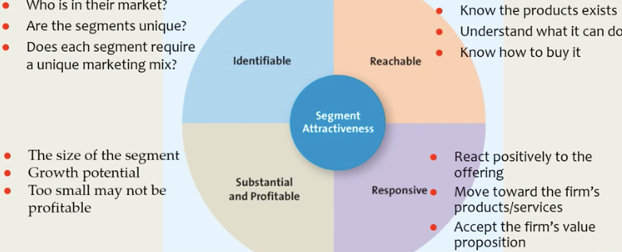

Step 4: Select Target Market:
- Upon selection, firms consider attractiveness of the opportunity (SWOT analysis – opportunity and threats) and its own competencies (strengths and weaknesses)
- Undifferentiated strategy (mass marketing)
  - Marketing strategy where all consumers are treated as one huge segment
  - Used when products offer the same benefits to everyone
    - No need for unique marketing mix (ex. Salt, spice, sugar)
- Differentiated strategy (most widely used)
  - Segment consumers and develop unique marketing mixes
  - Different offerings for each market segment
    - Ex. La senza (confident, fashion forward), la senza spirit (activewear), la senza express (bras and panties)
    - Ex. Volkswagen, Porsche, BMW, fiat
  - Helps diversify brand and lower risk
- Concentrated/niche strategy
  - Marketers select a single primary market and focus on a product to fit its needs
  - Ex. Whole foods: high income, health-conscious marketing
- Micromarketing 1-to-1 (popular)
  - Segmentation that allows consumers to design and develop their own products
  - Mass personalization/customization marketing strategy (one-on-one)
    - Ex. Jersey customization (tailors), Nike shoe customization

Positioning and positioning statement

Positioning: the mental picture that people have about a company and its products or services relative to competitors

Positioning statement: expresses how a company wants to be perceived by consumers
- These are reflected in the company’s slogan and taglines
- Elements of a positioning statement; 1) target market 2) offering name or brand 3) product/service category or concept 4) unique point of difference/benefits
  - Ex. Ford and the Mustang: For power and thrill lovers (1), the mustang (2), is a muscle car (3), that provides power and thrill unlike any other (4)

Ex. Gap positioning
- Old navy is positioned as brand where the whole family can find quality clothing at great prices
- Banana republic brand believes that what u wear should enable a life with no boundaries, and enjoy fashion
- Baby gap is positioned for affordable and comfort clothing for a young mother’s child

Value proposition: communicates the customer benefits to be received from a product or service and the reasons for wanting to buy it

Step 5: Develop Positioning strategy
- Positioning methods:
  - Value offered
    - One of the most important aspects of a consumer’s decision process
    - Can be the actual price and quality, or the benefit it offers (health+)
  - Product attributes
    - Attributes most important to target market (differentiated)
    - Focus on; product deisgn, innovation, quality, performance, reliability, product leadership
  - Benefits and Symbolism – benefits and meaning to the customer
    - Ex. Oral B offering best whitening and cleaning technology (functional and psychological benefits)
    - Ex. Nike swoosh symbolize the brands meaning
  - Competition
    - Position against a specific competitor (head-to-head) (apple vs galaxy)
    - Position against an entire product class (ali bank vs all banks – fees and charges)
  - Market leadership (SCA)
    - Where companies appeal to consumers by communicating that they are the leader of the market

Perceptual map: displays, in 2 or more dimensions, the position of products or brands in the consumer’s mind

Ideal point: the position at which a particular market segment’s ideal product would lie on a perceptual map

Positioning by using perceptual mapping
- 1) Determine consumers’ perceptions and evaluations in relation to competitors
- 2) identify the markets ideal points and size
- 3) identify competitors’ positions
- 4) determine consumer preferences
- 5) select the position
- 6) monitor the positioning strategy
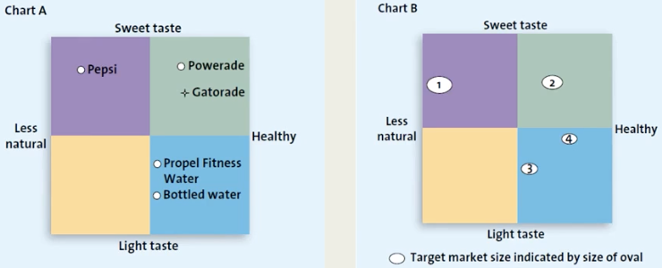

Uses of perceptual maps
1. they can tell us how consumers’ view our product – is our marketing communications effective in supporting the positioning we want
2. they can tell us how consumers view competitors’ products
3. they can identify areas of opportunities (less crowded quadrants)
4. they can show areas to avoid (very crowded)
5. They can show which quadrants are popular with consumers (crowded quadrants – maybe avoid) and
6. Multiple maps can be used to develop a deeper understand of the consumers perspective

Repositioning: refers to a strategy in which marketers change a brand’s focus to target new markets or realign the brand’s core emphasis with changing market preferences
- Risky and expensive, and sometimes necessary
- Ex. UPS repositioned from a delivery company to a logistics company
- Often fails

Brand repositioning gone wrong
- Gap changed logo and brand concept and was criticized and abandoned their efforts
- Changing logos, taglines, and slogans is not repositioning
  - Repositions starts with real changes in the marketing mix, customer service, operational strategies and other marketing efforts
- Marketers are asking consumers to forget everything they know about the company, which makes it often difficult to accept the change (failing)

Why repositioning
- 1) Changes in a firms environment
  - Consumers, competition, economic, technological conditions – that erode appeal of the brand
- 2) to enhance firm’s competitive advantage
- 3) why brand repositioning fails?
  - 1. Failure to bring customers along
  - 2. Unclear link between the new position and customers’ brand association
  - 3. Sending a coherent message regarding the new brand identity
  - 4. Inconsistency between old and new brand image or too big of a change in association (ex. Walmart repositioning to a luxury brand)
  - 5. Timeliness of repositioning – the time that elapsed between market changes and the repositioning
  - 6. Brand history may also play a role. Companies that have successful repositioned before are more likely to be successful

Chapter 7: Marketing research

Marketing research: consists of a set of techniques and principles for systematically collecting, recording, analyzing and interpreting data that can aid decision makers involved in marketing goods, services or ideas
- Systematically: describes how all research activities and processes are to be carried out
  - All aspect (collecting to analyzing data) must be done systematically
  - Systematically implies the process is organized, structured, and methodical
- A systematic process can minimize mistakes and enhance the reliability, validity, and credibility of the study.
  - Reliability: the extent to which the same result is achieved when a study is repeated under identical situations
  - Validity: the extent to which a study measures what it is supposed to measure
  - Credibility: the extent to which the results of the research are believable or plausible
    - All 3 helps marketers create phenomenal strategies

Why undertake marketing research? To improve managerial decision-making
- Examples of issues where marketing research can improve decision-making include, gaining a deeper understanding of:
  - 1) consumers, especially their changing needs, wants, preferences, lifestyles etc..
  - 2) opportunities and threats coming from the macroenvironment
  - 3) Competitive landscape (ex. Which competitors are growing, falling behind, entering, or changing strategies)
  - 4) The effectiveness of the marketing mix (4Ps) to their target markets
  - 5) Brand performance and how to revitalize brands

The marketing research process

Step 1: Defining the research problem
- Define problem (key task) and specify research objectives or questions to be answered
- Difficult part of process because marketers must separate the symptoms of the problem from the problem
  - If a marketing manager realizes sales are declined, is that the problem, or something else like changing customer preferences, competitors, etc..
- Can use exploratory and descriptive research to help clarify issue or problem (eg. Searching internet, news, talk of mouth, etc..)
- Research objectives:
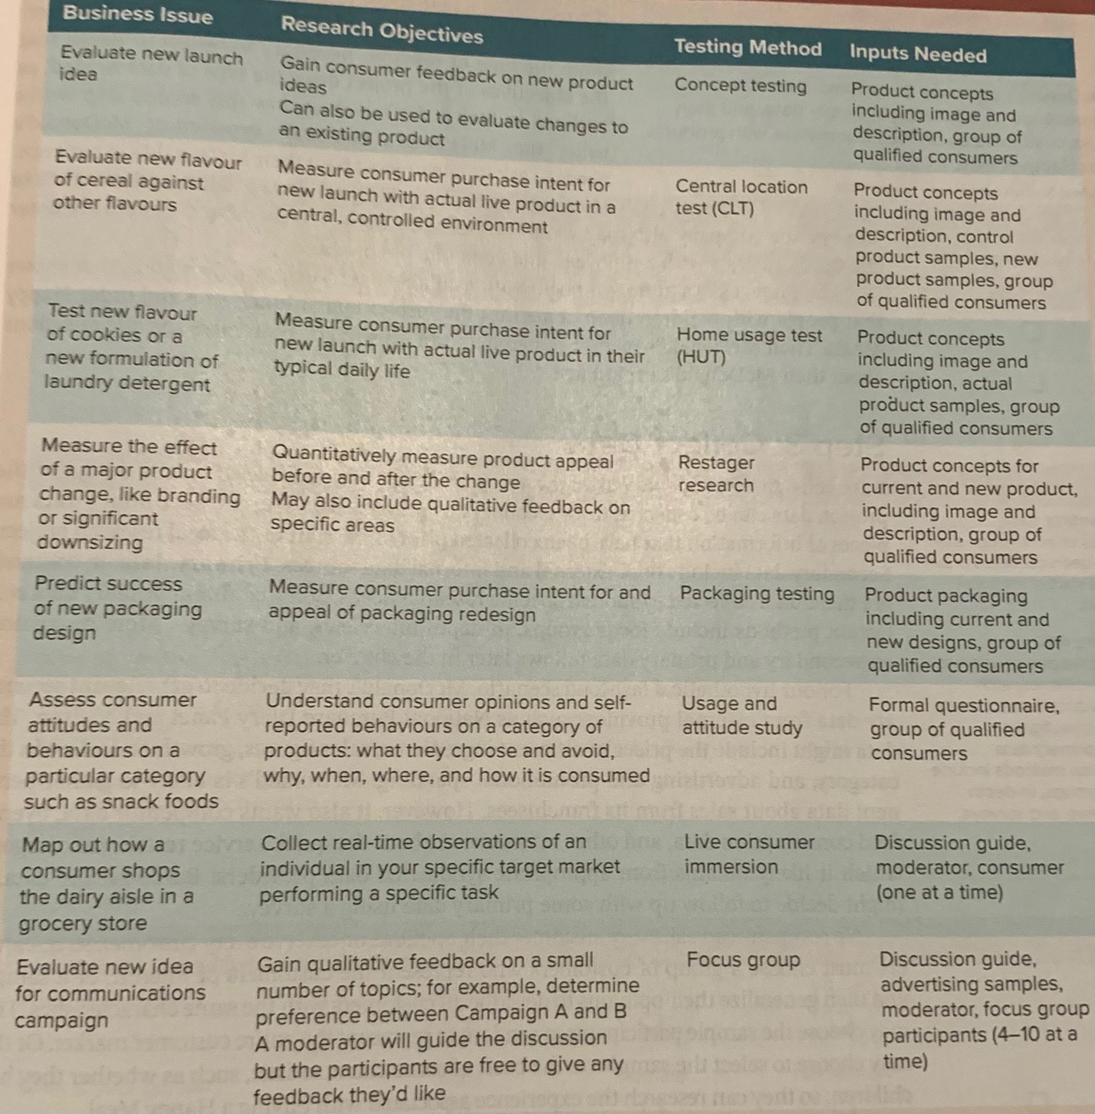

Step 2: Design the research plan
- Source of data (primary, secondary or both?)
- Research method (qualitative, quantitative, or both)
- Exploratory, descriptive, or casual
- Data collection method – surveys, experiments, focus groups, etc..
- Sampling plan: who are the subjects, type of sampling (random vs. non-random, size, representativeness, etc..
- Questionnaire design and administration (online, mail-in, length etc. Types of questions – open ended vs close ended, yes/no, scales – types of measurement scales
- Budget and timeframe for study to generate timely results

Exploratory designs: generate insights and deepen understanding (lit reviews, secondary info, focus groups, in-depth interview, pilot studies, etc..)

Descriptive designs: who, what, when, where, and how about behaviours, attitudes, motivations, etc..

Casual designs: cause-and-effect (relationship between independent and dependent variables)

Step 3: Collect Data (scales; attitudes, perceived quality, perceived value, loyalty, convenience)
- Secondary data: pieces of information that have been collected prior to the start of the focal project
  - Can be internal or external data e.g. syndicated data: available from commercial sources for a fee
  - CRAP test – currency, reliability, authority, purpose
  - Internal secondary data ex. Sales info of bagel sales over 3 years
- Primary data: data collected to address specific research needs or focal question (includes focus groups, in-depth interviews, and surveys)
  - Study meets industry’s ethical standards
  - Recruit qualified researchers
  - Detailed description of the process – Technologies? Remuneration?
  - Gather the data

Step 4: Analyzing data
- Converting data into information to explain, predict, and or evaluate a particular situation
- Involves data screening and cleaning to insure consistency and accuracy, and completion of the data set
- Can be an involved process if there are open ended questions, textual data, or video recording
- Quantitative or numerical responses requires less effort
  - Once data is cleaned the analysis begins with 2 techniques:
    - Basic statistical techniques: averages, standard deviations, frequencies, cross-tabulations, correlations, etc..
    - Advanced statistical techniques: regression analysis, analysis of variance

Data: raw numbers or other factual information limited value

Information: data that has been organized, analyzed, interpreted, and converted into a useful form for decision makers

Step 5: Determine an Action Plan
- Analysts prepare results for decision makers of marketing actions and strategies
- A marketing research presentation includes: an executive summary, the body of the report, the conclusions, the limitations, and appropriate supplemental tables, figures, and appendices

Secondary data
- Inexpensive data from census data, information from trade associations, books, journal articles, published reports in magazines and newspapers
- Can also purchase more expensive data from specialized research firms

Internal secondary data
- Rich cache of customer information and purchase history (ex. Costco membership)
- Data mining: the use of statistical analysis tools to search for patterns in data or relationships among variables
  - Firms use data mining for: customer-based analytics, Customer Lifetime Value (CLV) – profitability of the customer
- Big Data: extremely large quantities of data that companies have access to but are unable to handle using conventional data management and data-mining software
- Big data marketing research has seen changes recently due to:
  - 1) increase in amounts of data available 2) ability to collect data with customer relationship management (CRM) systems 3) the ease of collecting and storing this data 4) computing ability to manipulate data in real time 5) access to software to covert data into valuable insights for decision-making
    - Amazon: big data user as it compiles cx info to recommend relevant products (1/3 of sales)

External secondary data
- Free or inexpensive and accessible data such as statistics Canada data on retail trade, or statistics Canada census
  - May not meet the researchers needs
  - Good for a new business
  - Ex. demographics
- Syndicated data: data available for a fee from commercial research firms such as Symphony IRI group, national diary panel, Nielsen, and Leger marketing
  - Consumer data for a fee
    - May include: prices, sales figures, growth or decline, advertising and promotion spending
- Scanner data: a type of quantitative research that uses data obtained from scanner readings of UPC codes at checkout counters
  - Helps leading corporations access their marketplace
  - Focuses on weekly consumption of product at a unit of analysis (store)
- Panel data: a type of quantitative research that involves collecting information from a group of consumers over time; data collected may be from a survey or a record of purchases
  - Focuses on total weekly consumption by a person or household
  - Includes secondary and primary data
  - Secondary shows: when diet Pepsi has a big discount 80% of consumers switch from diet coke
  - Primary shows: insight of what they think of each option

Primary Data Collection Techniques
- Primary data: Data collected through interviews, surveys, experiments, to address the specific research needs/questions currently under investigation (generally what researchers need – specific information)
- Marketers collect primary data by observing:
  - Consumer behaviour, conducting focus groups, survey customers by mail, telephone, in-person, or the internet
- Qualitative or quantitative
- Downfalls: can be expensive, timely, interviewer bias, etc..

Qualitative vs Quantitative Data Collection
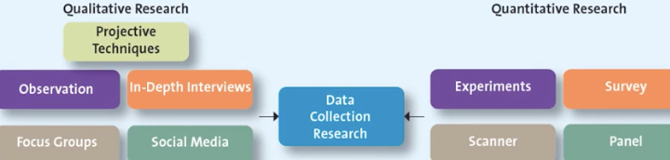

Qualitative research: exploratory in nature, more informal. Uses broad open-ended question methods, including observation, in-depth interviews, focus groups, and following social media

Reliability: extent to which the same result is achieved when a study is repeated in identical situations

Validity: extent to which a study measures what it is supposed to measure

Sample: segment or subset of population that adequately represents the entire population of interest

Quantitative research: structured responses that can be statistically tested to confirm insights and hypotheses generated via qualitative research or secondary data (used for confirmation)

Hypothesis: statement or proposition predicting a particular relationship among multiple variables that can be tested through research

Qualitative research methods:

1. Focus group interviews: is where a small group (6-12) are gathered in a physical room with a moderator, and they’re asked to share their views on the research topic (in-depth)
- Usually recorded
- can be done virtually or in-person
- gathers qualitative data

2. Observation: a qualitative method that studies people in their daily lives and activities in their homes, work, and communities
- can be done by humans or electronically using censors, bots, cameras, and other techniques
- useful to determine how consumers may use a product and for design and marketing
- Ethnography: an observational method that studies people in their daily lives and activities in their homes, work, and communities
  - Highly advanced process that tells us which consumers might use a product

3. Social media
- Booming source of data
- Blogs, likes, posts, polls, customer satisfaction, and more information..
- Virtual communities (ex. Sephora’s Beauty Talk)
- Social media pros vs cons:
  - Pros: larger accessible sample, people of all ages, large amount of information, current feedback, free consumer opinion, can filter data
  - Cons: not a statically representative sample, feedback may not be well thought out, anonymity, no depth of information about consumers, conversations are only observed, no consent to study their behaviour

4. In-depth interviews: a research technique in which questions are asked, listened to, and recorded for answers, and then further questions to clarify or expand on an issue
- Can measure historical context of interest, consumers emotions to a product
- Can be further used for surveys

5. Projective Techniques
- Test to see how consumers respond to stimuli (hypothetical scenarios)
- subjects are provided a scenario and asked to express their thoughts and feelings about it
- projective techniques are used when researches believes respondents may use bias or untruthful answer (especially if questions are sensitive)
- can provide insight on what respondents are thinking (if experienced)
- commonly used projective techniques are:
  - 1) Metaphors, analogies and similes
    - My (personal item (bag, watch, etc..) is like
    - “It’s what comfort tastes like”
  - 2) third party projections
    - What other people are doing, thinking, feeling, believing, sand saying about (product, service, company, brand, etc..)
      - Ex. What does your friend think about brand X?
  - 3) role playing
    - If you were (the CEO, manager, etc.), how would you change the product, service, etc..
  - 4) associations
    - Word: Volvo
    - Personification: if your (product) could talk, what would it say

Non-personal observation methods

Technology mediated: using technology to capture human behaviours or marketing phenomena, eg. Video cameras, traffic counters, optical scanners, eye-tracking monitors, and software

Social Media monitoring: based on conversations in social media e.g., Facebook, twitter, blogs, and products reviews

Sentiment analysis and opinion mining: using tech tools to identify, extract and quantify information in textual data

Netnography: a technique that requires engagement with online communities
- Ex. Markets will monitor a forum or group within the industry

Quantitative Research (Descriptive and experimental):
- Intended to verify insights and to aid decision makers in selecting a course of action

1. Experiments (Experimental Research): the researcher systematically manipulating 1 or more variables or conditions to determine if there is a causal effect on the outcome variable
- Ex. Ads on Facebook where they’re automatically targeted
- Ex. McDonalds adjusting prices to and measuring incomes

2. Survey: a systematic means of collecting info from people using a questionnaire
- Studies consumers’; attitudes, preferences, behaviours, and knowledge of products
- Cost-effective
- Unstructured questions: open-ended questions to hear one’s “own words”
- Structured questions: close-ended questions with specific answers
- Can gather descriptive research

3. Scanner: collecting information from a group of consumers over time, monitoring what they are exposed to and things they buy (primary or secondary data).

4. Panel: collecting information from a group of consumers over time. Survey or record of purchases. (primary or secondary data)

Data Collection Research
- Sampling (randomness, size, representativeness)
- Questions asked – closed/open-ended, etc..
- Measures used (yes, no; scales, etc.)
  - Researcher bias (Unknowingly influence respondents responses )

Designing a questionnaire (what to avoid)
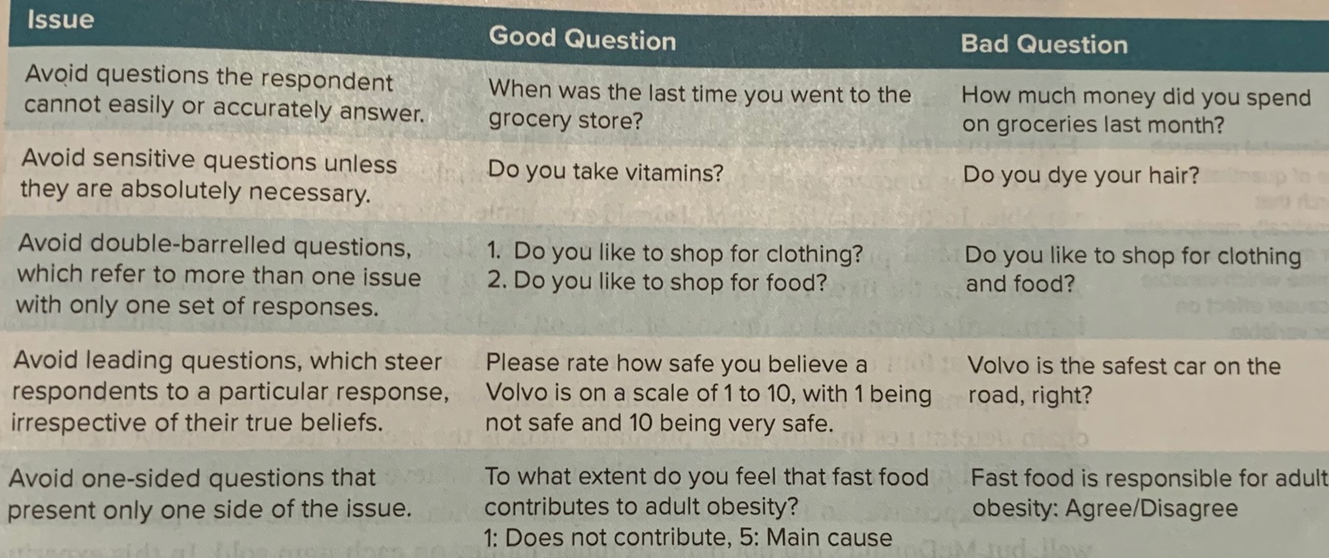

Qualitative versus quantitative research (Important!)
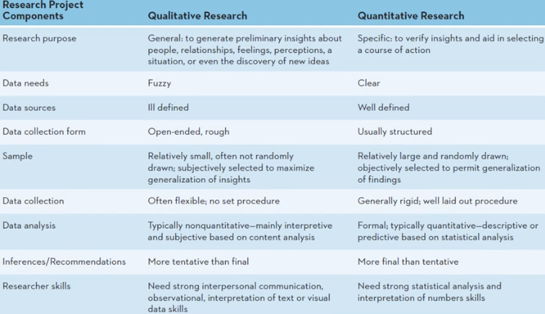

The ethics of using customer information
- Marketers have a duty to understand business ethics with customer information
- Firms notify customers information taken is confidential (no selling data)
- Firms must try to protect customer data and ensure privacy
- Marketing research should only be used to produce unbiased factual information

Summary
- The entire research process should be guided by the research objective
- Key to ensure a systematic process is followed, document the process, and minimize situations affecting reliability and validity of the study
- Costly decisions which must be carefully accessed

Further information:

Sustainable competitive advantage (SCA): you are the best in your industry/market and therefore have a competitive advantage as the leader.

- Marketing mix (4 Ps):
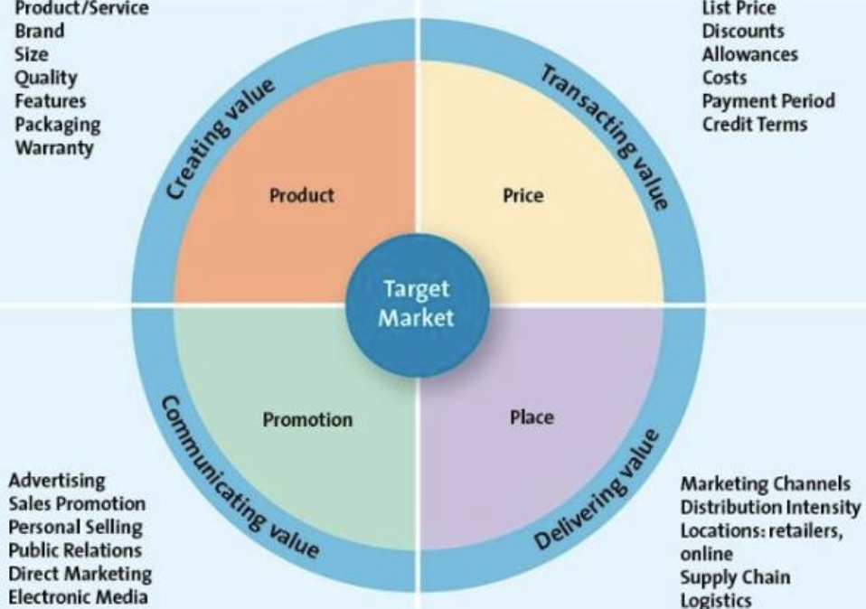

Marketing discussion questions midterm:

Chapter 4 – Consumer behaviour

1. Select one of the following sub-cultures: Chinese-Canadian, South Asian-Canadian, AfroCabibbean, or some other subculture you are familiar with and list all the aspects Marketers should consider in order to market effectively to them. Be specific.

Subculture is a group of people whose beliefs and values differ from the rest of a larger society which they live. When marketing to a Chinese-Canadian, certain aspects must be covered to affectively market to them. Marketer’s understand their cultural values and methods they should use for an appropriate product mix. Markets have to understand that consumer’s behaviour is related to culture strongly. Subcultures have many similarities, and allows marketers to design specific products for them. These subset of customers have a perceived sense of identity, and follow expected behaviours. Marketers want to be aware of their holidays, and can target advertisements tailored to them. Markets will have to consider other social factors as well such as their family. They have to tailor strategies to their lifestyle.

2.
Using the hierarchy of needs theory described in the textbook and presented in the prerecorded lecture, indicate, with justification, which of the needs the following brands are targeting - Nike (Just do it), Uber (everyone's private driver), BMW (for driving pleasure), Subaru (confidence in motion), Salvation Army (we see what others don’t), L'Oréal (because you’re worth it. You may use other information sources to justify your answer.

Maslow’s hierarchy of needs is theory of consumer motivation’s which need to be achieved in order from bottom to top. Firstly one must considered consumers physiological needs, then safety needs, love needs, esteem needs, and self-actualization needs. With Uber’s motto “everyone’s private driver” they are meeting these needs.
- Physiological needs: transportation
- Safety needs: private driver implies safe and reliable
- Love needs: private driver showing compassion for each passenger
- Esteem needs: globally respected and recognized establishment allowing people to feel good with their choice of transportation
  - Ex. Loreal “because youre worth it”
- Self-actualization:

3.
You apply for an entry-level job as a marketing analyst with a consumer-packaged goods firm. At the job interview the Marketing Director says to you, “over the years, I am amazed at how two consumers looking at the same product or advertisement yet seem to have different experiences”. Can you help explain this behavior to me?

- Perception (whats cheap vs whats expensive)
- Gender, age, religion, family, subculture

Two consumers looking at the same ad or product and having different experiences is due to perception. Perception is to process of organizing and interpreting meaning from something. This can take place due to learning, stimulus generalization and more.

People use products differently dependent on their age, gender, religion, and more. A kid may see a apple watch as a fun device, whereas the mother sees it as a life changing tool.

Consumers may also relate it to another product, and get value from it another person who did not have the previous product got. This is due to stimulus generalization.

4.
In the recorded lecture, I have asked for examples of marketing actions managers can implement to better serve customers or market their products. Make a note of all the instances from the presentation (both parts 1 & 2) and come prepared to discuss them in class.

strategies marketers can use at:

Need recognition:
- Stand-out/appealing branding and packaging
- Reminder advertising (Halloween season)
- Amazon: related items

Information search:
- Google adds (SEO)
- Accessible information (tailored for senior or millennials it varies (tvs vs social med.)
- Technically accessible
- Educating the customers (dell’s website breaks down specs so an average person can understa,d and dependent on the use, they’ll recommend how much power you truly need

Alternative evaluation:
- Differentiating products

Purchase decision:
- Stock
- Incentives
- Warranty
- Instillation offering
- Fee waived or guarentees

Post purchase:
- Warranties
- Customer feedback
- Satisfaction check
- Exchange systems

Chapter 5 – Business to business marketing (b2b)

1. What are some of the key differences between b2b and b2c markets?
- B2b involves selling to businesses whereas b2c is selling directly to the consumer
- B2b markets involve resserlers, institutions, government, manufacturs where b2c marketing is revolved completely around the consumer
- B2b markets have fewer buyers than b2c markets, are more geographically concentrated, and does larger orders
- Demand is also more inelastic in b2b transactions than b2c

2. What are some of the ways companies can segment b2b markets?
- Companies can segment b2b markets by:
  - Geographical location (country, city)
  - Firm sizes
  - Account sizes
  - Organization types (prive, nonprofit, government)
  - Types of products purchased (ex. Agricultural equipment – john deer)
- They can segment based on tiering (how well the cx matches business goals)
  - Ex. Revenue size
- Segmenting customers based on their needs
  - Highly scalable and can do need-based segments
- Segmenting customer based on sophistication
  - Technological tools being offered to highly techy firms
- Segmenting based on behaviour, such as the consumers lifestyle, actions, self-image, values and more

3. Explain why understanding market and customer characteristics are often considered the most important elements of successful B2B marketing
- Understanding your market and customers is the first step in marketing, and effects the whole process
- You need to understand characteristics and structure of the org. you are selling to
- You need to know who the decision-makers are, how their processes are, and who is most relevant in contribution to the decisions
- you need to understand the culture of the organization
- market characteristics
  - More buyers involved
  - Complexity varies
  - Professional purchasing efforts and negotiation
- customer characteristics are also important
  - understanding who is buying, and what they need can allow a b2b seller to make fitting offers

4. Explain how the role, structure, and behavior of a buying center may help a marketer sell to B2B buyers. Be clear and specific and use supporting examples.
- The buying centre is a group of people in charge of decision-making within b2b transactions and can play various roles, such as the influencer, decider, buyer, user, gatekeeper, initiator
- Roles:
  - Users – The users will be the ones to use the product, initiate the purchase process, generate purchase specs, and evaluate product performance after the purchase.
  - Influencers – The influencers are the tech personnel who help develop specs and evaluate alternate products. They are important when products involve new and advanced technology.
  - Deciders – Deciders choose the products.
  - Buyers – Buyers select suppliers and negotiate the terms of purchase.
  - Gatekeepers – Gatekeepers are typically secretaries and tech personnel. They control the flow of information to and among others within the buying center. Buyers who deal directly with a vendor are gatekeepers.
- Structure:
  - The composition and relationship of the people in the buying centre
    - 6 positions working on decision-making
    - Various levels of expertise
    - Various levels of control and hierarchy
    - Buying situations
      - New buy, straight rebuy, modified rebuy
- Behaviour
  - All persons contribute to an ultimate decision
    - Organizational culture: values of the firm

Chapter 6 – Segmentation, targeting, and positioning (STP)

1. Explain how STP add value to a company’s value proposition – use specific real-life examples to illustrate your answer.
- Segmentation:
  - Segmentation adds value as is it is focusing on a specific type of consumer and their similar wants, needs, and charecteristics
  - In depth understanding of the consumer group
  - Personalize marketing campaigns to fit your understood audience
  - Evluate if the segment is attractive for profit
    - Ex. consumers of different varities can perceive value in many different ways
      - An instrument store may sell guitars at various prices for different levels of players, ages, and rarity to meet many needs
- Targeting:
  - Targeting a select group of customers allows marketers to find strategies that work for them
  - Understanding SWOT (strength, weaknesses, opportunities, threats)
  - These strategies include differentiated and undifferentiated strategies for mass marking, a concentrated and niche strategy, and a micromarketing (1-1) strategy
    - Examples in real life:
      - Undifferentiated: selling salt widely with similar marketing as it’s a basic commodity
      - Differentiated: Nordstrom and Nordstrom rack, where on Nordstrom rack they are appealing to persons who want high quality luxirous items, at a more affordable price
      - Niche/concentrated: nofrills offers grocery essentials at a lower price for people who love to save money
      - Micromarketing (1-1): jersey customization, nike shoe customization

- Positioning:
  - Marketers understand their position to competitors and can use their advantage or the knowledge of their competitors to their advantage
  - Position around the target audience to create perceived value
    - Ex. Old navy offers cheap great quality clothing for a whole family whereas banana republic offers clothing for people who want to live with no boundaries, and enjoy fashion

2. What are the main features/elements of perceptual maps? How are perceptual maps used to develop positioning statements and positioning strategies?
- Perceptual maps displays in 2D the position of products or brands in the consumer’s mind
- They will compare other brands based on 2 categories of factors such as, calories; high calories and low calories, and price: high price and low price
- They allow to see openings in the market for a product
- Perceptual maps can allow us to:
  - See how consumers’ view the product as well as the competitors, identify areas of opportunity, identify avoidable areas, popular quadrants, and multiple maps used to develop a deeper understanding of the consumers perspective
- In positioning, perceptual maps show us the benefits of the markets products, competition, and values offered
- This allows a marketer to position perfectly to their target market, and express their strentghs and value

3.Select any 5 products or brands from the same category (e.g., coffee, cereals, soft drinks, clothing brands, shoe brands, restaurants) and develop a perceptual map. You can do this with classmates!
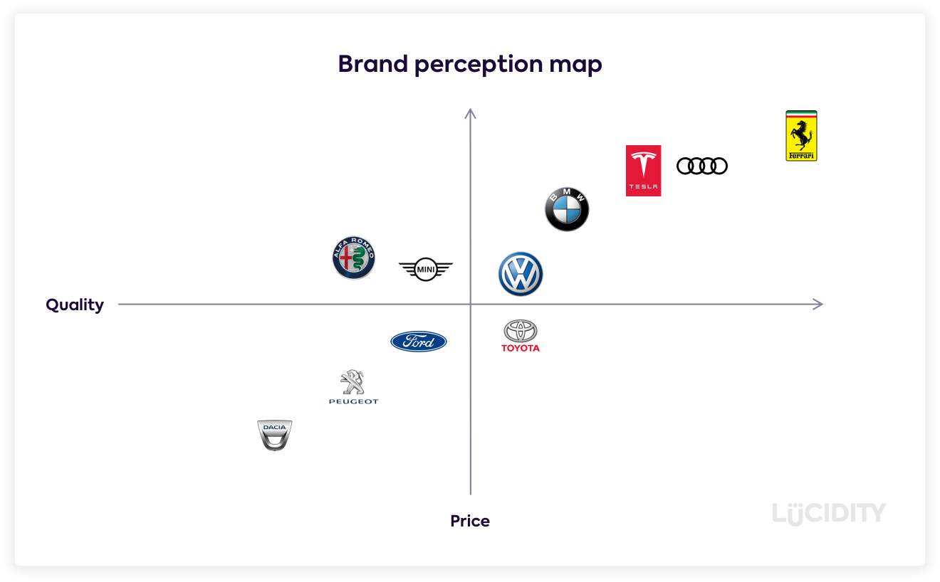

4.Can one product or brand be positioned to be attractive to different target markets? Provide one real-life example to illustrate your answer.
- Yes through having wide ranges of benefits helping various groups of persons
- Ex. Nike targets atheletes through professional and scientific gear, as well as persons who enjoy comfort and high quality equipment
- Ex. mcdonalds changing their messaging of a salad to be fulfilling and energy boosting, to not only appeal to healthy lifestyles, but to people who want a big boost
- Ex. binance offers an easy way for new crypto investors to buy and get started with crypto, appealing to a new amateur audience, on top of the more professional market

5.Explain what is meant by repositioning. Explain the reasons why marketers would consider repositioning their brands. What are the risks and challenges involved in repositioning.
- Repositioning is a strategy where marketers change a brand’s focus to target new markets or realign the brand
- It may change marketing mix, message, standpoints, values, and more
- Markets consider repositioning due to
  - Changes in the firms environment (competition, technology)
  - To enhance a competitive advantage (once noticed)
- Risks associated:
  - Failure to bring customers along
  - Unclear link between new position and customers brand association!
  - Inconsistent image between previous
  - Too big of a change
  - Timeliness of reposition
  - Brand history
  - Coherency

Chapter 7 – Marketing research

1. Joe Black, a Telfer grad, has opened his own hardware store in Toronto 10 years ago. He is very knowledgeable about the industry and is an experienced businessman. He has never conducted any marketing research. He wants to investigate if his marketing strategies need to be changed to increase satisfaction among current and future customer segments? Joe believes that his definition of his problem sounds too broad and decides to hire you to help get a more refined definition of this problem – what specific research question(s) would you recommend to Joe Black to ensure he gets actionable insights to his concern.
- He can perform both quantitative and qualitative research
- Wants to collect primary data, about current customers and their expressions of the brand satisfaction
- Quantitative research:
  - Survey – close-ended questionare to get an overall level of satisfaction from customers (are you satisfied with the stores employees, location, etc..)
  - Panel – too follow up with consumers and their purchases over time
- Qualitative research:
  - In-depth interviews
  - Social media polls
  - Projective techniques (see how consumers would feel about a hypothetical marketing scenario)

2. Identify as many ways or mechanisms as you can in which marketers collect data on their customers. Give examples of the types of data being collected. Give examples of the ways in which marketers use this data to serve customers.
- Marketers collect data on their customers through:
  - Scanners: consumer information collected over time monitoring what they buy and are exposed too
  - Interviews: qualitative data, in-depth responses, allows for consumers voice to be heard, interigate many aspects of the business, 1st hand consumer view
  - Social media: pages, posts, likes, interactions, feedback, polls
  - Projective techniques: what if scenario responses
  - Netnography: monitor a forum online and analyze responses
  - Experiments: Ads on facebook to see outcome variable
  - Survey: cheap collection of specific questions from your consumers
  - Scanner: collects consumer data of what they buy and are exposed too
  - Panel: collecting information from a consumer group over time
  - Data mining
  - Consumer feedback

3. What are the differences between quantitative and qualitative data? Do you think it is risky for marketers to make major marketing mix decisions based purely on qualitative data?
- Quantitative: structured, analytical, close-ended, used for confirmation
- Qualitative: exploratory, informal, open-ended, used for information
- Marketing with purely qualitative data may be risky due to:
  - Interviewer bias
  - Data needs may be unclear
  - Value may be misinterpreted by the analyst (needs strong interpretation skills)
  - Costly, should only be used for specific research unable to be gathered from quantitative data
  - Samples are small
    - In comparison, both types of data have pros and cons, and quantitative data should be used to confirm these qualitive insights

4. Emma is a marketing executive at a major consumer-packaged good firm responsible for marketing research as part of her job responsibilities. She told her market research team that any research they submit to her must be reliable, valid, and credible or else they risk losing their job. What is meant by reliable, valid and credible in marketing research? How can research analysts ensure a high level of reliability, validity and credibility. Be detailed and specific.
- Reliable: extent to which the same result is achieved when a study is repeated in identical situation
  - Researchers can ensure reliability by
    - Standardizing the examination
    - Suitable techniques that meet the objective
    - All members are given the same data
    - Recruiting qualified researchers
- Validity: extent to which a study measures what its suppose to
  - Validity can be ensured by:
    - Standardizing your conditions of research
    - Consistent application of testing methods (no changing instruments)
- Credible: extent to which a study believable or plausible
  - Credibility can be ensured by
    - The reputation of the research organization

5. A new men’s clothing store is trying to determine whether there is a significant market for its type of merchandise in a specific location where it is considering putting a store. Would it be most likely to use primary or secondary data or a combination of the two, to answer this question. Justify your answer.
- You could use primary and secondary data
- Primary data: specific information from customers behaviours through investigation
  - In depth interviews for open-ended first hand consumer opinions
  - Gather local consumer information
  - Gains confirmation of the marketing plan
- Secondary data: general consumer data available in census’, news, data mining, etc..
  - Demographics (age, income, gender, geographic location)
  - Cheap and easy way to acess the market
  - Great for start up businesses
  - Gives you a rough idea of consumers and competitors in the area
  - A base of information to develop a marketing strategy
  - Demographics

Weblinks:
- Subway. Eat fresh live fresh
  - Multiple updates to menu (avocado, sandwiches, 20+ items)
  - New customization options (micromarketing one-to-one)
  - Focus on core ingredients (better quality)
  - Free subs during certain periods
  - Food that’s craveable and innovative
  - Focus on original strength of being the best for customization
    - Downfall: tuna accusations, sugary bread, director child-porn
- Has a new value proposition
- Altering positioning to focus fresher and healthier options
- SWOT

Burger king
- Brand revamp (old fashion style)
- Menu updates (removing artificial ingredients)
- To promote this, they’re doing meal deals with celebrities, imitating mcdonalds (nelly)

America’s Supermarkets (Sustainable Competitive Advantage)
- Aldi is offering new ways to get groceries cheap with changes such as cart fees, bag fees, own grocery bagging
- Aldi keeps prices low by stripping down the shopping experience (efficient)
- Simple layouts and limited selection (efficient shopping)
- Small sizes stores

Walmart innovation with technology (SCA)
- 1. Mobile upgrades: app touch up, with ordering, store maps, stock availability
- 2. Lists: Walmart app allows making of shopping lists
- 3. Returns: returns within the app with just barcode and receipt
- 4. Robots: Robots to check stock, evaluate pricing and gain information
- 5. Associates: program to pay for college, scheduling on app
- 6. Automation: automated process with inventory (fast unloading)
- 7. Online: Ai and humans to recommend similar products

McDonalds (STP)
- Segmenting is central to McDonalds
- McDonalds doesn’t organize by brand, though has segment managers
  - Director of young adults, women, moms, African American
    - Puts McDonalds in a position to maximum target marketing efforts
- McDonalds uses segment insights (research about consumer behaviour)
- Collects data from each segment daily (pulls insight)
- Consumer insights: values, needs and lifestyle of each segment
- Each team makes a positioning profile for each profile
  - Then the creative team uses them to produce relevant adds
- Ex. southwest chicken salad – consumer intelligence provided such cool ingredients the general market would find it compelling
  - African Americans didn’t want the salad so they marketed the salad to be filling
  - Hispanic marketing brought ingredients with heritage, culture
  - Asian’s including a variety of tastes, with new things

Coke recipe change (product innovation)
- First change in 100 years to the recipe
- Major backlash online, through calls, in songs and media
- Coke tracked consumer reaction and learned to bring the original back
- Neflix promotion with “stranger things” featuring the new coke cans
- Coke zero (new target market)
- Had to adjust recipe and took media feedback to understand this
- Using its advnatgae with diet coke to stay above pepsi

Nestle (product innovation)
- Kitkat V (non-dairy)
  - Plant-based/alternative trend
- Also released vegan chocolate bars (health and enviormental reasons)

Gap (use of data)
- Increasingly personalized digitial marketing strategy (for large and diverse customers)
- Propreitary customer data platform (CDP) allows them to get an idea of customers
  - Uses first and third party data
- Uses media and other advertising channels with optimized messaging for each audience segment
- Uses all data sources (primary, secondary, internal, external…)
- Data helps predict customer behaviours quickly to tweak marketing strategies
- Uses AI for automation and personalized marketing (matches)
- Monitors new strategies incase a pullback is needed

