BUSI 100 Microeconomics Study Notes

Table of Contents
Lesson 1 – Chapter 1: Ten Principles 2
Lesson 1 – Chapter 2: Role of the Economist 4
Lesson 2 – Chapter 4: Supply and Demand 5
Lesson 2 - Chapter 17: Oligopoly, Game Theory, and Cooperation 6
Lesson 3 – Chapter 5: Elasticity (How responsive buyers are to a change in the price of a good) 7
Lesson 4 – Chapter 20: Income Inequality 9
Lesson 4 – Chapter 21: Consumer Choice 9
Lesson 5 – Chapter 13: The Costs of Production 11
Lesson 6 – Chapter 7: Consumers, Producers & Market Efficiency 13
Lesson 7 – Chapter 14: Competitive Markets (Milk & Margins) 14
Lesson 8 – Chapter 15: Monopolies (Microsoft, Government Improve Outcomes) 18
Lesson 9 – Chapter 6: Government Policies: Taxes, Wages, and Price Controls 20
Lesson 10 – Chapter 8: The Cost of Taxation (Deadweight Loss, 20
Lesson 11 – Chapter 10: Externalities 22

Lesson 1 – Chapter 1: Ten Principles

Principle #1 – People face tradeoffs (Production vs. Environment, generalize or specialize)
Efficiency: society is getting the maximum benefits from its scarce resources.
Equity: the benefits of the resources are distributed fairly among society's members.
Production possibilities: the only way of producing more of one good is to produce less of the other

Principle #2 – The cost of something is what you give up to get it (Work vs. Study, Pro sports dropouts)
Opportunity Cost: whatever must be given up to obtain something (e.g. time off of work to study, production possibilities frontier)

Principle #3 – Rational people think at the margin (Last minute airline seats are cheap).
Marginal Cost: the amount of increase from the margin of the initial cost (i.e. beyond the existing cost)
Marginal Benefit: a person's willingness to pay for a good is based on the marginal benefit that an extra unit of the good will yield

Principle #4 – People respond to incentives (more seatbelts = more accidents).
Incentives: prospects of rewards or punishments that make a person act

Principle #5 – Trade can make everyone better off.
Trade allows countries to specialize in what they do best and to enjoy a greater variety of goods and services.

Principle #6 – Markets are usually a good way to organize economic activity (Why Soviet communism failed, Adam Smith’s Invisible Hand)
Market Economy: an economy that allocates resources through the decentralized decisions of many firms and households as they interact in markets for goods and services
Invisible Hand: prices (the hand) direct economic activity (Adam Smith – Wealth of Nations)
Market prices reflect both the value of a good to society and the cost to society of making the good.

Principle #7 – Governments can sometimes improve market conditions (Laws protect property rights, income tax and welfare)
Market power: the ability of a single economic actor (or small group of actors) to have a substantial influence on market prices
Market failure: a situation in which a market left on its own fails to allocate resources efficiently
Externality: the impact of one person's actions on the well -being of a bystander (e.g. pollution)
Governments intervene in the economy to promote efficiency (maximize production of resources) or to promote equity (fairly allocate resources).

Principle #8 – A country’s standard of living depends on its ability to produce goods and services (China’s rising middle class)
Productivity: the quantity of goods and services produced from each hour of a worker's time

Principle #9 – Prices rise when the government prints too much money (1920s Germany)
Inflation: an increase in the overall level of prices in the economy (caused by increased quantity of money)

Principle #10 – Society faces a short-term tradeoff between inflation and unemployment (Canada’s 2008 stimulus package)
business cycle: the irregular and largely unpredictable fluctuations in economic activity, as measured by the production of goods and services or the number of people employed.

Summary
Individual decision making:
- people face tradeoffs among alternative goals
- the cost of any action is measured in terms of forgone opportunities
- rational people make decisions by comparing marginal costs and marginal benefits
- people change their behaviour in response to incentives
Interactions among people:
- trade and interdependence can be mutually beneficial
- markets are usually a good way of coordinating trade among people
- the government can improve market outcomes if there is market failure or inequity
The economy as a whole:
- productivity is the ultimate source of living standards
- money growth is the ultimate source of inflation
- society faces a short-run tradeoff between inflation and unemployment

Lesson 1 – Chapter 2: Role of the Economist

The Science of Economics (based on the Scientific Method)
Assumptions: economists assume away many of the details of the economy that are irrelevant
to the question at hand (e.g. in a basic circular-flow model international trade may be omitted)
Circular flow diagram: a visual model of the economy that shows how dollars flow through markets (e.g. households and firms)
Factors of production: labour, land, capital
Production Possibilities Frontier: a graph that shows the combinations of output that the economy can possibly produce given the available factors of production and the available technology

Micro vs. Macro
Microeconomics: how households and firms make decisions and how they interact in markets
Macroeconomics: economy-wide phenomena (inflation, unemployment, and economic growth)

Policy (Income Tax Rates, Rent Control, Free Trade)
“When economists are trying to explain the world, they are scientists. When they are trying to help improve it, they are policy advisers.”
Positive Analysis/Statements: claims that attempt to describe the world as it is
Normative Analysis/Statements: claims that attempt to prescribe how the world as it should be and involve value judgements
Economists are aware that tradeoffs are involved in most policy decisions. A policy might increase efficiency at the cost of equity.

Summary and Real Estate Applications
Economists try to address their subject with a scientist's objectivity. Like all scientists, they make appropriate assumptions and build simplified models in order to understand the world around them. Two simple economic models are the circular-flow diagram and the production possibilities frontier.
Economists who advise policymakers sometimes offer conflicting advice either because of differences in scientific judgments or because of differences in values. At other times, economists are united in the advice they offer, but policymakers may choose to ignore the advice because of the many forces and constraints imposed by the political process.
Suburban vs. Urban Housing: Assuming labour and capital are fixed, then construction has limited production possibilities. You can increase housing built in urban areas, but it will draw labour and capital away from suburban areas (opportunity cost on the production possibilities frontier). There are diminishing returns to be considered.
Marginal Analysis shows that even though a large project may be good, a small project may be better. You have to compare the marginal cost with the marginal benefit.

Lesson 2 – Chapter 4: Supply and Demand

Markets and Competition (Ice Cream)
Market: a group of buyers and sellers of a particular good or service
Competitive market: a market in which there are many buyers and many sellers so that each has a negligible impact on the market price
Demand Curve: the relationship between price and quantity (shows how the total quantity demanded of a good varies as the price of the good varies, while all the other factors that affect how much consumers want to buy are held constant) – can be shifted up or down by changes to income, prices of related goods/substitutes, tastes, expectations of the future, or number of buyers
Demand Schedule: a table that shows a demand curve relationship between price and quantity
Law of Demand: other things equal, the quantity demanded of a good falls when the price of the good
rises (e.g. lower prices increase the demand, so the slope is downward)
market demand: the sum of all the individual demands for a particular good or service
Law of Supply: when the price of a good rises the quantity supplied of the good also rises, and when the price falls the quantity supplied falls as well
Supply Schedule: a table that shows the relationship between the price of a good and the quantity supplied, holding constant everything else that influences how much producers of the good want to sell
Supply Curve: how the total quantity supplied varies as the price of the good varies, holding constant all other factors that influence producers' decisions about how much to sell – can be shifted up or down by changes to input prices/production costs, technology, expectations of the future, or number of sellers
A curve shifts only when there is a change in a relevant variable that is not named on either axis
Equilibrium: a situation in which the price has reached the level where quantity supplied equals quantity demanded (supply = demand)
Market-clearing price: everyone in the market has been satisfied: Buyers have bought all they want to buy, and sellers have sold all they want to sell.
Surplus: quantity supplied is greater than quantity demanded – sellers respond to the surplus by cutting their prices. Falling prices, in tum, increase the quantity demanded and decrease the quantity supplied. These changes represent movement along the supply and demand curves (not shifts in the curves). Prices continue to fall until the market reaches the equilibrium.
Shortage: quantity demanded is greater than quantity supplied - sellers can respond to the shortage by raising their prices without losing sales. These price increases cause the quantity demanded to fall and the quantity supplied to rise. Once again, these changes represent movements along the supply and demand curves, and they move the market toward the equilibrium.

Analysing Changes in Equilibrium
- decide whether the event shifts the supply curve, the demand curve, or both
- decide whether the curve shifts to the right or to the left
- use the supply-and-demand diagrams to compare the initial equilibrium with the new one

Summary
- The behaviour of buyers and sellers naturally drives markets toward their equilibrium. When the market price is above the equilibrium price, there is a surplus of the good, which causes the market price to fall. When the market price is below the equilibrium price, there is a shortage, which causes the market price to rise.
- In market economies, prices are the signals that guide economic decisions and thereby allocate scarce resources. For every good in the economy, the price ensures that supply and demand are in balance. The equilibrium price then determines how much of the good buyers choose to purchase and how much sellers choose to produce.

Lesson 2 - Chapter 17: Oligopoly, Game Theory, and Cooperation

Oligopoly: only a few sellers offer similar or identical products (WestJet/Air Canada, Bell/Rogers, etc.) and they are interdependent in a way that competitive firms are not
Game Theory: the study of how people behave in strategic situations
Collusion: an agreement among firms in a market about quantities to produce or prices to charge
Cartel: a group of firms acting in unison (OPEC oil companies)
Nash equilibrium: a situation in which economic actors interacting with one another each choose their best strategy given the strategies that all the other actors have chosen
The Prisoner’s Dilemma: In this game between two criminals suspected of committing a crime, the sentence that each receives depends both on his or her decision whether to confess or remain silent and on the decision made by the other.
Dominant strategy: a strategy that is best for a player in a game regardless of the strategies chosen by the other players
Resale Price Maintenance: wholesalers/manufacturers requiring retailers to sell at a certain price
Predatory Pricing: Firms with market power raise prices above the competitive level

Summary
- Oligopolists maximize their total profits by forming a cartel and acting like a monopolist.
- The prisoners' dilemma shows that self-interest can prevent people from maintaining cooperation.
- Policymakers use the anticompetition laws to prevent oligopolies from engaging in behaviour that reduces competition.

Lesson 3 – Chapter 5: Elasticity (How responsive buyers are to a change in the price of a good)

Elasticity is a measure of how much buyers and sellers respond to changes in market conditions (quantity supplied or quantity demanded)
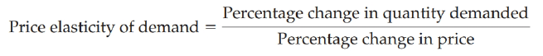
price elasticity of demand: a measure of how much the quantity demanded of a good responds to a change in the price of that good, computed as the percentage change in quantity demanded divided by the percentage change in price
Price sensitivity is the degree to which demand changes when the cost of a product or service changes. Price sensitivity is commonly measured using the price elasticity of demand, which states that some consumers won't pay more if a lower-priced option is available.
Factors that influence price elasticity:
- Substitutes: Goods with many close substitutes tend to have more elastic demand because it is easier for consumers to switch from that good to others (e.g. butter and margarine)
- Timeframe: short timeframe = less elastic (if it is raining and people are looking for an umbrella)
- Necessities vs. Luxuries: Necessities = less elastic (medicine) and luxuries = elastic (gold watch)
- Income Share: higher share of income = more elastic (price of a car doubling vs. price of gum doubling)
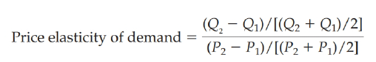
- Definition of the Market: Narrowly defined markets tend to have more elastic demand than broadly defined markets because it is easier to find close substitutes for narrowly defined goods.

Midpoint Method: used for calculating elasticities (shown above) and computes the percentage change by dividing the midpoint (average) or the initial and final numbers.
Unit Elasticity (Demand): when the elasticity is exactly 1 and the percentage change in quantity equals the percentage change in price
Perfect Inelasticity: changes in prices won’t affect demand (e.g. medicine like insulin)
Flat/horizontal demand curve = high elasticity steep/vertical demand curve = low elasticity
total revenue: the amount paid by buyers and received by sellers of a good (price x quantity sold or PxQ)
cross-price elasticity of demand: measures how the quantity demanded of one good responds to a change in the price of another good (e.g. increase in hot dog prices increases demand for hamburgers)
price elasticity of supply: how much the quantity supplied of a good responds to a change in the price of that good, computed as the percentage change in quantity supplied divided by the percentage change in price (quantity responds = elastic supply, quantity barely changes = inelastic supply). Think limited supply is inelastic (e.g. beachfront properties). In the short run, the quantity supplied is not very responsive to the price because firms cannot easily change the size of their factories to make more or less of a good.

Summary

The price elasticity of demand measures how much the quantity demanded responds to changes in the price. Demand tends to be more elastic if close substitutes are available, if the good is a luxury rather than a necessity, if the market is narrowly defined, or if buyers have substantial time to react to a price change.
The price elasticity of demand is calculated as the percentage change in quantity demanded divided by the percentage change in price. If quantity demanded moves proportionately less than the price, then the elasticity is less than 1 and demand is said to be inelastic. If quantity demanded moves proportionately more than the price, then the elasticity is greater than 1 and demand is said to be elastic.
Total revenue, the total amount paid for a good, equals the price of the good times the quantity sold. For inelastic demand curves, total revenue moves in the same direction as the price. For elastic demand curves, total revenue moves in the opposite direction as the price.
The income elasticity of demand measures how much the quantity demanded responds to changes in consumers' income. The cross-price elasticity of demand measures how much the quantity demanded of one good responds to changes in the price of another good.
The price elasticity of supply measures how much the quantity supplied responds to changes in the price. This elasticity often depends on the time horizon under consideration. In most markets, supply is more elastic in the long run than in the short run.
The price elasticity of supply is calculated as the percentage change in quantity supplied divided by the percentage change in price. If quantity supplied moves proportionately less than the price, then the elasticity is less than 1 and supply is said to be inelastic. If quantity supplied moves proportionately more than the price, then the elasticity is greater than 1 and supply is said to be elastic.

Lesson 4 – Chapter 20: Income Inequality

Gini coefficient: measure of inequality that calculates the extent to which the distribution of income among individuals within a country deviates from a perfectly equal distribution (0 = perfect equality)
in-kind transfers: transfers to the poor given in the form of goods and services rather than cash
utilitarianism: the political philosophy according to which the government should choose policies to maximize the total utility of everyone in society
liberalism: the political philosophy according to which the government should choose policies deemed to be just, as evaluated by an impartial observer behind a "veil of ignorance"
maximin criterion: the claim that the government should aim to maximize the well -being of the worst-off person in society
libertarianism: the political philosophy according to which the government should punish crimes and enforce voluntary agreements but not redistribute income (equality of opportunities not equality of incomes)
People Face Tradeoffs - Policies that penalize the successful and reward the unsuccessful reduce the incentive to succeed. Thus, policymakers often face a tradeoff between equality and efficiency.

Lesson 4 – Chapter 21: Consumer Choice

budget constraint: the limit on the consumption bundles that a consumer can afford
indifference curve: a curve that shows consumption bundles that give the consumer the same level of satisfaction
marginal rate of substitution: the rate at which a consumer is willing to trade one good for another
Properties of Indifference Curves:
- Higher curves are preferred to lower ones
- They are downward sloping (if the quantity of one good is reduced, the quantity of the other good must increase for the consumer to be equally happy)
- They do not cross
- They are bowed inward (because people are more willing to trade away goods that they have in abundance and less willing to trade away goods of which they have little)
perfect substitutes: two goods with straight-line indifference curves
perfect complements: two goods with right-angle indifference curves
optimum: the point at which this indifference curve and the budget constraint touch
normal good: other things equal, an increase in income leads to an increase in demand
income effect: a price change moves the consumer to a higher or lower indifference curve (Now that Pepsi is cheaper, my income has greater purchasing power. I am, in effect, richer than I was. Because I am richer, I can buy both more pizza and more Pepsi.)
substitution effect: a price change moves the consumer along a given indifference curve to a point with a new marginal rate of substitution (Now that the price of Pepsi has fallen, I get more litres of Pepsi for every pizza that I give up. Because pizza is now relatively more expensive, I should buy less pizza and more Pepsi.)
Giffen good: a good for which an increase in the price raises the quantity demanded

Summary

- A consumer's budget constraint shows the possible combinations of different goods he can buy given his income and the prices of the goods.
- The consumer's indifference curves represent his preferences. An indifference curve shows the various bundles of goods that make the consumer equally happy.
- The consumer optimizes by choosing the point on his budget constraint that lies on the highest indifference curve. At this point, the slope of the indifference curve (the marginal rate of substitution between the goods) equals the slope of the budget constraint (the relative price of the goods) and the consumer's valuation of the two goods (measured by the marginal rate of KEY concepts substitution) equals the market's valuation (measured by the relative price).
- When the price of a good falls, the impact on the consumer 's choices can be broken down into an income effect and a substitution effect.

Lesson 5 – Chapter 13: The Costs of Production

Production function: determines an output based on various inputs (e.g. land, labour, capital)
Short-run: the situation in which at least one input is fixed (e.g. output varies based on amount of workers/labour)
Long-run: a situation in which none of the inputs are fixed
Total product:
Marginal product: when you increase the value of an input by 1, how much you get in return (e.g. for each additional employee, you produce 10 more units per day). When the MPL is less than, then the APL is decreasing. Each additional unit of labor adds less to total output than the average. The slope of the production function measures the marginal product of a worker. As the number of workers increases, the marginal product declines, and the production function becomes flatter.
Diminishing marginal return: Diminishing marginal returns means that as the firm adds more labor, it creates more output at a decreasing rate. A total production function increases when it has a positive slope, and diminishing returns means that the positive slope gets smaller as more inputs are used.
Average product:
Fixed costs: costs that do not vary with the quantity of output produced (e.g. rent, insurance, utilities)
Variable costs: costs that vary with the quantity of output produced (e.g. supplies, stock, wages)
Marginal cost: Marginal cost rises with the quantity of output. This upward slope reflects the property of diminishing marginal product. Whenever marginal cost is less than average total cost, average total cost is falling. Whenever marginal cost is greater than average total cost, average total cost is rising. Many firms experience increasing marginal product before diminishing marginal product.
Average costs (total, fixed, variable) are divided by the quantity of output
Average costs: the cost of a typical unit of output if total cost is divided evenly over all the units produced.
Total Cost: The amount that the firm pays to buy inputs
efficient scale: the quantity of output that minimizes average total cost (bottom of the U-shape curve).
total-cost curve: the relationship between quantity produced and total costs. The total-cost curve gets steeper as the amount produced rises, whereas the production function gets flatter as production rises.
Total Revenue: The amount that the firm receives for the sale of its output
Profit = Total revenue – Total cost
Explicit costs: input costs that require an outlay of money by the firm
Implicit costs: input costs that do not require an outlay of money by the firm (usually ignored in accounting). These include opportunity costs (e.g. money used for purchasing the property could have been used as an investment instead)
economic profit: total revenue minus all the opportunity costs (explicit and implicit) of producing the goods and services sold
accounting profit: total revenue minus only the firm's explicit costs
economies of scale: long-run average total cost declines as output increases. Economies of scale often arise because higher production levels allow specialization among workers, which permits each worker to become better at a specific task
diseconomies of scale: long-run average total cost rises as output increases. Diseconomies of scale can arise because of coordination problems that are inherent in any large organization
constant returns to scale: long-run average total cost does not vary with the level of output
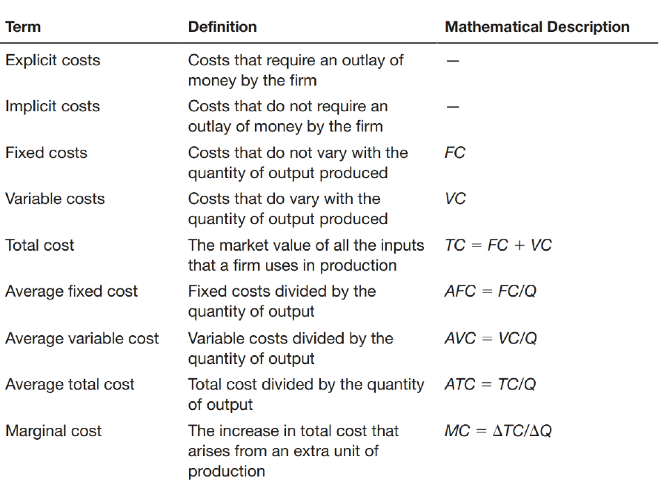
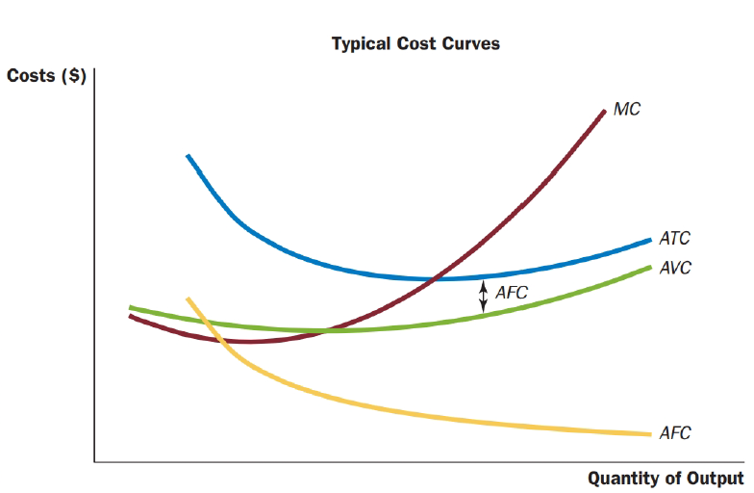

Lesson 6 – Chapter 7: Consumers, Producers & Market Efficiency

Welfare economics: the study of how the allocation of resources affects economic well-being (normative). The price that balances the supply and demand for turkey is, in a particular sense, the best one because it maximizes the total welfare of turkey consumers and turkey producers. No consumer or producer of turkeys aims to achieve this goal, but their joint action directed by market prices moves them toward a welfare-maximizing outcome, as if led by an invisible hand.

Consumer Surplus - The benefits buyers receive from participating in a market
willingness to pay: the maximum amount that a buyer will pay for a good (i.e. maximum purchase price) based on preferences and income
Consumer surplus (savings): the amount a buyer is willing to pay for a good minus the amount the buyer actually pays for it (e.g. buying a house you value at $200,000 for $180,000 = consumer surplus of $20,000). Consumer surplus measures the benefit buyers receive from participating in a market and is closely related to the demand curve for a product. Consumer surplus is usually a good measure of economic wellbeing.
The area below the demand curve and above the price measures the consumer surplus in a market.
Lower Price Raises Consumer Surplus

Producer Surplus - The benefits sellers receive from participating in a market
Willingness to sell: the maximum amount a seller must give up to produce a good (opportunity cost + expenses)
producer surplus (profit): the amount a seller is paid for a good minus the seller's cost. Producer surplus
is closely related to the supply curve.
Marginal seller: the seller who would leave the market first if the price was any lower
marginal cost curve: shows the cost of the marginal seller at each quantity
The area below the price and above the supply curve measures the producer surplus in a market.
Higher Price Raises Producer Surplus

Market Efficiency - The Benevolent Social Planner
Total surplus: consumer surplus + producer surplus OR value to buyers – cost to sellers
Efficiency: maximizing the total surplus received by all members of society
Free markets allocate the supply of goods to the buyers who value them most (willingness to pay) and the demand for goods to the sellers who can produce them at the lowest cost. Free markets produce the quantity of goods that maximizes the sum of consumer and producer surplus.
market failure: the inability of some unregulated markets to allocate resources efficiently due to 1) market power that keeps the price and quantity away from the levels determined by the equilibrium of supply and demand; and 2) externalities that impact the welfare of the market and participants

Lesson 7 – Chapter 14: Competitive Markets (Milk & Margins)

Market Power: if a firm can influence the market price of the good it sells
competitive market: a market in which there are many buyers and many sellers so that each has a negligible impact on the market price; their goods are largely the same; firms can freely enter or exit
price takers: buyers and sellers in competitive markets who must accept the price the market determines
maximum profit = total revenue (P x Q) – cost (C)
average revenue = total revenue (P x Q) divided by the quantity sold (Q); therefore, average revenue equals the price of the good
marginal revenue = the change in total revenue from the sale of an additional unit (MR = ∆TR / ∆Q)

Profit Maximization
Change in profit = marginal revenue – marginal cost (MR – MC)
Cost curves: most profit maximizing firms have the following curves
- Upward sloping marginal-cost curve (MC)
- U-shaped average total cost curve (ATC)
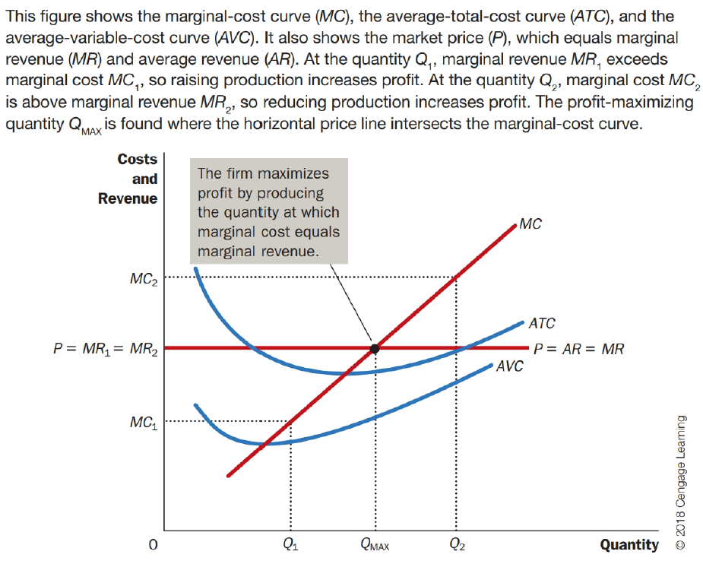
- The two curves (MC and ATC) cross and the minimum of the average total cost

Maximum profit happens where the price line (P) intersects with the marginal cost curve (MC)
3 general rules for profit maximization:
  - If marginal revenue is greater than marginal cost (MR > MC) the firm should increase its output.
  - If marginal cost is greater than marginal revenue (MC > MR) the firm should decrease its output.
  - At the profit-maximizing level of output, marginal revenue and marginal cost are exactly equal.
Connection to supply curves: because the firm's marginal-cost curve determines the quantity of the good the firm is willing to supply at any price, it is the competitive firm's supply curve

Temporary Shut Downs
Shutdown: a short-run decision not to produce anything during a specific period of time because of current market conditions (most firms cannot avoid their fixed costs in the short run but can do so in the long run); Shut down if TR < VC (total revenue is less than variable cost) OR P < AVC (price is less than average variable cost); the size of the fixed cost does not matter as they are a sunk cost
Sunk cost: the fixed costs incurred when making the short-run decision to shut down; a cost that has already been committed and cannot be recovered
shutdown price: the price that coincides with the minimum point on the average-variable-cost curve; start-up price would be anything higher than the shutdown price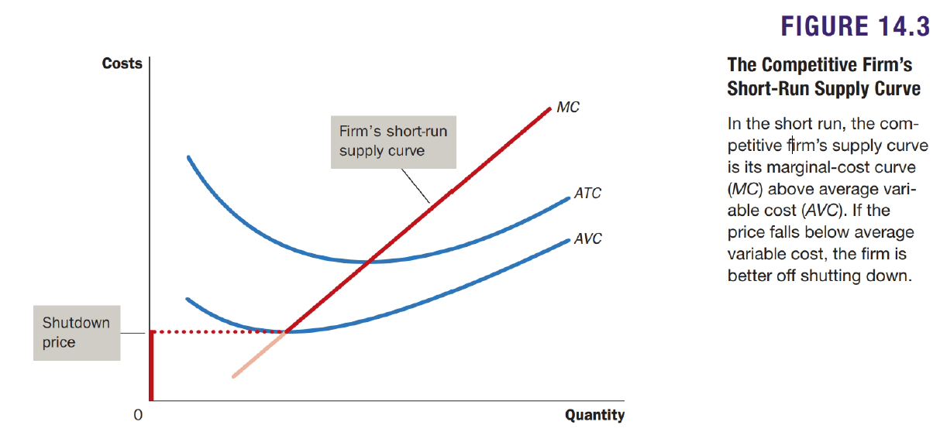

Exiting the Market
Exit: a long-run decision to leave the market; the firm exits the market if the revenue it would get from producing is less than its total costs (TR < TC or P < ATC)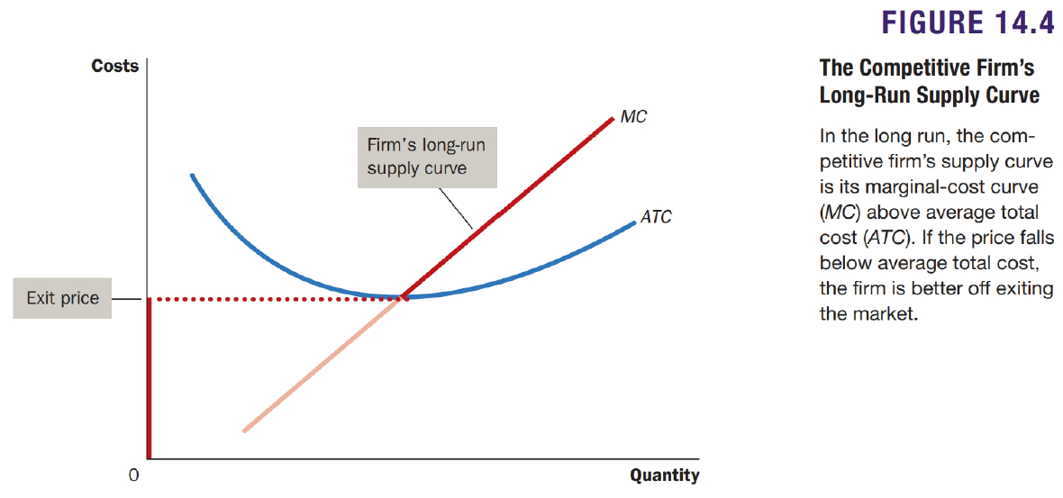
Profit = (P - ATC) x Q
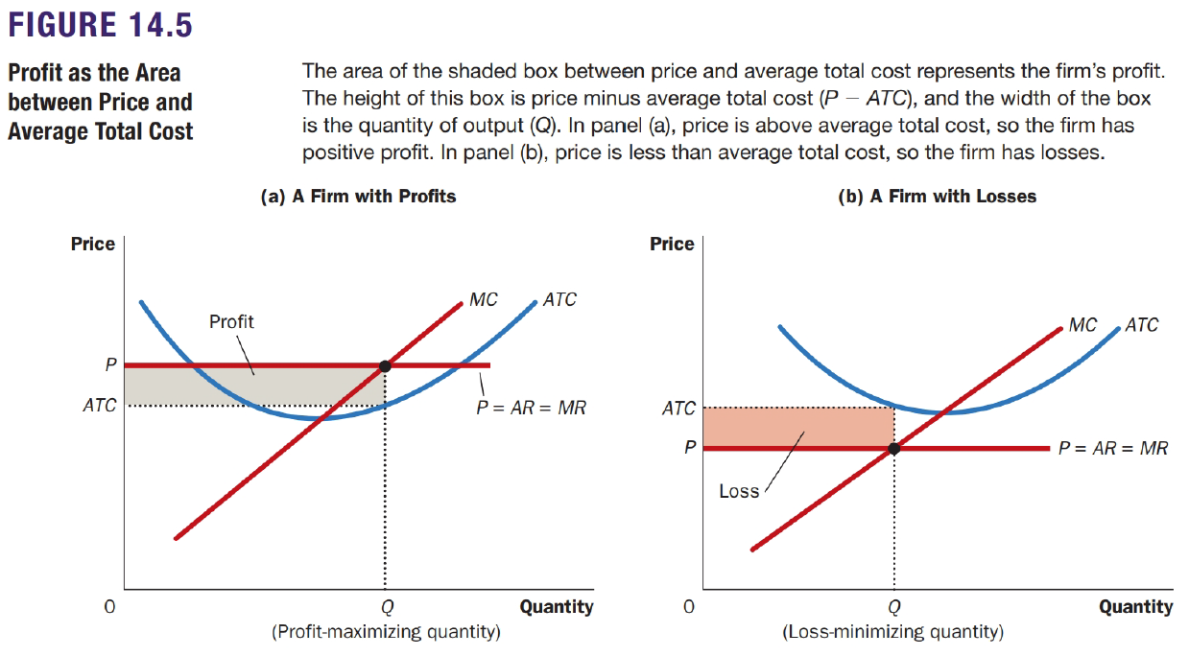

Supply Curves in Competitive Markets

In the short-run…
- entry will expand the number of firms, increase the quantity of the good supplied, and drive down prices and profits.
- exit will reduce the number of firms, decrease the quantity of the good supplied, and drive up prices and profits
- The process of entry and exit ends only when price and average total cost are driven to equality

Profit = (P - ATC) x Q
zero-profit equilibrium: economic profit is zero, but accounting profit is positive (still paid for opportunity cost)
Because firms can enter and exit more easily in the long run than in the short run, the long-run supply curve is typically more elastic than the short-run supply curve.

Lesson 8 – Chapter 15: Monopolies (Microsoft, Government Improve Outcomes)

Price maker: a monopoly charges a price that exceeds marginal cost
Monopoly: a firm that is the sole seller of a product without close substitutes. A monopoly remains the only seller in its market because other firms cannot enter the market and compete with it. Because a monopoly is the sole producer in its market, its demand curve is the market demand curve. It faces a downward-sloping market demand curve and has to accept a lower price if it wants to sell more output. A monopolist's marginal revenue is always less than the price of its good.
Barriers to entry for Monopoly Market:
- Monopoly resources: A key resource is owned by a single firm.
- Government regulation: The government gives a single firm the exclusive right to produce some good or service.
- The production process: A single firm can produce output at a lower cost than can a large number of producers.
natural monopoly: a monopoly that arises because a single firm can supply a good or service to an entire market at a smaller cost than could two or more firms (average total-cost curve continually declines). With a natural monopoly, average total costs (ATC) keep falling because of continuous economies of scale. In this case, marginal cost (MC) is always below average total cost (ATC) over the whole range of possible output.
The price effect: The price falls, so P is lower, which tends to decrease total revenue.
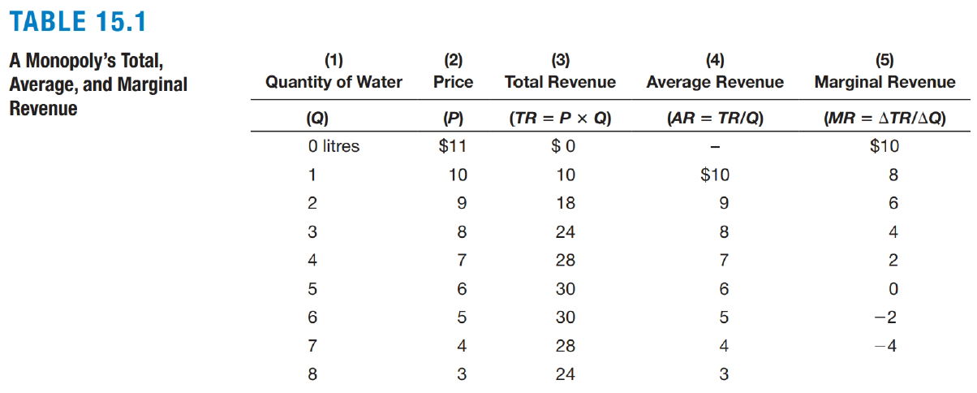

Profit Maximization
monopolist's profit-maximizing quantity (Pmax): is determined by the intersection of the marginal-revenue curve and the marginal-cost curve (MR & MC) then the demand curve shows the price consistent with this quantity
In competitive markets, price equals marginal cost.
In monopolized markets, price exceeds marginal cost

Social Welfare and Deadweight Loss
socially efficient quantity: where the demand curve and the marginal-cost curve intersect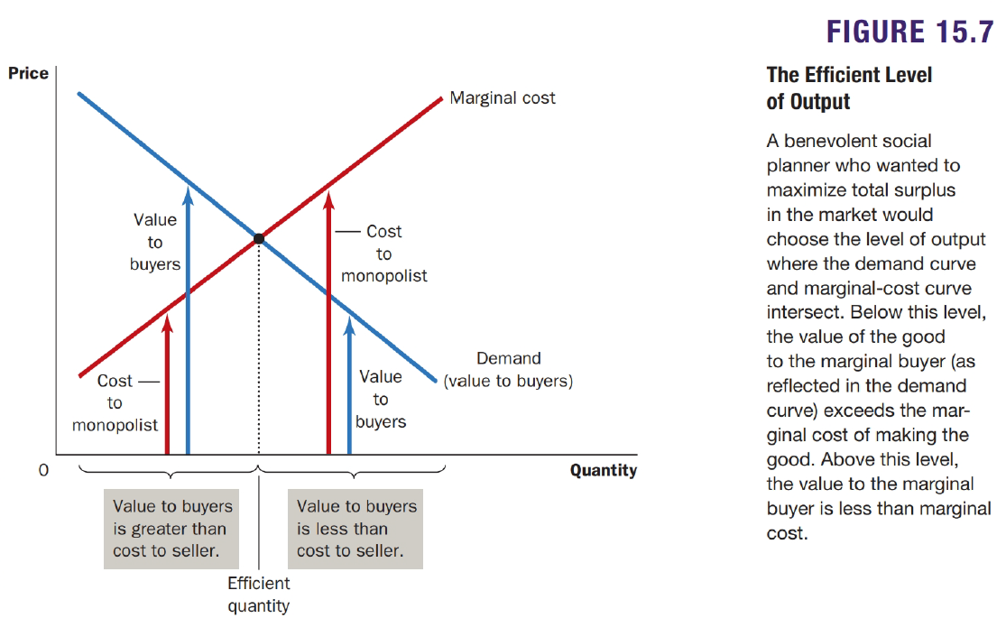

Price Discrimination
price discrimination: selling the same good at different prices to different customers
- by charging different prices to different customers they can increase its profit and charges each customer a price closer to their willingness to pay than is possible with a single price
- price discrimination requires the ability to separate customers according to their willingness to pay (age, income, location)
- price discrimination can raise economic welfare because it can eliminate the inefficiency inherent in monopoly pricing
arbitrage: buying a good in one market at a low price and selling it in another market at a higher price to profit from the price difference
Perfect price discrimination: the monopolist knows exactly each customer's willingness to pay and can charge each customer a different price (first-degree price discrimination)

Government Policy
Policymakers in the government can respond to the problem of monopoly in one of four ways:
- By trying to make monopolized industries more competitive
- By regulating the behaviour of the monopolies
- By turning some private monopolies into public enterprises
- Do nothing
Synergies: benefits of greater efficiency as a result of mergers
Crown corporations: Government-owned firms (Canada Post, CBC, VIA Rail)

Lesson 9 – Chapter 6: Government Policies: Taxes, Wages, and Price Controls

price ceiling: a legal maximum on the price at which a good can be sold (e.g. rent control)
price floor: a legal minimum on the price at which a good can be sold (e.g. minimum wage)
binding ceiling: The forces of supply and demand tend to move the price toward the equilibrium price, but when the market price hits the ceiling, it can rise no further. Thus, the market price equals the price ceiling. At this price, demand exceeds supply creating a shortage.
binding price ceiling = shortage
binding price floor = surplus

Taxes
tax incidence: the manner in which the burden of a tax is shared among participants in a market
Tax on buyers: makes buying less attractive which shifts the demand curve to the left/down by the size of the tax. Because sellers sell less and buyers buy less, it reduces the size of the market.
Taxes discourage market activity. When a good is taxed, the quantity of the good sold is smaller in the new equilibrium. Buyers and sellers share the burden of taxes. In the new equilibrium, buyers pay more for the good, and sellers receive less.
Tax on sellers: the quantity demanded is the same, so the demand curve does not change. However, the tax on sellers makes business less profitable, so it shifts the supply curve to the left/up by the size of the tax. The tax reduces the size of the market and buyers and sellers share the burden of the tax.
Taxes on buyers and taxes on sellers are equivalent.
In both, the tax places a wedge between the price that buyers pay and the price that sellers receive.
A tax burden falls more heavily on the side of the market that is less elastic because that side of the market can respond less easily to the tax by changing the quantity bought or sold.

Lesson 10 – Chapter 8: The Cost of Taxation (Deadweight Loss)

The impact of a tax on a market outcome is the same whether the tax is levied on buyers or sellers of a good. The relative elasticities of supply and demand determine how the tax burden is distributed between producers and consumers. A tax on a good causes the market to shrink.

Deadweight Loss

deadweight loss: the fall in total surplus that results from a market distortion, such as a tax
The losses to buyers and sellers from a tax exceed the revenue raised by the government. Taxes cause deadweight losses because they prevent buyers and sellers from realizing some of the gains from trade.
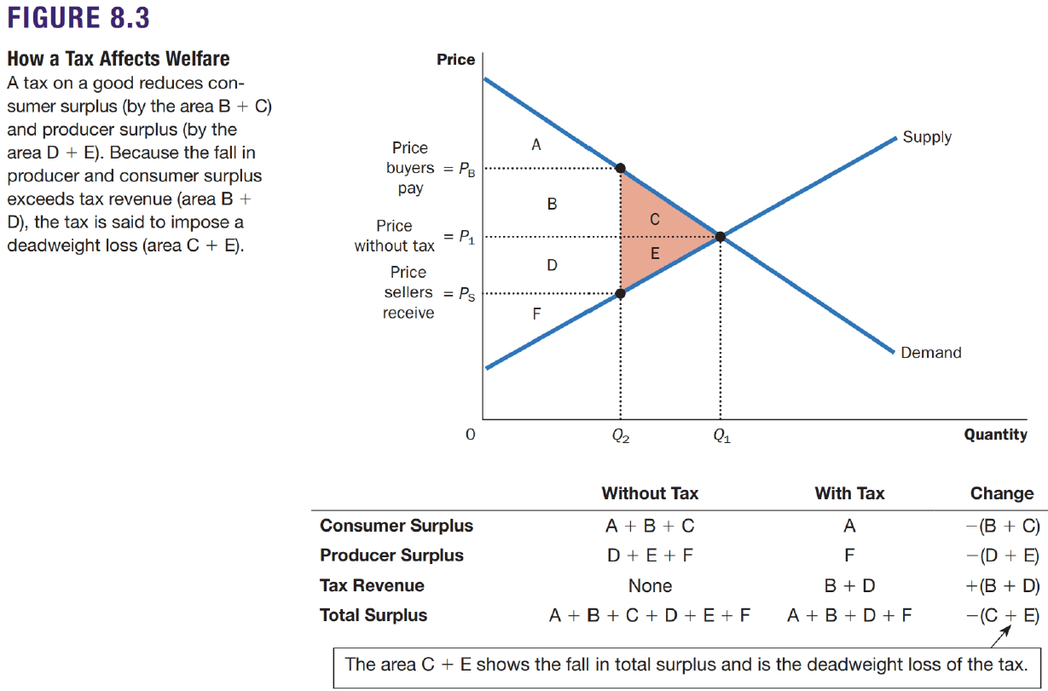

In the absence of any tax, the equilibrium of supply and demand maximizes the total surplus of buyers and sellers in a market. When the government imposes a tax, it raises the price buyers pay and lowers the price sellers receive, giving buyers an incentive to consume less and sellers an incentive to produce less. Because taxes distort incentives, they cause markets to allocate resources inefficiently.
greater elasticities = greater deadweight loss
Laffer curve: as the size of the tax grows larger, the deadweight loss grows larger; while revenue rises then falls
The deadweight loss of a tax rises even more rapidly than the size of the tax. This occurs because the deadweight loss is an area of a triangle, and an area of a triangle depends on the square (²) of its size. If we double the size of a tax, for instance, the base and height of the triangle double, so the deadweight loss rises by a factor of 4.
marginal cost of public funds: the total cost to society of raising one more dollar in tax revenue; it is equal to the incremental $1 in revenue raised plus the associated increase in deadweight loss, which means that the marginal cost of public funds will generally be greater than $1. The higher the size of the tax, and the more revenue generated by it, the higher the marginal cost of public funds.
marginal benefit of public funds: the value that society places on one more dollar of expenditure on a government program

Lesson 11 – Chapter 10: Externalities

Externality: when a person engages in an activity that influences the well-being of a bystander but neither pays nor receives compensation for that effect
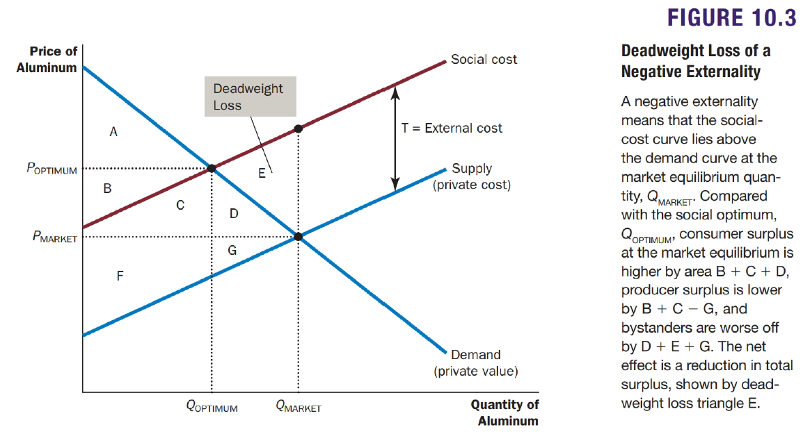
social cost: includes the private costs of the product producers plus the external cost imposed on the bystanders affected (the social-cost curve is above the supply curve because it includes the external costs imposed on society) and therefore the optimal quantity is smaller than the equilibrium quantity. Reducing and consumption below the market equilibrium level raises total economic well-being (deadweight loss).

Governmental Solutions
Command-and-control policies: regulate behaviour directly (e.g. environmental regulations)
Market-based policies: provide incentives so that private decision makers will choose to solve the problem on their own
corrective taxes: taxes enacted to correct the effects of negative externalities (e.g. imposing a tax on aluminum producers)
internalizing the externality: alter incentives so that people take account of the external effects of their actions
Suppose that two factories-a paper mill and a steel mill-are each dumping 500 tonnes of glop into a river every year. Environment Canada decides that it wants to reduce the amount of pollution. It considers these solutions:
1. Regulation: Environment Canada could tell each factory to reduce its pollution to 300 tonnes of glop per year.
2. Corrective tax: Environment Canada could levy a tax on each factory of $50 OOO for each tonne of glop it emits.
3. Tradable Pollution Permits: The steel mill wants to increase its emission of glop by 100 tonnes. The paper mill has agreed to reduce its emission by the same amount if the steel mill pays it $5 million. the deal does not have any external effects because the total amount of pollution remains the same. Thus, social welfare is enhanced by allowing the paper mill to sell its right to pollute to the steel mill.

Private Solutions
- The Golden Rule: This moral injunction tells us to take account of how our actions affect other people. In economic terms, it tells us to internalize externalities.
- Charities: many of which are established to deal with externalities.
- integrating different types of businesses
- interested parties to enter into a contract
Coase theorem: the proposition that if private parties can bargain without cost over the allocation of resources, they can solve the problem of externalities on their own - private economic actors can potentially solve the problem of externalities among themselves. Whatever the initial distribution of rights, the interested parties can reach a bargain in which everyone is better off and the outcome is efficient.

Challenges
- transaction costs: the costs that parties incur in the process of agreeing to and following through on a bargain (e.g. legal fees)
- bargaining simply breaks down
- coordinating everyone in a large deal is costly

