Chapter 3
Additional Readings
Culturally Sensitive Communication

Canadian Diversity
- Slide 2, 3, 4 on PowerPoint

“Enculturation”
- Learning the ways of your culture through the teachings of family, peers, school faith-based organizations, government, media

“Acculturation”
- When a person’s culture is modified through direct contact with or exposure to another culture

Improving Intercultural Communication
- Recognize and reduce “Ethnocentrism”
- Unconsciously incompetent
- Consciously incompetent
- Consciously competent
- Unconsciously competent
- Recognize “culture shock”
- Common psychological reaction
- Identify uncertainty and ambiguity
- Active listening and perception checking (seek feedback)
- Face fears

Effects of Cultural Barriers (Bowen, 2001)
- ↑ Hospital re-admissions
- ↑Possibility of Errors
- ↓Patient Satisfaction
- ↓Understanding of condition
- ↓Access to mental health and counseling
- ↓Representation of minorities in clinical and health research
- ↓Staff satisfaction and effectiveness
- ↑Risk of Liability
- ↑Health Costs
- ↓Compliance
- ↓Adequate management of chronic illnesses
- ↓Quality of care
- ↓Informed consent

How to Overcome Intercultural Communication Barriers
- Use straightforward language: speak slowly, clearly
- When appropriate, speak in the language of the people from the other culture
- Observe cultural differences in etiquette and nonverbal communication
- Listen for understanding (not necessarily agreement)

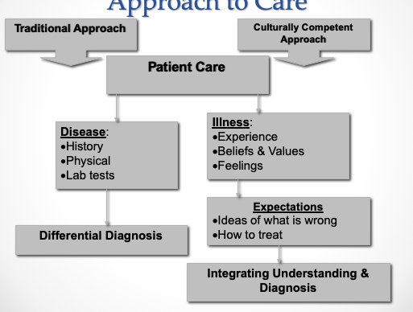

Chapter 3
Additional Readings
Gender, Aging and Communication

Gender and Communication
How VS why
- Expressive orientation (women)
- Instrumental orientation (Men)
- Content (verbal) // Relational (nonverbal)

Women tend to disclose more than men
- Especially in same-sex dyads
- Women tend to disclose more intimate information than men
- Women tend to increase the depth of disclosure as relationship becomes more intimate (not so for men)
- Equal in negative disclosures

Gender Differences in Communication Style
- Women prefer rapport-building // Men prefer independence and status (i.e. Accomplishment, recognition)
- Men prefer to solve problems alone // women prefer to discuss problems with another person
- Women want empathy, not solutions
- Men tend to be more directive, less apologetic // Women tend to be more apologetic, polite
-Women tend to use more gentle expletives (ex “oh dear”, FUCK)
-Men more-likely to use intimidation (ex direct aggression)

Listening and Gender (due to socialization)
- Men: tend to “lecture” // Women speak as if “non-expert”
- Women: “people-oriented” listening styles
- Men: tend to interrupt more (“time-oriented” listening style)
- Women: seek to be “liked” and express their interests
- Men: display of knowledge and expertise= “respect”
- Women: more nonverbal cues when listening (ex more eye-contact), less pure silence // proximity and body posture

Gender and Conflict Style (due to socialization)
- Women: more-likely to use indirect strategies, instead of confronting conflict head-on (to maintain harmony)
- Men: more-likely to withdraw if uncomfortable or if they do not get their way
-hypothesis: do women get more by “complaining”
- Women: more-likely reasoning and bargaining than aggression (during competition)
-Men: aggression can be a part of the friendship
- Men: more co-operative with other woman than with other men
- Differences are less pronounced, as sex-role stereotyping is diminishing in our cultural society

Gender Communication: A comparative Analysis of Communicational Approaches of Men and Women at Workplaces
- The female communication pattern and traits tend to be nurturing, indirect, and respectful. It is considered “rapport” type talk. The communication behaviors women tend to possess are as follows:
· Feeling
· Empathy
· Harmony
· Closeness
· Relationships
· Sharing
· Cooperation
· Group
· Intuitive

- The male communication pattern and traits tend to be honest, direct, and factual. It is considered “report” type talk. The communication behaviors men tend to possess are as follows:
· Reason
· Logic
· Power
· Rank
· Status
· Compete
· Winning
· Team
· Think

Supplemental Resources- Slide 8 Links

Aging and Communication
Why is communication central to figuring out the role of elder people in society?
- Reflects understanding and perceptions of aging:
-Shapes experience of aging // what messages do people receive?
- Age-group membership fundamentally important to our sense of “self” (social identity):
-Styles and content of communication

Gerontology and Geriatrics
Gerontology: the study of aging and older adults. It is multidisciplinary. Specialized area within various disciplines including nursing.
Geriatrics: Associated with the medical care of the elderly

Ageism
Personal: Language, ignoring/excluding, abuse
Institutional: Mandatory retirement, lack of representation in clinical trials
Intentional: Language used in media, lack of preparedness (ex crisis intervention)
Unintentional: Marketing stereotypes in pop culture, job discrimination

Culture as a Source of Ageism
- Negative images of aging in art and culture throughout history
- Schoolbooks rarely portray older people as examples
- Lack of Knowledge as a source of ageism
- Service sector slower or less attentive to older people

Elderspeak
- Baby talk to older people
-Few clauses; shorter phrases
-more filler (you know, like)
-Dearie, cutie, sweetie
- Based on stereotypes
-Older person has low mental ability or other impairment

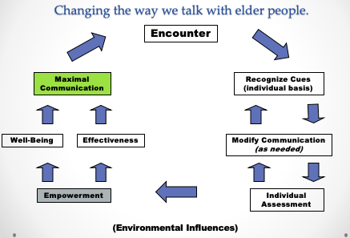

Recommendations
General tips for improving interactions with older adults
  - Be aware of the tendency to stereotype older adults
  - Avoid speech that may be patronizing (“elderspeak”)

Tips for optimizing interactions between HCP and older patients
  - Express understanding, compassion (during times of fear and uncertainty)
  - Ask questions about living situation and social contacts
  - Be aware of any cultural beliefs and values (re: illness and disease)
  - Shared decision-making (enhance autonomy)

Tips for optimizing interactions between HCP and older patients (continued)
  - Not only “what you say” but “how you say it”
  - Use direct and concrete language
  - Technical knowledge and emotional appeal when discussing treatments
  - Make sure to “check” for comprehension
  - Enhance patient satisfaction
  - Assist with IT challenges (internet, telecommunications)
  - Use humor, with discretion

COMMUNICATING WITH OLDER ADULTS IN HEALTH CARE SETTINGS
- Slide 16 Link

Chapter 3
Additional Readings
Ethical Communication

Healthcare Ethics
Ethics: set of “moral principles” that serve as a guiding philosophy for behavior
Code of ethics: in every healthcare profession (ex. CCPA)
Functions: education / policy / consultation (ie deal with facts and emotional issues)
Ethical Dilemma: conflict that requires careful consideration of all possible solutions to identify the one that balances the interests of all involved

Ethical Dilemmas
- Occur when there is clear conflict between two or more competing moral principles or claims
- Example: Ethical dilemma occurs when nurse wishes to be truthful with patient but family, physician wishing to spare patient distress prohibit informing patient about his condition.

Four Ethical Principles:
  - Autonomy: Patient makes the decisions.
  - Beneficience: Healthcare professional decides what is best for patient.
  - Nonmaleficience: “To do no harm”.
  - Justice: Resources, distributed responsibly.

Autonomy
  - Self-determination
  - Trust, respect, truthfulness, sharing, confidentiality
  - Adult, sound mind, written consent
  - The following needs to be addressed:
    - Language: appropriate (lay terms, primary language)
    - All risks and benefits must be outlined
    - Any and all alternatives must be discussed
    - Client must indicate understanding and acceptance of treatment

Autonomy: “Informed Consent”
- How much information is enough?
  - Is it possible to provide information in all of its detail?
  - Patients: understand “pros/cons” from medical perspective?
- Information overkill = more stress to patients (?)
  - Did patient feel pressured to make a decision?
- HCP must address unique conditions of each patient
- Family members can be gatekeepers
Slide 7 is important

Beneficence and Nonmaleficience
- To do good and to provide benefit (Paternalism).
- To “do no harm”
    - i.e. The Hippocratic Oath
Justice
- Ethical obligation to be fair.
- Rights-based, legal, and distributive.

Approaches to “Truth Telling”
Patient and Professional Relationship
- Strict Paternalism
  - Blatant “deception” by the HCP for the patient’s best interest
- Benevolent Deception
  - HCP withholds some (not all) of the truth from the patient
- Contractual Honesty
  - HCP discloses as much info as the patient desires
- Unmitigated Honesty
  - HCP tells all, even if patient does not want to hear the truth

Supplemental Resources- slide 10

Chapter 12
Additional Readings
Health Promotion Messaging

Three Communication Theories
Activation Model: (SENsation seeking TARgeting)
- Stimulation and sensation seeking
- Messages with high sensation value (creative, intense, explicit)
- Sex and drug use and other high-risk behaviors

Extended Parallel Process Model (EPPM)
- Fear appeal and scare tactics
- Threat appraisal: severity and susceptibility
- Efficacy appraisal: self-confidence and response efficacy (ie will this make a difference?)
-Both need to be high for fear appeal to work

Fisher’s Narrative Theory
- Human beings are storytellers
- Involves: personal life story, history, culture
- Truthfulness and consistency

Chapter 7a
Additional Readings
Interviewing- Techniques in Counselling

Types of Interviews and Interview Structure
- Common types of “interviews”: Information // Appraisal // Problem-solving // Persuasion // Job

Interview Structure:
- Opening
- Body (Asking Questions)
- Questions Types
  - Open & closed questions // probing questions // hypothetical questions
- Questioning Sequences
  - The Funnel Sequence
  - The Inverted funnel sequence
- Conclusion

Types of Interviews and Interview Structure (continued)
- Body (asking questions)
- Questioning sequences

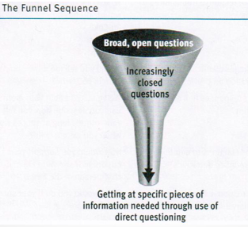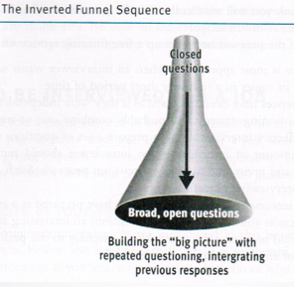

Responsibilities of the Interviewer
- Awareness of biases
- Adapting to an interviewee’s behaviour
- Recording information
- Listening effectively, responding thoughtfully:
-Asking appropriate questions
-Dealing wisely with sensitive content

Undergoing a Job Interview: Helpful Hints
- Be aware of your skills and abilities
- Preparation of your resumé
  - Personal information, career objective, education, experience, honours and special accomplishments, select optional information, and references.
- Identification, anticipation of your employer’s needs
- Listening / responding / asking appropriate questions
- After the interview: “follow-up”

Techniques in Counselling
- Phases in the Interviewing (counselling) process
- Preparation
- Planning for the first meeting (ie research//preparation)
- Logistics and paperwork (ie administrative aspect)
- Initiation
- “First contract” with client: establishment therapeutic climate
- Clarification of the purpose
- Formulating a “contract” and establishing mutual goals
- Exploration
- This is the main working stage (can be indefinite)
- Clients determination of their challenges, and subsequent management of their feelings
- Development of coping skills
- Termination
- Plan for interview (relationship) closure
- Summarization of challenges and accomplishments
- Discussion of the client’s emotional state
- May require maintenance or referral to other HCP

Communication Techniques in Interviewing (counselling)
- Questions
- Silence
- Restatement
- Reflection
- Clarification
- Interpretation

- Questions
Open: intended to facilitate disclosure
  - Time consuming; stimulates discussion, more complex answers
  - “Describe”, “explain”, “elaborate on”…
    - Ex. Tell me about your son’s challenges in school?
Closed: for clarification and facts
  - Does not allow for explanation of emotions; limits response (yes/no)
  - “Who”, “where”, “when”…
  - Ex. Was work stressful today?
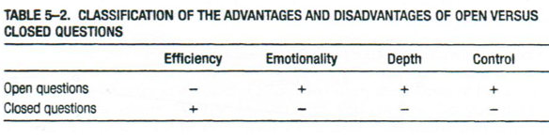
- Silence
- Encourages client disclosure (ex. when client has difficulty expressing thoughts/feelings)
  - May lead to client experiencing catharsis
- Allows clinician to collect her/his thoughts
- Appropriate & therapeutic (silence is less therapeutic if used too much)

- Restatement (paraphrasing)
- The “what” (ie. content) being expressed
- HCP does not add personal thoughts/feelings
- ex.“I hear you saying”, “it sounds like”, etc.
- Shows active listening // acts as feedback
- Confirms and validates the patient/client

- Reflection (feeling)
- “How” things are expressed
- More difficult than restatement: reflection requires picking out the emotional aspect
- Helps the client to handle their feelings
- Use to check accuracy of understanding
- Did HCP correctly understand patient’s concerns?
- Use when appropriate
- Do not use too soon or too frequently

- Clarification
- From broad to more focused topics
- Helps clinician determine what issue (i.e. challenge) is most pressing (primary)
- Allows better understanding of client’s thoughts and feelings
- May require closed-ended questions and client to provide specific examples

- Interpretation
- Clinician offers: explanation, new frame of reference, or way of looking at things.
- Designed to connect meaning to a feeling
- Client should have control over accepting or rejecting the clinician’s interpretation
- Suggestions for effective interpretation:
- Use same language as the client
- Prelude you are offering ideas // ask for feedback

Using the Narrative Model…
Hear the Clients story Listen for strengths (assets) “re-story” Action and change

Patient-centered Clinical Method (medicine)

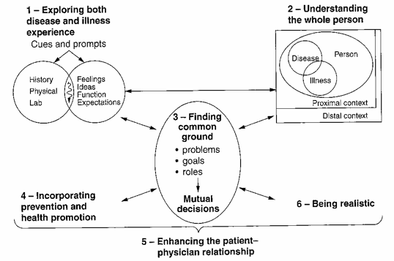

Chapter 7b
Additional Readings
Therapeutic Communication

Altruism: helping a fellow human being, in spite of one’s own personal hardships (difficulties)
Catharsis: learning to express and release feelings
Corrective recapitulation: “transference”
Existential Factors: learning from life
Universality: the human condition (hope)

Health Care Professional (HCP) focuses on:
- Patient’s perception of their most important concern
- Facilitating the expression of emotions
- Management and coping
- Guiding towards a course of action

Therapeutic Factors
Confirmation:
- Uncovering meaning in one’s life
- How one chooses to respond to life (ex. Man Search for Meaning)
- Human beings desire the feeling of acceptance
Cyclical process of disconfirming communication:
- HCP disconfirmed
- HCP less attentive to client
- HCP disconfirms client
- Client feels disconfirmed
- Client is less responsive to HCP
- Client disconfirms HCP
- Back to #1

Control:
- Perception an individual has about how she/he is connected to others
- Includes the degree to which we feel able to influence the nature and development of relationships
- “Complementary” // “Symmetrical”?
- Gives more “control” to the patient, when the HCP shares the “control”

Empathy:
- Feeling “with” the client, but not losing objectivity
- Ability to put yourself in the position of the other person
- Patients are empowered and have positive perceptions of health care experience
- Associated with better outcomes (i.e. assists with coping & resilience)

Trust:
- We trust when we see people act in a positive, consistent, and reliable manner
- HCP: competent, sincere, and caring
- Trust = patient feels valued as a person
- Recognize the act of “thing-ing”
- ex. “hip replacement patient on Ward B”

Barriers to Empathy
HCP:
  - 1) Inexperience
  - 2) Lack of motivation (caring)
  - 3) Distractions
  - 4) Fatigue (burnout)
Patient:
  - 1) Lack of openness, fear and rejection
  - 2) Inability to communicate through words (ex. language barrier)

Increasing Listening Effectiveness
Empathy and Objective Listening
  - An attitude: view others as being equal
  - A skill (unifying thoughts, feelings, emotions)

Nonjudgmental and Critical Listening
  - With an open-mind, question our own assumptions (i.e. listen for facts)
  - Be more tentative about what we think we know
  - Don’t be afraid of being “wrong”

Surface and Depth Listening
  - Most messages: more than one level of meaning
    - Meaningful contact = awareness of these multiple levels of meaning (literal and hidden)
  - Content vs. Relational aspect of message (use nonverbal cues)
  - “What” is being said // “Why” is it being said

Chapter 8b
Additional Readings
Health Communication Models

Leary Model
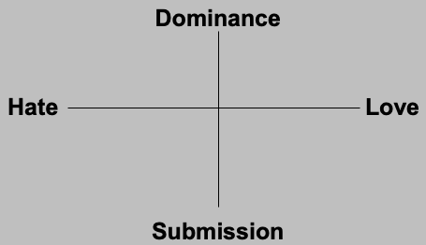
Two Dimensions:
- “Dominance - Submission” & “Hate - Love”
- Rule 1: “dominant” or “submissive” behaviours stimulate the opposite behaviours from others.
- Rule 2: “hateful” or “loving” behaviours stimulate the same behaviours from others.

Communication Networks
- Flow of communication between group members
Sociogram: 1) who talks to whom & 2) how often
- Line = verbal interaction between members
- Arrow = who sent the message

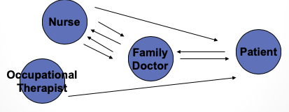

Ideal Communication Network
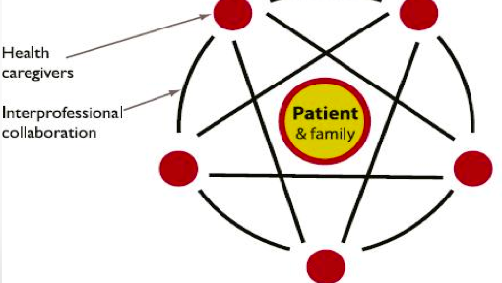

Chapter 8a
Additional Readings
Interprofessional Communication
Healthcare Relationships

Model of Health Communication (Northouse and Northouse)

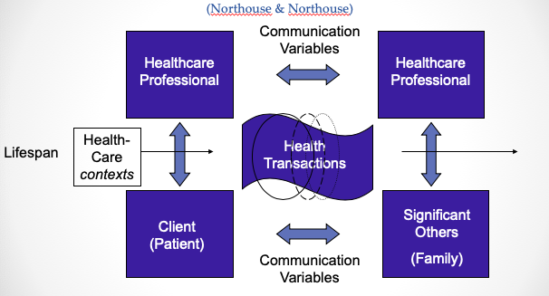

Relationships:
  - 1) Professional-Patient
  - 2) Professional-Professional
  - 3) Professional-Family Members
  - 4) Patient-Family Members
Transactions: interactions (verbal & non-verbal)
  - Includes content & relationship dimensions of messages
Contexts: setting of healthcare communication
  - Can also refer to the number of participants involved

- Professional-Patient Relationships
Barriers to effective communication
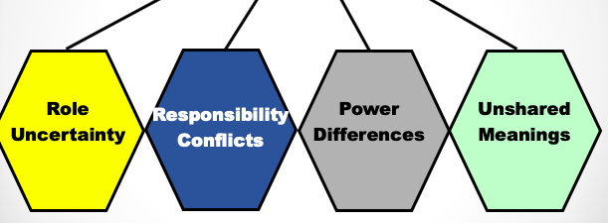
Role Uncertainty
  - Hesitation; only express physical concerns
  - Reinforces traditional communication
Responsibility Conflicts
  - Two factors: responsibility for disease and responsibility for cure
Power Differences (Leary’s Model)
- HCP = “dominant” // Patient = “submissive”

Unshared Meanings
- Person-minded, not word-minded
- Paraphrase; use many communicating methods

- Professional-Professional Relationships
Barriers to Effective Communication

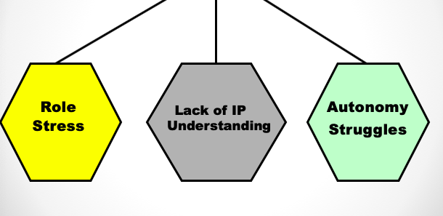
Role Stress: role conflict & role overload
Lack of Interprofessional Understanding
Autonomy Struggles
- Scope of practice (governing laws)
- Ability to access facilities
- Ability to gain reimbursement

- Professional-Family Member Relationships
Barriers to Effective Communication

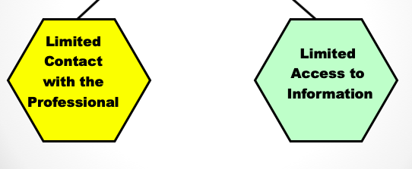
Limited Contact with Professionals
Limited Access to Information
  - Privileged: available to family but not yet to patient
  - Filtered: family receives after patient or third party

- Patient-Family Member Relationships
Barriers to Effective Communication

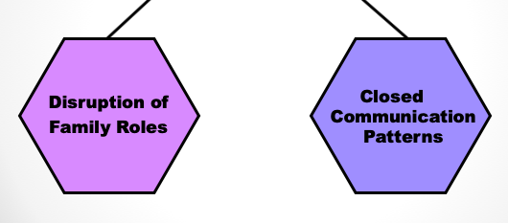
Disruption of Family Member Roles
  - Role adaptation
    - Ambiguity: too loose
    - Rigidity: too constricted
Closed Communication Patterns
  - Perpetuated by family rules, protectiveness
  - Define rules; rules need discarding?; new rules needed

Chapter 10
Additional Readings
Group Dynamics

Small groups:
- Closer relationships
- Full participation
- Shared goals

Large groups:
- Greater pool of talent and experience available for solving problems
- Shared effort (strength in numbers)

Optimum Number for Effectiveness
- 5-7 members is the optimum
- Content and process: Content receives more attention while process is usually what determines whether a group works effectively or not

Types of Groups

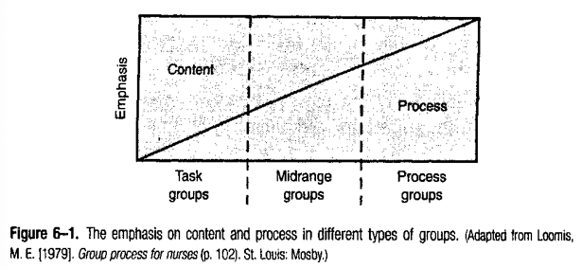

Phases of a Group
- Orientation: do I belong here?
- Conflict: control issues
- Cohesion: establishing unity
- Working: time, energy, depth in disclosure
- Termination: closure
- Developmental sequence of phases, similar for most groups; content and duration of phase vary with the kind of group and the group task
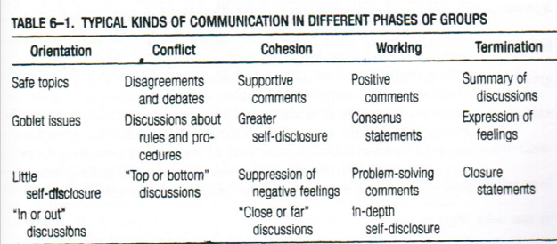

Chapter 11
Additional Readings
Conflict and Communication

Two Kinds of Conflict
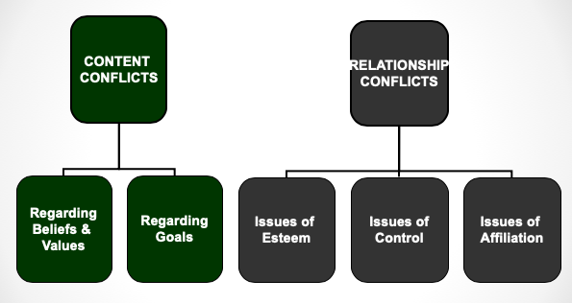
Levels of Conflict: Personal/Interpersonal/Intragroup/Issues of Affiliation

Conflict on the Content Level
- Conflict regarding Values & Beliefs
  - Religious, cultural, professional, etc.
- Conflict regarding Goals
  - Procedural: the “how”
  - Substantive: the “what”

Conflict on the Relational Level
- Issues of Esteem: worth, respect, etc.
- Issues of Control: power struggles.
- Issues of Affiliation: inclusion, affection.

Techniques for Managing Conflict
- Disarm the Opposition
- Cognitive Restructuring
- Face-Detracting // Face-Enhancing
- Blame // Empathy
- “Gunnysacking” // Present Focus
- Verbal Aggressiveness // Argumentativeness
- Appeal to a Third Party (ex. mediator)

