Chapter 1: The Challenges of Human Resources Management
What is Human Resources Management (HRM)?
  - An integrated set of processes, programs, and systems in an organization that focus on effective deployment and development of its employees

Key HRM activities:
    - Organizational work/work/job design – determining what tasks need to be done, in what order, with what skills, and how individual tasks fit together in work units
    - HR Planning – ensuring that people in the organization are the right people with the right skills at the right time in the right place
    - Recruitment and selection – sourcing, attracting, and hiring the people with the necessary skills and background
    - Training and development – providing the resources to assist employees in developing the necessary knowledge and skills to do their job today and in the future
    - Performance management – ensuring that there are appropriate mechanisms in place to provide feedback to employees regularly and to ensure that business objectives are met
    - Rewards and recognition – developing and administering a variety of rewards and recognition components, including pay and benefits, that will attract, retain, and engage employees
    - Occupational health and safety – ensuring that the safety and health of employees are maintained
    - Employee relations – ensuring that there are positive and constructive relations between the employees and their supervisors or managers and/or union representatives

HRM works to overcome current business challenges
    - Ex. Global economy, evolution of firms, technology quality, sustainability, developing human capital, demographic and employee concerns
Why Study HRM?
Managers need an understanding of HRM practices to effectively manage their employees. The line manager or supervisor is the key link between the employee and the organization.
Role of the Line Manager – people managers, not the HR professional or HR unit. Key role in coaching and influential on how the employees view their role in the organization. Remember, the key driver to success are the employees, and it’s up to the Line Manager to motivate and interact with them.

Role of the HR Professional – fulfill their role by actively involving others in the organization, particularly the supervisors and managers, in the development and design of HR programs.

The Ongoing Partnership – the HR professionals provide guidance and assistance as internal/external consultants to the line manager or to help design and deliver programs and services to better equip employees, supervisors and managers to contribute to organizational success.

Current Business Issues:

  - Global Economy
    - Impact - trade agreements and global markets
    - Effect on HRM – balancing a complicated set of issues related to different cultures, laws, and business practices

  - Evolution of Firms and Business Sectors
    - Continuing slow economy
    - Consolidation of businesses
    - Increased competition
    - Struggles for tech
    - Downsizing/rightsizing

  - Technology and Quality
    - Technology has allowed companies to improve processes
    - Quality initiatives key to customer retention
    - Six Sigma translate customer needs into a set of optimal tasks performed in concert with one another
    - Benchmarking – finding the best practices in other organizations that can be brought into our own.

  - Sustainability
    - More attention to environmental impact and economic growth
    - Old industries are losing jobs, new businesses are creating new careers

  - Developing Human Capital and Talent Management
    - Individual knowledge and skill have economic value to org’s
    - Managers need to ensure that employees have opportunities to increase their capabilities
    - Core competencies produce sustainable competitive advantage

  - Demographic and Employee Concerns
    - Diverse back grounds
    - Different generations
    - Skills and labour shortage
    - Gender accommodation
    - Rising levels of education
    - Changing nature of job rights, ethics, privacy and culture.
    - Changing attitudes toward work including balancing work and family

Business Strategy and HRM Strategy

Corporate Strategies:
    - Answer questions like – What business should we be in?
    - Ensure Long-term survival
    - Organizational growth

Business Strategies:
    - Focus on how do we do our business better?
      - Being competitive
      - Ensuring people processes provide competitive edge

HRM Strategy
    - Identifies and strengthens the key HR people processes and practices that are linked to the overall business strategy.

Chapter 2: The Legal Framework of HRM

The Law’s Impact on Managers
- Laws determine what is expected when managing people
- Laws are written to protect both the employer and the employees
- Treating employees fair is not just a legal requirement but also good business
The Legal Framework in Canada - 2 Sets of Legislation
Federal Government
    - Federal legislation applies to only 10% of the Canadian workforce
    - Federal Employment Laws
      - Canada Labour Code
      - Canadian Human Rights Act
      - PIPEDA (Personal Information Protection and Electronics Document Act)

Provincial/Territory Government
    - Provincial Employment Legislation
      - Similar to federal legislation
      - Provides certain rights and guarantees
      - Covers health and safety, human rights, privacy, unionized workplaces

Human Rights and Legislation (Federal and Provincial)
- All individuals should have an opportunity equal with other individuals to make for themselves the lives that they are able and wish to have and to have their needs accommodated, consistent with their duties and obligations as members of society, without being hindered in or prevented from doing so by discriminatory practices based on race, national, or ethnic origin, colour, religion, age, sex, sexual orientation, marital status, family status, disability, or conviction for an offence for which a pardon has been granted.

Discrimination (intentional/non-intentional)
      - Systematic discrimination – the exclusion of members of certain groups through the application of employment policies or practices based on criteria that are not job related

Bona Fide Occupational Requirement / Qualification (BFOR/BFOQ)
      - Justifiable discrimination
      - Able to set certain qualifications based on essential job requirements that can discriminate

Reasonable accommodation
      - Making adjustments to working conditions to prevent discrimination
      - Undue hardship
      - Differences in undue hardship for small and large org’s
Harassment
      - Hostile workplace behaviour and actions
      - Concept of the reasonable person
      - Development of policies and procedures to deal with complaints of harassment

Enforcement of Human Rights Legislation
- Complaint driven
- Investigation
- Determination of Reasonable cause
- Resolution/Reconciliation
- Decision
- Acceptance or Appeal

Employment Standards
- Minimum Obligations of Employers
- Covers such rights as:
  - Hours of work
  - Overtime pay
  - Vacation pay
- Administered by the agency of commission

Labour Relations Legislation
- Governs process and procedures between trade unions and employers
- Administered through a labour relations board

Employment Equity
- Employment of individuals in a nonbiased manner
- Legislation that focusses on four groups that have been historically at a disadvantage
- Designated groups:
  - Women
  - Visible minorities
  - Aboriginal people
  - Disabilities
- Systemic Discrimination
    - Hidden employment barriers
    - Result in inequities if individuals are discouraged from certain groups
      - Recruiting only friends
      - Inflated job responsibilities
      - No wheel chair access

Health and Safety Legislation and Workers Compensation
- Governs employer responsibility to provide healthy and safe workplace
- Administered through gov. agency
- Provides monetary payment to injured employees

Pay Equity
- Federal legislation that applies to federally regulated companies
- Equal pay for work of equal value
- Difficulty determining equal pay for dissimilar jobs

Diversity Management – the combination of organizational policies and practices that supports and encourages employee differences in order to reach business objectives
- Create an environment for success
- Optimizing everyone’s background for business success

Chapter 3: Creating a culture of well-being
Health and Safety: The Law
- Focus on workplace and working environment
- Regulated through federal and provincial legislation
- Operates on the premise that both employer and employees have a responsibility for a safe and healthy workplace
  - Occupational Injury: any injury (cut, fracture, amputation, etc.) resulting from a workplace accident
  - Occupational Illness: any abnormal condition that is the result of exposure to workplace conditions

Duties and Responsibilities of Employers
- Provide a hazard free workplace
- Comply with regulation
- Inform employees about safety requirements
- Keep records to compile annual records
- Report all accidents that caused injuries
Duties and Responsibilities for Employees
- Comply with acts and regulations
- Report hazardous conditions
- Follow safety rules and regulations
- Exercise right to refuse unsafe work

Duties and Responsibilities of Supervisors
- Advise employees of potential hazards
- Ensure workers wear safety equipment
- Provide written instructions
- Take every reasonable precaution
Duties of Joint Health and Safety Committees
- Create a non-adversarial climate in which labour and management can work together
- May require special training and education of members

Workers and Compensation
- Workers can receive benefits in the form of cash payouts or wage loss payments if absent due to work-related injury or serious illness
- Pays for medical expenses and vocational rehabilitation
- Pays for Industrial Disease: disease resulting from exposure related to a particular process, trade, or occupation in industry

Ways to Reduce Workers Compensation Costs
- Perform an audit to assess high risk within a workplace
- Prevent injuries by proper ergonomic design of the job
- Provide quality medical care to employees by experienced physicians
- Manage the care of the injured worker until their return to work
- Provide extensive worker training in all related health and safety areas

Creating a Safe Work Environment
- Promoting safety Awareness
- Safety awareness programs
  - Communication role of supervisor
  - Proactive safety training programs including use of information technology
- Enforcement of safety rules
- Accident investigations and records
Creating a Healthy Work Environment
- Health Hazards and Issues
  - WHMIS (Workplace Hazardous Materials Information Systems)
  - Indoor air quality
  - Technology
  - Cumulative trauma disorders
  - Communicable disorders

Workplace Violence and Security
- Reducing Workplace Violence
  - Training
  - Risk assessment
- Violence response teams
- Proactive security measures

Stopping Violence in the Workplace
- Establish violence prevention policy and standards
- Control violence hazards through workplace design and workplace practices
- Develop safety plan if any employee reports violence to ensure victim is safe

Stressors in the Workplace
- Stress – any demand caused by physical, mental, or emotional factors that requires coping behaviour
- Workplace stressor – a workplace evet, process, or practice that has the potential to cause worker stress
- More legislation is requiring that organizations provide psychologically safe work environments
- Manifestations of mental illness are increasing in the workplace

Building Better Health
- Health services – bigger organization have better health services
- Alternative approaches – traditional medicine, relaxation techniques, massage, etc.
- Wellness programs – access to flexible work hours, healthy food, fitness facilities, health professionals
- Disability management – integrated approach to managing disability-related benefits
- Employee assistance programs –provide short-term counselling and referrals to professionals
- Personal crises – inform employer and refer to EAP (employee assistance programs)
- Emotional problems and substance abuse – find help and identify the problem

Chapter 4: Defining and Designing the Work
Role of Line Manger
- Primary Individual who determines what work is to be performed and in what order
- Takes an active role determining the knowledge, skills, abilities and attitudes (KSA’s)needed to successfully perform the work

Job Analysis
- Process to gather job information
- Is a Cornerstone of HRM
- Identifies duties, tasks, skills, knowledge, attitudes, and abilities to perform at work
- A job description is the written output from job analysis
The Process of Job Analysis
  - Where you get job information
  - How you obtain job information
  - What job information is collected
  - Where the information goes
  - How information is used

Job Descriptions
- Written document that contains
- Job title
- Summary of job
- Job duties and responsibilities
- Job specifications (KSA’s)
- Performance standards
- Date
Problems with Job Descriptions
- Poorly written, using vague rather than specific terms
- Lack updating
- May violate law by containing specifications not related to the job
- Can limit scope of activities
- May not contain standards of performance

Standards of Performance
- Identifies expected results
- Minimizes misunderstanding

- Establishes foundation for taking corrective action
- Key to progressive discipline and legal dismissal
Job Analysis for Changing Environment
- New job analysis approaches include
  - Future orientation – managers have a view on how the jobs should be restructured to meet future organizational environment
  - Competency based – emphasis is placed on characteristics or behaviour of successful performers rather than on standard job duties and tasks and so on
  - Living job description - ongoing update, behavioral job description (job to be done & expected result)

Uses of Job Information from Job Analysis
- Recruitment – process of locating and encouraging potential applicants to apply for job openings
- Selection – process of choosing the individual who has the relevant qualifications and can best perform
- Legal issues – discriminatory job specifications, must show specifications relate specifically to the job
- Performance review – evaluating an employee’s performance is a responsibility for the line manager
- Health and Safety – job analysis identifies the health and safety-related physical and mental capabilities required to perform the job, and the work environment conditions where job is performed
- Compensation Management – worth (pay rate) based on what the job demands of an employee in skill, effort and responsibilities, as well as on the conditions and hazards under which the job is performed.

Job Design – Process of defining and organizing tasks, roles and other processes to achieve employee goals and organizational effectiveness
- Facilitate the achievement of organizational objectives
- Recognize the capabilities and needs of employees
- Job rotation – people move from one job to another to learn new tasks
- Job enlargement – expand a job in type of tasks expected to perform
- Leadership teams – multiple responsibilities & activities rather than defined functional leadership role.
- Job enrichment – a job takes on higher-order responsibilities
- Job crafting – a person initiates, shapes and customizes his or her work

Job Characteristics Model
- Skill variety – the degree to which a job entails a variety of different activities, which demand the use of a number of different skills and talents by the jobholder
- Task identity – the degree to which the job requires completion of a whole and identifiable piece of work = performing a job from beginning to end with a visible outcome
- Task significance – the degree to which the job has a substantial impact on the lives or work of other people, whether in the immediate organization or in the external environment
- Autonomy – the degree to which the job provides substantial freedom, independence and discretion to the individual in scheduling the work and in determining the procedures used in carrying it out
- Feedback - the degree to which carrying out the work activities required by the job results in the individual being given direct and clear information about the effectiveness of his or her performance

Job Enrichment
- Enriching jobs results in increased performance and satisfaction if there is modification to three psychological states
  - Meaningfulness
  - Sense of responsibility
  - Feedback on results
- Employees also need the desire and ability to make this a reality
Line Manager and Job Design
- Line manager needs to understand different forms of employee involvement
- Line manager will be expected to help create opportunities for involvement, as well as support and encourage employee involvement

Employee Empowerment & Engagement – process of involving employees in their work through a process of inclusion. Empowerment encourages employees to become innovators and managers of their own work

- Pushing down decision-making responsibility to those close to internal and external customer
- Participation – encourage employees to take control of their work tasks
- Innovation – receptive to people with innovative ideas and encourage people to explore new paths and take reasonable risks at reasonable costs
- Access to Information – employees must have access to a wide range of information to make decisions
- Accountability – employees should be held accountable for their behaviour towards others.
- Employee empowerment succeeds when the culture of a organization is open and receptive to change
- For empowerment to work, it must be aligned directly with the strategy of the organization and individual accountability throughout the entire enterprise

Employee Teams
- An employee-contributions technique in which work functions are structured for groups rather than for individuals, and team members are given discretion in matters traditionally considered management prerogatives, such as process improvements, product or service development, and individual work assignment. Employee teams are a logical outgrowth of employee involvement, the philosophy of empowerment, and employee engagement
- Groups of employees who assume a greater role in the production or service process
- Can be self-managed where they set own work schedules and deal directly with customers
- Virtual team – a team with widely dispersed members linked together through computer and telecommunication technology

Future Design of Organizational Work
- Non-Traditional employment forms such as contract work, telework, e-work, mobile work, pooling, home-based work, flextime or flexyear, time-limited projects, compressed workweek, etc.
- Use the convergence of social, mobile, and cloud computing technologies
- Dynamic and fluid relationships
- More attention needed in job crafting to ensure organization and context and culture is part of design

Chapter 5: Human Resource Planning, Recruitment, and Selection

Human Recourse Planning – Process that the people required to run the company are being used as effectively as possible, where and when they are needed, in order to accomplish the organization’s goals
- Links to organizations strategic plan
  - Ensure employees’ capabilities to adjust to changes in the environment
- Importance of HR Planning for Staffing Needs
  - Shifts in the composition of the labour force require managers become more involved in planning
HR Planning Approaches
- Trend Analysis – quantitative approach to forecasting labour demand on an organizational index
- Management Forecast – opinions and judgements of supervisors or managers and others that are knowledgeable about the organization’s future employment needs
- Staffing Tables – graphic representation of organizational jobs along with the numbers of employees currently occupying those jobs and future employment needs
- Markov Analysis – method or tracking the pattern of employee movements through various jobs
- Skills Inventory – Information about the education, experiences, skills, etc. of the staff
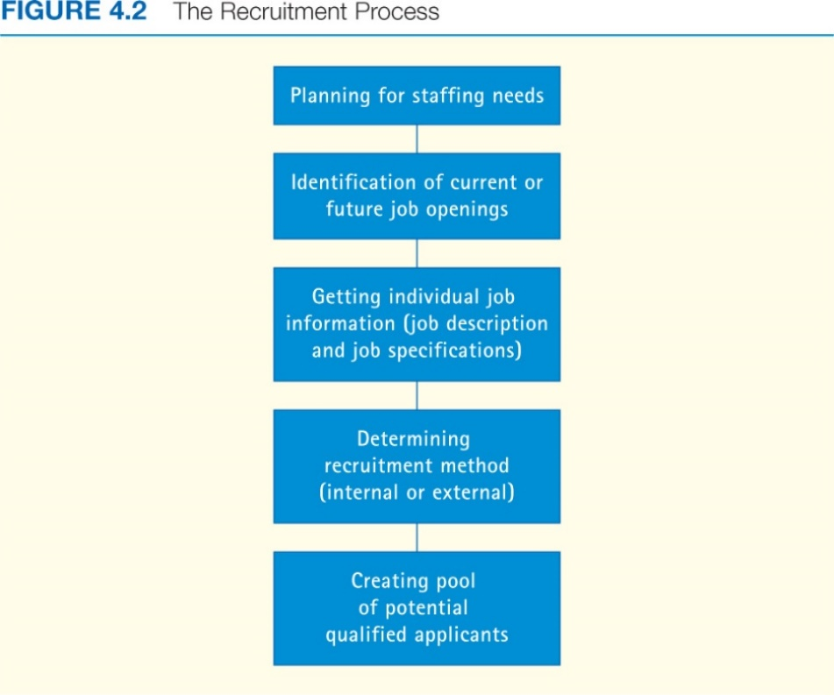
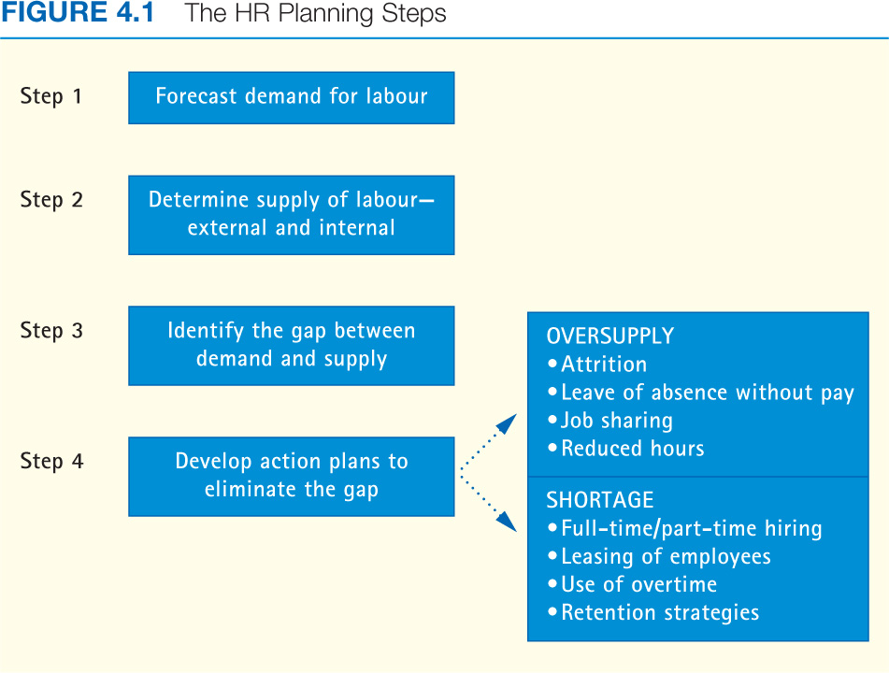

Recruitment – Process of locating and encouraging potential applicants to apply for jobs
Ways to Locate Qualified Internal Candidates

- Through the use of Human Resource Management System or Information System – resume tracking system, screen entire workforce for suitable candidates to fill an internal opening
- Succession planning – the process of identifying, developing, and tracking key employees for future promotions or transfers.
- Internal Job posting – various methods of communicating information about job openings

Advantages of Internal Recruitment
- Reward of past performance
- Motivates other employees
- Compatible with values and culture

Limitations of Internal Recruitment
- Lack of specialized training
- Lack of experience
- Lack of new ideas and perspectives
- Creates internal dissension

Advantages of External Employment
- Person brings different variety of experience
- Person has knowledge or skills that are required now

Disadvantages of External Recruitment
- Person may not know industry
- Lack of attraction due to salary constraints
- Lack of first hand info about job performance
- Might not align with company attitude
- Can cause internal dissension

Recruitment Outside the Organization
  - Advertisement – websites, newspapers, other media, reach a large audience of possible applicants
  - Internet – faster and generates higher-quality candidates than traditional advertising media
  - Employee agencies – charger a service fee for helping employers find candidates
  - Educational Institutions & Job fairs – employers go to meet new graduates for potential candidates
  - Employee referrals - #1 source of quality candidates, increase effectiveness with bonus (money)
  - Others: Unsolicited applications and resumes, professional organizations, unions, etc.

Recruitment for Diversity – Companies that aggressively sought and supported a diverse workforce outperformed the other companies. Requires line managers and supervisors to be knowledgeable about and supportive of their organization’s objective to have employees with diverse ethnic and cultural background.

Matching People and Jobs – selection = the process of choosing individuals who have relevant qualifications and who will best perform on the job to fill existing or projected job openings

Steps in the Selection Process
- Completion of application form or submission or resume
- Initial screening/interviewing by HR
- Employment test
- Supervisory or team interview
- Reference checks
- Hiring decision

Obtaining Reliable and Valid Information
- Reliability – the degree to which interviews, tests, and other selection procedures yield comparable data over time and alternative measures
- Validity – how well the selection procedure measures a person’s attributes and abilities to successfully perform the job, and predict job performance

Sources of Information about Job Candidates
- Applications forms and resumes – provide information on meeting minimum requirements for experience, education, and so on, provide a basis for questions the interviewers will ask, offer sources for reference checks

Interviewing Methods
- One on one – most frequent methods, ask question and make observations
- Panel or group – many interviews pool their observations to reach a consensus about the application
- Telephone interview – first screening process, minimize costs
- Internet based – objectivity, less likely to engage in “impression management”

Types of Interview Questions
- Structured Questions – based on job requirements, allow answers to be rated
  - Behavioral description interview – questions about what a person did in a given situation
  - Situational Interview Questions – question in which an applicant is given a hypothetical incident and asked how he or she would respond to it
- Unstructured Questions
  - Open-ended, allow the candidate to talk freely with little interruption from the interviewer
  - Trying to gain insight into personality / fit with corporate culture

Guidelines for Employment Interviews
- Establish an Interview plan – determine specific questions to be covered, review job requirements, application or resume data, test scores and other available information before seeing the applicant
- Establish and Maintain rapport – greet the applicant pleasantly, explain the purpose of the interview, display sincere interest in the applicant, and listen carefully
- Be an active listener – strive to understand, comprehend and gain insight into what is only suggested or implied. A good listener’s mind is alert, and facial expressions and posture usually reflect this fact
- Pay attention to non-verbal cues – an applicant’s facial expressions, gestures, body position, and movements often provide clues to that person’s attitudes and feelings. Interviewers should be aware of what they themselves are communicating verbally. Be cautious of nonverbal cues and cultures
- Provide information as freely and honest as possible – present a realistic picture of the job
- Use questions effectively – questions should be phrased as objectively as possible
- Separate facts from inferences – during the interview, record factual information. Later, record inferences or interpretations of the facts. Compare inferences with those of other interviewers
- Recognize biases and stereotypes – interviewer bias depending on the situation
- Control the course of the interview – stick to the interview plan. Provide the applicant with ample opportunity to talk, but maintain control of the situation in order to gather the information required
- Standardize the question asked – ask the same questions to all applicants for a particular job in order to increase reliability and avoid discrimination

Employment Assessments – objective and standardized way to assess a person’s KSAs, competencies, and other characteristics in relation to other individuals

Aptitude tests – measures of a person’s capacity to learn or acquire skills
Achievement tests – measures of what a person knows or can do right now

Types of Employment Tests
- Cognitively ability test – measures mental capabilities such as general intelligence, verbal fluency, numerical ability, and reasoning ability
- Personality and interest inventories – measure personal characteristics such as extroversion, agreeableness, and openness to experience
- Emotional Intelligence/Emotional and social competence – measure a personal set of qualities that are distinct from cognitive ability and important for success
- Physical Ability Test – measures physical ability for demanding and potential dangerous jobs
- Job Sample Test - require the applicant to perform tasks that are a part of the work required on the job
- Substance abuse testing – drug test for safety and law requirements

Reaching a selection decision
Factors Affecting Selection Decision
- Job Requirements: important to know the qualifications and expectations of the job
- Organizational Culture: is there a fit?
- Organizational Constraints: Policies, Finances, Business conditions
- Hiring for specific job or organization in the long run

Making the Selection Decision

- Summarize the Applicant Information
  - Can do – knowledge and skills, aptitude for acquiring new knowledge and skills
  - Will do – motivation, interests, personality characteristics
- Final decision can be made using a variety of techniques and strategies
  - Statistical approach – person involved will use different weights to the applicants’ background, often leads to different decisions and demonstration of biases and stereotypes based on personal judgement
  - Clinical approach – criteria for successful job performance are listed and weighting factors are assigned, identify threshold or cut-off, combine interview and assessment score to offer job to highest

Chapter 6: Orientation, Training, And Development

Orientation – Formal process of familiarizing new employees with the organization, their jobs, and their work unit and embedding organizational values, beliefs, and accepted behaviours
Training – The acquisition of skills, behaviours, and abilities to perform current work
Development – the acquisition of skills, behaviours, and abilities to perform future work or to solve an organizational problem

Scope and training Development

  - Training – Perform current work and Acquiring skills Behaviours Abilities
  - Development – Perform future work and Acquiring skills Behaviours Abilities

- Learning – an on-going change in behaviour and thinking

Training Model Process:
- Training needs and assessment – analyze training needs, identify training objectives and criteria
- Training design – pretest trainees, select training methods, plan training content
- Training delivery – schedule training, conduct training, monitor training
- Evaluation – measure training outcomes, compare outcomes to objectives and criteria

Workplace skills and capabilities

- Fundamental skills
  - Read and understand information
  - Write and speak so that others can understand
  - Use relevant skills and knowledge
  - Identify root problem
  - Evaluate solutions to make a decision
  - Use numbers to complete tasks, such as making estimates and verifying calculations
  - Manage information by locating, gathering, and organizing information using appropriate technology and systems

- Personal Management
  - Be flexible and adaptable
  - Honest and Ethical
  - Responsible for Setting goals
  - Be able to Work safely
  - Demonstrate positive attitudes and behaviours, such as dealing with people with honesty and integrity

- Teamwork Skills
  - Understand and contribute organizational or team goals
  - Understand and work within the dynamics of the group
  - Plan and make decisions with others and support the outcomes
  - Respect the thoughts and opinions of others
  - Adapt to changing requirements
  - Understand the role of conflict in group dynamics and resolve as appropriate

Systematic Approach to Training, orientation, and development
Conducting a needs assessment
  - How important is this issue to the success of the organization? If it is important, then proceed to answer 2, 3 and 4
  - What competencies or knowledge, skills, and abilities do employees need?
  - What competencies or knowledge, skills, and abilities do employees currently have?
  - What is the gap between the desired (Need) and the actual (Have)?

Designing the program
- Instructional objectives – desired outcomes of a training program
- Trainee readiness and motivation – the consideration of a trainee’s maturity and experience when assessing him or her

- Use positive reinforcement
- Eliminate threats and punishment
- Be flexible
- Have participants set personal goals
- Design interesting instructions
- Break down physical and psychological obstacles to learning

- Principles of learning – building bridge between org. and employees
- Goal setting – Clear training goals and objectives
- Individual differences – People learn at different rates and in different ways
- Active practice and repetition – frequent opportunity to practice for trainees
- Whole versus part learning – break tasks down or learn the job as a whole
- Massed versus distributed learning – 5 two hours periods or 10 one hour periods to learn
- Feedback and reinforcement – knowledge of result and motivation
- Meaningfulness of presentation – present the material to be learned in a meaningful manner
- Modeling – learn by watching, behaviour modification = technique that f behaviour s rewarded, it will be exhibited more frequently in the future

Implementation
Sample training development methods

    - On the job training – method by which employees are given hands-on experience with instructions from their supervisor or other trainer
    - Apprenticeship training – method by which a worker entering the skilled trades is given thorough instruction and experience, both on and off the job, in the practical and theoretical aspects of the work
    - Co-operative training – training program that combines practical on-the-job experience with education
    - Internship programs – programs jointly sponsored by colleges, universities, and other organizations that offer students the opportunity to gain real-life experience while allowing them to find out how they will perform in work organizations
    - Classroom training, instructions – enable max number of trainees and min number of instructors
    - Self-directed learning – individuals work at their own pace at programmed instructions
    - Audio-visual – teach the skills and procedures required for a number of jobs
    - Simulation – used when it is either impractical or unwise to train employees in the actual workplace
    - E-learning – learning that takes place through electronic media

    - On the job experiences
- Coaching – involves a continuing flow of instructions, comments, and suggestions from the manager to the employee or subordinate
- Mentoring – informal relationship in which an executive coach, advises, and encourage a junior employee, on goals, opportunities, expectation and standards to assist people reach their potential
- Understudy assignments – groom an individual to take over a manager’s job by helping the individual gain experience in handling important functions of the job
- Job rotation – provides, through a variety of work experiences, the broadened knowledge and understanding required to manage more efficiently
- Lateral transfer – involves horizontal movement through different departments, along with upward movements in the organization
- Special projects and junior boards – opportunity for individuals to become involved in the study of current organizational problems and in planning and decision-making activities
- Action learning – gives managers release time to work full-time on projects with others in the organization, some are combined with classroom, instruction, discussion and conferences
- Staff meetings – enable participants to become more familiar with problems and events occurring outside their immediate areas by exposing them to the ideas and thinking of other managers
- Planned career progressions – utilize all these different methods to provide employees with the training and development necessary to progress through a series of jobs requiring higher and higher levels of knowledge and/or skills

    - Seminars and conferences – useful for bringing groups of people together for training and development
    - Case studies – use documented examples to analyze and synthesize facts, variables and decisions
    - Management games – bring a hypothetical situation to life and provide experiential learning
    - Role Playing – assuming the attitudes and behaviour of others

Evaluating the Training Program
- Reactions – assess the reaction of participants
- Learning – test knowledge and skills before and after training program
- Behaviour – measure the extent of behaviour change and transfer of training = effective application of principles learned to what is required on the job
- Results – benchmarking = process of measuring one’s own services and practices against the recognized leaders in order to identify areas for improvement

Orientation and Planning
- Formal process of familiarizing new employees with the organization, their jobs, their work units and embedding values and beliefs and behaviours
- Make new employees feel welcome, identify with the organization and quickly become productive
- Continuous process – keep employees up-to-date with changes
- Co-operative Endeavour – coordinating orientation activities and provide new employees with information about conditions of employment, pay, benefits, and other non-supervisor responsibilities
- Careful Planning – emphasis on goals, topics, methods of organizing and presenting
- Basic Skills Training – Team Training – Diversity Training

Career Development
- Dynamic process that attempts to meet the needs of managers, employees and organization
- Career planning – a systematic approach where you would assess your values, interests, abilities, and goals, and identify the path(s) you would need to take to realize your career goals (Personal)
- Organization responsible for supplying information about mission and support
- Organizational needs linked to individual needs

Favourable Conditions for Career Development
- Management support – management staff at all levels must be trained in training and development
- Goal Setting – understand organization’s goals
Changes in HRM Practices
- Transfer – Placement of an individual in another job for which the duties, responsibilities, status, and remunerations are approximately equal to those of the previous job
- Promotion – Change of assignment to a job at a higher level in the organization

Special Development Needs
- Mentoring – managers who coach, advise, and encourage less experienced employees
- Specialized career development for diverse workforce
- Consideration for balance of work and personal life to keep career in perspective

Chapter 7: Managing Performance
Performance management system – a set of integrated management practices
Why a system approach in managing Performance?
- Improves organizations ability to get things done
- Increase employee satisfaction by involving them in teamwork and key decisions affecting their jobs
Strategic importance of performance management
- Alignment of individual goals with organizational goals
- Identify training and development needs
- Assessment of peoples’ strengths for business growth

Management practices
- Setting and communicating clear performance expectations for all work and all jobs
- Ensuring clear and specific standards of performance for all work
- Provide supportive and helpful coaching by supervisor to enable staff to reach their objectives
- Focusing on the accomplishments of objectives during performance review
- Recognizing and celebrating good performance
- Creating action plans to improve performance
Purposes of Performance Reviews
- Compensation – increase in base salary to some type of incentive, intended to motivate employees
- Administrative – promotion, transfer, and layoff
- Measurement of performance – accomplishments, compared to established goals
- Development – provide feedback to highlight strengths and areas need improving

Why do performance Management Systems Sometimes Fail?
- Performance management is seen as punishment tool
- The performance management system is perceived to be managed by HR department
- Performance management is a separate system and not linked to other processes such as rewards and succession planning
- Performance review interview is seen as unpleasant
- Employees are not clear on how they will be assessed
- Continuous feedback and coaching are not given to employee
- Constantly forcing out poor performing employees before trying to help them improve
- The managers are not trained in the performance management process
- Employees don’t know what is expected of them
- There is no process for involving employees in setting goals

Steps in an Effective Performance Management System
- Clarifying the work to be done – identifying the expected outcomes or results and determining how those results will be measured
- Setting goals and Establishing a Performance Plan – Employer working closely with employees
- Regular and frequent coaching – help employees achieve their goals
- Review performance – formal process to determine performance ratings
- Recognize and reward performance – promotion, opportunity to work on special project, praised by supervisor, profiled in a business journal about a particular achievement or receiving a reward of excellence
Complying with the Law
- Performance standards and ratings must be job related
- Employees must be given written copy of performance standards
- Managers must be able to observe performance and behaviours they are assessing
- Managers and supervisors should be trained in managing performance – how to set goals and performance standards, how to coach and conduct a formal review session, and how to write a review report or use any other written materials associated with the performance system
- Reviews should be discussed openly with employees and coaching or corrective guidance offered to help poor performers improve their performance
- Appeals procedure should be established to enable employees to disagree with their formal evaluation

Who should provide Performance Information?
- Manager/supervisor – performance review done by the employee’s supervisor
- Self – performance review done by the employee being assessed, generally on a form completed by the employee prior to the performance interview
- Subordinate – performance review of a superior by an employee, which is more appropriate for developmental than for administrative purposes
- Peer – performance reviews done by one’s fellow employees, generally on forms that are compiled into a single profile for use in the performance interview conducted by the employee’s manager
- Team – performance review based on TQM concepts (Total Quality Management), that recognizes team accomplishment rather than individual performance
- Customer – performance review that, like team review, is based on TQM concepts and seeks information from both external and internal customers

Putting it All Together = 360-Degree Review – provide employees with as accurate a view of their performance as possible by getting input from all angles: supervisors, peers, subordinates, customers, and the like. Use expertise, Customize system, Include many sources of input, Make use of feedback

Pros:
- Feedback provide broader perspective on employee performance
- Employees can become more aware of areas for improvement
- Strong performance from one area can help offset poor performance in another area
- Feedback is good for identifying developmental areas
- Provides more qualitative information
- Employee can determine who provides input
- Approach is more consistent with new types of organizational structures
- Encourage more accountability and employee empowerment

Cons:
- Organizational culture isn’t ready
- Managers can focus too much on specific feedback instead of looking at overall performance
- Manager doesn’t take the time to review report with employee
- People say what they want to say and aren’t objective
- System requires training to work well
- Employees may see as a way to get back at boss
- People can feel “ganged up on”
- System provides only a snapshot in time
- Can damage moral
- Confidentiality needs to be protected

Training reviewers
- Improve overall performance of management system
- Helps to remove barriers of time constraints and lack of knowledge
- Improve feedback

Performance Review Methods
- Trait Methods
  - Measure the extent to which employees possess certain traits
  - Used to ease developing list of traits
  - Can be biased and subjective
  - Graphic rating scales – a trait approach to performance review whereby each employee is rated according to a scale of characteristics

- Behaviour Methods
  - Behavioural checklist method
  - Behaviourally anchored rating scale (BARS) – a behavioural approach to performance review that consists of a series of vertical scales, one for each important dimension of job performance
  - Behaviour observation scales (BOS) – similar to BARS
- Results Method
  - Productivity Measures
    - Sales volume
    - Number of units without deficits
  - Management by Objectives
    - Philosophy of management
    - Goals established jointly by manager and employee

    - The Balanced Scorecard – four related categories
- Financial – to succeed financially, how should we appear to our shareholders
- Customer – to achieve our vision, how should we appear to our customers
- Processes – to satisfy our shareholders and customers, what business processes must we excel at
- Learning and growth – to achieve our vision, how will we sustain our ability to change and improve]

Advantages Disadvantages
Trait Are inexpensive to develop Have high potential for rating errors
Methods Use meaningful dimensions Are not useful for employee counselling
Are easy to use Are not useful for allocating rewards
Are not useful for promotion decisions
Behavioural Use specific performance dimensions Can be time-consuming to develop/use
Methods Are acceptable to employees Can be costly to develop
Are useful for providing feedback Have some potential for rating error
Are fair for reward and promotion decisions
Result Have less subjectivity bias Are time-consuming to develop/use
Methods Are acceptable to employees and superiors May encourage short-term perspective
Link individual performance to organizational performance May use contaminated criteria
Encourage mutual goal setting May use deficient criteria
Are good for reward and promotion decisions

Conducting Formal Performance Interview

- Ask for a self-assessment
- Invite participation
- Express appreciation
- Minimize criticism
- Change behaviour, not the person
- Focus on solving problems
- Be supportive
- Establishing goals
- Follow up
- Meeting set-up

Chapter 8: Rewarding and Recognizing Employees
What are Rewards?
- Financial
  - Direct compensation – employee wages and salaries, incentives, bonuses, and commissions
  - Indirect compensation – benefits, such as extended health and dental plans, supported by employer
- Non-Financial
  - Employee Recognition Programs
  - Flexible work hours
  - Programs that provide value to employee in exchange for their efforts

Linking Rewards to Company Objectives
- Structure of reward framework motivates employees and align with business objectives
  - When done successfully performance will increase
- Total Rewards includes career development and work climate/culture
Common Organizational Reward Goals
- Reward employee’s past performance
- Mesh employees’ performance with organizational goals
- Attract, motivate and retain staff
- Influence employee work behaviours and job attitudes
Management Practices
- Setting clear expectations
- Having specific standards of performance
- Providing supportive and helpful coaching
- Focusing on accomplishments
- Recognizing and celebrating good performance
- Creating action plans to improve performance

Equitable Pay – Compensation received is perceived to be equal to the value of the work performed
Pay for performance standard – standard by which managers tie direct compensation to employee or organizational effort and performance
  - Effort to raise productivity and lower labour costs
  - Relationship of employee effort to reward
- Motivational Factor
  - Quantitative measures of employees relative worth
  - Relates to perceived employee contribution to organize success

Internal Factors Determining Wages
- Compensation strategy of organization (individual, team, organization), a policy of rewarding employee performance, and elements of the pay system, such as overtime premiums, payment periods, and short- or long-term incentives
- Perceived worth of job – job evaluation = systematic process of determining the relative worth of jobs in order to establish which jobs should be paid more than others within an organization
- Employees relative worth – compare the performance of one employee to another
- Employers ability to pay – different pay and benefits per sector, economic conditions and competition faced by employers can also significantly affect the rates they are willing to pay

External Factors Determining Wages

- General economy
- Condition of the Labour Market
- Area wage rates
- Real wages – wage increases larger than rises in CPI; the real earning power of wages
- Cost of living
- CPI – Consumer Price Index
- Collective bargaining
- Legal requirements

Job Evaluation Systems
- Job ranking system
- Job classification system
- Point system
- Factor comparison
Compensation Structure
- Wage and salary Surveys
- Wage Curve – relative worth of jobs and wage
- Pay grades – groups of job of a particular pay
- Rate ranges – incentive to accept promotion

Other Ways to Determine Wages

- Competency based pay
  - Pay based on how many capabilities employees have or how many jobs they can perform
- Broad banding
  - Looking at the tendencies of an industry
  - Few wide salary bands

Employee Benefits
- Indirect rewards on behalf of employees to improve the quality of their work and personal life
- Can be voluntary or mandatory
Incentive plans
- Individual bonus
- Team or group based incentive
- Merit raises
- Profit sharing
- Employee stock ownership plans

Linking Benefits to Overall Rewards Programs
- Primary objective of benefits is to improve employee satisfaction and maintain a favourable competitive advantage
Benefits Required by the Law
- CPP/CPQ
- Employment Insurance
- Workers compensation insurance
- Provincial hospital and medical services
- Leaves without pay

Voluntary Benefits
- Health and welfare insurance
- Retirement and pension plans
  - Defined contribution plan – company matches employee contribution up to 5%
- Pay for time not worked
- Leaves of absence
- Wellness programs
- Employee Assistance program
- Educational Assistance
- Child and Eldercare

Chapter 9: Management Rights, Employee Rights, and Discipline
Management Rights

  - The rights of the manager – Managers function as the representative of the organization and therefore have the legal responsibilities and liabilities that go with the managerial role
- Why are they Important?
- What are some of these rights?
  - Right to set working hours
  - Right to hire
  - Right to set wages
- Can they be challenged? How?
  - Can be challenged through unions

Employee Rights
- Guarantee fair treatment from employer, particularly employee privacy
- Negligence – Failure to provide reasonable care which results in injury to consumers or employees
  - Reasonable care refers to the acts and measures an organization puts in place to look after and protect employee safety, privacy, and health and the procedures that are in place when one of these is threatened
- Employers can be held negligent by outside parties or parties if reasonable care is not exercised
Employment Protection Rights

- Statutory Rights
  - Rights that derive from legislation
- Contractual rights
  - Rights that derive from contracts
- Due process
  - Employee’s right to a fair process in making a decision related to employment relationship
  - A process that must be followed

Employment rights not a guarantee
Job Expectancy Rights
- Substance abuse and drug testing
- Employee searches and electronic monitoring
- Access to employee files
- Electronic Privacy
- Employee conduct outside the workplace

Tools and Techniques for Monitoring Employees

- Performance
  - Output, keystrokes, phone call
  - Use of resources
  - Communication content: email and web
  - Location: cards, pages
  - Covert: mystery shoppers
- Behaviours
  - Communication content: email and web
  - Location: cards, pages
  - Covert: mystery shoppers
  - Psychometric, testing, drug testing, biometrics
  - Lie detector tests

- Personal Characteristics
  - Psychometric, testing, drug testing, biometrics
  - Lie detector tests
  - Predisposition to health risk, genetic testing
  - Covert: mystery shoppers

Access to Employee files – Electronic Privacy
- Employers have the right to search and monitor employees, but must be reasonable in doing so
- Employees have no reasonable expectation of privacy in places where rules that provide for inspections exist
- Employees’ right to privacy does not extend to email and voice-mail messages
- Employers have the right to monitor materials created, received or sent on company-owned material

Disciplinary Policies and Procedures
- Effective policies and guidelines to use
- Justifiable reasons
- Key responsibility for discipline rests with employees’ immediate supervisor

Setting Organizational Rules
- Clearly stated expectation of performance and behaviour is foundation for effective discipline system
- Expectations govern employee behaviour standards
- Important to communicate to everyone in organization

Discipline
- Treatment that punishes
  - Ought to be about modifying behaviour
- Orderly behaviour in an organizational setting
- Training that moulds and strengthens desirable conduct and develop self-control
Common Disciplinary Problems
- Attendance Problems
- Dishonesty and Related Problems
- Work Performance Problems
- On the Job Behaviour Problems

Lack of Discipline
- Failure to act implies that the performance is acceptable
- Delaying discipline makes it more difficult to justify the action if challenged
Disciplinary Model
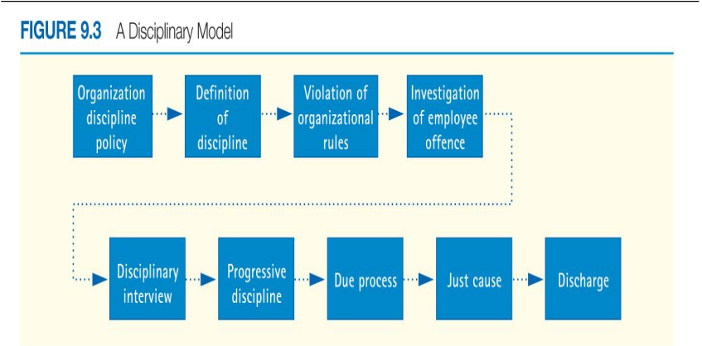
Investigating Disciplinary Problem
- Documentation of Employee Misconduct
  - Accurate and complete information
  - Supervisor needs to record incident immediately after infraction took place
- Investigative Interview
  - Need to check supervisors view with employee’s view
  - Concentrate on how situation violated performance standards
Effective Disciplinary Investigation
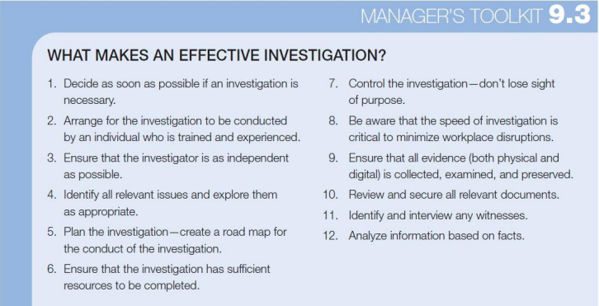
Types of Disciplinary Approaches
- Progressive discipline: application of corrective measures by increasing degrees
  - The means of which the result is achieved
- Positive Discipline, or nonpunitive discipline: System of discipline that focuses on the early correction of employee misconduct, with the employee taking total responsibility for correcting the problem
  - First conference – oral reminder
  - Second conference – written reminder
  - Decision making Leave – obtain employees commitment to meet standards or terminate

Compiling Disciplinary Record
- Complete written record
- Retained in employees’ official employment file
- Assist employer in identifying work expectation that are counter-productive to organizational success
Dismissing Employees
- Undertake after thorough and thoughtful review of facts
- Behave in a fair manner
- Personally, inform the employee
- Provide appropriate assistance and follow thorough

Grounds for Dismissal
- Wrongful dismissal
  - Terminating an employee’s employment without just cause
- Constructive dismissal
  - Changing an employee’s working conditions such that compensation, status, or prestige are reduced
- Examples of Just Cause
  - Excessive lateness or Absenteeism
  - Theft from the company
  - Improper or wrong conduct, such as fighting with a co worker
Appealing Disciplinary Actions
- Mediation – use of an impartial third party to help facilitate a resolution to employment disputes
- Step review System – system for reviewing employee complaints and disputes by successively higher levels of management
- Hearing officer – person who holds a full-time position with an organization but assumes a neutral role when deciding cases between management and aggrieved employees
- Open-door policy – policy of setting grievances that identifies various levels of management above the immediate supervisor for employee contact
- Ombudsperson – designated individual from whom employees may seek counsel for the resolution of their complaints
- Arbitration – see chapter 10

Organizational Ethics in Employee Relations
- Ethics – Set of standards of conduct and moral judgements that determine right and wrong behaviour
- Cultural guidelines that help us decide between right and wrong

Chapter 10: Labour Relations
Laws Governing Labour Relations
- Laws seek to create an environment in which both unions and employers can exercise respective rights
- Laws reflect government policy- federal or provincial
- Unions and other labour organizations can significantly affect the ability of managers to direct and control the various HR processes

Administration of Legislation
- Canada Industrial Relations Board administers and enforces Canada Labour Code
- Each province has its own labour relations board
- Quebec has a labour court and commission
Duties of Labour Relations Boards (LRB)
- Develop administrative regulations that describe how people unionize
- Hear complaints to unfair labour practices
  - Employer – can submit complaint if union is intimidating employees to join the union
  - Union – can submit complaint if Employer is intimidating employees not to join the union
- Determine if bargaining is done in good faith
- Remedy violations of legislation

Why Employees Unionize
- Desire to improve pay, benefits and working conditions – unhappiness with wages, benefits, and working conditions appear to be the strongest reason to join a union
- Dissatisfaction with managerial practices/supervisors – Favoritism shown by managers is a major reason for joining unions according to employees, failure to give employees an opportunity to participate in decisions affecting their welfare may also encourage union membership
- Social and status concerns – provide an opportunity to fraternize with other employees who have similar desires, interests, and problems

- Labour relations process – Logical sequence of four events:
- Workers desire collective representation
- Union begins its organizing campaign
- Collective negotiations lead to a contract
- The contract is administered

- Requirement of collective agreement
  - Union shop – provision of the collective agreement that requires employees to join union as a condition of their employment
  - Closed shop – provision of the collective agreement that requires employers to hire only union members
  - Open shop – provision of the collective agreement that allows employees to join or not join the union
How Employees Unionize

- Employee/Union contact
  - Initial word of mouth among employees
- Initial meeting
- Formation of in house committee
- Application to labour relations board
- Issuance of certificate by labour relations board
- Election of bargaining committee and contract/ commencement of negotiations

Membership card – a statement signed by an employee authorizing a union to act as a representative of the employee for purposes of collective bargaining

Employer Obligations and Tactics

- Cannot interfere with certification process
- prohibited from dismissing, disciplining, or threatening employees for exercising their rights to form unions
- cannot promise better conditions
- cannot change conditions
- must bargain in good faith

Union Obligations and Tactics
- Cannot Interfere with operation of the employer
- Cannot coerce or intimidate
- Must provide fair representation to all members of bargaining unit
- Bargaining unit – group of two or more employees who share common employment interests and conditions and may reasonably be grouped together for purposes of collective bargaining
- Cannot engage in illegal activities

Unfair Labour Practices – Specific employer and union illegal practices that operate to deny employees their rights and benefits under labour law

Certification Procedures
- Certification – Acquisition of exclusive rights by union to represent the employees
- Voluntary recognition – all employees outside Quebec may voluntarily recognize and accept a union
- Regular certification – union submitting the required minimum membership evidence to the LRB
- Prehearing votes – establish the level of support among the workers when unfair labour practices occur
- Contract negotiations – once a bargaining unit has been certified by the labour relations board, the employer and the union are legally obliged to bargain in good faith over the terms and conditions of a collective agreement
  - Union tells management what their problems are and how they want it to be fixed
  - Management takes problems and comes back with a offer which is continually negotiated until both parties are happy
- Decertification – majority of employees indicate that they don’t want to be represented by a union or they want to be represented by another union, or if the union has failed to bargain, an application for decertification can be made to the labour relation board

Impact of Unionization on Managers
- Affect the ability of managers to make decisions about employees
- Restricts the freedom of management to formulate HR policy and practices unilaterally
- Unions wish to achieve greater participation in management decisions that affect their members
- Management rights – decisions regarding organizational operations over which management claim exclusive rights, however, these rights are subjected to challenge and erosion by the union, at the bargaining table, through grievance procedure, and strikes
- Loss of Supervisory Flexibility – the focal point of the union’s impact is at the operating level (the shop floor or office facility), where the terms of the collective agreement are implemented on a daily basis
- Specific contract language can also reduce the supervisor’s flexibility to manage in such areas as scheduling, training, performance evaluation, and promotions

How Unions Operate

- Craft unions
  - Unions related to craft work (craft workers, carpenters, metal/wood workers, etc.)
- Industrial unions
  - Unions related to unskilled and semiskilled workers employed along industry lines
- Employee associations
- International Unions
- National unions
- Local union
- CLC (Canadian Labour Congress) – umbrella organization formed by many unions

Role of Shop Steward – employees who, as a nonpaid union official, represents the interests of members in their relations with management
Role of business agent – normally a paid labour official responsible for negotiating and administering the collective agreement and working to resolve union members’ problems

Labour Relations in Public Sector

- Special legislation
- Political nature of labour management relationship
- Effect of strikes
- Alternative services
- Management authority

The Collective Bargaining Process

Preparing for Negotiations
- Gathering bargaining data
  - Wage/benefit comparisons
  - Review of grievance
- Bargaining patterns: what has the union negotiated elsewhere
  - Pattern that is established across an industry (Car manufacturers)

Developing Bargaining Strategies (KEY!)

  - What are your objectives
  - What are the unions objectives?
  - Are you prepared to take a strike or lockout?
  - What is the nature of the union-management relationship?
- Forms of collective bargaining
  - Interest based bargaining – problem-solving bargaining based on a win-win philosophy and the development of a positive long-term relationship

Conducting Negotiations

- Bargaining teams
- Analyzing the proposals
- Resolving the proposals
- Style of negotiators

Power in Collective Bargaining
- Union
  - Striking the employer – Strike is a situation in which unionized workers refuse to perform their work during labour negotiations
  - Picketing the employer – pickets are used during a strike to make customers and the general public aware of the dispute
  - Boycotting the employer – refusal to patronize the employer

- Employer
  - Operating during strike
  - Locking out employees

Mediation and Arbitration
Mediator – third party in a labour dispute who meets with one party and then the other in order to suggest compromise solutions or to recommend concessions from each side that will lead to an agreement
Arbitrator – third-party neutral with decision making power who resolves a labour dispute by issuing a final and binding decision in an agreement
Interest arbitration – a mechanism to renew or establish a new collective agreement for parties
Right arbitration – a mechanism to resolve disputes about the interpretation and application of a collective agreement during the term of that collective agreement
Collective Agreement
- Residual rights – concept that management’s authority is supreme in all matters except those it has expressly conceded to the union in the collective agreement
- Defined rights – concept that management’s authority should be expressly defined and clarified in the collective agreement

- A legal, binding, written document
- A living document

  - Examples of Collective Agreement Provisions

    - Wages and benefits
    - Health and safety
    - Hours of work and overtime
    - Seniority
    - Discipline
    - Union checkoff dues

Form of Union security
- The closed shop states that employers will hire only union members
- The union shop provides that any employees not a union member upon employment must join the union within 30 days or be terminated
- The agency shop states that union membership is voluntary yet all bargaining unit members must pay union dues and fees
- The open shop allows employees to join the union or not. Nonmembers do not pay union dues

Grievance procedures
      - Complaint by employee/employer that some aspect of collective agreement has been violated
      - Grievance procedure: formal procedure that provides for the union to represent members and nonmembers in processing a grievance
- Informal meeting to discuss grievance between employee and supervisor
- Written complaint – between next-level supervisor and union official
- Written document – between manager and union business agent
- Judicial function – formal and legalistic, decisions are binding and enforceable through the courts

Initiating the formal grievance
- Must be expressed orally and/or in writing – ideally to the employee’s immediate supervisor
- May be taken to union steward

Grievance resolution – process in which a neutral third party (an arbitrator, a board, or a panel) assists in the resolution of an employee grievance

Rights of Arbitration
- Functions both to provide solution to grievance if parties unable to resolve
- Performed by neutral third party
- Both parties obligated to abide by decision

Arbitration Process
- Arbitration is a formal process to solve a grievance
- Provides full and fair hearing
- Union and employer are permitted to introduce evidence
- Witness sworn in
- Burden of proof usually rests union
- Arbitrator must decide

Arbitration Award
- Final and binding award issued by an arbitrator in a labour-management dispute
- Cornerstone decision is the collective agreement
  - Also use testimony and evidence
  - Arbitral standards
- Award is enforceable in civil courts
- 70% of arbitration cases are discipline cases

