Mos 2181 Chapter 1

Organizational behaviour: field of study devoted to understanding, explaining, and improving the attitudes and behaviours of individuals and groups in organizations

Human resources management takes the theories and principles studied in OB and explores the “nuts and bolts” applications of those principles in organizations.
- HR applies OB thinking & theories
- An OB study might explore the relationship between learning and job performance, whereas a human resources management study might examine the best ways to structure training programs to promote employee learning.

Strategic management focuses on the product choices and industry characteristics that affect an organization’s profitability.
- Eg. A strategic management study might examine the relationship between firm diversification (when a firm expands into a new product segment) and firm profitability.

The theories and concepts found in OB have also been heavily influenced by the popular management approaches of the day.

Frederick Taylor
- Scientific management
- Optimal and efficient work processes
  - e.g., careful observation, measurement, experimentation, Taylor and his colleagues would study how to optimize performance of any task (e.g., by reducing the number of hand movements exhibited by bricklayers, and thus reducing fatigue, more bricks could be laid in a given time period)
- Focus on scientific methods
Max Weber
- Bureaucracy
- Characteristics of bureaucracy included:
  - the division of labour with a high level of technical specialization
  - a strict chain of command (authority hierarchy) in which every member reported to someone at a higher level
  - a system of formal rules and procedures that ensured consistency, impartiality, and impersonality throughout the organization
  - decision making at the top of the organization.

*Both put heavy emphasis on specialization, coordination, and efficiency

Human Relations Movement
- The Hawthorne Studies made clear the limits with the classical approach to management
- The human relations movement recognized that needs, attitudes, and social influences within groups affect behaviour
- The studies revealed the importance of group values and norms, leadership, motivation, job satisfaction, and organizational culture
- Today, contemporary management theory recognizes the dependencies between the classical and the human relations approaches.

Contemporary Management Theory
- There are dependencies between the classical and human relations approaches
- There is no one best, universal principle

Integrative Model of Organizational Behaviour

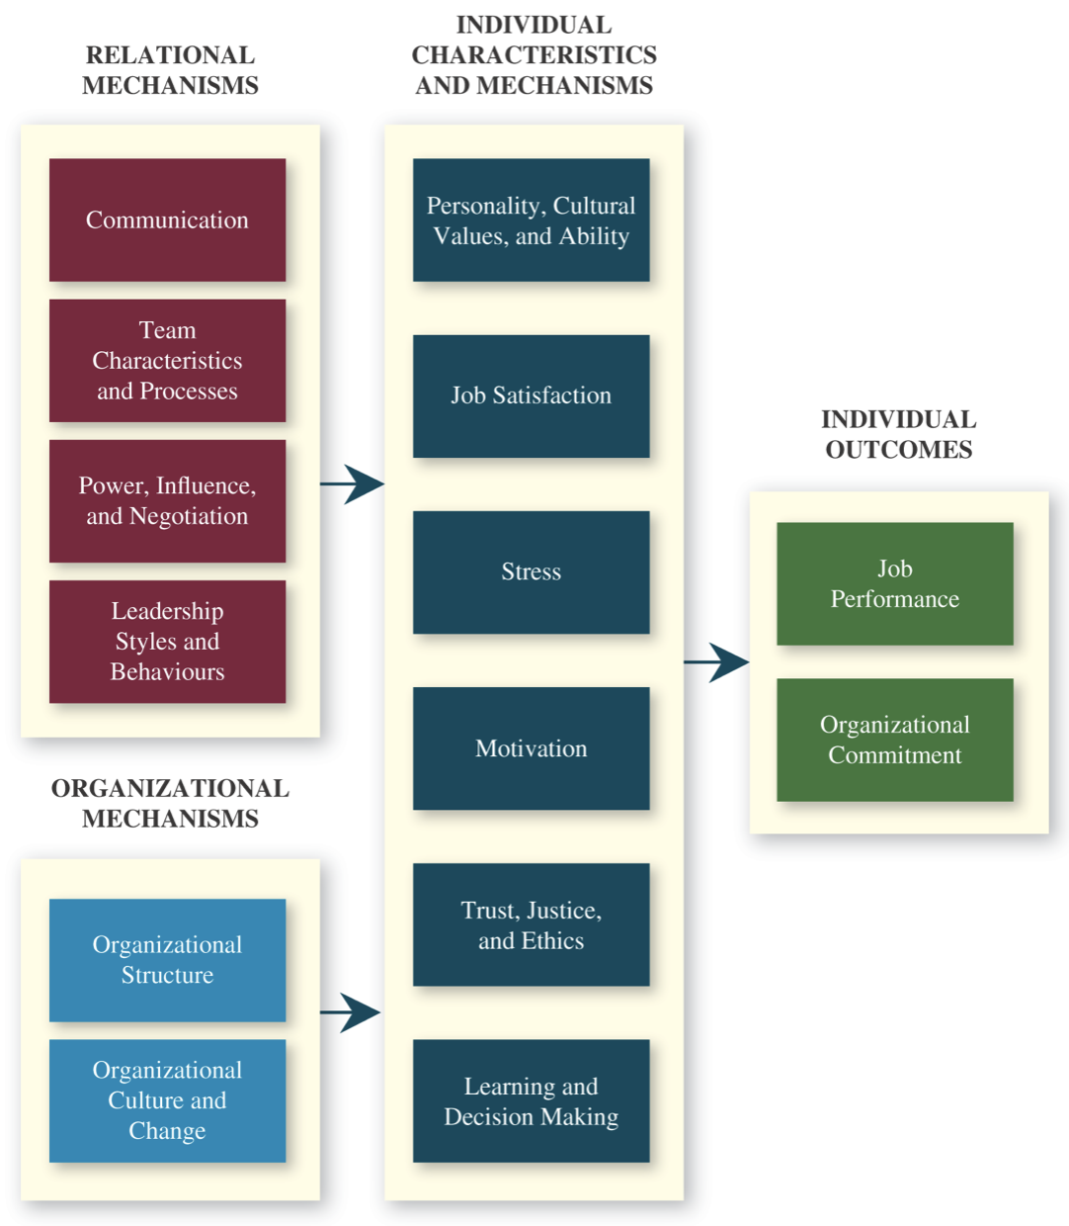
Individual Outcomes
- Most employees have two primary goals for their working lives: to perform their jobs well and to remain members of an organization they respect.
- Most managers have two primary goals concerning their employees: to maximize their job performance and to retain these employees for a significant length of time.
Individual Characteristics and Mechanisms
- We focus on several key personal characteristics—personality, cultural values, and ability—and describe their relationships to performance and commitment.
- Then we look at a number of important individual mechanisms:
  - job satisfaction: how employees feel about their jobs and day-to-day work
  - stress: employees’ psychological responses to job demands that tax or exceed their capacities
  - motivation: the energetic forces that drive employees’ work effort
  - trust, justice, and ethics: how strongly employees feel their company conducts business with fairness, honesty, and integrity
  - learning and decision making: the ways employees gain job knowledge and use it to make accurate judgments
Relational Mechanisms
- We describe how critical work relationships with co-workers and leaders shape the individual mechanisms of satisfaction, stress, motivation, trust, and learning.
Organizational Mechanisms
- Our integrative model acknowledges that individuals and groups function within a broader organizational context.
- Every company, for example, has an organizational structure that dictates how the units within the firm link to (and coordinate with) other units
- Sometimes structures are centralized around a decision-making authority; sometimes structures are decentralized, affording each unit some autonomy.

Resource-based View
- This perspective describes what exactly makes resources valuable—that is, what makes them capable of creating long-term profits
- Rare and inimitable resources help firms maintain a competitive advantage
  - Rare: in short supply
  - Inimitable: incapable of being imitated or copied
  - Resources: financial (e.g. revenue), physical (e.g. buildings, machines, technology), but also ones related to organizational behaviour, such as the knowledge, ability, and wisdom of the workforce and the image, culture, and goodwill of the organization.
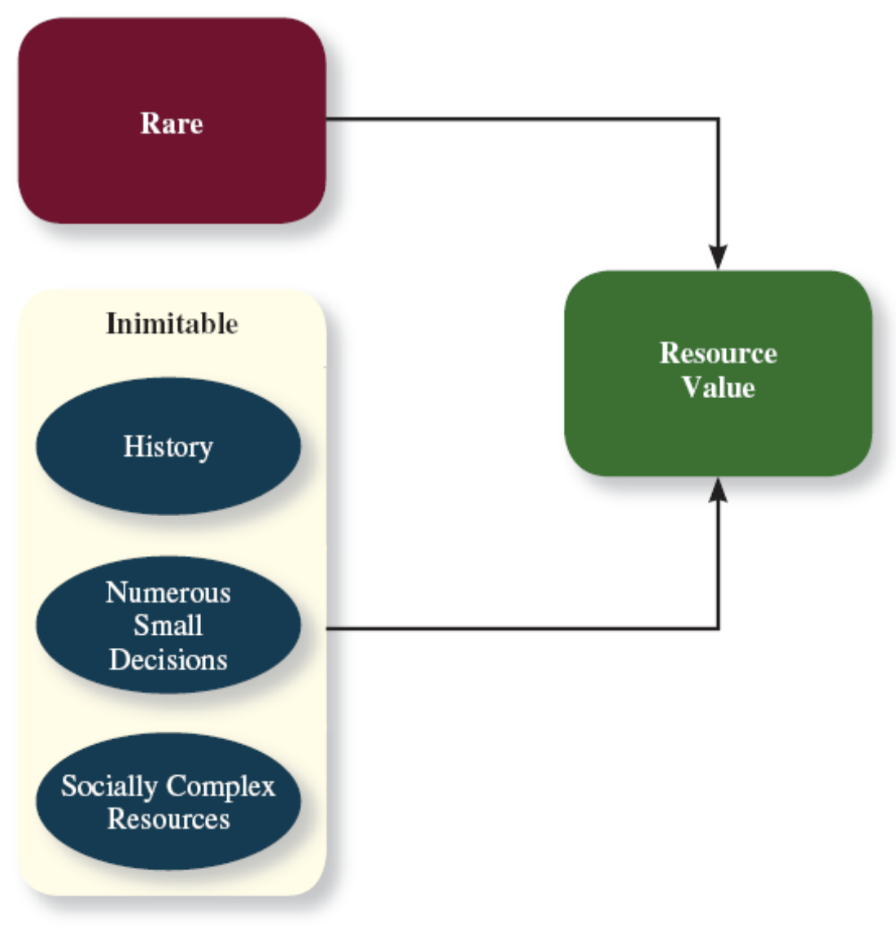
Good people are rare and hard to imitate. They bring wisdom, experience, and history. (Cannot be bought)

Good people are both rare and inimitable and therefore offer the organization a resource that is valuable for creating competitive advantage.

Numerous small decisions
The concept of numerous small decisions captures the idea that people make many small decisions day in and day out, week in and week out.

Big decisions can be copied; they are visible to competitors and observable by industry experts. In contrast, the “behind the scenes” decisions are less visible to competitors, especially those that involve hiring and managing employees.

Socially complex resources
People also create things like culture, teamwork, trust, and reputation, which are termed socially complex resources because it is not always clear how they come to be, though it might be clear which organizations do and do not possess them.

Rule of one-eighth
- Belief that, at best, one-eighth (12%) of organizations will do what is required to build profits by putting people first.
- High job performance depends not just on employee motivation but also on fostering high levels of satisfaction, effectively managing stress, creating a trusting climate, and committing to employee learning.
- Failing at any of those things might hinder the effectiveness of the other concepts in the model.

How people “know” about anything
- Philosophers have argued that there are several different ways of knowing things:
  - Method of experience: People hold firmly to some belief because it is consistent with their own experience and observations.
  - Method of intuition: People hold firmly to some belief because it “just stands to reason”—it seems obvious or self-evident.
  - Method of authority: People hold firmly to some belief because some respected official, agency, or source has said it is so.
  - Method of science: People accept some belief because scientific studies have tended to replicate that result using a series of samples, settings, and methods.

Theories & Hypothesis
- Theory: collection of assertions that specify how/why variables are related and the conditions under which they should (and should not) be related
  - Theories are often summarized with diagrams
  - Theories may be used to inspire hypotheses
  - Theories must be tested to verify that they are accurate
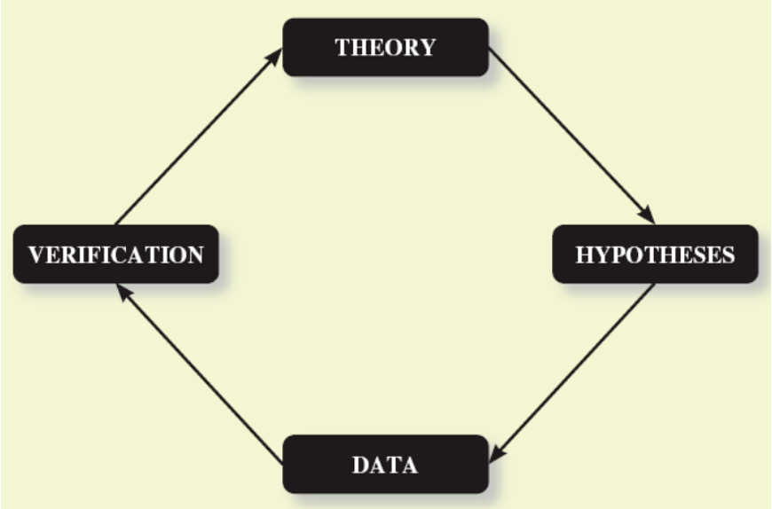
- Hypotheses: written predictions that specify relationships between variables
- Eg. “Social recognition behaviours on the part of managers will be positively related to the job performance and organizational commitment of their units.”

Correlation
- Statistical relationship between two variables
- abbreviated ‘r’
- Correlations can be positive or negative and range from 0 (no statistical relationship) to 1 (a perfect statistical relationship)
- A way to get a feel for the correlation is to look at a scatterplot
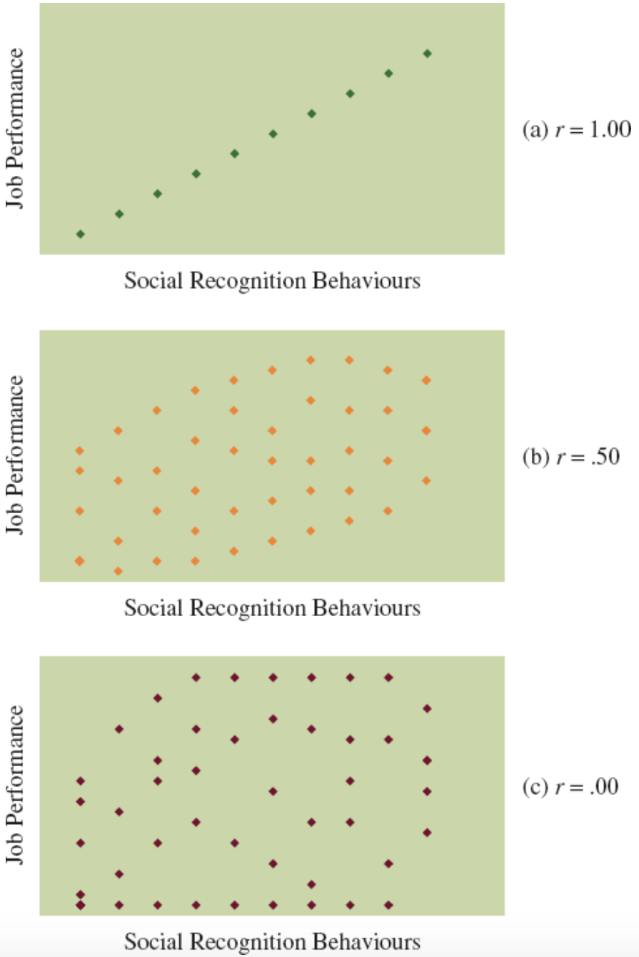

Conditions for Causation
- The two variables are correlated
- The presumed cause precedes the presumed effect (Cause must happen before the effect)
- No alternative explanation exists for the correlation

Meta-analysis
- Method that combines the results of multiple studies by calculating a weighted-average correlation across studies
- Correlations based on studies with large samples are weighted more than correlations based on studies with small samples

Evidence-based Management
- A perspective that scientific findings should form the foundation for management education
- Proponents of evidence-based management argue that human resources should be transformed into a sort of R&D department for managing people
- Definition is too restrictive
- Want to gather evidence from many different sources

