ADM 1300 Exam Review

Part A: Multiple choice

Chapter 1 (pg.3-4)

Why managers matter?
- Inspire you professionally and personally
- Energize you and your coworkers to accomplish things together that you couldn’t get done by yourself Provide coaching and guidance with problems
- Provide you a feedback on how you’re doing
- Help you to improve your performance
- Keep you informed of organizational changes
- Change your life

Type of Managers
- First-line managers
  - Manager at the lowest level of the organization who manages the work of nonmanagerial employees who are directly or indirectly involved with the production or creation of the organization’s products.
- Middle managers
  - Managers between the first-line level and the top level of the organization who manage the work of first-line managers
- Top managers
  - Managers at or near the top level of the organization-wide decisions and establishing the plans and goals that affect the entire organization

Chapter 4 (pg.88-90)

Global perspective
- Parochialism
  - Viewing the world solely through your own perspective, leading to an inability to recognize differences among people

- ethnocentric attitude
  - The belief that the best work approaches and practices are those of the home country

- polycentric attitude
  - The view that the managers in the host country know the best work approaches and practices for running their businesses

- geocentric attitude
  - A world-oriented view that focuses on using the best approaches and people from around the globe

Chapter 5 (pg.113-118)

- A. entrepreneurship (pg.125-132)
  - Financing, failure, risk management, reliability, lack of knowledge
  - Growth of organization as you are starting a business (Captions)
  - Challenges (bigger competitors, contingency plan to exit)

- B. slides (forms of business ownership) on brightspace
  - Partnership
    - Types- general, limited partnership
    - Type of partners
    - Disadvantages (fraud with partner, slower process, unexpected situations)
    - Advantage (access to more skills, less risk, better taxation, reliability)
  - Sole proprietorship
    - Owned by one person
    - Tax- pay like an individual
    - All the money you make is yours
    - Limited growth
    - Limited financial resources
  - Corporation
    - Separate legal entity
    - Can sue and can be sued
    - Loan money
    - Stock look into that, stakeholders

- Social enterprise
  - Organizations that are started in response to needs within the community

- How to start a firm: steps

- Issues that entrepreneurs face
  - managing downturns - have a plan B, a contingency plan
  - Managing Growth - The best growth strategy is a well-planned one.
    - Grow strategy should be part of a venture’s overall business goals and plan.
    - Rapid growth without planning can be disastrous.
    - The key challenges for an entrepreneur in organizing for growth include finding capital, finding people, and strengthening the organizational culture.

- Define small business
  - An organization that is independently owned, operated, and financed; has fewer than 100 employees; doesn’t necessarily engage in any new or innovative practices; and has relatively little impact on its industry

- Entrepreneurial process
  - Entrepreneurs must address four key steps as they start and manage their entrepreneurial ventures:
    - exploring the entrepreneurial context
    - identifying opportunities and possible competitive advantages
    - starting the venture
    - managing the venture
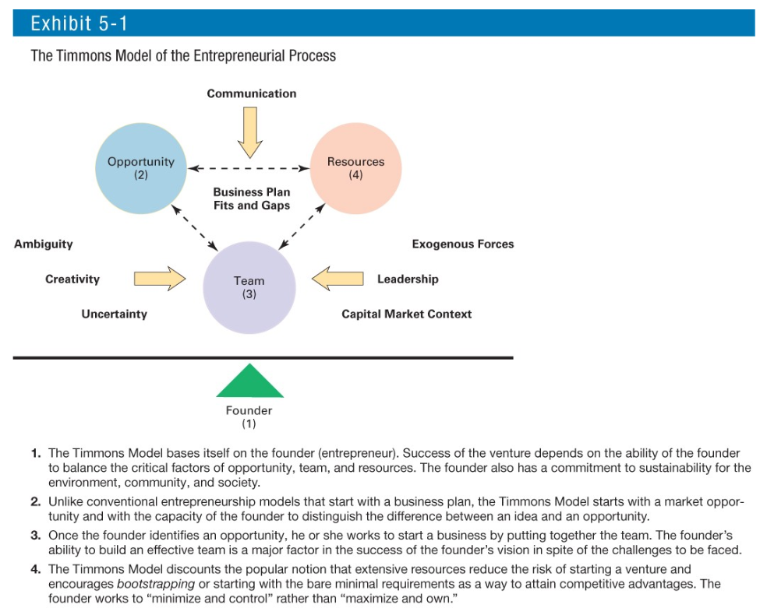

Chapter 8 (pg.196-197)

The Decision-Making Process
- Step1: Identify a Problem
  - Team is dysfunctional
  - A discrepancy between an existing and a desired state of affairs
  - Characteristics of problems:
    - A problem is recognized by awareness
    - There is pressure to solve the problem
    - The manager must have the authority, information, or
    - resources needed to solve the problem
- Step2: Identify Decision Criteria
  - Criteria that define what us relevant in making a decision
    - Costs that will be incurred (investments required)
    - Risks likely to be encountered (chance of failure)
    - Outcomes that are desired (growth of the firm)
- Step3: Allocate Weights to Criteria
  - Decision criteria are not of equal importance:
    - Assigning a weight to each item places the items in the correct priority order of their importance in the decision-making process.
- Step4: Develop Alternatives
  - Identifying viable alternatives:
    - Alternatives are listed (without evaluation) that can resolve the problem
- Step5: Analyze Alternatives
  - Appraising each alternative’s strengths and weaknesses:
    - An alternative’s appraisal is based on its ability to resolve the issues identified in steps 2 and 3.
- Step6: Select an Alternative
  - Typically the alternative with the highest total weight is chosen.
  - If the individual finds that the “best alternative” does not seem like the right alternative, the decision maker needs to decide if a review of the criteria is necessary before implementing the alternative
- Step7: Implement the Alternative
  - Putting the chosen alternative into action:
    - Conveying the decision to those affected by it and gaining their commitment to it.
- Step8: Evaluate Decision Effectiveness
  - Effectiveness – The soundness of the decision is judged by its outcomes:
    - How effectively was the problem resolved by outcomes resulting from the chosen alternatives?
    - If the problem was not resolved, what went wrong?

Chapter 9 (pg.189, 222-225)

o Why do manager planning methods?
o Planning process: steps
o Business models
Approaches to Planning
- Establishing a formal planning department:
  - A group of planning specialists who help managers write organizational plans
  - Planning is a function of management; it should never become the sole responsibility of planners
  - Plans are developed by members of organizational units at various levels and then coordinated with other units across the organization (communication)

- Effective planning in Dynamic Environments
  - Develop plans that are specific but flexible. (Contingency)
  - Understand that planning is an ongoing process. (Good knowledge in the project)
  - Change plans when conditions warrant.
  - Persistence in planning eventually pays off.
  - Flatten the organizational hierarchy to foster the development of planning skills at all organizational levels.
  - *Delegate with departments to be able to accomplish the goal within the organization

- How to analyze the external environment
  - Environmental scanning: Screening information to detect emerging trends.
  - Competitor intelligence: Gathering information about competitors that allows managers to anticipate competitors’ actions rather than merely react to them.

Chapter 10 (pg.241-244)

- Strategic Management:
What managers do to develop the organization’s strategies.
- Why is Strategic Management Important?
  - It results in higher organizational performance.
  - It requires that managers examine and adapt to business environment changes, allowing them to better cope with uncertain environments.
  - It’s involved in many of the decisions that managers make.

- Strategic Management Process
  - Step 1: Identify the Organization’s Current Mission, Goals, and Strategies
  - Step 2: Conduct an External Analysis
  - Step 3: Conduct an Internal Analysis
  - Step 4: Formulate Strategies
  - Step 5: Implement Strategies
  - Step 6: Evaluate Results
- Benchmarking
- SW(internal)OT(external) analysis
- Forecasting
- Environmental scanning (external)
*More on the old midterm review

Chapter 11 (pg. 285-295)
Situation question
• Centralization and formalization
- organizing: Arranging and structuring work to accomplish an organization’s goals
- organizational structure: How job tasks are formally divided, grouped, and coordinated within an organization
- organizational chart: The visual representation of an organization’s structure
- organizational design: The process of developing or changing an organization’s structure
- work specialization: The degree to which activities in an organization are subdivided into separate job tasks; also known as division of labour
- Departmentalization: the basis on which jobs are grouped together.
  - Functional (engineer, accountant)
  - Product: product line
  - Geography
  - Process: work activities (sawing, assembling)
  - Customer (retail, wholesale, government)
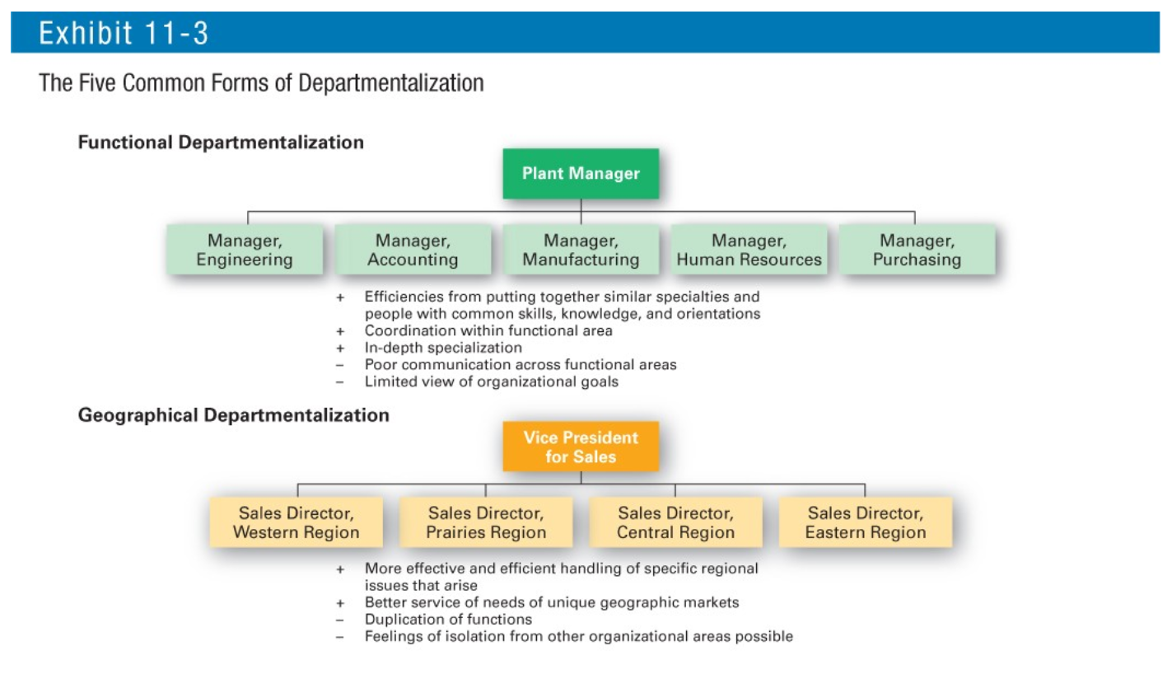
- Formalization: the degree to which jobs within the organization are standardized and the extent to which employee behaviour is guided by rules and procedures.

- Mechanistic org: Highly specialized, narrow span of control, highly formalized
- Organic org: highly adaptive and flexible

Chapter 12 (pg. 311-312)
• Communication in business
- interpersonal communication: Communication between two or more people
- organizational communication: All the patterns, networks, and systems of communication within an organization

• Define dysfunctional communication

• Motivate and encourage employees/communication (incentives)

Chapter 14 (pg. 373 -385)

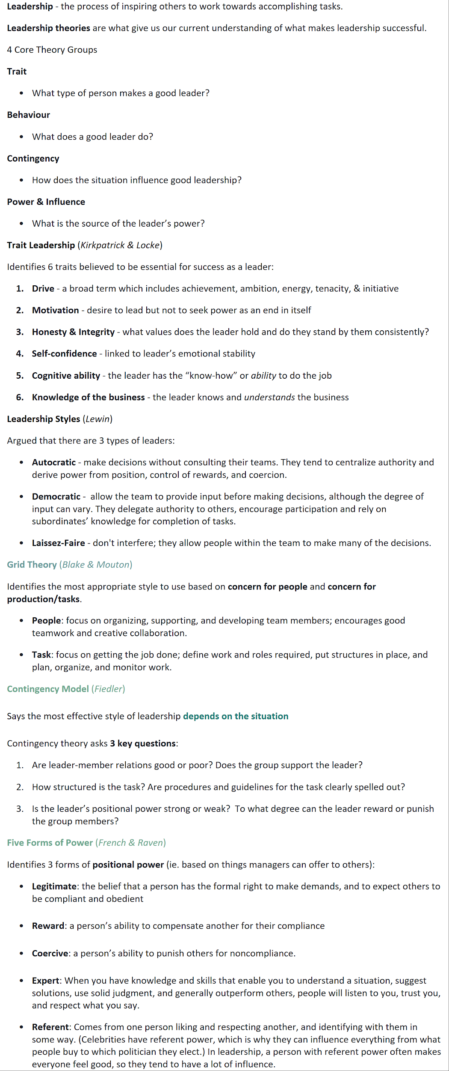

Chapter 16
• Forms of groups (formal, informal)
- Formal: Work groups that have designated work assignments and tasks directed toward organizational goals.
  - Command Groups: Groups that are determined by the organizational chart and composed of individuals who report directly to a given manager.
  - Task Groups: Groups composed of individuals brought together to complete a specific job task; their existence is often temporary because once the task is completed, the group disbands.
  - Cross-Functional Teams: Groups that bring together the knowledge and skills of individuals from various work areas, or groups whose members have been trained to do one another’s jobs.
  - Self-Managed Teams: Groups that are essentially independent and, in addition to their own tasks, take on traditional managerial responsibilities such as hiring, planning and scheduling, and performance evaluations.
- Informal: Groups that are independently formed to meet the social needs of their members.
• Self-manage teams
No answers on the exam booklet put them on scantron

*************************************************************************************

Part B
5 questions (10marks*5)
1. Chapter 8, no info
One question is listing Q (# them) (guess: possibly this is chapter 8 Q)

The Decision-Making Process
- Step1: Identify a Problem
  - Team is dysfunctional
  - A discrepancy between an existing and a desired state of affairs
  - Characteristics of problems:
    - A problem is recognized by awareness
    - There is pressure to solve the problem
    - The manager must have the authority, information, or
    - resources needed to solve the problem
- Step2: Identify Decision Criteria
  - Criteria that define what us relevant in making a decision
    - Costs that will be incurred (investments required)
    - Risks likely to be encountered (chance of failure)
    - Outcomes that are desired (growth of the firm)
- Step3: Allocate Weights to Criteria
  - Decision criteria are not of equal importance:
    - Assigning a weight to each item places the items in the correct priority order of their importance in the decision-making process.
- Step4: Develop Alternatives
  - Identifying viable alternatives:
    - Alternatives are listed (without evaluation) that can resolve the problem
- Step5: Analyze Alternatives
  - Appraising each alternative’s strengths and weaknesses:
    - An alternative’s appraisal is based on its ability to reslolve the issues identified in steps 2 and 3.
- Step6: Select an Alternative
  - Typically the alternative with the highest total weight is chosen.
  - If the individual finds that the “best alternative” does not seem like the right alternative, the decision maker needs to decide if a review of the criteria is necessary before implementing the alternative
- Step7: Implement the Alternative
  - Putting the chosen alternative into action:
    - Conveying the decision to those affected by it and gaining their commitment to it.
- Step8: Evaluate Decision Effectiveness
  - Effectiveness – The soundness of the decision is judged by its outcomes:
    - How effectively was the problem resolved by outcomes resulting from the chosen alternatives?
    - If the problem was not resolved, what went wrong?

2. Chapter 9, nature and purpose of planning

- involves defining goals, establishing an overall strategy for achieving those goals, and developing a comprehensive set of plans to integrate and coordinate the work needed to achieve the goals.
  - 1. Planning provides direction to managers and nonmanagers alike. When employees know what their organization or work unit is trying to accomplish and what they must contribute to reach goals, they can coordinate their activities, cooperate with each other, and do what it takes to accomplish those goals. Without planning, departments and individuals might work at cross-purposes and prevent the organization from efficiently achieving its goals.
  - 2. Planning reduces uncertainty by forcing managers to look ahead, anticipate change, consider the impact of change, and develop appropriate responses. Although planning won’t eliminate uncertainty, managers plan so they can respond effectively.
  - 3. Planning minimizes waste and redundancy. When work activities are coordinated around plans, inefficiencies become obvious and can be corrected or eliminated.
  - 4. Planning establishes the goals or standards used in controlling. When managers plan, they develop goals and plans. When they control, they see whether the plans have been carried out and the goals met. Without planning, there would be no goals against which to measure work effort.
- goals (objectives): Desired outcomes or targets
- plans: Documents that outline how goals will to be met

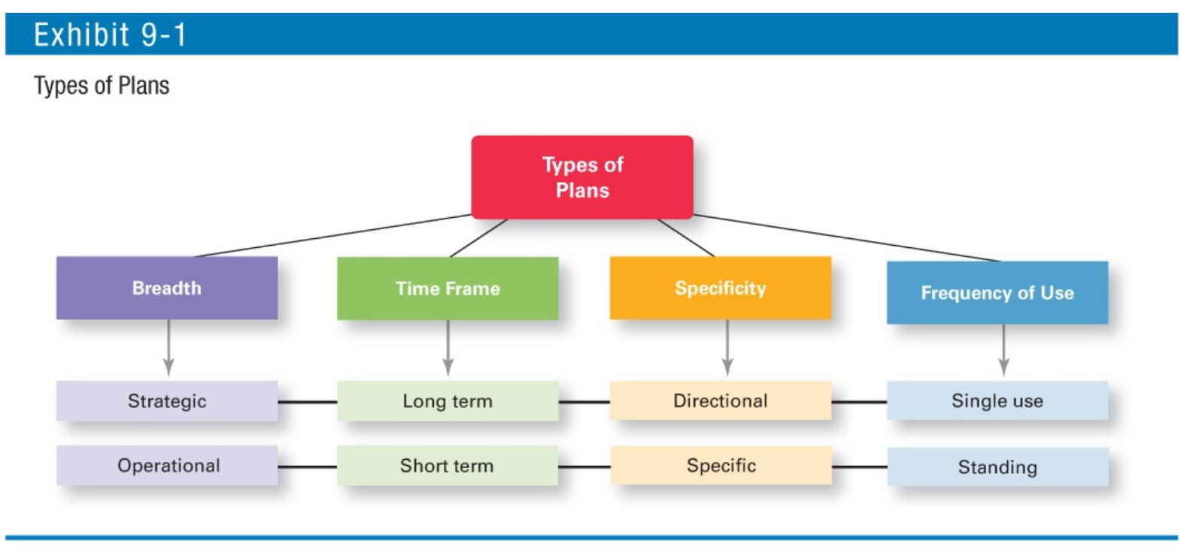

3. Chapter 17, control process
a. Three main steps
- Measuring actual performance
  - Statistical reports, oral reports, and written reports

- Comparing actual performance against standard
- Taking managerial action
  - Correct actual performance
    - Immediate corrective action
    - Basic corrective action
  - Revise the standard
    - Variance may be a result of an unrealistic standard (a goal is way too high or too low)
GOALS: Organizational, Divisional, Department, Individual

4. Chapter 16, stages of group development
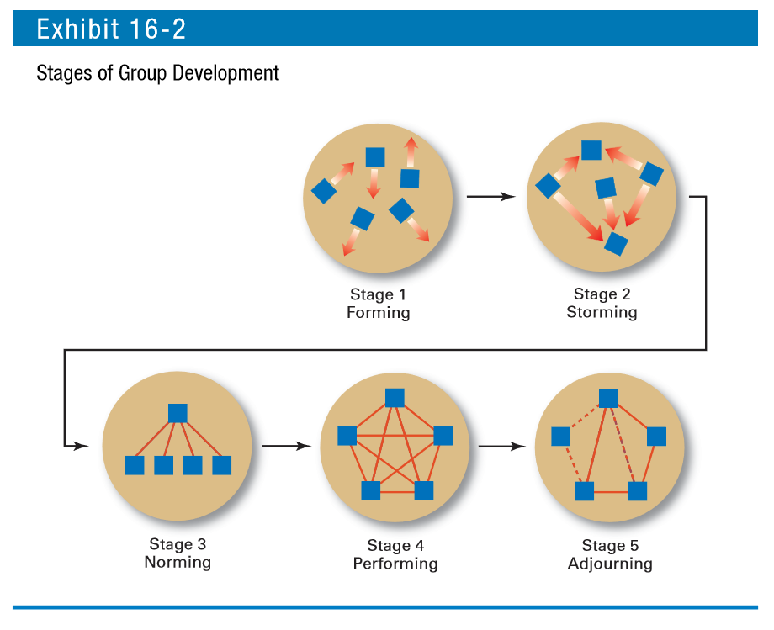
The forming stage has two phases.
The first occurs as people join the group. In a formal group, people join because of some work assignment.
After they’ve joined, the second phase begins: defining the group’s purpose, structure, and leadership. This phase involves a great deal of uncertainty as members “test the waters” to determine what types of behaviour are acceptable. This stage is complete when members begin to think of themselves as part of a group. (Initial task orientation) (defining the group’s purpose, structure, and leadership.)

The storming stage is named because of the intragroup conflict that occurs over who will control the group and what the group needs to be doing. When this stage is complete, there is a relatively clear hierarchy of leadership and agreement on the group’s direction. (individuals resist control by the group and disagree over leadership.)

The norming stage is one in which close relationships develop and the group becomes cohesive. There’s now a strong sense of group identity and camaraderie. This stage is complete when the group structure solidifies and the group has assimilated a common set of expectations (or norms) regarding member behaviour. (Cooperation & harmony gets stronger as roles are established within the team) (cohesive and establishes its norms for acceptable behaviour.)

The fourth stage of group development is performing. The group structure is in place and accepted by group members. Their energies have moved from getting to know and understand each other to working on the group’s task. This is the last stage of development for permanent work groups. (Team is now organized, motivated, and well-functioning)

However, for temporary groups—project teams, task forces, or similar groups that have a limited task to do—the final stage is adjourning. In this stage, the group prepares to disband. Attention is focused on wrapping up activities instead of task performance. Group members react in different ways. Some are upbeat, thrilled about the group’s accomplishments. Others may be sad over the loss of camaraderie and friendships. (Closure with praise around job well done)(no longer concerned with high levels of performance)

5. Chapter 13, human resources process

GOAL:
1. Getting the right people
2. Developing a quality workforce
3. Maintaining a quality workforce
a. Why is it important?

- First, as various studies have concluded, it can be a significant source of competitive advantage. People-oriented HR gives an organization an edge by creating superior shareholder value.
- Second, HRM is an important part of organizational strategies. Achieving competitive success through people means managers must change how they think about their employees and how they view the work relationship. They must work with people and treat them as partners, not just as costs to be minimized or avoided.
- Finally, the way organizations treat their people has been found to significantly impact organizational performance. For instance, one study reported that improving work practices could increase market value by as much as 30 percent. Work practices that lead to both high individual and high organizational performance are known as high-performance work practices.
  - Self-managed teams
  - Decentralized decision making
  - Training programs to develop knowledge, skills, and abilities
  - Flexible job assignments
  - Open communication
  - Performance-based compensation
  - Staffing based on person–job and person–organization fit
  - Extensive employee involvement
  - Giving employees more control over decision making
  - Increasing employee access to information
- The common thread among these practices seems to be a commitment to involving employees; improving the knowledge, skills, and abilities of an organization’s employees; increasing their motivation; reducing loafing on the job; and enhancing the retention of quality employees while encouraging low performers to leave.
- Human resource management process: Activities necessary for staffing the organization and sustaining high employee performance
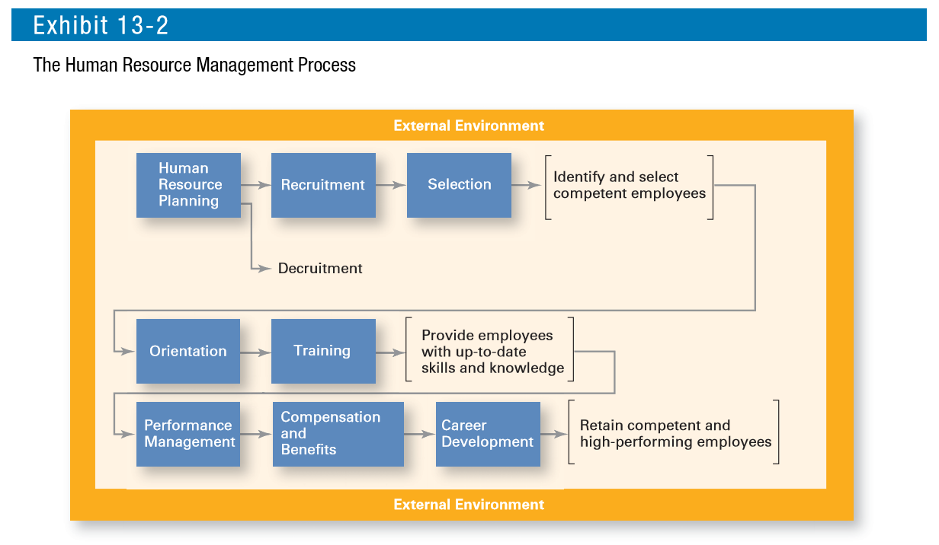
Leads to success by
1. Identifying the talent
2. Resource to competitive advantage by gaining good shareholder value
3. Enhance the work ability
4. Understanding workforce, the ability to read the employees’ minds

