Disease
- Definition: disturbance of structure/function of the body
  - Organic disease: explained by intrinsic deficit in organ
  - Functional disease: function impaired, no correlation between symptoms and pathophysiology
- Functional diseases
  - Irritable bowel syndrome: disorder of lower GI tract, altered bowel movements and pain
  - Hypertension: chronically increased blood pressure
  - Chronic fatigue syndrome: long-standing severe and disabling fatigue without proven physical/psychological cause
  - Spasms: sudden involuntary muscular contraction or convulsive movement
  - Headaches: pain in any part of the head (scalp, upper neck, face, interior of head)
  - Vertigo: false sensation of movement, dizziness
  - Fibromyalgia: poor sleep, fatigue, mental cloudiness, widespread aching/stiffness in soft tissues
- Pathology: study of disease
  - Pathophysiology: deranged function in an individual/organ due to disease, change in function from a structural defect
  - Pathogenesis: how disease develops (bacteria, virus)
  - Morphology: structure of a tissue/organ
    - All disease can be diagnosed by examining changes at cellular level
    - Cells attempt to adapt to stressors, become injured and die as disease progresses

Disease Classification
- Congenital/hereditary
  - Congenital: present since birth
  - Hereditary: genetic, inherited (not necessarily congenital)
- Inflammatory
  - Autoimmune diseases
  - Infection, cell injury
- Metabolic
  - Dysregulation of metabolism and impaired energy production
- Neoplasm
  - Irregular cell growth, proliferation
- Degenerative
  - Aging, joints, lumbar disc issues
  - Abnormal degeneration occurs in advance of aging process
- Endocrine
  - Inappropriate inflammatory reaction
  - Autoimmune diseases
- Malnutrition
  - Deficiencies, obesity
- Obstructions/deposits
  - Cholesterol/mineral deposits
  - Atherosclerosis, kidney stones

Cellular Mechanisms of Disease
- Genetic: DNA, mtDNA, gene-environment interactions
- Proteins: too few/many, non-functional, post-translational modification errors, dysfunctional receptors
- Young people: most common deaths by accidents
- Old people: most common deaths by cancer
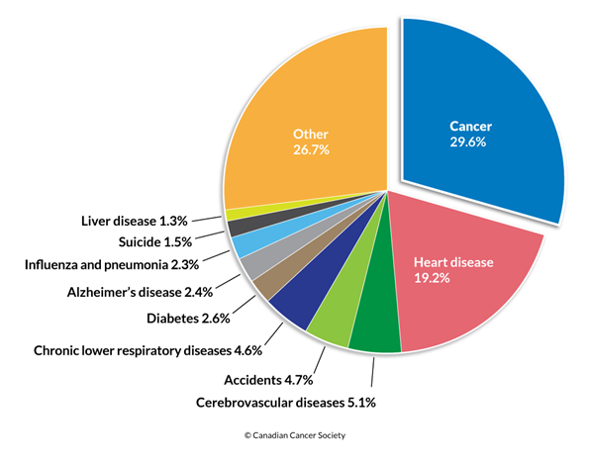

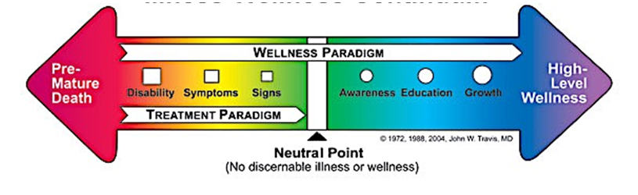

Determinants of Health
- Income and social status
- Social support networks
- Education and literacy
- Employment and working conditions
- Social/physical environments
- Personal health and coping skills
- Healthy child development
- Biology and genetic endowment
- Health services, gender, culture

Diagnostic Tests
- Invasive test: pain, discomfort (eg. Endoscope, needles, catheters)
- Non-invasive test: no risk (eg. urinalysis, chest x-ray)
- Clinical laboratory tests
  - Evaluate constituents and concentrations of substances in blood, urine; evaluate organ function
  - Microbiologic tests: detect presence of pathogens
  - Serologic tests: detect/measure presence of antibodies
- Electrical activity
  - Measure electrical impulses associated with bodily functions
  - Eg. ECG, EEG, EMG
- Ultrasound
  - Mapping echoes produced by high-frequency sound waves transmitted into the body
  - Reflect where there is a change in tissue density
  - Eg. Fetal development, function of heart
- X-ray
  - Pass through the body
  - Dense structures (bone) = white (absorb rays)
  - Structures with air = black
  - Fat, muscle = grey
  - Eg. Mammogram, angiogram/arteriogram
- Computed tomography (CT) scan
  - Performed by x-ray machine
  - Images of body in cross-section by rotating the x-ray tube around the patient
  - Data transmitted to a computer that reconstructs cross-sectional images
  - Used for detecting abnormalities of internal organs
- MRI
  - Produce computer-constructed images of organs/tissue
  - Device consists of strong magnet capable of developing magnetic field
- Positron emission tomography (PET)
  - Study body functions
  - Injects biochemical compound (glucose) labeled with positron-emitting isotope
  - Assess distribution and metabolism of compound by measuring radiation produced in the body
  - Radiation output fed into computer that constructs images
  - Eg. Alzheimer's, Parkinson's, stroke, tumours, cardiac function
- Cytologic/histologic exams
  - Examination of cells identified in fluid (eg. Pap smear)
- Biopsy
  - Histologic examination of tissue sample removed from affected organ

Screening Tests
- Genetic screening
  - Detect gene carriers of heritable disease
  - Identify risk of disease in adult
  - Eg. Breast/ovarian cancer, Huntington's disease
- Amniocentesis
  - Insert hollow needle through abdominal wall into uterus, withdraw fluid from sac surrounding fetus
  - Detect chromosomal disorders
  - Eg. Down syndrome, spina bifida, anencephaly

Constitutive VS Facultative Skin
- Constitutive skin colour
  - Natural, genetically determined colour of epidermis
  - Uninfluenced by UV light or hormone exposure
  - Seen in areas with little sun exposure (eg. Underside of upper arm)
- Facultative skin colour
  - Results from exposure to UV light and environmental factors
  - Darker than constitutive skin
  - Eg. Tanning

Red Colour Changes
- Flushing or erythema
  - Caused by vasodilation -> increased blood flow -> warmth, redness
  - Eg. embarrassment, inflammatory response, fever, meds, alcohol, etc.
  - Dark skin
    - Feel warm to touch
    - May cause hyperpigmentation or hypopigmentation with no redness visible
- Bruising
  - Damaged blood vessels -> bleeding under skin
  - Appear darker than surrounding skin
  - Colour changes as hemoglobin breaks down
- Petechiae
  - Tiny red/purple spots indicate pinpoint bleeds in capillaries
  - Flat to the touch, don't lose colour when you press on them
  - Eg. Idiopathic thrombocytopenia (less platelets), medications, infections, leukemia

Blue Colour Changes
- Bruising or bleeding under skin
- Cyanosis
  - Blue/grey skin tone, lips, nails
  - Caused by low oxygen levels
  - Central cyanosis (lips, mucous membranes, tongue) occurs when arterial oxygen saturation falls below 85%
  - For dark skin
    - Examine nails, oral mucous membranes
    - May present as grey/white (not blue)
  - Yellow undertones

White Colour Changes
- Diascopy/blanching/capillary refill test
  - Test to push on skin then release, skin will temporarily be white as blood supply was interrupted
  - Used to determine whether a lesion is vascular, non-vascular, or hemorrhagic
  - Detect early pressure sores, bedsores, decubitus ulcers
  - Eg. Raynaud's syndrome, vitiligo
  - For dark skin
    - No response to blanch test over bony prominence
- Pallor
  - Skin becomes pale
  - For dark skin
    - More evident on face and palms
    - Skin tone may appear ashen or grey

Yellow Colour Changes
- Jaundice
  - Yellowing of skin and eyes, first on head/face before spreading down body
  - Caused by high level of bilirubin (bile pigment)
  - Caused by hepatitis, gallstones, tumours
  - For dark skin
    - Yellowing of whites of eyes is more noticeable
- Neonatal jaundice
  - Common in newborn babies
  - Result of liver being underdeveloped -> bilirubin levels
  - Usually no treatment required, disappears after a week
  - Can indicate liver disease, metabolic disorder, etc.

Tan-Bronze Colour Changes
- Addison disease
  - Destruction of adrenal cortex
  - Feedback inhibition of hypothalamus and anterior pituitary gland is interrupted
  - ACTH secreted continuously
  - Increased MSH (bronze hyperpigmentation)
  - For dark skin
    - Generalized hyperpigmentation of skin and mucous membranes
    - Pigmentation more marked at sites of friction (hands, feet, gum)

Cell
- General
  - Semi-permeable membrane
  - Organelles
  - Nucleus
  - Homeostasis
  - Cell-environment communication
  - Cell function-tissue
- Phenotype: biological trait not secondarily acquired
- Genotype: genetic basis for hereditary phenotype
  - Environment-gene interactions (virus, ionizing radiation, epigenetics)
- Gene: gene information store
- mRNA: gene readout message
- tRNA: bifunctional adaptor molecule, matches mRNA with amino acid
- rRNA: part of enzymatic complex, directs polypeptide assembly
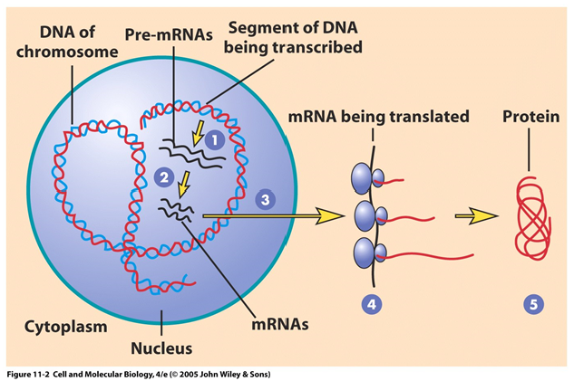
- Proteins
  - Macromolecules, constructed from unbranched chains of amino acids
  - Integral membrane proteins, transmembrane proteins, peripheral membrane proteins

Cells and Disease
- Cellular injury causes most disease, change in structure/functioning in response to a stressor
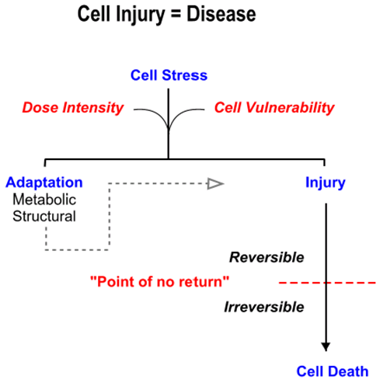

Disease-Producing Cellular Stresses
- Endogenous: originating within organism
- Exogenous: originating from external source (eg. Bacteria)
- Hypoxia
  - Depriving tissues of oxygen
  - Causes: interrupted blood supply (ischemia), pulmonary disease/hypoventilation, heart failure, impaired oxygen carrying capacity of blood
  - Depletes ATP and generates oxygen-derived free radicals
- Chemical injury
  - Number of chemicals, organic/inorganic compounds, by-products of normal metabolism, toxins synthesized by microorganisms
  - 2 mechanisms
    - Direct injury from chemical (eg. Cyanide inactivates enzyme cytochrome oxidase in mitochondria required for aerobic respiration)
    - Parent compound is harmless but metabolites are toxic (eg. Acetaminophen overdose is toxic to liver)
- Physical agents
  - Mechanical injury: crush, fractures, lacerations, hemorrhage
  - Extremes of heat/cold: burns, heat stroke, frostbite, hypothermia
  - Ionizing/non-ionizing radiation: x-rays, UV
  - Sudden changes in atmospheric pressure: blast injury, decompression injury
  - Noise trauma
- Infection
  - Exposure to pathogenic viruses, bacteria, fungi
  - Pathogenic organisms cause injury by
    - Replicating inside host cells, disrupting structural integrity (eg. Herpes)
    - Producing toxin that is harmful to host cells (eg. clostridia, diphtheria)
    - Triggering inflammatory/immune response that injures host cells (eg. Rheumatic fever, tuberculosis)
- Immune reactions
  - Exaggerated immune reactions (anaphylaxis, allergy) or inappropriate targeting of body's own cells (autoimmunity) -> chronic inflammation, cell injury
  - Suppression of immune system (drugs) can increase vulnerability to microbial invasion
- Nutritional imbalance
  - Deficiency/excess in normal cellular substrates
  - Obesity, malnutrition, scurvy, iron deficiency anemia, etc.
- Genetic abnormalities
  - Inherited/acquired mutations in genes that alter synthesis of proteins
  - Leads to developmental defects, abnormal metabolic functioning

How Cells Respond to Stress
- Adapt: alter structure/processes to achieve new homeostasis
- Injury: irreversible, functions impaired (eg. Sunburn)
- Adaptation vs injury dependent on
  - Severity of stress and duration of exposure (dose intensity)
  - Vulnerability of cells to stress
- Why cells are vulnerable
  - Genes required to respond to stress may be mutated
  - Cell is exposed to atypical stress

Disease at Cellular Level
- Adaptive structural changes
- Cell swelling
- Intracellular accumulations
- Calcification
- Enzyme leakage
- Cell death

Adaptive Structural Changes
- Modify size/shape, pattern of growth, metabolic activity
- Atrophy
  - Decrease in individual cell size due to lower rates of metabolism and decreased protein synthesis
  - Reduction in cell number via apoptosis
  - Atrophic cells have
    - Less structural proteins
    - Fewer mitochondria
    - Less endoplasmic reticulum
  - Physiological conditions: fetal development, involution of thymus, reduction in uterus post-partum
  - Pathological conditions: immobilization, loss of innervation, loss of blood supply, pressure atrophy, malnutrition, loss of endocrine stimulation, hormone-induced atrophy
- Hypertrophy
  - Increase in tissue mass due to increase in cell size (accelerated protein synthesis)
  - Physiological: increased functional demand, hormonal stimulation
  - Pathological: increased heart size in response to abnormal workload by chronic hypertension
- Hyperplasia
  - Increase in tissue mass due to increased rate of cell division
  - Increase in growth factors, activation of intracellular signaling pathways, transcription factors turn on genes -> increased cell proliferation
  - Physiological: bone marrow cells at high altitude produces more RBCs
    - Hormone stimulation: thyroid hyperplasia during pregnancy, breast tissue
  - Pathological: chronic irritation/repetitive trauma, chronic inflammation, exposure to hormones
- Metaplasia
  - Change from one type of cell to another that's better able to tolerate adverse conditions (trans-differentiation)
  - Abnormalities in: morphology, cell number, cell maturity, pre-malignant
- Dysplasia
  - Disordered cellular morphology, organization, function; loss of cellular differentiation
  - Always a pathologic process
  - Pre-malignant change, may arise subsequent to metaplasia
  - May be present for years before development of neoplasia (tumour)
  - Mild-moderate dysplasia is reversible by removal of pathologic stimuli
- Cellular adaptations
  - Remodeling: transcription -> translation -> post-translation -> metabolic
  - Genetic modification: direct interaction of transcription factors and co-activators of DNA
  - Epigenetic modifications: chemical modification of histones or methyl groups to facilitate/block access of transcriptional machinery to DNA

Cell Death
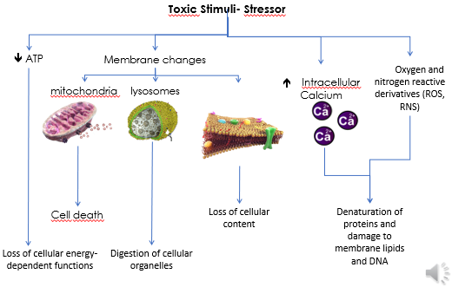
- Homeostasis
  - Membrane changes -> loss of membrane integrity, leakage of cell contents
  - Ions maintained at intracellular levels according to homeostasis
- Increasing intracellular calcium
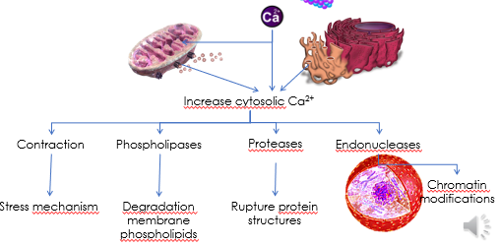
- Depletion of ATP
  - Ischemia: reduced oxygenated blood flowing to cells, form of hypoxia
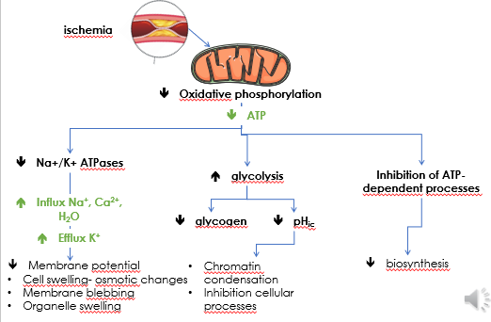

Reactive oxygen (ROS) and Nitrogen (RNS) Species
- ROS: formed as by-product of cellular metabolism
  - Cell has many enzymes to break down ROS
  - Exogenous stress -> ROS levels rise and damage cells
- RNS: produced in body, increases at times of stress
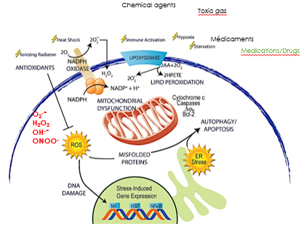

Necrosis
- Inflammation and secondary injury to surrounding tissues
- Enzymatic digestion of cell by its own hydrolytic lysosomal enzymes (liquefaction necrosis)
- Denaturation and precipitation of cellular proteins (coagulation necrosis)

Apoptosis
- Programmed cell death
- Normal physiologic process designed to eliminate unwanted, abnormal cells
- Does not induce inflammation
  - Absence of membrane lysis
  - Emission of signals allowing phagocytosis of apoptotic bodies
- Morphological changes
  - Formation of membrane blebs
  - Compaction and nuclear fragmentation
  - Permeabilization of mitochondrial membranes
  - Formation of apoptotic bodies
- Pathways
  - Intrinsic: triggered by internal factors
  - Extrinsic: triggered by extracellular signals
- Role
  - Developing embryo, hormone-dependent tissues, aging
  - Process in tissue remodeling (embryogenesis)
  - Opposes cell proliferation, inhibition of apoptosis favourable for tumour growth
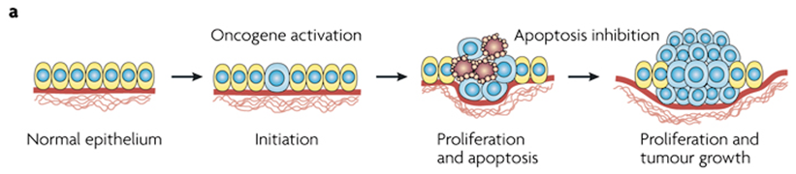
- Digit formation
  - If cells in interdigital space fail to undergo apoptosis, fetus will be born with webbed hands/feet (syndactyly)

Necrosis VS Apoptosis
 | Necrosis | Apoptosis
Stimuli | Pathologic  consequence of irreversible cell injury | Physiologic  Genetically regulated
Histology | Large numbers of cells affected  - Cell swelling  - Cellular acidosis  - Organelle disruption  - Loss of membrane integrity  - Coagulation/liquefaction of proteins | Few cells affected  - Cell shrinkage due to hydrolysis and cross-linking of proteins  - Organelles remain normal  - Cell breaks down into apoptotic bodies
DNA breakdown | Random  Diffuse fragmentation/dissolution of nucleus | Orderly  nuclear condensation and fragmentation
Tissue reaction | Inflammation + secondary injury | No inflammation or secondary injury

Autophagy
- Induced by nutrient deprivation
- Cell degrades its cellular constituents to provide essential elements for survival (eg. Amino acids)
- Formation of autophagosomes that fuse with lysosomes
- Can degrade small molecules or whole organelles
- Occurs during cell stress -> leads to injury
  - Can be "quality control" mechanism rather than cell death
- Benefits: remove damaged organelles, limit infection, metabolic substrates for adaptive protein synthesis and bioenergetic needs
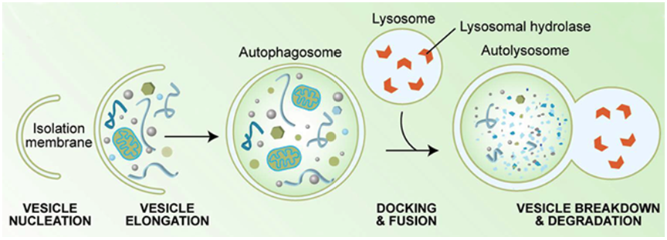

Cell Death
- Homeostasis
  - Membrane changes -> loss of membrane integrity, leakage of cell contents
  - Ions maintained at intracellular levels according to homeostasis
- Increasing intracellular calcium
- Depletion of ATP
  - Ischemia: reduced oxygenated blood flowing to cells, form of hypoxia

Reactive oxygen (ROS) and Nitrogen (RNS) Species
- ROS: formed as by-product of cellular metabolism
  - Cell has many enzymes to break down ROS
  - Exogenous stress -> ROS levels rise and damage cells
- RNS: produced in body, increases at times of stress

Necrosis
- Inflammation and secondary injury to surrounding tissues
- Enzymatic digestion of cell by its own hydrolytic lysosomal enzymes (liquefaction necrosis)
- Denaturation and precipitation of cellular proteins (coagulation necrosis)

Apoptosis
- Programmed cell death
- Normal physiologic process designed to eliminate unwanted, abnormal cells
- Does not induce inflammation
  - Absence of membrane lysis
  - Emission of signals allowing phagocytosis of apoptotic bodies
- Morphological changes
  - Formation of membrane blebs
  - Compaction and nuclear fragmentation
  - Permeabilization of mitochondrial membranes
  - Formation of apoptotic bodies
- Pathways
  - Intrinsic: triggered by internal factors
  - Extrinsic: triggered by extracellular signals
- Role
  - Developing embryo, hormone-dependent tissues, aging
  - Process in tissue remodeling (embryogenesis)
  - Opposes cell proliferation, inhibition of apoptosis favourable for tumour growth
- Digit formation
  - If cells in interdigital space fail to undergo apoptosis, fetus will be born with webbed hands/feet (syndactyly)

Necrosis VS Apoptosis
 | Necrosis | Apoptosis
Stimuli | Pathologic  consequence of irreversible cell injury | Physiologic  Genetically regulated
Histology | Large numbers of cells affected  - Cell swelling  - Cellular acidosis  - Organelle disruption  - Loss of membrane integrity  - Coagulation/liquefaction of proteins | Few cells affected  - Cell shrinkage due to hydrolysis and cross-linking of proteins  - Organelles remain normal  - Cell breaks down into apoptotic bodies
DNA breakdown | Random  Diffuse fragmentation/dissolution of nucleus | Orderly  nuclear condensation and fragmentation
Tissue reaction | Inflammation + secondary injury | No inflammation or secondary injury

Autophagy
- Induced by nutrient deprivation
- Cell degrades its cellular constituents to provide essential elements for survival (eg. Amino acids)
- Formation of autophagosomes that fuse with lysosomes
- Can degrade small molecules or whole organelles
- Occurs during cell stress -> leads to injury
  - Can be "quality control" mechanism rather than cell death
- Benefits: remove damaged organelles, limit infection, metabolic substrates for adaptive protein synthesis and bioenergetic needs
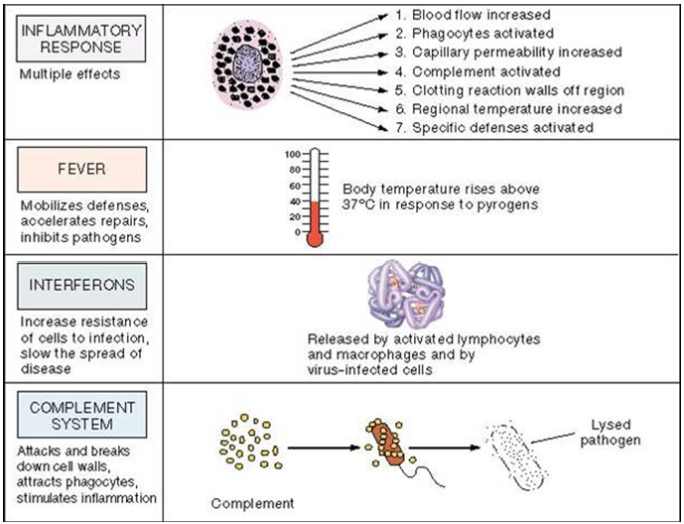

Inflammation
- Accumulation of fluid in interstitial space -> enlarged tissues
- Symptoms
  - Redness: caused by dilation of capillaries, slowing blood flow
  - Swelling: caused by transudation (movement out of vessel) of plasma from dilated vessels, fluid in inflamed tissue increases
  - Tenderness/pain: secondary to irritation of sensory nerve endings
- Process: vasodilation, increased tissue permeability
  - Damaged tissues release histamines, increase blood flow to the area
  - Histamines cause capillaries to leak, releasing phagocytes and clotting factors into the wound
  - Phagocytes engulf bacteria
  - Platelets move out of capillaries to seal the wound
- Functions of inflammatory response
  - Delivery of cytokines and cells to sites of injury
  - Formation of physical barrier to prevent more tissue damage
  - Wound healing and tissue repair

Process
- Tissue trauma
  - Vasoconstriction of damaged blood vessels
  - Release of thromboxane A2 and serotonin
  - Hemostasis: blood clotting
- Histamine release
  - Dilation of non-injured blood vessels for increased blood flow to site of injury (mediated by histamines, prostaglandins)
  - Produce redness and sensation of heat (pyremia)
  - Transudation of fluid into tissue spaces (swelling)
- Increased capillary permeability
  - Small vessels become permeable to plasma proteins
  - Increase osmotic pressure of interstitial fluid
  - Water drawn out of vessels -> edema
- Cells involved
  - Chemotaxis: directed migration of WBCs to site of inflammation
  - Histamine: dilate arterioles, increase permeability
  - Serotonin: increase vascular permeability, vasoconstriction
  - Prostaglandins: vasodilation and increased permeability
  - Leukotrienes: increase permeability, chemotactic activity
  - Mast cells: granulocytes in CT, contain histamine and other chemical mediators
    - Degranulate in response to physical injury, chemical agents, immunological processes
  - Blood platelets: contain histamine and serotonin
  - Bradykinins: arteriolar dilation, increase capillary/venule permeability, increase migration of WBCs, produce pain
- Movement of neutrophils in and out of blood vessels
  - Neutrophils packed in blood vessels with RBCs, transported to site
  - 5 steps of adhesion cascade: capture, rolling, slow rolling, firm adhesion, transmigration
  - Increased endothelial expression of vascular cell adhesion molecule 1 (VCAM-1)
  - Enables leukocytes to stick to endothelium
  - Very late antigen-4 (VLA-4) binds to VCAM-1 on endothelial cells
- Inflammatory exudate
  - Exudate: fluid mixture of protein, leukocytes, debris
  - Serous: fluid accumulated in injured skin
  - Fibrinous: fibrinogen (sticky film) exudate between surfaces, causes adhesions
  - Purulent: pus
  - Hemorrhagic: ruptured capillaries, produces bloody exudate
- Wound repair
  - Resolution: dead material/debris removed by phagocytosis
  - Regeneration: proliferation of new cells, form capillary network, vessels anastomose to establish blood circulation
    - Anastomosis: joining blood vessels
    - Angiogenesis: formation of new blood vessels, mediated by vascular endothelial growth factor (VEGF)
  - Repair: fibroblasts migrate to damaged area, form granulation tissue
    - Intermediate stage: proliferation, migration of keratinocytes, fibroblasts, matrix deposition, angiogenesis
    - Late stage: remodeling of extracellular matrix, resulting in scar
  - Epithelization
    - Covering surface with epithelial tissue
Covers the wound
    - Scar forms 6-7 days post injury
  - Wound contraction
    - Pulls sides of wound together
    - Fibroblasts produce collagen to hold it together
  - Remodeling
    - Strengthen new tissue, return to function
    - Balance newly formed collagen with destruction of old collagen
    - 3 weeks-3 years
- Scars
  - Contracture: burns, skin retracts (shrinks)
  - Hypertrophic: too much collagen, stays within wound boundary
  - Keloid: raised, too much collagen, extends beyond wound boundary

