CHAPTER 1: WHY HRM?
VIDEO: What makes a successful company? It is the people that work there. The designers, the marketing teams, the software developers. HR is a very basic business function based on a set of specific processes.
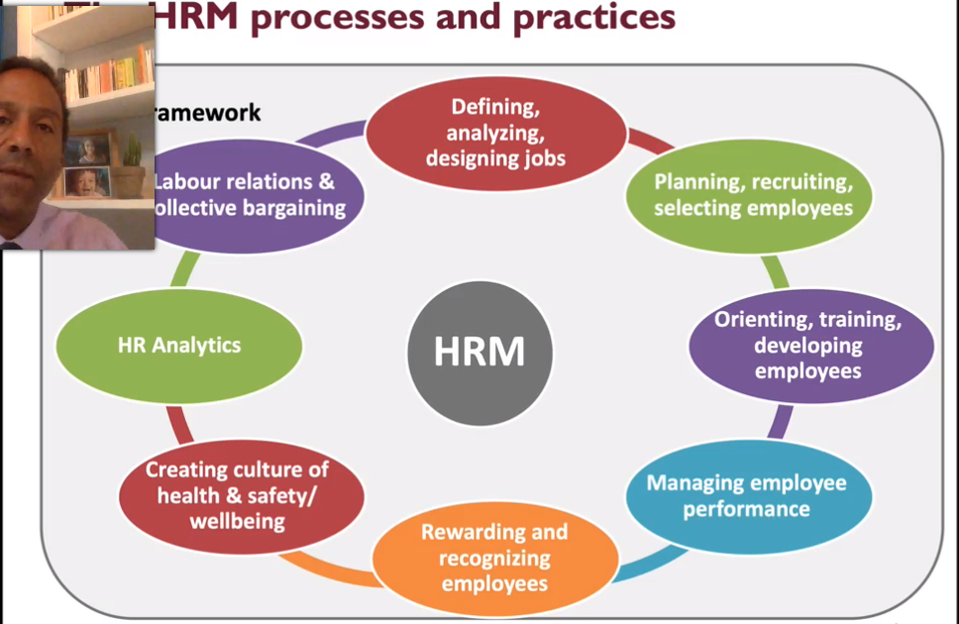
HR Processes:

HR processes is understanding the job and understanding the tasks that people need to do (job analysis and job design).
Planning and recruiting employees- bringing talents in. Deals with deciding who gets into the company and who doesn’t get in which is a very important process.
Important to give feedback to employees and identifying who is a great performer and who isn’t. Important that you recognize talents of employees and reward them appropriately either with compensation or something else.
Health and safety- important that the work place is a setting where employees can be successful and that it is a safe work environment and motivating for employees.
HR Analytics: making decisions about people using data which is extremely important for HR.
Labour relations- important in HR especially in Quebec since most of the workforce in Quebec is unionized. Important to know how to deal with a unionized workforce such as negotiating for collective agreements.
Every part of HR has a legal component. Why does HR matter?- because it is related(linked) to the success of the company. HR deals with people which is why it is important since people are essential to society, protection of people are important and which is why there is a legal system in place.HR deals with employees well being and this is why it is important to do it well.
12 sets of competencies in order to be in the HR order and that are key to become a HR professional:
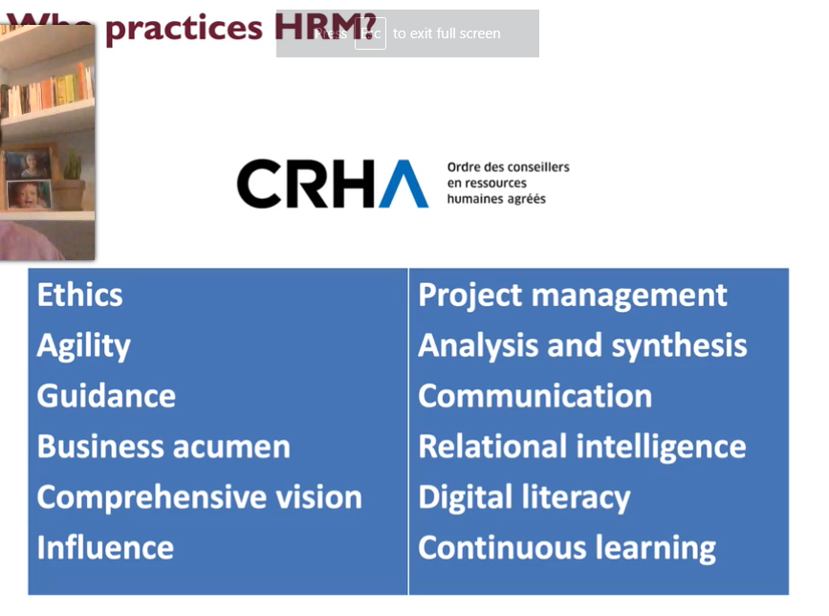

Most important competency is ethics since as a HR professional you need to follow strict professional guidelines.
Challenges of HRM (business challenges): business challenges that have an impact on HR. One of the challenges is the pandemic that changes everyone’s lives businesses included. It changes how we conduct business and these changes in business has significantly affected HR. Use of technology. Another challenge is globalization- businesses have supply chains and units around the world which has a significant impact on HR. Another challenge is technology- HR has been affected and influenced by technological advances. Conducting training, selecting employees, recruiting employees through social media. Final challenge is cost containment- businesses doing business has become more competitive due to globalization and technology, which has increased competition which made companies more conscious of their costs. HR under pressure to produce systems that increases the efficiencies of organizations and allow organizations to produce more with less.
CHAPTER 1: PERSPECTIVES
ON HUMAN RESOURCES
MANAGEMENT:
EXPLORING WHY HRM
MATTERS

HRM is a strategic process having to do with the staffing, compensation, retention, training, and employment law and policies of the business. The human resources (HR) manager will be to not only write policy and procedures and to hire people (the administrative role) but also to use strategic plans to ensure the right people are hired and trained for the right job at the right time.

Companies must view their staff as intellectual capital.

What is HRM?

Human resource management (HRM) is an integrated set of processes, practices, programs, and systems in an organization that focuses on the effective deployment and development of its employees.

HRM processes: employing people, training them, compensating them, developing policies relating to them, and developing strategies to retain them. HRM is important to an organization because in order for a company to be successful it needs its employees to support the company.

HRM was also called the personal department that was in charge of hiring people. It is separated into HRM and human resource development. HRM is critical to a company’s success and should be part of a company’s strategic plan since businesses depend on their staff to help them achieve the company’s vision and mission.

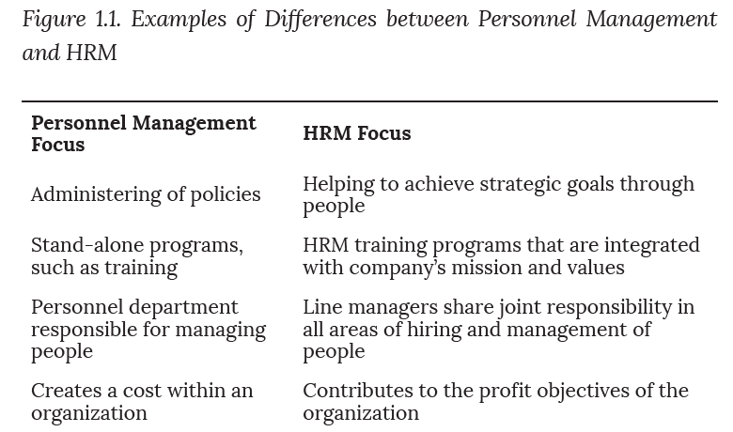

4 waves of HR evolution: Wave 1- Early 1900: Wave 1 focused on the administrative work of HR personnel, such as the terms and conditions of work, delivery of HR services, and regulatory compliance (e.g., payroll), still exists but it is done by technology or outsourcing. Wave 2- 1970’s: Wave 2 focused on innovative HR practice areas, such as, compensation, learning, and sourcing. Wave 3- 1990’s: Wave 3 HR is integrating HR strategy with the business’s strategy. Human resources began to look at the business strategy to determine what HRM priorities to work on and how to best use resources. Wave 4- 2000’s: In Wave 4, HRM became a competitive aspect for businesses. Organizations get ahead of the competition with their HRM practices.

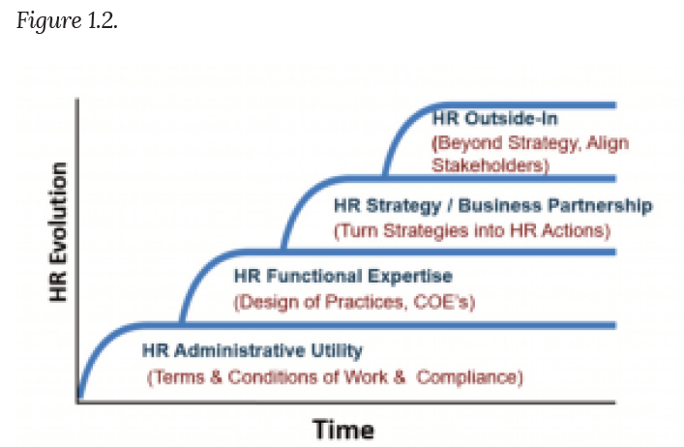

The Role of HRM in Organizations
A manager’s role is always linked with HRM, meaning that a manager will always need to do one of the tasks related to HRM such as selection, compensation, and motivation of employees.
8 Main Roles of HRM:

Dealing with Laws and Setting Policies & Procedures

Legislation and HRM: HRM needs to be aware and follow the laws concerning the workplace. The legal framework that HRM needs to follow are discrimination laws, Health and safety requirements, Compensation and benefits requirements (e.g., minimum wage and holidays), and Labour laws. The legal aspect of human resources is always changing therefore HRM needs to constantly communicate these changes to their management team.

Policies and HRM: Other than the laws that HRM needs to follow, organizations have their own policies that they put in place to ensure fairness (e.g., vacation policy above those legally mandated), to enhance effectiveness (e.g., internet usage policy), or simply to reinforce the culture (e.g., dress code). One of the roles of HRM, management and executives are to see that if by implementing policies it would solve issues in the company such as repeated tardiness of employees or lack of business etiquette of several employees in business meetings.

Job analysis and job design

For a company to be successful many tasks need to be completed by employees. For these tasks to be completed at its maximum efficiency they need to be done by capable employees. HRM is responsible for the definition and organizations of these tasks through the processes of job analysis and job design.

Talent Acquisition

Even though companies have high tech machines, humans are still needed therefore one of the major tasks of HRM is staffing. The staffing process includes hiring people, posting a job, and negotiating salaries.

4 steps of staffing: 1- Development of a staffing plan allows HRM to see how many people they should hire based on revenue expectations.
2- Development of policies to encourage multiculturalism at work. Multiculturalism in the workplace is becoming more and more important as there is an increasing amount of people from a variety of backgrounds in the workforce.

3- Recruitment. This involves finding the right people to fill the open positions.

4- Selection. At this stage, people will be interviewed and selected, and a proper compensation package will be negotiated. This step is followed by training, retention, and motivation.

Training and Development

Once the company has hired new employees the organization will ensure that they will be properly trained so that they can develop their skills and grow within the company. Training is a key factor in employee motivation since as the employee continues to grow their skills, they are happier in developing new skills which in turn the organization will have a higher productivity rate and a higher retention of employees.

Examples of training programs: Job skills training, such as how to use a computer program, Training on communication, Team-building activities, policy and legal training, such as sexual harassment training, safety training and ethics training.

Performance Assessment and Management

Another main goal of HRM is employee performance which is how good are employees at the tasks that they do. Ex: a barista needs to make a cup of coffee within a certain amount of time and present it to the customer in a pleasant manner. An employee’s performance can be defined in several different ways depending on the complexity of their job. It is HRM’s responsibility to have a system in place in order to be able to measure employees’ performances, gather those data to help the employees and the company.

Examples of performance appraisal systems: A 360 appraisal process, A behavior checklist, A graphic rating scale, MBO or management by objectives.

Once HRM has a system in place to measure employees’ performance they use this system to provide feedback for employees, determine compensation (e.g., bonus, raise, etc.), and take disciplinary measures.

Compensation and Benefits Administration

HRM needs to ensure that the compensation package given to the employees is up the industry standard and that it is high enough so that people will want to work for the company. Also, HRM needs to make sure that the compensation given is similar to the pay that other people are receiving in similar jobs in other organizations. A pay system is set in place so that employees receive their compensation package based on their number of experiences in their role, how long they have been working for their current company, their education, etc. Employee compensation includes Pay, Health benefits, Retirement plans, Stock purchase plans, Vacation time, Sick leave, Bonuses, Tuition reimbursement, etc.

Labour Relations

Labour union (aka trader’s union/worker’s union) it is an organization that is formed to best serve the interest of the employees in a company. HRM negotiate and manage union contracts which include compensation, work schedules, benefits, discipline, and other work-related processes. Labour unions are very important especially in Quebec, so it is important for HRM to have a good understand of labour unions in order to have an effective organization.

Health and Safety

The safety of employees is one of the main concerns for a company. Federal and provincial laws are created to ensure the safety of employees in the workplace. HRM needs to be aware of the requirements to ensure the safety of their employees and to ensure that they meet federal, provincial, and union requirements concerning workplace safety. Worker protection issues might include the following: Chemical hazards, heating and ventilation requirements, use of “no fragrance” zones, protection of private employee information.

HR Analytics

HRM has been affected with the continuous advancement in technology. They can collect information about employees through the Human Resources Information System to discover the performance of employees, how satisfied the employees are with their employer and based on that information can reassure and motivate their employees.

HRM as an Integrated Set of Processes

HRM can be described as a set of different processes, and each HR process is connected with the other HR processes. The effectiveness of HRM lies in how well integrated these processes are and how they are aligned to support the mission and strategy of the organization. Ex: a new policy concerning workplace bullying can only be effective if the employees are trained to respect it and if it is part of their performance appraisal.

HR Competencies

12 competencies that needs to be followed to be a successful HR professional:

Ethics: Following a code of ethics, being fair to all and protecting the public is the core value for members of a professional Order. As part of their ethical code HR professionals need to continuously avoid conflict of interest and to preserve professional confidentiality. Many HR managers are required to work with highly confidential information, such as salary information, so a sense of ethics is essential when managing this information.

Agility: HR managers need to be able to continuously adapt within the complex environment that we are in today.

Guidance: The HR professional must help individuals, teams, or organizations find and implement concrete solutions that suit their situation. The HR professional needs to support employees in solving problems or meeting their objectives.

Business Acumen: HR managers are able to find opportunities and identify strategies that when implemented in the organization will benefit the company, all the employees and society. For these to be effective it’s important that the HR manager understand what the business the company is in does and the business’s practices.

Comprehensive vision: The ability to have an overview of the organizational context, both internal and external, at the local, regional, and international levels is important for the HR professional. He or she must identify issues and opportunities in order to be proactive. (ask teacher).

Influence: The HR professional must have the ability to identify resources that can be used to effectively increase their power to act. The HR manager must have the ability to inspire confidence and direct people toward a shared goal; and to motivate people to follow their lead.

Project management: HR manager needs to be able to organize their own work, manage their times as well as others. They need to have the ability to prioritize tasks so that they can be as efficient as possible and meet the deadlines for those tasks.

Analysis and synthesis: HR manager need to be able to use the information that they have available in order to solve or understand any situation that is presented to them. HR manager needs to be able to identify all the characteristics of a problem and be able to evaluate the main issue of the problem.

Communication: The HR manager needs to be able to present the information and adapt its wording based on the situation that the HR manager is presented, in a way that is understood easily to the audience while at the same time captures their interest. They also would need to be able to write the information in a way that is understood by everyone.

Relational intelligence: HR managers needs to be able to build relationships and create meaningful connections with people.

Digital Literacy: HR managers needs to be able to understand and use computers and technologies of all kinds to help them in completing their tasks.

Continuous Learning: The HR professional needs to be able to evaluate his or her professional practice so as to continuously develop both professionally and personally. He or she demonstrates their willingness to learn new things with interest and motivation.

The HR Professional: The HR Order

HR is governed by a professional order. The role of a professional order is to: Monitor their members’ competence and integrity; Supervise the practice of the profession; and Regulate the practice of the profession.

The main goal of a professional Order is to protect the public. When the Order grants licenses to individuals it is a privilege and they are expected to meet the highest standards of integrity and compliance. Graduating with a major in HR automatically qualifies for the Order in HR. For the Quebec Order there is a language requirement.

HR Jobs: Most companies need a HR department or at least a manager who has HR skills. List of HR jobs: Recruiter/talent acquisition manager, Compensation analyst, Human resources assistant, Employee relations manager, Benefits manager, Work-life coordinator, Training and development manager, Human resources manager, Vice president for human resources.

HRM and Business Challenges

HR processes are an internal part of an organization they need to have an external focus and help organizations overcome the challenges that they face. Thus, HRM is also heavily influenced by the external environment. The HR manager needs to consider the many outside forces that may affect HR processes and the organization as a whole.

Business Challenges

Organizations need to be able to adapt to the changes in the environment, and they need to be aware about the external factors that can positively/negatively impact the company. Examples of external factors:

Globalization and offshoring
Changes to employment law
• Health, safety, and employee protection
• Employee expectations
• Diversity of the workforce
• Changing demographics of the workforce
Changes in education profile of workers
• Layoffs and downsizing
• Technology used
• Increased use of social networking

HR managers need to be aware of external factors so that they can develop policies that can meet the company’s and the customer’s needs. If a company operates without considering the external factors this will alienate the employees which will make them unhappy and unmotivated to work

four broad categories of external factors faced by organizations:

Pandemics: One of the biggest challenges that organizations had to take into consideration during the year 2020 was the pandemic. The effect that the 2008 economic crash had on HRM was an economic slowdown and major layoffs. The pandemic was unique to all the other crisis since it is essentially a human crisis. COVID brought a variety of HR issues such as turnover, absenteeism, and burn-out. It has also accelerated the transformation of HR processes such as telework, remote training, and compensation (think of all of the controversy around the salary of nursing home staff).

Globalization: Most organizations have international connections. For organizations, globalization is found in their supply chains, core activities, or customer base. The implication of globalization is significant for HRM. For HRM professionals, globalization means dealing with people from different cultures and adjusting to different employment laws and business practices.

Technological Changes: Technology has impact HR in 2 major ways. 1st: technology influences skills and competencies that employees need to perform at their job. Technology also creates a workforce that expects to be mobile since now we are able to work from home. A major challenge concerning technology is that organization needs to be kept up to date with the rapid-paced changing technology so that they can keep their employees’ technological knowledge up to date. Technology also creates additional stress on employees with an increase in job demands and sitting in front of the computer all days is mentally and physically exhausting. The ability to manage your personal brand (because of the increasing importance of social media), digital fluency, and resilience are some of the ‘super skills’ that are needed for the new world of work.

2nd way that technology influences HRM, is how HRM is delivered. There are more jobs that are being replaced by robots and AI. Interviews and training are now being done virtually, companies use social media to recruit their staff, more companies are training their employees to use VR technology to do their jobs. Benefits of VR technology for organizations: Payroll and benefits management are now fully automated. All of these processes are centralized in Human Resource Information Systems (HRIS), and as a result, the large variety of databases available to perform HR tasks is mind boggling. These systems can be very useful to track recruiting and hiring processes, compensation, and training.

Cost Containment and Efficiency: With global competition and costs increases there is more pressure on organizations to increase their efficiency and their productivity. As profit margins become smaller, every department has to look for ways to maximize its contribution for the organization. For HRM, this means that the processes it manages contribute to the ‘bottom line’ in an objective and measurable way. Ex: HRM needs to make their case on why they need a $20K budget for employee training and how this would improve productivity and profits within the company. The impact of HRM on the business is often complex and to demonstrate the impact that HRM has on a business requires a solid understanding of business principles. Ex: implementation of a wellness program- more exercise, healthier eating, organic food provided will increase costs but will make the country as a whole healthier and people will have less health issues.

CHAPTER 2: HRM, SOCIETY AND THE LAW

Video: Law and HRM is important because we need to know about how to protect the employees and the company. How to make sure that my staff are happy, motivated and wants to come to work? The law is changing because societies, social factors are extremely important when we're talking about the law. In terms of social factors, we're talking about every city. There's a lot of different nationalities and races within the workplace. Also, there's been a rise of women within the workplace. General Motors, the traditional male-dominated industry changed their CEO to a female CEO Mary Barrow. We talk a lot about in terms of the evolving workforce. The baby boomers are getting older, they are living longer, and should be out of the workforce. However, companies realize that they need the manpower and the knowledge of the baby boomers that you don't have with the new workforce. They are finding ways to have the baby boomers DO work longer.
The pandemic has forced organizations of finding new ways to do business. Working remotely has become the new norm. Organizations has realized that work can be done remotely by anyone as long has been completed. Role of HRM is not to know the law by heart but the organization wants to know what can they do so that their employees feel safe and protected? Also, to ensure that the company doesn’t get a lawsuit because of an incident that occurred in the workplace? There are various work law depending on where the company operates. The 2 most important laws in Canada are the Canadian Charter of Rights and Freedom, and the Canadian Human Rights Act. Human Rights is anything that is protected based on race, ethnicity, religion, gender, age, disability, and sexual orientation. These are taboo subjects in the workplace and should never be discussed. Discrimination can be direct or indirect(systematic). Direct discrimination is when you are clearly discriminating against any one of these different nationalities or race or gender. Indirect discrimination is when put in laws in place that indirectly discriminates against people. Ex: employer decides that everyone has to work Friday nights after sundown and Saturday as well which discriminates against the Jewish faith for the Sabath.

Harassment can be sexual or psychological. Sexual harassment most of the time won’t be very obvious. Employers should stay away from any inappropriate sexual implications. This could be sexual jokes/cartoons for either genders. Psychological harassment is harder to prove as there are 5 criterias the needs to be met. There has been an uprising of being informed about the mental well-being of employees, and employers realize that mental burnout is critical. One of the criterias are that the person has done something to purposefully harm you and has done it repetitively. As a human resource manager, your obligations are to prevent sexual/psychological harassment from happening in the workplace for your employees is to implement a good anti-harassment policy that has a zero tolerance policy concerning harassment. This is so employees will feel safe coming to work and that the organization will take their complaints seriously. And within this policy, it will speak of the different types of behaviors. You must realize that you can not cover all the behaviors. But what you can do is figure out what to do once someone is feeling harassed. If an employee is feeling harassed there are various telephone numbers that they can call which will be anonymous as the organization wants employees to feel safe when they come forward without fear of retaliation concerning harassment. Another aspect is the Code of Ethics which states what behaviour is appropriate in the workplace and what to do if you ever feel that you are being harassed or someone is taking advantage of you.

Fundamental rights concerning employment standards. This concerns how much overtime is acceptable, what is a regular work week schedule? What does the paternity and maternity look like? In Quebec, we're very fortunate to have a very good paternity and maternity leave. After they give birth, women are entitled to have a year off. And they can also share that with their partner. And the partner can't be away. They're entitled to about five weeks off to care for their newborn babies. Which is very different from the USA where they get only 6 weeks off. The other aspect that human rights will be aware of is the privacy, data privacy is at the forefront of everybody's mind. There is the personal information electronics act that protect employees and their privacy. Human resources have employees’ SIN, medical file, performance report has to be protected, and who has access to those files are part of the aspect of human resource management. Another aspect is pay equity- although now there are more women in high level roles, they are still getting paid less than men. Although the gender pay gap is narrowing it still has a long way to go.

Social Factors: The Constantly Evolving Workers

Diversity: The workforce has changed from being only white males to a wide range of race, ethnicity, gender, physical abilities, etc. HR managers wants to ensure that they hire, train and retain employees from different backgrounds. The reason that HR hires diverse group of employees beyond the legal and ethical standards required is that it make the company more competitive, and they can have access to a more diverse range of talents and increased profits. Diversity is linked to business strategy.

Employees’ Expectations: HRM needs to take into account on how employees’ values and attitudes are changing. There are 3 areas that have evolved.

Rights and ethics: In today’s society employees are more aware about their rights. With social media there is employee militancy occurring in organizations. Employees are willing to put in their effort and time to work at a company, but if that company doesn’t meet their expectations of values and ethics then they will speak out about it. Employee militancy has moved from advocating for workers right (e.g., better pay, gender equity) to pushing for a better society. Ex: Facebook employees made a virtual protest so that Facebook executives takes a tougher stance on Donald Trump’s posts.

Issues that are important to employees:

Sustainability: Amazon employees went on strike due to Amazon’s inaction regarding climate change and reducing their carbon emissions.

Privacy: A new start up have developed advanced technology for their employees so that they can gather audio date, know when the employees are sitting/standing, and track where their employees are. This advance technology is a major invasion of privacy and the employees are taking this to court.

Work life balance: Work life balance is important for employees as it reduces stress and prevents burnouts. To satisfy this desire some employers added a game room and bean bags. Although most employees states that they don’t care for these perks. It’s important for employer’s to create a flexible work environment that satisfies employees’ work life balance.

HRM and The Law

The Legal Framework

The Canadian Charter of Rights and Freedoms: HR managers need to have a clear understanding of the legal framework. The constitution Act of 1982 is the highest law in Canada, and it enshrined the Charter of Rights and Freedoms in Canada’s Constitution which guarantees fundamental rights to every human, including: rights of freedom of speech, press, assembly, association, and religion.

The Canadian Human Rights Act (CHRA): The CHRA became effective in March 1978. It proclaims that “all individuals should have an opportunity equal with other individuals to make for themselves the lives that they are able and wish to have and to have their needs accommodated, consistent with their duties and obligations as members of society, without being hindered in or prevented from doing so by discriminatory practices based on race, national or ethnic origin, colour, religion, age, sex, sexual orientation, gender identity or expression, marital status, family status, genetic characteristics, disability or conviction for an offence for which a pardon has been granted or in respect of which a record suspension has been ordered.” The impact that is has on HRM is that everyone should have an equal opportunity to work. Everyone should have these opportunities regardless of their race, gender, religion, etc.

Enforcement of Canadian human rights laws: The CHRA only applies to federal government departments and agencies, Crown corporations, and to businesses under federal jurisdictions such as banks, airlines, and communication companies. Employees of those organizations that fall under the Canadian Human Rights Laws who feel discriminated against can file complaints directly to the Canadian Human Rights Commission. Once a complaint is filed and meditation fails then the Human Rights Commissioner can decide to dismiss the complaint; send the complaint to conciliation; defer the decision and request more information and further analysis; or refer the complaint to the Canadian Human Rights Tribunal.

Quebec Human Rights Laws: Organizations that are not under the CHRA fall under the provincial human rights laws. Although federal and provincial laws are similar there are some differences one of which includes the protection of sexual orientation that was included in Quebec’s law first before any other provinces in 1977. The protections are not universal as they reflect the society that they intend to influence. Ex: basic protections in Canada need to be gone to court in the USA.

Enforcement of Provincial human rights laws: Employees that fall under the Quebec Huma Rights laws and are feeling discriminated against can file a complaint to the human rights tribunal of Quebec. As with the federal the Quebec human rights laws has a systematic process. Once an investigation is taken and submitted to the minister in charge of administering human rights legislation, and if the complaint is substantiated, the two parties are asked to reach a settlement. If no agreement is reached, the case is presented to the province’s human rights commission (tribunal).

Pay Equity: Over time the federal and provincial governments have implemented various laws to deal with the gender wage gap discrimination. In 1996 Quebec implement the Pay Equity Act to eliminate the pay discrimination against women and to enforce employers to correct the pay in female dominated jobs. Pay equity is equal pay for equal work which is based on 2 main principles- 1- Pay equality – Male and female workers must be paid the same wage rate for doing identical work. 2- males and females should be paid the same for jobs of similar nature that may have different titles.

Discrimination in Organizations

Discrimination and the Law

Discriminations laws are implemented so that they are in correspondence with the values of society. These laws do not prohibit discrimination at large, they only prohibit discrimination along certain characteristics. The Canadian Human Rights Commission states that one can’t treat a person differently because of their age, race or disability. In a sense we can discriminate against people on other characteristics other than the ones mentioned in the Canadian Human Rights Commission. Ex: discriminate against based on height, weight, favourite ice-cream, etc. It’s important for HR managers to understand discrimination so that they can take action if it occurs in the workplace.

Direct Discrimination: A discriminated action is taken based on the protected category mention in the Human Rights Commission. Ex: truck company can’t say males wanted, or women only for a waitress/waiter job.

Indirect (systemic) Discrimination: Indirect discrimination is when you treat someone the same as everyone else, but your treatment of the person has a negative effect on them because of their protected characteristic. Ex: A truck company banning cornrows or dreadlocks for its drivers. Consequence: This rule would affect Blacks more than other racial groups because they are more likely to have this hairstyle. If organizations can objectively justify the use of a criteria by showing business necessity, job relatedness or by claiming bona fide occupational qualification (BFOQ) than the criteria can be used, even if it leads to discrimination.

The Concept of Job Relatedness: The concept of job relatedness refers to the requirement that employment decisions be based on the requirements of a position. The criteria used in hiring, evaluating, promoting, and rewarding people must be directly tied to the jobs performed. Ex: warehouse requires employees to be 175cm is legal if they can prove that this is required in order to do the job as this discriminates against women.

Bona Fide Occupational Qualification: A Bona fide occupational qualification (BFOQ) is a justifiable reason for direct discrimination. Ex: requiring Catholic school teachers to be Catholic is deemed acceptable (discrimination based on religion). Also, airlines are allowed to have mandatory retirement age for pilots, for safety reason (age discrimination).

Duty to Accommodate: Organizations have an extra responsibility regarding discrimination. Employers are required to adjust their policies, rules and practices so that individuals are able to work without facing discrimination. The duty to accommodate means that sometimes it is necessary to treat someone differently in order to prevent or reduce discrimination, this is especially true when it comes to physical disabilities. Ex: employee with a speech impediment doesn’t have to answer the phone but they can do filling work instead. The law states that the limits for employer’s duty to accommodate employees up to the point of undue hardship on the employer. Undue hardship is the point where the accommodation either (a) cost too much, or (b) creates health or safety risks for all employees. Ex: Saputo has the financial means to accommodate an employee who is hearing impaired by investing in assistive listening devices such as a microphone, an amplifier, and an earpiece or headphone jack. This would be more difficult to do for your local dépanneur.

Sexual and Psychological Harassment: There needs to be a psychological harassment prevention and complaint process policy that needs to be put in place and be available to all employees. Psychological harassment includes behaviours such as verbal comments, actions/gestures of a sexual nature. Psychological/sexual harassment needs all the elements mentioned below:

Vexatious behaviour: This behaviour is humiliating, offensive or
abusive for the person receiving it and it damages their self-esteem and causes them distress.

Repetitive in nature: An accumulation of inappropriate verbal comments, gesture/behaviour is harassment. A pattern is not necessary to be considered harassment if a serious act of any of these behaviours occurs in an isolated incident it is considered harassment.

Verbal comments, gestures or behaviours that are hostile or unwanted: The comments, gestures or behaviours must be considered hostile or unwanted. If the behaviour is sexual, it can still be considered harassment even if the victim did not clearly express their refusal.

Affect the person’s dignity or integrity: Psychological or sexual harassment has a negative effect on the person by feeling put down, belittled, ridiculed at both the personal and professional levels, which also affects their physical health.

Harmful work environment: When an employee is experiencing psychological/sexual harassment the workplace becomes a harmful environment for them, and they might become isolated from their colleagues due to the hostile verbal comments, gestures/behaviours directed towards them.

all employers must:

1. Create anti-harassment policies or revise existing ones to ensure that they specifically address psychological harassment and sexual harassment in the workplace.

2. Confirm that clear and consistent internal processes to address harassment complaints are set and implement

3. Implement their new or revised anti-harassment policies as soon as possible

4. Make their new or revised policies available to all their employees.

Company-Specific Code of Ethics: Several organizations go beyond the legal obligations that they must follow and implement a code of ethics and policies for ethical decisions related to their business. Some code of ethics holds employees “accountable to the highest standards of integrity, honesty and ethics. It also means having the wisdom and courage to do the right thing.

Managing Employment Equity in Organizations

The Implementation of Employment Equity in Organizations:

1. Senior Management commitment and assignment of senior staff
2. Data collection and analysis
3. Employment systems review
4. Establishment of a work plan
5. Implementation
6. Follow-up process that includes evaluation, monitoring, and revision

Senior Management Commitment: It is essential to have senior management on board with the deal of pay equity as when the policy is written regarding pay equity and communicated to everyone and discussed frequently it will create a more supportive culture in the workplace. From top management, employment equity should be put in the hands of a senior manager, joint-labour management committees, and employment equity advisory committees.

Data Collection and Analysis: Employment equity act states that employers may gather data on members of selected groups that they have chosen as long as employees voluntarily agree to be identified or identify themselves as members of selected groups, and the data must only be used for employment equity and reporting purposes.

Types of information to be used to provide internal assessment of diversity in an organization:

Stock data: shows the status of designated groups in occupational categories and compensation levels. At Lightspeed for example, a Diversity and Inclusion annual survey showed that there were 16.8 percent of employees who identified as LGBTQ+, which is two to three times higher than other tech companies. Those employees are in the organizational chart and for different compensation levels would be considered stock data.

Flow data: provides a profile of the employment decisions affecting designated groups (i.e., interview results broken down by gender of applicants). To obtain this information a voluntary self-identification questionnaire is distributed to employees.

Employment Systems Review: Employment systems/practices is when employers do activities such as recruitment, hiring, training and development, promotion, job classification, discipline, and termination. These activities are reviewed to ensure that the job-related requirements are followed, and no members of specific groups are excluded. It is important that the principle of reasonable accommodations be respected, and that the organization attempts to adjust the working conditions or schedules of employees, such as redesign job duties, adjust schedules, and upgrade facilities to accommodate them.

Establishment of a Work Plan: The workforce analysis and the review of the employment system gives the employer a solid foundation to develop a diversity workplan with realistic goals and timetables. The workplan is a document that describes how proposed actions are to be achieved. Ex: the police wants to increase the number of visible minority in their workforce as there is a significant larger percentage of non-visible minorities in the police workforce. The city has engaged in a series of recruiting events in specific neighbourhoods to try to increase the number of minority applicants.

Implementation: Each plan is unique to each organization. Some may target specific occupations or designated groups while others may be more general. The success of these plans depends on top management’s commitment to the process, how the roles are defined, the resources available, and the effectiveness of communication strategies.

Evaluation, Monitoring, and Revision: Using stock and flow data, is important to monitor progress of diversity advantages. With careful monitoring, the employer can evaluate overall success of the initiatives and also respond to organizational and environmental changes. Annual progress reports should be provided to all employees to communicate initiatives and achievements.

CHAPTER 3: ANALYZING AND DESIGNING WORK

Video: The fundamental unit of HRM is people. HRM is about the relationship between jobs and people. For the first concept- jobs are tasks which is a set of an activity that somebody does, and a job is a set of tasks that is done by someone. For the 2nd concept- people are those that bring certain abilities, knowledge, and skills to their jobs. Ex: as a professor brings communication ability to the job. To get the refinement of jobs and people is by looking at a process called job analysis. Job analysis is a systematic way to tease out the tasks required (for the job) and the human abilities needed to perform these tasks. In HRM everything comes from a good job analysis.

If you want to train, recruit, manage performance, everything comes from a good job analysis. Job analysis is systematic analysis of a job. It’s very technical and very precise. It is like taking a picture of a moving objects. Jobs are constantly changing and as a HRM specialist need to update the job analysis. Job analysis is important because they provide the legal basis for a lot of HR decision. How do you prove job relatedness? If you're going to use 300 pound bench press as a criteria to select for a particular job. And that 300 pound bench press strength test discriminates against women because women tend to pass the test at a lower rate than men. You need to prove that that upper body strength is essential to the job. You prove this with job analysis. You are collecting information and forming a picture of a job.

Job design is shaping, building, and creating jobs. Ex: Coffee barista job there is four things/tasks that is required for you to get your coffee. Your order needs to be taken; your payment needs to be processed. The coffee needs to be made, and then your coffee needs to be served. Some coffee shops have one person do the 4 tasks and others have the 4 tasks split between 2 employees. In a job design you can add/remove tasks and modify the jobs. The purpose of job design is to make jobs better, which depends on what could make a job more efficient. Coffee shop- and look at how to accelerate the speed so you have less employees for more customers producing coffee very fast. Job design is also about how to motivate employees wanting to come to do their job. It is also about how to design a job so that there are fewer accidents in the workplace.

Job Analysis

Job analysis is a systematic process used to identify and determine what are the duties and requirements for a particular job. It also allows HR managers to understand what tasks people perform in their jobs, and the human abilities required to perform their tasks.

Job analysis aims to answer questions such as:
• What are the specific elements of the job?
• What physical and mental activities does the worker undertake?
• When is the job to be performed?
• Where is the job to be performed?
• Under what conditions is it to be performed?

Job analysis includes reviewing employees’ responsibilities, researching job description of similar jobs with their competitors and analyzing any new responsibilities that need to be added. For HRM, job analysis is the foundation for any other HR processes. Examples of how the results of job analysis can be used in HRM:
• Production of accurate job postings to attract strong candidates.
• Identification of critical knowledge, skills, and abilities required for success to include as hiring criteria.
• Identification of risks associated with the job responsibilities to prevent accidents.
• Design of performance appraisal systems that measure actual job elements.
• Development of equitable compensation plans.
• Design training programs that address specific and relevant knowledge, skills, and abilities.

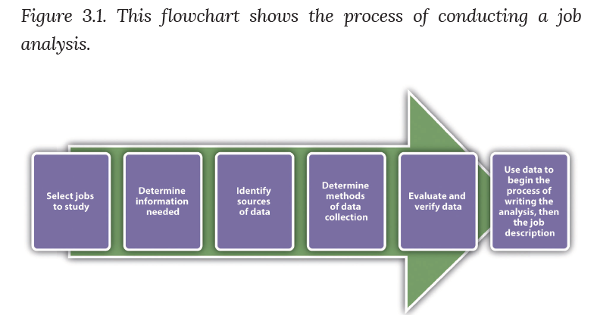

1-The Job as Unit of Analysis: As organizations grow and develop HR manager needs to look into the different elements of the jobs and determine the newer elements of the jobs and what elements are no longer required. HRM can’t build their HRM processes if they don’t have an up to date and accurate picture of the elements of the job. Ex: today’s university professors’ need to know how to use zoom in order to be able to teach. University HR needs to be aware of this so that they hire tech savvy professors which is much different from the requirements from 5 years ago. With the evolution of jobs there are new characteristics that are included in jobs, also there have been an accelerated rate of change in the job market. Ex: AI has been making a big impact. In the future most menial and even some high paying jobs will be done by AI.

2-Determine Information Needed: The information gathered from the job analysis falls in two categories: the task demands of a job and the human attributes necessary to perform these tasks. Thus, two types of job analyses can be performed: a task-based analysis or a competency- or skills-based analysis.

Task-based job analysis (most common): This type of job analysis is to identify elements of a job. The task statement expressed in this analysis is the most important element of the task analysis process. The task statement describes a worker’s actions and provides a clear, complete picture of what is being done, how it is being done and why it is being done. A task statement will answer the following questions: 1. Performs what action? (action verb) 2. To whom or what? (object of the verb) 3. To produce what? or Why is it necessary? (expected output) 4. Using what tools, equipment, work aids, processes?

When writing task statements, always begin each task statement with a verb to show the action you are taking. Also, do not use abbreviations and rely on common and easily understood terms. Be sure to make statements very clear so that a person with no knowledge of the department or the job will understand what is done. Ex: Analyze and define architecture baselines for the Program Office. Analyze and support Process Improvements for XYZ System

Competency-based job analysis: A competency-based analysis focuses on the specific knowledge and abilities an employee must have to perform the job. This analysis is more appropriate for specific, high-level positions.

3-Identify the Source(s) of Data:
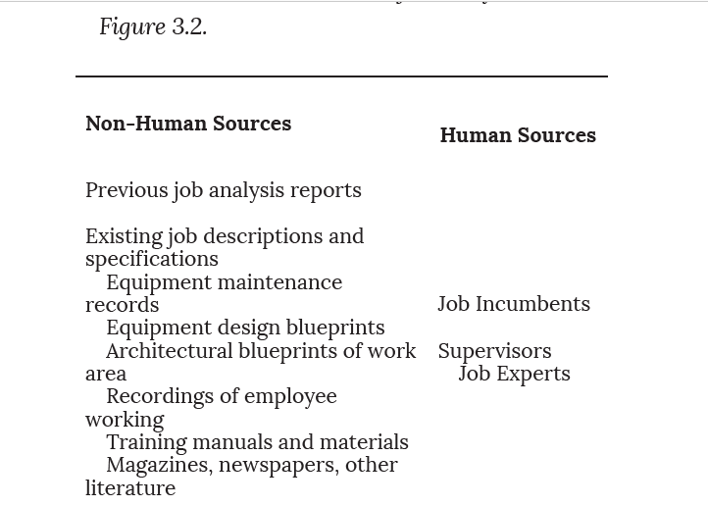

4-Determine Methods of Data Collection: The most effective method of collecting information is through direct observation, questionnaires or interviews.

Open-ended questionnaire: Managers answers questionnaires concerning the skills, knowledge and abilities required to do the job which the HR manager gathers and uses it to compile a set of job requirements needed for the job.

Structured questionnaire: These questionnaires only allow specific responses aimed at determining the nature of the tasks that are performed, their importance, frequencies, and, at times, the skills required to perform them. The structured questionnaire is helpful to define a job objectively. This questionnaire shows how an HR professional might gather data for a job analysis which can be completed on paper/online.

Interview: In a face-to-face interview, the interviewer obtains the necessary information from the employee about the KSAs needed to perform the job. The interviewer uses predetermined questions, with additional follow-up questions based on the employee’s response. This method works well for professional jobs.

Observation: Employees are observed performing their tasks which are then interpreted into the KSA’s for the job. Observation provides a realistic view of the job’s daily tasks and activities and works best for short-cycle production jobs.

Work diary or log: It is a record that includes the frequency and the timing of the tasks over time. HR analyzes the information and interprets them into duties and responsibilities.

5-Evaluate and Verify the Data: Once obtained, job analysis information needs to be validated. This can be done with workers performing the job or with the immediate supervisor, for accuracy purposes.

6-Using the Data to Yield a Job Analysis Report: Once the job analysis has been completed, it is time to write the job description. These are technical documents that can be very detailed.

Job Analysis: The Process that Defines Job Relatedness: A job analysis will be able to differentiate what elements are essential/non-essential for the job. Employers need to be able to show why certain tasks are essential/non-essential to the job. Finding out what the essential characteristics of a job are, is fundamental in determining whether some employment decisions are discriminatory or not. Ex: a job that states frequent travels must be essential to the job or else it’s discriminatory against women. Employers would still need to accommodate those with family. The purpose of a job analysis is to determine the job relatedness of employment procedures like training, selection, compensation, and performance appraisal.

To comply with the law, an employer may consider the
following questions:
1. Is the job analysis current or does it need to be updated?
2. Does the job analysis accurately reflect the needs and expectations of the employer?
3. Which are essential requirements and which are nonessential?

Job Description

Job description is a summary of the job analysis and should always include:

1. Date
2. Job title
3. National Occupation Classification (NOC) code
4. Job functions (the tasks the employee performs)
5. Knowledge, skills, and abilities (what an employee is expected
to know and be able to do, as well as personal attributes)
6. Education and experience required
7. Physical requirements of the job (ability to lift, see, or hear, for
example)

The National Occupation Classification (NOC) Code: This code provides a classification for describing the work performed by Canadians. The NOC code can •define and collect statistics related to work and jobs in Canada. • Analyze labour market trends in Canada. • Extract practical career planning information.

For example, statistics gathered for Human Resource Manager (NOC 0112) shows the following trends: Human resources managers plan, organize, direct, control and evaluate the operations of human resources and personnel departments, and develop and implement policies, programs and procedures regarding human resource planning, recruitment, collective bargaining, training and development, occupation classification and pay and benefit administration.

Tips to Writing a Good Job Description: Think of the job description as a snapshot of the job. Make sure the job description is interesting to the right candidate applying for the job. Avoid acronyms. Don’t try to fit all job aspects into the job description. Proofread the job description. Be sure to include the pertinent information:
◦ Title
◦ NOC code
◦ Department
◦ Reports to
◦ Duties and responsibilities
◦ Terms of employment
◦ Qualifications needed

Job Design: Job design is the process of organizing work into the tasks required to perform a specific job. It involves the conscious efforts to organize tasks, duties and responsibilities into a unit of work to achieve certain objectives. Job design can increase employees’ productivity and their satisfaction. When an organization is changing or expanding, human resource professionals must help plan for new jobs and shape them accordingly. To design jobs, the person must have a detailed understanding of the job and have a detailed knowledge of the tasks required to perform the job.

Designing Efficient Jobs: Job Characteristics Model: The Job characteristic model has 5 core job characteristics that are used to design jobs.

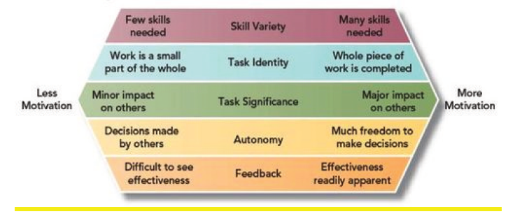

Skill Variety: the extent to which the job requires a person to utilize multiple skills. Car wash employee directing customers into the automated car wash shows low levels of skill variety. A car wash employee who acts as a cashier, maintains car wash equipment, and manages the inventory of chemicals demonstrates high skill variety.
Task identity: the degree to which a person is in charge of completing an identifiable piece of work from start to finish. A web designer who designs parts of a website will have low task identity, because the work blends in with other Web designers’ work. The webmaster who designs an entire web site will have high task identity.

Task significance: whether a person’s job significantly affects other people’s work, health, or well-being. A janitor who cleans the floors at an office building may find the job low in significance. However, janitors cleaning the floors at a hospital may see their role as essential in helping patients get better. When they feel that their tasks are significant, employees tend to feel that they have an impact on their environment, and their feelings of self-worth are boosted.

Autonomy: the degree to which a person has the freedom to decide how to perform his or her tasks. Ex: professor that needs to follow a set textbook has low autonomy, but a professor who is free to choose what textbook to use has high autonomy. An increase in autonomy, increases the motivation of employees to work because they can decide how to do their job which increases productivity for the organization.

Feedback: the degree to which people learn how effective they are being at work. Feedback at work may come from other people, such as supervisors, peers, subordinates, and customers, or it may come from the job itself. Salesperson gives presentation but isn’t informed of client’s decision has low feedback. If they get a notification that a sale was made because of the presentation, then feedback is high. whether feedback is present, the sign of feedback (positive or negative), whether the person is ready to receive the feedback, and the way feedback is given will all determine whether employees feel motivated or demotivated as a result of feedback.

The 5 core job characteristics makes employees feel that their work is meaningful, they feel responsible for the outcomes, and they gain knowledge of the results of their work. These 3 psychological states allow for an increase in job satisfaction, increase motivation, higher performance, lower absenteeism, and lower turnover rate. Even if managers design a job in a way that is supposed to motivate employees, not all employees will feel that way. In this case the manager can change the employees perspective on how they see the job to get them motivated.

Approaches to Job Design

Engineering Approach: industrial engineering is organizing the work that employees have to do in a way that maximizes their efficiency which in turn reduces the overall costs for the company. This also reduces the complexity of the work, making it so simple that almost anyone can be trained quickly and easily to perform the job. Such jobs tend to be highly specialized and repetitive. Although this can maximize efficiency, since the work will become repetitive the workers will quickly lose motivation because they’ll feel their work is meaningless. Which is why organizations combine industrial engineering with other job design approaches.

Job Enlargement: is when the scope of a job-( the activities that an employee is expected to do), is extended and additional tasks are added to the job. Job enlargements is also known as horizontal expansion of job activities. Ex: Mr.A working as an executive for a company and performing 3 activities for his job. Then through job enlargement 4 more activities are added to his existing job, he now performs 7 activities. It must be noted that the new activities which have been added should belong to the same hierarchy level in the organization. Benefits: increase in employee satisfaction, customer service and increase the chances of errors being caught. But if the activities added are too simple this would decrease employee motivation.

Job Enrichment: It’s a job design approach to make employees’ work interesting by giving them more responsibilities than what the job was originally intended for to create professional growth and recognition. Benefits: reduced turnover rate, increased productivity and reduced absences since the employees will have more autonomy on how they do their work. A side affect of this is that employees might expect a pay raise or another form of compensation due to their increased in responsibilities and if they don’t receive it, they will loose their motivation to work. Also some employees might not want to have the autonomy of their work and can become frustrated due to this fact.

Contemporary Issues in Job Design

Certain trends that have emerged in the design of jobs in organizations. These trends are:
1. Telecommuting
2. Team-based work
3. Flexible working hours
4. Alternative work patterns
5. Artificial intelligence

Telecommuting: Due to the pandemic, working from home is the new normal. Before there was much resistance because of the worry of the lack of supervision. In the future telecommuting will have an enormous affect on organizations and on society in general.

Team-Based Work: Teamwork involves a set of tasks and activities performed by individuals who collaborate with each other to achieve a common objective. That objective can be creating a product, delivering a service, writing a report, or making a decision.

Effective teamwork requires that everyone work as one unit. Effective teams share five characteristics:
• Shared values: a common set of beliefs and principles about how and why the team members will work together
• Mutual trust: confidence between team members that each puts the best interest of the team ahead of individual priorities
• Inspiring vision: a clear direction that motivates commitment to a collective effort
• Skill/talent: the combined abilities and expertise to accomplish the required tasks and work productively with others
• Rewards: recognition of achievement toward objectives and reinforcement of behaviour that supports the team’s work
Flexible Working Hours: The adjustment of working hours based on work demands or employee preferences is an important factor in designing work. 5 day work week can be compressed in a 4 day work week with each day being a 10 hour shift. Flexible work schedule is when the employees can start early and then leave early or start late and leave late. With this schedule the employer might ask the employee to work core work hours.
Artificial Intelligence: The rise of artificial intelligence is having major implications in how work is performed. Just like how some machines are able to do physical tasks, AI would be able to do mental tasks. Ex: an accountants job of inputting data on a spreadsheet, taking a customer’s call and giving them the best solution.

