Learning Objectives
1.1 | Describe what the operations function is and how it relates to other business functions
1.2 | Discuss the key factors that have contributed to the evolution of operations and the initiation of supply chain management
1.3 | Discuss how and why businesses operate globally and explain the roles China and India play in the current global market
1.4 | Calculate and interpret productivity measures used for measuring competitiveness
1.5 | Discuss the process of developing, deploying, and monitoring the success of an operations strategy

Operations Management: the design, operation and improvement of manufacturing and service systems
Operations: a function or system that transforms inputs into outputs of greater value
- Requirements and feedback from customers are used to adjust factors in transformation process
- 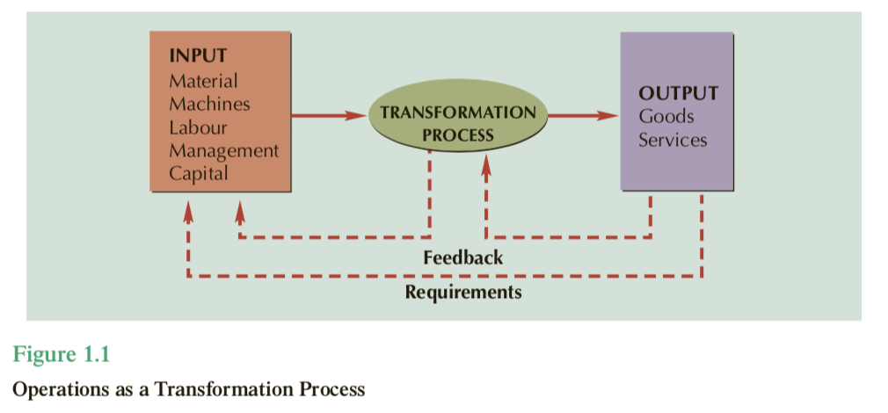
Value chain: a series of activities from supplier to customer that add value to a product or service
- Operations can take many different forms
  - Physical - manufacturing operations
  - Locational -
  - Exchange
  - Physiological
  - Psychological
  - Informational

1.1 The Operations Function
- 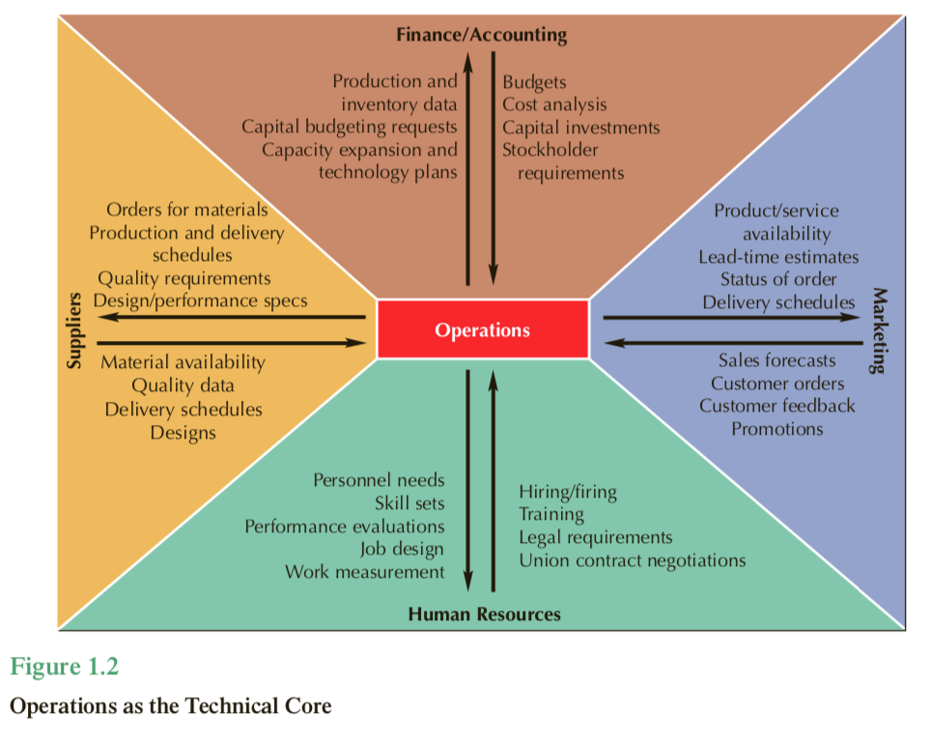

1.2 The evolution of Operations and Supply Chain Management
- Operations management did not begin until industrial revolution ins 1700s
- Prior to that, every piece was unique and made by one person, known as craft production
- Craft production: the process of handcrafting products or services for individual customers
- Now, due to coal and iron availability, machines do work, under an overseer, in a factory
- Quality revolution: an emphasis on quality and the strategic role of operations
- Lean production: an adaptation of mass production that prizes quality and flexibility
- Supply chain management: managing the flow of information, products, and services across a network of customers, enterprises, and suppliers
- It is likely, the next revolution is the Green Revolution, where industries take green initiatives

Timeline
- 1776
  - Division of Labour: dividing a job into a series of small tasks, each performed by a different worker
- 1790s
  - Interchangeable parts: the standardization of parts, initially as replacement parts, which enabled mass production
- 1800s
  - Cost accounting and other control systems
- 1900s
  - Scientific management: the systematic analysis of work methods
- 1913
  - Mass production: the high volume production of a standardized product for a mass market
- 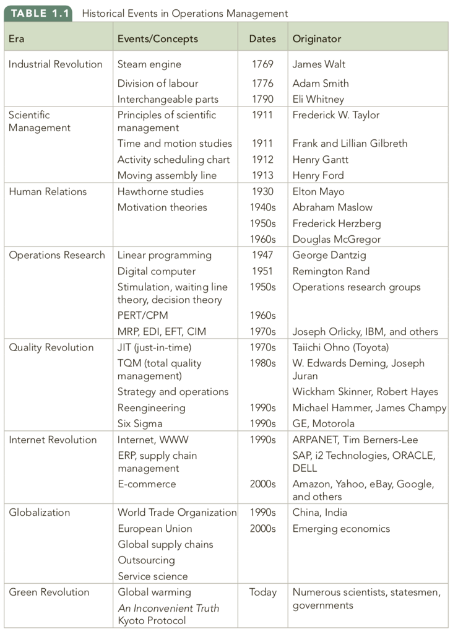

1.3 Globalization
- 2/3 of todays businesses operate through global markets
- China is the worlds largest manufacturer
- India is the worlds largest service provider - lots of outsourcing of techsupport etc, lots of highly skilled engineers / scientists

1.4 Productivity and Competitiveness
- Productivity: the ratio of output to input
  - Output can be expressed in any unit
  - Single-factor productivity: compares output with individual inputs, labour hours, investment in equipment, material, or square footage
  - Multifactor productivity: relates outputs to a combination of inputs, such as (labour + capital) for example
  - Total factor productivity: compares total quantity of goods and services produced with all the inputs used to produce them
  - Most common measure is labour hours
  - 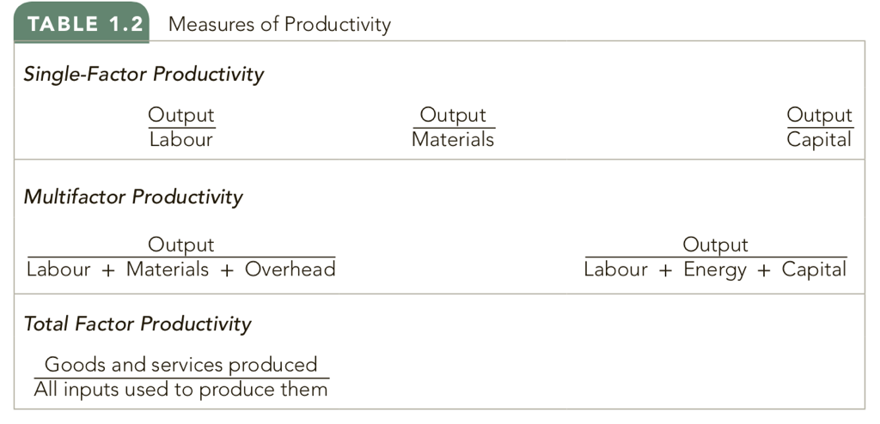
- Competitiveness: the degree to which a nation can produce goods and services that meet the test of international markets

1.5 Strategy and Operations
- Strategy: provides direction for achieving a mission
- Strategy formulation consists of five basic steps
  - Defining a primary task
    - Primary task: what the firm is in the business of doing
  - Assessing core competencies
    - Core competency: what the firm does better than anyone else
  - Determining order winners and order qualifiers
    - Order qualifiers: what qualifies an item to be considered for purchase
    - Order winner: what wins the order
  - Positioning the firm
    - Positioning: how the firm chooses to compete
      - Competing on cost
      - Competing on speed
      - Competing on quality
      - Competing on flexibility
        - Flexibility: the ability to adjust to changes in product mix, production volume, or design
        - Mass customization: the mass production of customized products
  - Deploying the strategy
    - Strategy deployment
    - Policy Deployment (hoshin planning): translates corporate strategy into measurable objectives
      - Hoshins: the action plans generated from the policy deployment process
- Balanced scorecard: a performance assessment tool that includes metrics related to customers, processes, and learning and growing, as well as financials
  - Examines finances, customers, processes, learning and growing
- Key performance indicators (KPIs): a set of measures that help manages evaluate performance in critical areas

