BIO1140 - Introduction to Cell Biology - Midterm 2
Professor: Dr. Alexandra Pettit Due - Mar 16th noon

General Instructions:
- This exam is worth 14% of your final mark.
- This exam is open book. I encourage you to use any of the materials I have given you for the class (videos, articles, molecular animations, etc…) and the notes you have created while working with this material. All answers eligible for full marks can be developed from an understanding of these materials.
- This is an individual exam, you are not to complete it in groups. Should there be evidence of collaboration or plagiarism on your submitted exam, you will face allegations of academic fraud.
- You should expect to complete the exam in ~ 90 minutes; you should NOT spend copious amounts of time reading and researching to complete the exam. Should you choose to consult any outside sources, they must be referenced as part of your answer.
- You can answer this exam in any way you choose/are able. This includes but is not limited to:
  - Printing the exam, filling it in by hand, then scanning/photographing it.
  - Answering each question by hand on a blank paper, then scanning/photographing it.
*You do not need to recopy the questions to your sheet of paper but be sure to clearly indicate which question you are answering and if you must copy sequences/images/etc… to your sheet, do so very carefully to avoid making errors.
  - Handwriting your answers digitally. (e.g. with a stylus capable of writing in e-ink)
  - Typing your responses directly into the file.
- You may ask questions via email. Question which can be answered (e.g. – the question is relevant, makes sense, and does not require disclosing the answer), will be posted along with the answer to the ‘midterm 2 questions’ discussion board on Brightspace for all students to see. Only questions of a technical nature (i.e. – submission issues) will be answered in the final 30 minutes of the exam.
- Name the digital file (use .pdf format ONLY) containing your completed exam student#_1140_midterm2_surname.pdf
(e.x - I would name my completed exam – 12345678_1140_midterm2_Pettit.pdf).
- You must submit your completed exam by noon on Mar 16th.
  - Upload a single pdf file with the entire completed exam to the "BIO1140_Midterm 2 Exam" on Brightspace by noon on Mar 16th.
  - You will receive an email confirmation of the receipt of your submission.

I do, recognize that last minute issues are at times unavoidable and I will navigate these with you on a case by case basis.

If you find yourself unable to submit your file due to technical issues (e.g. – computer crash, poor internet connectivity, etc…) you should do the following if at all possible:
- avoid re-opening your exam file after the deadline
- contact me as soon as you are aware an issue has arisen
- if possible (i.e – using your data plan or an alternative internet connection), send me your exam file via email

Helpful Hints and Tips:
- If completing the exam digitally, it is recommended that before beginning to write, that you name and save the document and also activate any automatic save function that your software may have.
- If scanning/photographing your exam to digitize a handwritten file, you may find it helpful to use a free app/program such as clear scanner (for android or iPhone) or pdf merge (web based) to compile multiple pages into a single file.

Academic Integrity Statement
Please complete the section below and submit it with your exam. If completing the exam by hand on blank paper, you do not need to re-copy the academic integrity statement, but you must sign your document.
- I have completed this assignment independently. _______ (initial here)
- I will keep the contents of this examination confidential. _______ (initial here)

By signing this statement, I am attesting to the fact that I have reviewed the entirety of my submitted work and that this assessment meets all of the rules in uOttawa’s Academic Regulations about Academic Integrity. I confirm that I did not act in any way that would constitute cheating, misrepresentation, or unfairness, including but not limited to, using unauthorized aids and assistance, impersonating another person, or providing unauthorized assistance to someone else.

Signature: _________________________________________ Date: ________________________
Name (print/type):___________________________________ Student # : ____________________

Exam Questions
The questions on the following pages ask you to consider a novel cell biology scenario. Throughout the exam, you will find pertinent background information about this specific scenario. You are expected to use the provided information AND apply the knowledge you have acquired thus far in BIO1140 to answer the questions posed.
You must answer all the questions below. Answer each question as concisely as possible, unless otherwise specified, limit yourself to no more than 2-3 sentences per response. Do not simply put all related information about a topic down to answer a question. If a question, asks you to provide a specified number of answers (e.g. – 2 reasons why something occurs) only the first X entries you include in your answer will be graded. Answers in point form and/or those accompanied by drawings will be accepted so long as they are complete.

For you master’s degree you have joined a lab that seeks to identify and investigate novel organisms that can survive in rare and challenging environments. You will be working with a research associate in the lab to continue characterizing cultured cells (e.g – cells grown in a dish) isolated cells from a complex multicellular eukaryotic organism Onlinus extremus.

Preliminary evidence from research in the laboratory has shown that O.Extremus is capable of both fermentation and cellular respiration. While they can survive on a wide variety of questionably food-like fuel sources, like most other eukaryotic organisms’, glucose is its preferred fuel source.

Question 1 (17 marks total) - Your first task in the lab is to learn how to culture these cells and begin expanding the culture (increasing the # of cells) so that you may later conduct experiments on them. You take two aliquots, each with an equal number of cells, and place them in two different culture vessels, one is a sealed airtight flask (culture 1) and the other is an open topped culture dish (culture 2). You provide both with the same growth media that contains their preferred fuel source, glucose.
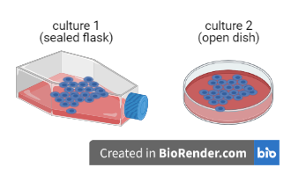
a) Are the cells in cultures 1 and 2 deriving all their energy in the same way? (1 mark) _______ (Yes or No)

Explain why or why not. Be sure to name the specific processes by which each culture is deriving its energy. (3 marks)

b) Another important part of culturing cells is changing their media to remove the waste products they produce and provide the cells with fresh nutrients. Will one of these cultures (#1 or #2 as described above) need to have their media changed more frequently than the other? (1 mark)
_______ (Yes or No)

If yes, which culture will need to have its media changed more often and why?
If no, why not? (2 marks)

Having now learned how to conduct basic cell culture, you are ready to complete your first experiments. Below is a portion of the respiration pathway in O.Extremus in which electrons are transferred from NADH to O₂; the energy of this reaction is coupled to the pumping of H⁺, and ultimately ATP production.

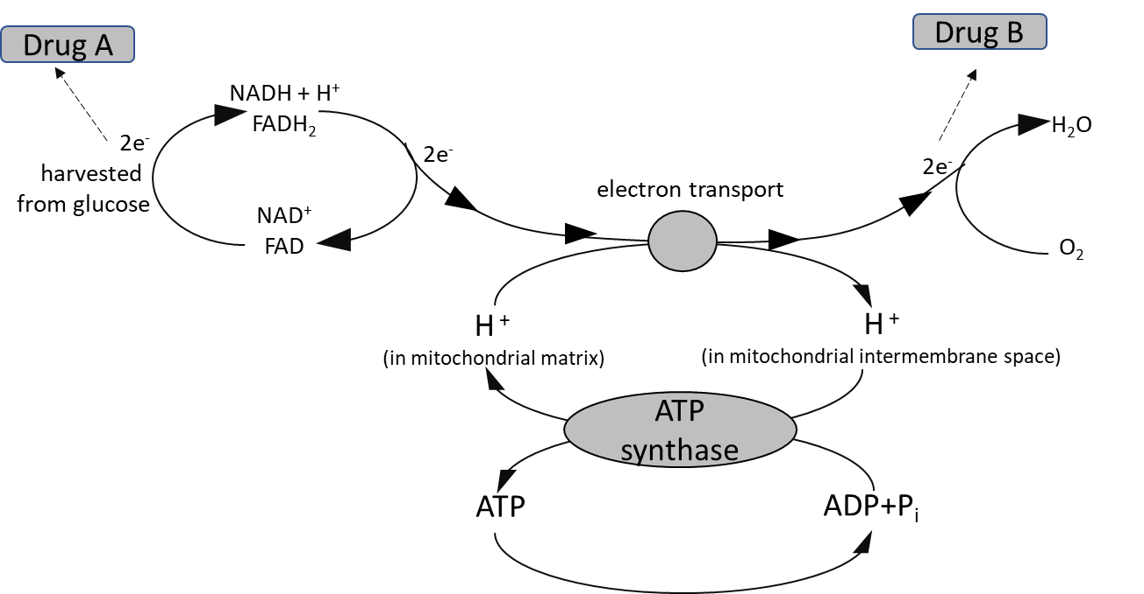

c) To learn more about the role of the electron transport chain in generating energy during respiration in this organism, you use two drugs. These drugs can each pick up electrons from specific intermediates in the pathway as shown above.

You treat cells carrying out respiration with either a saturating dose of drug A or B, so that all the electrons which would normally continue along the pathway are captured by the drug in question. Complete the following table. (8 marks)

In the presence of … | Will the cells continue to consume O₂?  Yes or No  (1 mark each) | Will the cells continue to produce CO₂?  Yes or No  (1 mark each) | Will the rate of ATP synthesis increase, decrease, or stay the same?  Explain your reasoning.  (2 marks each)
Drug A
Drug B

d) O.Extremus displays abnormally high activity levels of an enzyme called ATPase. This results in increased hydrolysis of ATP to ADP and later AMP. What effect would this have on the overall metabolic rate in these cells? Explain your reasoning. (2 mark)

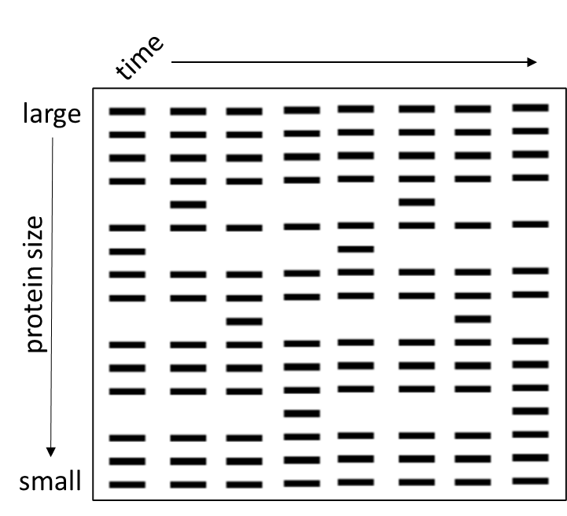
Question 2 (15 total points) - You are curious to learn if O.Extremus cells contain proteins that are similar to the cyclins found in eukaryotic cells. To determine this, you radioactively label all the proteins in the cell to allow for their visualization on a gel. Next you synchronize the cells, ensuring they are all in the same stage of the cell cycle at the same time, and then stimulate cell division by adding a growth factor. Finally, you isolate proteins from the cells at different time points and run them out on a gel such that the proteins are separated by size and visualized due to their radioactivity. The results of this experiment are below.

a) Circle ALL of the protein bands on the gel that would be good candidates for cyclin proteins. (3 marks) Explain your choices.

b) How many cell cycles did your experimental time points cover if each of the protein bands you selected above are actually cyclin proteins? Explain you answer. (2 marks)

c) Growth factor mediated cell signalling in O.Extremus begins with a receptor that is VERY similar to the PDGF receptor you remember learning about in your cell bio class. To learn more about this receptor protein, you create a series of mutants that are each missing various protein domains. Synthesis on the rough endoplasmic reticulum and trafficking along the endomembrane system occurs as expected for all three mutants but their localization and functionality vary. Using the data provided below, complete the following table. (6 marks)
Mutant | Protein location | Binds growth factor  (yes or no) | Signal transduction occurs  (yes or no) | Which protein domain  was mutated?
A | plasma membrane | no
B | extracellular |  | no
C |  | yes |  | intracellular kinase domain
d) You determine that growth factor binding to this receptor ultimately results in the activation of the G₁ cyclin-Cdk4 complex, which phosphorylates and thereby inactivates RB. This leads to the release of E2F and ultimately allows the cell to transition from G₁ to S phase. (This process is depicted below)
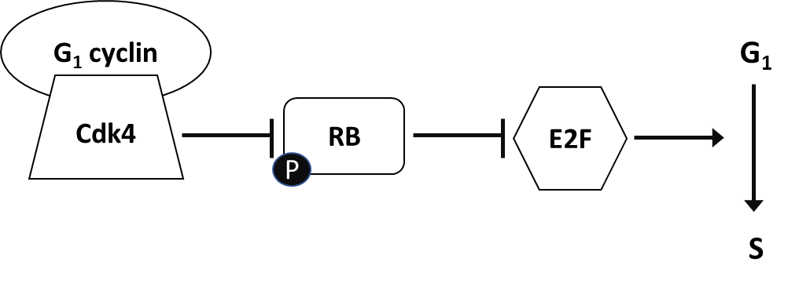

Based on your knowledge of other eukaryotic organisms, modify the diagram above to illustrate specific protein(s) that would participate in regulating this pathway if DNA damage was detected in these cells. What effect would this have on the progression of the cell cycle? If there is more than one possible outcome be sure to outline each one. (4 marks)

Question 3 (19 marks total) - Below are two cell signalling pathways that work together to regulate cell growth, proliferation and ultimately the size of organs in O.Extremus. In other closely related organisms, dysfunction of these pathways has been associated with tumor growth.
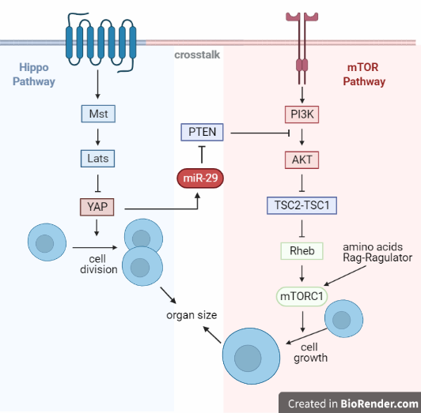
mTOR pathway:
- Growth factors bind and stimulate the receptors.
- Receptors can activate the phosphatidylinositol 3 kinase (PI3K) – Akt signaling pathway.
- The activated Akt, a serine threonine kinase, inhibits theTSC1–TSC2 complex, allowing Rheb to activate mTORC1.
- In parallel, amino acids activate the mTORC1 pathway through a mechanism requiring the Rag–Ragulator complex.

Hippo pathway:
- The binding of the ligand activates the receptors which activate Mst and Lats.

- YAP activity is modulated by phosphorylation of Mst and Lats. YAP upregulates miR-29, which in turn downregulates PTEN, an inhibitor of PI(3)K and Akt. So, the two pathways crosstalk and coordinate cell number and growth.
a) The hydrolysis of GTP to GDP is a reversible reaction as shown below. The ΔG for the reaction is ±30.5 kJ/mol.
ΔG = ± 30.5 kJ/mol
GTP + H₂O GDP + P_{i}

Draw the reaction tracing of the forward catalyzed AND uncatalyzed reactions on the graph below. Label the reactants and the products, indicate the overall free energy change, and activation energy (E_{A}) of the reaction. (5 marks)

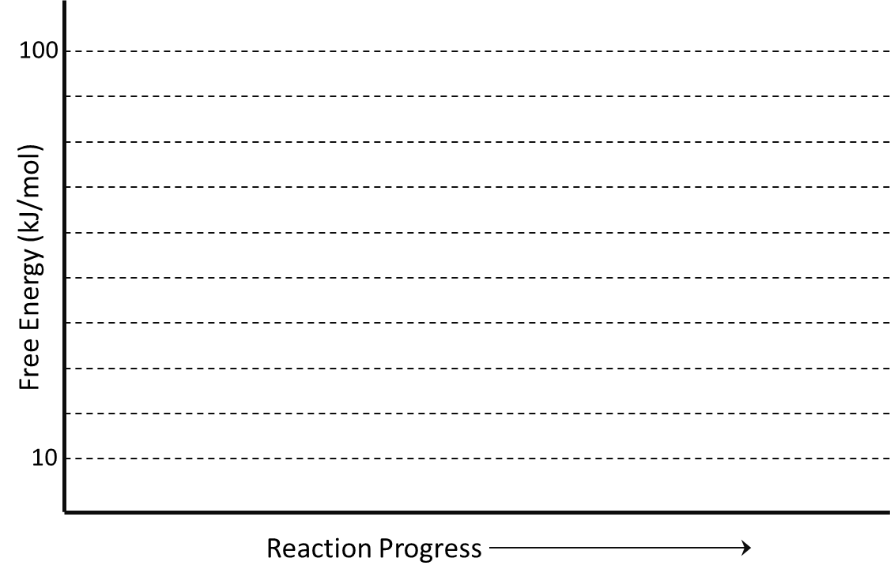

b) Which signalling pathway in the above diagram utilizes this forward reaction? Circle the correct answer. (1 mark)
mTOR pathway Hippo pathway Both pathways Neither pathway
c) Which protein possesses this enzymatic activity within that pathway? (1 mark)

d) What purpose does this forward reaction serve in that pathway? (1 mark)

e) Does the reverse reaction participate directly in this pathway? (1 mark) ___________ (Yes or No)

f) Which signalling pathway in the above diagram relies on phosphorylation/dephosphorylation as part of its transduction cascade? Circle the correct answer. (1 mark)
mTOR pathway Hippo pathway Both pathways Neither pathway

g) Consider the following mutations in different components of the signaling pathway. (9 marks)
mutant #1: A heterozygous gain-of function mutation that results in a constitutively active YAP.
mutant #2: A homozygous loss-of-function mutation in PTEN.
mutant #3: A constitutively active mTORC1

Complete the table for each of the above mutations relative to wild type (i.e. – cells that do NOT contain any mutations) reference cells that are treated with ligands that bind to both receptors. You should consider each mutation independently.
 | Oncogene or tumor suppressor gene | mTORC1 active (yes/ no) | YAP active (yes/no) | Cell growth  (more/less) | Organ size (bigger or smaller)
 | 1 mark/box | 0.5 marks/box
Mutant 1
Mutant 2
Mutant 3

