Formal Lab - Experiment 3

Experiment Title:
Extraction

Procedure:
As outlined in the lab manual (Department of Chemistry University of Ottawa, Extraction, 2013, pp. 1-6)

Results:

Part A: 1. Methyl blue is in the aqueous phase and is soluble in water
2. Methyl Red is in organic phase. Sitting on top of ether-water solution in the ether
which is less dense than the water.
5. The addition of the salt NaClc causes the purple to sit on top meaning that it is in the
organic phase.
Part B :

Figure 1:
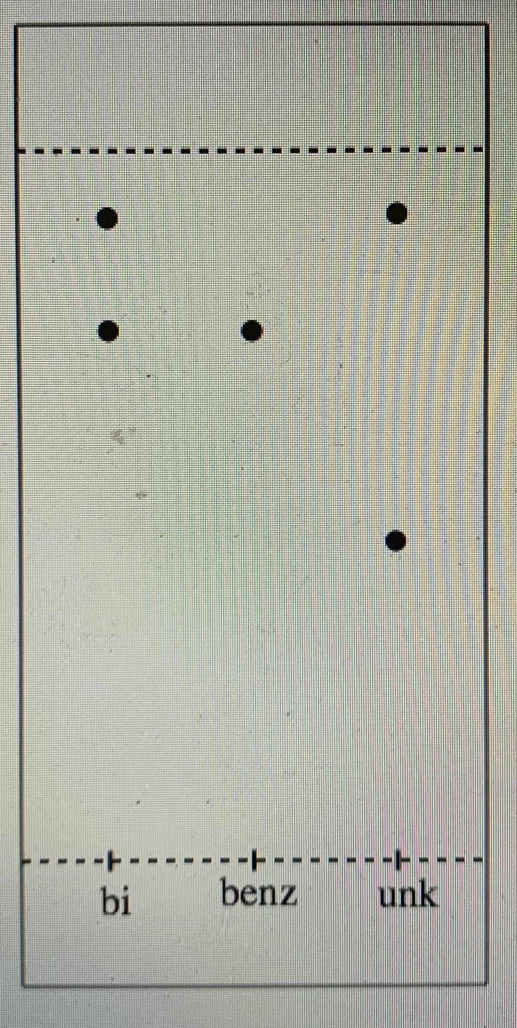
Solvent System: 2:8 mixture of ethyl acetate and hexanes

Rf_{Bi1}= 3.3/ 4.4 = 0.75
Rf_{Bi2}= 4/ 4.4 = 0.91
Rf_{Benz}= 3.3/ 4.4 = 0.75
Rf_{unk1}= 2/ 4.4 = 0.45
Rf_{unk2}= 4/ 4.4 = 0.86

Legend:

bi → biphenyl
benz → benzophenone
Unk → unknown

Figure 2:

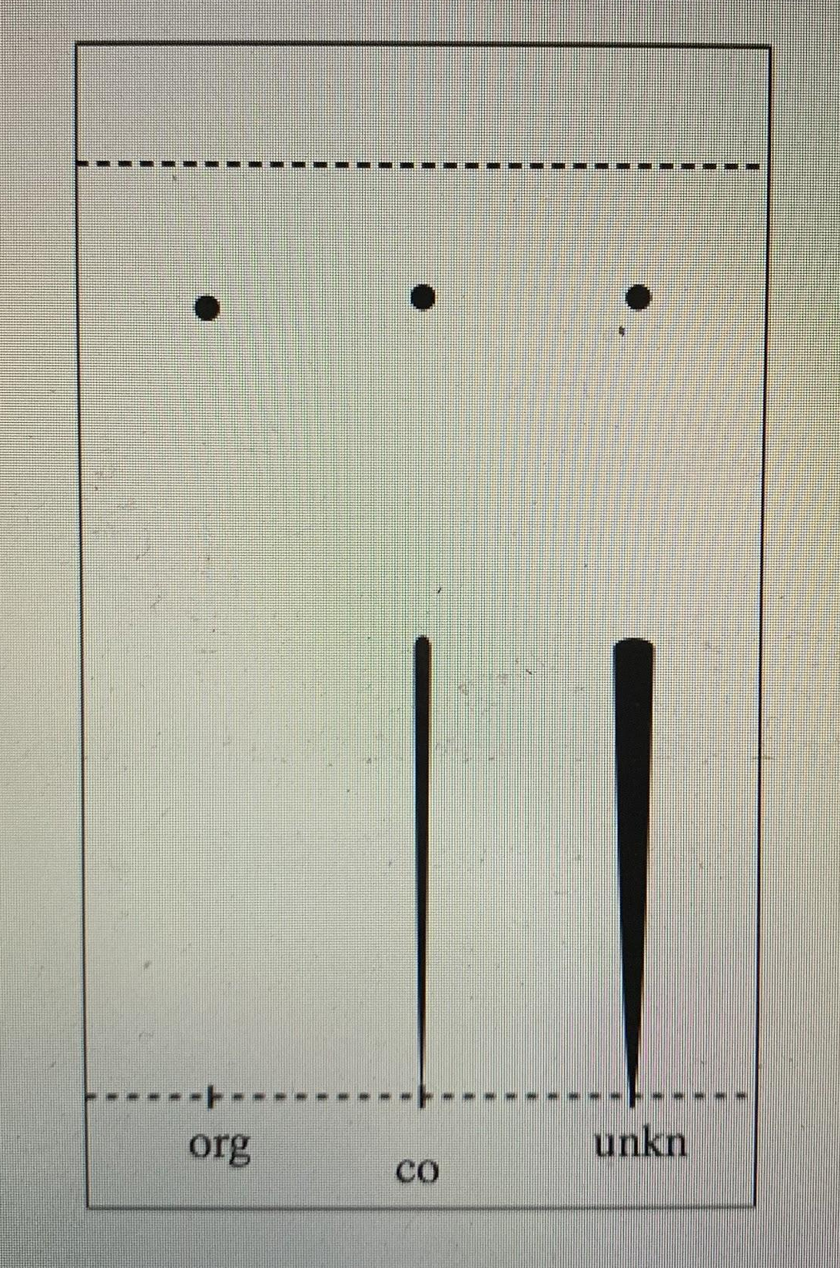
Solvent System: 2:8 mixture of ethyl acetate and hexanes

Rf_{Org}= 3/ 3.5 = 0.86
Rf_{Co1}= 1.7/ 3.5 = 0.49
Rf_{Co2}= 3/ 3.5 = 0.86
Rf_{unk1}= 1.7/ 3.5 = 0.49
Rf_{unk2}= 3/ 3.5 = 0.86

Legend:

Org → organic layer
Co → Co - Spot
Unk → Unknown

Table of Results

Unknown Sample # | 337
Initial Mass | 0.53g
Mass Obtained | 0.38g
Composition | Benzoic Acid and Biphenyl
Percent Yield | 71.7%

Flow Chart
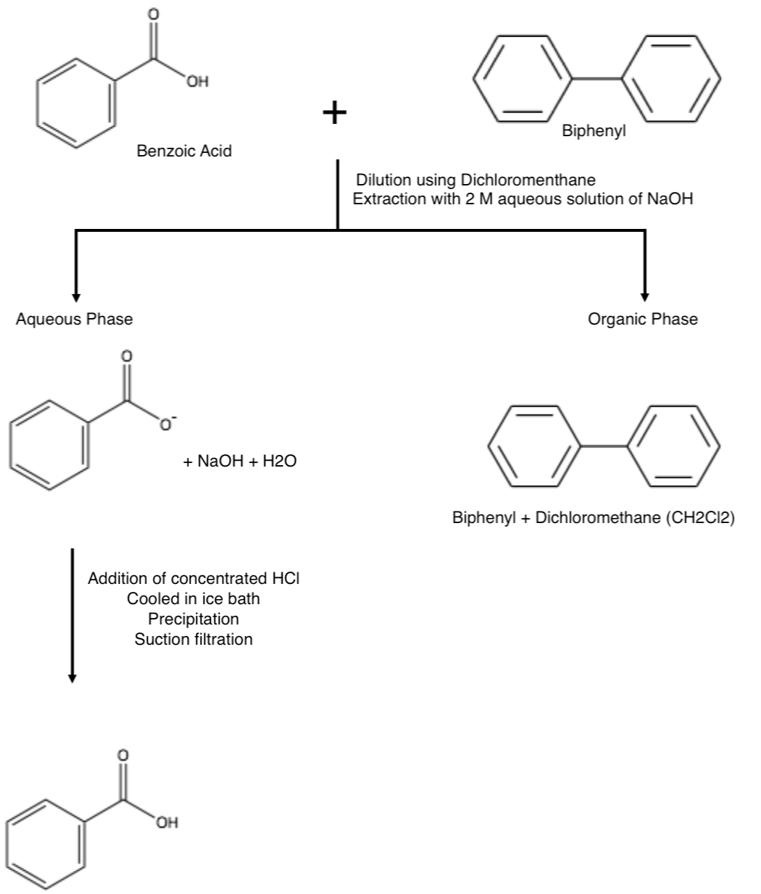

Discussion:
Part A : The methyl blue finds itself in the aqueous phase due to its solubility in water. We can recognize this by the blue colour appearing at the bottom as water is more dense than ethyl, leaving the aqueous phase at the bottom. Methyl red is in the organic phase which is evident from the yellow colour sitting on top of a clear solution. With the knowledge that ether is less dense than water and that ether is the organic phase , we can determine that the methyl red has dissolved into the organic phase. Altogether, an extraction between ether and water would be an excellent way to separate methyl blue and red. Water and ether are immiscible, Methyl blue si miscible with water and Methyl red is miscible in ether which allows them to be separated as there will be an organic phase (ether) and aqueous phase and each component will only be miscible in one. The dash of green in between the phases is a very small amount of the ether and water mixing together which will separate with time.

The salt causes the crystal violet to be more soluble in the organic phase as NaCl is more soluble in water ( aqueous phase). The NaCl makes the aqueous phase more polar, thus increasing the ionic strength of the water. In turn, it causes the crystal violet to be pushed into the organic phase (common ion of chlorine) due to the NaCl being added to saturation but one could also say that the aqueous phase was made too polar by NaCl for crystal violet to dissolve in, causing it to be repelled into the organic phase.

Part B:
- Sample of benzoic acid and unknown is found to biphenyl by TLC plate match in Figure 1 ( Rf values correspond). Sample is mixed with dichloromethane.
- Figure 1: biphenyl lane was contaminated with a little bit of benzophenone however, still able to tell which is which (benz is lower, bi is higher).
- Benzoic acid was ionized by the addition of NaOH into the separatory funnel and making the aqueous layer. Since biphenyl is non-polar, it does not react with sodium hydroxide and instead dissociates in dichloromethane which makes the organic layer. Due to dichloromethane’s chlorine molecule, it is more dense than water which means that the organic layer will be at the bottom and the aqueous will be at the top. Repetition of this step is done to obtain a greater yield of the organic phase from the aqueous layer.
- After doing reactive extraction, the aqueous phase receives an addition of concentrated HCl which acidifies the solution. This is an acid-base reaction and made a precipitate. Suction filtration and air drying was used to extract the precipitate which contains the unknown.
- The precipitate was weighed and was used to calculate the yield which denoted the effectiveness of retaining the original mass of the compound. It was found to be 71.7% effective.
- After this, thin-layer chromatography (TLC) was used to determine whether the phases were purely separated and the composition of the our unknown sample.
- Figure 1 TLC demonstrates that the composition of our sample is indeed biphenyl and benzoic acid.
- Figure 2 TLC shows that the benzoic acid was fully separated from the organic phase leaving only biphenyl.
- The TLC to validify the aqueous phase did not develop properly and there was no one else in our section who had done the same sample and completed that TLC.
- The aqueous TLC should have shown that biphenyl was fully separated from the aqueous phase (only smear for benzoic acid in aqueous lane) and the co-spo and unknown lanes would be identical to that of Figure 2.

Questions:
- It would be difficult to perform extraction because it is miscible with water, resulting in there not being an organic phase for separation.
- The addition of NaCl to such test tube would diminish the amount of dye in the aqueous phase/layer. The salt, a strong ionic compound, would take precedence in saturating the aqueous layer and reduce the space available for the dye in the aqueous phase. Thus, pushing the dye to go to the organic phase where there is space.
- Kd = Solubility of Water/ Solbi;ty of oTher
= ( 2.0g/100mL ) / ( 20.0g/100mL )
= 0.10
0.10 = ( ( 1.4g - Y ) / (100mL) ) / ( Y/ 100mL)
0.10 Y = ( 1.4 g - Y )
Y = 1.27g

So, 1.27g of Y would be removed from the water by a single extraction.
- First Extraction :
Kd= Solubility of Water/Solubility of Ether
0.10 = ( (1.4g – Y)/100 mL) ) / ( Y/50 mL )
Y = 1.17g
First extraction, 1.17 g removed.

Second Extraction:

Remaining mass = 1.4g - 1.17g = 0.23g

0.10 = ( (0.23g – Y)/100 mL) ) / ( Y/50 mL )
Y = 0.19g
Second Extraction, 0.19g removed.

After two extractions, 1.36g of Y was removed

- The student can take a sample drop of water and release it into the mixture. Water is quite polar and will dissolve into the aqueous phase which will help the student to denote the aqueous phase. Knowing which is the aqueous phase leaves the other to be the organic phase. Furthermore, a strong dye like methylene blue can be used in place of water and for this specific dye would indicate and dye the aqueous phase.
- Adding concentrated HCl to the mixture of both compounds allows benzylamine to be protonated and become charged, allowing it to be miscible in the aqueous phase. Since benzylamine has taken the aqueous phase, it pushes naphthalene to the organic phase, and in turn, creating two liquid layers that can be separated and extracted.

Calculations:
Rf Values:
Rf_{Bi1}= 3.3/ 4.4 = 0.75

Percent Yield:
% yield = (final mass) / (initial mass) x 100%
= (0.38g / 0.53g ) x 100%
= 71.7 %
The percent yield of benzoic acid is 71.7%.

Annexe:

Raw Data:


