Chapter 1:

Organizational Behaviour: a field of study devoted to understanding, explaining, and ultimately improving the attitudes and behaviours of individuals and groups in organizations

Human Resource Management (HRM): takes the theories and principles studied in OB and explores the “nuts and bolts” applications of those principles in organizations

Strategic Management: focuses on the product choices and industry characteristics that affect an organizations profitability

Frederick Taylor: was the father of scientific management (a theory of management that analyzes and synthesizes workflow); focused on using scientific methods to design optimal and efficient work processes and tasks

Max Weber:
- Another important contributor to the classical approach to management, most often associated with the term bureaucracy
- For weber the bureaucratic form was a technically superior method of organizing, coordinating, and controlling human work activities
- Father of bureaucratilc model/rational legal model; aims to formalize and rationalize authority and decision making; authority lies within the position not the person (you leave = so does your authority)
- Legacy was “red tape’ and “iron cage”

Characteristics of bureaucracy include:
- Division of labour: the division of labour with a high level of technical specialization
- Chain of command: a strict chain of command in which every member reported to someone at a higher level
- System of rules and procedures: a system of formal rules and procedures that ensured consistency, impartiality, and impersonality throughout the organization
- Decision making at the top: decision making at the top of the organization

Hawthorne studies drove the human relations movements:
- Illumination study: finding optimal lighting for factories
- Hawthorne effect: employees worked harder with changing conditions because they knew they were being watched

Why OB, who uses OB and who cares about OB?
- Firms who do a good job managing OB concepts become more profitable
- The resource-based view: a model that argues that rare and inimitable resources help firms maintain competitive advantage
  - Rare: in short supply (good people are rare)
  - Inimitable: history, numerous small decisions, quality of people, socially complex resources (culture, teamwork, trust, reputation)
- 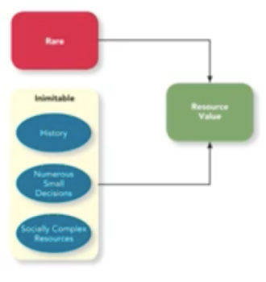
- The rule of 1/8 = only 12% of organization actually fully and effectively apply insights from OB; only half of organizations believe that managing OB has a change on their profit; half of those who do see a connection only make a single change rather than a more comprehensive and systematic approach to actually apply OB
  - One must bear in mind that one-half of organizations won’t believe the connection between how they manage their people and the profits they earn. One-half of those who do see the connection will do what many organizations have done—try to make a single change to solve their problems, not realizing that the effective management of people requires a more comprehensive and systematic approach. Of the firms that make comprehensive changes, probably only about one-half will persist with their practices long enough to actually derive economic benefits. Since one-half times one-half times one-half equals one-eighth, at best 12 percent of organizations will actually do what is required to build profits by putting people first. 1
Two Primary outcomes of OB:
- Job performance and organizational commitment
- Factors that affect the two primary outcomes
  - Individual characteristic mechanisms (cultural values, personality, ability)
  - Relational mechanisms
  - Organizational mechanisms and structure

- It turns out that making a causal inference—establishing that one variable really does cause another—requires establishing three things:27 first, that the two variables are correlated; second, that the presumed cause precedes the presumed effect in time; third, that no alternative explanation exists for the correlation. The third criterion is often fulfilled in experiments, in which researchers have more control over the setting

meta-analysis: A method that combines the results of multiple scientific studies by essentially calculating a weighted-average correlation across studies (with larger studies receiving more weight)
analytics: The use of data (rather than just opinions) to guide decision making
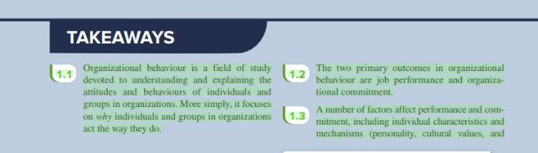
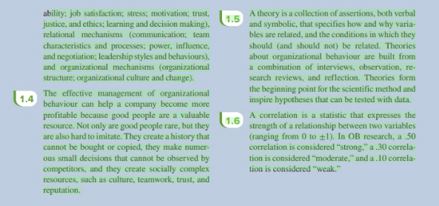Chapter 2:

job performance is formally defined as the value of the set of employee behaviours that contribute, either positively or negatively, to organizational goal accomplishment
- this definition includes behaviours within the control of employees, but it puts a boundary on which behaviours are (and are not) relevant to job performance
  - task performance
  - citizenship behaviour

Task performance: includes employee behaviours that are directly involved in the trans-formation of organizational resources into the goods or services that the organization pro-duces
- Put differently, task performance is the set of explicit obligations that an employee must fulfil to receive compensation and continued employment.
- One way of categorizing task performance is to consider the extent to which the context of the job is routine or changing. Routine task performance involves well-known responses to demands that occur in a normal, routine, or otherwise predictable way.
- In contrast, adaptive task performance, or, more commonly, adaptability, involves employee responses to task demands that are novel, unusual, or at the very least, unpredictable
- Finally, creative task performance is the degree to which individuals develop ideas or physical outcomes that are both novel and useful
- Organizations identify the behaviours that underlie task performance with job analyses; which is a process by which an organization determines requirements of specific jobs
  - The National Occupational Classification (NOC). The NOC is a primary reference on occupations in Canada that organizes over 40,000 job titles into 500 occupational group descriptions

Citizenship behaviour: voluntary employee behaviours that contribute to organizational goals by improving the context in which work takes place

- The first category of citizenship behaviour is the one with which you’re most likely to be familiar: interpersonal citizenship behaviour. Such behaviour benefits co-workers and colleagues and involves assisting, supporting, and developing other organization members in a way that goes beyond normal job expectations.
- The second category of citizenship behaviour is organizational citizenship behaviour, which means supporting and defending the company, working to improve its operations, and being especially loyal to it.28 For example, voice involves speaking up and offering constructive suggestions for change.
  - voice involves speaking up and offering constructive suggestions for change.
  - Civic virtue: refers to participating in the company’s operations at a deeper-than-normal level by attending voluntary meetings and functions, reading and keeping up with organizational announcements, and keeping abreast of business news that affects the company.
  - Boosterism means representing the organization in a positive way when out in public, away from the office, and away from work.

- Three important points should be emphasized about citizenship behaviours
- Citizenship behaviour are relevant in virtually any job, regardless of the nature of its tasks, and research suggests that these behaviours can boost organizational effectiveness; citizenship behaviours have a significant influence on the bottom line
- Because citizenship behaviours are relatively discretionary and influenced by the specific situation the employee is working in, they can vary significantly over time; citizens who engage in citizenship behaviour at one point may not engage in citizenship behaviour at another point
  - Employees can develop citizenship fatigue; worn out and on edge from engaging in citizenship behaviour for too long or in large amounts
- From and employee’s perspective it maybe tempting to discount the importance of citizenship behaviour and just focus on doing your own job tasks and avoiding any “extra work”; however, discounting citizenship behaviours is bad because supervisors don’t always see these as optional; it also can raise your job evaluation and could give you promotions and raises (it pays to be a good citizen!!)

- Counterproductive behaviour: This third broad category of job performance is counterproductive behaviour, defined as employee behaviours that intentionally hinder organizational goal accomplishment.
  - Property deviance refers to behaviours that harm the organization’s assets and posses-sions. For example, sabotage represents the intentional destruction of physical equip-ment, organizational processes, or company products
  - Production deviance is also directed against the organization but focuses specifically on reducing the efficiency of work output.
    - Wasting resources is the most common form of production deviance; it occurs when employees use too many materials or too much time to do too little work
  - in contrast to property and production deviance, political deviance refers to behaviours that intentionally disadvantage other individuals rather than the larger organization.
    - Gossiping—casual conversations about other people in which the facts are not con-firmed as true—is one form of political deviance.
    - Incivility represents communication that is rude, impolite, discourteous, and lacking in good manners.
    - Those more serious interpersonal actions may involve personal aggression, defined as hostile verbal and physical actions directed toward other employees. Harassment falls under this heading and occurs when employees are subjected to unwanted physical con-tact or verbal remarks from a colleague. Abuse also falls under this heading; it occurs when an employee is assaulted or endangered in such a way that physical and psycho-logical injuries may occur
  - 4 points should be noted about counterproductive behaviour:
- There is evidence that those who engage in one form of counterproductive behaviour also engage in others
- Like citizenship behaviour, counterproductive haviour is relevant to any job
- Counterproductive behaviour may be contagious, and its negative consequences may ripple throughout an organization
- Its often surprising which employees engage in counterproductive behaviour (its usually those who can afford to or who could likely get away with it)
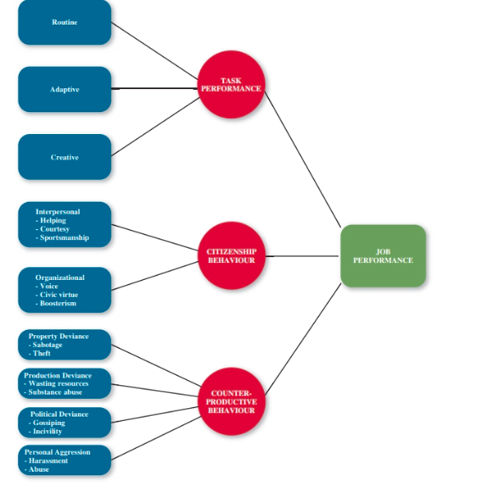

Performance Management:
- management by objectives (MBO): A management philoso-phy that bases employee evaluations on whether specific performance goals have been met
- behaviourally anchored rating scales (BARS): Use of examples of critical incidents to evaluate an employee’s job performance behaviours directly
- 360-degree feedback A performance evaluation system that uses ratings provided by supervisors, co-workers, subordinates, customers, and the employees themselves
  - the 360-degree feedback: approach involves collecting performance information not just from the supervisor but from anyone else who might have first-hand knowledge about the employee’s performance behaviours
- forced ranking: A performance management system that forces managers to rank each of their people into one of three categories: the top 20 percent, the vital middle 70 percent, or the bottom 10 percent
- sportsmanship: maintaining a positive attitude with co-workers through good and bad times
- helping: assisting co-workers who have heavy workloads, aiding them with personal matters, and showing new employees the ropes
- courtesy: sharing important information with coworkers

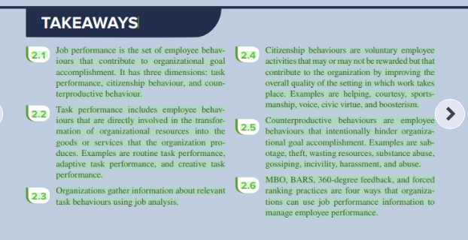
Chapter 3:

Organizational commitment: defined as the desire on the part of an employee to remain a member of the organization. 7 Organizational commitment influences whether an employee stays a member of the organization (is retained) or leaves to pursue another job (turns over).
- Employees who are not committed to their organizations engage in withdrawal behaviour, defined as a set of actions that employees perform to avoid the work situation—behaviours that may eventually culminate in quitting the organization.
- 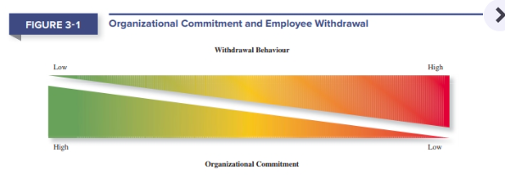

- These sorts of emotional reasons create affective commitment (sadness), defined as a desire to remain a member of an organization due to an emotional attachment to, and involvement with, that organization. 9 Put simply, you stay because you want to.
  - The erosion model suggests that employees with fewer bonds will be most likely to quit the organization
  - social influence model: A model that suggests that employees with direct linkages to co-workers who leave the organization will them-selves be more likely to leave
- These sorts of reasons create continuance commitment (anxiety), defined as a desire to remain a member of an organization because of an awareness of the costs associated with leaving it. 10 In other words, you stay because you have to.
- These sorts of reasons create normative commitment (guilt), defined as a desire to remain a member of an organization due to a feeling of obligation. 11 In this case, you stay because you ought to. 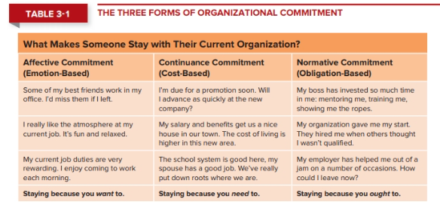
- Four primary responses to negative events at work
  - Remove yourself from the situtaion (absent from work more often); exit
  - Attempt to change the circumstances in order to work out the issues; active
  - You might just grin and bear it even though youre unhappy; loyalty
  - You might just go through the motions and mentally “check out”; neglect
- Sometimes neglect can be even more destructive than exit because you are working against the team rather than just not being a part of it

- Psychological or: consists of actions that provide a men-tal escape from the work environment
  - Looking busy
  - Day dreaming
  - Socializing instead of doing work
- physical withdrawal: A physical escape from the work environment
  - long breaks
  - missing meetings
  - tardiness
  - absenteeism: A form of physical withdrawal in which employees do not show up for an entire day of work

- withdrawal models
  - independent forms model of withdrawal, which argues that the various withdrawal behaviours are uncorrelated with one another, occur for different reasons, and fulfil different needs on the part of employees
  - compensatory forms model of withdrawal, which argues that the various withdrawal behaviours negatively correlate with one another—that doing one means you’re less likely to do another.
  - progression model: A model indicating that the various withdrawal behaviours are positively correlated, so that engaging in one type of withdrawal makes one more likely to engage in other type
- social contracts
  - psychological contracts reflect employees’ beliefs about what they owe the organization and what the organization owes them.
  - transactional contracts that are based on a narrow set of specific monetary obligations
- commitment initiatives
  - perceived organizational support: the degree to which employees believe that the organization values their contributions and cares about their well beings
  - Commitment can also be fostered by specific initiatives directed at the three commitment types
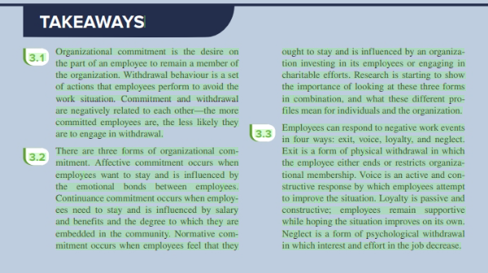
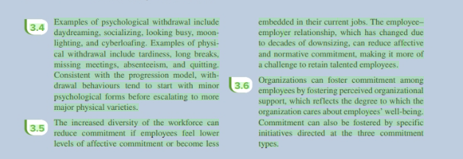
Chapter 4:

Cultural values: defined as shared beliefs about desirable end states or modes of conduct in a given culture.
- Culture: The shared values, beliefs, motives, identities, and interpretations that result from common experiences of members of a society and are transmitted across generations
  - individualism–collectivism: The degree to which a culture has a loosely knit social framework (individualism) or a tight social framework (collectivism)
  - power distance: The degree to which a culture prefers equal power distribution (low power distance) or an unequal power distribution (high power distance)
  - uncertainty avoidance: The degree to which a culture tolerates ambiguous situations (low uncertainty avoidance) or feels threatened by them (high uncertainty avoidance)
  - masculinity–femininity: The degree to which a culture values stereotypically male traits (masculinity) or stereotypically female traits (femininity)
  - short-term vs. Long-term orientation: The degree to which a culture stresses values that are past-and present-oriented (short-term orientation) or future-oriented (long-term orientation)

Personality: the structures and propensities inside people that explain their characteristic patterns of thought, emotion, and behaviour.
- The 5 big factors of personality: (big five taxonomy)
  - Conscientiousness: Dimension of personality-reflecting traits like being dependable, organized, reliable, ambitious, hard-working, and persevering
  - Agreeableness: Dimension of personality-reflecting traits like being kind, cooperative, sympathetic, helpful, courteous, and warm
  - Neuroticism: Dimension of personality-reflecting traits like being nervous, moody, emotional, insecure, jealous, and unstable
    - negative affectivity: A dispositional tendency to experience unpleasant moods such as hostility, nervousness, and annoyance
    - locus of control: One’s tendency to view the cause of events and personal outcomes as internally or externally controlled
  - openness to experience: Dimension of personality-reflecting traits like being curious, imaginative, creative, complex, refined, and sophisticated
  - extraversion: Dimension of personality-reflecting traits like being talkative, sociable, passionate, assertive, bold, and dominant
    - zero acquaintance situations: Situations in which two people have just met
    - status striving A strong desire to obtain power and influence within a social structure as a means of expressing one’s personality
    - positive affectivity A dispositional tendency to experience pleasant, engaging moods such as enthusiasm, excitement, and elation

Ability: the relatively stable capabilities people have to perform a particular range of different but related activities
- cognitive ability: Capabilities related to the use of knowledge to make decisions and solve problems
  - verbal ability Various capabilities associated with understanding and expressing oral and written communication
  - quantitative ability: Capabilities associated with doing basic mathematical operations and selecting and applying formulas to solve mathematical problems
  - reasoning ability: A diverse set of abilities associated with sensing and solving problems using insight, rules, and logic
  - spatial ability: Capabilities associated with visual and mental representation and manipulation of objects in space
  - perceptual ability: The capacity to perceive, understand, and recall patterns of information
- Wonderlic Personnel: Test A 12-minute test of general cognitive ability used to hire job applicant
- general cognitive ability: The general level of cognitive ability that plays an important role in determining the narrower cognitive abilities (the g factor)
- re relligence: A set of abilities related to the understanding and use of emotions that affect social functioning
  - self-awareness: The ability to recognize and understand the emotions in oneself
  - other awareness: The ability to recognize and understand the emotions that other people are feeling
  - emotion regulation: The ability to recover quickly from emotional experiences
  - use of emotions: The degree to which people can harness emotions and employ them to improve their chances of being successful in whatever they are seeking to do
- physical abilities: things related to physically being able to do things
  - strength: The degree to which the body is capable of exerting force
  - stamina: The ability of a person’s lungs and circulatory system to work efficiently while he or she is engaging in prolonged physical activity
  - flexibility: The ability to bend, stretch, twist, or reach
  - coordination: The quality of physical movement in terms of synchronization of movements and balance
  - psychomotor ability: Capabilities associated with manipulating and controlling objects
  - sensory ability: Capabilities associated with vision and hearing

typical performance: Performance in the routine conditions that surround daily job task

maximum performance: Performance in brief, special circumstances that demand a person’s best effort

situational strength: The degree to which situations have clear behavioural expectations, incentives, or instructions that make differences between individuals less important

trait activation: The degree to which situations provide cues that trigger the expression of a given personality trait

communion striving: being seen as warm, kind and cooperative

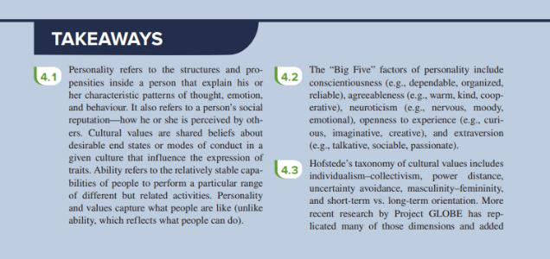
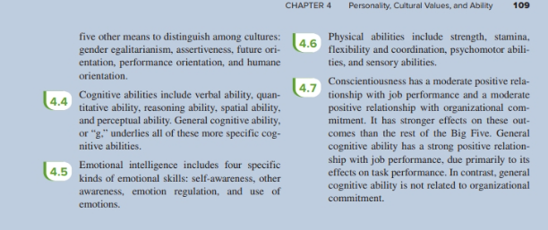
Chapter 5:
job satisfaction: A pleasurable emotional state resulting from the appraisal of one’s job or job experiences; represents how a person feels and thinks about his or her job

Value-percept theory: a theory that argues that job satisfaction depends on whether you perceive that your job supplies the things that you value
- Dissatisfaction = (Vwant – Vhave) × (Vimportance)

Facets of job satisfaction:
- promotion satisfaction: Employees’ feelings about how the company handles promotions
- pay satisfaction: Employees’ feelings about the compensation for their jobs
- supervision satisfaction: Employees’ feelings about their boss, including his or her competency, communication, and personality
- co-worker satisfaction: Employees’ feelings about their co-workers, including their abilities and personalities
- satisfaction with the work itself: Employees’ feelings about their actual work tasks

Job Characteristics theory:
- Variety: the degree to which a job requires different activities and skills
- Identity: the degree to which a job offers completion of a whole, identifiable, piece of work from beginning to end with a visible outcome
- Significance: the degree to which a job really matters and impacts society as a whole
- Autonomy: the degree to which a job provides freedom, independence, and discretion to perform the work
- Feedback: the degree to which the job itself provides information about how well the job holder is doing

- knowledge and skill: The degree to which employees have the aptitude and competence needed to succeed on their job
- growth need strength: The degree to which employees desire to develop themselves further
- job crafting: When employees shape, mould, and redefine their job in a proactive way

- Pleasantness: The degree to which an employee is in a good mood versus bad mood
- Activation: The degree to which moods are aroused and active, as opposed to unaroused and inactive
- Flow: a state in which employees feel a total immersion in the task at hand, sometimes losing track of how much time has passed
- Affective events theory: A theory that describes how workplace events can generate emotional reactions that impact work behaviours
- emotional labour: The management of their emotions that employees must do to complete their job duties successfully
- emotional contagion: The idea that emotions can be transferred from one person to another

- job satisfaction leads to life satisfaction

- Job Descriptive Index (JDI): A facet measure of job satisfaction that assesses an individual’s satisfaction with pay, promotion opportunities, supervision, co-workers, and the work its

Components of attitude:
- Cognitive
- Affective
- Behavioural
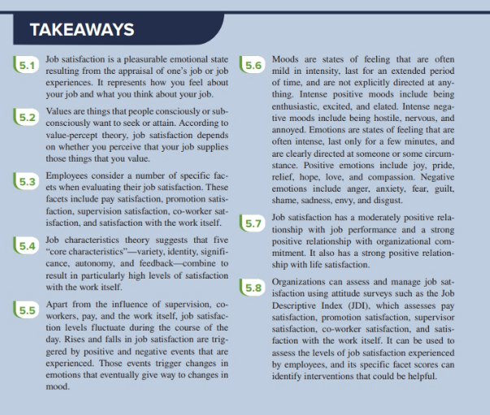

Chapter 6: mes

Stress: The psychological response to demands when there is some-thing at stake for the individual, and when coping with these demands would tax or exceed the individual’s capacity or resources
- Stressors: Demands that cause the stress response
- Strains: Negative consequences of the stress response
  - physiological strains: Reactions from stressors that harm the human body
    - psychological strains: Negative psychological reactions from stressors such as depression, anxiety, and anger
    - burnout: The emotional, mental, and physical exhaustion from coping with stressful demands on a continuing basis
  - behavioural strains Patterns of negative behaviours associated with other strains
    - Type A Behaviour Pattern: A type of behaviour exhibited by people who tend to experience more stressors, to appraise more demands as stressful, and to be prone to experiencing more strains than most others
  - Support:
    - social support: The help people receive from others when confronted with stressful demand
    - instrumental support: The help people receive from others that can be used to address a stressful demand directly
    - emotional support: The empathy and understanding people receive from others that can be used to alleviate emotional distress from stressful demands

Transactional theory of stress: a theory that explains how stressful demands are perceived and appraised as well as how people respond to the perceptions of appraisals
- primary appraisal: Evaluation of whether a demand is stressful and, if it is, the implications of the stressor in terms of personal goals and well-being
  - benign job demands: job demands that are not appraised as being stressful
  - hindrance stressors: stressors that tend to be appraised as thwarting progress toward growth and achievement
    - role conflict: others having differing expectations of what an individual needs to do in a role
    - role ambiguity: a lack of direction and information about what needs to be done in a role
    - role overload: an excess of demands on an employee preventing him or her from working effectively
    - daily hassles: minor day-to-day demands that interfere with work accomplishments
  - Challenge stressors: stressors that tend to be appraised as opportunities for growth and achievements
    - Time pressure: the sense that the amount of time allotted to do a job is not quite enough
    - Work complexity: the degree to which a job requirements tax or just exceed employee capabilities
    - Work responsibility: the number and importance of the obligations an employee has to others
    - Work-family conflict: a form of role conflict in which the demands of a work role hinder the fulfillment of the demands in a family role or vice versa
    - Negative life events: events such as a divorce or death of a family member that tend to be appraised as hinderance
    - Financial uncertainty: uncertainty with regard to the potential for loss of livelihood, savings, or the ability to pay expenses
  - Non-work stressors: things like family time demands and positive life events that can impact how an employee works
- secondary appraisal: When people determine how to cope with the various stressors, they face
  - behavioural coping: Physical activities used to deal with a stressful situation
  - cognitive coping: Thoughts used to deal with a stressful situation
  - problem-focused coping: Behaviours and cognitions of an individual intended to manage the stressful situation itself
  - emotion-focused coping: Behaviours and cognitions of an individual intended to help manage emotional reactions to the stressful demand

- stress affects job performance and organizational commitment
Stress management:
- assessment:
  - stress audit: an assessment of the sources of stress in a workplace
- reducing stressors:
  - job sharing: two people sharing the responsibilities of a single job
- providing resources:
  - training interventions: practices that increase employees’ competencies and skills
  - supportive practices: ways in which organization help employees manage and balance their demands
- reducing strain:
  - relaxation techniques: calming activities to reduce stress
  - cognitive behavioural techniques: various practices that help workers coper with life’s stressors in a rational manner
  - health and wellness programs: employee assistance programs that help workers with personal problems such as alcoholism and other addictions

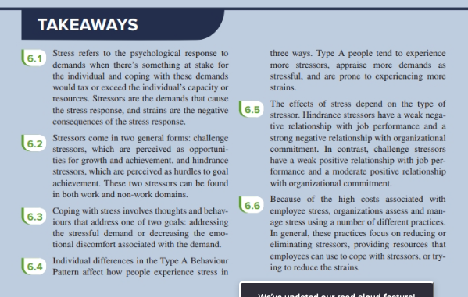

Chapter 7: Motivation

Motivation: A set of energetic forces that determine the direction, intensity, and persistence of an employee’s work effort

Engagement: A widely used term in contemporary workplaces that has different meanings depending on the context; most often refers to motivation, but can refer to affective commitment

expectancy theory: A theory that describes the cognitive process employees go through to make choices among different voluntary responses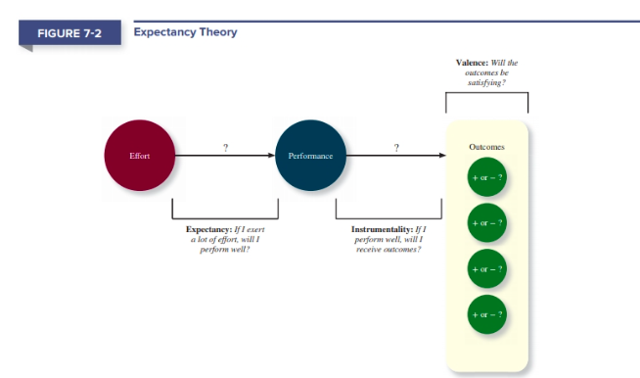

expectancy: The belief that exerting a high level of effort will result in successful performance on some task

self-efficacy: The belief that a person has the capabilities needed to perform the behaviours required on some task
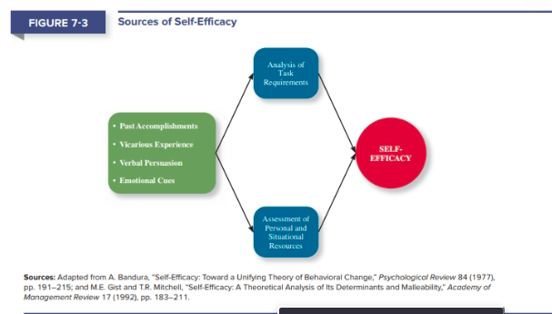

Instrumentality: The belief that successful performance will result in some outcome or outcomes

Valence: The anticipated value of the outcomes(s) associated with successful performance

Needs: Groupings or clusters of outcomes viewed as having critical psychological or physiological consequences, outcomes are deemed more attractive if they help satisfy needs

extrinsic motivation: Desire to put forth work effort due to some contingency that depends on task performance

intrinsic motivation: Desire to put forth work effort due to the sense that task performance serves as its own reward

meaning of money: The idea that money can have symbolic value (e.g., achievement, respect, freedom) in addition to economic value

Motivational Force = E → P × Σ [(P → O) × V]

goal setting theory: A theory that views goals as the primary drivers of the intensity and persistence of effort
- goal commitment: The degree to which a person is determined to reach the goal
- task complexity: the degree to which the information and actions needed to complete a task are complicated
- feedback: in job characteristics theory, the degree to which the job itself provides information about how well the job holder is doing

specific and difficult goals: Goals that stretch an employee to perform at his or her maximum level while still staying within the boundaries of his or her ability

self-set goals: The internalized goals that people use to monitor their own progress

S.M.A.R.T. goals: Specific, Measurable, Achievable, Results-based, Time-sensitive goals, which Microsoft managers are trained to encourage in employees

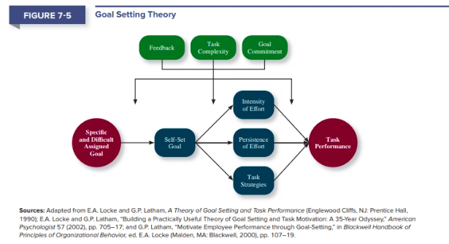

equity theory: A theory that suggests that employees create a mental ledger of the outcomes they receive for their job inputs, relative to some comparison other

comparison other: Another person who provides a frame of reference for judging equity

equity distress: An internal tension that results from being over-rewarded or under rewarded relative to some comparison other

cognitive distortion A re-evaluation of the inputs an employee brings to a job, often occurring in response to equity distress

internal comparisons: Comparing oneself to someone in your same company

external comparisons: Comparing oneself to someone in a different company

psychological empowerment: An energy rooted in the belief that tasks are contributing to some larger purpose

meaningfulness: A psychological state reflecting one’s feelings about work tasks, goals, and purposes, and the degree to which they contribute to society and fulfil one’s ideals and passions

self-determination: A sense of choice in the initiation and continuation of work tasks

competence: The capability to perform work tasks successfully

impact: The sense that a person’s actions “make a difference”—that progress is being made toward fulfilling some important purpose

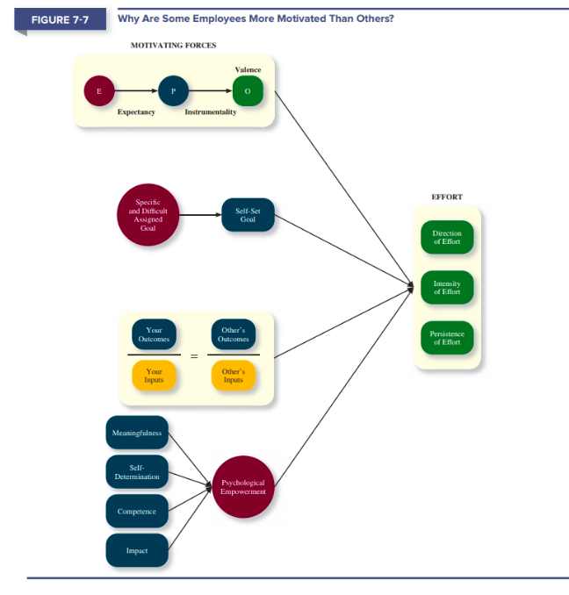

Motivation can affect job performance (strong) and organizational commitment (moderate)
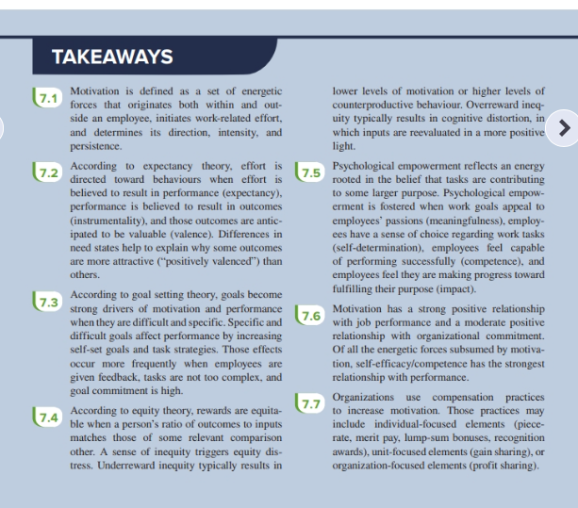

Chapter 8: trust, justice, and ethics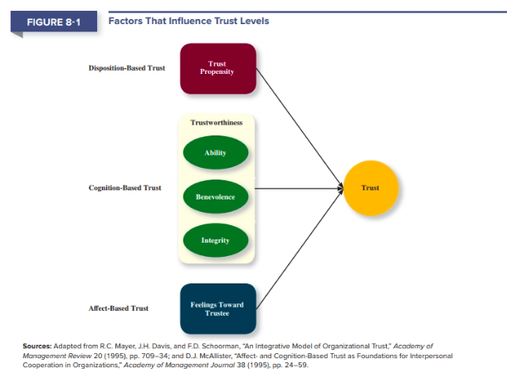

Disposition-based trust: trust rooted in one’s own personality, as opposed to a careful assessment of the trustee’s trustworthiness

Cognition-based trust: means your trust is rooted in a rational assessment of the authority of trustworthiness

Affect-based trust: means your trust depends on feelings toward the authority that go beyond any rational assessment

trustworthiness Characteristics or attributes of a person that inspire trust, including perceptions of ability, benevolence, and integrity

ability (dimension of trustworthiness): The skills, competencies, and areas of expertise that enable an authority to be successful in some specific area

benevolence (dimension of trustworthiness): The belief that an author-ity wants to do good for a trustor, apart from any selfish or profit-centred motive

integrity (dimension of trustworthiness): The perception that an authority adheres to a set of values and principles that the trustor finds acceptable

trust has a moderate correlation to job performance and a strong correlation to organizational commitment
- affects ability to focus: the degree to which employees can devote their attention to work
- economic exchange: work relationships that resemble a contractual agreement by which employees fulfil job duties in exchange for financial compensation
- social exchange: Work relationships characterized by mutual invest-ment, with employees willing to engage in “extra mile” sorts of behaviours because they trust that their efforts will eventually be rewarded

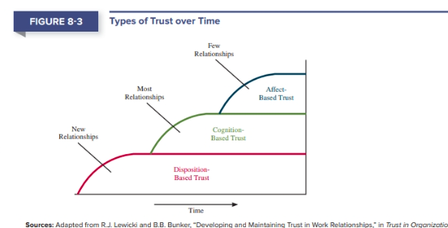

Justice:
Distributive justice: the perceived fairness of decision-making outcomes

Procedural justice: the perceived fairness of decision-making processes

Interpersonal justice: the perceived fairness of the interpersonal treatment received by employees from authorities
- on the extreme end, interpersonal unjust actions create abusive supervision: The sustained display of hostile verbal and nonverbal behaviours, excluding physical contact, by a supervisor

informational justice: The perceived fairness of the communications provided to employees from authorities

whistle-blowing Employees’ exposing illegal or immoral actions by their employer

Ethics:
Four components of the model of ethical decision making: a model that argues that ethical behaviours result from the multistage sequence of moral awareness, moral judgement, moral intent, and ethical behaviour
- moral awareness: recognition by an authority that a moral issue exists in a situation
  - moral attentiveness: the degree to which people chronically perceive and consider issues of morality during their experiences
- moral judgement: the process people use to determine whether a particular course of action is ethical or unethical
  - One of the most important factors influencing moral judgment is described in Kohlberg’s theory of cognitive moral development: this theory argues that as people age and mature, they move through various stages of moral development—each more mature and sophisticated than the prior one.
  - Moral principles: prescriptive guides for making moral judgements
- Moral intent: an authority’s degree of commitment to the moral course of action
  - Moral identity: the degree to which a person views himself or herself as a moral person
- Ethical behaviour: how we react

Organizations can become more trustworthy with good CSR

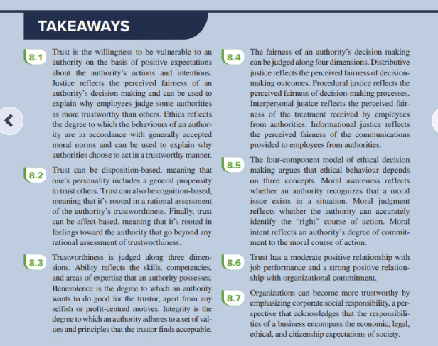

Chapter 9: Learning and Decision Making
Learning: a relatively permanent change in an employee’s knowledge or skill that results from experience

Decision Making: the process of generating and choosing from a set of alternatives to solve a problem

Expertise: the knowledge and skills that distinguish experts from novices

Explicit Knowledge: knowledge that is easily communicated and available to everyone; what we do when we study for exams

Tactic knowledge: knowledge that employees can only learn through experience; “know-how”, “know-who”, “know-what” knowledge.

Methods of learning:
- As an employee it can be hard to build a high level of tactic knowledge without some level of explicit knowledge to build from
- The tactic knowledge employees acquire can be the single most important asset a company possesses
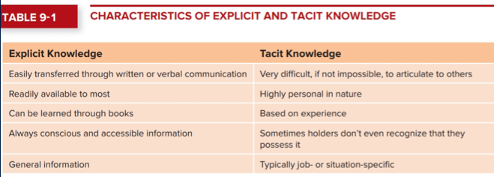

How do employees get this knowledge?

Reinforcement: “operant conditioning”; we learn by observing the link between our voluntary behaviour and the consequences that follow it

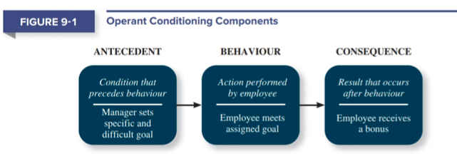
- Contingencies of reinforcement: four specific consequences used by organizations to modify employee behaviour;
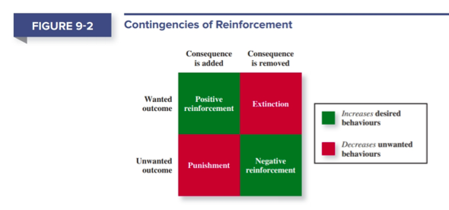
  - Positive reinforcement: occurs when a positive outcome follows a desired behaviour; offered a reward; increases desired behaviour; giving a reward for a job well done, raises, promotions etc.
  - Negative reinforcement: a reinforcement contingency in which an unwanted outcome is removed following a desired behaviour; increases desired behaviour; performing a specific task well to not get yelled at (removes unwanted outcome as a result of desired behaviour)
  - Punishment: an unwanted outcome that follows an unwanted behaviour; decreases unwanted behaviours; suspension or termination will remove unwanted behaviour
  - Extinction: the removal of a positive outcome following an unwanted behaviour; decreases unwanted behaviours; suppose a co-worker acts childish to get attention at work; finding a way to remove the attention will remove the unwanted behaviour
  - Positive reinforcement and extinction should be the most common forms of reinforcement used by managers to create learning among their employees
- Timing of reinforcement is also very important; important to examine the timing of when the contingencies are applied or removed;
- Schedules of reinforcement: the timing of when contingencies are applied or removed
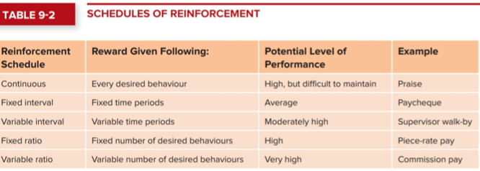
  - Continuous reinforcement: a schedule of reinforcement in which a specific consequence follows each and every occurrence of a certain behaviour
  - Fixed interval schedule: a schedule whereby reinforcement occurs at fixed time periods (most common)
  - Variable interval schedule: a schedule whereby reinforcement occurs at random periods of time
  - Fixed ratio schedule: a schedule whereby behaviours are reinforced after a varying number of them have been exhibited

Observation:
- Social learning theory: a theory that argues that in addition to learning through reinforcement, people in organizations have the ability to learn through the observation of others; argued that this is the primary way that workers learn and gain knowledge in organizations
- Behaviour modelling: employees observing the actions of others, learning from what they observe and then repeating the observed behaviour
  - Attentional process > retention Process > production process > reinforcement
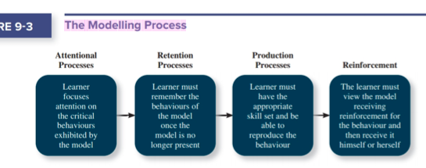
Goal orientation: people learn differently based on their goal orientation and their predispositions and attitudes toward learning and performance
- Learning oriented: a predisposition or attitude according to which building competence is deemed more important by an employee than demonstrating competence
- Performance-prove oriented: a predisposition or attitude by which employee focus on demonstrating their competence so that others think favourably of them
- Performance-avoid orientation: a predisposition or attitude by which employees focus on demonstrating their competence so that others will not think poorly of them

Methods of decision making:
- Programmed decisions: decisions that become somewhat automatic because people’s knowledge allows them to recognize and identify a situation and the course of action that is needed to be taken; realizing they’ve dealt with it before
  - Sometimes come across as intuition: an emotional judgement based on quick unconscious gut feelings
  - Intuitive decision making is very important during a crisis situation: a change whether sudden or evolving that results in an urgent problem that must be addressed immediately
    - Therefore, managers who make decisions face two major questions: How can they ensure that others follow their lead when the path is unclear, and how can they confirm that their intuition is not faulty?
- Non-programmed decision: decision that is made by an employee when a problem arises that is new, complex and not recognized
  - Rational decision-making model: a step-by-step approach to making decisions that is designed to maximize outcomes by examining all available alternatives
    - Step 1. Identify the criteria that are important in making the decision, taking into account all involved parties
    - Step 2. Generate a list of all available alternatives that might be potential solutions to the problem; evaluating them is not yet important, just list as many as possible.
    - Step 3. Evaluating the alternatives against the criteria laid out
    - Step 4. Select the alternative that results in the best outcome
    - Step 5. Implement the alternative
  - This model does assume that people are perfectly rational, although this is not true; there are not always clear and definite problems that need to be solved

Decision making problems:
- Limited information
  - Although employees may believe they are rational, they are all bound to bounded rationality: the notion that people do not have the ability or resources to process all available information and alternatives when making a decision
  - Satisficing: what results when decision makers select the first acceptable alternative considered
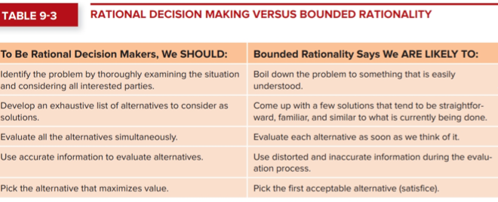
- Faulty perceptions
  - Perception: the process of selecting, organizing, storing, and retrieving information about the environment
  - Selective perception: the tendency for people to see their environment only as it affects them and is as its consistent with their expectations
  - Projection bias: the faulty perception by decision makers that others think, feel, and act as they do
  - Social identity theory: people identify themselves by the groups to which they belong and perceive and judge others according to the groups they associate with
  - Stereotype: occurs when assumptions are made about others on the basis of their membership in a social group
  - Heuristics: simple and efficient rules of thumb that allow one to make decisions more easily; not bad; lead to correct decisions more often than not but can also lead us to inaccurate decisions.
  - Availability bias: the tendency for people to base their judgements on information that is easier to recall; people are scared to fly because crashes get so much more publicity, but ultimately planes are safe because they statistically rarely fail
  - Types of bias
    - Anchoring: tendency to rely to heavily on one trait or piece of information even when the anchor may be unreliable or irrelevant
    - Framing: tendency to make different decisions on the basis of how a question or situation is phrased
    - Representativeness: tendency to assess the likelihood of an event by comparing it to a similar event and assuming it will be similar
    - contrast: tendency to judge things erroneously based on a reference that is near to them
    - recency: tendency to weigh recent events more than earlier events
    - ratio effect: tendency to judge the same probability of an unlikely event as lower when the probability is presented in the form of a ratio of smaller rather than of larger numbers

- faulty attributions: attributions;
  - fundamental attribution: argues that people have a tendency to judge others’ behaviours as due to internal factors
  - self-serving bias: occurs when we attribute our own failures to external factors and our own successes to internal factors
  - consensus: used by decision makers to attribute cause; whether other individuals behave the same way under similar circumstances
  - distinctiveness: used by decision makers to attribute cause; whether the person being judged acts in a similar fashion under different circumstances
  - consistency: used by decision makers to attribute cause; whether the individual has behaved this way before under similar circumstances
- escalation of commitment: focuses on what happens as a decision begins to go wrong; a common decision-making error, in which the decision maker continues to follow a failing course of action

Is learning important for OB?
- Yes; it affects job performance because it is moderately correlated with task performance
- Learning is only weakly related to organizational commitment

Training: a systematic effort by organizations to facilitate the learning of job-related knowledge and behaviour
- Knowledge transfer: the exchange of knowledge between employees
- Behaviour modelling training: when employees observe the actions of others, learn from what they observe, and then repeat the observed behaviour
- Communities of practice: groups of employees who learn from one another through collaboration over an extended period of time
- Transfer of training: occurs when employees retain and demonstrate the knowledge, skills, and behaviours required for their job after training ends
- Climate for transfer: an organizational environment that supports the use of new skills
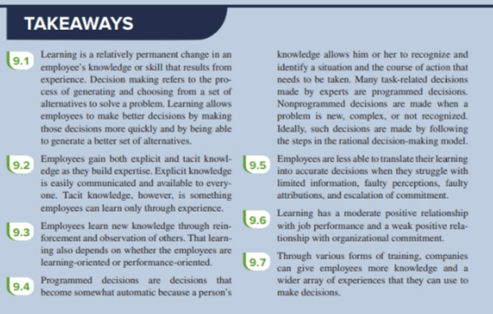

Chapter 10 – communication

Communication: the process by which information and meaning is transferred from a sector to a receiver

Communication Process:
- Information
- Sender
- Encoding
- Message
- Decoding
- Receiver
- Understand

Face-to-face communication: the exchange of information and meaning when one or more individuals are physically present, and where communication occurs without the aid of nay mediating technology; natural, immediate, and embody a type of comprehensive interdependence in the sense that we “act and react” in real time to the content and tone of the messages being exchanged

Verbal communication: a form of communication in which messages and sent and received using written and spoken language
- Primary way organizational members communicate with each other

Nonverbal communication: any form of information that doesn’t involve spoken or written words; actions, body language, and demeanor

Computer-mediated communication: the exchange of information and meaning using an electronic digital medium; both an omnipresent and unavoidable reality in virtually all organizations

Web 2.0: describes websites and applications through which users actively interact, create, collaborate, and communicate

Email: a popular method of exchanging written digital messages form an author to one or more recipients; lacks the same richness as a face-to-face conversation or a telephone call; the immediacy an informal nature of emails messages encourages many senders to construct cryptic, idiosyncratic messages that can be hard to interpret; likelihood of conflicts and misunderstandings increases substantially among those who are limited to email communication; concern is the sheer volume of emails

Videoconferencing: a communication medium that permits real-time, live interaction and discussion between remote individuals or groups via satellite or internet

Wiki: a highly flexible web 2.0 application that allows people to quickly exchange verbal information and collaboratively solve problems, learn, manage projects, and create knowledge
Potential issues in the communication process
- Communicator competence: the ability of communicators to encored and interpret messages
  - Ability differences with respect to these activities has been shown to be a major source of communication problems
  - Another problem relates to the emotions and emotional intelligence of the individuals involved; communicators ability to regulate their emotions and understand the emotions of others can result in clearer communication
- Noise: disturbing or distracting stimuli that block or interfere with the transmission of a message. Face to face communication is particularly sensitive to the presence or absence of noise
- Information richness: the amount of depth of the information transmitted in a message
  - Face-to-face has the highest level of richness bc senders can convey meaning through words, body language, facial expression, and tone of voice. And they can get feedback
  - Computer generated reports that consist largely of numbers is the worst end of information richness
  - Mid-range is personal written note
  - Higher information richness is desired when the task is complex and hard to understand, the more cues available to the receiver the better, however it can overcomplicate the communication process for straightforward and simple tasks
- Gender difference: different ways men and women tend to process and interpret information and communicate with others
  - men tend to use a process that allows then to maintain/achieve status, independence, and power
  - women tend to send messages and use a style that builds and strengthens their relationships
  - these can be serious because they can lead to miscommunication and misunderstandings between men and women during communication
- privacy: a state in which individuals can express themselves freely without being observed, recorded, or disturbed by other, unauthorized individuals or groups
  - anonymity allows people to feel like they can say whatever they want, however in an organization this is not necessarily true

- being a good communicator means attending to the fundamental elements of the communication process, and managing issues that might undermine it; mastering both the sending and receiving sides of the equation; good communicators are able to use their skills to discern and resolve these difficulties; and they appreciate the context in which communication is occurring

how does information flow within organizations?
Formal communication:
- downward communication: communication that flows from the top to the bottom of the vertical channel
- upward communication: communication that flows form the bottom to the top of the vertical channel; managers at higher levels finding out relevant information about day-to-day workplace events happening in stores
- Horizontal Communication: when information flows among members of work groups, teams, or functional units who reside at the same level of an organization

Formal communication networks
- Communication networks: refer to the ways the members of a team or work unit typically interact and exchange messages.
- Degree of centralization: the more information flowing through fewer people the higher the degree of centralization
  - All channel network structure: a communication network in which any member can send and receive messages from any other
  - Circle network structure: a communication network in which members send and receive messages from individuals who are immediately adjacent to them
  - Chain network structure: a communication network in which information is passed from member to member, for one end of the chain to the other
  - Y network structure: a communication network in which one member controls the flow of information between one set of members and another
  - Wheel network structure: a communication network in which all communication between members is controlled by a single member

Informal communication networks: spontaneous and emergent patterns of communication that result from the choices individuals make on their own; tend to be quite small
- Grapevine: the primary informal communication network within an organization, used by people to circulate information about their work or other people.
- Rumours: messages that travel along the grapevine that lack evidence as to their truth or validity
- Gossip: rumours about other people

How important is communication:
- supervisor feedback: one kind of downward communication in which the supervisor provides information to a subordinate about his or her job performance
- supervisor feedback has a weak correlation with job performance and a strong correlation to organizational commitment

Interviewing
- job interview: a conversation initiated by one or more persons to gather information and evaluate the qualifications of the applicant for a job
- reliability: the extent to which the selection procedure (e.g. job interview) is free from random error
- predictive validity: the extent to which the selection procedure (e.g. job interview) predicts future job performance
- two types of job interviews
  - behavioural description: applicants are told about important job attributes of the role they are applying for (e.g. effective teamwork, sharing leadership, dealing effectively with customer complaints) and then asked to reflect upon their past work experience and describe behaviours that demonstrate the attribute in question; applicants are asked to structure their answers in the following way:
    - describe the circumstances that led up to the behaviours
    - describe what was done (i.e. the behaviours)
    - describe the consequences of the behaviour for the team and organization
    - provide the name of someone who can verify the information
  - situational: look to the future; interviewers present several realistic job scenarios that each involve a dilemma that needs to be resolved (i.e. the scenario description reveals tension between the need to maintain production with the need to maintain safety.

Chapter 11 Key terms

Action Processes: teamwork processes, such as helping and coordination, that aid in the accomplishment of teamwork as the work is actually taking place

Action Teams: teams of limited duration that perform complex tasks in contexts that tend to be highly visible and challenging

Cohesion: a team state that occurs when members of the team develop strong emotional bonds to other members of the team and to the team itself

Cross-training: training team members in the duties and responsibilities of their teammates

Deep-level diversity: diversity of attributes that are inferred through observation or experience, such as one’s values or personality

Goal interdependence: the degree to which team members have a shared vision of the team’s goal and align their individual goals with that vision

Groupthink: behaviours that support conformity and team harmony at the expense of other team priorities

Individualistic roles: behaviours that benefit the individual at the expense of the team

Interpersonal Processes: teamwork processes, such as motivating and confidence building, that focus on the management of relationships among team members

Management teams: relatively permanent teams that participate in managerial-level tasks that affect the entire organization

Mental models: the degree to which team members have a shared understanding of important aspects of the team and its task

Outcome interdependence: the degree to which team members share equally in the feedback and rewards that result from the team achieving its goals

Parallel teams: teams composed of members from various jobs within the organization that meet to provide recommendations about important issues

Potency: a team state reflecting the degree of confidence among team members that the team can be effective across situations and tasks

Process gain: achievement of team outcomes greater than those one would expect on the basis of the capabilities of the individual members

Processes loss: achievement of team outcomes less than those one would expect on the basis of the capabilities of the individual members

Project team: teams formed to take on one-time tasks, most of which tend to be complex and require input from members from different functional areas

Punctuated equilibrium: a sequence of team development during which not much gets done until the halfway point of a project, after which teams make necessary changes to complete the project on time

Role: a pattern of behaviour a person is generally expected to display in a given context

Similarity-attraction approach: a theory explaining that team diversity can be counterproductive because people tend to avoid interacting with others who are unlike them

Surface level diversity: diversity of observable attributes such as race, gender, ethnicity, and age

Task interdependence: the degree to which team members interact with and rely on other team members for information, materials, and resources needed to accomplish work for the team

Taskwork processes: the activities of team members that relate directly to the accomplishment of team tasks

Team: two or more people who work interdependently over some time period to accomplish common goals related to some task-oriented purpose

Team building: fun activities that facilitate team problem solving, trust, relationship building, and the clarification of role responsibilities

Team-building roles: behaviours that influence the quality of the team’s social climate

Team composition: the mix of the various characteristics that describe the individuals who work in the team

Team diversity: the degree to which team members are different from one another

Team process: the different types of activities and interactions that occur within a team as the team works toward its goals

Team process training: the use of team experiences that facilitates the team’s ability to function and perform more effectively as an intact unit

Team states: specific types of feelings and thoughts that coalesce in the minds of team members as a consequence of their experience working together

Team task roles: behaviours that directly facilitate the accomplishment of team tasks

Teamwork processes: the interpersonal activities that promote the accomplishment of team tasks but do not involve tasks accomplishment itself

Transactive memory: the degree to which team members’ specialized knowledge is integrated into an effective system of memory for the team

Transition processes: teamwork processes, such as mission analysis and planning, that focus on preparation for future work in the team

Transportable teamwork competencies: team training that involves helping people develop general teamwork competencies that they can transport form one team context to another

Value in diversity problem-solving approach: a theory that supports team diversity because it provides a larger pool of knowledge and perspectives

Virtual teams: team in which the members are geographically dispersed, and interdependent activity occurs through email, web conferencing, and instant message

Work teams: relatively permanent teams in which members work together to produce goods and/or provide services

Chapter 12

Accommodating: a conflict resolution style by which one party gives in to the other and acts in a completely unselfish way

Alternative dispute resolution: a process by which two parties resolve conflicts through the use of a specially trained, neutral third party

Apprising: an influence tactic in which the requestor clearly explains why performing the request will benefit the target personally

Arbitration: a process by which a third party determines a binding settlement to a dispute between two parties

BATNA: acronym for best alternative to a negotiated agreement

Centrality: how important a person’s job is and how many people depend on that person to accomplish their tasks

Coalitions: an influence tactic in which the influencer enlists other people to help influence the target

Coercive power: a form of organizational power based on the ability to hand out punishment

Collaboration (as conflict resolution method): a conflict resolution style whereby both parties work together to maximize outcomes

Collaboration (as influence method): an influence tactic whereby the leader makes it easier for the target to complete a request by offering to work with and help the target

Competing: a conflict resolution style by which one party attempts to get his or her own goals met without concern for the other party’s results

Compliance: a response to influence tactics in which the target is willing to do what the leader asks but does it with a degree of ambivalence

Compromise: a conflict resolution style by which conflict is resolved through give-and-take concessions

Consultation: an influence tactic whereby the target is allowed to participate in deciding how to carry out or implement a request

Discretion: the degree to which managers have the right to make decisions on their own

Distributive bargaining: a negotiation strategy in which one person gains and the other person loses

Exchange tactic: an influence tactic in which the requestor offers a reward in return for performing a request

Expert power: a form of organizational power based on expertise or knowledge

Influence: the use of behaviours to cause behavioural or attitudinal changes in others

Ingratiation: the use of favours, compliments, or friendly behaviours to make the target feel better about the influencer

Inspirational appeal: an influence tactic designed to appeal to one’s values and ideals, thereby creating an emotional or attitudinal reaction

Integrative bargaining: a negotiation strategy that achieves an outcome that is satisfying for both parties

Internalization: a response to influence tactics in which the target agrees with and becomes committed to the request

Legitimate power: a form of organizational power based on authority or position

Mediation: a process by which a third party facilitates a dispute resolution process but no formal authority to dictate a solution

Negotiation: a process in which two or more interdependent individuals discuss and attempt to reach agreement about their differences

Organization politics: individual actions directed toward the goal of furthering a person’s own self-interests

Personal appeals: an influence tactic in which the requestor asks for something based on personal friendship or loyalty

Political skill: the ability to understand others and the use of that knowledge to influence them to further personal or organizational objectives

Power: the ability to influence the behaviour of others and resist unwanted influence in return

Pressure: an influence tactic in which the requestor attempts to use coercive power through threats and demands

Rational persuasion: the use of logical arguments and hard facts to show someone that a request is worthwhile

Referent power: a form of organizational power based on the attractiveness and charisma of the leader

Resistance (to influence tactics): a response to influence tactics in which the target refuses to perform a request and puts forth an effort to avoid having to do it

Reward power: a form of organizational power based on the control of resources or benefits

Substitutability: the degree to which people have alternatives in accessing the resources that a leader controls

Visibility: how aware others are of a leader and the resources that leader can provide

Chapter 13

active management-by-exception: a type of transactional leadership in which the leader arranges to monitor mistakes and errors actively, and takes corrective action when required

autocratic style: a leadership style in which the leader makes the decision alone without asking for opinions or suggestions of the employees in the work unit

consideration: a pattern of behaviour in which the leader creates job relationships characterized by mutual trust, respect, for employee ideas, and consideration of employee feelings

consultative style: a leadership style in which the leader presents the problem to employees asking for their opinions and suggestions before ultimately making the decision himself or herself

contingent reward: a more active and effective type of transactional leadership, in which the leader attains follower agreement on what needs to be done using rewards in exchange for adequate performance

delegating: a leader behaviour in which the leader turns responsibility for key behaviours over to employees

delegative style: a leadership style in which the leader gives the employee the responsibility for making decision within some set of specific boundary conditions

facilitative style: a leadership style in which the leader presents the problem to a group of employees and seeks consensus on a solution, making sure his or her own opinion receives no more weight than anyone else’s

idealized influence: the power held by a leader who behaves in ways that earn the admiration, trust, and respect of followers, causing followers to want to identify with and emulate the leader

individualized consideration: a type of influence in which the leader behaves in ways that help followers achieve their potential through coaching, development, and mentoring

initiating structure: a pattern of behaviour in which the leader defines and structures the roles of employees in pursuit of goal attainment

inspirational motivation: a type of influence in which the leader behaves in ways that foster an enthusiasm for and commitment to a shared vison for the future

intellectual stimulation: a type of influence in which the leader behaves in ways that challenge followers to be innovative and creative by questioning assumptions and reframing old situations in new ways

laissez-faire leadership: a type of leadership in which the leader avoids leadership duties altogether

leader effectiveness: the degree to which the leader’s actions result in the achievement of the unit’s goals, the continued commitment of the unit’s employees, and the development of mutual trust, respect, and obligation in leader-member dyads

leader emergence: the process of becoming a leader in the first place

leader-member exchange theory: a theory describing how leader-member relationships develop over time on a dyadic basis

leadership: the use of power and influence to direct the activities of followers toward goal achievement

life cycle theory of leadership: a theory stating that the optimal combination of initiating structure and consideration depends on the readiness of the employees in the work unit

neutralizers: situational characteristics that reduce the importance of the leader and do not improve employee performance in any way

participating: leader behaviour in which the leader shares ideas and tries to help the group conduct its affairs

passive management-by-exception: a type of transactional leadership in which the leader waits around for mistakes and errors, then takes corrective action as necessary

readiness: the degree to which employees have the ability and the willingness to accomplish their specific tasks

role making: the phase in a leader-follower relationship when a follower voices his or her own expectations for the relationship, resulting in a free-flowing exchange of opportunities and resources for activities and efforts

role taking: the phase in a leader-follower relationship when a leader provides an employee with job expectations and the follower tries to meet those expectations

selling: when the leader explains key issues and provides opportunities for clarification

substitutes: situational characteristics that reduce the importance of the leader while simultaneously providing a direct benefit to employee performance

substitutes for leadership model: a model that suggests that characteristics of the situations can constrain the influence of the leader, which makes it more difficult for the leader to influence employee performance

telling: when the leader provides specific instructions and closely supervises performance

time-driven model of leadership: a leadership model in which the focus shifts away from autocratic, consultative, facilitative, and delegative leaders to autocratic, consultative, facilitative and delegative situations, and in which several factors combine to make some decision-making styles more effective in a given situation and others less effective

transactional leadership: a pattern of behaviours in which the leader rewards or disciplines the follower on the basis of performance

transformational leadership: a pattern of behaviour in which the leader inspires followers to commit to a shared vision that provides meaning to their work while also serving as a role model who helps followers develop their own potential and view problems from new perspectives

Chapter 14

Bureaucratic structure: an organizational form that exhibits many of the facets of a mechanistic organization

Business environment: the outside environment, including customers, competitors, suppliers, distributors, and other factors external to the firm, which all affect organizational design

Centralization: aspects of structure that dictates where decisions are formally made in organizations

Chain of command: specifies who reports whom; signifies formal authority relationships

Client structure: an organizational form in which employees are organized around serving customers

Company size: the number of employees in a company

Company strategy: an organization’s objectives and goals and how it tries to capitalize on its assets to make money

Formalization: the degree to which rules and procedures are used to standardize behaviours and decisions in an organization

Functional structure: an organizational form in which employees are grouped by the functions they perform for the organization

Geographic structure: an organizational form in which employees are grouped around the different locations where the company does business

Matrix structure: a complex form of organizational structure that combines a functional and multi-divisional grouping

Mechanistic organizations: efficient, rigid, predictable, and standardized organizations that thrive in stable environments

Multi-divisional structure: an organizational form in which employees are grouped by product, geography, or client

Organic organizations: flexible, adaptive, outward-focused organizations that thrive in dynamic environments

Organizational chart: a drawing that represents every job in the organization and the formal reporting relationships between those jobs

Organizational design: the process of creating, selecting, or changing the structure of an organization

Organizational structure: formally dictates how jobs and tasks are divided and coordinated between individuals and groups within the company

Product structure: an organizational form in which employees are grouped around different products that the company produces

Restructuring: the process of changing an organization’s structure

Simple structure: an organizational form that features one person as the central decision-making figure

Span of control: represents how many employees each manager in the organization has responsibility for

Technology: the method by which an organization transforms inputs to outputs

Work specialization: the degree to which tasks in an organization are divided into separate jobs

Chapter 15

Anticipatory stage: a stage of socialization that begins as soon as a potential employee develops an image of what it would be like to work for a company

ASA framework: a theory (attraction, selection, attrition) that states that employees will be drawn to organizations with cultures that match their personality, organizations will select employees that match, and employees will leave or be forced out when they are not a good fit

Basic underlying assumptions: the ingrained beliefs and philosophies of employees

Ceremonies: formal events, generally performed in front of an audience of organizational members

Communal culture: an organizational culture type in which employees are friendly to one another and all think alike

Countercultures: subcultures whose values do not match those of the organization

Creativity cultures: a specific culture type focused on fostering a creative atmosphere

Culture strength: the degree to which employees agree about how things should happen within the organization and behave accordingly

Customer service culture: a specific culture type focused on service quality

Diversity culture: a specific culture type focused on fostering or taking advantage of a diverse group of employees

Encounter stage: a stage of socialization beginning the day an employee starts work, during which the employee compares the information as an outsider to the information learned as an insider

Espoused values: the beliefs, philosophies, and norms that a company explicitly states

Fragmented culture: an organizational culture type in which employees are distant and disconnected from one another

Language: the jargon, slang, and slogans used within an organization

Mentoring: the process by which a junior-level employee develops a deep and long-lasting relationship with a more senior-level employee within the organization

Mercenary culture: an organizational culture type in which employees think alike buy are not friendly to one another

Networked culture: an organizational culture type in which employees are friendly to one another, but everyone thinks differently and does his or her own thing

Newcomer orientation: a common form of training during which new hires learn more about the organization

Observable artifacts: aspects of an organization’s culture that employees and outsiders can easily see or talk about

OCAI: Organizational Culture Assessment Instrument (OCAI), a structured diagnostic tool used to describe and categorize corporate cultures

Organizational culture: the shared social knowledge within an organization regarding the rules, norms, and values that shape the attitudes and behaviours of its employees

Person-organization fit: the degree to which a person’s personality and values match the culture of an organization

Physical structures: the organization’s buildings and internal office designs

Realistic job previews: the process of ensuring that a prospective employee understands both the positive and negative aspects of the job

Reality shock: a mismatch of information that occurs when an employee finds that aspects of working at a company are not what he or she expected them to be

Resistance: the deliberate act of opposing or withstanding change

Rituals: the daily or weekly planned routines that occur in an organization

Safety culture: a specific culture type focused on the safety of employees

Socialization: the primary process by which employees learn the social knowledge that enables them to understand and adapt to the organization’s culture

Stories: anecdotes, accounts, legends, and myths passed down from cohort to cohort within an organization

Subcultures: cultures created within small subsets of the organization’s employees

Sustainability culture: culture that focuses on sustainability

Sustainability: the degree to which people have alternatives in accessing the resources that a leader controls

Symbols: the images an organization uses, which generally convey messages
Understanding and adaption: the final stage of socialization, during which newcomers come to learn the content areas of socialization and internalize the norms and expected behaviours of the organization

