Critical Thinking Concepts

Chapter 1: What is critical thinking?

- Critical: to question, analyze, or make sense of something
- Critical thinking can lead us to reject a conclusion or decide to accept an idea as valid.

Critical Thinking About Business
- Dominant discourses are economic performance and the productivity of companies, global markets, financial investment, consumer awareness, changing career paths, and unemployment.
- Market for business books stems from business managers’ struggles to compete effectively with rival companies.
- Critical thinkers recognize that the same idea can appear in radically different forms. Discard the terminological chaff and conserve the enduring kernels of truth in the current understanding of how business works.
“Age of the expert”
- We count on experts to tell us how to look for a job, how to invest for out retirement, how to deal with difficult people, etc.
- Experts disagree; their ideas contradict on another.
- If business experts were infallible, there would be little need for critical thinking. BUT they are not.

Buyer Beware
- Ideas are not necessarily reliable, valid, or scientifically sound.
- Business books are often easily read and so believable
- Authors are likely to influence the naive, those who consume them without critically evaluating the content.
- A critical thinker does more than passively accept the ideas of others.
- “Run like a business”, embracing the values such as profitability, marketing, and competition.
“Confirmation bias”: you will receive articles from friends about what they know you are interested in, when researching you unconsciously prefer articles that line up to your original beliefs and evidence that contradicts your view is disregarded

False information:
- Spreads more quickly since it is more emotionally extreme
- Could lead to:
  - Poor strategic planning
  - Inappropriate investments
  - Damage to the company’s/brand’s reputation
- Best way to overcome: encourage people to be critical thinkers

The Sponge

- A reader who acts like a sponge simply soaks up the information.
- Absorb the basics of marketing theory
- Preliminary to the next step
- Being a critical thinker means going beyond the level of being a passive sponge.

Dimensions of Critical Thinking
Can be divided in 5 major parts:
1
- Critical thinking is purposeful: we are trying to settle a problem
- Central Claim
2
- Quality of the data and reasons that are available to support claims.
- Is the information accurate?
- Quality of the Evidence
3
- Can we identify the points of view that underlie the stated beliefs and evaluate their strengths and weaknesses?
- Underlying Assumptions and Values
4
- Interference about cause and effect.
- Causal Claims
5
- The way in which ideas are expressed in order to persuade readers and listeners.
- Techniques of Persuasion

Critical Thinking and Effective Communication
- Improve your own arguments when you write or speak.

Chapter 2: Claims
Critical thinking: analyzing the validity of arguments presented in a text
- Identify author's major conclusions
- Describe and evaluate supporting evidence
- Uncover assumptions and values
- Determine soundness of causal logic
- Deconstruct use of persuasive language

Claim: major conclusion of a piece of writing
- Explicitly or implicitly stated
- What is the author trying to persuade you to accept?
- Likely locations:
  - Cue words: therefore, thus, in summary, clearly, in short

Different types of claims
- Unproblematic claims:
  - Consistent with our own experiences and observations
  - Facts independent of interpretation
  - Agreement among experts or strongly supported general claims that are common sense
  - Technical or mathematical claims
- Contestable claims
  - Not commonly accepted knowledge
  - Often introduce new ideas that awaken curiosity
  - Sometimes presented as if it were a fact
  - Cannot stand on their own
Rewards motivate employees: known fact, non-contestable

Some once uncontested claim can be re-examined in later years. (the world is flat)

Presenting claims
- Clear and emphasis
- Claim near beginning or end
- Cue words
- Make your titles work for you
- Have reliable and independent sources to support your claim
- Make your claim memorable for your readers

Concept maps:
- A compact way of summarizing complex material
- Use boxes, arrows, figures to show relationships between ideas

Chapter 3: Evidence

Claim + evidence = argument
Claim: central idea that the author is trying to persuade you to accept
Evidence: any statement that is a response to the question "why is this true"
Argument: several arguments can be present in a longer piece of writing
- Evidence: any statement that is a response to the question: Why is this true?
- In the absence of evidence, a claim is merely an unsubstantiated opinion
Finding the Evidence
- Evidence helps us to form judgments about claims.
- Can consist of: Stats, details of past events, anecdotes, quotes
- Argument: the combination of a claim and the evidence for it.
- Cue words indicate that the author is about to present a piece of evidence:
  - Because, as a result, in the first place, for example, in addition, given that, studies show, for the following reasons
Quality of Evidence
Criteria to test the quality of the evidence:
- Sufficiency
- Precision
- Accuracy
- Authority
- Representativeness
- Clarity of expression

- Evidence may be strong and substantial or weak and shaky.
- Evaluating whether the supporting evidence is of high quality and makes the claim highly probable, or whether it is of low quality, making the claim highly dubious.

Many ways to test the quality of evidence:
Accuracy:
- Difficult to judge without an independent source of information
  - 2 ways to proceed:
    - Do our own research to verify accuracy
    - Use proxies to evaluate
      - Trivial errors, grammar, spelling mistakes, inaccurate quotes, lack of precision
- More often we use proxies or other cues to decide whether the information is accurate.
- “Trivial” errors, like grammar and author’s reliability make the argument less persuasive.

Precision:
- Comes from number and direct quotes
- Ambiguous words should not be overused
- Precision creates the impression of accuracy
  - Be aware of over-precision: over-precision can detract from credibility of evidence
- 9.2% vs. “about 10%”
  - 9.2% is more accurate

Sufficiency:
- How much evidence
- Importance of claim
- Potential damage
- Fallacy of hasty generalization (quick conclusion without all the variables)
- Must present sufficient evidence to support a claim
- if you had a single personal experience with a rude cashier last week, this incident alone would not be sufficient to support the claim that retail customer service has deteriorated markedly.
- When the evidence is not sufficient to support a claim, we say that the author is guilty of fallacy of hasty generalization.
  - A fallacy is defined as an “erroneous, but frequently persuasive, way of being led from a reason or circumstance to a conclusion”

Representativeness:
- The variety in the sources of evidence should match the variety in population
- Fallacy of hasty generalization is also relevant to unrepresentative evidence

Authority:
- An authority when has training, credentials, experience
- Classics or current writing
  - Currency of the source important: current writing is more authoritative than older sources (other than classics)
- Context-dependent
- Fallacy of false appeal to authority: endorsers are providing evidence outside their area of expertise.
- Fallacy of argumentum ad populum: the mere fact that many people accept a belief is not itself evidence that the belief is correct.
  - Bandwagon effect (many or most people believe...)

Clarity of Expression:
- clearly stated and what it signifies
- quantitative data should be interpreted
- Direct quotation should also be interpreted

Other objections: issues of relevance related to underlying assumptions

Chapter 4: Underlying Assumptions

- Uncovering assumptions and value

Underlying assumptions: a logical link that fills the gap between the evidence and the claim.

Why are they “underlying”?
- logical link that fills the gap between the evidence and the claim
- Implicit or explicit principles that form the bases of our beliefs and reasoning
- Tells bus whether evidence provided for a claim is relevant

What must be true if the claim is to follow from this evidence? What general principal might link this particular claim to this particular evidence? What beliefs might I expect from this type of person? Could someone believe this evidence and still disagree with the claim? Why?
- Because once a person’s assumptions about a certain topic are formed, they are the foundation of everything she thinks, says, and does on that topic.
- Different people have different assumptions, reflecting different values
- We tend to pay most attention to an author's underlying assumptions when they conflict with our own point of view.

How to find Underlying Assumptions
- Looking at what people write, then making guesses about what they must believe in order to have written that
- Ask:
  - What must be true if the claim is to follow from this evidence
  - What general principle might link this particular claim to this particular evidence
- Put oneself in the role of the writer.
- the gap between evidence can be small, making it easy to find
- the gap can be large, making it hard to find.

Reality Assumptions
- Our beliefs about what events have taken place, what exists, or how things work in the world.
- Our beliefs about reality (about the the way things are)
Challenging Reality Assumptions:
- Once an author’s assumptions are made explicit, the next step is to evaluate their accuracy.
- In general, to challenge reality assumptions, we must present information showing that the author’s notions of reality and how the world works are debatable or just plain wrong.
- Can prove that an assumption is incorrect

Value Assumptions
- Our ideals, standards of right and wrong, the way things ought to be.
- Value conflicts are quite common – mostly because values are ranked differently by different people
Challenging Value Assumptions
- Very difficult because people's ranking of values are set and will rarely change
- The task of the critical thinker becomes one of demonstrating that the author's argument is rooted in a particular, idiosyncratic set of value assumptions. Since other people might have different, but equally valid, set of values, the argument is therefore not universally acceptable

Effective writing
- Make it clear that each piece of evidence is relevant
- Ask yourself: is this assumption always true? Are there circumstances in which the reality assumptions do not hold?
- Think about expected readers: what do they know? What is implicit to them?

Eg.
Claim: 3 things employees really want: career, community and cause
Evidence 1: They wanted a career and a community and a cause. 90% of our people had a tie in importance between at least two of the three buckets.
Evidence 2: (any of the following)
- Representativeness (all Facebook employees, employees around the globe)
- Precision (quantitative survey results, few details about the three specific motives)
- Authority (expertise of authors, publication in HBR)
- Clarity (presence of graphs, writing style)

Assumptions that underlie this evidence:
- Biased crowd
- Assumed that if they met these requirements then they would be happy at work

Eg.
Claim: smokers who continue smoking against doctor's advice should have to wait longer that non-smokers for medical treatment
Evidence: British system gives a lower priority to smokers for coronary operations; Canadian health system is over extended
Underlying assumptions:
- Sick smokers who continue to smoke should be punished
- Doctors should be obeyed
- British doctors are role models for Canadians
- Deal with over-extended system by prioritizing (vs more $)

Appendix 1: Business Terms in popular discourse
Board of directors: Group of people who have the legal to guide the affairs of a corporation/firm
- Legal responsibility to guide company to their vision and goals
- Principle duties: selection and evaluation of senior management, establishment of firm’s policies and objectives, financial decisions, regular view of performance, accountability to shareholders

Corporate governance: refers to the rights/responsibilities of the board of directors, managers, and owners of a company
- Directors should be intelligent, informed team members and able to stand up to management
- Boards believe the person they’ve appointed to run their company is more capable than the average boss

Bottom Line: a summary that expresses how successful a company has been from a financial point of view term for company’s profit or net income.

Triple Bottom Line: describes accounting not only for financial performance, but also for social and environmental performance.

CEO: Chief Executive Officerstrategic direction of the company
- Sets company policies and a strategic direction to ensure the firm’s success
- Is appointed but the board of directors to head the firm’s activities
- Works with a top management team of other senior officers to make decisions for the organization
- Team may include Chief Financial Officer (CFO), Chief Operating Officer (COO), Chief Information Officer (CIO)
  - aka “C-suite”

Emotional Intelligence: Ability to understand and manage your own emotions accurately perceive and understand other’s emotions and use emotions competently to sustain good relationships.
- Lack of emotional intelligence can prevent promotion or even result in dismal

Globalization: Steady increase in extent to which markets, labour, knowledge, and technology, as well as commercial, social, and political activities in countries around the world are integrated.

Multinational corporation operates (MNC) in two or more countries
  - i.e. Apple, office in one part of the world but operates throughout

Knowledge Workers
- Employees who work primarily with their intellect and knowledge, and who create value for a firm by processing and creating information

Intellectual Capital: the set of intangible assets that a company owns/controls (i.e.: copyright, and business networks)

Outsourcing
- Delegating some of the organization’s activities to an outside manufacturer/service supplier
- Sometimes termed contracting out
- Offshoring: when work is delegated to another country
- Core competence is the central activity and specialize expertise company

R&D
- Research and Development activities in a firm that combine scientific research and technological development to produce innovations in products/services

Shareholders
- Part owners of the corporation people who’ve invested in a company and have been issued shares in the company in proportion to their investment
- Are a broader group of people who have interest in the firm because they are influenced by its actions
- This group includes stakeholders, employees, customers, suppliers, and government and community where the firm located
- Corporate social responsibility is when a company is sensitive to the needs of its stakeholders

Business Theories

Chandler: The enduring logic of industrial success

“Managerial enterprise”
Dominant companies: founders and senior executives implemented “logic of managerial enterprise”
- Logic of managerial enterprise: dynamic growth and competition drives modern industrial capitalism
- Managerial enterprise: large industrial concerns in which operating and investment decisions are made by a hierarchy of salaried managers governed by a board of directors

2 key concepts:
- Economies of scale:
Large plants can produce products at a much lower cost than small ones because the cost per unit drops as the volume of output rises
  - 2 types of costs: variable (labor, raw materials) and fixed costs (mortgage, rent, electricity)
  - If you produced more units, you have more units to share the fixed costs
- Economies of scope
Large plants can use many of the same raw and semi-finished materials and intermediate production processes to make a variety of different products
  - Eg. Using baking soda for many different uses
- This concept applies to everyone, not just manufacturing companies
  - Eg deloitte: has accountancy, business consultancy – spread the expertise of the people you already invested in

In order for firms to benefit
3 conditions for firms to benefit from these economies:
- Constant flow of materials
- Create national and international marketing and distribution functions
- Recruit teams of lower and middle managers

Secondary claims
- Once a firm loses the opportunity to be a first mover (first investor), it is difficult to regain competitive advantage (challenger tries to have the advantage)
- Challengers must:
  - Build plants of comparable size
  - Create distribution and sales organizations to capture markets
  - Recruit management teams to compete
- First movers transformed the structure of industries (innovation and strategy important)
- Entrepreneurial companies that do not make investments to create organizational capabilities cannot achieve long-term success

What was done to compete:
- Improve quality and creating new markets
- Lowering costs
- Better production and distribution
- Systemic research and development to improve products and processes
- Better sources of supply and more effective marketing
- Differentiated their products
- Moved from declining markets into growing ones

Horizontal company growth: combining with competitors
Vertical company growth: moving backward to control materials and forward to control outlets

*Essential to invest in in production, distribution and management

Competitive dynamics: where Britain went wrong
3 smaller companies took the lead because they made essential investments in production, distribution and management
- Bayer invested in marketing, distribution and management
- Global position helped by systemizing and rationalizing production by concentrating its operations under a single management

What IBM did right
IBM: first to make investments pursue as a wide of a commercial market as possible
- Research and production
- Expansion of international marketing organization
- Increase in management
What made IBM dominant:
- British failed to invest in production, distribution and management
- Conforming to the logic of industrial growth kept companies competitive

Why companies cannot survive even if they are big:
- Diversification movement:
  - Senior managers chose to grow through diversification – acquire businesses in which they had few organizational capabilities to give them a competitive edge – ignored logic of managerial enterprise
    - Bigger was worse not better
  - Growth through unrelated diversification us a poor corporate strategy (he speaks about the related diversification) - this is a dominant paradigm in business
  - Growth came by moving abroad or into new markets in related industries
  - Many moved into unrelated industries where they had no knowledge of the targets operations bcs they were told that management was a general skill
    - This lead them to believe that they would be as successful in other industries other than their own
- Business ownership patterns (stock market investors) have diminished the likelihood of many firms' long-term success
  - Not willing to wait for something that will not pay in the short term but will pay in long term success
Diversification led to the separation of top management at the corporate office from middle management responsible for operating divisions and battling for profit and market share

Separation because:
- Top managers had little knowledge/experience with technological processes and markets of the divisions or subsidiaries they acquired
- Large number of acquired businesses created an overload in decision making in the corporate office
- Many more divisions but senior executives has experience in these divisions
  - Therefore relied on financial data (didn’t help) because initial accouting methods has been replaced by other reporting techniques devised by independent accountants
This lead to managerial weakness:
- Which led to the scale of operating units in unheard-of numbers
  - This made buying and selling of corporations a business

Restructuring for competitiveness
- Flexibility (large companies being sold, bough, split up and recombined) can help enhance competitive capabilities if it is used in a long-term strategy
- Restructuring the industry through reshaping product lines and organizational strategies
- Companies stuck to the same basic strategy: pursuing growth through economies of scope and developing markets that fit their core production and research technologies
- Important to recruit managers with the experience and sill to understand the enterprise’s complex technological products and processes in the intricacies of its many markets and activity of its competitors
- The development, production and distribution of goods needed to be coordinated if not they will lose markets and profits to those in other nations/industries

The curvilinear relationship between diversification and performance
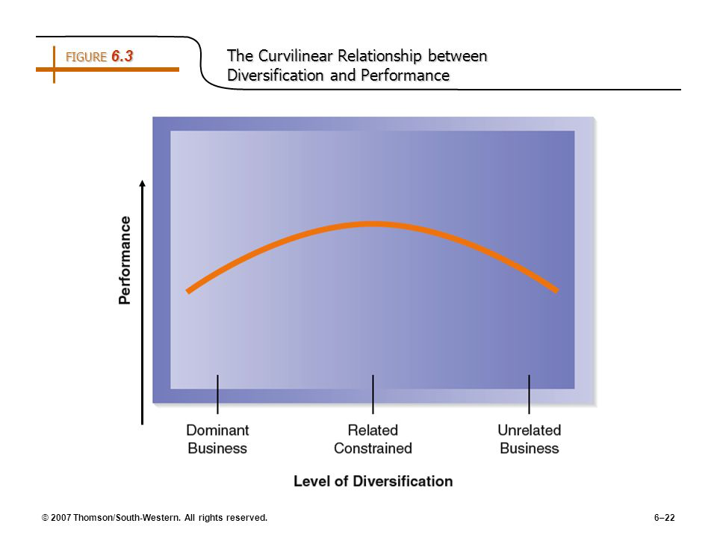

Chandler concept list
- Economies of scale and economies of scope:
- Functional divisions, management hierarchy and geographical expansion
- First movers (plant your flag and establish and invest) & challengers (try to be number one)
- Research and development (innovation)
- Related and unrelated diversification
- Separation of tip and middle managers (in the case of unrelated diversification)
- Entrepreneurial enterprise (staying small)
- Managerial enterprise (large firms)
- Stock market pressure (due to ownership pattern) - thinking of short-term results instead of long term, may lead you to make quick moves in prospects of what's happening but bad long term wise)

Greiner: Evolution and revolution as organizations grow

Working in small and big business
- Small: you are involved in every, privy in big decisions, a lot of depth in one area
- Big: recognition, more trained employees
Most challenging part of growing business
- Developing a consumer base
- Building up a name / credibility level

A theory of organizational life cycles, with a focus on growth

Greiner's major claims:
- Organizational growth is characterized as a series of developmental phases
- Managements practices that work well in one phase bring on a crisis in the next
  - Icarus paradox: big wings made of wax, they melted
  - Anything that brings you success will have to be replaced, or else they will bring you downfall

Greiner's primary concepts:
- Age of the organization
- Size of the organization
- Stages of evolution
- Stages of revolution
- Growth rate of industry (group of companies that sell similar products to similar market)
- Management style (leadership style – having to do with leader or CEO)
- Organizational structure (functions within the organization, line of authority, level of hiearchy)
Organizations grow through a series of evolution and revolution phases
- Function of the age and size of the firm

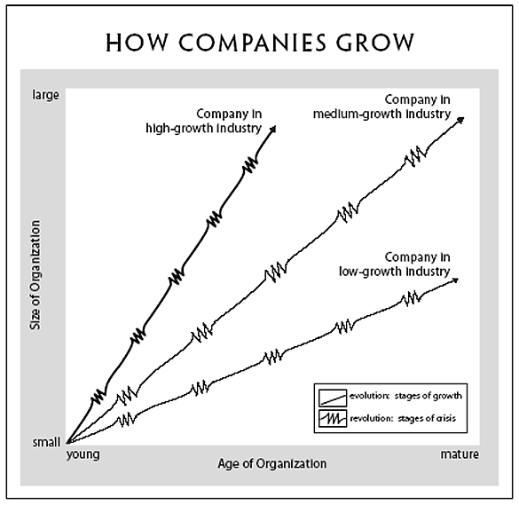

Management practices that work well in one phase bring on a crisis in the next

- Each stage of revolution needs a diff management style
- Argues that if the growth rate of the industry is high, then size will increase much more quickly
- If declining industry, size will inc slowly with age

5 phases of growth:
- Creativity
Eg. Small family firm
Focused more on their product than on their management
- Crisis of leadership: the founder cannot run the organization – hire a manager
- Phase of direction
Proper accounting system put in place, more people are employed
- Crisis of autonomy – low level employees have the knowledge of the market but their knowledge gets lost and is not forwarded to the people at the top
- Delegation
More power given to middle and lower managers
Each division is an enterprise itself
- Crisis of control – top managers don’t know well the different parts of the organization, lower managers are taking control
- Coordination
Divisions are merged together to form larger business units that have specific targets on returns of investments (each division is an investment center owned by head office)
Each business unit designs a business strategy to support cooperate strategy as a formal strategic planning
- Red-tape crisis: people start to resent to rules of bureaucracy
- Collaboration

Needs change as an organization grows: need to recognize change and trust others
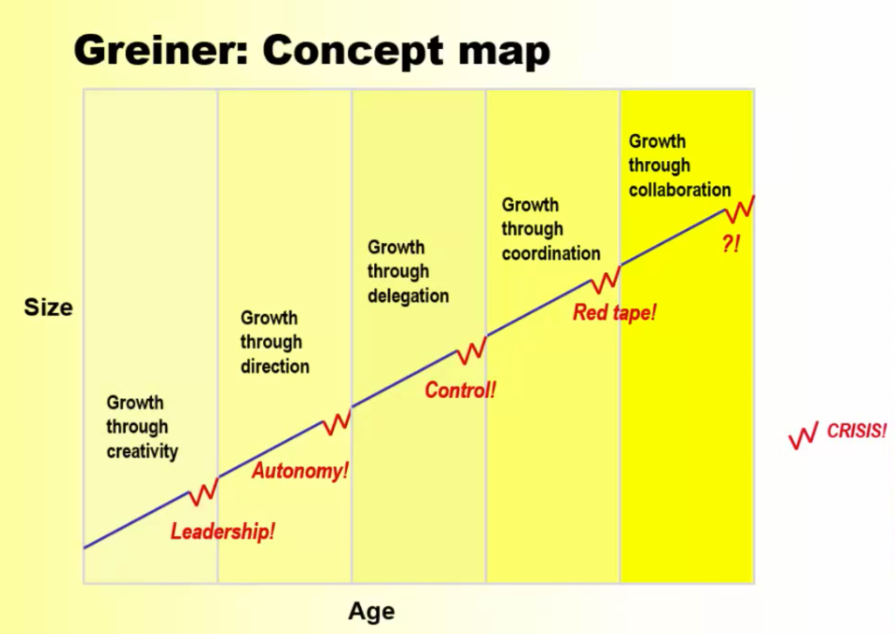

Advantage of large, bureaucratic organizations
- Hierarchical authority promises control and responsibility
- Specialization of sub-units promises accountability, control and expertise
- Management by rules promises control and consistency
- Being impersonal promises objectivity, consistency and equality
--> downside: red-tape crisis

Employees' examples of red tape:
- Each department has its own agenda, and departments don’t cooperate to help other departments get the job done
- Top managers are dangerously ill-informed and insulated from what is happening on the front lines or in the field
- Quantitative measurements are favored over qualitative measurements, so the concentration is one quantities of output, with less and less concern for quality of output
- Both employees and customers are treated more as numbers than people

Greiner's secondary claims:
- Organizations should not try to skip phases
  - When a crisis is happening try not to go back to what it was before
- Top managers whole style is no longer appropriate should remove themselves (eg. Steve jobs removed himself)
- Growth is not inevitable

Greiner's retrospective commentary:
- small firms either die or are acquired by larger ones (not all will go by these stages) -- same message that chandler gave us
- Possible that within each phase, there can be crisis
- Replaced delegation by decentralization

For each evolution phase, you should know
- The exact name of the evolution phase
- The characteristics of the evolution phase (what is happening)
- The issues that lead to a crisis
- The exact name of the crisis
- The required solution for the crisis
*solution that may have worked in a previous phase may not work in new bigger/complex environment

Barney: Looking inside for competitive advantage
Jay Barney

- He is one of the most influential contributor within the field of strategy today
--> why is it that some companies are more successful than others?

The swot framework

SWOT analysis is the traditional tool for strategic analysis
SWOT framework has two components: Internal and External environmental analysis
--> this is not Barney's theory
Barney's article provides a tool to assess the organization's internal resources and capabilities
Internal environment (strengths and weaknesses):
- Internal resources and capabilities of the firm
External environment (opportunity and threat):
- Business and societal trends, industry conditions and competitive environment
- Beyond our control
- Eg: overall stress on supply chain, government policies

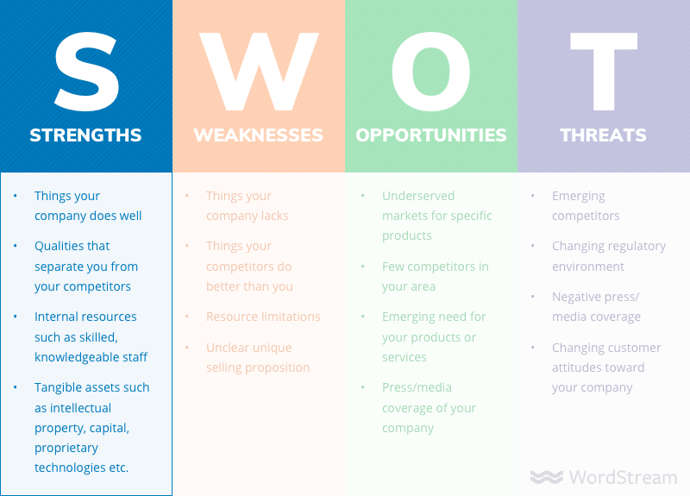

Barney's major claims

- A firm will have a sustained competitive advantage
  - If its resources and capabilities are valuable, rare, inimitable and organized in a way to exploit opportunities
- A firm will be successful if it has resources with the right attributes and characteristics
  - Must analyze competitive implications and internal strengths and weaknesses
- The most careful and complete analysis of firm's competitive environments cannot, by itself explain their success
  - Opportunities and threats are not enough
- Strategists also need to analyze the competitive implications of firms' internal strengths and weaknesses

Resources & capabilities:

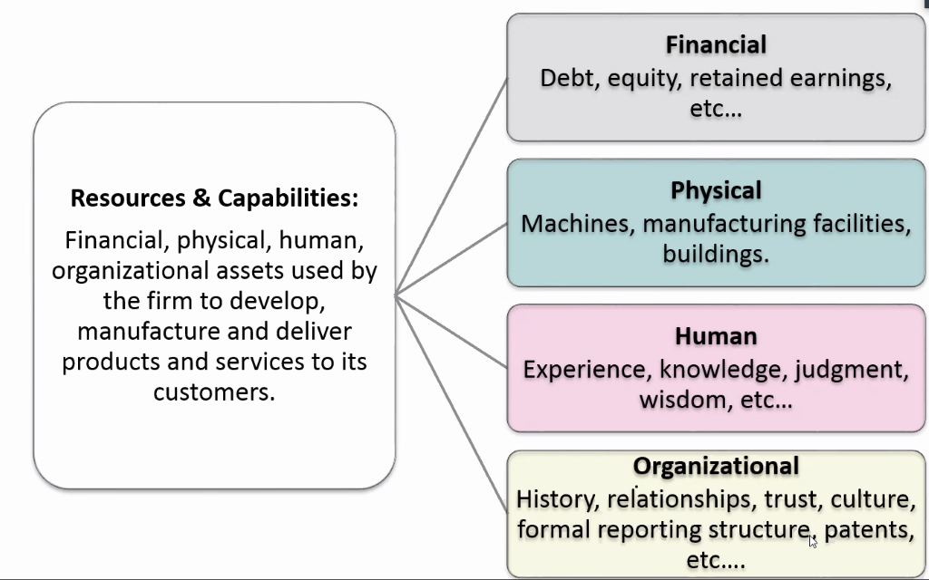

Barney's Model

Tangible resources
Financial | - Firm's cash and cash equivalents  - Firm's capacity to raise equity  - Firm's borrowing capacity
Physical | - Modern plant and facilities  - Favorable manufacturing locations  - State-of-the-art machinery and equipment
Technological | - Trade secrets  - Innovative production processes  - Patents, copyrights, trademarks
Organizational | - Effective strategic planning process  - Excellent evaluation and control systems

Intangible resources
Human | - Experience and capabilities of employees  - Trust  - Managerial skills  - Firm-specific practices and procedures
Innovation and Creativity | - Technical and scientific skills  - Innovation capacities
Reputation | - Brand name  - Reputation with customers for quality and reliability  - Reputation with suppliers for fairness, non-zero-sum relationships

Tacit knowledge: cannot be easily explained in words
- Many intangible resources are tacit knowledge

Capabilities
- Firm competences or skills the firm employs to transfer inputs to outputs
- Capacity to combine tangible and intangible resources, using firm processes to attain desired end (They will develop routine that makes them better at combining and recombining capabilities which makes it a unique)
- Example:
  - Outstanding customer service
  - Excellent product development
  - Innovativeness or products and services
  - Ability to hire, motivate and retain human capital

Four important questions about resources and capabilities

- They form VRIO framework (this is barney's framework)

- The question of value
- Does a firm's resources and capabilities enable it to exploit an opportunity, and/or neutralize a threat
  - Value becomes real through the exchange

Firms can create different value in different ways
  - Rolex and Timex both manufacture watches but they exploit very different valuable resources
Rolex:
  - Responds to high status reputation for fashion
  - Quality manufacturing and commitment to excellence
Timex:
  - Responds to demand for practical, reliable, low-cost timekeeping
  - Emphasizes its high-volume, low-cost manufacturing skills

- The question of rareness
How many competing firms already possess these valuables, resources and capabilities?

- The question of imitability
- Do firms without a resource or capability face a cost disadvantage in obtaining it compared to firms that already possess it?
- Is it possible for another company to be good at what I'm good at?
- How is it that some companies can develop resources and capabilities that are hard to imitate by other companies?
- Importance of history:
  - valuable and rare resources acquired or developed through unique historical circumstances can be a source of sustained competitive advantage
- Importance of numerous small decisions:
  - a firm's competitive advantage seems to depend on numerous "small decisions" (rather than big ones) through which a firm's resources and capabilities are developed and exploited in developing, nurturing and exploiting resources
- Importance of socially complex resources:
  - reputation, trust, friendship, teamwork and culture, while not patentable are much more difficult to imitate

- The question of organization
Is a firm organized to exploit the full competitive potential of its resources and capabilities?

Applying VRIO framework – the value and rarity of a firm's resources

If a firm's resources are... | The firm can expect...
Not valuable | Competitive disadvantage
Valuable, but not rare | Competitive parity (equality)
Valuable and rare | Competitive advantage (at least temporarily)

Applying VRIO framework – the value, rarity and inimitability

If a firm's resources are... | The firm can expect...
Valuable, rare, but not costly to imitate | Temporary competitive advantage
Valuable, rare and costly to imitate | Sustained competitive advantage (if organized properly)

Summary

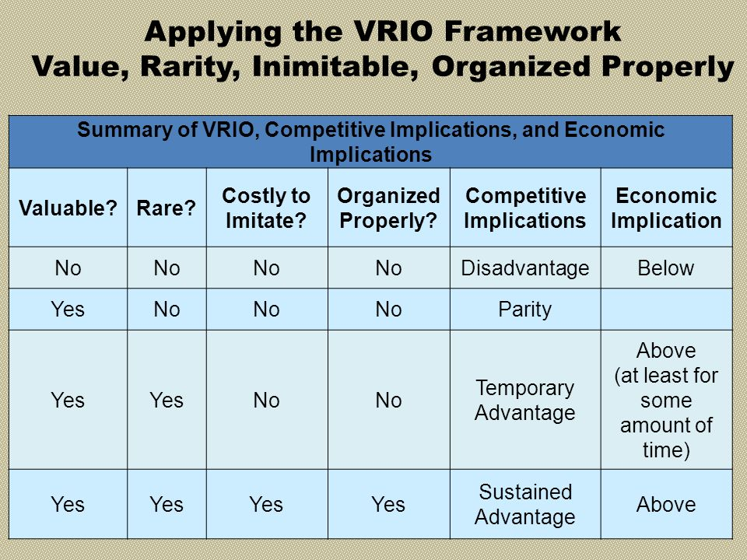
We are looking for above average returns in the long term

Collins & Porras: Building your company’s vision
Vision provides guidance about what core to preserve, and what future to stimulate progress toward

Key concept:
A well-conceived vision
A well-conceived vision is composed of 2 things:
- Core ideology:
  - Core values
  - Core purpose
- Envisioned future
  - BHAG (goals)
  - Vivid description of what it will be like to achieve goals

Core ideology

Def: enduring character of an organization – a consistent identity that transcends product or market life cycles, technological breakthroughs, management fads and individual leaders.
- Very general – not expressed referring to a product
- Glue that holds organization together: (eg. religion, declaration of independence in the US, ideas in principle in scientific communities)

Core values:
essential and enduring tenets; small set of timeless guiding principles; beliefs about what is important
Eg. Sony: pioneer, not following others, encouraging creativity
- Should not be more than 3-5 core values
- Should be short
- Stand the test of time
How to identify core values: Mars group
- Company wants to start subsidiary on mars. Which 5-7 would you send? These people are exemplars of values
--> timeless guiding principles: what is important
--> "code of ethics" or "how we do business"

Core purpose:
the organization's reason for being; people's idealistic motivations for doing the company's work; capture the soul of the organization
Eg. Merk: improve human life
- Cannot fulfill a purpose
- Most dedicated people are volunteers (there is meaning to their work)
5 Ys:
- What's core purpose? Then ask "why is that" 5 times
- On the 5th one, there is no reference to the product or market (because these change, but purposes don’t change)
- Must be general and should last forever
--> organization's reason for being, idealistic motivations, should of the organization
--> why do we exist? Don't discuss products

Discovering core ideology
- You do not create or set core ideology
- Description of what actually exists, not just what we wish existed
- Needs to be meaningful and inspirational only to people inside the organization
- Find people who are predisposed to share the organization's core values and purpose
- More than creating a perfect statement
The authenticity, discipline and consistency with which the ideology is lived – not the content of the ideology – differentiate visionary companies from the rest of the pack

Envisioned future
BHAGs: Big, hairy, audacious goals
- 10-30 years
- Powerful way to stimulate progress
- Clear & compelling: serves as unifying focal point of effort; acts as a catalyst for team spirit
- Take little or no explanation
- Not a sure bet

Vivid description
Vibrant, engaging and specific description of what it will be like to achieve the BHAG
- Passion, emotion and conviction are essential parts of vivid descriptions
- Be aware of the "We've arrived syndrome" - never finished – always establish another envisioned future
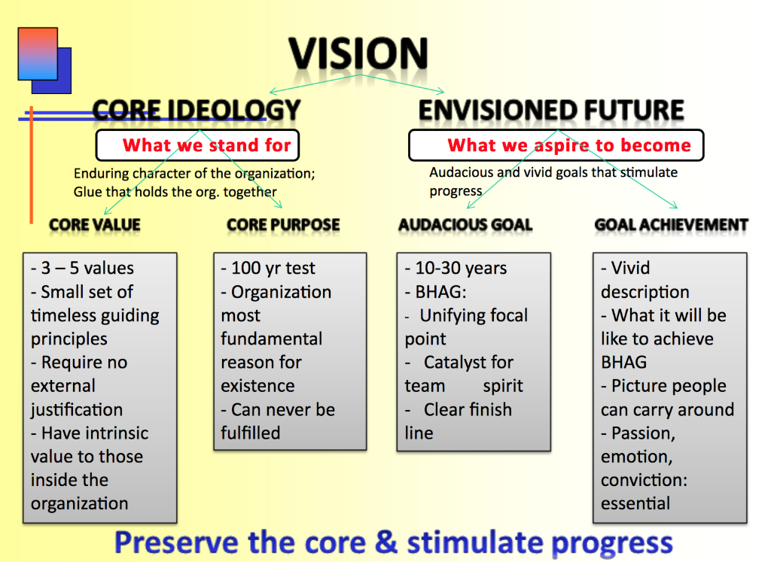

Stability coexists with change: preserve the core, stimulate progress

Handy: The sigmoid curve
The downfall of Kodak
- Kodak used to replace the word camera
- 1976: company had a 90% market share of photographic film sales in US (almost monopoly)
- 1975: they developed the digital camera but didn’t release it
- 2012: bankruptcy chapter 11

The rise of Samsung
- Mr lee believes that you don’t need to be facing a crisis before you start to change

KODAK

2012
A B

Curve 1: camera and film
A: 90% of market share in 1976
B: decline of the company

Started new curve after bankruptcy protection chapter 11: digital printing

SAMSUNG
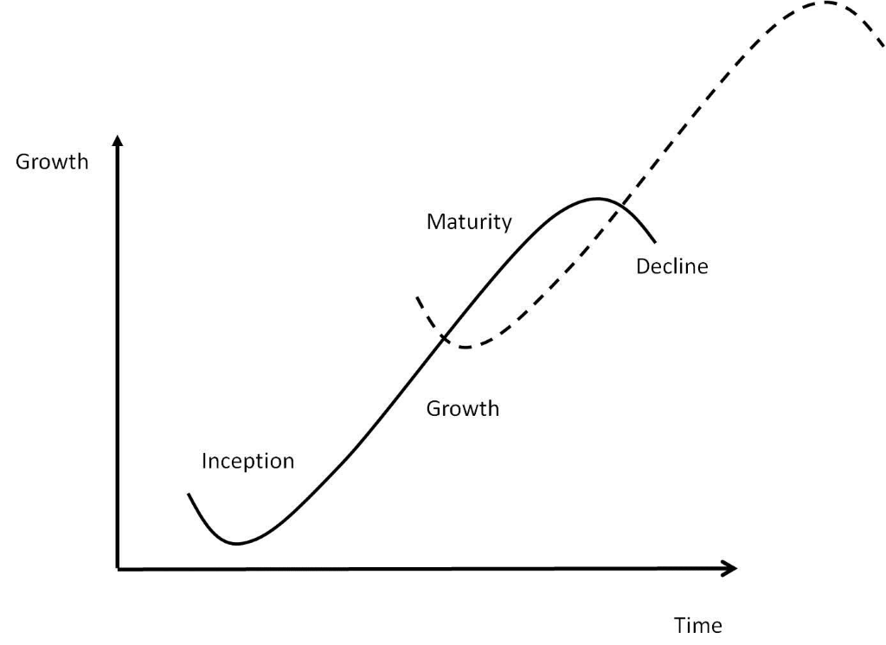

Start a second curve even if things are doing well (at point A)
B: product is less popular (start at point A and not point B)

Sigmoid curve: key to effective growth
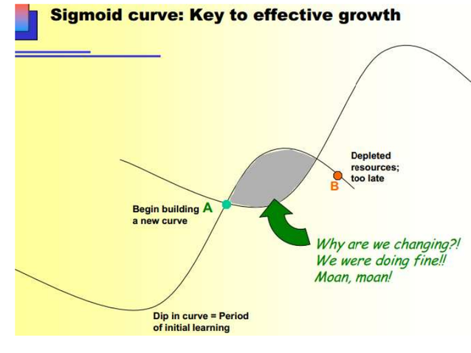First curve: first product
Second curve: second/new product, new way of operating, new strategy, new culture

Best to start building second curve at point A: point in time when the first product is still popular. There is:
- Time
- Resources
- Energy
Needed to get the new curve through its initial explorations and floundering before the first curve dips downward

Grey area: period of transition – why are we diverting valuable resources to a second product when things are going well?
- At point A everything is fine and many people It would be folly to change when the current way is working so well
- Two groups of people and two sets of ideas are competing for the future: those in curve 1 want to move to curve 2 eventually

Do not start at point B
- Current leaders are discredited because they are perceives to have led organization down the hill
- Resources are depleted and energies are low
- Hard to mobilize resources or restore the credibility which they had at the peak
- People will bring in new people at the top because they believe that are the ones who have the credibility and the vision to lift the place back onto the second curve

SECOND CURVE
- Very different product/culture/operating /strategy from first
- People have to be different: those who lead the second curve are not those who led the first curve
  - those leading the first curve have to ensure you get to point B (hold first curve long enough to support early stages of second curve)
  - Hard to abandon first curve

Fertilizing the second curve:
- Must recognize that new ideas can co-exist with the old
- Look at those who will be leading the organization in the future
- Forsee changes they might see in the industry and how the organization will adapt to them
- Seniors must give permission and encouragement for second-curve thinking
- Next generation must accept responsibility for second curve thinking: they need to put it first, before first curve, they have the responsibility to shape the future
- The discipline of the second curve requires that you always assume that you are near the peak of the first curve, at point A, and should therefore be starting to prepare for the second
- Organizations should assume that their present strategies will need to be replaced within 2-
- 3 years and that their product life cycles are shower than they were
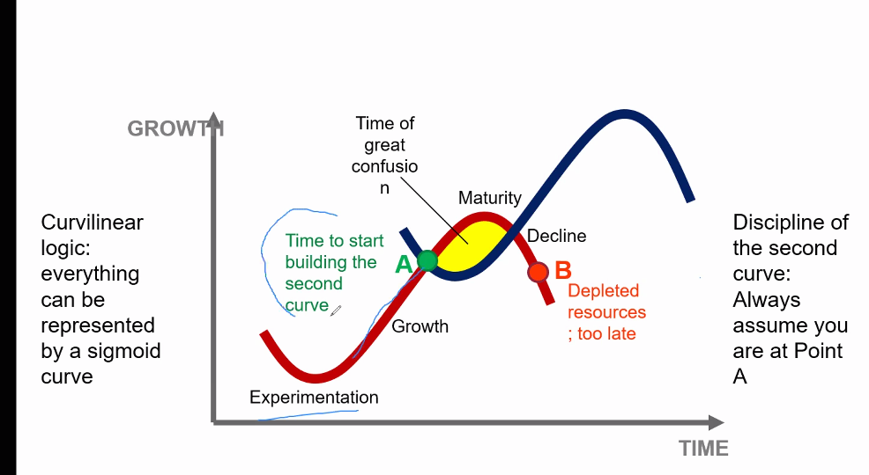

Some questions
- Is it easy for a company to know where it stands on sigmoid curve?
  - No. People tend to think they are further up on the curve than where they actually are. Nearer to point B than to point A
  - Better to have an objective answer
- What is the discipline of the second curve?
  - Always assume you are near the peak of the first curve
  - Assume present strategies will need to be replaces within 2-3 years & product life cycles are shorter than they were
  - Individuals should work on the assumption that a new directions will be needed in 2-3 years
- If you realize that you are not that far in the first curve, will this be a waste of time?
  - No, it creates the right mindset to welcome change
  - No major commitments will have been undertaken until the second curve overtakes the first, which can't happen as long as the first curve is on the rise
  - Forces one to challenge the assumptions underlying the first curve and devise possible alternatives
- What is the curvilinear logic?
  - Everything we know in life can be modelled on a sigmoid curve: by the time you know where you ought to go, it's too late to go there
  - What got you where you are wont keep you there
  - Entrust the curvilinear thinking to the next generation
  - There has to be a life beyond the organization for the leaders of the first curve

"Capitalism, newly triumphant, probably has to re-invent itself"
- Fall of the berlin wall: capitalism will be everywhere
- Maybe it is time the capitalism starts its second curve

Viewpoints on change: What have other authors has to say about managing change? Are their ideas consistent with the sigmoid curve? In what ways do they differ?

- Collins and Porras: you need stability (enduring character by preserving the core ideology) also need envisioned future (dynamic part of the vision should change)
  - No idea of enduring character in Handy
- Greiner: new leader, new structure, new managements
  - Shaded area: when change is brought about there is a bit of a crisis
  - For handy: two curves are happening simultaneously
  - For Greiner: you are in the crisis

In one sentence, describe Handy's sigmoid curve idea: sums up to store of life itself, we start slowly, experimentally and falteringly, we wax and then we wane
- Curvilinear logic, everything can be represented by a sigmoid curve
- All that we know of change, be it personal por organizations, tells us that the real energy for change comes once when you are looking disasters in the face, at point b on the first curve
- The secret of balance in a time of paradox is to allow the past and the future to coexist in the present
Can you think of a company that declines because it failed to reinvent itself?
- Blockbuster: what stopped them in their peak? Didn't do digital streaming
- HMV: when we went to digital world, they disappeared. Why isn't apple itunes hmv streaming? They couldn’t transition to a digital format
- Blackberry: failed to introduce apps

Essential Tutorials

Is google a search engine:
Yes, but it has 3 main drawbacks:
- Thermometer - Measures popularity:
  - Listens to IP address and where it is coming from
  - See which sites link to a certain site, if from gov websites you increase page rank score (page rank algorithm)
  - Looking for authoritative information --- disconnect
- Mirror - returns results specifically for you as an individual
  - Builds a profile of you (gmail account, IP address, kind of brouser used, bkind of plug-ins)
  - Caters popular results based off of what it thinks you need based off your profile (eli pariser calls this filter bubble)
  - Problematic because you are trying to break out of filter bubble in academic setting
- Sunglasses – blind that shields you from things not on free web
  - Blind: only gives you partial information
  - Only covers the free web: only picks up websites that allow it in (robot.txt block google from accessing it)
  - Statistics Canada does not allow google to search its free web
  - Anything that is protected by copyright not released by owner on free web will not appear on google
  - A lot of secrets out there: financial records of private companies

How to train your google
Who are the people on the internet posting interesting things? Information from the gov’t
- Use little widget icon advanced search site or domain: .gc.ca (site: .gc.ca)
- Advanced search exact phrase (“…”)
- Advanced search file type pdf
- Dig deeper into gov websites (Or even diff level of gov’t)
- Look at trade associations, lobby groups “….association” (they have a bias)

What can you learn from Wikipedia
- Follows the same format/structure as any other encyclopedia (international encyclopedia of the social and behavioral sciences)
Main differences:
    - Library they had to pay for it whereas Wikipedia is free
    - Wikipedia is edited on an open editorial process whereas other encyclopedias have a more closed hierarchal method
    - Both have:
      - Read entry: text and table of content that explains the content
      - See the “see also” section: more general and more specific concepts related to your topic
      - Reference list: sources, documents, papers – use these additional sources as your sources in your bibliography (don’t talk about encyclopedia)
- You always want to use encyclopedias as the beginning point of research but not the destination
      - Use the reference list to find your sources

Finding the best sources for your paper

Concordia libraries website discovery search a lot of hits, means you have to go more into detail look at kind of information formats
- news sources (factual, history authority (NY times), or entertainment) – shorter
- magazines (inform or entertain) – trade publications: geared towards people in certain industries
- academic/scholarly/peer-review journals (Harvard business review): include theory and research in your paper – longer than news sources
  - have literature review: preliminary research to contextualize their research (and therefore have bibliography)
  - demonstrate science
  - pearl of citation: go from one bibliography to another to find your info
  - try to quote from these!!!
  - More precise (if you want more general: encyclopedia)
Ibis report: industry reports
Passport: consumer reports

Library website help/how to source and course access business research portal ibis world (data base for industry reports for US, canada and china)

For citation – citing business databases in APA format will give you an example
Not allowed to print and distribute
Passport: could look up many topics, keyword search, geographies (could compare diff countries)

