Quiz 2 review for 211

Lecture 8:

Drugs that changed the world:
Psychosis: an abnormal condition that effects 1% of the population, which causes difficulties in determining what is real and what is not. The Symptoms include delusions, hallucinations, incoherent speech and inappropriate beh.

Direct Dopamine receptor antagonists: they are receptor blockers
Antipsychotics (neuroleptics): (first generation or classical)
- Used to cute and reduce the symptoms of psychosis
- they are dirty drugs; they bind to more than one type of receptor.
- Common action they have is to directly block D2 dopamine receptors.
- These receptors are inhibitory metabotropic receptor that are in neurons all over the brain.

Direct Serotonin receptor agonists: They are receptor activators

- A lot of drugs that cause hallucinations, but the most popular ones are the ones that activate Serotonin 2A receptors.
- These are also inhibitory metabotropic receptors.
- Not all of these direct serotonin 2A receptor agonists causes hallucinations, some cause massive while others do nothing of that sort.

4 main drugs directly activate serotonin 2A receptors:

mescaline
psilocybin
LSD
lisuride
hallucinogens
not a hallucinogen

Lisuride: does have any hallucinogenic properties, it doesn’t make people feel good in any way.

- When these agonists bind and activate this metabotropic receptor, they launch an intracellular signaling cascade that starts with the g protein ‘G_{q/11}’.
- Serotonin normally activates this receptor the same way.
- It turns out, however, that hallucinogenic drugs activate the receptor in a peculiar way, which stimulates an additional g protein known as ‘G_{i/o}’.
- It is the 5HT2A receptor-induced activation of G_{i/o} proteins that causes hallucinations

In summary: the hallucinations are caused when you get the serotonin receptor to cause activation of the G_{i/o} protein cascade.

Biased Agonism: when a metabotropic receptor ligand causes the receptor to preferentially activate one type of intracellular g protein, whereas another ligand at the same receptor might preferentially activate a different g protein.

Drug Categorization:

Direct agonists/antagonists: these are the drugs that affect the postsynaptic receptor activity by directly binding to postsynaptic receptors

Indirect agonists/antagonists: these are the drugs that affect the postsynaptic receptor activity by indirectly binding to postsynaptic receptors, they bind to the proteins that aren’t postsynaptic receptors.

- Receptor agonist: directly or indirectly increases the activity of postsynaptic receptor proteins.
- A receptor antagonist is a drug that directly or indirectly decreases the activity of postsynaptic receptor proteins.

The target of drugs is to change the activity of the postsynaptic membrane. The goal is to target a specific receptor protein to see we can change the communication between neurons, to change information processing or to fix some disease or reduce some of the symptoms.

Drugs can be categorized in different ways:
  - according to their behavioural effects (e.g., upper, downer, stimulant),
  - according to their physiological effects (e.g., action potential blocker),
  - according to their actions on specific proteins (e.g., serotonin reuptake blocker),
  - according to their effects on postsynaptic receptor activity.

However, these terms (upper, downer), don’t correspond to what is happening in the cells, what these uppers and stimulants do is activate dopamine receptors.

Downers and depressants: activate inotropic GABA receptors and depress neural activity

Competitive Binding:
Direct agonists/antagonists can be classified as competitive or non-competitive

- A competitive agonist acts similarly to the endogenous neurotransmitter. It activates the receptor by binding where the neurotransmitter normally binds. We will get the same effect and the receptor will open.
* It won’t activate it the same way all the time, sometimes the pore might stay longer and other times it might open larger, because the drugs are a different molecule. *
Direct receptor agonists can be full agonists or partial agonists.
*Example of the context on page 7 of the transcripts*

*****If you are someone who has a lot of serotonin activity baseline and you take a competitive direct agonist drug you won’t feel much change, but if you take a partial agonist, there will be less serotonin overall activity because this one is not doing a as good job as the full agonists drug was doing. There will be less overall receptor activity with partial agonists. ******

- A competitive antagonist attaches to the same binding where the neurotransmitter normally binds, but it doesn’t activate the receptor. Competitive antagonists are full antagonists. It prevents the activation of the receptor.

**** The competition for a binding site between an endogenous neurotransmitter and an exogenous drug will depend on their relative concentrations and their affinity for the binding site. Affinity refers to the probability and tightness of ligand-receptor binding. ********

Non-Competitive Binding: When a drug binds to a receptor at a site that does not interfere with the binding site of the principal ligand. It is possible for a neurotransmitter to bind on one site of a receptor while a drug binds on another.

A non-competitive agonist: fully or partially activates the receptor.

A non-competitive antagonist: fully blocks receptor activation. It doesn’t compete for the neurotransmitter binding site. It “wins” without competing by binding to an alternative site.
If the drug is there, it doesn’t matter how many neurotransmitters are there, you will see no receptor activity.

Allosteric modulators: Non-competitive drugs that only influence receptor activity when the neurotransmitter is also bound to the receptor.
  - Negative allosteric modulators reduce the effect of the primary ligand, reduce the likelihood of a neurotransmitter binding, or make it so it doesn’t fully activate the neurotransmitter
  - Positive allosteric modulators amplify the effect of the primary ligand, amplify the effect of the neurotransmitter, keep the receptor open for longer.

****Some of the most popular depressants, anti-anxiety, sleeping pills are positive allosteric modulators and ionotropic GABA receptors. They increase the inhibition throughout the brain and reduce neural activity and take the edge off. *****

- Parkinson’s disease is a neurological disorder that is characterized by tremors, rigidity of limbs, poor balance, and difficulty initiating movements.

- It is caused by the degeneration (death) of dopamine neurons in the midbrain.

- The amino acid L-Dopa is often used as a drug to treat Parkinson’s disease because it increases dopamine production in the brain and thus acts as an indirect dopamine receptor agonist.

- They tried injecting Tyrosine, it wasn’t as successful as L-DOPA because it got broken down by the other cells and very little got to the brain to the dopamine receptors.

- Since the other cells reject L-DOPA, most of it makes it past the blood brain barrier, where the dopamine neurons take it, they make tons of dopamine from it and package more dopamine in every vesicle, release an excess amount of it.

***Conventional neurotransmitters are made in axon terminals. They are made from precursor molecules (generally from amino acids).
- In some cases, precursor molecules can be administered as drugs since they can increase the amount of neurotransmitter that is made and released. In such cases, the precursors acts, as receptor agonists.

The synthesis of neurotransmitter from precursor molecules is controlled by enzymes.
- Some antagonists work by blocking these enzymes, thus reducing production of the neurotransmitter so there is less in each vesicle.

Once made, neurotransmitters are packaged into synaptic vesicles.
- Some antagonists work by blocking the transporter proteins that package neurotransmitter into vesicles. When this occurs, the synaptic vesicles can remain empty, so nothing is released when they fuse with the presynaptic membrane.

Resprine: specifically binds to the vesicular monoamine transporter, this drug blocks the transporter and the vesicles don’t get filled.
Less effect of dopamine, serotonin, norepinephrine = lower blood pressure
High effect = catastrophic network disruption.

Many proteins in the axon terminal regulate synaptic vesicle exocytosis (i.e., vesicle fusion with the presynaptic membrane)
- Some antagonists (e.g., botox) work by blocking the vesicular release machinery, so no neurotransmitter is ever released.
- Some agonists (e.g., black widow spider venom) work by binding and activating the vesicular release machinery to directly cause the release of neurotransmitter

The clearance of neurotransmitters from the synapse is controlled by reuptake transporter proteins and enzymatic deactivation
- Some agonists block the enzymatic deactivation of neurotransmitter in the synaptic cleft (e.g., neostigmine).
- Other agonists block neurotransmitter reuptake proteins.
Some agonists can even reverse the reuptake proteins, so that they start to traffic neurotransmitter into the synapse as soon as it is made (before it is packaged into a synaptic vesicle).

Neurotransmitter reuptake:

- Methylphenidate, Cocaine:
Drugs that block the reuptake of catecholamine neurotransmitters. They block the dopamine & norepinephrine reuptake transporters. These are agonists to the dopamine and norepinephrine postsynaptic receptors.

- Adderall, Crystal meth:
Drugs that reverse catecholamine transporters, causing dopamine and norepinephrine molecules to flow directly out of the presynaptic terminal (non-vesicular release).
[Ecstasy (MDMA) does a similar thing to all the monoamine transporters (i.e. causes them to run backwards).

The drug commonly known as Ecstasy (MDMA) can cause monoamine reuptake transporters to run in reverse. What does this mean?
- monoamine neurotransmitters will be released from neurons even when they don’t have an action potential.
- monoamine neurotransmitters will be released from neurons in a non-vesicular manner
- monoamine neurotransmitters won’t be recaptured and reused by the neurons that release
them.
- Ecstasy acts as an agonist for serotonin, dopamine, and norepinephrine receptors.

Dose Response curve:
A dose response curve is a graph of the magnitude of an effect of a drug as a function of the amount that is administered. It is obtained by giving subjects various doses of drug (typically according to weight).
*** Higher doses cause larger effects until the point of maximum effect***

Pharmacokinetics:
Process by which drugs are absorbed, distributed within the body, broken down, and excreted
Example: if you snort cocaine, it stays for a longer time of period than being injecting in your bloodstream.

Routes of Drug Administration:
There are many ways to get drugs inside the body and brain. The route of administration affects where the drug goes, in what quantity, for how long.

Effects of Repeated Administration:
- Tolerance: is when an effect of the drug diminishes because of repeated administration. It is the body’s attempt to compensate for the effects of the drug.

*****E.g., a regular heroin user must take larger and larger amounts of the drug to keep feeling the same effect. Having developed tolerance to heroin, the user will suffer withdrawal symptoms which are opposite effects of the drug (i.e. euphoria vs dysphoria).
E.g., barbiturates have sedative and depressive effects. The sedative effect shows tolerance, but the depressive effect does not. Thus, if larger doses of barbiturates are taken to achieve a sedative effect, you run the risk of taking a dangerously high dose of the drug.*****

- Sensitization: occurs when a drug becomes more and more effective through repeated use.
- A placebo: is an inert substance that has no direct physiological effect. It is given to subjects to control the effects of mere administration of a drug.

What are the similarities & differences between:
Heroin : crosses the blood-brain barrier quickly because it is very lipid (fat) soluble.
Morphine: crosses the blood-brain barrier a bit slower because it is less lipid soluble.
Imodium Anti-Diarrheal: does not cross the blood-brain barrier.

****THEY ARE ALL VERY STRONG OPIATES****

Lecture 9:
Extra notes:
Magnetic Resonance Imaging (MRI)
- When molecules (of the body) are in a strong magnetic field, the hydrogen atoms (i.e., single protons) spin with a particular orientation (defined by the magnetic field).
- When you shine low-energy radio signals at the body, the protons will absorb that energy and will change their spin & start spinning in different directions.
- 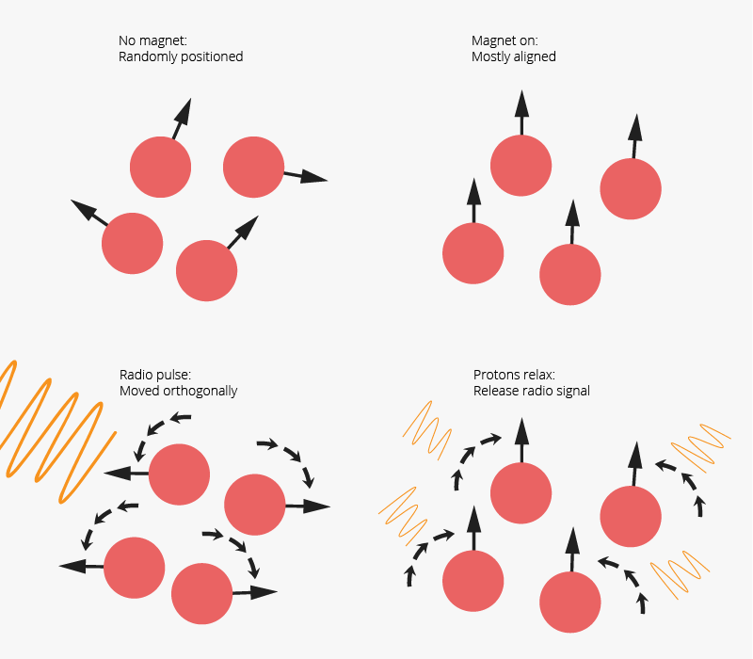

- When the protons flip back, they give off their own low-energy radio signals, we measure where those are come from.

Functional Magnetic Resonance Imaging (fMRI):
- The idea that creating a drug that you can put into the body that will be affected by a magnetic field and will be able to absorb radio signals, but the way that do that will depend on whether they’re bound to a signaling molecule.

Macroelectrodes (EEG):
- EEG’s provide a diagnostic tool with which particular states of consciousness or types of cerebral atrophy are associated with specific patterns of EEG waveforms.

How to study the animal brain:
- If you want to know what an area of the brain is good for, cut it out of an animal and see how their behavior changes.
- Experimental ablation (lesion study): involves the removal or destruction of a portion of the brain. Presumably the functions that can no longer be performed following the surgery are the ones the brain region normally controls.

Viral-Mediated Gene Delivery:
- Almost all lab-made viral constructs contain a section of DNA that encodes a fluorescent protein (e.g., GFP). Fluorescent proteins are used to later identify the infected cells.

We can target opsin expression to specific neurons in the brain according to:
    - Where their soma are located (e.g., neurons in the amygdala)
    - Where their axons are located (e.g., neurons that form synapses in the amygdala)
    - The proteins they express (e.g., neurons that make serotonin or dopamine)
    - Whether they recently had more action potentials than normal (e.g., active neurons)

Tracing Neural Connections:
Retrograde labeling (tracing afferent axons: to map out where the axons were coming from
- Various chemicals, such as fluorogold can be used as a retrograde tracer.
- Fluorogold molecules are taken up by axon terminals and transported back to the cell body.
Anterograde labeling (tracing efferent axons): to map out where the axons in the area were going too
- Various chemicals, such as PHA-L, can be used as an anterograde tracer.
- PHA-L molecules are taken up by cell bodies and transported down to axon terminals.

Bregma: The junction point where pieces of skull fuse together. Bregma is often used as a reference point for stereotaxic brain surgery.
Stereotaxic surgery: It is used to inject things into the brain, such as drugs, viruses, or tracer molecules (dyes). It is also used to permanently implant things, like cannula, electrodes, or fiber optic cable.
Studying the human brain… Lecture 9:
Technique | Function | Principles | Correlation vs Causation vs Structure | Invasive vs Non-invasive | Advantages | Disadvantages
Computerized tomography scan  (CT) | Scans structure of living brain | X-ray (high energy) radiation is delivered from all angles.  X-ray detector sends information to the computer to produces images. Light is absorbed in areas where there is dense tissue | Structure | Non-invasive | Cheap, fast  Great to see if there is any hole or something growing or obvious abnormality. | -High energy radiation.  -Poor spatial resolution.  -Not great for soft tissue like brain
Magnetic resonance imaging | Scans structure of living brain | Magnetic field uses spin of hydrogen atom. Looks at the density of these atoms. Radio frequency waves passed through the body | Structure | Non-invasive | High spatial resolution
Diffusion tensor imaging (variant of MRI) | Visualizes axon tracts | Measures direction and speed of water molecule diffusion. | Structure | Non-invasive
Functional MRI | Measures brain activity during behavior | Measures oxygenated blood flow (BOLD) based on magnetic properties of blood. | Correlation | Non-invasive | -This technique is safe, it doesn’t involve any needles or chemicals.  -Decent spatial resolution and temporal resolution, can make enzyme-activated magnetic resonance contrast agents for any molecules.
Positron emission tomography | Detects radioactive compounds | Radioactive compound is injected. Its location and concentration in the brain translated into images. | Correlation | Non-invasive | You can make any compound radioactive! Classic example is radioactive glucose, to detect changes on energy expenditure (i.e. neural activity) over time 2-DG takes longer to be broken down, unlike the sugar molecule. | Expensive (need to synthesize molecules, and since they decay rapidly, must be made on site before the experiment)
Macroelectrode EEG  (oldest technique) | Records activity of a large number of neurons on cortical surface | Electrode measures electrical activity (action potentials and post-synaptic potentials). | Correlation | Non-invasive | High temporal resolution. Pretty cheap and non-invasive.  You detect if it someone is aroused or relaxed, asleep or in deep sleep. | Hard to interpret the meaning of waves. Low spatial resolution.

Studying the rodent brain… stereotaxic surgery, Important details., viral mediated gene delivery
Technique |  | Function | Principles | Correlation vs Causation vs Structure | Invasive vs non-invasive | Advantages | Disadvantages
Neuronal Tracing |  | Map axonal projections in the brain. | Inject fluorescent molecules that are transported anterogradely to map efferent projections (PHA-L)  Inject fluorescent molecules that are transported retrogradely to map afferent projections (fluorogold). | Structure | Invasive | Ability to map out pathways in the brain. Create circuit diagrams. | Molecules don’t fill up the whole neuron. This is why we’ve started to use fluorescent molecules expressed using viral-mediated gene delivery.
Microelectrode EEG |  | Records activity of a single neuron | Electrode measures electrical activity (action potentials and post-synaptic potentials) | Correlation | Invasive | High temporal resolution | Who knows what you’re recording from?
Electrical stimulation |  | Manipulates neural activity with electrical current | Electrical current is passed through a wire to stimulate neurons (cell bodies and axons) | Causation | Invasive | High temporal precision | Who knows what you’re stimulating?
Pharmacological/  Chemical  manipulation |  | Manipulates neural activity with drugs | Drug is administrated into a brain region through a guide cannula | Causation | Invasive | Animals can serve as their own controls. | Drugs diffuse over a large distance
Optogenetics |  | Manipulates activity of specific neurons/  pathways | Light opens up light-sensitive proteins (found in bacteria) to allow movement of ions for excitation or inhibition | Causation | Invasive | Reversible, high temporal specificity. Manipulate genetically/pathway-defined populations | How do we know whether our manipulations are physiologically meaningful?
Calcium Imaging |  | Record neural activity from specific (genetically-defined) neurons | Calcium-sensitive fluorescent proteins absorb and emit more light when action potentials occur (because calcium comes in during action potentials). | Correlation | Invasive | Record from genetically/pathway-defined populations. Even intermingled neurons. | What do we do with all this data?
Ablation/Lesions | Radio Frequency | Destruction  of a brain region | Burn a part of the brain with low energy radiation. | Causation | Invasive | Kills neurons dead. | Destroys cell bodies AND axons passing through.
Ablation/Lesions | Excito-toxic | Destruction of a brain region | Use an ionotropic glutamate receptor agonist to induce excitotoxicity and apoptosis  Such as kainic acid | Causation | Invasive | Specific to cell bodies. Doesn’t kill axons passing through | Animals can’t serve as their own controls. You need a sham lesion group.
 | Sham liasons | Placebo procedure | Duplicates all steps of producing brain lesions except for one that actually causes extensive brain damage
 | Reversible lesion | Temporary brain lesion | Achieved by injecting drugs that block or reduce neural activity in a given region  - Voltage gated sodium channel blockers or GABA receptor agonists that hyperpolarize cell bodies. |  |  |  | You need to use a drug that targets receptor proteins and not the proteins in the action potential and block them.
Microdialysis |  | Measure concentrations of molecules in the extracellular fluid (a more delicate technique without causing a lot of damage) | Collect extracellular fluid while an animal performs a behavioural task. Sampled through a dialysis membrane.  Technique used to see when neurotransmitter signaling increases or decreases in relation to beh events. | Correlation | Invasive | Can detect small molecules present during behaviour. Only small protiens (10-30 amino acids) can pass through the dialysis membrane | Poor temporal resolution
Immunohisto-  Chemistry (IHC) |  | Localize proteins in (brain) tissue | Fluorescent antibodies are washed onto a brain slice and bind indirectly to the protein of interest. | Structure | Invasive  (The animal is dead). | Localize any protein if you have the antibody. | Cannot localize small molecules like neurotransmitters. They have to be at least 6 amino acids long
cFos IHC |  | Localize Fos protein in brain tissue | Neurons with high activity make Fos. IHC can detect Fos after behaviour to localize neurons that were recently active. | Correlation | Invasive  (The animal is dead). | Identify brain areas that were active during a given behaviour. | Poor temporal resolution
Studying the rodent brain…
Technique | Function | Principles | Correlation vs Causation vs Structure | Invasive vs non-invasive | Advantages | Disadvantages

Studying the rodent brain…

Lecture 10:
Dialysis: refers to the use of an artificial semipermeable membrane to either deliver molecules to or measure the amount of molecules in some solution or brain area.
- Can take time for the concentration of molecules to equilibrate across the dialysis membrane, fasted sampling rate possible is once per minute.
- Collecting samples that corresponds to 5-10 mins intervals.

Immunohistochemistry: The most common technique to identify which cells make a specific protein is. It takes advantage of the Antibodies which are the proteins made by the immune system.
Antibodies: by nature, are designed to selectively bind to a single type of protein.

c- Fos: Immediate Early Genes are genes that tend to be expressed following periods of elevated spiking activity.

Chapter 6: Vision

Sensation: Sensation refers to how cells of the nervous system detect stimuli in the environment (such as light, sound, heat, etc.), and how they transduce these signals into a change in membrane potential and neurotransmitter release.

Perception: refers to the conscious experience and interpretation of sensory information.

Sensory neurons: neurons that are doing the sensation, are specialized neurons that detect a specific category of physical events. They accomplish this task with receptor proteins that are sensitive to specific sensory stimuli, specific features of the extracellular environment, such as:

- the presence of specific molecules (via chemical interactions)
  - smell, taste, nausea, pain
- physical pressure (ion channels that are gated by)
  - touch, stretch, vibration, acceleration, gravity, balance, hearing, thirst, pain
- temperature (ion channels that are gated by)
  - heat, cold, pain
- pH (acidity, basicity) (ion channels that are gated by)
  - sour taste, suffocation, pain
- electromagnetic radiation (photons)
  - vision
** Some non-human animals have the ability to sense electrical and magnetic fields, humidity and water pressure***

Sensory Transduction: it is some active conversion of some sensory stimulus in the environment, whether it`s light or sound into a change of the membrane potential (receptor potential) is the process called sensory transduction.
- Receptor Potential: Graded change in the membrane potential of a sensory neuron caused by sensory stimuli
Sensory Neuron: Specialized neuron that detects a specific category of physical events (sensory stimuli).
- E.g., photoreceptor (cells) transduce light into receptor potentials, these cells aren’t very long, and they don’t have an axon or an action potential.*-

Not all sensory neurons have axons or action potentials, but they all release neurotransmitter. The sensory neurons that do not have action potentials are small cells that release neurotransmitter in a graded fashion, dependent on their membrane potential. The more depolarized they are, the more neurotransmitter they release, the more influx of calcium the more neurotransmitters released or less influx = less neurotransmitters released.

Opsins: the receptor proteins that can absorb light and that are sensitive to it. type of protein that, in conjunction with retinal, is responsible for the transduction of visual information
Each photoreceptor cell in our eye contains only one of these types of opsins, which means we have four different types of photoreceptor cells:

1) rod cells, which express rhodopsin (most sensitive out of all 4 of them, especially sensitive to low levels of light) (it is good to see if there is any light and if things are moving around)
2) red cone cells, which express the red cone opsin (Sensitive to long wavelengths)
3) green cone cells, which express the green cone opsins(most sensitive to light in all of
the 3 cone cells) (sensitive to medium wavelengths)
4) blue cone cells, which express the blue cone opsin (sensitive to short wavelengths)
- The cones cells are not particularly sensitive to light because there are three different kinds of them and they are each sensitive to different kind of wavelengths.
  - Cones cells are the ones that encode color vison, whereas Rod cells are in the peripheral vison and detects the light.

Photoreceptors (cell): the cells in our eyes, responsible for vision. They are all inhibitory metabotropic receptors. photoreceptor cells transduce the electromagnetic energy of photons into receptor potentials

***When we detect light, these opsins proteins found in the photoreceptor cells are inhibitory metabotropic receptors and through G-protein signaling cascaded, they hyperpolarize the neuron. Hyperpolarization of the cells is what the brain interprets as seeing light***

Retinal: Small molecule (synthesized from vitamin A) that binds to opsin proteins. In mammals, retinal is the actual molecule that absorbs the energy of photons. The type of light that retinal can interact with is dependent on the opsin protein that retinal is bound to

**** When light comes in, it hits the retinal wall., and 1 electron in the molecule absorbs the energy of the light and the electron goes into high energy state which shifts the 3D structure of this molecule, it goes back to the normal shape when an enzymes along with the help of ATP ****

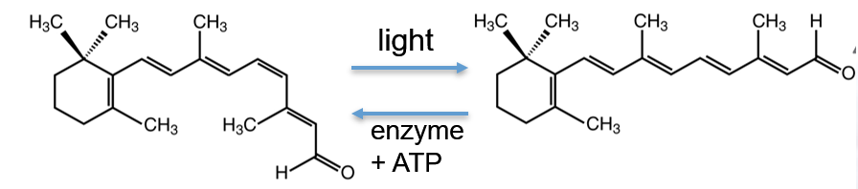

Visible light refers to electromagnetic energy that has a wavelength between 380 and 760 nm. We detect this light using four kinds of photoreceptor cells (1 rod cell & 3 cone cells). It is the only form of light in the spectrum that is strong enough to absorb the energy and hold on to it.

Wavelength: determines how much energy is in that light, in that photon, in that disturbance of the electromagnetic field.

How light interacts with matter?
- Gamma rays are high energy light so they pass through our body and matter and we don’t see them (cause death or cancer)
- Same is for X-rays(can be dangerous if used often) and Ultraviolet rays (reason for sunburn pain), only difference is that they are less intense than gamma, respectively.
- All of these 3 are so strong they basically knock the electron out of the molecule and even the body. These kinds of lights are called ionizing radiation.
- Television and radio broadcast band lights are not strong enough to do anything to your body, the most they will do is shake up the molecules a little bit and head up the body a little, as well as the radar and inrared rays.

Important Facts:
- If there is only one opsin working, you can’t detect colours, it will be all monochromatic.
- The amount that any one cone will be activated depends both on the wavelength of the light and the amount of it (its intensity).
- Activation of all 3 cones = detection of colors
- See slide 20 for more examples of the wavelengths and colour detection.
- Paint is the subtraction of light from white and light is adding all of the colours together.

Perceptual Dimensions of Color & light: our perception of light has 3 dimensions to it
  - Brightness – intensity, how much light there is, goes from black (no light) to very bright (lots of brightness). If brightness is 0%, your image will be all black.
  - Saturation – purity, how deviated off of the center point you are, how pure is the colour. If saturation is 0%, you are in the middle of the color cone where there is no color (equal contribution from all wavelengths) which means you have a black and white image. At 100% you are a pure color and you are not mixing anything.
  - Hue – dominant wavelength, what colour it is, goes in range of 1-360 degrees

Hue and saturation have no impact if there is no brightness.

Color Vision Deficiency: 3 forms of color blindness, there are mutations in the opsins proteins, where the opsins protein cannot be made, and cannot detect light.
  - Protanopia: Absence of the red opsin, red opsin is not functional. Visual acuity is normal because red cone cells get filled with green cone opsin. People with this inherited condition have trouble distinguishing colors in the green-yellow-red section of the spectrum
  - Deuteranopia: Absence of the green cone opsin (1% of males). Visual acuity is normal because green cone cells get filled with red cone opsin. People with this inherited condition have trouble distinguishing colors in the green-yellow-red section of the spectrum.
  - Tritanopia: Absence of the blue cone opsin (1% of the population). Blue cone cells do not compensate for this in any way, but the blue cone opsin is not that sensitive to light anyway, so visual acuity is not noticeably affected.

*****Visual acuity that is caused by the absence of these cells is that, you will still be able to see just as clear as anyone else, and sense light, you just might not be able to differentiate between the colour spectrums depending on which opsin is mutated.*******
Achromatopsia: true color blindness!!!!!

- There are a lot of axons and blood vessels that are going out of our eye.
- Optic nerve: where all the axons and blood vessels are grouped together, there is no photoreceptors in that part of your retina, do you have blind spots in each eye.

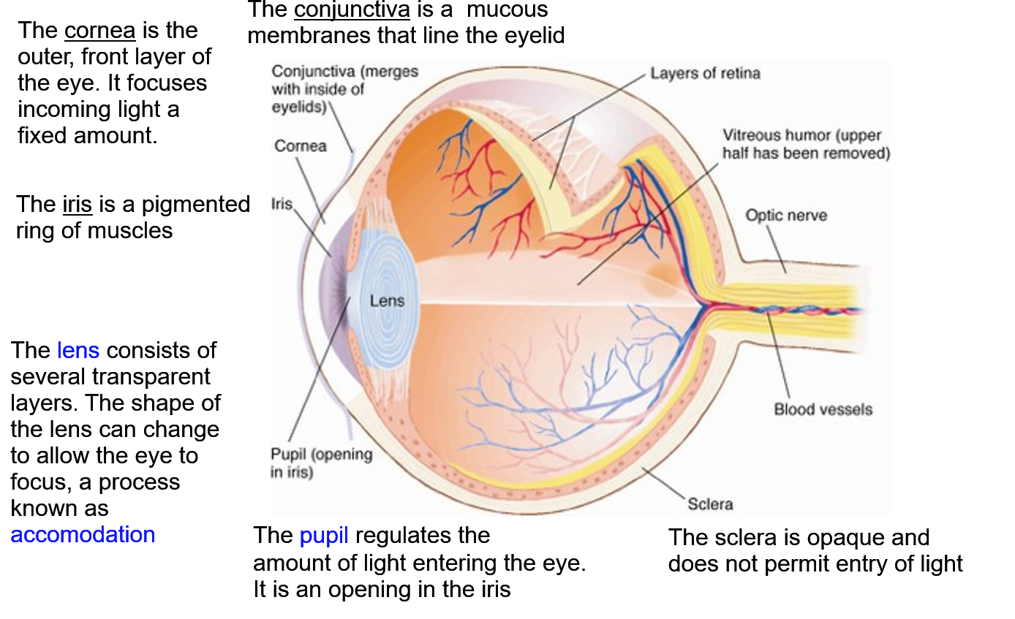

- The interior lining (furthest back part) of the eye is the retina. The retina contains photoreceptor cells. In humans, photoreceptor cells are classified as rod or cone cells.
- Light passed through the lens and crosses the vitreous humor, a clear, gelatinous fluid
- The central region of the retina is the fovea. It contains a high density of photoreceptors and thus mediates acute vision.

Fovea and Periphery of Retina:
Fovea: The fovea primarily contains cone cells, each of which connects to a single downstream collection of cells (a bipolar cell which in turn connect to a single ganglion cell). Thus, photoreceptors in the fovea can register the exact location of the input. This enables high resolution, color vision. They have a 1:1:1 connection.

Periphery: collections of photoreceptors (primarily rods, which use the opsin rhodopsin) converge onto fewer and fewer downstream collections of neurons (bipolar and ganglion cells). Although precise location and shape of input is heavily impeded, the periphery enables the perceptions of faint lights and general shapes (low resolution).10x more photoreceptor cells than bipolar cells and 2x more bipolar cells than ganglion cells.

- Foveal vision is sensitive to detail & color
- Peripheral vision is sensitive to dim light

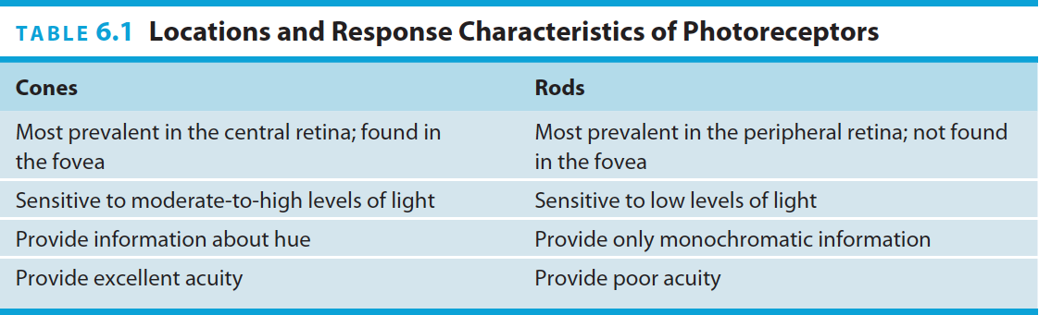.
Movement of the eye:
- Pursuit movements allow us to maintain an image of a moving object.
- Saccadic movements – rapid, jerky shifts in your gaze from one point to another. Our eyes scan a scene by making saccadic movements.

Neurons in the retina:

- ***When light first comes in, it goes directly to the back of the eye to the opsin proteins that are holding the retinal, those proteins are inhibitory metabotropic receptors. ***

- Photoreceptor cells: neurons responsible for the transduction of light; they project to bipolar cells. Do not have any action potentials, get hyperpolarized by the light, they release less glutamate, less than they do in the dark. They release glutamate in a graded manner dependent on their membrane potential. Photoreceptors cells depolarize in the dark and release more glutamate and less in the light because they get hyperpolarized.

- Bipolar Cells: There are OFF and ON cells.
Off Bipolar cells: have regular, ionotropic glutamate receptors, depolarized by glutamate and always releasing it in the dark cause they are always receiving this glutamate from the photoreceptor cells that are depolarized in the dark.

On Bipolar Cells: only express inhibitory metabotropic glutamate receptors, more light = photoreceptor cells get hyperpolarized and stop releasing glutamate

- Retinal Ganglion Cells: typical neuron, the only neurons in the retina that sends axons out of the eye. They receive information from bipolar cells and project to the rest of the brain; their axons give rise to the optic nerve, which leaves the retina through the optic disc (i.e., the blind spot of the retina).

- ****The receptive field of a neuron involved in visual processing is defined as the area of visual space where the presence of light influences the firing rate of that neuron (i.e. the part of space in which light must fall to get a response from the neuron) ****
- Receptive fields become larger as you move away from photoreceptors towards the brain
- If light in a particular part of the visual field decreases cell activity, this is considered a receptive field.
- If light in a particular part of the visual field increases cell activity, this area is known as a receptive field.
- Shining a light on a cell in V1 won’t do anything, because cells in V1 don’t have any light-sensitive opsins the way photoreceptors do. We would have to shine It on the on or off receptive field of the cell
- Simple cells in primary visual cortex are sensitive to lines of light, and their receptive fields are typically organized in a center-surround fashion.
- ON cells are excited by light in the center and are inhibited by light in the surround.
- OFF cells are excited by light in the surround and are inhibited by light in the center.

Alternative Pathways:
• Superior Colliculus: involved in controlling fast reflexive movements in response to light
• Hypothalamus: (not shown) regulates sleep/wake cycles

The What & Where & How in the visual stream
- The dorsal stream of visual information processing starts in primary visual cortex and ends in posterior parietal cortex. It is involved in identifying spatial location. It encodes where objects are, if they are moving, and how you should move to interact with or avoid them

- The ventral stream starts in primary visual cortex and ends in inferior temporal cortex. It is involved in identifying form (shape). It encodes what the object is and its color

Depth Perception:
- Monocular vision: Some V1 neurons respond to visual input from just one eye.
- Binocular vision: Most V1 neurons respond to visual input from both eyes.
- Depth perception: There are many monocular cues that can be used to estimate depth, such as relative size, amount of detail, relative movement as we move our eyes, etc. These are the cues we use to appreciate depth when looking at a 2-dimensional image (e.g., on a photograph or TV screen).
- Stereopsis: The perception of depth that emerges from the fusion of two slightly different projections of an image on the two retinas. The difference between the images from the two eyes is called retinal disparity. It results from the horizontal separation of the two eyes. It improves the precision of depth perception, which is particularly helpful when trying to plan movements to interact with objects in space.

Agnosia: a deficit (problem) in the ability to recognize or comprehend certain sensory information, like specific features of objects, persons, sounds, shapes, or smells, although the specific sense is not defective nor is there any significant memory loss.
Akinetopsia – a type of visual agnosia caused by damage in an area of the dorsal visual stream (in the parietal lobe of the cerebral cortex)
  - It is a deficit in the ability to perceive movement

Cerebral achromatopsia: - visual agnosia caused by damage to the ventral visual stream. People with cerebral achromatopsia deny having any perception of color. They say everything looks dull or drab, and that it is all just “shades of grey”.

Prosopagnosia: Failure to recognize particular people by sight of their faces; caused
by damage to the fusiform gyrus (fusiform face area)

Predictive coding theory: read the transcript for examples and explanation

Visual information pathways:
- Thalamus: (specifically the lateral geniculate nucleus, which in turn projects to the primary visual cortex in the occipital lobe of the cerebrum): Visual information is processed in this pathway to determine what you are looking at. This pathway creates an internal (mental) representation of your entire visual space: the objects in it, their position and relative attentional value.

- Midbrain (specifically the superior colliculi): Visual information is used here to control fast visually guided movements. The midbrain doesn’t really know what you are looking at, but it knows where light is moving in visual space

- Hypothalamus: Visual information is used here to control circadian rhythms (such as sleep-wake cycles). The hypothalamus doesn’t know what you are looking at, but it knows how much light is present in your environment.

Anatomy Of the Skin:
- The outermost layer of skin is called epidermis (“above dermis”). Cells here get oxygen from the air (not the blood).
- The middle layer is called dermis. The deepest layer is called the hypodermis (or subcutaneous, “below the skin”). Sensory neurons are scattered throughout these layers.
- Free nerve endings primarily respond to temperature and pain.
- Meissner’s corpuscles are only found in glabrous skin. They detect very light touch and localized edge contours (brail-like stimuli).
- Glabrous skin is ‘hairless’ skin (e.g. palms of hands and feet)

Perception of Temperature:
2 categories of thermal recptors; hot or cold. Pain information is processes in some of these cells
Poorly localized information, axons that carry it to the CNS are unmyelinated or thinly myelinated. Very slow
Some of the receptor proteins that are sensitive to temperature can also be activated by certain ligands (e.g., capsaicin molecules activate heat receptors and menthol molecules activate cold receptors).
If you touch something very cold and hot at the same time, your brain will think It is painful because it can’t detect and differentiate completely what temperature it is at.

Pain:
- Pain sensation is mediated by free nerve ending in the skin.
- pain receptors; Nociceptors // Mechanoreceptors (intense pressure, pinching, stretching, etc).
- Other types of free nerve ending appears to respond to extreme heat (or the presence of chemicals such as capsaicin, the active ingredient in chili peppers).

From the Body to Primary Somatosensory Cortex:
Axons from skin, muscles and internal organs enter the CNS via spinal nerves. There are 2 main pathways:
1. Poorly localized information (e.g., crude touch, temperature, and pain) immediately crosses over in the spinal cord and the first synapse is there. This information then ascends to the thalamus through the spinothalamic tract.
2. Highly localized information (e.g. fine touch) ascends ipsilaterally through the dorsal column of the spinal cord. The first synapse in this pathway is in the medulla. From there the information crosses over to the contralateral side as it ascends to the thalamus.

Both pathways get bundled together in the midbrain before synapsing in the thalamus. From there, information goes to primary somatosensory cortex in the parietal lobe.

Because of all of this, if we were to apply electrical stimulation to different sites on the primary somatosensory cortex, patients would report these sensations at specific parts of their bodies.

