Experiment 2 Analysis of Aspirin

Abstract:
In this experiment, the quantity of acetylsalicylic acid (ASA) in Aspirin tablet and powder were determined using the method of back titration, and the concentration of ASA was calculated in the form of weight percentage. The results showed that aspirin tablets contained 319.3mg, 310.7mg, 316.3mg, respectively; and the aspirin powder contained 78.8% of ASA. Determining the mass or concentration in Aspirin was important not only in the field of chemistry and pharmacology, but also in this way we could assess if the drug were made under pharmaceutical manufactures’ stipulation.

Introduction:
Aspirin is widely known to reduce pain, inflammation, and prevent strokes and heart attacks. Different dosages of Aspirin could produce different effects and target in different medical therapies. As one of the commonly used drugs in the global market, it is important that the drug has the same amount of dosage or concentration as its manufacturer described. Otherwise, if the dosage of the drug were either lower or higher than it should be, it will put a huge health threat on the people who are taking it. Hence, it is essential to assess the concentration of the drug not only for the public health but also for the future research and medical purpose.
In this experiment, the mass and concentration of ASA in an Aspirin headache tablet were determined by the method of back titration. The Aspirin tablets (or powder) were dissolved in excess standardized NaOH, in which 1 unit of ASA reacted with 2 units of NaOH. The amount of excess NaOH was then determined by titrating with standardized HCl in a standard strong acid and strong base reaction by a 1:1 ratio.
The method behind this experiment was easy to understand, and for analyte like Aspirin which had little solubility in water, back titration was ideal. However, the method was time consuming, and large sample size may require to decrease the systematic error and to make results more accurate and convincing.

Experimental:
1). Procedure
Refer to Lab Manual p32-34; except the blank titration of NaOH was skipped since running out of time.
2). Measurements for Sample Preparation
# | m(KHphthalate) (g)
1 | 0.85
2 | 0.7983± 0.0001
3 | 0.7701± 0.0001
Table 1. Mass of potassium hydrogen phthalate used in s NaOH standardization.

# | m(tablet) (mg) | m(powder) (mg)
1 | 433.8± 0.1 | 440.7± 0.1
2 | 435.9± 0.1 | /
3 | 427.3± 0.1 | /
Table 2. Mass of 3 Aspirin tablet and Aspirin powder.

Results and Discussion:
1). Data
# | m(KHphthalate) (g) | V(NaOH) (mL)
1 | 0.85 | 34.38± 0.01
2 | 0.7983± 0.0001 | 31.3± 0.01
3 | 0.7701± 0.0001 | 31.92± 0.01
Table 3. Total volume of NaOH used in standardization.

# | V(HCl) (mL) | V(NaOH) (mL)
1 | 25± 0.03 | 19.50± 0.01
2 | 25± 0.03 | 19.55± 0.01
3 | 25± 0.03 | 19.60± 0.01
Table 4. Total volume of standardized NaOH used in HCl standardization.

# | V₁(HCl) for tablet 1  (m₁ = 433.8± 0.1mg)  (mL) | V₂(HCl) for tablet 2  (m₂ = 435.9±0.1mg)  (mL) | V₃(HCl) for tablet 3  (m₃ = 427.3± 0.1mg)  (mL) | V(HCl) for powder  (m = 440.7± 0.1mg) (mL)
1 | 23.00± 0.01 | 23.8± 0.01 | 23.04± 0.01 | 21.95± 0.01
2 | 21.55± 0.01 | 22.8± 0.01 | 22.71± 0.01 | 22.21± 0.01
3 | 23.5± 0.01 | 22.46± 0.01 | 22.4± 0.01 | 21.96± 0.01
Table 5. Total volume of HCl used in back titration for 3 Aspirin tablets and powder.

2). Results
# | c(NaOH) ± sd (M) | c(HCl) ± sd (M)
1 | 0.121± 0.003 | 0.0947± 0.0002
2 | 0.125± 0.003 | 0.0949± 0.0002
3 | 0.118± 0.003 | 0.0952± 0.0002
Table 6. Concentration of NaOH and HCl with standard deviation (sd) after standardization.

Tablet | Individual |  | Group
# | m(ASA) ± sd (g) | %wt ± sd | m(ASA) ± sd (g) | %wt ± sd
1 | 0.32 ± 0.03 | 73.9 ± 7.7 | 0.317 ± 0.009 | 73.8 ± 2.3
2 | 0.31 ± 0.02 | 71.0 ± 5.0 | 0.317 ± 0.008 | 74.0 ± 2.7
3 | 0.32 ± 0.01 | 74.1 ± 2.5 | 0.32 ± 0.01 | 74.0 ± 2.3
Mean | 0.32 ± 0.05 | 73.2 ± 1.8 | 0.32 ± 0.009 | 73.9 ± 2.3
Table 7. The mass and concentration of 3 Aspirin tablets from individual data and group data. Mean of individual data and group data were also calculated. Standard deviations were displayed (sd).

Powder | Individual  %wt ± sd | Group  %wt ± sd
1 | 78.8 ± 2.0 | 76.2 ± 2.1
Table 8. The concentration of Aspirin powder from individual data and group data. Standard deviations (sd) were displayed.

T test | T value* | T value at 95%
Tablet: individual mean (N=3)and manufacture mean | 3.077 | 4.303
Tablet: group mean (N=18)and manufacture mean | 3.62 | 2.11
Tablet mean (N=18)and powder mean (N=6) | 1.72 | 2.07387
Table 9. T test with corresponding t value at 95% significant level and calculate t value*.

Figure 1. Shewhart chart of group samples with the manufacture mean as the target line.

3). Discussion:
The results obtained showed that in average ASA concentration was 316.33mg/tablet, 73.2% in tablet weight percentage, and 78.8% in powder percentage. From the group results, the average of ASA concentration in Aspirin tablets was 317.57mg/tablet, 73.97% in tablet weight percentage, and 76.2% in powder weight percentage. We could see that there were not much difference between individual results and group data in the ASA concentration and weight percentage in Aspirin tablet; while there was a 4.83% difference of the weight percentage in the Aspirin powder between individual and group results. The random error may came from experimental apparatus and glassware, and the systematic errors were most possible caused during the procedure of titration. The equivalence point was found by observing the color change , and this was not accurate enough. The point when the color changed, it was always slightly over titrated. To make the results as accurate as possible, we may increase the sample size and the number of titrations.
The standard deviation in the individual results were slightly large, and this indicated that the values obtained were slightly “spread” around the mean value. By increasing the number of experiments and sample size, this may be reduced to a relative smaller value.
From the t test conducted (refer to table 9), the calculated t value of ASA concentration between individual mean and manufacture mean was 3.077 which was smaller than the critical t value (4.303), so we could conclude that the results were not significantly different, and therefore, the means were considered to be the same. For the calculated t value of ASA concentration between group mean and manufacture mean was 3.62 which was larger than the critical t value (2.11), which we were able to conclude that the group mean was different from the manufacture mean. By comparing with the ASA concentration of Aspirin powder and tablet, the calculated t value was 1.72 which was smaller than the critical value of 2.07387. This indicated that the concentration between Aspirin powder and tablet were not significantly different.
According to the Shewhart chart, there were some non-successive points found on the same side of the lower bound of the action line, which indicated the exitance of the systematic error. The values were produced by different person in the group, and with each person only had a sample size of 3, which could largely contributed to the error term. Besides, the Aspirin powder and tablet were not completely dissolved in NaOH which could also cause a smaller concentration comparing to the real value. By increasing the sample size and the number of titration from the same person, the systematic error may be reduced.

Conclusion
The individual Aspirin tablet data showed no difference in the ASA concentration comparing with the real value provided by manufacturer, and the ASA weight percentage was also not significantly different between the form of Aspirin tablet and powder. However, the sample was relative small and for a more accurate result, more samples may assessed.

Calculation:
- Calculations from individual data
1). Concentration of potassium hydrogen phthalate
Take table1 #1 as an example:
m = 0.85g, MM = 204.23g/mol, V=0.05L
c = (m/MM)/V = (0.85g/204.23g/mol)/0.05L = 0.08324M
2). Concentration of NaOH
Take table 6 #1 as example:
n(NaOH) = n(KHphthalate) = m/MM = 0.85/204.23g/mol = 0.00416mol
c (NaOH) = n/V = 0.00416/0.03433 = 0.1212M
3). Concentration of HCl
Take table 6 #1 as an example:
Standardized c (NaOH) = 0.1214M, V(NaOH) = 0.0195L, V(HCl) = 0.025L
n(HCl) = n(NaOH) = c (NaOH) V(NaOH) = 0.1214M * 0.0195L = 0.002367mol
c(HCl) = n(HCl)/ V(HCl) = 0.002367mol/0.025L = 0.094692M
4). Concentration of ASA in tablets
Take tablet#1 (table 7 #1 individual) as an example:
V(HCl) = 0.023L, c(HCl) = 0.0949348M, V(NaOH) = 0.025L, m(tablet 1) = 0.4338g
n(NaOH)excess = n(HCl) = c(HCl)* V(HCl) = 0.09493M*0.023L = 0.002183mol
n(NaOH) = n(NaOH)total - n(NaOH)excess = c (NaOH)* V(NaOH) -n(NaOH)excess
= 0.1212M*0.025L - 0.002183mol = 0.0008515mol
n(ASA) = n(NaOH)/2 = 0.0008515mol/2 = 0.00042575mol
m(ASA) = n(ASA)*MM(ASA)*4 = 0.00042575mol*180.15g/mol*4 = 0.30681g
%wt = m(ASA)/m(tablet 1) = (0.30681g/0.4338g)* 100% = 70.626%
5). Mean concentration of ASA
Take table 7#1 as example:
Like above 4) calculated, similarly, we could get all m1, m2 and m3 of ASA in 1
tablet.
m1= 0.30681g, m2= 0.3563g, m3 = 0.294667g
m= (m1+m2+m3)/3 = (0.30681g + 0.3563g + 0.294667g)/3 = 0.3192g
6). Standard Deviation (sd) of ASA
Take table 1 #1 as example:
m=0.3192g, m1= 0.30681g, m2= 0.3563g, m3 = 0.294667g
Sd = $\sqrt{\frac{{(m-m1)}^{2}+{(m-m2)}^{2}+{(m-m3)}^{2}}{2}}$ = 0.0326
- Calculations from group data
1). Group mean of mg ASA/tablet
E8 = AVERAGE(B8:B25) = 317.5689444
2). Group mean of %wt ASA in tablet
F8 = AVERAGE(C8:C25) = 73.96961111
3). Group mean of %wt ASA in powder
G8 = AVERAGE(D8:D13) = 76.19033333
4). Standard deviation
Group ASA mg/tablet: E11 = STDEV(B8:B25) = 8.72352688
Group ASA %wt in tablet: F11 = STDEV(C8:C24) = 2.298213095
Group ASA %wt in powder: G11 = STDEV(D8:D13) = 2.060375176
5). T test between individual mean and manufacture mean
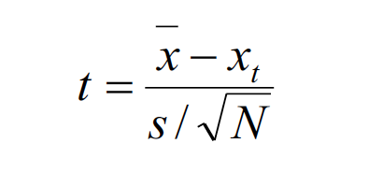
Where $\overline{x}$ = 325mg, x_{t} = 316.33mg, s = 4.88, N=3
t = 3.077
6). T test between group mean and manufacture mean
Where $\overline{x}$ = 325mg, x_{t} = 3167.57mg, s = 8.72, N=18
t = 3.62
7). T test between group %wt in tablet and %wt in powder
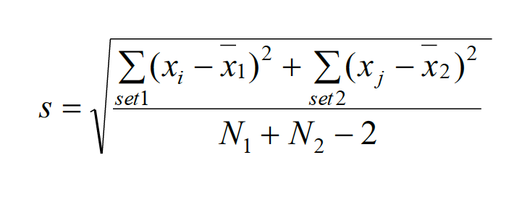
Where $\overline{x1}$ = 73.97%, $\overline{x2}$ = 76.19%, N1 = 18, N2 = 6
s = 8.40
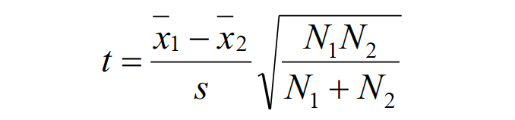
Where $\overline{x1}$ = 73.97%, $\overline{x2}$ = 76.19%, N1 = 18, N2 = 6, s = 8.40
t = 1.72


