CST8116 Assignment 04
  - Using Git within Eclipse.

Instructions
- This assignment focuses on using the Git version control system, within an Eclipse Environment.

- Expectation: you have already reviewed and completed instructions for Git installation and configuration
  - Installing and initial configuration: See Hybrid 05 content area, within week 05 lecture notes content area
  - Using Git in Eclipse: See Hybrid 08 content area, within week 10 lecture notes content area
    - The handout here will walk you through this lab assignment as well.
  - If you have not installed Git, or worked through the handouts for Hybrid 08 do so now.

- This assignment handout has brief step-by-step instructions
- You will need to screen shot your running program
- You will need to screen shot your Git History for the project in Eclipse
- Submit your source code file, and your Git Repository as a zip archive.
(Follow Lab Professors Directions)

Steps

Create an Eclipse Project
- Name the project: Assignment 4

Create a Git Repository for the project
- Create a Git Repository using Eclipse for your Assignment 4 Project
- Create the following location on your hard drive for the repository:
C:\CST8116_Assignment_04_Your_Name
Your_Name should be your full name, as see in ACSIS separating each name with underscores.
- You will need to zip this folder and submit it after completing all of the steps in this lab.

Add the Project files to the Git Staging area
- Add your project to the Git staging area within Eclipse (See hybrid handout(s) )

Verify .ignore file
- Make sure that the .ignore file has an entry for /bin/
- If you cannot see the .ignore file reference the hybrid handout on how to modify the package explorer filters.

First Commit
- Commit the initial project files
  - Enter a commit message
“New Project Assignment04 by YourFullName”
  - Omit the double-quotes.
  - replace YourFullName with your actual name
  - Add a signed-off by entry with your name and email using the interface (see hybrid handout)
  - Commit.

Create a source code file and add to version control
- Add a class to the project naming it Assignment04YourFullName where YourFullName is your full name as it appears in ACSIS. For Example Stanley Pieda would name the class File Assignment04StanleyPieda
- Check off the box to create a main method.
- Right-click on the file and add it to the Git Staging Area

Second Commit
- Commit the new source code file.
  - Enter a commit message
“Added source code file Assignment04YourFullName with method main”
  - Omit the double-quotes.
  - replace YourFullName with your actual name
  - Add a signed-off by entry with your name and email using the interface (see hybrid handout)
  - Commit.

Copy starter code into source code file
- Copy the starter code located here (also included in a text file) into method main.
- Modify the code so that it prints out your name, instead of Junior Programmer
- Add programmer comments to the file in the usual manner for our course.
- Note:
  - You will be asked to fix a mistake in the loop condition in a later step.
  - Currently if you run the program as presented here, it will crash (this is on purpose).

int[] primes = { 2, 3, 5, 7 };

for(int index = 0; index <= primes.length; index++) {

System.out.println(primes[index]);

}

System.out.println("Program by Junior Programmer");

Save the changes to the file. (Just normal Save button in Eclipse).

Third Commit
- Commit the changed source code file.
  - Enter a commit message
“Added programmer comments, and starter code to method main.”
  - Omit the double-quotes.
  - Add a signed-off by entry with your name and email using the interface (see hybrid handout)
  - Commit.

Run the program / fix the bug / run the program & Screen Shot.
- Run the program and observe the error message.
- Fix the problem with the loop condition.
- Run the program and take a screen shot for your MS Word document.

Fourth Commit
- Commit the changed source code file.
  - Enter commit messages, use Separate lines, blank line between each.
“Corrected the problem with the loop.”
“The condition was permitting the loop to run too many times.”
  - Omit the double-quotes.
  - Add a signed-off by entry with your name and email using the interface (see hybrid handout)
  - Commit.

Take screen shot of Git history in Eclipse
- View the Git History in Eclipse.
- Ensure that your Project (not just the source code file) is selected in the Package Explorer so that the full history is shown.
- Take a screen shot that shows your commit: id, message, author, authored date, committer, and committed date.
- This is an example created by Stanley Pieda
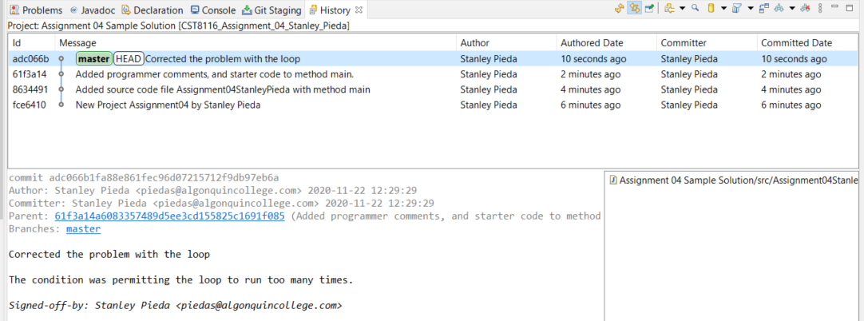

Submit MS Word document with screen shots, your Java file, and a zip archive of the Git Repository you created.
Follow any additional instructions provided by your lab professor.

Your lab professor may verify your repository using command line tools, e.g. >git log to determine that it closely matches your screen shot taken from Eclipse.

Microsoft Word Document Format
See the template example, suggested headings below

Screen Shot Running Program
Screen Shot Git History in Eclipse

Grading (10 points)
Criteria | Missing / Poor (0) | Below Expectations (1) | Meets Expectations (2)
Screen Shot, Program Execution | Missing or poorly done (missing student name in screen shot) | Shows program executing successfully, may only have part of student’s name in output. | Shows program executing successfully, student’s full name as part of output.
Screen Shot, Git History | Missing or poorly done (missing student name in screen shot) | Shows some but not all of the requested commits, or commit text not correct. May only have part of the student’s name in the screen shot. | Shows all four requested commits and closely matches sample screen shot. Student’s full name is visible in the screen shot.
Source Code Comments | Missing or poorly done | Missing some of: Programmer comments at top of file, descriptive comment for class and method name. | All completed: Programmer comments at top of file, descriptive comment for class and method name.
Source Code Fixed | Missing or poorly done or is un-modified starter code. | Problem with loop condition not fixed correctly; starter code was copied into method main. | Problem with loop condition is fixed; starter code was copied into method main.
Git Repository | Missing from submission or only a project folder and not a full Git Repository. | Does not have requested folder name for repository, git log command may show inconsistencies when compared to screen shot. | Has requested folder name for repository, git log command closely matches the history seen in the screen shot.

Submission Requirements
- Upload these items to Brightspace by the due date:
- MS Word document containing screen shots.
- Java file with programmer comments and source code.
- Assignment 04 Git Repository within a zip archive (CST8116_Assignment_04_Your_Name.zip)
  - Your_Name should be your full name as seen in ACSIS.
- Follow your lab professor’s instructions regarding lab submissions for their lab section.

Appendix: Sample git log
- Students are not required to submit a screen shot like this one, it is here for demonstration only.
- Use the space-bar if there are multiple pages of output.
- Enter a ‘q’ for quit, to exit the log tool.



