Assessment: Assignment #04
Student Name: xxxxxxxx
Lab Professor Name: David Houtman
Lab Section Number: 363
Due Date: 6th December 2020

1. Screen Shot Running Program

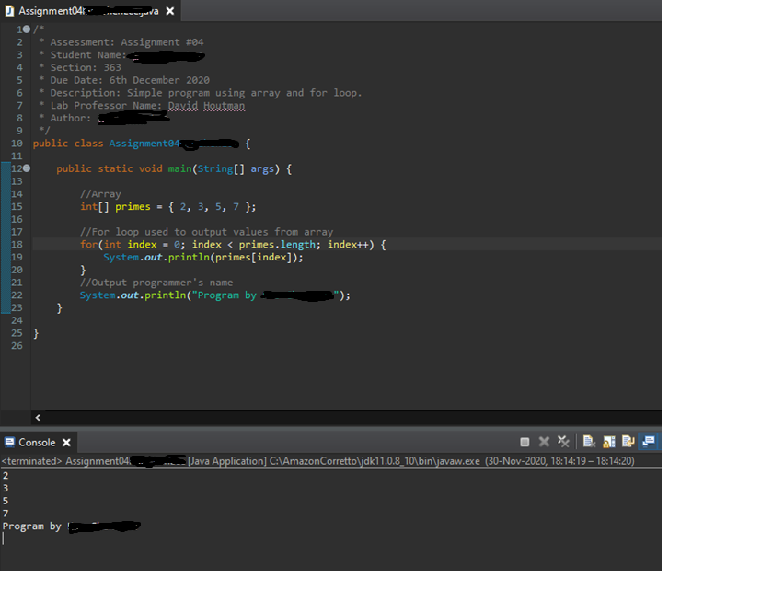

2. Screen Shot Git History in Eclipse



