BIOL 1080 lecture 1
January 6, 2020
Systems biology: The systematic study of complex interactions in biological systems.
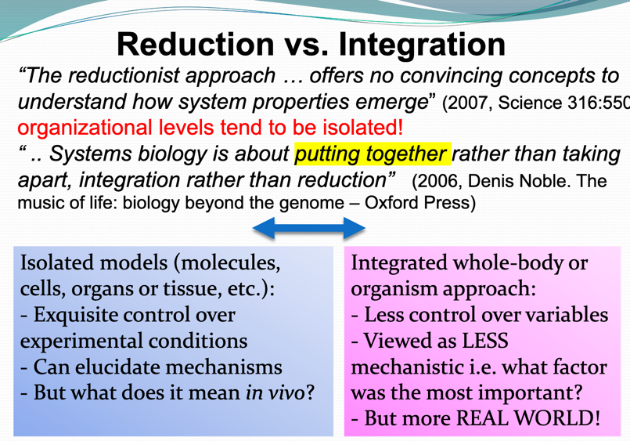
Main goal- to better understand the entirety of the processes that happens in a biological system



