Chapter 1: (introduction and triangle)
• Business exists to satisfy the wants and needs of society
• Business influences, and is influenced by, other businesses, government(s) and civil society
• The consequences of business are good and bad; winners and losers are inevitable
• Every single product in use today has consequences
• Society expects business to be profitable, but to do so ethically and in a socially responsible way
• There are many stakeholders – some real, some not◊ technology and globalization complicates this relationship
• All levels of government:
– Federal
– Provincial
– Municipal
Rules or “sorting” mechanisms of coordination for each segment are based on different principles:
– Business -- supply and demand forces
– Government -- redistribution and coercion
– Civil society -- cooperation, reciprocity and solidarity

Chapter 2: (types of businesses and governance)
• The economic system in Canada is a private enterprise system
– Rewards firms for effectively and efficiently meeting the wants and needs of customers
– Basic rights of a private enterprise system:
• Private property • Freedom of choice • Profits • Competition
• Sole Proprietorship (SPs) Advantages:
– Easy and cheap to start – Secrecy – Flexibility and control – Pride of ownership – Distribution and use of profit – No special taxes – No government regulation
• Sole Proprietorship (SPs) Disadvantages:
– Unlimited liability – Limited financial resources – Limited skills pool – Overwhelming time commitment – Few fringe benefits – Limited growth – Limited life span
• Silent partners – Known to the public, no active management role
• Secret partners – Unknown to the public, but take an active role in management
• Nominal partners – Lend their name for public relations, but are actually not involved
• Dormant partners – Neither known to the public nor active in management
The Partnership
• Advantages
– Ease of organization – More financial resources (capital and credit) – Shared management – Combined knowledge and skills – Faster decision making – Few regulatory controls
• Disadvantages
– Unlimited liability – Partners are responsible for the business activities of all others – Division of profits – Disagreements among partners – Life of a partnership
The Corporation
• Advantages
– More money for investment – Limited liability – Separation of ownership from management – Ease of ownership change – Perpetual life – Size – Perceived legitimacy
• Disadvantages
– Initial cost – Paperwork – Two tax returns – Termination difficult – Double taxation – Greater expectations for social responsibility and ethical conduct from stakeholders
How an organization steers itself
• Stakeholders – Values – Rules – Processes – Impact – Accountability – responsibility
Corporate Governance Key Players
-Shareholders -Board of Directors - Officers/Senior Employees

Boards of Directors Responsibilities:
– Accountability – Management control systems – Disclosure – Financial reporting – Shareholder & stakeholder rights – Risk – performance

Chapter 3: (Canadian government)
• Canada is a democracy, a constitutional monarchy and a federal state, with 10 largely self-governing provinces and three territories
• A Federal State
– A federal state is one that brings together a number of different political communities with a common government for common purposes, and separate “states” or “provincial” governments for the particular purposes of each community
– Federalism combines unity with diversity
– The British North America Act, 1867, was the instrument that brought the Canadian federation into existence

Specific Rights and Freedoms
} Democratic rights } Fundamental freedoms } Mobility rights } Legal rights } Equality rights } Official language rights } Minority language education rights

• Canada: – governed by a system of parliamentary democracy with powers divided among the various levels of government that constitute our federalist state

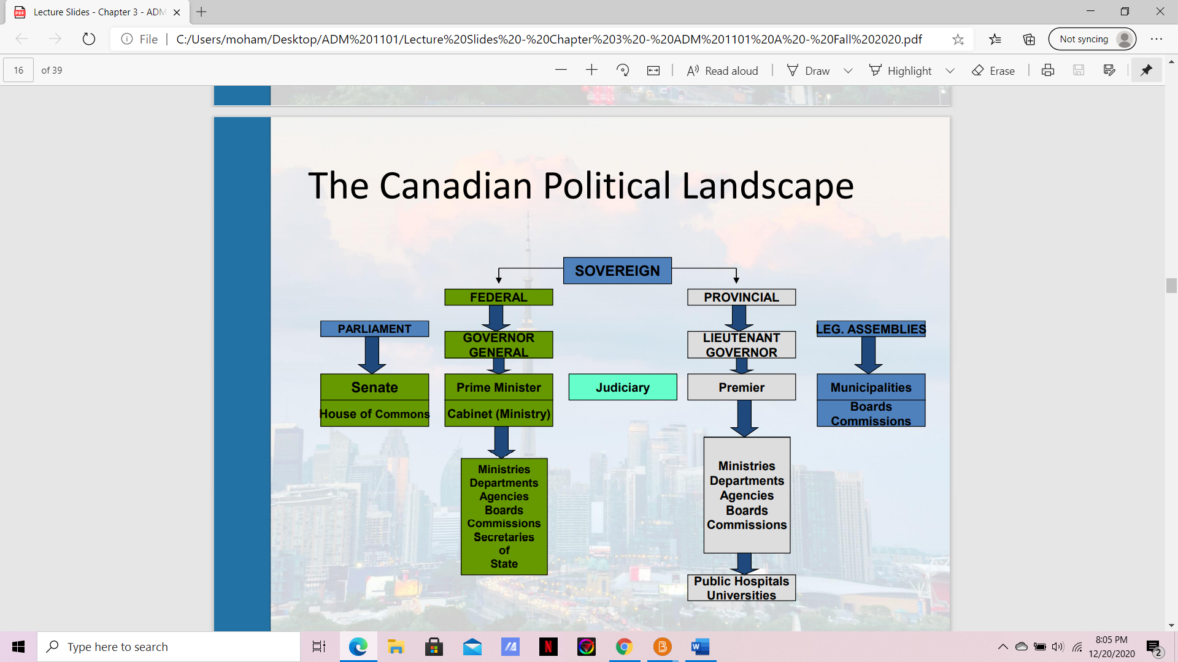

Chapter 4: (social part of triangle)

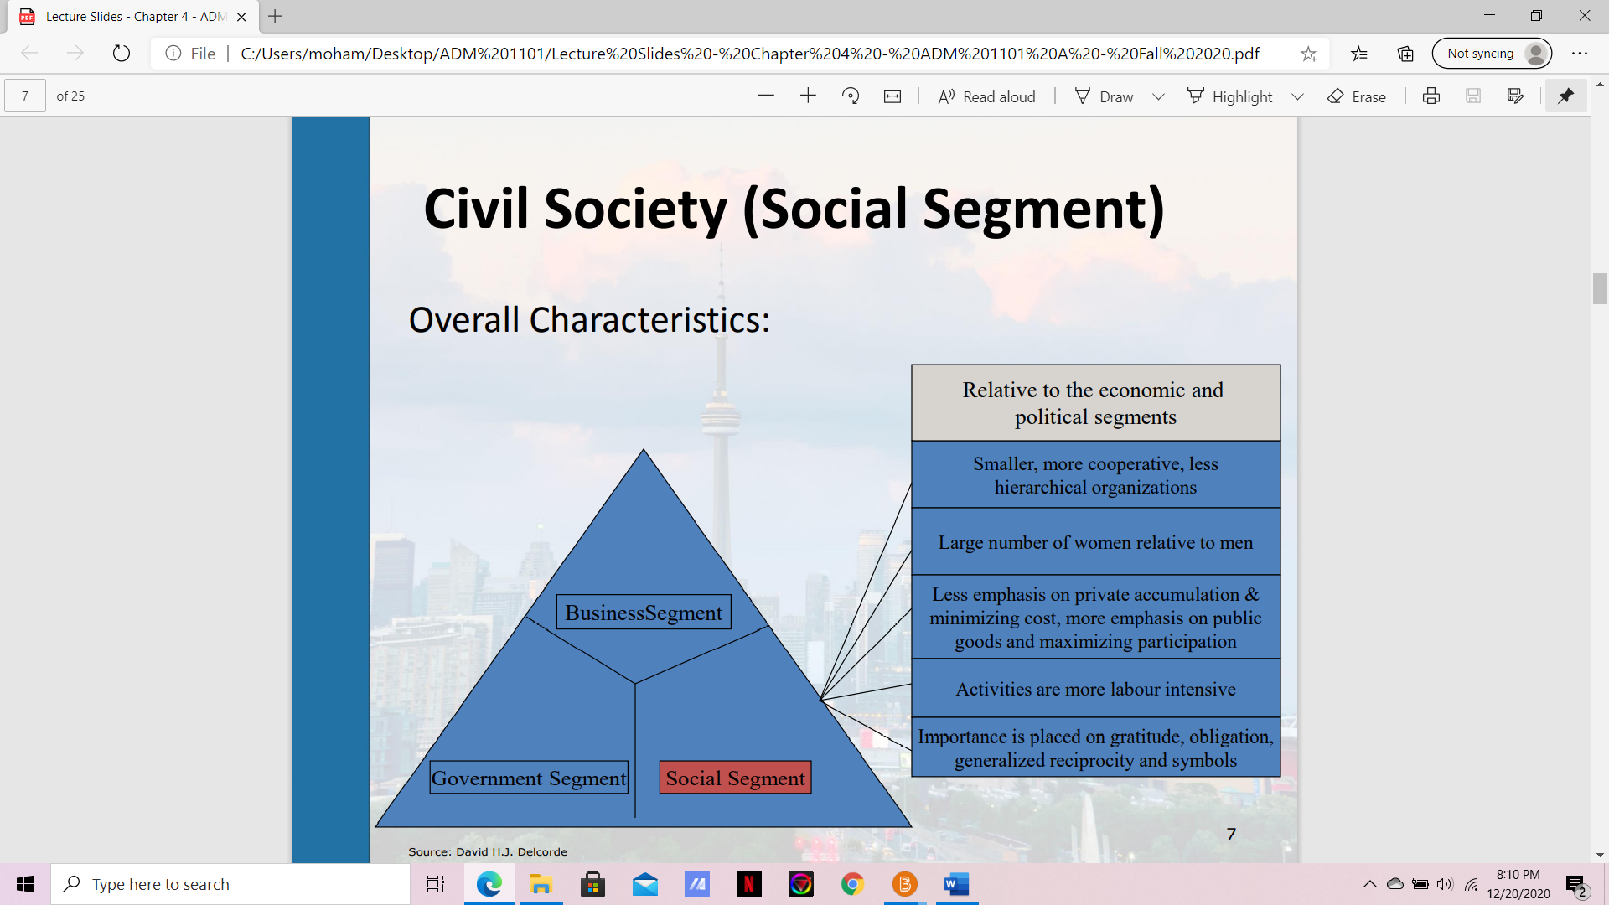

Chapter 5: (shareholders and stakeholders)
Shareholder Viewpoint:
◦ A business exists to make money – greatest efficiency is achieved through profit maximization
◦ > profits, > taxes paid to government for use in dealing with social issues
◦ Property rights theory (corporation owned by shareholders)

Stakeholder Viewpoint:
◦ Business has a responsibility to do more than maximize profits
◦ Business has caused several problems so it has a responsibility to fix them
◦ Social institution theory (society provides the very existence of business through legal frameworks)
7 © Sean Locke Photography/Shutterstock.com Shareholder View vs.

1. Stakeholders’ interests will not always be clear 2. Some stakeholders will win, others will lose 3. Stakeholders watch how the organization treats other stakeholders 4. Stakeholder management will cost money, but might be cheaper than not managing stakeholders 5. Stakeholders and stakeholder groups are not static 6. Stakeholder contributions are essential

• Core stakeholders are essential to the firm’s survival • Strategic stakeholders are directly affected by threats and opportunities the organization faces • Environmental stakeholders are all others in the organization's environment

Chapter 6: (globalization)
• Globalization: a process of decreasing constraints on the interactions among the nations and peoples of the world.
• Economic globalization: the integration of fragmented markets into a global economy.
• Political globalization: the process by which world power relationships change, and there is a loss of sovereignty by the state.
• Social or cultural globalization: the emergence of a worldwide cultural system.

Globalization: Key Drivers
• Market • Cost • Competition • Government • Technology

Arguments FOR globalization:
1. Increases economic growth rate, prosperity and opportunity for all participants
2. Private corporations and open markets provide better goods and services to society
3. Increases civil liberties and reduces inequalities
4. Leads to lower prices, higher employment in developing countries and better standards of living
5. Facilitates the transfer of technology, capital, intellectual property and skilled labour
6. A cleaner world environment
7. Rising standard of living in developing countries 8. Limits on international behaviour

Arguments AGAINST globalization:
1. Increases the wealth of giant corporations and leaves developing countries poorer
2. Harms the environment
3. Neuters government’s ability to govern and results in conspiracies between corporations and governments
4. Increases unemployment in developed countries
5. Reduces standards (manufacturing, health, quality, environmental)
6. Periodic financial crises are caused, disrupting the economies of many countries
7. Intellectual property is not respected
8. Homogenizes cultures
9. Fuels income inequality between nations
10. Increases the gap between haves and have-nots
11. Causes problems that cannot be resolved by single nations
12. Globalization institutions run by developed countries

Hofstede
• Power distance – how a society deals with the fact that people are unequal in a social and status sense
• Uncertainty avoidance – how society copes with uncertainty and deals with risk
• Individualism – collectivism – the relative closeness of the relationship between one person and others • Masculinity – femininity – the sexuality of roles in society and the degree to which society allows overlap between the roles of men and women

Chapter 7: (ETHICS)
Value judgements - Subjective evaluations of what is considered important, based on how managers intuitively feel about the goodness or rightness of various goals
INFLUENCES ON ETHICAL BEHAVIOUR
• Individual morals • National and ethnic cultures • Government legislation and regulation • The legal system • Religion • Colleagues or peers • Education • Media • Corporate mission, vision, and values statements • Union contracts • Competitive behaviour • Activist or advocacy groups • Business or industry organizations • Professional associations

Business ethics helps business understand how to deal with:
ϒ The uneasiness of many public stakeholders with the growing power and influence of business in society
ϒ Providing significant contributions to society
ϒ Mitigate business malpractices with the potential to inflict harm on individuals, communities, and the environment
ϒ Increasingly complex demands to be ethical
ϒ Formalizing business ethics, given that few business people receive formal ethics training or education ϒ Ethical violations that continue to occur in business, across countries
ϒ How to assess the benefits and problems associated with different ways of managing ethics in organizations
ϒ Issues that transcend the traditional framework of business studies and confront some of the most important questions faced by society

Chapter 8: (Collab with government and business) (Lobbying)
– Government as the “guardian”
• Collectivist • Public interest • Risk averse
– Business as the “commercial”
• Individualist • Private interest • Risk tolerant

Functions of a Government Relations Department
• Legislative monitoring and analysis • Regulatory agency liaison and response • International legislative monitoring and analysis • Domestic and international market development assistance • Trade association liaison • Political analysis and response • Government information services • Relations with think tanks and public interest groups

Business dealing with government – fundamental errors
- Dealing only with the politicians 2. Approaching the government at the wrong time 3. Providing tome-like reports to politicians 4. Wading in on an issue too late 5. Assuming influence is directly proportional to company size 6. Using an unprepared, disorganized and uncoordinated approach 7. Reacting to government on an issueby-issue basis

Motivations for 3P
• Raise private money for capital costs of infrastructure • Stimulate innovation • Transfer project risks from the public to the private sector • Encourage competition to bring down project costs and improve efficiency
Concerns for 3P
• More costly • Non-competition clauses limit system wide planning & service integration • Contractual obligations reduce long-term policy flexibility • Data confidentiality can limit public consultation • Cost savings achieved by reducing worker wages and benefits

Types of Issues: Strategic vs. Operational Issues
• Strategic
– involve public resolution of broad policy directions – resolution from the top – must incorporate public opinion – legislative involvement – Typically proactive
• Operational
– more technical – may be resolved without public stand – bottom up decisions – regulatory or bureaucratic decisions – Typically reactive

What do lobbyists do?
• Be informed of emerging legislation that could affect their clients or organization • Be knowledgeable of the position of key players on the issue • Be credible with good contacts • Understand the issue from several perspectives • Understand the public policy process • Prepare the client to lobby – not lobby for the client

Advocacy Advertising Five key targets:
– KEY Stakeholders – Politicians and public servant advisors – Media influencers – Influential intellectual leaders – Politically aware persons with influence

