HOS2288 International Investigation
Patrick Johnson

- Country: United Kingdom, Scotland
- I selected Scotland because in 2012 I visited Scotland for a rugby tournament with my high school and enjoys their culture and style of food. When I was down, I notice they used a continental style of dining, kept fork in the left hand, knife in the right hand and tines down. I was only in Scotland for 3 out the 10 days during my trip so, I have some knowledge of the country itself, but it is still limited.
- I chose the city of Edinburgh because that was the city that I personal visited during my trip.
- Source:

[1] | K. R. Dimberg, "https://www.tasteofhome.com/collection/royal-family-rules-for-food/," Taste of home, 09 January 2020. [Online]. Available: https://www.tasteofhome.com/collection/royal-family-rules-for-food/. [Accessed 2021].  This website is about the 12 food rules they must follow in the royal family.
[2] | Y. Publishing, "etiquette scholar," 2019. [Online]. Available: https://www.etiquettescholar.com/dining_etiquette/table-etiquette/europe-w_table_manners/scottish.html. [Accessed 20221].  This website is about etiquettes in Edinburgh Scotland
[3] | ScotlandIsNow, "ScotlandIsNow," ScotlandIsNow, [Online]. Available: https://www.scotland.org/about-scotland/food-and-drink. [Accessed 2021]
[4] | J. H. Earn, "Countries and their cultures," Advameg, INC, [Online]. Available: https://www.everyculture.com/Sa-Th/Scotland.html. [Accessed 2021].

- At the Dinner Table in Edinburgh
- Conversation and Behavior
From what I noticed myself and from what I read online conversations are generally friendly, people from Edinburgh Scotland avoid conversation that might embarrass themselves or others. Behaviors are quite normal, shaking the hands of men, women and children when meeting them for the first time. They use a firm handshake with eye contact. Pub behavior, the next round should be bought before the previous round is finished and when it is your turn to buy a round for the whole group, everyone is expected to take part. The traditional Scottish toast-and the most common one you will hear in Scotland-is "Shlante," which means "To your health."[4]
- Cutlery
General normal cutlery. Although here are some traditional kitchen utensils.
Traditional Scottish Kitchen Utensils
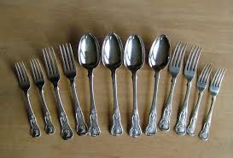
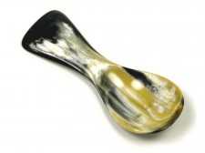
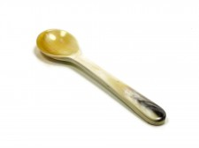

Abbeyhorn Salt Spoon Abbeyhorn Square End
Tea Caddy Spoon

- Dishware
In Edinburgh Scotland, their dishware is more formal, fancy, and antique. They are known for have plenty of tea party and here is just an example of one set:
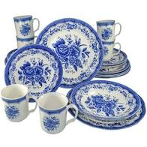
- Setting
The host and hostess will be seated at the opposite ends of the table, facing one another. The male guest of honor will be seated to the right of the hostess and the female guest of honor will be placed to the right of the host.[1] Will seating at the table, always keep your hands above the table.
- Service
Serves in restaurants and pubs, in general restaurants/café have table service but pubs do not. If you would like food at a pub, you would go to the bar and order food yourself. After they note your table, a server will come and drop off the food to you. During the dinner service are home they service lobster, fresh fish, and cured meat and cheese. After every time it is tradition to have a sit in the living room for some tea and crumpet/shortbread.
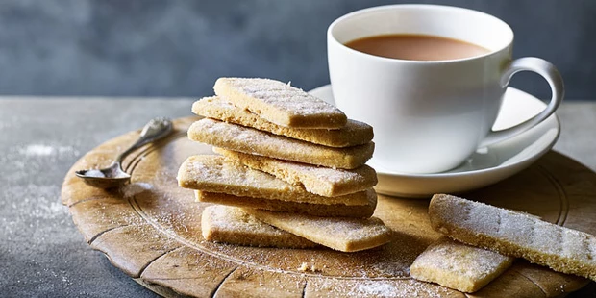

- Three dining etiquette Rule from Edinburgh
1.Fold the napkin in half on their lab and wipe the inside of the napkin, to keep clothes clean. [3]
2. Holding the teacup with the thumb and pointer finger on top of the handle, while using the middle finger to stabilize the bottom of the handle.
3.This rule is only from the royal table, but you are not allowed to use garlic. Garlic is banned at the royal table
- Three elements of Edinburgh’s dinner practices to be added to my dinner party:
- Have tea and crumpets are your meal. I feel like this is a nice was to relax with you guest and still share a nice conversation to end the night.
- No garlic at the table. Although garlic is good, at a fancy dinner table you could not want to have garlic breath.
- Sit you guests to the opposite side of the table from you, so you can have a nice conversation with your guests.

