BIOL368
Genetics and Cell Biology Laboratory

Project Number:2
Project title: Sterilization and aseptic technique

Introduction:

In microbiology, aseptic plays an important role in maintaining a pure culture medium, and it also helps prevent dangerous microorganisms from spreading in the environment (Daniel Aruscavage 2013). The purpose of this lab is to emphasize the aseptic technique. Students can become familiar with sterilization, and disinfection. And, they can properly apply them to each piece of equipment in the lab. Furthermore, the objective is to help students to practice steaking a single bacterial colony by using a loop or inoculating stick. Then, they can count those new colonies with visible count and optical density method.
Aseptic is a technique to avoid contamination when scientists handle cultured bacteria. Autoclaving and heating are two methods used in this lab. Each method is properly used depending on materials. In terms of autoclaving, Erlenmeyer flask, solution, and all glassware are placed in a pressure chamber. All Infected objects are sterilized under extremely high heat and pressure. In terms of heating, Bunsen Burner is an indispensable apparatus. To illustrate, the inoculation loop, spreader, and mouth of glass are sterilized directly over an open flame. Furthermore, the flame also creates an airflow to keep all pathogens and other microorganisms from falling into sterile media. (Concordia Biology Department 2021).
Steaking is a technique used to transfer a bacterial colony to new plates. An inoculation loop and, the stick are used to collect a cell of E. coli. The inoculation loop must be heated and let allowed to cool before collecting a colony of E. coli. On the new plate, a single cell of E.coli is streaked by
a zigzag motion. The process is repeated about serval times until half of the culture plate is covered with E. coli. In terms of inoculating sticks, the process should be the same as the inoculation loop, however, the inoculating sticks do not need to sterilize. The new stick is used for each time. (Concordia Biology Department 2021).
Viable count with the naked eye is a method to determine the total colonies. Serial dilution plays a vital role in counting the number of colonies. the reason is that serial dilution reduces the bacterial concentration in the culture, therefore, the number of E. coli falls within a countable range,30-300 colonies. The initial concentration of bacterial can obtain by dividing CFU by dilution factor. (Avishai Ben-Davida, and Charles E.Davidsonb 2014). On another hand, optical density is also applied to count the number of colonies in a diluted solution. At OD₆₀₀, cell particles in solution can disperse the amount of light from the spectrophotometer. In normal, the absorbance of 1 has 5 x108 of cells (Gray-Mitsumune 2021). Therefore, the concentration of the sample can be directly calculated from the absorbance of the diluted solution.
The ubiquity of microorganisms in different environments is the last objective in this lab. TSA and malt agar are two test media for bacterial and fungal growth. According to Sarah Quinlan 2018, TSA agar contains a higher nitrogenous substance, a nutrient needed by many bacteria. Due to the higher carbon content, melted extract agar is a good medium for fungi.
Materials and methods:
All procedures are performed according to the BIOL368 lab manual (Concordia Biology department 2021).
Table 1: descriptions of contamination experiments performed by the technician
medium | Sample description | Incubation Temperature, Time
MATL 9A | Floor, phone, bottom of shoe, top of shoe | 25ºC  1 week
MATL 9B | unwashed left hand, unwashed right hand, washed left hand, washed right hand | 30ºc  48h
TSA 9A | unwashed left hand , unwashed right hand, washed left hand, washed right hand | 30ºc  48h
TSA 9B | Floor, phone, bottom of shoe, top of shoe | 25ºc  1 week

Figures and Tables:
Optical density
Table 2: OD₆₀₀ reading of E.coli and calculated cell density of the orginal culture (individual)
OD₆₀₀ | Cell density of diluted culture  (cells/ml) | cell density of the orginal culture  (cells/ml)
0.533 | 2.670 x 10⁸ | 2.670 x 10⁹

OD₆₀₀ =1 = 5 x 10⁸ cells / ml
OD₆₀₀ = 0,533 => number of cell in 10 fold dilution= 0.533 x 5 x10⁸ =2.670 x10⁸ cells /ml
orginal culture= 2.670 x10⁸ x 10 = 2.670 x 10⁹ cells /ml

Table 3: Grubb's Test for OD₆₀₀ section data
 | Student 1 | Student 2 | Student 3 | Student 4 | Student 5 | Student 6 | Student 7 | Student 8 |  | Student 9
OD₆₀₀ | 0.507 | 0.536 | 0.531 | 0.523 | 0.518 | 0.548 | 0.611 |  | 0.542 | 0.533
Z | 1.066 | 0.093 | 0.261 | 0.529 | 0.697 | 0.309 | 2.424 |  | 0.108 | 0.194
Z critical | 2.21

OD₆₀₀ average = (Studen1 +...+ student 9 )/9
OD₆₀₀ average = $\frac{0.507+....0.533}{9}$= 0.593
OD₆₀₀ standard devidation =$\sqrt{\frac{\sum{{(x-\overline{x} )}^{2}}}{n-1}}$
OD₆₀₀ standard devidation =$\sqrt{\frac{{(0.507-0.593)}^{2}+{(0.533-0.593)}^{2}}{9-1 }}$ = 0.030
Z= $\frac{| mean -value| }{SD}$
Z value= $\frac{|0.593-0.507|}{0.030}$= 1.066
Z(student 7) = 2.424 > 2.21 = oulier

Table 4: OD₆₀₀ reading of E.coli ( section)
Student | OD₆₀₀ | Cell density of diluted culture  (cells/ml) | cell density of the orginal culture  (cells/ml) | Average cell density of the orginal culture  (cell/ml)
1 | 0.507 | 2.535 x10⁸ | 2.535 x 10⁹ | 2.694 x10⁹
2 | 0.536 | 2.680 x 10⁸ | 2.680 x 10⁹ | 2.694 x10⁹
3 | 0.531 | 2.655 x10⁸ | 2.655 x10⁹ | 2.694 x10⁹
4 | 0.523 | 2.615 x 10⁸ | 2.615 x 10⁹ | 2.694 x10⁹
5 | 0.518 | 2.590 x 10⁸ | 2.590 x 10⁹ | 2.694 x10⁹
6 | 0.548 | 2.740 x 10⁸ | 2.740 x 10⁹ | 2.694 x10⁹
7 | outlier | outlier | outlier | 2.694 x10⁹
8 | 0.542 | 2.710 x 10⁸ | 2.710 x 10⁹ | 2.694 x10⁹
9 | 0.533 | 2.670 x 10⁸ | 2.670 x 10⁹ | 2.694 x10⁹

OD₆₀₀ =1 = 5 x 10⁸ cells / ml
OD₆₀ = 0,507 = 0.507 x 5 x10⁸ =2.535 x10⁸ cells /ml
orginal culture= 2.535 x10⁸ x 10 = 2.535 x 10⁹
Average of section = (AvergeStuden1 +...+ student 9 )/8
Average of section = $\frac{(2.535 +2.680+2.655+2.615+2.590+2.740+3.055+2.710+2.670) * {10}^{9}}{8}$ = 2.694 x10⁹
Standard deviation: = =$\sqrt{\frac{\sum{{(x-\overline{x} )}^{2}}}{n-1}}$
$\sqrt{\frac{{(2.553*{10}^{9}-2.694*{10}^{9})}^{2} +..........+({2.670*{10}^{9}-2.694*{10}^{9})}^{2} }{8-1}}$ = 6.643 x 10⁷
Coefficeint of variation (CV) = (standard devidation /avarage cell denisty of orginal culture)* 100 = $\frac{6.643*{10}^{7 }}{{2.694*10}^{9}}$ x100 = 2.51%

Figure 1: avarage value of cell density of the orginal culture ( section ) with standarad diviation as error bar

Viable count:
Table 5: Viable count for dilffernt dilutions plates prepared by teachician (individual)
Dilution | 10⁻⁵ | 10⁻⁶ | 10⁻⁷
Volume plated | 0.1 | 0.1 | 0.1
colony count | 3905 | 323 | 39
viable count(CFU/ml) | 3.9 x 10⁹
sample calculation:
CFU= number of colonies /( dilution factor* volume plated) = $\frac{39}{0.1*{10}^{-7 }}$ = 3.9 x 10⁹ (cfu/ml)

Table 6: Viable count for dilffernt dilutions plates prepared by teachician (section)
Student | Dlution | Colony count | Viable Count (CFU/ml)
1 | 10⁻⁵ | 926
1 | 10⁻⁶ | 233
1 | 10⁻⁷ | 53 | 5.3 x 10⁹
2 | 10⁻⁵ | 956
2 | 10⁻⁶ | 301
2 | 10⁻⁷ | 41 | 4.1 x 10⁹
3 | 10⁻⁵ | 1248
 | 10⁻⁶ | 219
 | 10⁻⁷ | 36 | 3.6 x 10⁹
4 | 10⁻⁵ | 2044
 | 10⁻⁶ | 321
 | 10⁻⁷ | 31 | 3.1 x 10⁹
5 | 10⁻⁵ | 2708
 | 10⁻⁶ | 391
 | 10⁻⁷ | 45 | 4.5 x 10⁹
6 | 10⁻⁵ | 1967
 | 10⁻⁶ | 304
 | 10⁻⁷ | 42 | 4.2 x 10⁹
7 | 10⁻⁵ | 2716
 | 10⁻⁶ | 403
 | 10⁻⁷ | 33 | 3.3 x 10⁹
8 | 10⁻⁵ | 1880
 | 10⁻⁶ | 359
 | 10⁻⁷ | 42 | 4.2 x 10⁹
9 | 10⁻⁵ | 3905
 | 10⁻⁶ | 323
 | 10-⁷ | 39 | 3.9 x 10⁹

sample calculation : CFU/ml =number of colonies/ dilution factor x volume plate(ml)
dilution factor= 10⁻⁷ : CFU/ml = $\frac{53}{0.1*{10}^{-7}}$= 5.33 x 10⁹
Table 7: Average value and standard dividation of section viable count data

 | Average viable count  (cfu/ml) | Standard deviation
 | 4.02 x 10⁹ | 6.61 x10⁸

sample calculation:
Average viable count (cfu/ml)= (Studen1 +...+ student 9 )/9
= $\frac{(5.3+.....+ 3.9){10}^{9}}{9 }$= 4.02 x 10⁹
Standard deviation = =$\sqrt{\frac{\sum{{(x-\overline{x} )}^{2}}}{n-1}}$
$\sqrt{\frac{({5.3*{10}^{9 }-4.02*{10}^{9})}^{2}+........({3.9*{10}^{9}-4.02{*10}^{9})}^{2}}{9-1}}$= 6.61 x10⁸
Coeffient of variation ( CV) =(standard devidation /avarage cell denisty of orginal culture)* 100 $\frac{6.61*{10}^{8}}{4.02*{10 }^{9}}$ x 100 =16.43%

Figure 2: visable count of section with standarad diviation as error bar

Ubiquity of microganism :
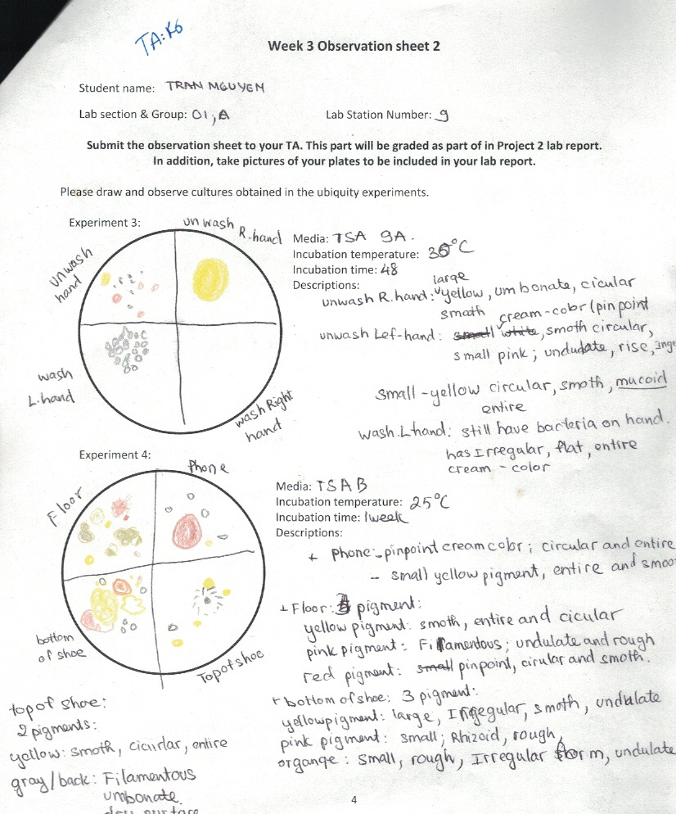
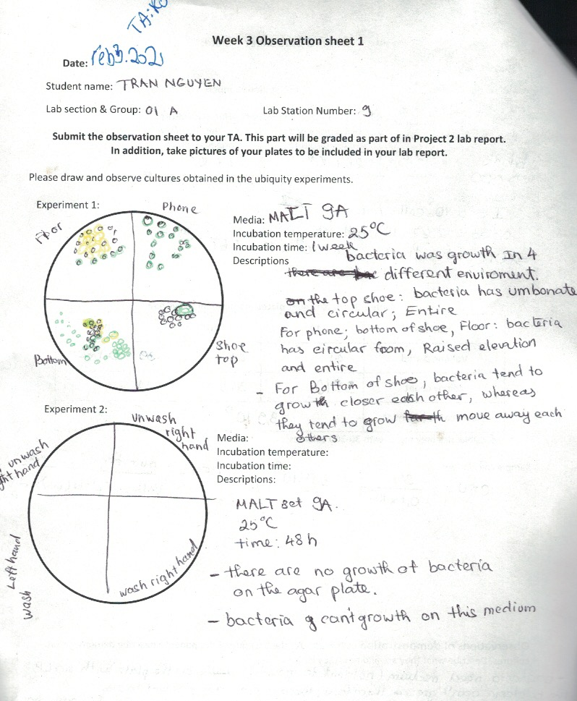

Result and Discussion:
In this lab, students are introduced to the aseptic technique to maintain a pure culture medium. During the experiment, students will practice 2 counting methods: optical density and visible counting. there are two common ways to find the number of bacterial colonies in the original culture. By comparing the results of the two methods above, students will evaluate the pros and cons of each method. In terms of the optical density part, the E.coli culture is diluted to 10 fold dilution with LB solution. Then, the diluted culture is measured at 600nm. As table 2 has shown, the absorbance of 10 fold dilution is 0.533, counting for 2.670 x 10⁸ cells/ml. As a 10 fold dilution, the orginal culture should be 10 times higher than diluted culture; it is calculated to be 2.670 x 10⁹ cells/ml. Furthermore, the average value of cell density of the original culture from my section is 2.694 x10⁹ cell/ ml, and the standard deviation is 6.643 x 10⁷. To compare individuals with the section, there is no large difference in the OD₆₀₀ value of each student. However, one of OD₆₀₀ is removed due to the failure in Grubb's test. In table 3, The Z- the value of student 7 is higher than the Z- critical, 2.424 > 2.21. Therefore, this data is considered an outlier. On another hand, the coefficient of variation (CV) is 2.51% which the precision of this method is high ( S.Aerts ,G.Haesbroeck, C.Ruwetc 2014). In the visible count part, The E. coli culture is mix with MinA solution for their serial dilution, 10⁻⁵, 10⁻⁶, and 10⁻⁷. And 0.1 ml of each dilution is spread on LB plates. Due to the serial dilution, each plate will have a different number of bacterial colonies. From individual data in table 5, the 10⁻⁵ plate has 3905 colonies, 10⁻⁶ plate has 323 colonies, and 10⁻⁷ has 39 colonies. The 10⁻⁷ plate is used to calculate the viable count (CFU/ml). The reason is that the number of colonies on 10⁻⁷ plates falls within the countable range from 30 to 300. Therefore, It will reduce the potential for error ( Breed RS, Dotterrer WD. 1916). My viable count is calculated to be 3.9 x10⁹. In contrast, the average of viable count (4.02 x 10⁹ cell/ml) in the section and the standard deviation (6.61 x10⁸ ) are calculated in table 7. The coefficient of variation in the viable part is 16.43 %. Overall, there is a huge difference in the coefficient of variation between the optical density and the visible count. The difference leads to a contradiction in our expectations. In terms of optical density. All samples are prepared with the fresh culture at the same time, so there is no difference in the number of cells. Moreover, a Spectrophotometer counts all types of cells in the cuvet such as viable cells and dead cells (Gray-Mitsumune M. 2021). Therefore, the cell density of the original culture is accurate. Due to the higher coefficient of variation in colonies, the result of the colony-forming unit is not precise. There are several reasons to explain why the number of counting is more variable, First of all, E. coli colonies do not evenly distribute over the plate. Therefore, a single colony can not be distinguished. Secondly, there is contamination that leads to an inaccurate counting result. Finally, some bacteria can not survive during incubation, therefore, each plate has a different number of bacterial colonies. For the Ubiquity of microorganism, the growth of microorganism is dependent on proper nutrient sources. For example, TSA agar contains a higher nitrogenous substance, a nutrient needed by many bacteria. Whereas, melted extract agar is a good carbon source for fungi (Sarah Quinlan 2018). Due to their material , some of them are also incubated at different temperatures. In particular, the Shoe, phone, and floor are incubated at room temperature in a week, whereas, the hand is incubated at 30ºC in 48 hours. As we can see, there is no growth on the surface of the MALT 9A plate, therefore, there are no fungi on those hands. On MALT 9A, there is 4 type of fungi with difference color. For the top shoe, the fungi have a big green colony and some small back colonies which indicate two types of fungi. They have an umbonate and circular entire margin. The bottom of the shoe has the same colonies, however, unlike the top shoe colonies, they tend to grow far away from each other. On the TSA 9A plate, the unwashed right hand has a huge yellow pigment with a circular and smooth surface. The unwashed left hand has three different bacterial colonies. they are small with 3 different colors; back, yellow, and pink. Washed left hand also has serval cream color bacteria on its surface. They have an irregular form with a flat and entire margin. From the observation, it indicates that some bacteria also can survive in a soap environment. On the TSA 9B plate, 4 materials all same types of colonies. Some yellow pigments are mostly smooth except for the bottom shoe has irregular. To sum up, the lab achieve its goal. Aseptic techique is fully introduce to all students. It can conclue that optical density and viabale count are two effective methods to find the total cell in orginal culutre.

Reference:

Avishai Ben-Davida, and Charles E.Davidsonb. 2014, Estimation method for serial dilution experiments, https://www.sciencedirect.com/science/article/pii/S0167701214002577 (accesesed on Feb 12,2021).
Breed RS, Dotterrer WD. 1916, The number of colonies allowable on satisfactory agar plates. J Bacteriol 1:321–331

Concordia Biology Department 2021. Biology 368 Genetics and Cell Biology Laboratory Manual. Montreal, QC. Concordia University. P7-16.

Daniel Aruscavage. 2013, Semester-Long Assessment of Aseptic Technique in Microbiology Labs, https://www.ncbi.nlm.nih.gov/pmc/articles/PMC3867764/ ( accessed on Feb 12, 2021).

Gray-Mitsumune M. 2021. BIOL 368 Lecture 3. Presented at Concordia University, Montreal, QC, Feb 5, 2021.

Sarah Quinlan 2018, Types of Agar Plates, https://sciencing.com/types-agar-plates-8131230.html ( accessed on Feb 12, 2021).

S.Aerts ,G.Haesbroeck, C.Ruwetc 2014, Multivariate coefficients of variation: Comparison and influence functions, https://www.sciencedirect.com/science/article/pii/S0047259X15001906, (accessed on Feb 12, 2021).

