Test #1:

Origin of Life; Chemical Evolution:

Miller-Urey Experiment (1953);
What is the purpose?
The major question which the Miller-Urey experiment answers is where life begins
Hypothesis
Biomolecules evolved from organic molecules made naturally from early earth atmosphere
What
Miller-Urey mimicked earlier Earth’s environment: water, methane, ammonia, and hydrogen
Result
About 10-15% of total carbon in the system was now in the form of organic compounds
2% had formed amino acids, including 13 of the 21 proteingenic amino acids found in eukaryotic cells

Interpretation:
- Natural processes could produce the building blocks of life without requiring a creator to synthesize them in the first place
- This was possible because the early composition of Earth was highly reducing
- Overtime these substances multiplied, evolved and interacted with each other to form more complex molecules
- Monomers to polymers

Monomers vs. Polymers;
- Polymers are formed from monomers, mostly via formation of covalent bonds
  - Polymerization involves addition or condensation (dehydration removal of water) reactions
  - Degradation of polymers involves hydrolysis reactions (addition of water)
- Condensation reaction requires an investment of energy for new bond formation
  - Hydrolysis reaction releases energy by breaking bonds
- In carbohydrates, monomers are monosaccharides. Two monosaccharides join to form a disaccharide. The covalent bond that joins them is called glycosidic bond. This linkage can be repeated many times, resulting in the production of polysaccharides
- In proteins, monomers are amino acids. The bond that joins two amino acids are called a peptide bond, resulting to a dipeptide. This linkage can also repeat many times, resulting to the production of polypeptide. A protein is formed when a polypeptide undergoes higher-order self-reorganization.
- In nucleic acids, monomers are nucleotides. Each nucleotide is composed of a base, pentose sugar and a phosphate group. Condensation reaction between two nucleotides forms DNA + RNA, the bond that hold 2 nucleotides together is a phosphodiester bond. The linkage between two nucleotide can repeat many times to form a polynucleotide chain.
- With lipids, there are a maximum of three linkages to form a polymer from a glycerol. The bond that forms here is an ester bond via condensation.
  - Fatty acid chain is a monomer
  - Polymer formed by attachment of 1,2,3 fatty acid chains to one glycerol is called a monoglyceride, diglyceride, triglyceride.

Intermolecular forces and Water:

Covalent vs. Non-Covalent bonding:
What us the one distinguishing factor between covalent and non-covalent bonding?
  - Non-covalent bonds DO NOT share electrons
covalent bonds are stronger than non-covalent bonds. Why?
  - Covalent bonds form when 2 non-metal atoms share a pair of electrons in the outer shells of the atoms. The outer shell is now filled, resulting to stable atoms. A lot of energy is needed to break this bond.
covalent bonds are very stable. Why?
  - Stable = do not break spontaneously. At atmospheric pressure and temperature, the thermal energy of a covalently-bonded molecule is much lower than energy required to break a covalent bond.

The major non-covalent interactions that determine the structure and function of biomolecules are electrostatic interactions and hydrophobic interactions.
Electrostatic interactions: dissociation energy depends on the increase entropy of surrounding water molecules rather than on direct attraction between nonpolar groups.
Van der Waals are much weaker than hydrogen bonds
Covalent bond has a dissociation energy of up to 400 KJ/mol

The optimal bond distance in charge-charge interactions is determined by the sum of the potential energies of attraction and repulsion (not exclusively)

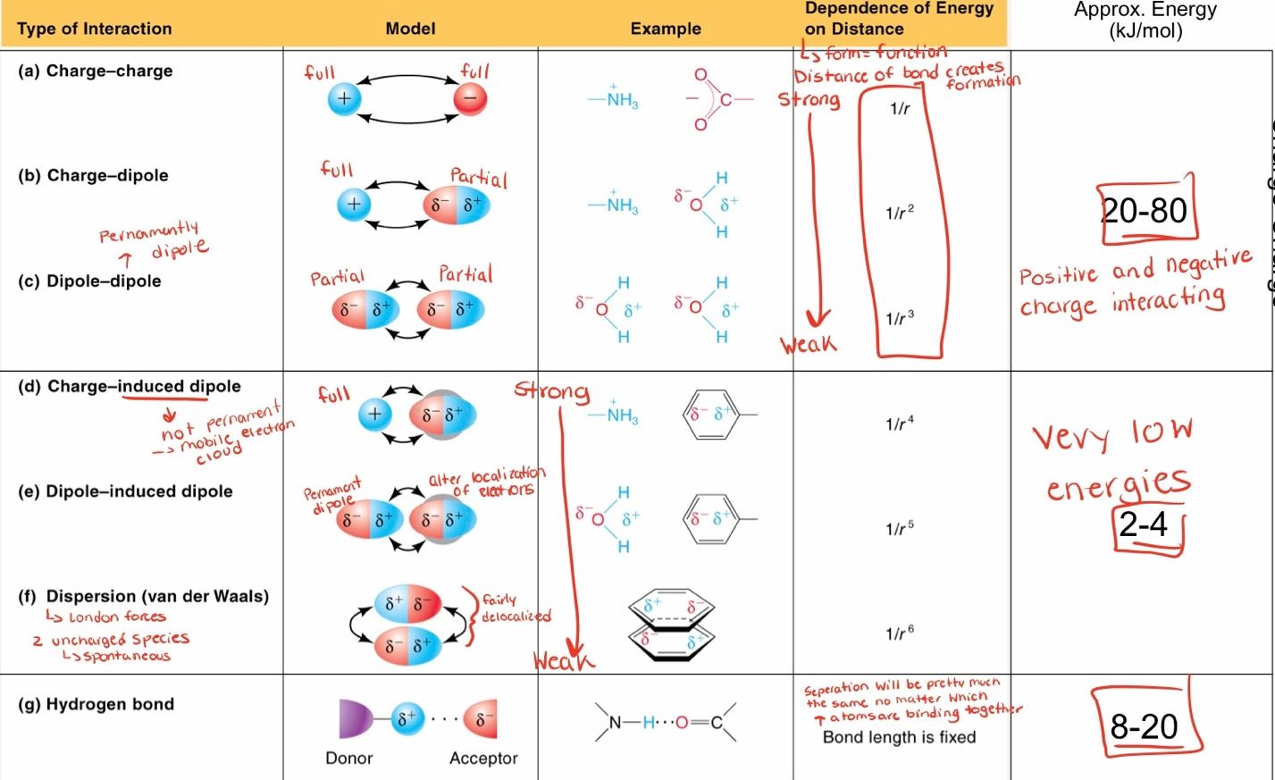

Hydrophobicity vs. hydrophilicity:
- Exclusion of nonpolar substances by water is called hydrophobic effect
this effect is critical for the folding of proteins and self-assembly of biological membranes
- When a sufficiently high concentration of amphipathic compounds is dispersed in water, they form micelles
Polar = dipole moments (van der Waals)
- Molecules with greater Van der Waal forces are more hydrophilic

Hydrophobic effect:
- The formation of a bilayer vesicle from amphiphiles in water results in polar head groups facing the aqueous phase
- As the surface of a clathrate results in an increase in entropy
- The hydrophobic effect is a driving force for biochemical self-assembly; different amino acids in a protein will assemble themselves to maximize exterior H-bonding and minimize non-polar/hydrophobic interactions by burying these regions internal and away from water
- Clathrates results in ice-like water, resulting in ΔS<0.
- The hydrophobic effect is driven by the solvent, and is considered a non-covalent intermolecular interaction
Water:
- Because of the uneven distribution of charge in O-H bonds, and their angled arrangement, the water molecule has a permanent dipole
- Water molecules can form hydrogen bonds with each other. Hydrogen bonding contributes to the high specific heat and heat of vaporization of water
- Because it is polar, water can dissolve crystalline electrolytes. Water molecules form a solvation sphere around each dissolved ion. Organic molecules may be soluble in water if they contain ionic or polar functional groups that can form hydrogen bonds with water molecules.
- Hydrophobic effect is the exclusion of non-polar substances by water molecules

Acids, Bases, pH; Buffers:

Weak acids and bases are key for maintaining environmental pH in the face of changing protonation states of a biomolecule
weak acids and bases are used for buffers
a larger Ka (and smaller pKa) is an indication of a strong acid

Buffers:
When an acid and base are added to solution, there is an interaction of their dissociated species that shifts their equilibrium positions in line with Le Chatelier’s principle.
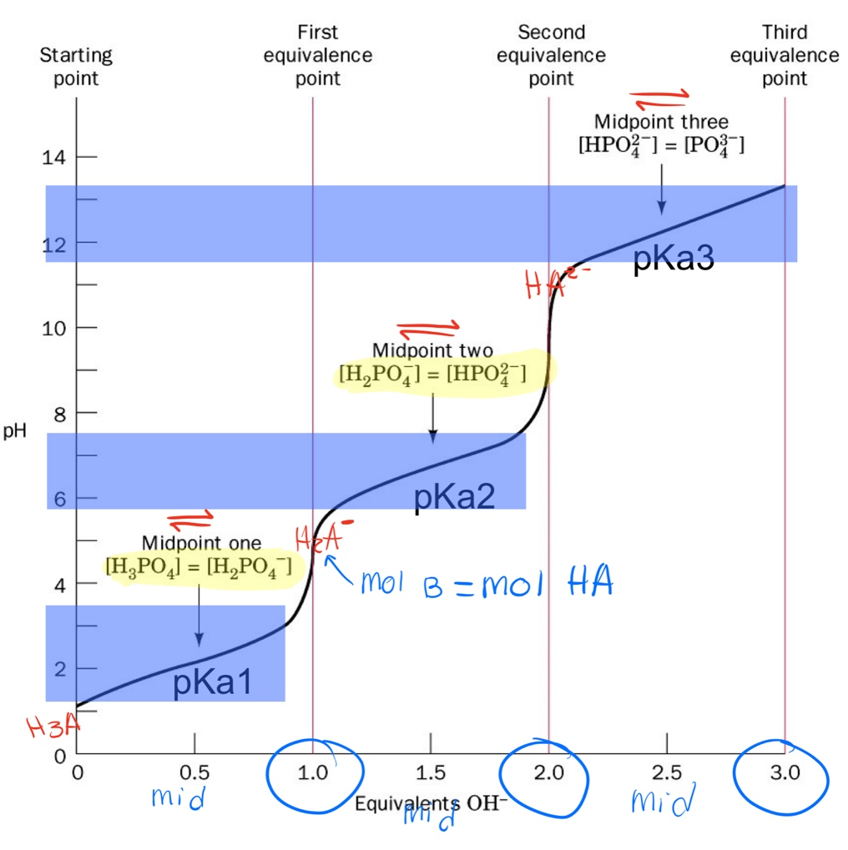
Midpoint: [HA] =[A]
midpoint = pKa

Equivalence point: point at which chemically equivalent quantities of acid and base have been mixed

Buffering capacity is a measure of how much titrant (or acid) can be consumed by the buffer system. The more buffer component mass that exists, the more titrant it can consume.

Proteins as buffers:
Zwitterions or ampholytes; biomolecules that are polyprotic, with one proton site being acidic and one proton site being basic
- Contain both acidic and basic pKa
Isoelectric point (pl); when the biomolecules net charge is zero
- At pl, the predominant form is the zwitterion. However, non-zwitterionic states exist but they are at equal concentrations, maintained a net charge of 0

