Chapter 2 – Specialization and Exchange
Production–possibility frontier (PPF):
The slope of the line tells us the opportunity cost of x
The reciprocal tells us the opportunity cost of y (1/slope)

Opportunity Cost: the value of what you have to give up in order to get something; the value of your next-best alternative. For example: opportunity cost of good A is how much of good B must be given up to produce good A.
Absolute Advantage: the ability to produce a good using fewer inputs than another producer (inputs such as labour hours); it is the number of resources used to produce something, NOT how much is given up.

Comparative Advantage: the ability to produce a good at a lower opportunity cost than another producer (such as giving up less of one good to produce more of another)

Chapter 3 – Supply and Demand
Law of Demand
Ceteris Paribus (means all other factors held constant)
- As price increases, Qd decreases
- As price decrease, Qd increases
Geometrically, the demand curve gives a negative slope
Changes in price DO NOT SHIFT the demand curve, but rather move along the curve

Shifts in demand curve are caused by a change in the relevant factors OTHER than price.
Relevant factors include:
- Price (primary factor)
- Consumer preferences
- Consumer income
- Prices of related goods
- Expectations of future prices (don’t worry about this one in the textbook; although true, it's "too confusing")
- Number of buyers

Substitute Goods (a good that can be used in place of another)
- As price of good B increases, demand for good A increases
- As price of good B decreases, demand for good A decreases

Complementary Goods (a good used in conjunction with another good)
- As price of good B increases, demand for good A decreases
- As price of good B decreases, demand for good A increases

Law of Supply
- As price increases, the willingness to sell and produce increases
- As price decreases, the willingness to sell and produce decreases
Geometrically, the supply curve gives a positive slope
Changes in price DO NOT SHIFT the supply curve, but rather move along the curve

Relevant factors include:
- Price (primary factor)
- Prices of inputs (capital, land, labour)
- Technology of production
- Number of sellers
- Ignore expected future prices in the textbook!

Side note; prices of inputs + technology of production = costs of production

Demand and Supply relationship
The prevailing price is the equilibrium price (the point at which demand and supply intersect)

When Qs is greater than > Qd, a surplus emerges;
- Price falls, Qs falls due to law of supply
- Price falls, Qd rises due to law of demand
  - Until the equilibrium price is achieved

When Qs is less than < Qd, a shortage emerges;
- Price rises, Qs rises due to law of supply
- Price rises, Qd falls due to law of demand
  - Until the equilibrium price is achieved

Chapter 4 – Elasticity
Elasticity: in general terms, is a numerical measure of how much one variable responds to a change in another variable. Elasticity measures the responsiveness of Qd or Qs to one of its determinants.

Price elasticity of demand is always negative (because P and Qd move in opposite directions along the D curve)
Price elasticity of supply is always positive

Midpoint method for computing % change
= End value – Starting value X100
Midpoint value (average of end value and starting value)

Begin with the midpoint method to find the percentage change for both values (Q and P), then plug into PED/PES formula.

Price Elasticity of Demand (always a negative number):
PED = Percentage change in Qd
Percentage change in P

Rearranged formula for % change in Qd:
% change in Qd = PED * % change in P

Essentially, each 1% change in price causes Qd to change by its elasticity unit. Therefore, elasticity units <1 are relatively inelastic, and elasticity units >1 are relatively elastic (same for both supply and demand).
For example, if price increases by 20% and the elasticity unit is -1.5, then Qd will fall by 30%. (% change in P * PED)

The steeper the demand curve, the more inelastic the good or service in question is
The flatter the demand curve, the more elastic the good or service in question is

Elasticity of demand determinants:

Higher | Lower
If close substitutes are available | If close substitutes are not available
If the good is narrowly defined | If the good is broadly defined
If the good is a luxury | If the good is a necessity
The larger the cost relative to income | The smaller the cost relative to income
The longer the time horizon | The shorter the time horizon

Price Elasticity of Supply (always a positive number):
PES = Percentage change in Qs
Percentage change in P

The steeper the supply curve, the lower the elasticity
The flatter the supply curve, the higher the elasticity

Income Elasticity of Demand
Measures the response of Qd to a change in consumer income (Y)

Income elasticity of demand:
IED = Percentage change in Qd
Percentage change in Y

An increase in income causes an increase in demand for a normal good
- Hence, for normal goods, the income elasticity is > 0 (relatively elastic)
An increase in income causes a decrease in demand for an inferior good (relatively inelastic)
- Hence, for inferior goods, the income elasticity is < 0

Cross-Price Elasticity of Demand
Measures the response of the quantity demanded for one good, Qd1, to a change in the price of another, P2

Cross-Price Elasticity of Demand:
PES = Percentage change in Qd1
Percentage change in P2

For substitutes, the cross-price elasticity is > 0 (relatively elastic)
For complements, the cross-price elasticity is < 0 (relatively inelastic)
Chapter 5 – Efficiency

Consumer Surplus
Definition: welfare economics (not about social assistance or income assistance programs; but rather well-being)
    - Allocation of resources (input and outputs) affects economic well-being
    - Think of price as a measure of the consumer’s willingness to pay given a quantity
    - Is derived from the demand curve

Consumer surplus is a measure of consumer well-being that reflects the payment rendered.
*It is the point under the demand curve, but above the transaction line (the market price)
Consumer surplus (CS) = willingness of demanders to pay – requirement to pay (total revenue, or price * quantity)
    - Example: John’s willingness to pay (reservation price) is $100 and the going transaction price (market price) is $80, then John’s consumer surplus is $20. ($100-$80)

Reservation Price (demand side): the highest price a consumer is willing to pay for purchase – rather than forgoing it. At this price consumer surplus = $0.

Satiation Point: the maximum satisfaction that can be achieved by a consumer.
    - The willingness to pay tends to decline within an individual as his/her consumption level rises (law of diminishing marginal utility – chapter 7)

Producer Surplus
Producer surplus is the counterpart for consumer surplus on the supply on side – it is a measure of producer welfare.
*It is the point above the supply curve, but below the transaction line (the market price)
    - the benefit that firms receive from producing in the market
    - Think of price as a measure of the producer’s willingness to supply given a quantity
    - derived from the supply curve

Producer surplus (PS) = price producers receive – willingness to supply (their costs $)
    - Example: Grandma’s willingness to supply is $500 and the actual price received is $600, then Grandma’s producer surplus is $100 ($600-$500).
    - An increase in price received raises the level of producer surplus, while a decrease lowers it.

Reservation Price (supply side): the lowest price a producer is willing to accept in exchange for a good or service. At this price producer surplus = $0.
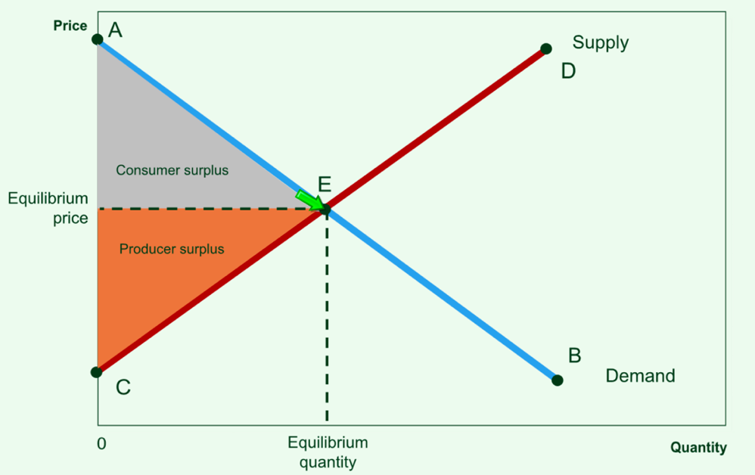

Market Efficiency
Total surplus (TS) (or social surplus) = CS + PS
OR
TS = willingness of demanders to pay – cost incurred by suppliers

Efficiency: is the property of a resource allocation of maximizing the total surplus received by all members of society.

The S & D equilibrium consists of the quantity of goods that maximizes the sum of consumer and producer surplus, and is therefore efficient.
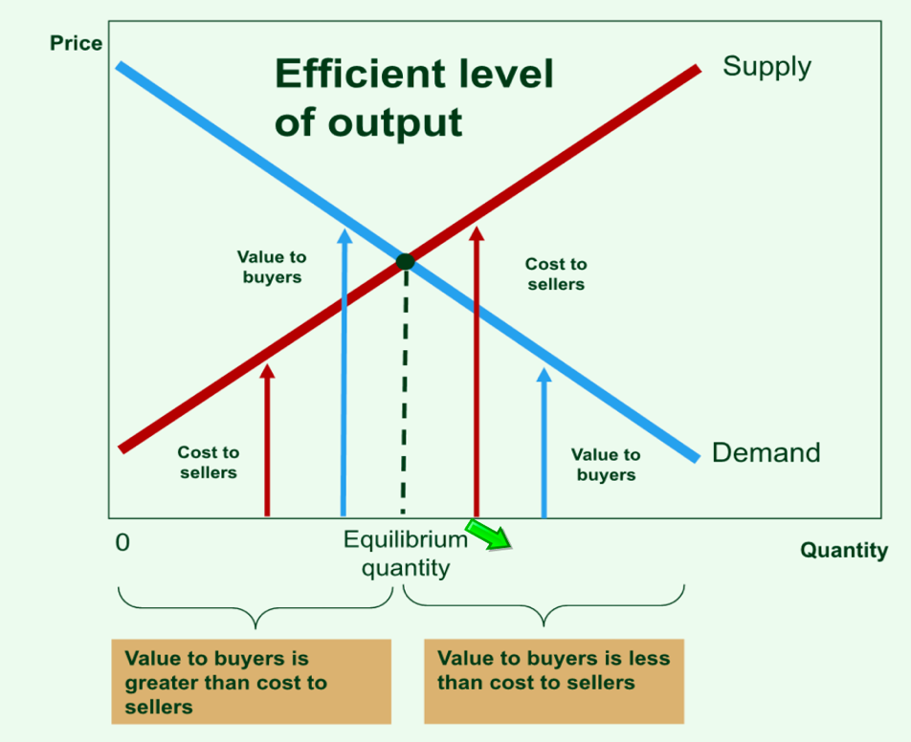
According to free market economics, it is thought that in most cases, for most markets, the S & D equilibrium is efficient, and welfare maximizing (or maximizing total surplus)
    - Situations in which that condition does not apply are called ‘market failure’ by free market economists

Deadweight loss (DWL): the loss in total surplus that occurs whenever the actual output price combination is not the equilibrium combination, and is therefore not efficient.
    - Technically, DWL is the area below the D curve yet above the S curve over the range of would-be transactions.

Chapter 6 – Government Intervention
Price controls:
Policies to control prices directly
Price ceilings – A legal maximum on the price of a good or service (i.e. rent control)
Price floors – A legal minimum on the price of a good or service (i.e. minimum wage)

Taxes/subsidies – An amount charged or received per unit of a good or service
    - The economic effects of a tax are the opposite to those of a subsidy (a subsidy can be thought of as a negative tax)
All of these policies above affect the allocation of resources; they will either reallocate resources to other markets, or are wasted (resulting in a reduction of well-being)

Price Ceilings
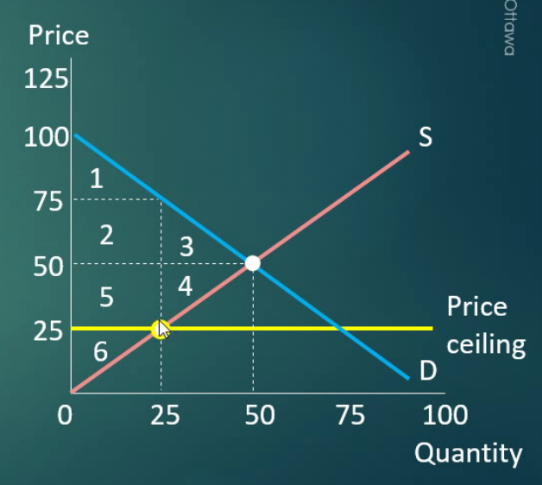 | A price ceiling causes a deadweight loss, and a transfer of welfare from producers to consumers.  In equilibrium without a price ceiling:  CS = 1 + 2 + 3  PS = 4 + 5 + 6  TS = 1 + 2 + 3 + 4 + 5 + 6  In equilibrium with a price ceiling:  CS = 1 + 2 + 5  PS = 6  TS = 1 + 2 + 5 + 6  Change in TS = - 3 - 4 (thus DWL = 3 + 4)

Scenario example: Suppose the government implements a price ceiling on housing rentals for $400 per month. The demand curve is P = 900 – 20Q and the supply curve is P = 40Q, where Q is measured in thousands of rental units. What is the equilibrium quantity and price without rent control?
Qd = Qs
900 – 20Q = 40Q
900 = 60Q
Qs and Qd = 15 (thousand rental units)

P = 900 – 20(15) = $600 per unit or P = 40(15) = $600 per unit
What is the quantity and price with a rent control of $400?
In this case Qd ≠ Qs  P = 40Q  400 = 40Q  Qs = 10 (thousand rental units) | P = 900 – 20Q  400 = 900 – 20Q  Qd = 25 (thousand rental units)
Since Qd > Qs, there is a shortage of (25 – 10) 15 (thousand rental units).

Price Floors
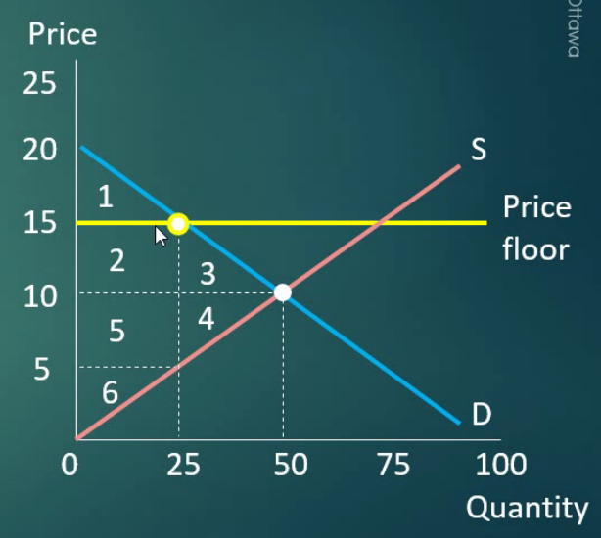 | A price floor causes a deadweight loss, and a transfer of welfare from consumers to producers.  In equilibrium without a price floor:  CS = 1 + 2 + 3  PS = 4 + 5 + 6  TS = 1 + 2 + 3 + 4 + 5 + 6  In equilibrium with a price floor:  CS = 1  PS = 2 + 5 + 6  TS = 1 + 2 + 5 + 6  Change in TS = - 3 - 4 (thus DWL = 3 + 4)

Taxes
There are two types of taxes:
Ad valorem tax – a % of the good’s price.
Specific or per-unit tax – a fixed dollar amount for each unit sold.

Tax on Buyers
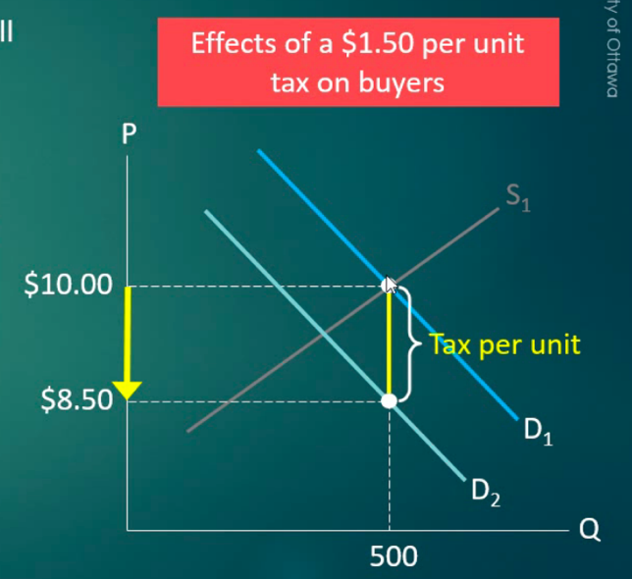 | A tax of $1.50 on buyers would mean that the market price would have to fall by $1.50 for buyers to be willing to buy the same output as before.  Hence, the after-tax demand curve shifts down by the amount of tax imposed on buyers.  D1 is still the demand curve that reflects consumers’ maximum WTP, however in the presence of tax we call it the before tax demand curve (p).  D2 reflects buyers’ demand as a function of the after-tax price (p – t). This curve/line is the price consumers pay to producers.

Tax on Sellers
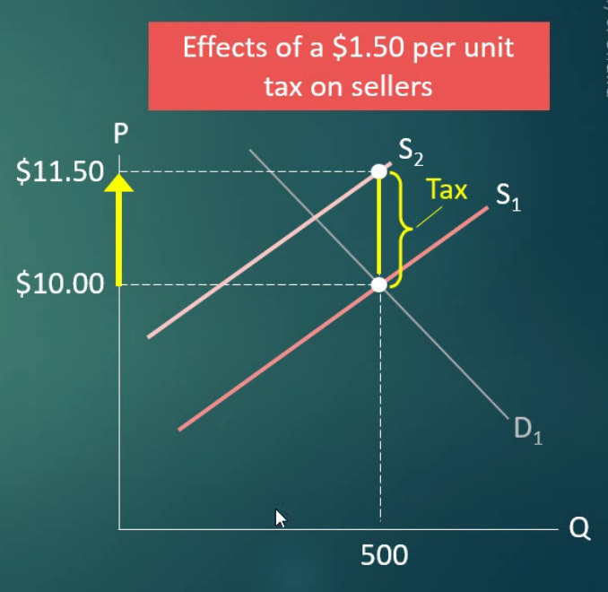 | With a tax imposed on suppliers, the opposite occurs than with buyers. At each Qd, the price to produce each good or service increases by $1.50. Thus, sellers will only continue to supply the same amount if the price increases by $1.50.  Hence, the after-tax supply curve shifts up by the amount of tax imposed on sellers.  S1 reflects the private costs of production (the before-tax supply curve).  S2 reflects the total costs of production (called the after-tax supply curve).

Tax effects on welfare
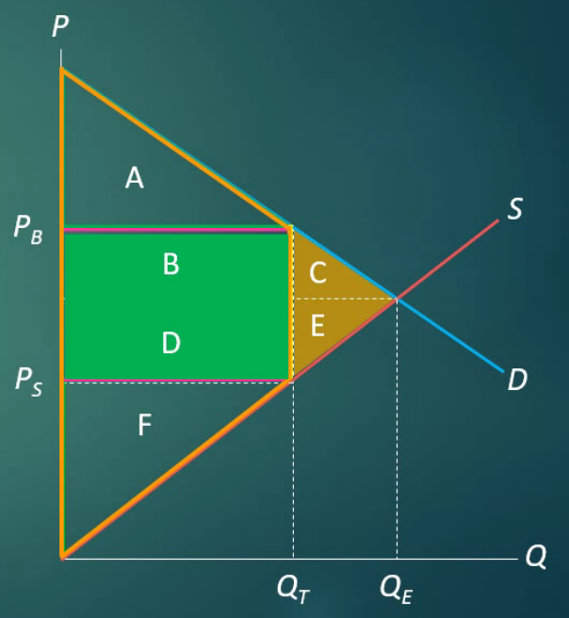 | In equilibrium without a tax:  CS = A + B + C  PS = D + E + F  TR (tax revenue) = none  TS = A + B + C + D + E + F  In equilibrium with a tax:  CS = A  PS = F  TR = B + D  TS = A + B + D + F  Comparisons:  Change in CS = - B - C  Change in PS = - D - E  Change in TR = B - E  Change in TS = - C – E (thus DWL = C + E)

Key points on taxes:
Taxes reduce equilibrium output, raise the price consumers pay, lower the price producers receive, transfer surplus from consumers and producers to government, and create a deadweight loss.

Scenario example (determine the effects of a tax):
Suppose the government imposes a tax on buyers of $30 per room. Find the new Q, Pb, Ps, the incidence or tax, and the DWL.

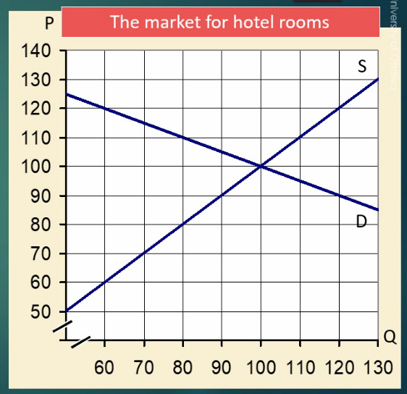 | Q = 80 units (found at the point where there is a $30 difference – the tax imposed – in the price consumers will pay and the price sellers will supply)  Pb = $110 (found at new Q point)  Ps = $80 (found at new Q point)  Tax incidence:  Buyers (consumers) = $10 (1/3 tax)  Sellers (suppliers) = $20 (2/3 tax)  DWL = ($30 * 20)/2  = $300

Subsidies
The effects of a subsidy are opposite to those of a tax.
    - Therefore, a subsidy can be thought of as a negative tax
    - Like a tax, it puts a wedge between supply and demand
    - Like a tax, the effects of a subsidy will be the same whether the subsidy is levied on producers or consumers
Impacts of a subsidy:
    - Equilibrium output rises
    - The price buyers pay (Pb) falls
    - The price sellers receive (Ps) rises
    - The difference between Ps and Pb is the amount of the subsidy
    - The subsidy is paid by government (out of tax revenues)

Subsidy DWL is calculated on the right side of the equilibrium, whereas tax DWL is calculated on the left side of the equilibrium.

Recap:
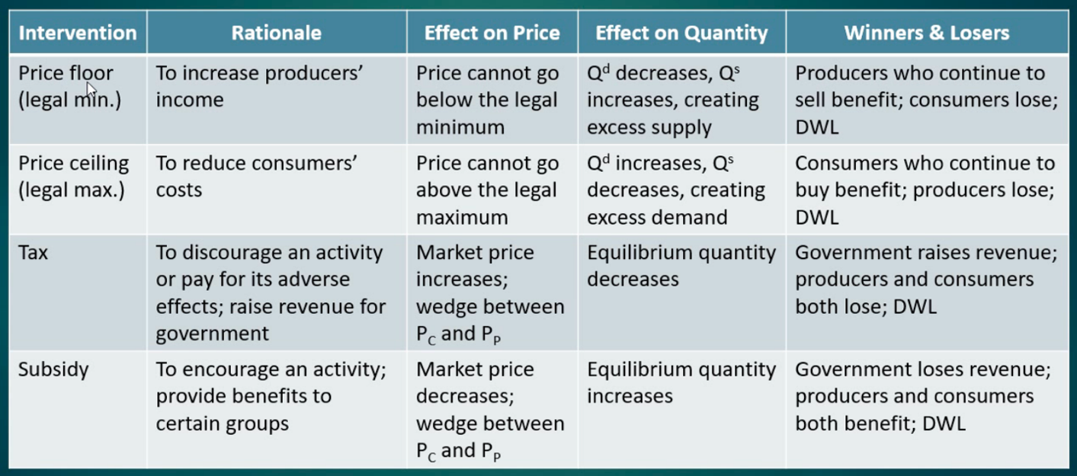

Chapter 7 – Consumer Behavior
Consumer preferences are measured by utility (a measure of well-being or satisfaction that consumers derive from the act of consuming), of which there are two relevant quantities:
- Total utility
  - A function that refers to the complete amount of well-being or satisfaction gained from consumption.
    - Due to consumer greed, more is preferred to less (thus, has a positive slope)
- Marginal utility
  - Is the change in total utility derived from consuming one more unit of the good/service; it measures the per unit utility from each good/service consumed. Therefore, it is the change in total utility / the change in quantity consumed.
    - Just like total utility, marginal utility is > 0 due to consumer greed.
    - However, marginal utility falls (but usually remains positive) as the level of consumption rises, this is known as the law of diminishing marginal utility.

Diminishing Marginal Utility: each additional increment of consumption yields less additional satisfaction than the unit that was consumed right before it.
    - This law underlines the law of demand, and is the reason why the demand curve is negative. As consumption increases, marginal utility decreases; hence the negative slope.
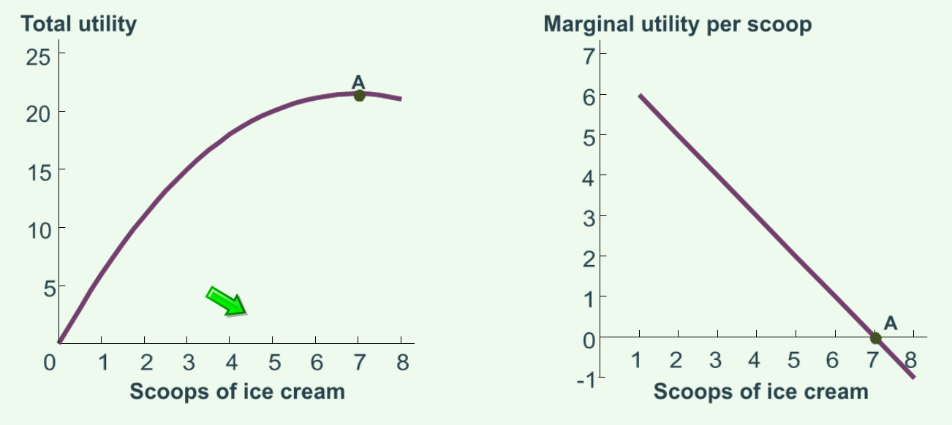
(figure 7.1) (green arrow is just the prof’s cursor)

Total utility increases with each scoop of ice cream until the seventh scoop at point A (the satiation point), at which point total utility is maximized. | An individual maximizes utility when total utility is greatest or marginal utility zero (seen at 7 scoops of ice cream).

Maximizing utility within constraints (consumption possibilities frontier):
The graph of the locus of such affordable bundles is called the budget constraint.
- Given the two prices, the income level, and the consumer’s taste, the consumer chooses the bundle of goods/services along the budget constraint that maximizes their total utility
  - Any combination on the graph beyond the budget line is unaffordable
  - Any combination on the graph within the budget line means income is unspent

Budget Constraint Example (7.2 in textbook):
Let Qm be the # of movies that are viewed (y-axis)
Let Qc be the # of concerts that are attended (x-axis)
Pm and Pc are the prices per movie/concert, respectively
The equation is then Pm * Qm + Pc * Qc = inc (income)
In slope-intercept form, the equation is Qm = Y/Pm – (Pc/Pm) * Qc
    - Where slope is (– Pc / Pm), and the intercept is Y / Pm

Similar to the production possibilities frontier, the budget constraint graph is the consumption possibilities frontier.
    - It shows the trade-offs that the consumer faces between two good
    - Is always linear as long as the prices are constant

Chapter 12 – The Costs of Production
Profit = Total revenue (TR) – Total cost (TC)
Total cost = Fixed costs (FC) + Variable costs (VC)

Fixed costs: costs a firm incurs regardless of the quantity of output; therefore, they are constant as quantity produced increases.

Variable costs: costs that depend on the quantity of output produced; therefor they increase as quantity produced increases.

Explicit vs Implicit Costs
Opportunity Cost: the value of what you have to give up in order to get something; the value of your next-best alternative. (from chapter 2)
    - Opportunity cost has two components: explicit costs and implicit costs

Explicit costs require an outlay of money (i.e. paying wages to workers).

Implicit costs do not require a cash outlay; rather they represent opportunities that could have generated revenue if the firm had invested its resources in another way (i.e. the opportunity cost of the owner’s time).
Both implicit and explicit costs must be included to account for the firm’s total costs.

Example: Suppose you need $100,000 to start a business. Interest rate for loans and savings rates are 5%.
- Case 1: You borrow $100,000
  - Explicit cost = $5,000 (5%) interest on the loan
- Case 2: You use $40,000 of your own savings and borrow the other $60,000
  - Explicit cost = $3,000 (5%) interest on the loan
  - Implicit cost = $2,000 (5%) foregone interest you could have earned on your $40,000 by investing it in something other than your business (an opportunity cost)
In both cases, total costs equal $5,000.

Economic Profit vs Accounting Profit
Accounting profit = Total revenue – Explicit costs
Economic profit = Accounting profit (Total revenue – Explicit costs) – Implicit costs

Production Function
It is the relationship between quantity of inputs and the resulting quantity of outputs.
    - In the case below, the production function increases at a decreasing rate (it gets flatter as L increases because the MPL falls as L increases)
    - In some cases, it can increase at an increasing rate in the beginning; however, the production function will always begin to decrease at some point. This is due to the law of diminishing marginal product (or returns).
Example:
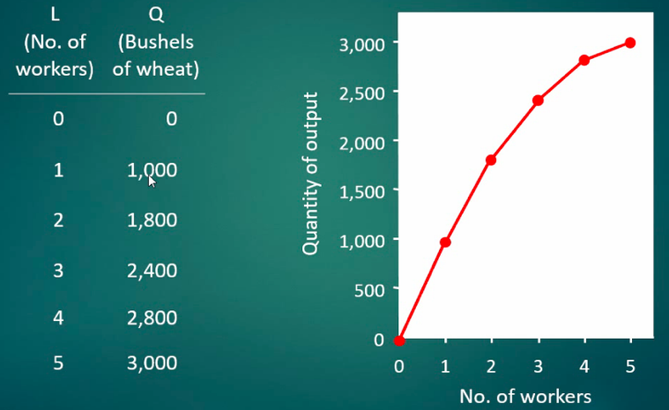

Marginal Product: the increase in output that is generated by an additional unit of input. MP usually diminishes as the input increases.

Marginal product of labour: MPL = ΔQ / ΔL
Average product of labour: AP = Q / L
(Where Q = level of (production) output, L = labour, Δ = the change in…)
Average product is always above marginal product on a graph.

Why MPL is Important
In our example above, when the farmer hires an extra worker:
- Her costs rise by the wage she pays the worker, w
- Her output rises by MPL
- The value of that extra output (what she can sell it for/the price of the good) rises by p x MPL
  - p x MPL is the farmer’s benefit from hiring the extra worker

Therefore, if the benefit exceeds the cost (p * MPL ≥ w), hire the extra worker; if the cost exceeds the benefit (p * MPL < w), do not hire the extra worker.

Marginal Cost (MC)
Marginal Cost: the increase in total cost from producing one more unit. MC curve is usually upward-sloping.
MC = ΔTC / ΔQ or MC = ΔVC / ΔQ because ΔFC is always the same (0).

Recall that TC = VC + FC = wL + FC
Therefore, ΔTC = wΔL
Therefore, MC = wΔL / ΔQ = w / MPL

Why MC is important
Since firms want to maximize profit, “thinking at the margin” (looking at MC) tells the firm whether to produce more or less.
- If the cost of producing (MC) an additional bushel of wheat for example is less than the revenue they would get from selling it, then the farmer’s profit rises if they produce more.
  - Hence, if p (price) > MC, the firm should produce more (or vice versa).

Average Fixed Cost: fixed cost divided by the quantity of output. AFC = FC / Q
AFC always falls as Q rises because the firm is spreading its fixed costs over a larger number of units.
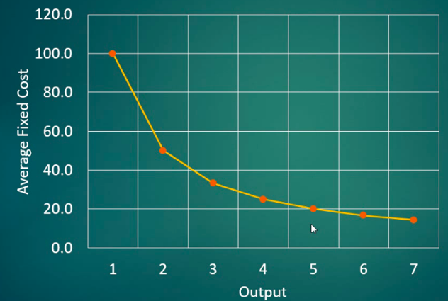
Average Variable Cost: variable cost divided by the quantity of output. AVC = VC / Q
As Q rises, AFC may fall initially. Alternatively, AVC may always increase as Q rises.
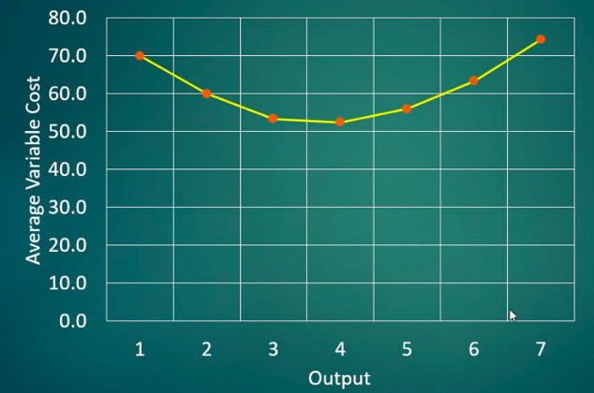

Average Total Cost: total cost divided by the quantity of output. ATC = TC / Q
    - ATC is also referred to as the “cost per unit” or the “unit cost”
Usually, the ATC curve is “U-shaped”, it follows the AVC but includes AFC.
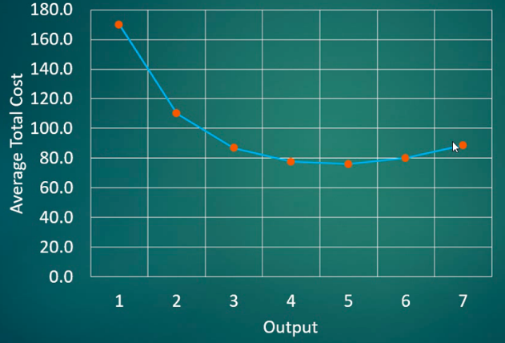

Note also that: ATC = AFC + AVC

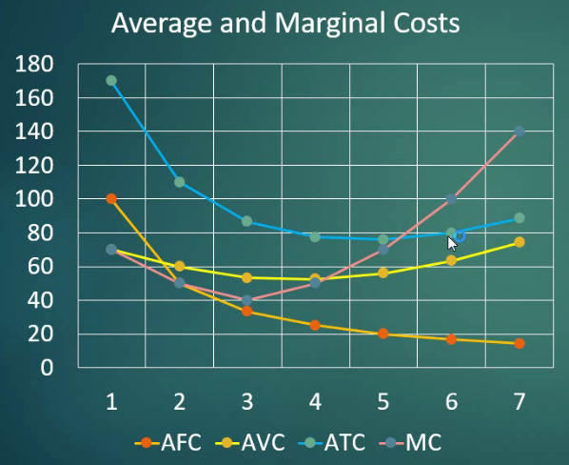

Efficient scale: the quantity that minimizes ATC. This is the ideal point where the firm would like to operate at.
Costs in the Short Run vs Long Run
In the short run:
- Some inputs are fixed (e.g. factories, land)
- The costs of these inputs are FC
In the long run:
- All inputs (costs) are variable (e.g. firms can build more factories or sell existing ones)
- Fixed costs do not go to $0, they simply become variable costs.

How ATC changes as the Scale of Production changes
Economies of scale: ATC falls as Q increases.
- Economies of scale occur when increasing production allows greater specialization
  - Workers are more efficient when focusing on a narrow task
  - More common when Q is low

Constant returns to scale: ATC stays the same as Q increases

Diseconomies of scale: ATC rises as Q increases.
- Diseconomies of scale (also referred to as decreasing returns to scale) are due to coordination problems in large organizations
  - Example: when management becomes stretched, can’t control costs
    - There may be coordination problems, red tape and reduced flexibility to respond to problems/opportunities
  - More common when Q is high

Added note on the relation of MC and ATC:
- The MC curve intersects the ATC curve at minimum average total cost
  - When MC < ATC, ATC falls as Q rises
  - When MC > ATC, ATC rises as Q rises

Chapter 13 – Perfect Competition
Chapter 13 compares the differences between perfectly competitive markets and monopolized markets (chapter 14) and how they operate.

Market structure: refers to the characteristics of the market’s organizational or competitive nature, and describes the nature of competition and the pricing policy followed in the market.
    - Provides the final element that is needed to derive the supply curve
    - Essentially, it places constraints on the pricing behavior of firms

Features of perfectly competitive markets (the markets DNA if you will)
- Many buyers and sellers
- Homogenous (standardized) product – goods and services are indistinguishable
- Perfect information regarding prices and quality (buyers are aware of the going price and quality)
- Free entry into the industry – no significant barriers to entry

Price-takers: buyers and sellers who cannot affect the market price.
    - The textbook lists this behaviour as a characteristic as opposed to being a pre-condition, although it is, it’s important to note it is a result of these pre-existing features (the 4 listed in bullets above)
Note: there is no such thing as a perfectly competitive market; however, it is ideal from an economics point of view.
    - Some fairly close real-world examples are the stock market, banking services, fast food, and retail grocery.

Marginal cost (MC) = ΔTC / ΔQ
Marginal revenue (MR) = ΔTR / ΔQ (MR is the slope of the TR function)
Average revenue (AR) = TR / Q = P * Q / Q = P (price) (the Q’s cancel out so average revenue is just equal to P, which is revenue sold per unit)

In perfectly competitive markets:
- P = MR for all units produced, at all times (this is not true in monopolized markets)
- MR = MC for the last unit produced, in the long run and short run, due to profit maximizing behaviour
- Since P = MR and MR = MC, P = MC for the last unit produced.
- there are TWO demand curves
  - One D curve for the entire market
  - One D curve for each individual firm, this curve is infinitely elastic at the going price

Where does the firm’s price come from?
    - It is dictated by the market
    - Meaning the firm is a price taker (it can only charge that price)

What if firms try to charge a higher price?
    - There are many sellers, so customers can go elsewhere
    - Homogenous product, so cannot say its product is better
    - Perfect information, so everyone knows what the going price and quality are

Profit Maximization
This occurs at the output level where TR – TC is the highest, or MR = MC
    - This means that the firm breaks even on the last unit of output that it produces and sells

If the firm is producing at a level where MR does not = MC, then the following is occurring:
- It does not necessarily mean that the firm is making losses
- If MR > MC, more should be produced
- If MR < MC, less should be produced
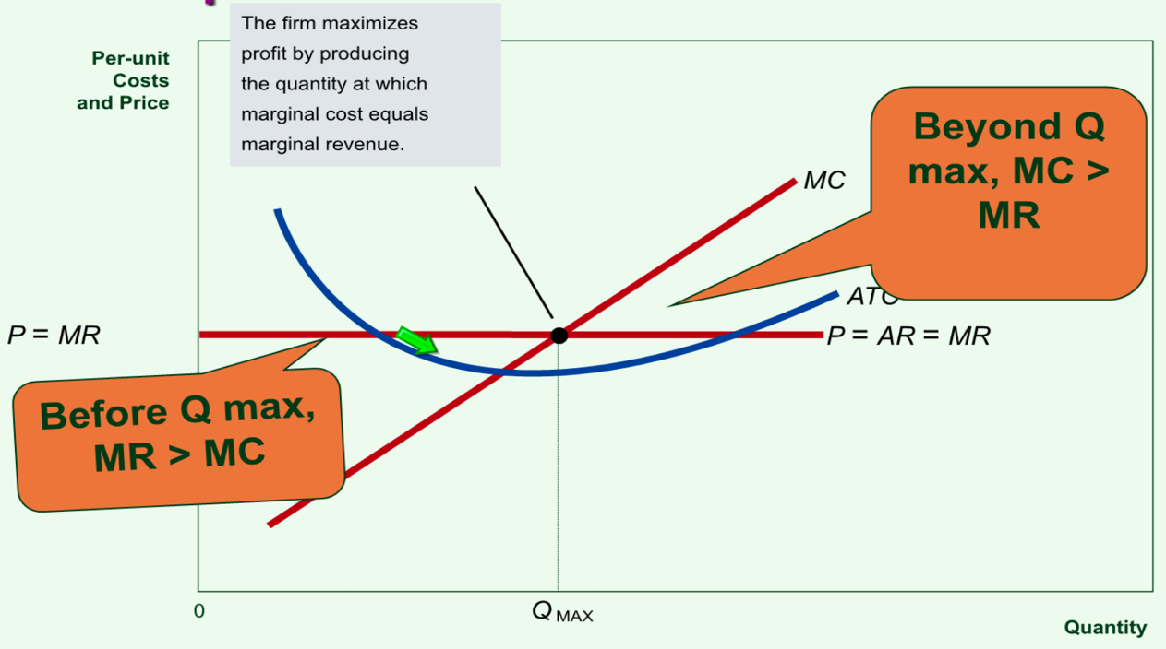

Equilibrium profit determination
Profits = TR – TC = Q * P – TC * (Q/Q) = Q * P – Q * (TC/Q) = Q * (P – ATC)
The factor (P – ATC) is the profit margin
    - If P > ATC, profits are +
    - If P < ATC, profits are –
The value of ATC depends on the operating level of the firm
    - Take ATC corresponding to that level of output
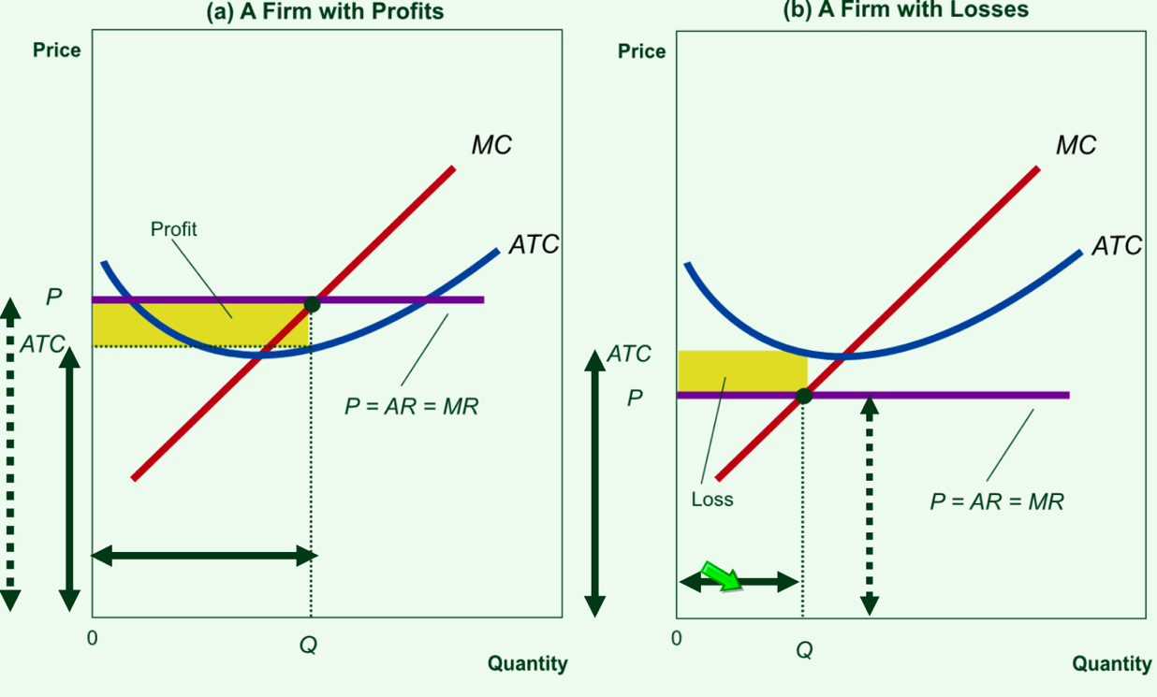
Solid horizontal arrows represent the output equilibrium price
Solid vertical arrows represent the average total cost quantities at that level of output
Dotted vertical arrows represent the price (also MR) quantities at that level of output

To determine profit maximizing output level, select where MR = MC (where they intersect).
Shutdown point (example to follow)
The firm will operate in short run as long as P = MR > AVC (TVC per unit). Or simply, as long as TR > TVC.
    - Total revenue must cover the total variable costs of operating
    - If all variable costs are covered, and at least some of the fixed costs are covered, the firm will continue to operate in the short run.

Consider the following: P = $31, MR = $31 for all units. At Q = 10, MR = MC = $31. P = $31 but AVC = $20. Since P > AVC, the firm will operate in the short run.
Therefore, if P = $31, Qs = 10 giving us one point on the S curve.

If P = $17, MR = $17. At Q = 7, MR = MC = $17. P = $17, but AVC = $17. Price is barely sufficient to cover AVC, so TVC is paid for but TFC is lost. If she shuts down, she will lose TFC, but if she continues, she will also lose them.
Therefore, if P = $17, Qs = 7 giving us another point on the S curve. If P < $17, Q = 0, hence $17 is the shutdown point.
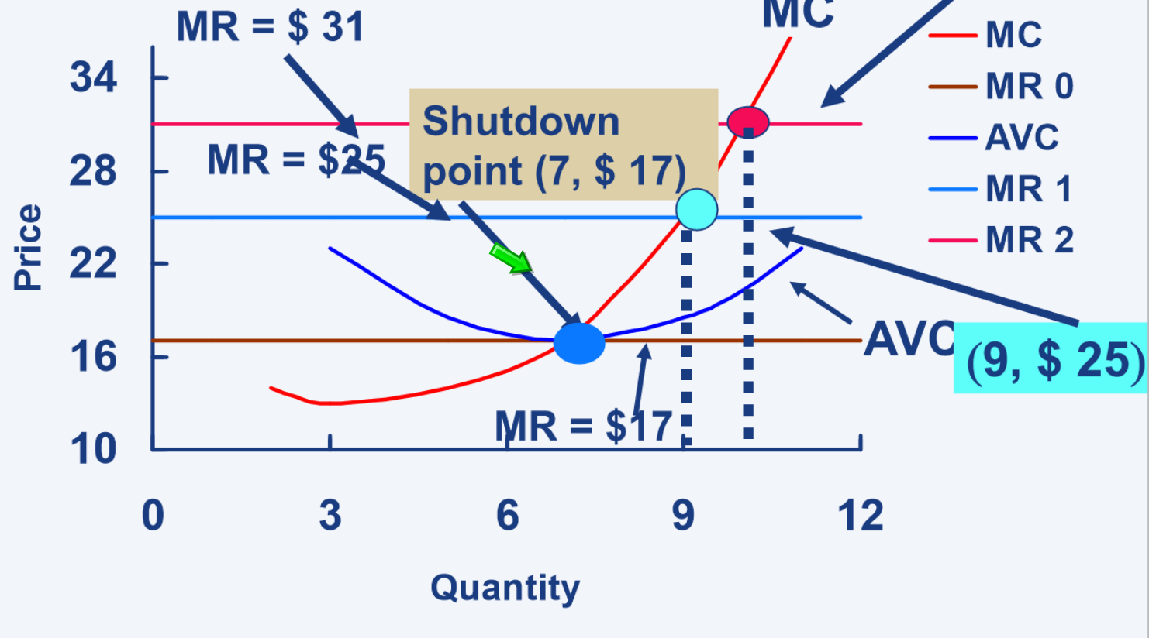
This essentially illustrates the derivation of the S curve for a perfectly competitive firm.
    - A perfectly competitive firm’s S curve begins where MC ≥ AVC since this is the firm’s shutdown point.

Market S curves
The market S curve is the horizontal summation of the individual firm S curves
    - Since all firms are identical, think of the market S curve as the individual firm S curve multiplied by the number of firms
Note: in perfect competition, the S curve = the MC curve (provided that price is above the minimum point of the AVC curve), and the D curve = the P curve.

From short run to long run
Long run equilibrium in a perfectly competitive market:
    - Economic profits = 0, also P = ATC
    - P = ATC = MC
    - Firms operate at capacity (where ATC are as low as possible)
    - All cost savings are passed on to consumers in the form of lower prices
    - All high cost producers perish if they are not ‘lean and mean’

If economic profits are being made, the firm has a supernormal rate of return (above the norm).
Given the notion that firms will enter due to the assumption of free entry, in a supernormal case, 4 things will happen:
- Market supply increases (S curve shifts right)
- Market price decreases, thus firm price decreases
- This process stops when profits = 0, as there is no further incentive to enter
- Supply stops shifting, no more changes in market/firm price
In essence, the supernormal profits are competed away by entry into the industry. Profits thus serve a useful allocative function.
At the new long run equilibrium, market Q increases, firm Q decreases (because firm price decreased – law of supply), and the number of firms increases.

If economic loses are being made, the firm has a subnormal rate of return (below the norm).
    - Typically, TR covers all of the TVCs but not all TFCs therefore the firm can still operate in the short run, but making loses
In a subnormal case, 4 things will happen:
- Firms will exit, market supply decreases (S curve shifts left)
- Market price increases, so firm price increases
- This process stops when profits = 0, as the is no further incentive to exit
- Supply stops shifting, no more changes in market/firm price.
In essence, the economic losses are competed away by the exit from the industry. Losses thus serve a useful allocative function.
At the new long run equilibrium, market Q decreases, firm Q increases (because firm price increased – law of supply), and the number of firms decreases.

Overall
This market structure is consumer-friendly and producer-hostile.
    - The consumer pays the lowest possible price, and the quantity produced is the highest possible (compared to other forms of market structure)
    - This is why lobbies representing workers, managers, suppliers, and stockholders pressure vociferously to prevent liberalisation policies.

Chapter 14 – Monopoly

