Respiratory Physiology
Basic principles
- Diffusion is the final step of oxygen movement
  - Diffusion is slow over long distances so it is good for smaller organisms but when you get to larger complex animals with higher metabolic rate, diffusion is not enough to delivery adequate oxygen
- For aerobic metabolism, require O₂ supply and CO₂ removal
  - O₂ supply critical
  - CO₂ removal needed to avoid acid-base disturbance
  - Diffusion adequate for animals <1 mm diameter, high SA:V, low MR
  - Gas exchange organ plus circulatory system
    - Increasing size and complexity
    - Increasing rates of cellular metabolism
- Oxygen cascade(vertebrate)
  - 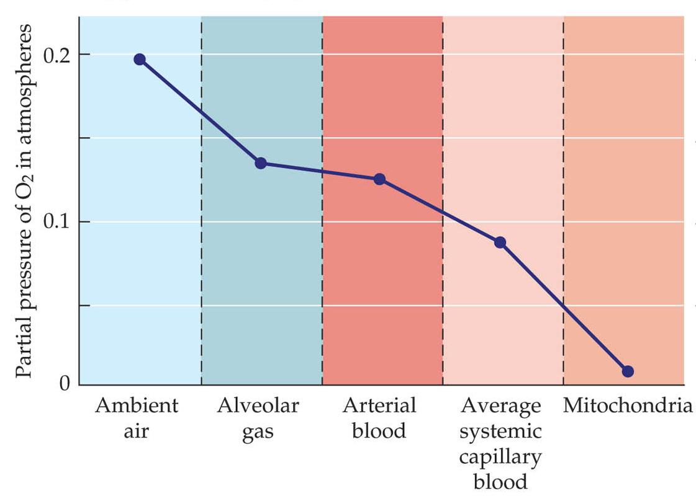
- 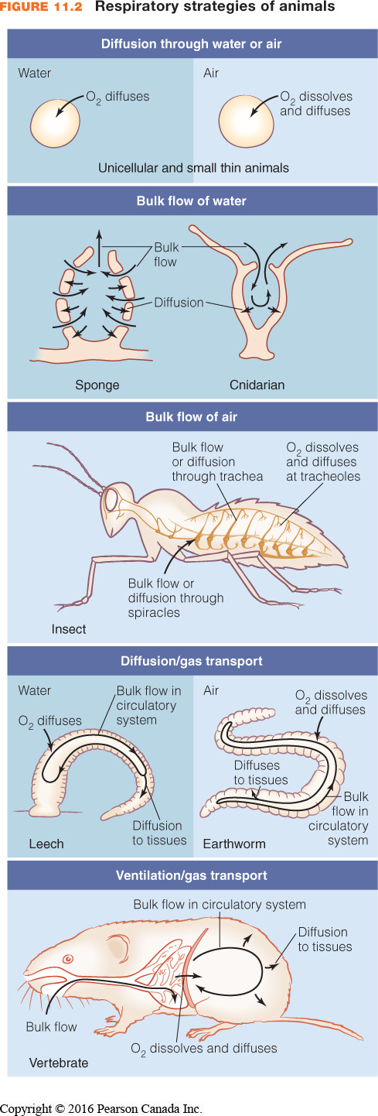
  - the circulatory system is important for delivering oxygen and removing CO2
  - the respiratory system is important to allow gas to enter the blood because the animal surface is not good for that
  - pp of oxygen decreases
- Transfer of respiratory gases:
  - 1. Ventilation (convection – carried by the flow of water or air)
    - Bulk transport of O₂ (and CO₂) to gas exchange surface via respiratory medium
    - Breathing air or water which brings oxygen to the gas exchange organ
  - 2. Diffusion of O₂ and CO₂ across the respiratory epithelium
    - Thin layer of cells (0.5 - 15 µm)
    - Oxygen then diffuses across the gas exchange surface
    - Relies on the Fick principle
      - This is why we want a large surface area with a thin epithelium
  - 3. Circulation (convection)
    - Bulk transport of O₂ and CO₂ by blood between gas exchange surface and tissues
    - The CV system then carries the oxygen to the tissues (convective step)
  - 4. Diffusion of O₂ and CO₂ between blood and cells
  - 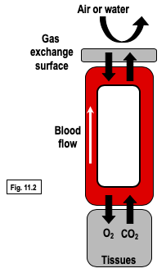
- Diffusion and convection
  - Diffusion: movement of molecules from one region to another due to Brownian motion
    - e.g. movement of O₂ and CO₂ between respiratory medium & blood or blood & tissues
    - Fick equation: Mgas = ΔPgas · Kgas · SA/T
      - Diffusion is driven by the partial pressure gradient
    - Diffusion depends on ΔP, not ΔC
    - Kgas describes mobility of gas through diffusion barrier
      - Permeability coefficient
      - This depends on the gas (CO2 moves easier than O2) and the properties of the tissue
    - Mobility of gases higher in air than in water
      - Oxygen in air moves a lot fast than water
    - Sea turtles
      - Mother turtle lays eggs on dry land in a spot where they cannot get wet from the sea
      - Why do they do this?
        - The mobility of oxygen in the air is fast in air than water, that if the egg is surrounded by water, the hatchlings/embryos do not get enough oxygen so they die
  - Convection: transport of O₂ or CO₂ due to the bulk movement of the medium
    - Gases are carried by the bulk flow of what they are in
    - e.g. ventilation, gas transport in blood
    - Mgas = Vmedium · ΔCgas
      - The movement of the gas depends on the flow of the medium and the concentration of gas in the medium
      - Rate of delivery is dependent on how fast the medium is moving
    - Allows higher rates of gas transfer
    - Reduces boundary layers
      - Layers of stagnant air and water that become depleted of oxygen when there is diffusion of oxygen out of it
- Properties of gas determined by its partial pressure, but metabolic functions depend on concentration
  - Capacitance (ß) = slope of line
  - Air = 21% O₂, 79% N₂ and inert gases, 0.03% CO₂
    - 760 Torr = 101.3 kPa = 1 atm
    - Atmospheric pressure = 760 Torr PO₂ = ?
      - 159.6 Torr
    - All gases have same capacitance (slope = 1/RT) because the follow the universal gas law (PV = nRT)
      - Can
    - If air can hold 1.2 mL O₂ L⁻¹ Torr⁻¹, then what is the concentration of O₂ in air at atmospheric pressure?
      - 192 mL of O2/L
    - 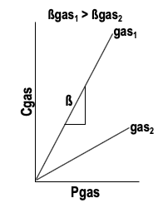
      - We know pp drives gas movements but the animal needs an adequate concentration of gas
      - Capacitance is the relationship between P and C
  - Liquids
    - Consider water in equilibrium with air ⇒ may have same partial pressures of gases but different concentrations owing to different ß
    - ß in liquid determined by physically-dissolved gas and any chemical reactions that occur (determines the capacitance)
    - 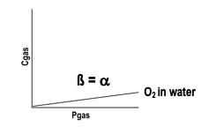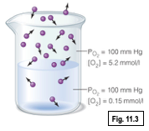
      - Oxygen in air over top of water
      - Pp of oxygen in the air and water is the same
      - The concentration of oxygen in air compared to water is not the same
      - The capacitance of oxygen in water Is a lot lower than that of air
  - Physically dissolved gases
    - α = solubility coefficient
    - α depends on gas, temperature, ionic concentration
      - αCO₂ > αO₂ in water
      - α ⇓ with ↑ temperature
      - α ⇓ with ↑ salinity
    - e.g. O₂ in water: [total O₂] = [physically dissolved O₂] = PO₂αO₂
    - Seawater holds less oxygen compared to freshwater
  - Chemically-bound gases
    - Respiratory pigments in blood (e.g. haemoglobin) bind O₂ and CO₂
    - CO₂ reacts with water
    - Total concentration of gas = physically dissolved + chemically bound
      - Needed to know the total oxygen in the blood since O2 is bound to Hb
    - e.g. O₂ in blood: Hb binds O₂
[total O₂] = [physically dissolved O₂] + [HbO₂]
= PO₂aO₂ + [HbO₂]
= PO₂ß _{blood} O₂
      - total amount of oxygen in blood is the amount that is physically dissolved and the amount that is chemically bound to Hb
    - e.g. CO₂ in water at physiological pH: CO₂ + H₂O « H₂CO₃ « H⁺ + HCO₃⁻
      - CO2 reacts with water, so you need to take into account the dissolved CO2 and the amount that has chemically reacted with water to make bicarbonate ions
    - [total CO₂] = [physically dissolved CO₂] + [HCO₃⁻]
= PCO₂aCO₂ + [HCO₃⁻]
= PCO₂ß _{water} CO₂
    - e.g. CO₂ in blood:
[total CO₂] = [physically dissolved CO₂] + [HCO₃⁻] + [carbamino CO₂]
= PCO₂ß _{blood} CO₂
      - need to look at what has dissolved, what has reacted in water, and what has bound to Hb
    - ß takes into account both physically dissolved gas AND chemically bound gas
    - 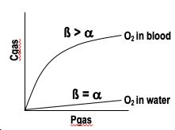
      - Total amount of oxygen in blood also depends on the amount bound to Hb
      - Gases that are dissolved in liquid
        - The amount of gas that is physically dissolved and the amount of gas that is chemically bound
  - Discuss in groups: What is the concentration of O₂ in blood vs water?
    - Assume air-equilibrated blood or water
    - Water can hold 0.0015 mmol O₂ L⁻¹ Torr⁻¹ (a) whereas blood can hold 0.1 mmol O₂ L⁻¹ Torr⁻¹ (ß)
      - Water
        - PO2=160 torr
        - α=0.0015
        - C=PO2α
        - 0.24 O2/L
      - Blood
        - PO2=160 torr
        - α=0.1
        - C=PO2α
        - 16 O2/L
  - Consolidate your knowledge:
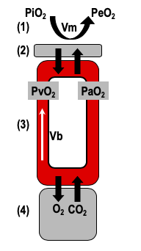
    - Calculate (as a percentage) the contribution of physically dissolved CO₂ to the total blood CO₂ content. (3 marks)
a_{plasma}CO₂ = 0.065 mmol L⁻¹ Torr⁻¹
ß_{blood}CO₂ = 1.55 mmol L⁻¹ Torr⁻¹
PCO₂ = 4 Torr
- Gas transfer revisited
  - Recall:
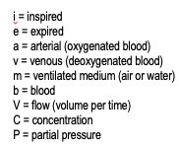
    - Diffusion – Mgas = DPgas · Kgas · SA/T (Fick equation)
    - Convection – Mgas = Vmedium · DCgas
  - 1. MO₂ = Vm· (CiO₂-CeO₂) = Vm· ßmO₂ (PiO₂-PeO₂)
    - Amount o2 in blood = Flow of the medium x change in concentration
      - If no concentration, can use capacitance coefficient with the pp
  - 3. MO₂ = Vb· (CaO₂-CvO₂) = Vb· ßbO₂ (PaO₂-PvO₂)
    - Can use blood flow
  - 2 and 4. MO₂ = DPO₂· KO₂· SA/T
(26/09/2019)
- Drugs used to treat hypertension
  - ACE inhibitors
    - Inhibits ACE which converts renin to angiotensin
    - They lower the amount of angiotensin that is produce
    - Angiotensin is a potent vasoconstrictor
    - Also regulates salt and water reabsorption in the kidney
  - Ca channel blockers
    - Block Ca channels on the vessels (smooth muscle in arterioles)
    - This prevents them from contracting as much and therefore reduce the contraction
    - Can also act on heart to reduce the force of pumping, and therefore decreased CO
  - Diuretics
    - Increase the amount of urine production and therefore this decreases the water in the vessels
  - Beta1 blockers
  - Angiotensin receptor blockers
    - Similar to ACE but this blocks the receptors
Pop quiz
- Distinguish between vagal tone and vasomotor tone
  - Vagal tone: the amount of PNS innervation of the heart
  - Vasomotor tone: SNS of the vasculature
- Gas exchange systems are usually coupled to circulatory systems. Why? Provide an example where this is not the case.
  - Typically coupled with gas exchange systems because this provides more efficient gas diffusion to meet the body’s requirements. Large animals cannot obtain enough O2 by diffusion to their organs so they need a circulatory system to deliver it, but they also need a method for delivering air because the air cannot diffuse through the skin to get to the blood this means there is a specialized spot for the gas to occur
  - Insects. Gas exchange system that delivers oxygen right to the tissues; they have a circulatory system that they use for heat transfer and nutrients but not for gases
- Sketch the “oxygen cascade” for an insect

- Distinguish between capacitance and concentration.
  - Concentration: the number of molecules unit/volume
  - Capacitance: the slope of the relationship between pressure and concentration
Blood O2 transport
- Importance of respiratory pigments for blood O₂ transport
  - aO₂ blood = 0.03 mL O₂ L⁻¹ Torr⁻¹
    - the solubility of oxygen in blood is very low
  - ßO₂ blood = 2 mL O₂ L⁻¹ Torr⁻¹
    - if you have Hb, the capacitance of blood is a lot more than the dissolved
  - Without pigment, require very high Vb
    - How high?
    - If MO₂ = 900 mL O₂ min⁻¹, PaO₂ = 100 Torr, and PvO₂ = 40 Torr, calculate Vb (in L min⁻¹) for a human that lacks haemoglobin. Compare this value to the ‘normal’ Vb for a human.
      - Has Hb
        - 7.5 L/min
      - No Hb
        - 500 L/min
    - When you don’t have Hb, you need to pump the blood substantially faster to be able to deliver the amount needed
- 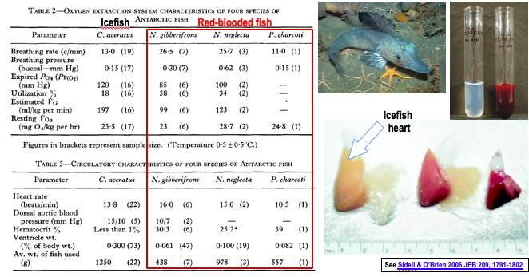
  - The icefish do not have a pigment in their blood
  - Their heart is a lot larger to compensate for the needed increase in CO since they can only bring oxygen through dissolved oxygen in the blood
    - Their oxygen consumption is relatively the same
    - Heart rates are similar
    - This means that the SV has to be much larger than the stroke volume in the red blooded fish
- Respiratory pigments
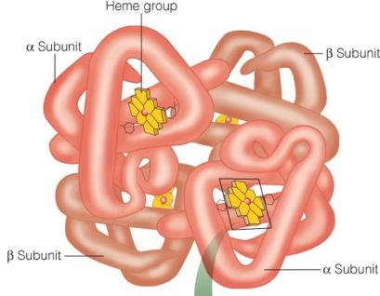
  - Vertebrates: haemoglobin (Hb)
  - Hb-O₂ is bright red, deoxy-Hb is blue-red
  - Tetrameric globin plus 4 haeme groups
  - Others include haemocyanin (Cu-based, in arthropods and molluscs; blue with O2), haemerythrins (e.g. polychaete worms; violet pink), chlorocruorins (annelids; green when O2, colorless when no O2)
  - Recall fish-crustacean comparison
    - Vertebrate advantage?
      - The respiratory pigment is within a cell in vertebrates
      - Advantage in a cell
      - This is an advantage because it is in the blood cell and this has less of an impact of osmolarity**
  - 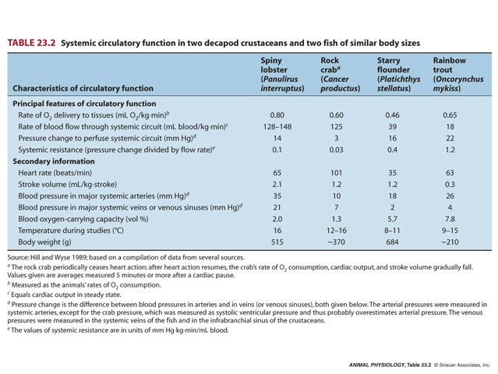
  - O₂ equilibrium curve
    - Hb + O₂ ⇔ Hb-O₂
    - % sat. = [Hb-O₂]/ (total [Hb])*100%
    - P₅₀ = PO₂ at which Hb is 50% saturated with O₂
      - High P₅₀ ⇒ low affinity
    - Shape reflects subunit interactions
      - Sigmoidal curves exhibit co-operativity
      - Hyperbolic curves – single subunit or no
subunit interactions
    - Plateau region
      - Large changes in PO₂ have little effect on Hb-O₂ saturation (O₂ content)
      - Margin of safety
      - Little effect of hyperventilation or breathing 100% O₂
    - Steep region
      - Small changes in PO₂ have a large effect on Hb-O₂ saturation
      - Helps maintain PO₂ gradients for diffusion
  - 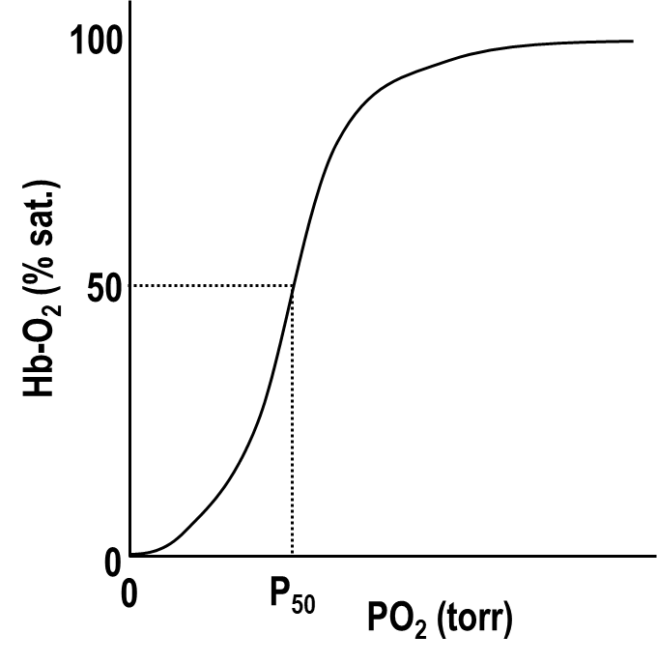
    - Saturation of Hb on y and pressure of O2 on x
    - This is reversible; the amount of oxygen bound to Hb id dependent on the partial pressure of oxygen
    - At high pp, there is high saturation
    - At low pp, Hb will give up its oxygen so the amount of saturation is lower
  - 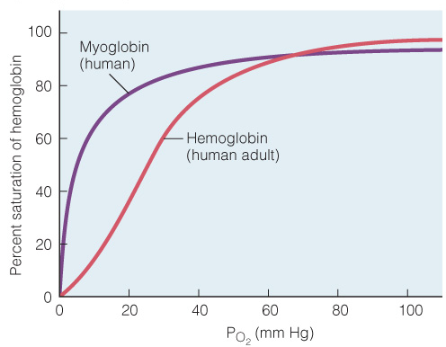
    - Some are sigmoidal and others are hypobolic
    - This depends on whether the subunits interact with each other
    - Cooperativity causes the sigmoidal curve
    - Can get small changes in saturation with large changes in partial pressure
    - Steep region
      - Helps maintain the driving force of oxygen movement by diffusion
      - Need pp to change slowly but a lot of oxygen in then blood
- Marked variations exist in the shape of O₂ equilibrium curves between and within species
  - Co-operativity
  - Environmental O₂ availability
  - Developmental stage
  - 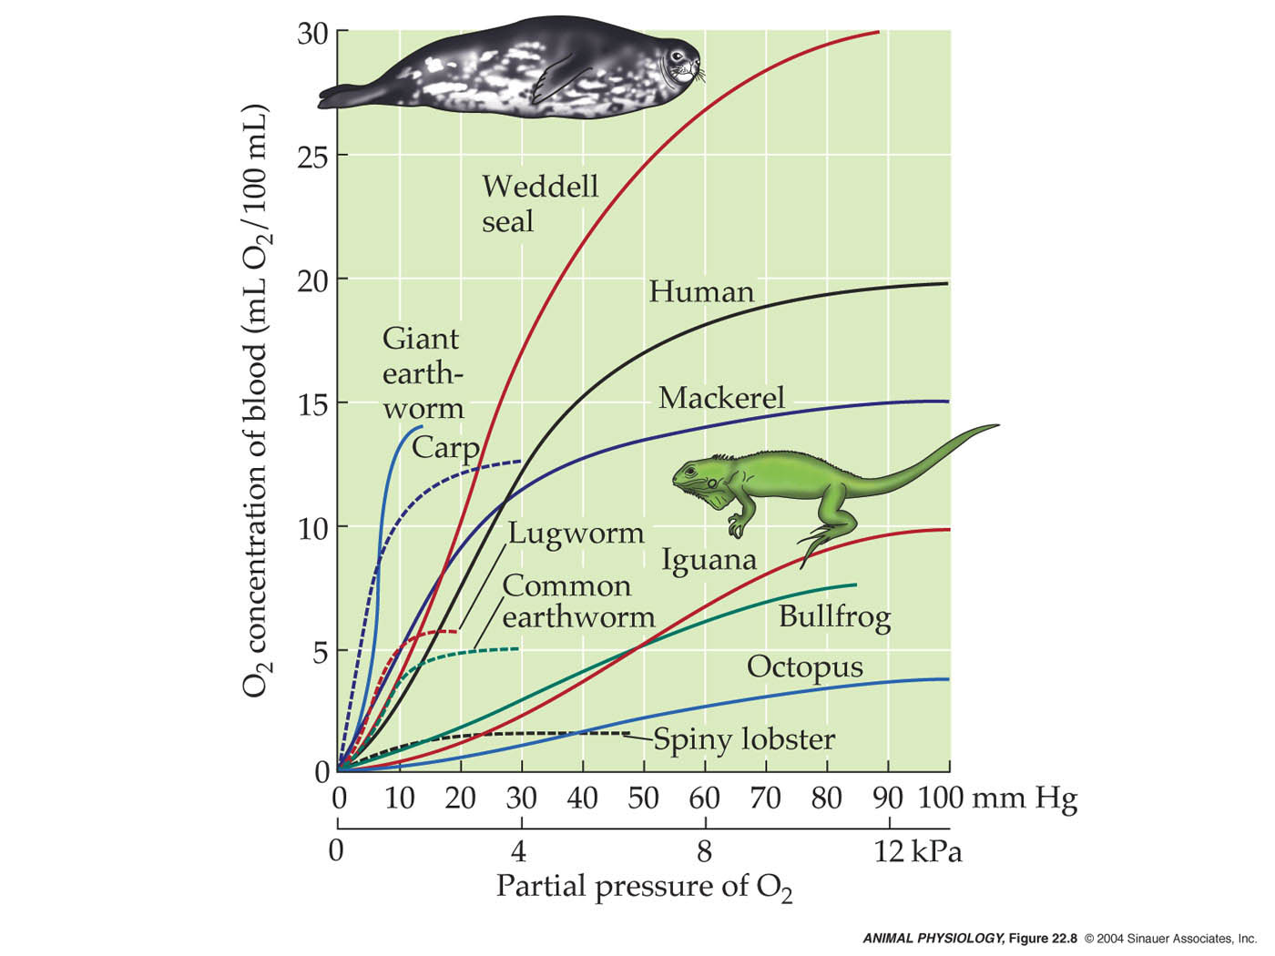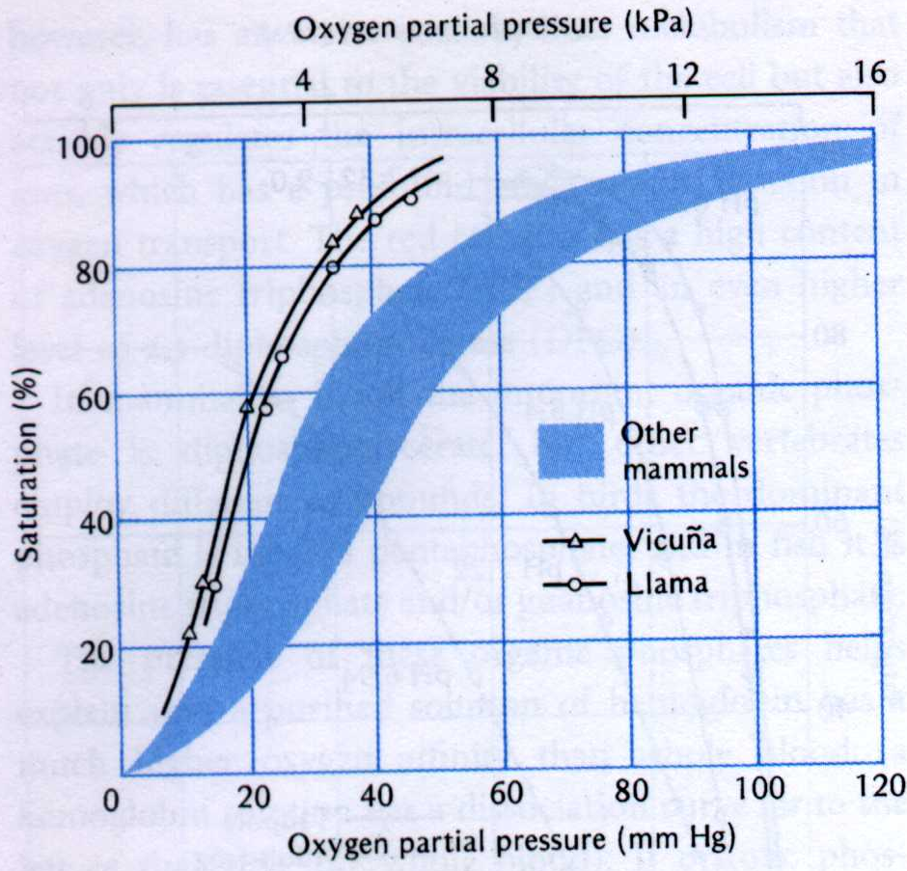
    - Variety of carrying capacity and affinity of Hb for O2
      - Affinity is steepness
    - Environmental oxygen availability is a big factor for determining these differences
      - Divers need a large oxygen store
        - Seals have high Hb levels compared to a human that does not dive
      - Animals that inhabit hypoxic environments
        - Carp live in water that is O2 poor; the curve is shifts to the left, p50 is low pp of oxygen so they have a high affinity for oxygen
    - Left shifted curve means high affinity and they are able to extract more oxygen from the environment
- Discuss in groups: Sketch an O₂ equilibrium curve for a normal human and one that has taken EPO or used blood doping to increase blood O₂ carrying capacity
  - Why is EPO or blood doping dangerous?
    - Makes your blood more viscous, when you work out you are sweating so more water is leaving
      - This is dangerous because it increases resistance
      - Increasing resitance, you need to increase pressure generated to push the blood around the system, making the heart have to work harder, which can lead to heart failure
  - Increasing Hb will be shifted to the left
  - Dangerous because it increases the viscocity of the blood
(30/09/2019)
- Pop quiz – true or false
  - Te PO2 of air-equilibrated water is 760 Torr or 1 atm
    - False
    - Value is 160 Torr (21%)
  - The solubility (a) of blood for O2 is higher than that of plasma
    - False
    - Solubility is the same – only looks at physically dissolved gas
    - Difference between blood and plasma is the presence of Hb which can chemically bind oxygen
  - For the Antarctic icefish, the capacitance of blood for O2 is equal to the solubility of blood for O2
    - True
    - Does not have Hb so that means there is no chemical binding of oxygen and looking at what is only dissolved, so capacitance and solubility are the same thing
  - For the Antarctic icefish, the capacitance of blood for CO2 is equal to the solubility of blood for CO2
    - False, CO2 can chemically react to make bicarbonate ions (reacts with water), capacitance has to take into account the chemical reaction and dissolved CO2
  - The blood oxygen carrying capacity describes how readily O2 binds to Hb
    - False
    - Affinity describes how readily O2 binds to Hb, the carrying capacity is how much O2 is present which depends on how much Hb is present
      - Carrying capacity is the maximum concentration of O2 that can be in the blood
  - Animals that live at high altitude benefit from Hb with a highP50 value to more readily take up oxygen from the oxygen-poor air
    - False
    - Want a low P50 value because you can have a lower partial pressure to be able to take up more oxygen
- Factors affecting Hb-O₂ binding
  - Bohr effect
    - If yu increase the amount of CO2 in blood, or decrease pH, you get a right shift of the oxygen equilibriu, curve
      - This is reversible, so lowering
      - This is done by allosteric interactions
    - Right shift with ↑ CO₂ or [H⁺] (⇓ pH)
    - Left shift with ⇓ CO₂ or [H⁺] (↑ pH)
    - Physiological significance
      - Tissues: CO₂ added to blood ⇒ right shift ⇒
enhanced O₂ unloading
      - Lungs/gills: CO₂ lost from blood ⇒ left shift ⇒ enhanced O₂ loading
    - This Is important for oxygen exchange at the organ and in the lung
      - At the organs, the affinity decreases so more O2 can unload
        - Right shift
      - At the lung, CO2 levels are low, so affinity increases and more O2 can bind
        - Left shift
    - 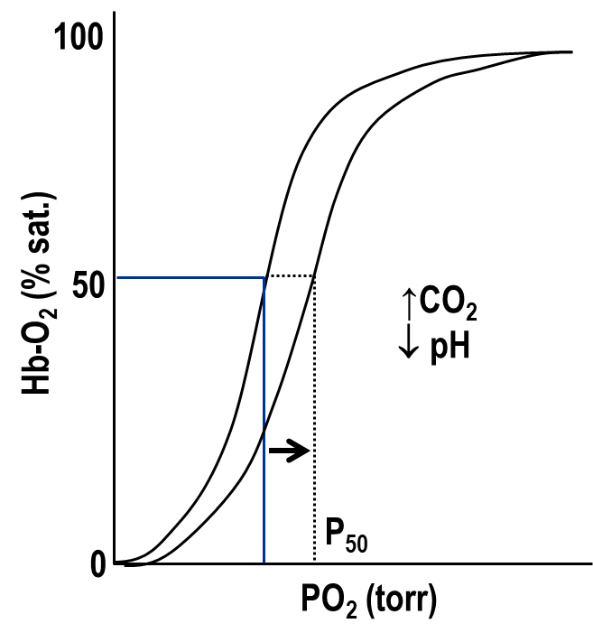
  - Temperature
    - ↑ temperature ⇒ right shift
    - ⇑ temperature ⇒ left shift
    - Significant for O₂ unloading in working muscle
    - Increased temperature for ectotherms: metabolic rate but ⇑ O₂ loading and solubility
      - Animals that are ectotherms (body temp is set by environmental)
        - When temp goes up, their metabolic rate increases
        - The increase in temperature makes it harder to uptake oxygen even if their metabolic rate
        - Good for delivery but bad for uptake
      - The solubility of O2 in plasma will also decrease at warmer temperatures
    - 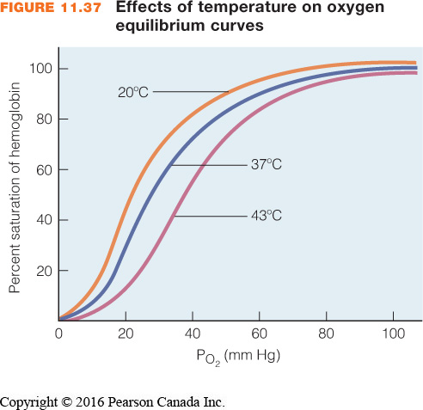
      - As long as the temperature change occurs in a tissue that is active
  - Organic phosphates
    - ↑ [organic phosphates] ⇒ right shift
      - This lowers the affinity of Hb for oxygen
      - And vice versa
    - Mammals – 2,3-biphosphoglycerate (2,3-DPG)
    - Birds – inositol pentaphosphate (IPP)
    - Fish and amphibians – ATP and GTP
    - Significant under chronic low O₂ (hypoxic) conditions
e.g. high altitude, hypoxic water
      - Humans at high altitude increase 2,3-DPG levels!
      - cf high altitude mammals
    - 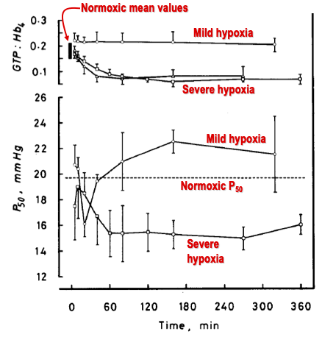
      - Important when animals are in low oxygen conditions
      - Trout
        - Trout in normal conditions, mild hypoxia, and severe hyoxia over time
        - The levels of GTP fall in animals that are exposed in sever hypoxia – this enhances Hb O2 binding ability in environments where there is not a lot of oxygen
    - 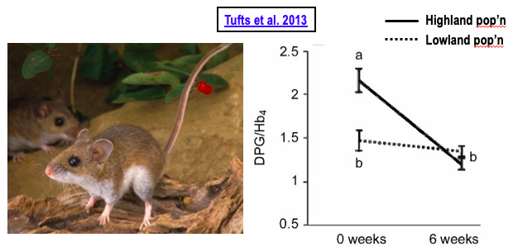
      - In mammals, when in hypoxia, there is an increase in 2,3-DPG levels, which is opposite of what you’d predict
      - Deer mice live at a bunch of different altitudes; show adaptations for life at high altitude
        - Very small living at high altitude and temperature is cold
        - Since they are small, they need to maintain high temp and high metabolism
        - RBC levels of 2,3-DPG levels were measured at high and low levels
          - High altitudes were brought down to low altitufe and the levels of 2,3-DPG levels fall
        - Reason for this?
          - If you look at animals adapted to high altitude, they have a left shifted curve
          - Mammals that are adapted for high altitudes have a left shifted curve so it doesnt really matter
            - The increase in 2,3-DPG allows for more efficient oxygen unloading
- Discuss in groups
  - Sketch an O₂ equilibrium curve for a normal human at sea level, and a normal human ascending to the peak of Mt. Everest without supplemental O₂. Note that hyperventilation at altitude causes PaCO₂ to fall

- Y-axis is % saturation – allows us to compare it between the two
- Normal human

- Ascending mt. Everest
  - Hyperventilation will decrease CO2 levels, the Bohr effect causes a shift to the left
  - increase in 2,3-DPG levels, shifting it to the right
  - more or less cancel out so the curve should be similar to what is at sea level
Blood CO₂ transport
- CO₂ carried in the blood in 3 forms:
  - Physically dissolved
  - Carbamino CO₂
    - Hb + CO₂ ⇔ H⁺ + Hb-CO₂
    - Of variable importance depending on species
  - HCO₃⁻ ions
    - CO₂ + H₂O ⇔ H₂CO₃ ⇔ H⁺ + HCO₃⁻ (at normal blood pH)
      - Bicarbonate cannot diffuse through membranes, so need CA to catalyze CO2 to bicarbonate directly or back to CO2
    - Carbonic anhydrase (CA)
      - CO₂ + H₂O ⇔ H⁺ + HCO₃⁻
      - Zinc metalloenzyme
      - ~15 isoforms known in mammals
      - Much less known about other vertebrates
  - 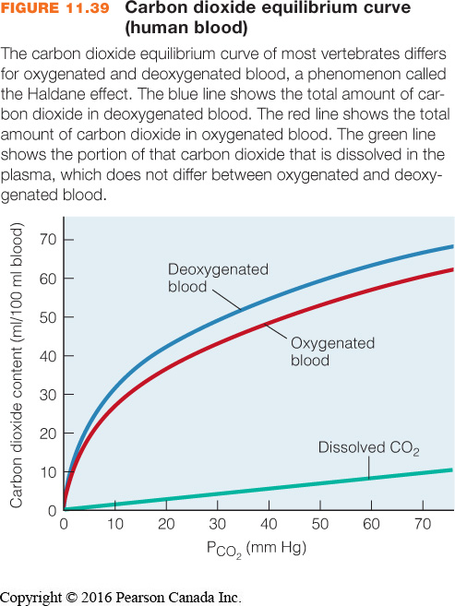
    - Physically dissolved gas does not account for much CO2
    - Have the CO2 bound to Hb – carbamino CO2
      - Still relatively small (5-10% is bound to Hb)
    - CO2 reacts with water, forming carbonic acid which dissociate to protons and bicarbonate (90%+ is carried this way)
- CO₂ movement from tissues to blood
  - Haldane effect = deoxy-Hb has a higher affinity for H⁺ than oxy-Hb
    - O₂ release in tissues allows greater H⁺ binding by Hb for CO₂ loading into blood
    - O₂ binding in gills/lungs provides H⁺ for CO₂ excretion
  - 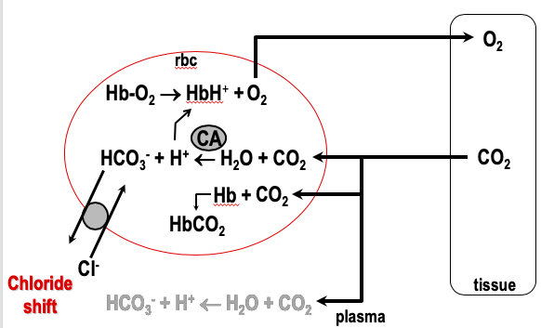
    - CO2 is being produced in the tissues, driving CO2 into blood (down pp gradient) and O2 diffuses in
    - CO2 reacts with water in the plasma to make protons and bicarbonate
    - Not usually CA present in plasma
      - That means the reaction is relatively slow and not as important
    - CO2 diffuses into cell where it can bind to Hb or react with H2O and CA to make protons and bicarbonate ions
    - To keep the reaction going, the products needs to leave the cell via the chloride shift
      - A Cl- will replace a bicarbonate ion via anion exchanger (facilitated diffusion)
      - If bicarbonate ions build up, reaction will stop
      - Protons will bind to Hb
        - Hb can act as a buffer – protons can bind and release
        - Some of the locations are affected by oxygen binding
          - So deoxygenated Hb has a higher affinity for protons than oxygenated Hb
          - This is good because O2 is leaving the cell into the tissues, leaving behind deoxy Hb, where protons can bind
    - This increases the amount of CO2 that can be carried
- CO₂ movement from blood to air
  - 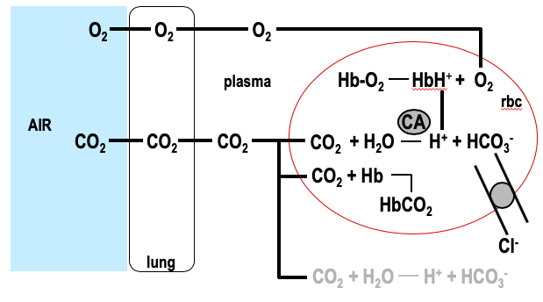
    - Want CO2 to leave blood into air – something that has lungs
    - In this case, we have air (low in CO2), so CO2 will go towards air
    - O2 is high in air so O2 will move into the blood
    - Oxygen will bind to Hb, causing dissociation of protons
      - Haldane effect
    - Protons will bind with bicarbonate and via CA, will produce CO2 which will leave the blood via diffusion
      - chloride shift will cause HCO3 to enter the cell
    - CO2 will also dissociate from Hb, causing it to dissociate and diffuse to tissues
    - Protons and HCO3 in blood will also react to make CO2 and water
- CO₂ movement from blood to water - teleost fish
  - 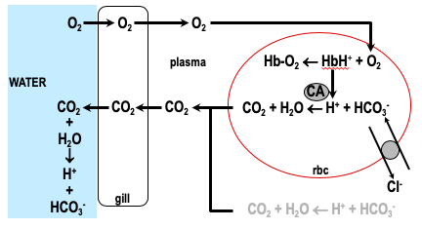
    - This is in water
    - Do not have CO2 binding to Hb
    - CO2 will turn back into bicarbonate and protons
      - Very easy for water breathers to get rid of CO2
      - Because CO2 is chemically converted to bicarbonate ions which maintains the partial pressure gradient, allowing CO2 to move easily
    - This is for a bony fish
- CO₂ movement from blood to water – elasmobranch fish
  - Extracellular CA contributes 30-60% of CO₂ excretion
  - No Haldane effect
  - 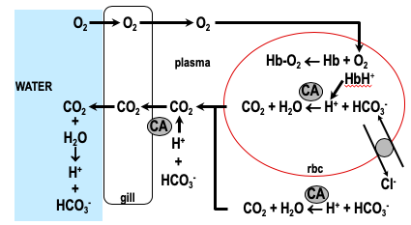
    - Not all water breathers are the same
    - This is for cartilaginous fish like sharks and rays
    - They lack the Haldane effect – no link between oxygenation status and Hb serving as a buffer
    - Have CA attached to the gill membrane and floating in the plasma so plasma reactions are important here unlike before
Gas Exchange Organs
- Vertebrate respiratory organs (not the only ones vertebrates have; there are also other ones)
  - Integument (skin)
  - Gills = evaginated extension of body surface
  - Lungs = invaginated, internalised gas exchange surface
- Common design features
  - Large surface area – diffusion
  - Thin epithelium – diffusion
  - High permeability – diffusion
  - Richly vascularised – maintain gradient
  - Typically ventilated – maintain gradient
  - MO₂ = ΔPO₂· KO₂· SA/T
    - Fick equation
    - Shows relationship between structure and function
- Air vs water
  - Capacitance
    - Recall MO₂ = Vm·ßmO₂ (PiO₂-PeO₂)
      - Flow of mediumxcapacitance of mediumxpartialpressuredifference
    - ßwO₂ << ßaO₂
      - capacitance of water is a lot lower than air
    - To achieve a given MO₂, Vwater >> Vair
  - Density and viscosity
    - In-and-out flow vs one-way flow
    - Greater energy expenditure on ventilation
  - Specific heat capacity and the challenges of homeothermy for water-breathers
    - Ventilation vs blood flow (ventilation:perfusion ratio)
    - ßbO₂ ≈ ßaO₂ >> ßwO₂
      - capacitance of blood and air are much larger than water
    - In water-breathers (e.g. fish), Vw:Vb = 10-20:1
      - Ventilation to perfusion ratio is high so more water moves through the gills more than the blood travels there
    - In air-breathers (e.g. mammals & birds), Va:Vb = 1:1
      - The ventilation to perfusion is 1:1
      - Equal flow of blood to lungs and air to lungs
  - Consequences for control of ventilation
    - O₂ uptake challenging but CO₂ removal easy for water-breathers
      - Control for breathing is due to O2 because can remove CO2 easy
    - Ventilation usually keyed to O₂ in water-breathers but CO₂ in air-breathers
      - CO2 determines ventilation in air breathers
  - 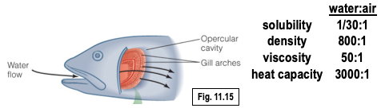
    - Solubility is O2 in water is low compared to air
      - This impacts water-breathers; they are breathing medium that is very low in oxygen
      - This is important for how much of the medium has to be ventilated
    - The water is denser and more viscous than air
      - This impacts the design of water gas exchange
        - This is a one way system
          - Water comes in the mouth and passes through the gills where it exits the body
      - in air, air comes in and out in the same route
        - if you needed to breathe more in a medium is more viscous, youd need to work harder, that is why fish have a one way system
      - water breathers
        - typically use a one way flow, an exception is the lamprey
    - the cost of breathing in water breathers is much higher than air (in fish)
      - 10% of metabolic rate to just breathe
      - Despite this, they still need to move large volumes of water and there is an energetic cost

  - 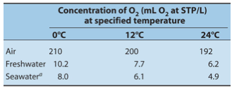
  - 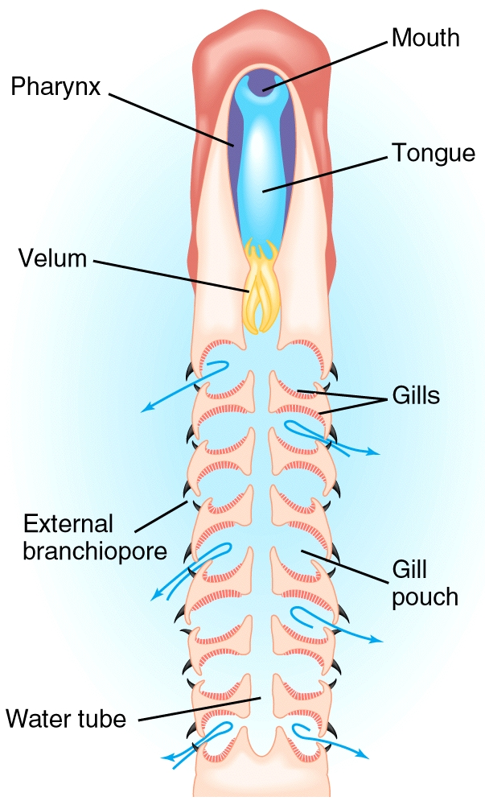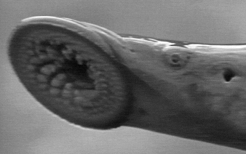
    - Lamprey is a jawless fish
    - Instead is has a plate which attach to the fish (parasite) and eats the tissue and blood of the fish
    - This produces a challenge for breathing
    - When not on a fish, the water comes in the mouth and exits through the gill puches
    - When on a prey item, then the mouth is occupied with feeding, so at that point, you have tidal flow (in and out) of the gill pouches
- Integument
  - Variable importance
    - Trivial in most mammals, birds and reptiles
    - Significant in most amphibians
    - Significant in some fish that lack scales, e.g. eels, catfish
  - Why? Why is this not the norm (why is skin not a good gas exchange organ – look at fick equation)
    - If you want a thick, impermeable covering to protect yourself, you will not have good gas exchange
    - Shows exchange of oxygen in red and CO2 in grey
      - Does not matter in fish, reptiles, bird and mammals
      - Important for amphibians
      - Most common in amphibians
        - Lungless salamander
          - Only uses skin for breathing – no lungs or gills

(04/10/2019)
- Pop quiz
  - Sketch an O2 equilibrium curve for blood (labeling the axes appropriately) and use it to illustrate the Bohr effect. Explain how the Bohr effect benefits O2 delivery during exercise.

    - Red – normal oxygen curve
    - Purple – right shift; caused by decrease pH, increase CO2, increase temperature, increase 2,3-DPG
    - Green – left shift; increase pH, decrease CO2, decrease temperature, and decrease 2,3-DPG
    - During exercise, you are using more ATP and therefore there is an increase of CO2 by product. There is also an increase in lactic acid, making the pH lower with the additional protons. The pH will allow for unloading of oxygen (decreasing affinity of O2 for Hb) more easily, supplying the working muscles with more oxygen for metabolism
  - Sketch a CO2 equilibrium curve for blood (labeling the axes appropriately). Add a line representing physically dissolved CO2. Use your sketch to explain the importance of the red blood cell to blood CO2 transport

    - Red – dissolved CO2
    - Green – curve in blood
    - CO2 does not dissolve efficiently in the plasma, even with increasing PCO2
      - Luckily, red blood cells have carbonic anhydrase (this speeds up the reaction because the plasma does not have CA, which makes it slower) which allows for CO2 to be combined with water to make bicarbonate and protons which are then transported outside of the cell
      - This is important because it allows more CO2 to be dissolved following a chemical reaction, which can then be reversed when it has to be removed from the blood
      - You can also have a small amount of CO2 binding to Hb
- Model of gas exchange
  - Cutaneous blood vessels absorb O₂ by diffusion across skin
  - Max arterial PO₂ < environmental PO₂
- Limitations
  - No (active) ventilation of skin, just body movements
  - Surface area & thickness -> limit size and/or metabolic rate
    - Extensive folding of skin?
    - Vulnerability to abrasion & desiccation
  - 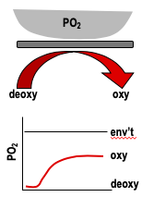
    - No active ventilation so pressure gradient will not be good
    - SA is relatively large, but if you have large animals with high metabolic rates, you wont have enough SA
      - Some animals try to make up for it by increasing SA by making folds
- Gills
  - Evagination of body surface
  - Surface area
    - Increased by extensive folding
    - Total SA correlated with lifestyle
  - External (branching off of the body and floating in water; problem – vulnerable and difficult to ventilate) vs internal gills (some kind of tissue covering; protects and makes ventilation more efficient)
    - e.g. Necturus (mud puppy) vs fish
    - Protection for fragile gills
    - More effective ventilation

  - 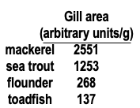
    - Which fish is the better athlete?
      - Mackerel
        - Has a higher gill surface area
        - Good correlation with capacity to gain O2 for metabolic rate and gill surface area
- Ventilation
  - Gills placed between buccal and opercular chambers
    - Water comes in the mouth, through the
  - Water flow driven by combination of buccal and opercular pumps
    - Opercula open and close and mouth sucks in water to have water coming in
  - Unidirectional and nearly continuous water flow
    - Water flow across the gill is nearly continuous
  - See Fig. 11.14
  - Ram ventilation
    - Facultative vs obligate
    - Obligate
      - Lost the capacity to pump water over their gills
        - Big tuna are obligate
        - They swim around with their mouth open so water flows in their mouth through their gills
        - Lost the ability for buccal and opercular pumps to actively pump

  - 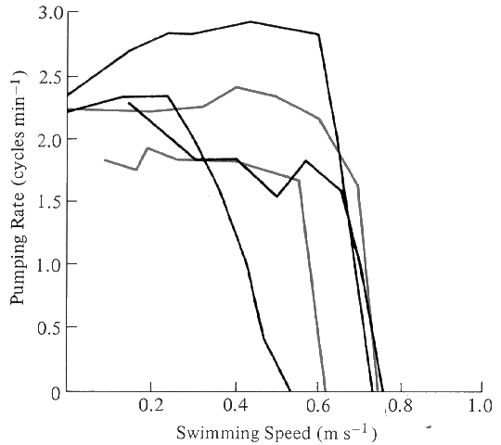
    - Breathing rate and swimming speed
      - Swimming faster causes them to stop breathing and water will move over the gills
      - Turn off the opercula to save energy
  - 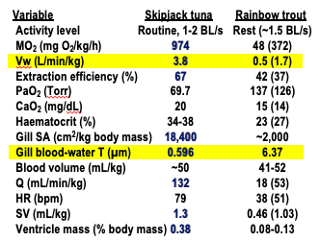
    - Vw - ventilatory flow
      - Trout at rest and tuna at slowest speed
        - Tuna uses ram ventilatory strategy to maximize ventilation flow
- Gill structure
  - 4 gill arches
  - Filaments & lamellae
  - Lamellae form sieve
  - Lamellae are gas exchange units
  - 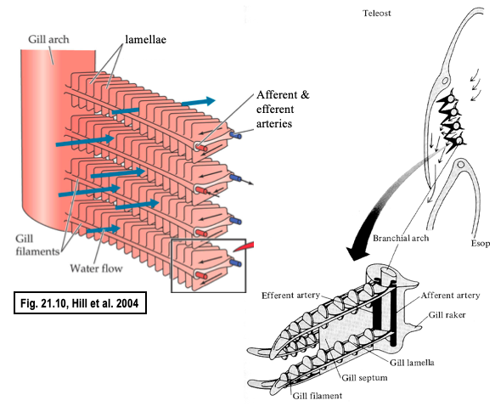
    - Two rows of filaments
      - From each filament, there are flat plates called lamellae – smallest structure in the gill where gas transfer can occur
      - Oreo cookie
        - There is a space of blood between two structures making up the lamella (icing between two cookies)
- Why don’t gills work in air?
  - The gills collapse in air and the SA becomes really low
  - Very little structure, so when you take them out of the water that is supporting them, they collapse and there is little SA for O2 uptake
  - Some amphibians can breathe air
    - They have more structure so they don’t collapse
- Lamellar structure
  - 2 epithelial sheets with a vascular space between
    - Pillar cells hold the two sheet apart
  - Pillar cells (p)
- Blood flow
  - Counter-current = in opposite direction to water flow
    - Blood moves through the lamella and water moves the opposite wat
    - Very important
- Diffusion barrier
  - mucus layer, lamellar epithelium
  - ~5 µm
    - Sounds small but this is a lot larger than mammals
  - blood-to-water diffusion distance correlated with lifestyle
    - Tuna has 1/2um and in trout is 6.4um
    - To maximize you want large SA and thin diffusion distance
  - 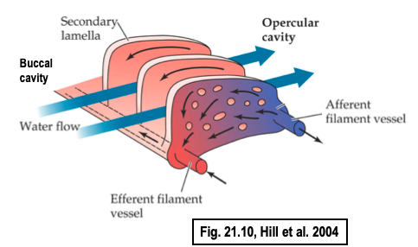
    - Oxygen moves across the lamella into the blood
      - This means the thickness is the thickness of the lamella and any mucus on it
- Model of gas exchange
  - Concurrent vs counter-current exchange
  - In a counter-current system, PaO₂ approaches PiO₂
  - 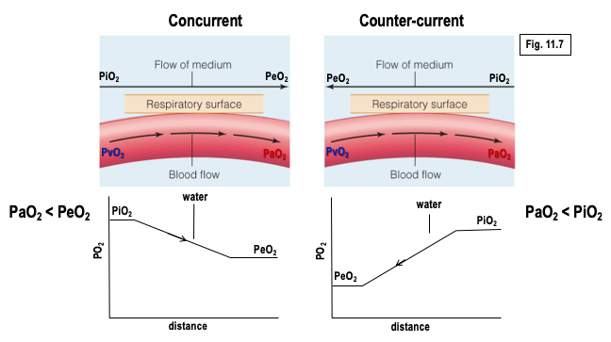
    - Right
      - Blood flowing through the gill left to right and water going from right to left
      - O2 moves from oxygen into blood
      - Inspired water has more O2 than expired
      - Blood is gaining oxygen, PPO2 in blood leaving the gill, it will be closest to water that is entering the gill
      - This is important because it maintains the PP gradient
      - Makes for more efficient O2 uptake
    - Left
      - At the beginning, there is a high pressure difference, allowing for a lot to come in initially, but since expired O2will have less O2 in it, there pressure gradient is lower and therefore the O2 in blood is lower than counter-current
- Extraction efficiency, E = (PiO₂ - PeO₂)/PiO₂ * 100%
- Fish gill > bird lung > mammalian lung
- 20-60% 40% 20-25%
  - Mammalian lungs are not that efficient
    - Its okay because we breathe air and air is O2 rich
  - 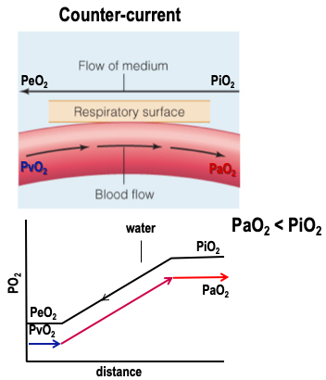
  - How much O2 has been removed from air/water as a percentage of pressure of air inspired
- Lungs
  - Invaginated, internalised gas exchange surfaces
    - Extensive folding
      - High SA
    - Trends among vertebrates: smaller size of air spaces, greater number, increase in total exchange area
      - Tendency to increase lung SA by making spaces smaller
    - Humans - total surface area for gas exchange = 80 m²
      - Within a lung
      - Size of tennis court
  - Note presence of air-breathing organs in many fish species – highly variable in structure
  - Lungs and ventilation
    - Active pumping of air
      - We actively pump air
    - Tidal flow
      - Air goes in and out of single passage
    - Positive pressure pump (amphibians – gulp of air) or suction pump (reptiles, birds, mammals – expand volume of lung and draw air in)
      - Reptiles typically rely on body wall
        - Muscles on the body wall expand the rib cage
          - This a problem because the muscles are also used for moving, so they cannot run and breath at the same time
          - Some Can get around it by only running on back feet to keep body wall muscles for breathing
      - Mammals have diaphragm
        - Muscle used for expanding the lungs that is independent from locomotion
      - Birds use air sacs
        - Air sacs are not needed for locomotion
  - 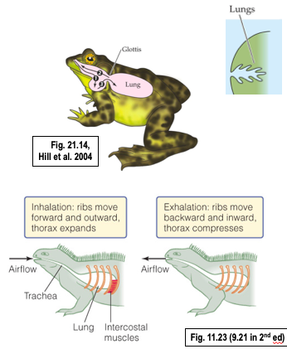
- Mammalian lung
  - Structure
    - Conducting vs respiratory airways
      - Conducting just bring air to the gas exchange
      - Respiratory – alveoli and bronchioles which allow for gas exchange
    - Alveoli are gas exchange units
    - Capillary network
    - Low diffusion distance (~0.5 µm) – some variation in thickness with metabolic rate (e.g. some bats, ~0.12 µm)
  - 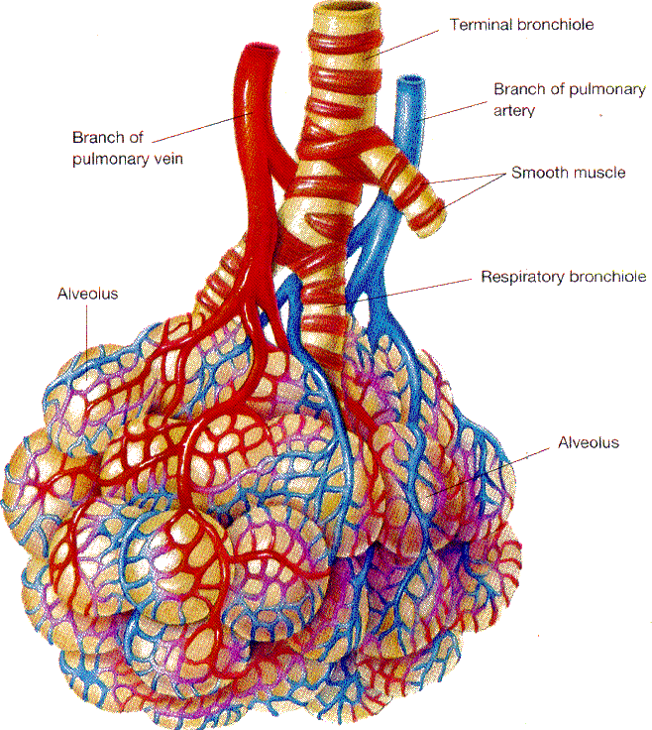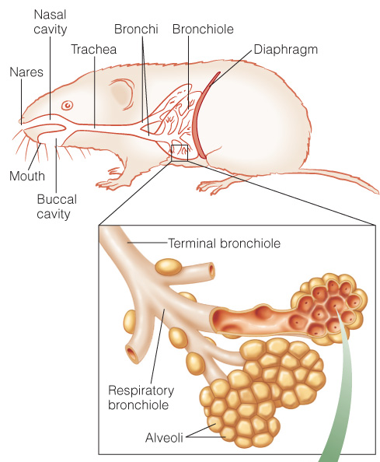
  - Ventilation
    - Thoracic cage - ribs and diaphragm
    - Pleural space and pleural fluid (in between membrane and wall of thoracic cage); cannot expand or contract since there is fluid, sucking the lungs to the body wall
    - Inspiration: expansion of thoracic cage -> contract (lower) diaphragm & raise ribs –> ↑ lung volume -> ↑ alveolar pressure -> draws air into lungs
    - Expiration: passive vs active
    - What happens if the seal is broken?
      - Can cause lung to collapse - pneumothorax
    - Resistance to airflow?
      - You are breathing air that has low viscosity but the air is going through ever smaller pathways
      - As the airways get smaller, the potential for resistance increases
      - Asthma attack decreases radius to increase resistance
      - An aute treatment for this is a B2 agonist
        - This will cause dilation
    - 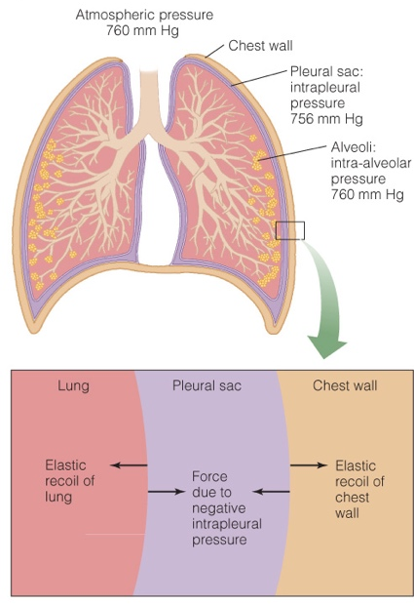
  - Model of gas exchange
    - Circulated, pool-type gas exchange mechanism
    - PaO₂ < PeO₂
    - Tidal ventilation -> P_{A}O₂ < PiO₂
      - Tidal volume (~500 ml)
        - The amount of air going in and out of lungs with each breath
      - Anatomical dead space (~150 ml)
        - Conducting respiratory system
      - Alveolar ventilation volume (~350 ml)
      - Residual volume (~2000 ml)
        - With each breath, you are adding 350mL of fresh air to 2L of air that remains in lungs
    - 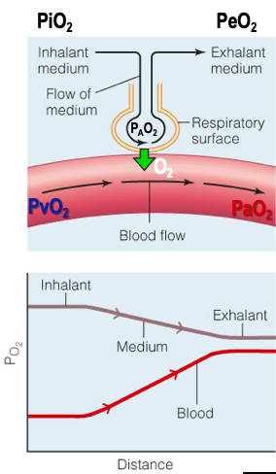
      - This is not counter-current
      - Just a circulated pool
        - Pool of air over flow of blood
        - Max PO2 achieved is exhaled O2
        - Not as efficient
      - Have air in the alveolus and blood going through capillary
        - The alveoli is ventilated
        - Oxygen will diffuse from alveolar air into blood
  - Discuss in groups: What happens to PaO₂ when you breathe through a snorkel?
    - You increase the anatomic dead space
    - Continuing to ventilate 500mL, the alveolar PO2 will start to fall
    - Need to breathe in more to accommodate this
_

