Finance COMM 421

-purchase textbook
-journals can be weekly or daily

Three Types of Firms
- Sole Proprietorship
- Partnership
- Corporation

Sole Proprietorship
- Business owned and run by one person
  - E.g. dog-walking service
- Very small with few, if any, employees
  - Straightforward to set up – many new businesses use this organizational form, at least initially
  - Expenses can be deducted
- A key limitation of a prio

Partnerships
- The income is split among partners according to their ownership in the partnership
- The partnership ends on the death or withdrawal of any single partner
- General partners have unlimited liability
  - A lender can require any or all partners to repay all the firm’s outstanding debts
- Limited Partners have limited liability
  - Their liability is limited to their initial investment
  - A limited partner (LP) has no management authority

Corporations
- Separate business entity that is a legally defined, artificial being
  - A corporation has many of the legal powers that people have
    - Can borrow money, own assets, be sued, pay taxes, etc.
  - A corporation can potentially live forever
    - Ownership rights (e.g. shares) can be bought and sold
    - If an owner dies, ownership of the corporation passes to the original owner’s heirs (e.g. children)
  - A corporation is responsible for its own obligations
    - The owners are not liable for any obligations of the corporation (but Directors may have some liabilities)
    - The words/letters at the end of the company name signify it is a limited liability corporation (Corporation/Corp, Incorporated/Inc. Limited/Ltd)
      - Microsoft Corporation, Apple Inc., Royal Caribbean Cruises Ltd.
    - In the USA, “LLC” is also used

Formation of a Corporation
- A company is “formed” under the provincial Business Corporation Act of a certain province, or the Canada Business Corporation Act
  - Every company has at least one shareholder (owner) and at least one Director (a human who directs the company)
- The articles of incorporation or the corporate charter is the constitution of the corporation
  - Private companies can have a shareholder’s agreement that defines rights of owners (shareholders)
- Different purposes of companies
  - Operating company (OpCo) – conducts business operations
  - Holding company (HoldCo) – holds shares of other companies, or assets (e.g. Intellectual Property)
- Setting up a corporation is more costly than setting up a sole proprietorship
- Corporations pay taxes
  - Differences in debt vs. equity tax influences corporate finance decisions

Ownership of a Corporation
- No upper limit on the number of owners
- The entire ownership stake of a corporation is divided into shares known as stock
  - Common Shares get a right to “vote” and share of the profits (dividends)
  - Other classes of shares can, but do not have to, exist and can, but do not have to, get different rights
- The collection of all the outstanding shares of a corporation is known as the equity of the corporation
- An owner of a share of stock in the corporation is known as a shareholder, stockholder, or equity holder
  - Shareholders can be individual humans, or other companies or partnerships etc.
  - Companies can choose to have their shares traded on a public “stock exchange”, such as the NYSE, TSX, etc.

Company Financial Statements
- Accounting statements that report the financial position of company
- Balance Sheet
  - Assets = Liabilities + Shareholder Equity
  - Current Assets – Current Liabilities = Net Working Capital
- Income Statement
  - Revenue – Expenses = Net Income
  - Retained Earnings (which adds to shareholder equity) = Net Income – Dividends
- Notes to the financial statements contain important information
  - Risk management activities, financial policies, stock options, etc.
- Market Capitalization = market price share X number of shares
  - Market value NOT same as “shareholder equity” from balance sheet (book value)
  - P/E ratio, D/P ratio
- Leverage: use of debt to fund activities

Financial Manager
- The financial manager plays a critical role inside any business
  - What investments to undertake or products to launch
    - What creates “value” – what is “valuable” (net present value)
    - Profit is NOT the same as financial value (you can be profitable but not NPV valuable)
  - How to raise funds pay for those investments or to develop those products
    - Issue stocks or bonds, bank loans, etc.
  - How to manage risks faced by the firm
    - Liquidity/cash, hedging foreign currency risk, etc.
  - How to return value to investors
    - Dividends, buybacks, exits, mergers/acquisitions, etc.
  - Strategic and tactical planning
- The financial manager does all these with the goal of maximizing something, usually

Management of a Corporation
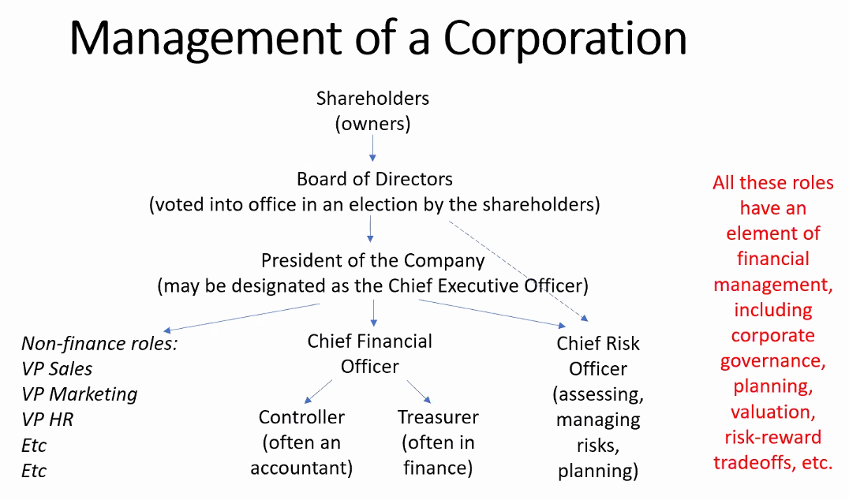

Financial Instruments and Markets interact with Financial Institutions

Homework for Journal
- Find a company of your own choice by searching

