COMM 420 – Marketing

Situational Analysis

Marketing Process
- Step 1: Business Planning
- Step 2: Situation Analysis
- Step 3: Develop Strategy
- Step 4: Marketing Mix
- Step 5: Implement & Control

5C Framework
- Company, Consumers, Climate, Competitors, Collaborators (+ Category)

Category
- Define the category (industry) in which the company competes
- Relevant facts/data
  - Size of market
  - Growth of market
  - Functional Segments

Customers/Consumers *consumers within the category (current + potential)
- Who are they?
- What benefits do they seek? Motivation?
- Frequency?
- Any insights, behaviours?
- If not ours, then whose?
- Penetration? Potential customers?

Competitors
- How intense? Size of competitors?
- Barriers to entry
- Their S&W
- How they will respond
- Direct
  - Similar product, same need
- Indirect
  - Different product, same need (substitutes)

Company (Strengths + Weaknesses)
- Product offerings, Brand reputation, Image, Results & Experience, Resources Available, Goals

Collaborators
- Suppliers, Intermediaries (distribution firms, resellers), Marketing Services, Agencies, Alliances

Climate: Macro-environmental Factors
- PEST Analysis
  - Political
    - Laws, Legislation
    - Industry Standards
    - Regulatory Agencies
    - Political Atmosphere
  - Economic
    - Exchange Rates, Inflation, Interest Rates
    - What are the major economic factors that affect a firm’s ability to compete?
  - Socio-cultural
    - Social trends – trends that shape consumer values
      - Carry less, stay local, going green, sharing economy, health & wellness
    - Culture – beliefs, values, attitudes
      - Need to understand culture significant influence on consumer behaviour
    - Demographics – income, education
    - Green Marketing/Greenwashing
  - Technological
    - Not just communications but science
    - How technology improves your product or the delivery of your product
      - Product design
      - Distribution

Opportunity ≠ Strategy
- Opportunity: Raw materials become less expensive
  - Strategy: Decrease price or increase profit margin
- Opportunity: Increase demand in overseas markets
  - Strategy: Expand outside of North America

Marketing
- Marketing is all about value
- Product: Creating Value
- Price: Capturing Value
- Place: Delivering Value
- Promotion: Communicating Value

Recap
- Companies conduct a situation analysis to gather and evaluate information about the internal and external environment which is used when developing market strategies
- A situation analysis ends in a SWOT, which is a summary of the key findings that should drive a company’s strategy

Consumer Behaviour

What Influences Consumer Behaviour?
- Psychological Factors
- Social Factors
- Situational Factors
- Marketing Mix

Psychological Factors
- They can interrelate with each other
- Attitudes
- Perception
- Learning
- Lifestyle
- Needs/Motives

Attitude
- Judgements we have as consumers
- Learned and long-lasting
- An enduring evaluation about a product/idea
- Think (cognitive)
  - Apple iphone 11 what the phone can do
- Feel (affective)
  - Iphone 5s family moments
- Do (behavioural)
  - KFC sandwich limited time

Perception
- How we select, organize, and interpret information to form a meaningful picture
- Usually unconscious, from upbringing/culture/interests
- No right or wrong, we just perceive things differently

Perception vs. Attitude
- Perception tends to precede attitude
- Perception is the way we see the world; how we filter things; the meaning we apply to stimuli
- Attitude is more of an opinion, a judgement

Learning
- Change in behaviour (or thought) as a result of experience or information
- Change in attitude
- Shaping
  - Free Sample Coupon Full Price
Lifestyle
- The way consumers spend their time and money

Social Factors
- Reference Groups
- Family/Group Buying Decisions
- Culture

Social Reference Groups
- People to whom an individual look when forming attitudes about an object
- Direct (member)
  - People you know, family, friends
- Indirect (non-member)
  - Presentations, celebrities
  - Aspiration (want to be in)
  - Dissociative (don’t want to be in)

Family/Group Buying Decisions
- Initiator (person who suggests buying product)
- Influencer (a person whose view or advice influences the buying decision)
- Decider (the individual with $/authority to choose which product to buy)
- Buyer
- User

Situational Factors
- Specific to the situation at hand
- Purchase Situation
  - Graduation/wedding/events
- Shopping Situation
  - Store environment, sales rep, demonstration in store
- Temporal state
  - State of mind

Consumer Decision Process
- 1: Need Recognition 2: Search for Information 3: Evaluation of Alternatives 4: Purchase & Consumption
5: Post-Purchase
1. Need Recognition
- Perceive a gap between actual and ideal state
- Functional or psychological need?
  - Functional = performance of product/service
  - Psychological = personal gratification
- Often both needs are addressed
- Goal is to find the right balance

2. Information Search
- What affects how long or how hard you’re willing to search for a product
- What Affects Search?
  - Perceived costs and benefits of search
  - Locus of Control
    - Degree to which people believe that they, not external forces, have control over outcome
  - Perceived or actual risk
    - Performance, financial, social, safety, psychological risk
  - Product type (and level of involvement)
    - Specialty (strong preference)
    - Shopping (prolonged search)
    - Convenience (quick purchase)
    - Unsought (unknown, disliked, etc.)

3. Evaluation of Alternatives
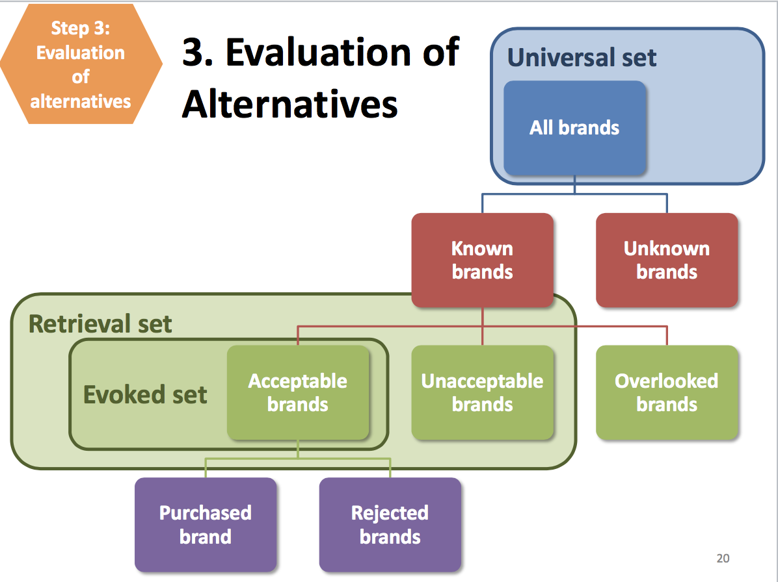
- Evaluative Critera & Determinant Attributes
- Consumer Decision Rules
  - Compensatory
    - Trades off one or more attributes for another
  - Non-compensatory
    - Focuses on one attribute (or subject); doesn’t consider others regardless of how important they are

4. Purchase and Consumption
- Converting purchase intentions into purchases
- Once a consumer has decided on a product, make it easy for them to buy it

5. Post-purchase
- Compare actual experience with expectations
  - Satisfaction = Performance – Expectations
- Customer satisfaction is critical
  - Brand loyalty
  - Word of mouth
- Post-purchase Cognitive Dissonance
- What can marketers do to ensure positive post-purchase outcome?
  - Set realistic expectations
  - Demonstrate proper use
  - Offer exchange/upgrade
  - Encourage feedback
  - Reach out to and thank customers

Cognitive Dissonance – Buyer’s Remorse
- Consumer experiences anxiety about correctness of purchase decision
- You splurge on a new sweater, which you buy online
  - When it arrives, it doesn’t fit quite right
  - Dry clean only

Recap
- Our decisions are influenced by psychological factors, social factors, situational factors, and marketing strategies
- Consumer decision-making follows a recognizable pattern: When there is a need to fulfill, consumers seek information, decide between options, purchase, and then react
- Good marketers influence consumers at each of these steps

Textbook – The Consumer Decision Process

Need Recognition
- Unsatisfied need to reach a desired state
- Most goods and services seek to satisfy both functional and psychological needs
- Functional Needs
  - Pertain to the performance of a product or service
- Psychological Needs
  - Personal gratification consumers associate with a product and/or service
- Successful marking requires determining the correct balance of functional and psychological needs that best appeal to the firm’s target markets

Information Search
- Length and intensity of the search are based on the degree of perceived risk associated with purchasing the product/service
- Internal
  - Buyer examines their own memory/knowledge about the product or service gathered through past experiences
- External
  - Buyer seeks information outside of their own knowledge base
  - Talking with friends/family/salesperson
  - Can also scour media for unsponsored and unbiased information
- Factors Affecting Consumers’ Search Processes
  - Perceived Benefits vs. Perceived Costs of Search
    - Spending a lot of time researching which house to buy
    - Not spending a lot of time researching on a dollhouse for their kid
  - The Locus of Control
    - People who have an internal locus of control believe they have control over the outcomes of their actions
      - Generally engage in more search activities
    - People with an external locus of control believe fate or other factors control their outcomes
  - Actual or Perceived Risk
    - Performance Risk
      - Involves the perceived danger inherent in a poorly performing product/service
    - Financial Risk
      - Monetary outlay and includes the initial cost of purchase as well as the costs of using the item/service
    - Physiological risk
      - Fear of actual harm should a product not perform properly
    - Psychological risk
      - Way people will feel if product/service does not convey the right image
    - Social risk
      - Fears that consumers suffer when they worry others might not regard their purchases positively

Evaluation of Alternatives
- Attribute Sets
  - Consumer mind organizes and categorizes alternatives to aid his or her decision process
  - Universal sets
    - All possible choices for a product category
  - Retrieval sets
    - Brands/stores that can be readily brought forth from memory
  - Evoked set
    - Brands/stores that the consumer states they would consider when making a purchase decision
    - Increased the likelihood of purchase and therefore reduced search time
  - Evaluative Criteria
    - Set of salient or important attributes about a particular product
      - Price, fit, materials, reputation, service support
  - Determinant Attributes
    - Product/service features that are important to the buyer and on which competing brands/stores are perceived to differ
- Consumer Decision Rules
  - Set of criteria that consumers use consciously or subconsciously to quickly and efficiently select from among several alternatives
  - Compensatory Decision Rule
    - Assumes that the consumer trades off one characteristic against another
    - Good characteristics compensate for bad characteristics
      - Paying more for a product because of its benefits
  - Non-compensatory Decision Rule
    - Choose a product/service on the basis of one characteristic or one subset of a characteristic, regardless of the values of its other attributes

Purchase and Consumption
- Conversion Rate
  - Retailers measure how well they have converted purchase intentions into purchases
    - Number of real or virtual abandoned carts in stores/websites

Post-purchase
- Customer Satisfaction
  - Build realistic expectations
  - Demonstrate correct product use
  - Provide money-back guarantees and warranties
  - Encourage feedback
- Post-purchase Cognitive Dissonance
  - Internal conflict that arises from an inconsistency between two beliefs or between beliefs and behaviors
  - When consumer questions the appropriateness of a purchase after decision has been made
  - Likely for products that are expensive or with high levels of risks

Customer Loyalty
- Need customer satisfaction to maintain customer loyalty

Undesirable Consumer Behaviour
- Negative Word of Mouth
  - When consumers spread negative information about a product/service to others

Segmentation, Targeting & Positioning

Step 3: Develop Strategy
Target Market (STP)

Market Segmentation = Dividing total market into smaller, homogenous groups

Segmentation
- Dividing total market into smaller, homogenous groups
- Consumers have different needs to be met

Common Segmentation Bases
- Going down the list tends to be more practical, powerful, and meaningful
- Each segmentation base has many segmentation variables
1. Geographic
2. Demographic
3. Psychographic
4. Behavioural
5. Benefit

Geographic Segmentation
- Dividing market (homogenous groups) by location
- Variables
  - City, region, country
  - Climate, topography, geography
  - Urban, rural

Demographic
- Dividing consumer groups by measurable characteristics
- Examples
  - Gender, Age, Generation, Ethnicity
  - Income, Education, Occupation, Marital Status, Household Size
- Different Dove products
  - Men, women, baby, age

Psychographic Segmentation
- Tapping into psychological mindset of how people live
- Based on values, attitudes and lifestyles, activities, interests and opinions
- Often used in addition to demographics
- Info gathered through surveys on activities, interests, and opinions (AIO-studies)
- Variables
  - Lifestyle: adventurous, affluent, frugal, intellectual, trendy
  - Attitudes & Values: environmentalist, security conscious, vegetarian, risk averse
  - Activities & Interests: books, fitness, hobbies, shopping, sports
  - Political Views: Conservative, Democrat, Independent, Liberal, Republican
  - Opinion: easily led or opinionated, helpful, negative, positive
- “community-oriented with traditional values who enjoys spectator sports and spends time with the family”
  - An added layer to the demographics

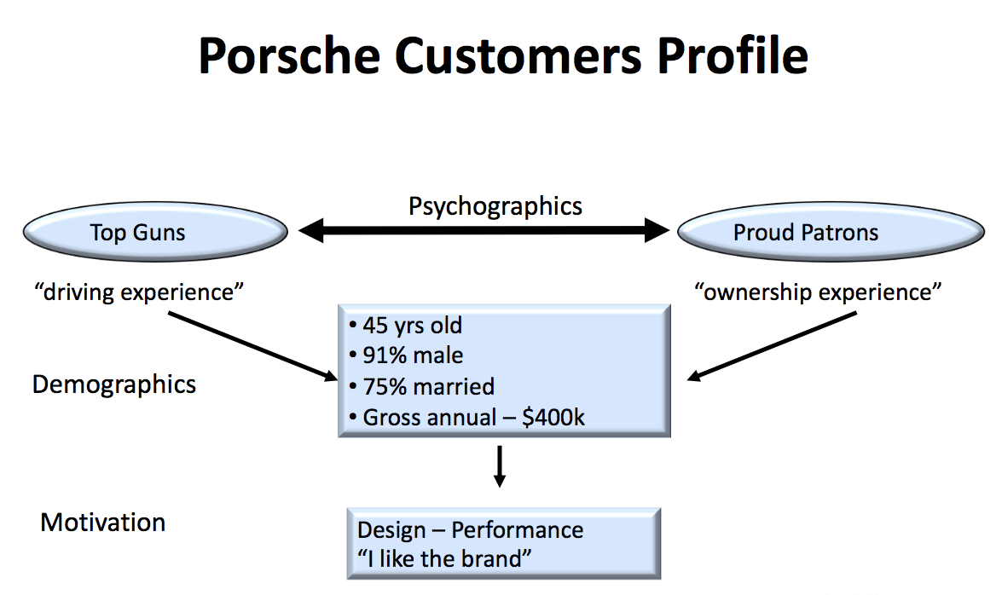

Behavioural Segmentation = Product Usage
- Focuses on whether & how much people buy or use a product
  - Usage rate – heavy, medium light
  - User status – non; lapsed uses; regulars; first time
  - Brand loyalty
  - Occasion
  - Attitude
  - Loyalty Status
  - Buyer-Readiness Stage
  - Needs & Benefits
  - Decision Roles

Benefit Segmentation
- Relates to product attributes/benefits
- Focuses on the need it fulfills, or the problem it solves
- Basis for product differentiation
- Consider Toothpaste
  - Therapeutic
    - Cavity protection
    - Gum protection
    - Plaque, tartar
  - Cosmetic
    - Whitening
    - Fresh breath
  - Sensitive Teeth

Segmentation
- Sometimes different segments overlap with each other
- Companies come up with segment profile names that involve overlap
  - Porsche example
- Consumer Segment Profiles in a coffee shop
  - Lunchers
  - Chitchatters
  - Wifi workers
  - Morning to-goers

Criteria for Targeting
How would you evaluate the segments?
- Potential
  - Current size of segment, anticipated growth and buying power
  - Financially worth pursing (i.e. profitable)
- Feasibility
  - Willing and able to be reached through communication and distribution

Profitable Segments
- Can research or make assumptions re:
  - Segment size
  - Segmentation Adoption Percentage. Profitability
  - Purchase Behavior
  - Gross margin less fixed costs

Targeting Strategies
- Undifferentiated (mass)
- Differentiated (multi-segment)
- Concentrated
- Micro-Marketing

Positioning
- Products place in minds of consumers relative to competing products
- Implants unique benefits & differentiation in the consumer mind
- Target Market + Differentiation
  - Aka Value Proposition

Positioning Statement Formula
For [target audience], [company/product] is a [category/frame of ref] that [point of parity] and/but
[point of difference]
- PoP is often the main benefit offered by all products in the category

Example – Dove Soap
- Positioning
  - For women, Dove is a soap that cleans and moisturizes while they wash. Unlike other soaps, Dove contains ¼ moisturizing cream

Listerine
- Listerine, the mouthwash category founder:
  - To folks with bad breath Listerine is the mouthwash that cleans breath fast and is easy

Listerine vs. Scope
- Listerine, the mouthwash category founder:
  - Positioning: To folks with bad breath, Listerine is the mouthwash that cleans breath fast and is easy
  - Tagline: For halitosis, use Listerine
- Scope enters the market:
  - Positioning: To folks with bad breath, Scope is the mouthwash that cleans breath fast and is tasty
  - Tagline: For sweet breath, use Scope
- Listerine gets nervous and tries to reposition
  - Scope “tastes great” = “ineffective”
  - Positioning: To folks with bad breath, Listerine is the mouthwash that cleans breath with special medical cleansers to make sure it’s really done
  - Tagline: The taste people hate, twice a day
- Scope knows effectiveness is a core value:
  - Positioning: To folks with bad breath, Scope is the flavoured mouthwash that cleans breath effectively
  - Tagline: Scope works. Don’t let the good taste fool you

Perceptual Maps
- A key to positioning a product effectively is the perceptions held by consumers
- Perceptual Map
  - Displays the position of products of brands in the consumer’s mind

Consider Nutrl Vodka Soda
- Consumers of legal age who consume alcoholic beverages
- Consider positioning:
  - For traditional drinkers, Nutrl is the ready-to-drink alcoholic beverage that is refreshing and uplifting. Unlike other drinks, it is all natural and simple, containing only 3 natural ingredients
Reading: Ch.9

Undifferentiated Targeting Strategy, or Mass Marketing
- A strategy a firm can use if the product/service is perceived to provide the same benefits to everyone, with no need to develop separate strategies for different groups
- Focus on similarities in needs as opposed to differences

Differentiated Targeting Strategy
- A firm targets several market segments with a different offering for each
- Helps them obtain a bigger share of the market and increase the market for their products overall
  - Diversify the business and lower the company’s overall risk
- Can be costly

Concentrated Targeting Strategy
- An organization selects a single, primary target market and focuses all of its energies on providing a product to fit that market’s needs
- Entrepreneurial start-up ventures
  - Limited resources

Micromarketing
- When a firm tailors a product/service to suit an individual’s wants or needs
  - Usually small providers
- The internet helps facilitate this segmentation strategy
- Cookies allow advertisers to use retargeting technologies to link their advertisements to the browsing history of any individual user
- Amazon is renowned for the algorithms it uses to provide recommendations for related products as they browse the site, which match customer profiles to those of other customers

Step 5: identify and Develop Positioning Strategy
- Market Positioning
  - Process of defining the marketing mix variables so that target customers have a clear, distinctive, desirable understanding of what the product does or represents in comparison with competing products
- Value Proposition
  - Communicates the customer benefits to be received from a product/service and provide reasons for wanting to purchase it
  - Maintaining a unique value proposition can be sustained in the long-term only in monopoly situations or possibly monopolistic competition situations
- Firms must constantly and closely monitor their competitors’ offerings
- Main Value Proposition Components
  - Target Market
  - Offering name/brand
  - Product/service category or concept
  - Unique point of difference/benefits

Product Strategy

Step 3: Develop Strategy
- Segment – identify possible consumer segments
- Target – evaluation and select target segments
- Positioning – create “value proposition”

Step 4: Marketing Mix
- Make decisions regarding the 4 P’s
- Decisions on 4P’s should reflect the target and positioning identified in step 3

What is a Product?
- Anything that might satisfy a want/need
- Anything of value that can be offered through exchange
  - Physical object/good, Services, Places, Person, Organization, Idea

Product Types
- Specialty
- Shopping
- Convenience
- Unsought

Product – Core Customer Value
- People don’t buy features They buy benefits
  - Features: What it’s made of
  - Benefits: How it benefits you

Product Mix
- Company’s complete assortment of goods and services
- Includes product lines and individual offerings
  - Virgin: phone, radio, Airlines, etc.

Product Line
- Group of associated items considered similar
  - Virgin Radio
  - Virgin Atlantic
- Depth
  - Number of products in a product line
  - Different Virgin Radio Stations
- Breadth
  - Number of product lines in a company
  - Different Virgin offerings: phone, radio, airlines

Line Extensions
- New product added to existing line (depth)
- Closely related to other products in firm’s existing line
  - Add sizes, types, colours, price
- Finer segmentation can meet consumer needs better
- But may result in cannibalization & increased product costs/complexity
- 89% of new products
- Different Crest toothpastes, flavours of Oreos, flavours of vitamin water

Brand Extension
- New line added to existing mix
- Brand name applied to new product line
- Sometimes complementary product line, sometimes different
- Dove going into haircare, skincare, etc.
- 6% of new products
- Avoids costs of new brand development; allows for efficient promo
- But possible dilution of parent brand
- Dove making different products, Snickers making ice cream

Services are (compared to goods):
- Intangible activity
- Variable
  - Hard to standardize
- Inseparable from service provider
- Perishable
- Service-Dominant
  - Haircuts
- Good-Dominant
  - Retailers

Growth Strategies
 | Current Product | New Product
Current Market | Market Penetration | Product Development
New Market | Market Development | Diversification

Market Penetration
- Steal Market Share
  - Attract new customers from currently targeted segment
- Intensify Consumption
  - Encourage existing customers to buy more (quantity) or more often (frequency)
  - Promotions (BOGO)

Market Development
- Target a new segment
  - Introduce a current product to a new domestic or international market
  - Oreos in different countries with different flavours

Product Development
- Introduce a new product
  - Introduce a new product to the currently targeted segment

Diversification
- A New Product, A New Audience
  - Introduce a new product to a new segment
  - McDonalds introducing salads
- Can be related or unrelated diversification

Product Life Cycle – Industry Level
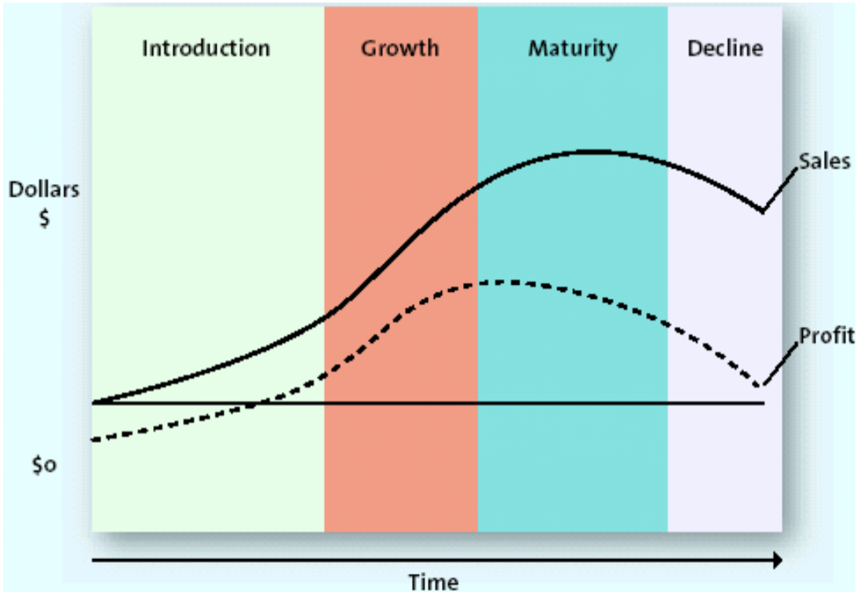

Introduction Phase
- Goal: Build Awareness
  - Firm tries to build demand for new market entry
  - Competition is limited
- Products: Few
- Promotion: Often high to build awareness and instigate trial
- Price: Often high to cover R&D costs and promotion spend
- Distribution: Limited

Growth Phase
- Goal: Establish Brand and Build Loyalty
  - Sales volumes & profits rise rapidly
  - Competition increase
- Products: Often improvements are evident
- Promotion: Steady spending on promo
- Price: Can vary
- Distribution: Expands

Maturity Phase
- Goal: Defend (or increase) market share
  - Industry sales grow but plateau (demand flat)
  - Many competitors, intense
- Products: Often Modifications
- Promotion: Heavy spending likely
- Price: Competition likely
- Distribution: Aim to outdo competition

Decline Stage
- Goal: Maximize profits, exit or niche
  - Innovations, shifts in preferences Decline
  - Industry profits fall
- Product: Manufacturers gradually drop declining items
- Promotion: Scaled Back
- Price: Often prices are cut unless niche product
- Distribution: Selective

Product Life Cycle – Recap
- Reflects industry in 4 Stages
- Indicates sales, profits, and time
- Shape of PLC curve will differ from industry to industry
- Timeline for a PLC will vary
- Offers a starting point for marketers when developing their strategies

Product Strategy Recap
- A company’s product mix has depth (length of product line) and breadth (number of product lines)
  - A growing company may extend a line or the brand
- Compared to products, services are more challenging to market because they are intangible, variable, perishable, and inseparable
- To grow, a company may double down on current segments with current products (market penetration), reach a new market (market development), develop a new product (product development), or reach a new market with a new product (diversification)
- Product categories go through phases as identified by the Product Life Cycle concept

New Product Development
- Innovation
  - Process of transforming ideas into new products and services
- Diffusion of Innovation
  - Process by which new products spread through a market group
  - Helps predict rate at which product will be adopted
  - Helps predict potential sales

Diffusion of Innovation Theory
- Not everyone adopts things at the same time
- Time of Adoption of the Innovation
  - Innovators (2.5%)
    - Risk-takers, highly knowledgeable about product category
    - Word of mouth is very important
  - Early Adopters (13.5%)
    - Not at the premiere, but will be watching it when it comes out
  - Early Majority (34%)
    - Crucial to profitability
    - More risk averse
    - Critical mass formed
  - Late Majority (34%)
    - Full market potential has been reached
    - Wait until product is well-established or on sale
  - Laggards (16%)
    - Avoid change
- Not one type of consumer for all categories

Rate of Adoption
- Speed at which products diffuse varies and depends on
  - Relative Advantage
    - Better than what is out there fast acceptance
  - Compatibility
    - If it fits with what consumers are currently using
  - Observability
    - Easily observed and benefits can be communicated easily
    - Demonstrations, advertising, promotions, etc.
  - Complexity
    - How easy the product is to use
  - Trialability
    - Able to test, try the product out without commitment

Diffusion of Innovation: Applegate Hotdogs
- Consider hot dog category:
  - Sales in decline
  - Applegate innovates with new product idea “The Cleaner Weiner”
- Compared to traditional hot dogs, was it
  - Relatively advantageous, Compatible, Observable, Complex, Trialable

What is a Brand?
- Name, logo, symbol, character, slogan, jingle, etc. AND Reputation and Experience
- “a complex bundle of images and experiences in the consumer’s mind”
- Branding is the promise that you make The promise that you keep
- Brand = Trust

Value of a Brand
- For Marketers
  - Competitive protection
  - Decreasing marketing costs
  - Establishes loyalty
  - Asset – part of company’s value
- For Consumers
  - Facilitate Purchases
    - Identification
    - Trust
    - Decreasing risk & search cost

Brand Equity
- Value or worth of a brand
- Set of assets/liabilities linked to brand
- Brand extensions/Brand Licensing/Co-Branding (Collaborations)

How Do Firms Create and Measure this thing called Brand Equity?
- Brand Awareness
- Perceived Value
- Brand Associations
  - Symbols, Logos, Famous Personality
- Brand Loyalty

Distribution Strategy

Distribution
- All activities required to get the right product to the right place at the right time
- Very behind the scenes, can be very expensive
- Doesn’t act in isolation, may impact other parts of marketing mix
- Producers use intermediaries because they create better efficiency in making goods available to target markets
  - Transform the assortments of products made by producers into the assortments wanted by consumers

Channel Design Decisions
- Firms often struggle between what is ideal and what is practical
- Marketing channel design
  - Analyzing consumer needs
  - Setting channel objectives & intensity
  - Identifying major channel alternatives
  - Evaluating channel alternatives

Sample Channel Structures
- Direct Channels
  - Producer Consumer
- Indirect Channels
  - Via Retailer (Shoppers, Walmart)
  - Wholesaler Retailer Consumer
    - Cost will probably go up
  - Agent/Broker Wholesaler Retailer
    - International distribution
- Services can be direct or indirect
  - Agents/Brokers (Travel Agents)
- Some can have multiple channels
  - Apple can sell via their own channels, but also through best buy, etc.

Qualities of an Effective Channel
1. Efficient: Reduces number of marketplace contacts
2. Sorts: Matches consumers’ needs to companies’ products
3. Facilitates: Flow of products, information, promotion, payment, and ownership
4. Standardizes: Makes transactions efficient and fair

Channel Strategy & Design
1. Distribution Intensity
2. Channel selection and design
- Customer/Market factors
- Product factors
- Organizational factors

Distribution Strategy & Design
- Distribution Intensity
- How widely do you want your product to be available to be customers?
- Intensive (widely available) Selective Exclusive (exclusive retailers)

Channel Selection/Design
- Customer/Market factors:
  - Expectations
  - Geographic location, dispersion
  - Average order size/ quantity
  - Service Needs
- More customers there are, more channels there needs to be
- Product Factors:
  - Perishability
  - Complexity, customization
  - Product type
- Organizational Factors
  - Size and resources
  - Product line scope
  - Level of control desired (lululemon)

Retailing Strategy
- Like other businesses, retailers develop strategies and want to offer value to their customers
- Decisions are made regarding the 4 P’s

Product
- Merchandising: categories & specific products/lines
- Private Labels (“in-store brands”)
- Services offered
- Atmospherics
  - Does the store design:
    - Match the brand vision?
    - Enhance the brand equity?
    - Engage the target consumer?
    - Showcase the products?

Pricing
- Pricing defines value
- Meet retailer and consumer expectations
- RRSP
- Mark-ups, Mark-downs
- Manufactures can’t dictate retail selling price

Distribution
- Convenience and Access
- Location (applies to brick-and-mortar and online)
- Hours of operation
- Merchandising
  - Organization, placement of products in store
- E-commerce impact from COVID 10x penetration

Promotion
- Brand building
- General info or shopping-specific
- In store: point of purchase (POP)
  - Displays, coupons, trials, demonstrations
- Out-of-store:
  - Social media, flyers, window displays, other promotional tools

Branding
- Product is what you sell, a brand is the perceived image of the product you sell, and branding is the strategy to create that image

Brand
- Brand is a name, term, design, symbol, or any other feature that identifies one seller’s good or service as distinct from those of other sellers
- Not just physical features, but also the feelings that consumers develop towards the product

Branding
- Branding is endowing products and services with the power of a brand
- Giving a meaning to specific organization, company, products, or services by creating and shaping a brand in consumers’ minds
- Strategy designed by organizations to help people to quickly identify and experience their brand
  - Give them a reason to choose their products over the competitions
- Objective: attract and retain loyal customers and other stakeholders by delivering a product that is always aligned with what the brand promises

Who Does it Affect?
1. Consumers
2. Employees/Shareholders/Third Parties
- Successful branding adds to a company’s reputation
- If you don’t like or feel connected to a brand, you would not want to work for it or invest in it

How can it be done?
- Brand definition
- Brand positioning statement
- Brand identity
- Advertising and communications
- Sponsoring and partnerships
- Product and packaging design
- In-store design
- Workspace experience and management style
- Customer service
- Pricing strategy

Pricing Strategy

Five C’s of Pricing
- Value sits at the centre
- Company Objectives (internal)
- Customers
- Competition
- Costs (internal)
- Channel Members

Company Objectives
- What drives the company’s overall approach to pricing?
- Marketing/Sales Orientation
  - Maximize volume and market share
- Financial/profit orientation
  - Maximize profit or return
- Competitive Orientation
  - Relative to competitors

Customer
- Perceptions of value
  - Pricing takes this into consideration
- Demand curve
  - Hard to dictate
- What do we mean by price elasticity of demand?
  - How sensitive consumers are to price changes
  - Given a specific change in price, what will be the impact on the total quantity demand of the product
  - If quantity demand increases a lot, consumers are very sensitive
  - Price Elasticity = % change in quantity demanded/ % change in price
- What factors influence price elasticity of demand?
  - Proportion of Budget (less sensitive)
    - Spending small amount $
    - Buying relatively smaller amount
  - Substitution Effect (less sensitive)
    - If difficult to substitute
    - If costly to switch
  - Perception of Fairness (less sensitive)
    - If price viewed as fair, or product quality justifies the price

Competition
- Level of competition often shapes pricing
- Monopoly, Oligopoly, Monopolistic Competition, Pure Competition
- “Reactive approach” to market is common if similar product exists in market (link to value)

Channel Members
- Manufacturers, wholesalers, and retailers can have different pricing priorities
  - Can have recommended price

Costs
- Firms must understand costs as links to profitability
- But remember, cost does not equal value
- Variable Costs
  - Vary with production volume
- Fixed Costs
  - Unaffected by production volume
- Total Cost
  - Sum of variable and fixed costs

Break-Even Analysis
- Planning tool
- “At this price, what level of sales is required to cover costs?”
- BE = FC / Price – VC

Promotional Strategy Pt. 1

What is ‘Promotion’?
- All forms of communication used by companies to inform, remind, persuade, and influence consumers
- Getting the right message to the right audience through the right media

Promotional Mix
- Advertising
  - Paid communication for placement of a message
- Direct Marketing
  - Individualized targeting to solicit a response
- Personal Selling
  - Two-way communication between buyer and seller
- Sales Promotion
  - Excitement-building programs
- Public Relations (PR)
  - Publicity to build community/reputation

The Communication Process
- Communication only takes place is meaning is transferred (message received)
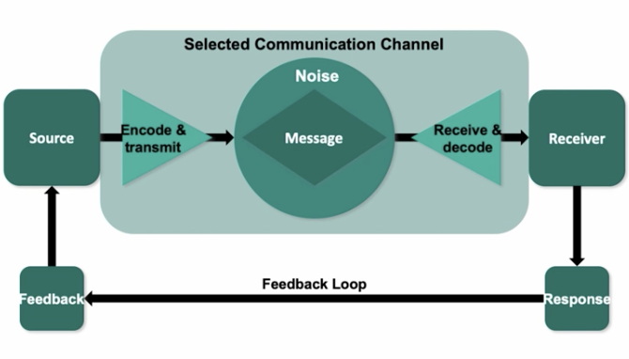
- 4 Areas where things can go wrong:
  - Message can be wrong in encoding process
  - Channel can be wrong (not directed at target consumer)
  - Receiving end: message not interpreted/translated properly
  - Nose: distractions/interference companies end up using repetition

Effective Promotion
- Accomplishes 3 tasks:
  - Gains receiver’s attention
  - Achieves shared understanding between receiver and sender
  - Stimulates receiver’s needs, suggests appropriate method of satisfying them
- Steps to reach purchase decision
  - Attention (think) Interest (feel) Desire (feel) Action (do)

AIDA Model:
- Consider how consumers react to communication – Promotion should move consumers toward action

- Awareness
  - Senders first must gain the attention of the consumers
- Interest
  - After the customer is aware, they must be persuaded to investigate
- Desire
  - The message should move the consumer from “I like it” to “I want it”
- Action
  - Purchase is just one type of action
  - Promotions are an action
  - What else can consumers do?

PRESENTATION SCRIPT

A&F is already an established clothing brand that operates worldwide. The brand currently targets men and women looking for everyday luxury styles. Although a household name previously, in recent years A&F has suffered with backlash from the previous brand image. The purpose of this presentation is to suggest implementations which will allow A&F to remain a leader in the heavily competitive apparel industry.

Distribution
A&F distribute their products through direct channels and distribution intensity is selective. Consumers will have to browse either A&F’s retail store or online platform to be able to purchase the products.

Currently in Canada, there are 6 A&F retail stores spread across the country in densely populated areas. Having brick-and-mortar stores in those malls allow A&F to target OOO Millennials effectively because they are often away from the office and will go shopping to stay at the forefront of trends. Having retail stores in large malls are also beneficial for A&F to target OOO Millennials who may not have had exposure to the brand previously.

OOO Millennials have a strong desire to stay trendy, and A&F can help them achieve that goal by strategically placing the newest trends on their mannequins through the window display. This will attract potential consumers into the store, and then the items will be placed on the first few tables or racks that they see when they enter.

Recommendation
We recommend that A&F keeps their 6 retail stores as-is in Canada because they are doing well in those urban centers. They are centralized in cities where there are a lot of young millennial workers, and in malls that are close to many office buildings. Accessibility is important for OOO Millennials, and the current retail stores are already the most accessible for them. Instead of opening more brick & mortar stores, A&F should focus more on their e-commerce platform that is currently thriving, and very popular among the target segment’s age group. To capture incoming consumers into this target segment, A&F can open pop up stores in select universities as well.

